Table of Contents

**Stock - BOM (Production)** 1

***Stock grid*** 1

**Setup Stock information** 2

***Lookup - Production Contra account*** 2

***Enter quantity*** 3

***Messages*** 3

**Search (Central search)** 4

**Stock - BOM (Production)**

***Stock grid***

* Click here to show/hide/move bands (Mouse over) first asterisk

* Click here to show/hide/move columns (Mouse over) second asterisk

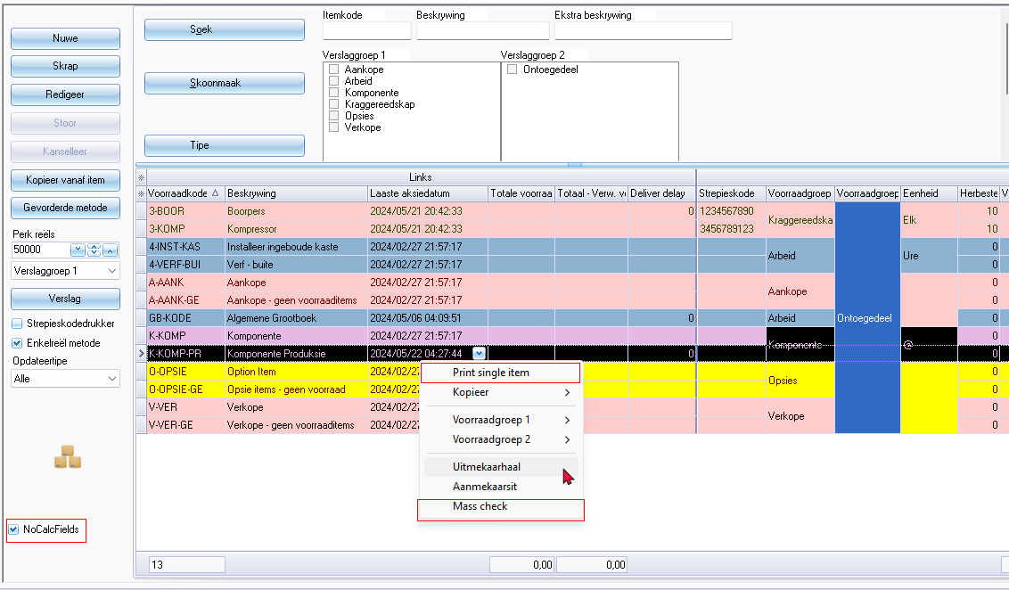

**Setup Stock information**

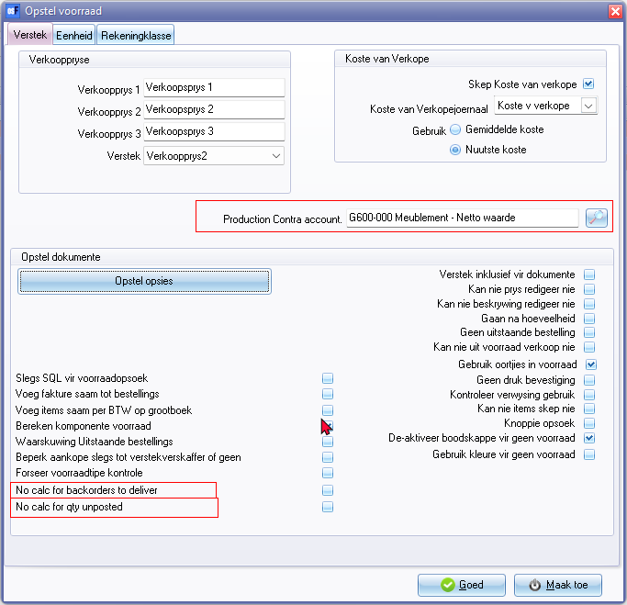

Production Contra account

Lookup - Select account (Titlebar caption)

***Lookup - Production Contra account***

***'n Foto wat teks, skermskoot bevat

Beskrywing outomaties gegenereer***

Select account (Lookup - Titlebar caption)

***Enter quantity***

***'n Foto wat teks, skermskoot, nommer, lyn bevat

Beskrywing outomaties gegenereer***

***Messages***

Assemble / Disassemble context menu confirmation message -

*Please setup production contra accout in stocksetup.*

error message

*Total of salespercentage BOM not 100% auto adjusting for 98*

Assemble / Disassemble confirmation-log included in this message

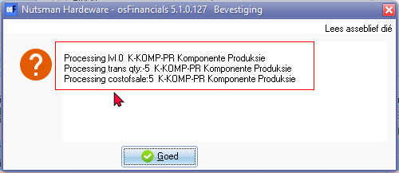

Processing lvl

Processing trans qty

Processing costofsales

**Search (Central search)**

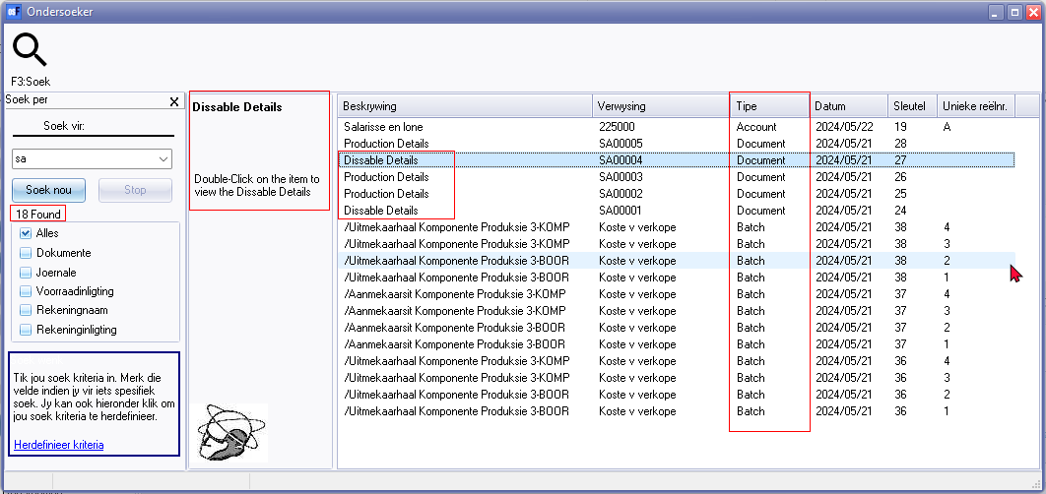

Show details (context menu)

Found

Type column - Account, Stock, Document, Batch

Description and details alignment with document types

* Dissable details (Should be "*Assemble*" or "*Production Details*")
* Production details (Should be "*Production Details*" or "*Disassemble*")

See Stock item - Document groups tab + Transactions tab - The search descriptions does not match the translatable document type on these tabs.

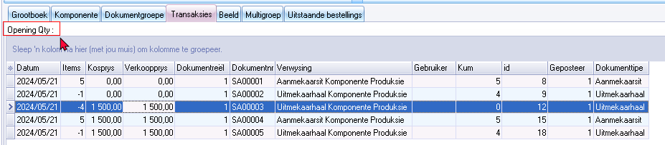

Opening Qty :

Open document (context menu option) on Stock item - Document groups tab + Transactions tab)