Table of Contents

**Stock** 2

***Stock grid*** 2

***Stock grid tabs*** 3

***Stock item tabs*** 4

***Ledger tab*** 4

***Document groups tab / Transactions tab*** 4

***Backorders tab*** 4

***Documents - Backorders*** 5

***Debtors - Backorders tab*** 6

**Setup Stock** 6

***Stock information*** 6

***Lookup - Production account*** 7

***Tax classes (Lookup - Title bar captions)*** 7

**Linked sale (stock type)** 7

**Stock**

***Stock grid***

* Click here to show/hide/move bands (Mouse over) first asterisk

* Click here to show/hide/move columns (Mouse over) second asterisk

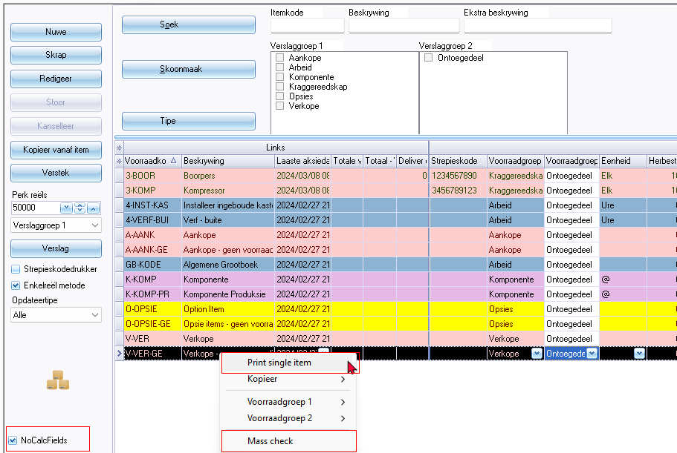

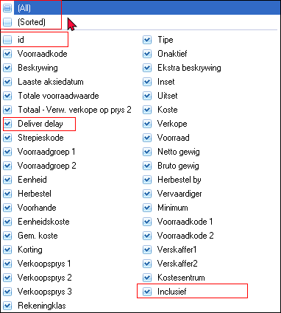

***Stock grid tabs***

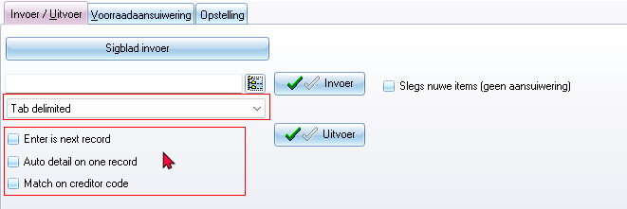

File types list

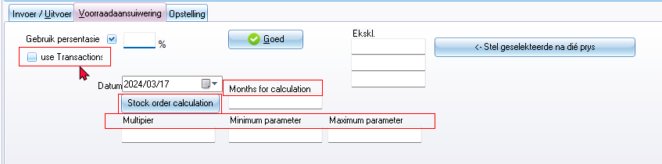

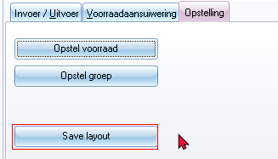

3583 = Save grid layout

***Stock item tabs***

***Ledger tab***

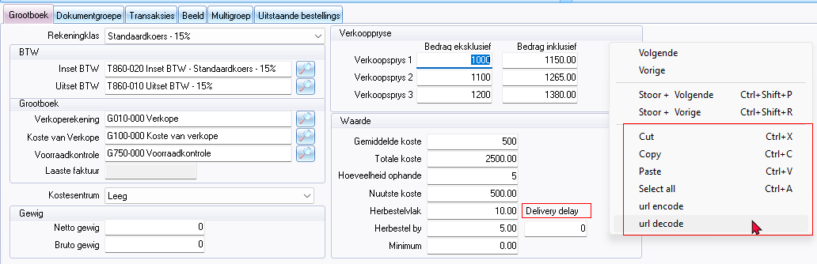

***Document groups tab / Transactions tab***

Context menu - Open document

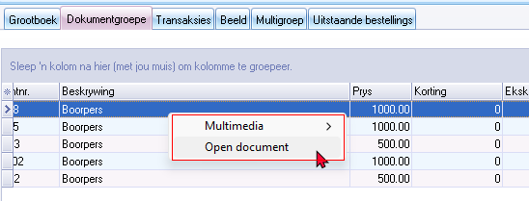

***Backorders tab***

Also see Backorders on

* Debtors - Backorders tab
* Edit **→** Backorders
* Documents - Backorders

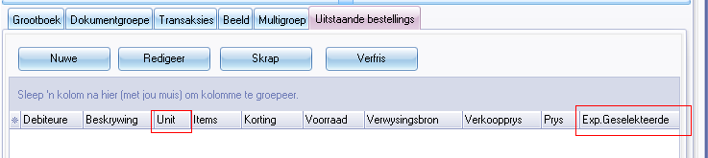

Unit 1131 / 1775

Description 1708

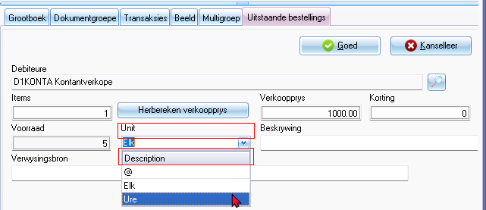

***Documents - Backorders***

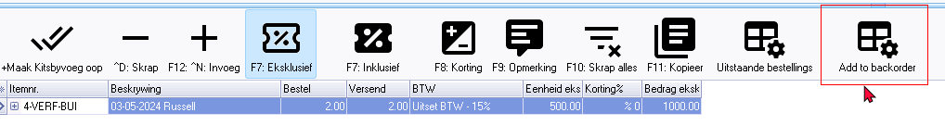

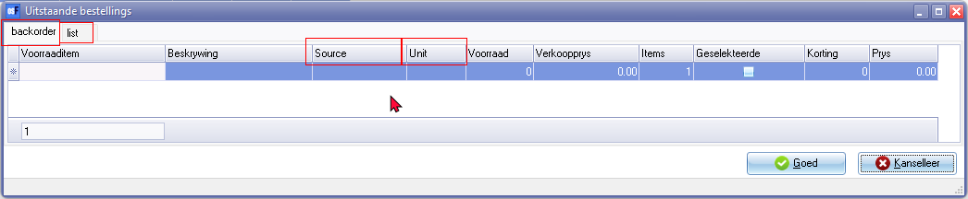

backorder 906050

list 903011

Source 3202

Unit 1131 / 1775

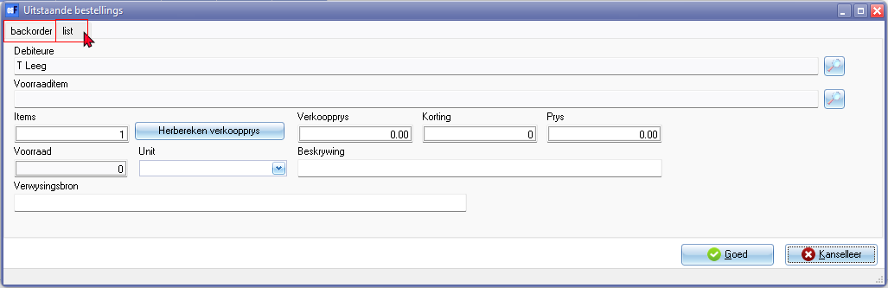

***Debtors - Backorders tab***

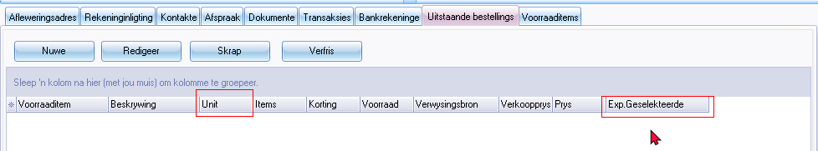

Unit 1131 / 1775

Exp. Geselekteerde (Exp. Selected)

**Setup Stock**

***Stock information***

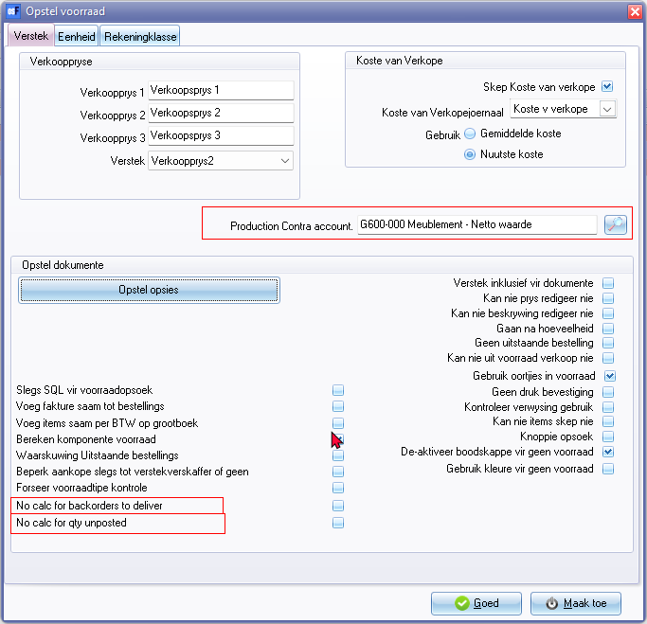

***Lookup - Production account***

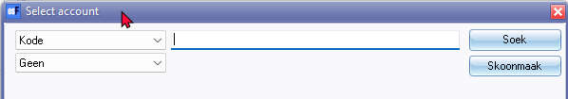

Select account (Lookup - Titlebar caption)

***Tax classes (Lookup - Title bar captions)***

Input

Output

Sales account

Cost account

Stock account

**Linked sale (stock type)**

Lined items

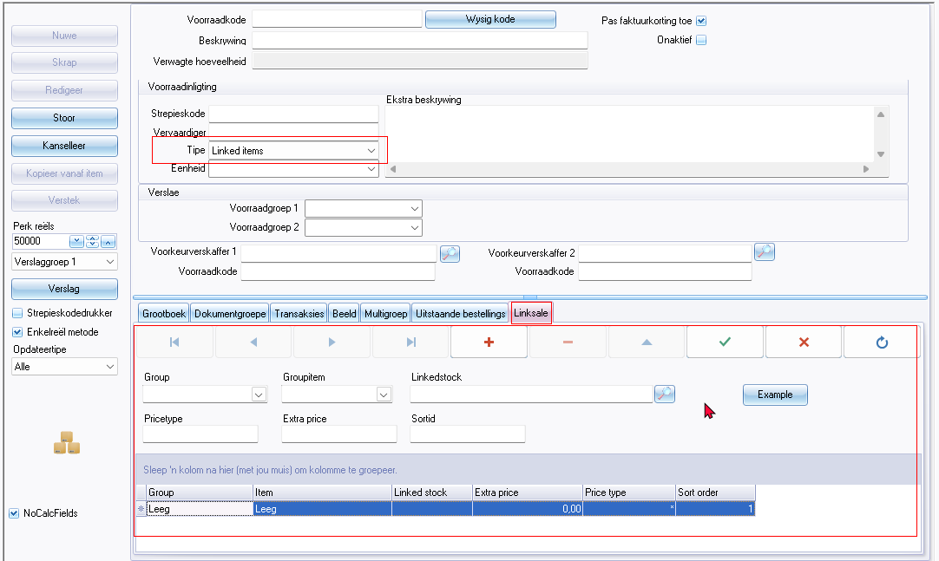

**Linked sale**

**Form**

* Group
* Groupitem
* Linkedstock
* Example (button)
* Price type 902007
* Extra price 3150
* Sortid

**Columns**

* Group
* Item 1410
* Linked stock
* Extra price 3150
* Price type 902007
* Sort order

Example button screen

Linked detail (titlebar caption)

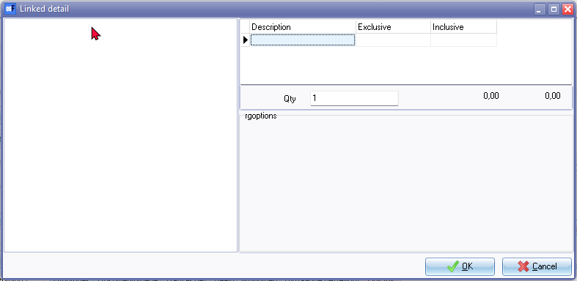

Description 1708

Exclusive 906011

Inclusive 906012

Qty 1710

"*rgoptions*"