Table of Contents

**Tranaslations Outstanding** 1

**Delete record confirmation message** 2

**Grids columns (Global All grids)** 2

**Ribbons Minimize / Collapse / Hide** 3

**Start ribbon** 3

***Registration*** 4

***Update*** 4

***Open Set of Books*** 5

***Create Set of Books*** 6

***Backup / Restore*** 7

***Search for unposted items*** 8

**Data integrity check** 9

***Update ledger*** 10

***Documents tab*** 10

***Batches tab*** 11

***Edit - Documents - Delete*** 12

***Search (Investigator)*** 13

**Tranaslations Outstanding**

Outstanding labels screenshots and notes by function (Language ids of existing labels included where available)

Translations-Access-Control

Translations-Bank

Translations-Bank-Import

Translations-Batches

Translations-Budgets

Translations-Calendar

Translations-Debtors-Creditors

Translations-Documents

Translations-Report-Designer

Translations-Import-Export

Translations-Reports

Translations-POS-Standard

Translations-Setup

Translations-Spreadsheets

Translations-Stock

Translations-Stock-BOM

**Delete record confirmation message**

Tax classes (Setup - Stock information)

Setup - Countries

Setup - Currencies

Setup - Workflow

Setup - Accounts - Budget tab

Setup - Accounts - Bank links tab

Reportman - Delete button to delete report

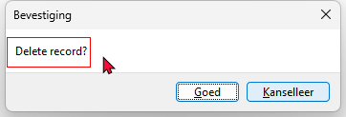

Translated in the Delete option on Budget - Transactions tab with the screen theme

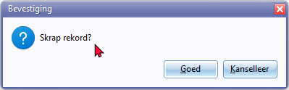

LabelID 20002 -

*Skrap rekord?*

*Delete record*

**Grids columns (Global All grids)**

* Click here to show/hide/move bands (Mouse over) first asterisk

* Click here to show/hide/move columns (Mouse over) second asterisk

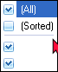

(All)

(Sorted)

**Ribbons Minimize / Collapse / Hide**

* Minimize the Ribbon (Right click on ribbon tab)
* Collapse the Ribbon

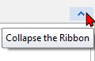

* Pin the Ribbon

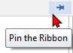

**Start ribbon**

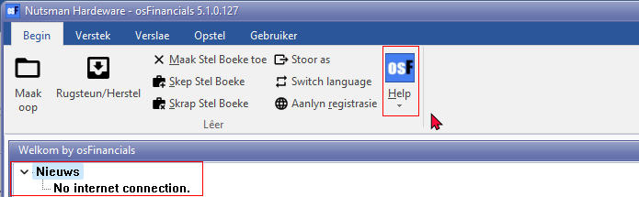

***Registration***

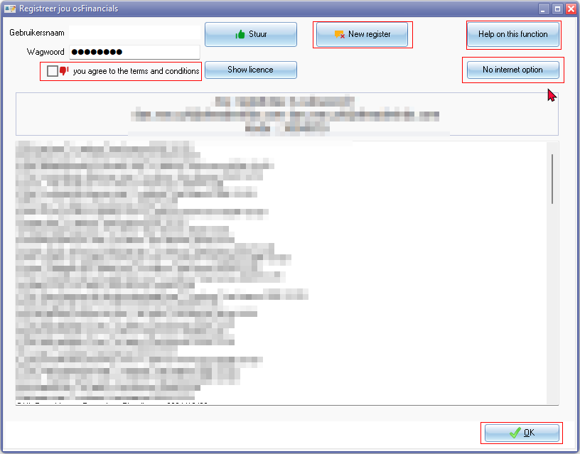

***Update***

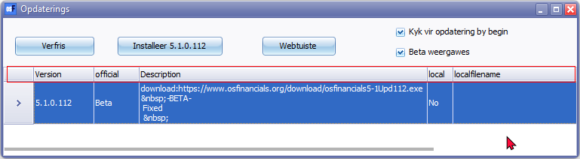

***Open Set of Books***

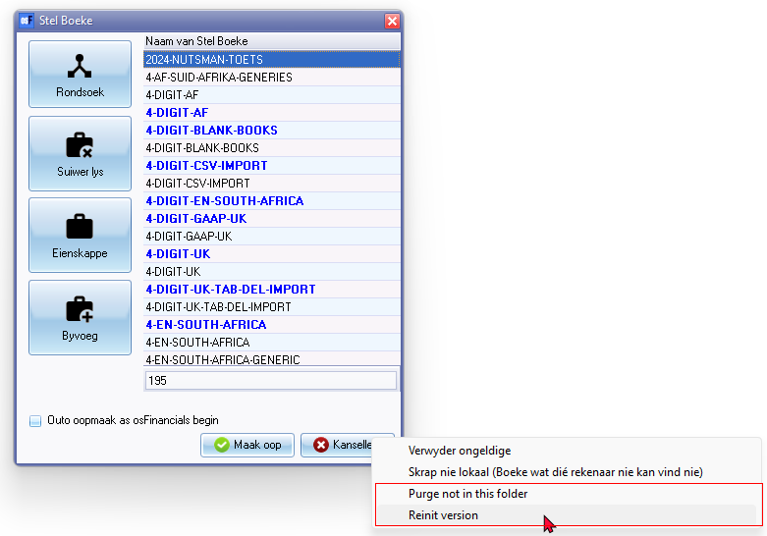

Context menu

* Purge not in this folder
* Reinit version

***Create Set of Books***

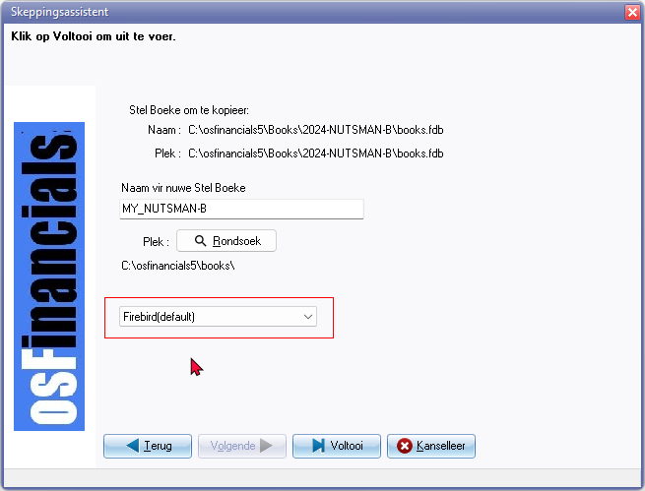 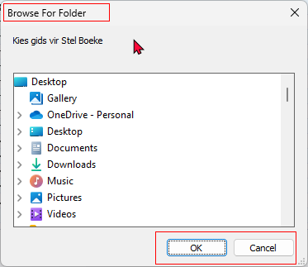

Browse For Folder 2110

***Backup / Restore***

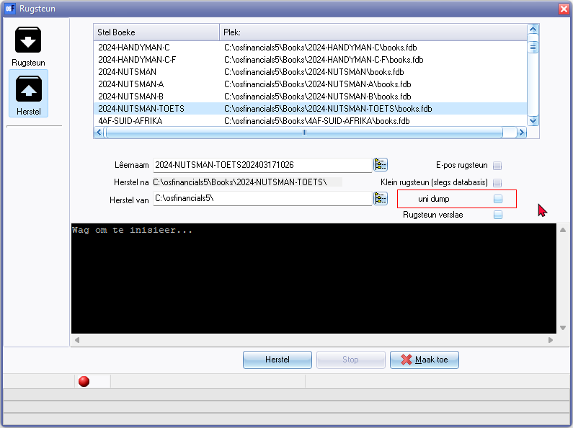

***Search for unposted items***

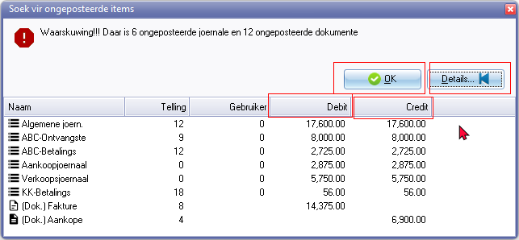

Buttons

* OK 21093
* Details 2428
* Columns 20007 / 20064
* Debit 211
* Credit 212

**Data integrity check**

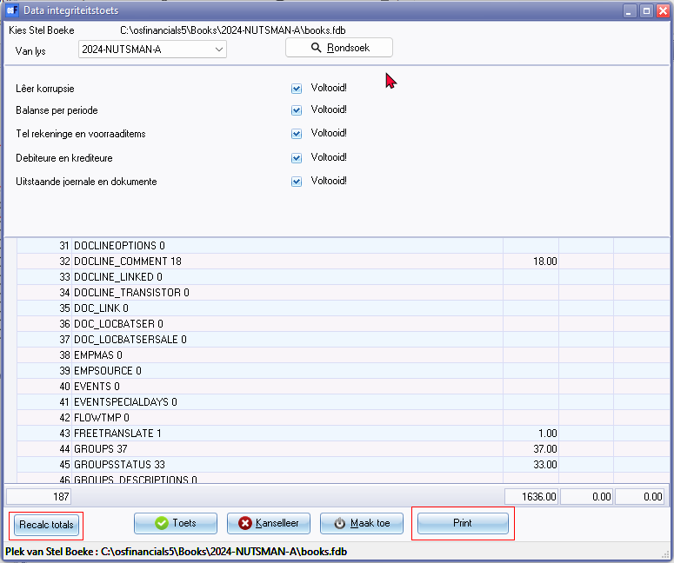

Recalc totals

Print (21052)

Browse for folder (2110)

***Update ledger***

***Documents tab***

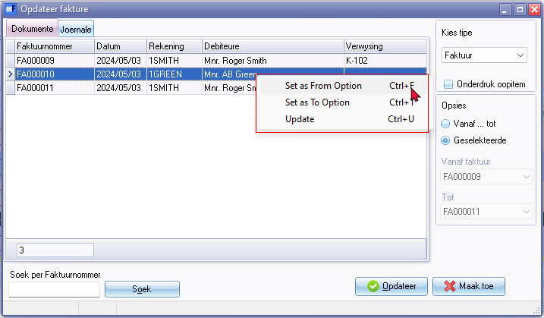

***Batches tab***

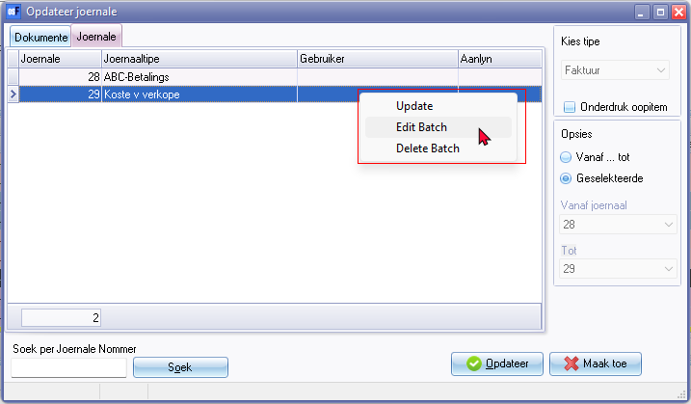

Context menu

* Update 358
* Edit Batch
* Delete Batch

***Edit - Documents - Delete***

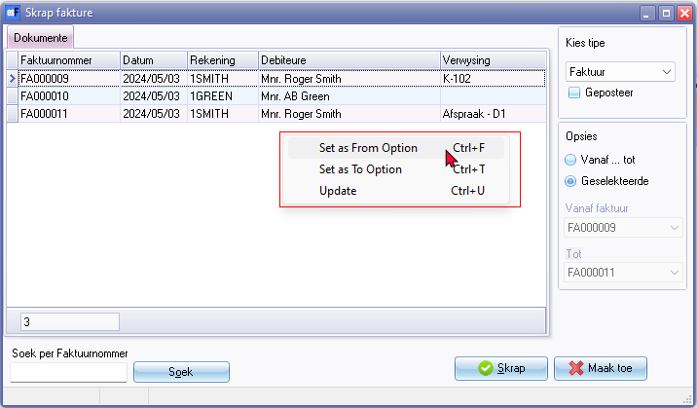

Context menu

* Set as From Option
* Set as To Option
* Update 358

***Search (Investigator)***

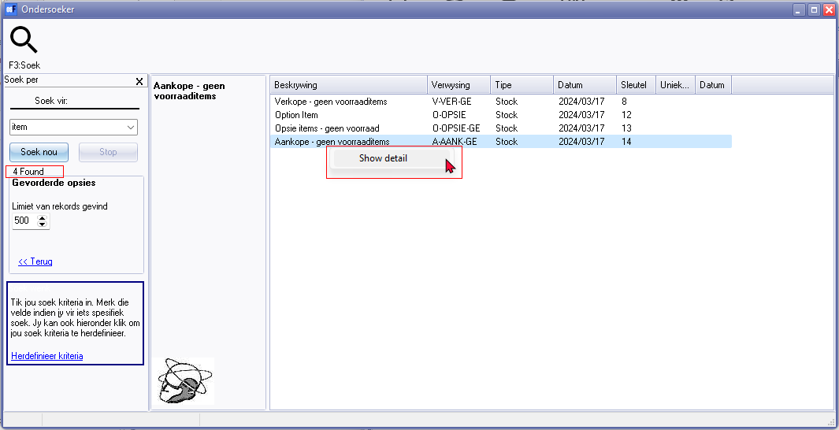

Found

Context menu

* Show detail 392 / 2191

Type column - Account, Stock, Document, Batch