Module 04 | Lecture 02
High-Resolution Imagery for Disaster Mapping
Drone-Based Damage Assessment Applications
Instructor  Dr. Giorgos SFIKAS | Date / Version  30 March 2026] | v1.0 | Duration  90 min lecture + 45 min exercise

Contents

Learning Objectives
01 | Understand the need for automatic change detection, using 2D or 3D techniques.
02 | Understand the way photogrammetric products such as DEMs and 3D point clouds are used for disaster mapping and damage assessment.
03 | Learn about debris estimation and automatic volume change analysis using UAV sensor-based data.

Following the immediate, chaotic life-safety phase of a disaster, the operational focus of emergency management transitions toward recovery and rehabilitation. This phase necessitates precise, quantitative assessments of structural damage and debris generation. Drone-based analytical methods provide unmatched granularity in detecting topographical
changes, evaluating structural integrity, and estimating massive volumetric displacements.

1. Pre- and Post-Disaster Image Comparison
Change detection is the foundational analytical mechanism for identifying and quantifying disaster impacts. Within the context of UAV imagery, these methodologies are generally bifurcated into two-dimensional (2D) and three-dimensional (3D) analyses. Two-dimensional change detection relies on the direct, pixel-by-pixel comparison of pre-event and post-event orthomosaics [1]. Advanced machine learning algorithms are trained to evaluate subtle alterations in texture, spectral reflectance, and geometric boundaries to identify anomalies. Convolutional Neural Networks are classic examples of architectures that have «stood the test of time» with respect to combining good accuracy metrics and minimizing computational requirements vis-a-vis more recently proposed network types, like Transformers.
While 2D analysis excels at mapping horizontal land-cover changes—such as the spatial extent of a flood inundation, the perimeter of a wildfire, or the lateral displacement of a landslide—it possesses a critical limitation: it cannot inherently discern vertical collapse or volumetric reduction.

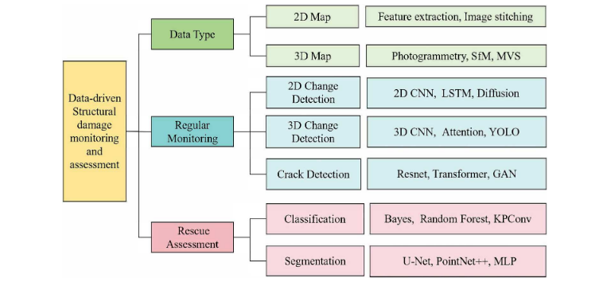
Figure 1: The architecture of data-driven structural damage monitoring and rescue assessment methods. The type of data and the target tasks influence the selection of the damage assessment methods [1]

Consequently, 3D change detection has become the critical frontier for accurate structural damage assessment. By generating continuous 3D point clouds and Digital Surface Models
(DSMs) of the post-disaster environment and comparing them against pre-disaster baseline models (which may be derived from archival UAV flights, municipal LiDAR databases, or satellite photogrammetry), algorithms can compute precise volumetric and geometric differences. This allows for the identification of subtle structural deformations, such as roof slumping, wall inclination, or structural tilting, which may not be visible from a strictly top-down 2D perspective, thus providing a scientifically rigorous evaluation of structural integrity without requiring surveyors to physically contact dangerous, unstable buildings.
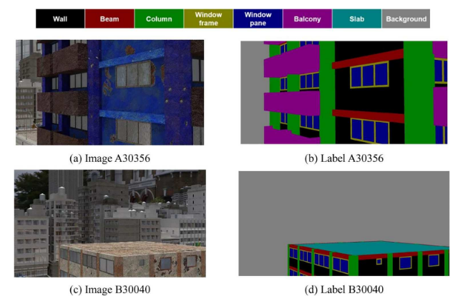
Figure 2: Damage assessment based on segmentation methods [1].

2. Detecting Collapsed Infrastructure and Height Reduction
Height reduction analysis is specifically deployed to detect completely or partially collapsed infrastructure resulting from violent seismic activity, severe meteorological events, or explosive blasts. The methodology involves the direct mathematical subtraction of the post-event DSM from the pre-event DSM across the affected area. If the vertical difference across a defined building footprint polygon exceeds a predefined parameter threshold—a threshold that accounts for standard photogrammetric measurement noise and minor seasonal variations—the structure is mathematically classified as collapsed or severely damaged [1]. This automated height reduction calculation eliminates the subjectivity and slow pace inherent in manual visual inspections. In dense urban environments devastated by earthquakes, where thousands of individual structures require immediate assessment, this algorithmic approach provides rapid, quantifiable estimates. It enables structural engineers and urban search and rescue teams to concentrate their dangerous, detailed physical inspections on buildings that exhibit partial height reduction - which strongly indicates severe internal floor failure but potential survivability in void spaces - rather than totally pancaked structures or completely undamaged assets [2].

3. Volume Change Analysis for Landslides
For geohazards involving massive material displacement, such as landslides and mudflows, volume change analysis is critical for understanding the mechanics of the failure and predicting future instability. By comparing pre- and post-event elevation models, analysts can map both the zone of depletion (where material has fallen away, resulting in a negative volume change) and the zone of accumulation (where the landslide deposit has settled, resulting in a positive volume change). The precision of these volumetric calculations depends heavily on the sensor modality utilized. Research indicates that fixed-wing UAV systems equipped with high-end LiDAR sensors can achieve volume estimation errors as low as 4.8%, due to their ability to penetrate surviving vegetation and accurately map the bare earth beneath the landslide deposit. In contrast, multirotor systems relying solely on optical cameras and Structure from Motion (SfM-MVS) photogrammetry generally exhibit higher volume estimation errors—averaging around 12.1%—because they model the top surface of the displaced vegetation rather than the true ground level. Despite this slightly higher error rate, the rapid deployment capabilities, lower cost, and high temporal resolution of optical drone systems make them the preferred tool for
continuous, iterative monitoring of an active landslide's volume over time [3].

Debris Estimation for Cleanup Planning

Calculating the total volume of debris generated by collapsed buildings, destroyed infrastructure, or severe storms is a critical logistical prerequisite for recovery operations. The calculated volume dictates the required number of heavy transport vehicles, the necessary allocation of landfill or processing space, and the overall financial budget of the cleanup effort. The volume of a debris pile is calculated by establishing a synthetic baseline surface representing the original ground beneath the debris, and integrating the vertical distance from this baseline to the top of the debris surface across the affected area. This precise methodology significantly outperforms traditional, eye-level approximation techniques. Furthermore, integrating deep learning models with UAV photogrammetry allows stakeholders to automatically extract construction and demolition (C&D) debris piles from complex urban backgrounds, calculating their volumes and projected areas automatically to support intelligent waste management decisions.

Discussion Questions

- How are change detection methods useful in pre- and post- disaster comparisons? What are some differences between 2D and 3D methods, in terms of either mechanism or capability?
- In landslides, how are zones of accumulation and zones of depletion differentiated?
- How are debris pile volumes calculated in an urban disaster setting?

6. Hands-on Exercise
We have seen how UAV imagery is crucial in geospatial monitoring and post-hoc estimation. Orthophotos & DEMs are important products in this respect. In this exercise, you will be tasked to create an orthophotography given a Digital Elevation Model and UAV imagery data.

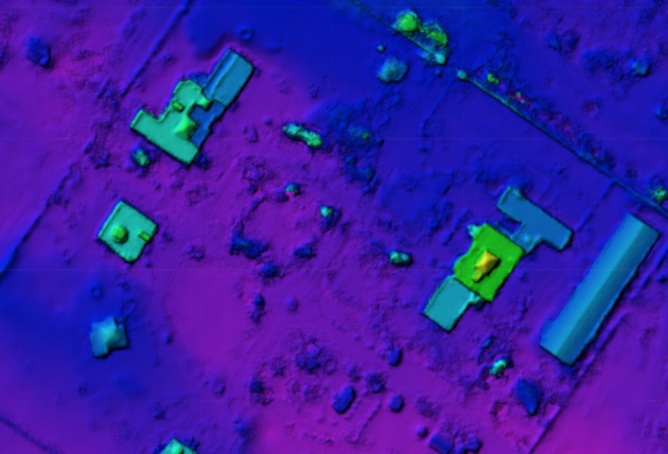
Figure 3: Digital Elevation Model. Pseudocoloring corresponds to estimated heights (Z coordinate) per position (X,Y coordinates)

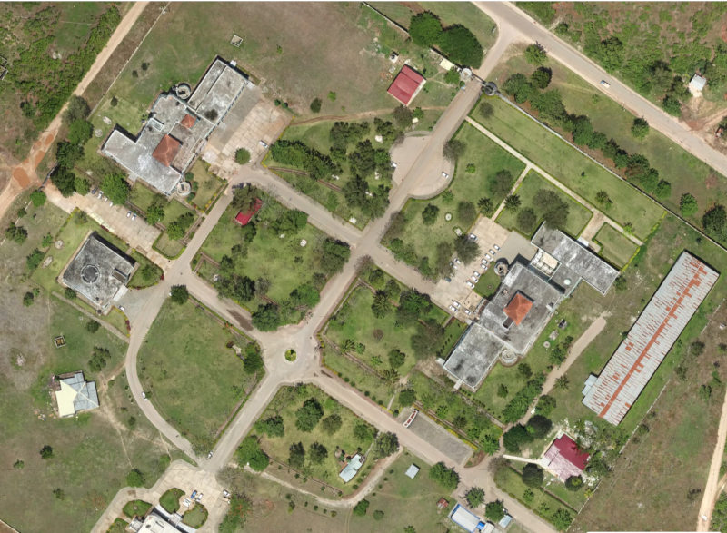
Figure 4: Orthophography corresponding to Digital Elevation Model of Figure 3.

Steps:
- Open the Jupyter Notebook: module_04/notebooks/04_orthophoto_creation.ipynb
- Load the Digital Elevation Model.
- Load the UAV imagery data.
- Use the collinearity condition to map X,Y,Z from the DEM to the imaging data.
- Display the orthophotomap.

Key Terms & Definitions
3D Change Detection | The process of comparing pre- and post-disaster elevation models or point clouds to compute precise volumetric and geometric differences, allowing analysts to identify vertical collapse or structural deformations that are not visible in traditional top-down 2D imagery.
Height Reduction Analysis | An automated, algorithmic method used to detect completely or partially collapsed infrastructure by mathematically subtracting a post-event Digital Surface Model (DSM) from pre-event baseline elevation data.
Volume Change Analysis | An analytical method used for mass movement geohazards, such as landslides, to map and quantify displaced material by evaluating the vertical differences between pre- and post-event elevation models.
Zones of Depletion and Accumulation | In landslide volumetric analysis, the zone of depletion refers to the area where material has fallen away (resulting in a negative volume change), while the zone of accumulation is the area where the displaced material has finally settled (resulting in a positive volume change).
Zonal Statistics | A spatial analysis operation within Geographic Information Systems (GIS) used to calculate specific metrics—such as the total volume of a debris field or the maximum height of a building—by aggregating and evaluating raster pixel values within a defined geometric boundary or polygon.

References & Further Reading
[1] | Zhuoyue Yang, Yuxin Xu, Hao Song & Kang Yu (2025) Data-driven structural  damage monitoring and assessment based on unmanned aerial vehicle images: A Survey,  International Journal of Digital Earth
[2] | US National Institute of Standards and Technology, «Drones in Disaster Zones: How Advanced 3D Mapping Technology Can Help First Responders Save Lives», [https://www.nist.gov/blogs/taking-measure/drones-disaster-zones-how-advanced-3d-mapping-technology-can-help-first]
[3] | Chen, Yong, et al. "UAV Image-Based 3D Reconstruction Technology in Landslide Disasters: A Review." Remote Sensing 17.17 (2025): 3117.
GitHub | Course repository: github.com/<your-username>/drr-course/module_04_high-resolution-imagery-for-disaster-mapping

