Module 04 | Lecture 02
High-Resolution Imagery for Disaster Mapping
Drone Imagery Processing and Photogrammetric Workflows
Instructor  Dr. Giorgos SFIKAS | Date / Version  30 March 2026 | v1.0 | Duration  90 min lecture + 45 min exercise

Contents

Learning Objectives
01 | Understand the basics of photogrammetric pipelines
02 | Learn how to generate 2D Geospatial Products
03 | Understand the basics of DSM and DEMs.

The transformation of raw aerial imagery into georeferenced orthophotography, 3D reconstructions and Digital Surface Models relies on highly sophisticated photogrammetric pipelines. Open-source solutions lead to powerful, accessible solutions to these capabilities, enabling emergency management agencies, universities, and researchers to process high-resolution spatial data without incurring prohibitive software licensing costs.

1. OpenDroneMap Ecosystem and Infrastructure

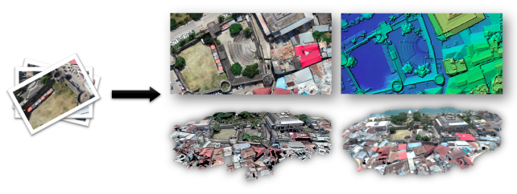
Figure 1: Photogrammetric pipelines use collections of camera shots as input and convert it to various products, including full 3D reconstructions, Orthophotomaps and Digital Terrain Models.

OpenDroneMap (ODM) is open-source drone imagery processing software, utilizing a computational pipeline for photogrammetic tasks. ODM converts two-dimensional raw drone images into geometrically corrected orthomosaics, 3D models, and point clouds. The collection images are matched to one another by applying steps of keypoint detection & matching [2]. Subsequent steps involve solutions of standard problems in geometric Computer Vision, including Relative Pose Estimation, Pose Graph optimization, and Bundle adjustment. Collectively, this processing chain makes up for the Structure from Motion pipeline (SfM), reconstructing the precise camera positions and the three-dimensional geometry of the scene.
The ODM ecosystem offers immense deployment flexibility. It can be operated via a highly technical command-line interface utilizing Docker, or through a more user-friendly graphical interface known as WebODM. Processing high-resolution aerial datasets requires significant computational resources. While small datasets of fewer than 100 images can be processed with a minimum 64-bit CPU and 4 GB to 8 GB of RAM, larger post-disaster mapping tasks frequently require upwards of 16 GB of RAM, robust multi-core processors, and at least 20 GB of free disk space to prevent system bottlenecks and processing failures. The option to utilize GPU hardware is available, significantly speeding up parallel processing like interest point detection [2,3].
To facilitate training and system calibration, the ODM community provides numerous standardized sample datasets, allowing operators to upload provided images and test their hardware configurations [4]. These datasets vary significantly in scale and complexity, ranging from small collections like the "sand_key" dataset (100 images, 536 MB) or the "caliterra" dataset (77 images, 272 MB), to much larger and more complex projects like the "rising_valley_nir" dataset, which consists of 566 images and occupies 2810 MB of disk space. Utilizing these real-world datasets is crucial for operators to master the generation of photogrammetric products like Digital Surface Models (DSMs), Digital Terrain Models (DTMs) or orthomosaics; the latter are highly detailed, distortion-free aerial maps that can be seamlessly overlaid onto existing Geographic Information Systems (GIS) for immediate spatial analysis. DSMs, and the closely related DTMs, will be discussed in the following subsection.
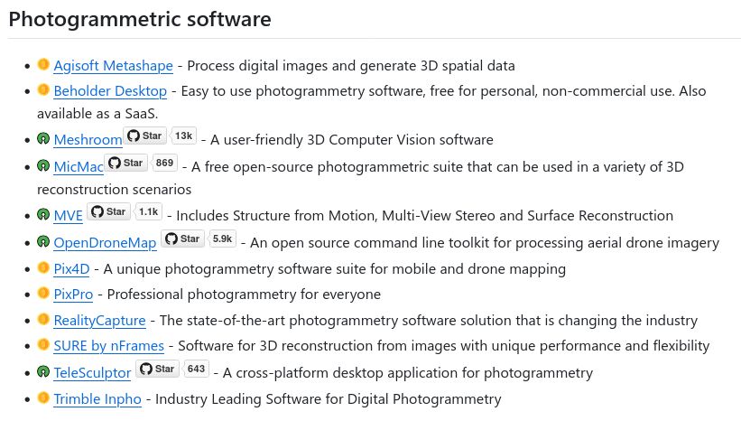
Table 1: A list of Photogrammetric software (source: github.com/awesome-photogrammetry/). There are both numerous proprietary and open-source solutions.

2. Digital Surface Models and Digital Terrain Models

Beyond the generation of 2D orthomosaics, the true power of ODM in a disaster management context lies in its ability to generate critical 3D elevation data -- these products are collectively referred to by the umbrella term Digital Elevation Model (DEM) [8]. By invoking specific processing flags within the command-line interface or WebODM settings, users can generate a Digital Surface Model (DSM) utilizing the --dsm flag. A DSM captures the absolute elevation of the highest surfaces in the scanned area, encapsulating tree canopies, buildings, infrastructure, and piled disaster debris. When mapping the immediate physical impacts of an event, such as the volume of rubble generated by an earthquake, the DSM provides the exact top-down topographic profile of the affected zone [5].
To understand the underlying topography and calculate the actual height of structures, analysts must generate a Digital Terrain Model (DTM) using the --dtm flag. The DTM corresponds to the «bare earth», and is created by careful (automatic) stripping away of all above-ground features. In ODM, this complex extraction is achieved using the Simple Morphological Filter (SMRF) algorithm [6]. The SMRF algorithm evaluates localized elevation gradients within the dense point cloud, classifying individual points as either ground or non-ground. SMRF excels at minimizing Type I errors (misidentifying ground as non-ground) but is notably less effective at preventing Type II errors (misidentifying non-ground objects as ground). This trade-off is critical when generating DTMs for visual analysis, as residual non-ground features will appear as prominent artifacts in the final surface model [7].

Successful DTM generation in complex, debris-strewn urban disaster zones requires precise
parameter tuning by the operator. The --smrf-slope parameter adjusts the algorithm's
sensitivity to steep terrain, while the --smrf-threshold parameter defines the minimum vertical distance required to classify an object as a non-ground feature. The --smrf-window
parameter dictates the radius of the largest feature to be removed, and the --smrf-scalar value scales the elevation variance. Furthermore, utilizing the --dem-gapfill-steps parameter is essential in urban scenes; increasing this value to 4 or 5 allows the software to accurately interpolate the ground surface where massive structures or debris piles once stood, preventing deep digital artifacts or "holes" in the final terrain model.
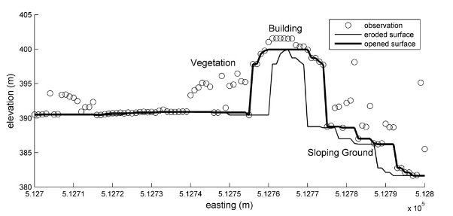
Figure 2: An open operation applied to a transect of 3D point data. It represents an early step of the filter operation [6].

3. Calculating Building Heights and Structural Metrics
The mathematical relationship between the generated DSM and the DTM forms the
foundational basis for extracting precise structural metrics, particularly the calculation of
building heights. By mathematically subtracting the underlying bare-earth DTM from the
top-surface DSM across the entire raster grid, analysts generate a normalized Digital Surface Model (nDSM), which is also referred to as a Canopy Height Model (CHM) in forestry and agricultural contexts [8]. The resulting pixel values in the nDSM represent the absolute height of objects relative to the immediate ground level.
Within open-source GIS environments such as QGIS, this calculation is executed using map algebra tools. Specifically, inputting the DSM as Raster Layer A and the DTM as Raster Layer B, and applying the simple arithmetic formula $A - B$.
In a rapid disaster response context, comparing the pre-disaster expected heights of
structures against the newly calculated post-disaster nDSM data allows automated algorithms to instantly flag buildings that have suffered catastrophic pancaking, roof collapse, or severe structural tilting.

4. Discussion Questions

- In your own words, how would you define the photogrammetric process, and how do software like ODM address the end-goals of photogrammetry?
- Define & explain similarities and differences of the following notions: Digital Elevation Model, Digital Terrain Model, Digital Surface Model.
- Explain the steps you would take in a real-world scenario where building height estimation is required.

5. Hands-on Exercise

In this exercise you will experiment with photogrammetry, through the powerful open-source OpenDroneMap software.
Steps:
- Open the Jupyter Notebook: module_04/notebooks/02_photogrammetry_with_odm.ipynb
- Install ODM and prerequisite software.
- Setup and load one of the designated datasets to ODM.
- Inspect the various photogrammetric products.

Example: Running OpenDroneMap on a collection of images.
// Place your images (e.g. jpegs) in a folder named “images” (for example /my/project/images).
// A recommended set is material from the “odm_mygla_dataset”. You can download it using:
git clone git@github.com:merkato/odm_mygla_dataset.git

// After installing Docker, simply run:
docker run -ti --rm -v /my/project:/datasets/code opendronemap/odm --project-path /datasets

// The products will be organized as follows:
|-- images/
|-- img-1234.jpg
|-- ...
|-- opensfm/
|-- see mapillary/opensfm repository for more info
|-- odm_meshing/
|-- odm_mesh.ply # A 3D mesh
|-- odm_texturing/
|-- odm_textured_model.obj # Textured mesh
|-- odm_textured_model_geo.obj # Georeferenced textured mesh
|-- odm_georeferencing/
|-- odm_georeferenced_model.laz # LAZ format point cloud
|-- odm_orthophoto/
|-- odm_orthophoto.tif # Orthophoto GeoTiff

// Other dataset you can try: University of Texas at Dallas, see [9].

Key Terms & Definitions
Photogrammetry | The art, science, and technology of obtaining reliable information about physical objects and the environment, through processes of recording, measuring, and interpreting images and patterns of electromagnetic radiant energy and other phenomena [1]. These processes generate estimates about the spatial environment, such as 3D models and orthophotomaps, from a series of 2D photographs.
Aerophotogrammetry | Photogrammetry with an input of aerial imagery.
Structure from Motion (SfM) | The photogrammetric process, in the sense of using 2D photographs as inputs and setting as a goal to perform estimates about the 3D environment. In SfM, these are in particular the exact camera positions corresponding to the input images, and the 3D geometry of the photographed scene.
Orthomosaic | A highly detailed, geometrically corrected aerial photograph (or a stitched composite of many photographs) where perspective distortion has been removed so that the scale is uniform across the entire image, allowing it to be used exactly like a map.
Digital Elevation Model (DEM) | An umbrella term for a three-dimensional representation of terrain or surfaces, which broadly encompasses both Digital Surface Models (DSMs) and Digital Terrain Models (DTMs).
Digital Surface Model (DSM) | A 3D elevation model that captures the absolute height of everything sitting on top of the earth's surface, encompassing buildings, tree canopies, infrastructure, and the terrain itself.
Digital Terrain Model (DTM) | A 3D elevation model representing the bare-earth surface, generated by algorithmically stripping away all above-ground features such as vegetation and human-made structures from the dataset.

References & Further Reading
[1] | American Society for Photogrammetry and Remote Sensing (ASPRS) https://www.asprs.org/
[2] | R.Szeliski, «Computer Vision», 2nd edition, 2024.
[3] | https://github.com/OpenDroneMap/ODM
[4] | https://www.opendronemap.org/odm/datasets/
[5] | Baltsavias, Emmanuel, Scott Mason, and Dirk Stallmann. "Use of DTMs/DSMs and orthoimages to support building extraction." Automatic extraction of man-made objects from aerial and space images. Basel: Birkhäuser Basel, 1995. 199-210.
[6] | Pingel, Thomas J., Keith C. Clarke, and William A. McBride. "An improved simple morphological filter for the terrain classification of airborne LIDAR data." ISPRS journal of photogrammetry and remote sensing 77 (2013): 21-30.
[7] | Orthophoto & DEM tutorial on ODM documentation. Retrieved from https://docs.opendronemap.org/tutorials/
[8] | Guth, Peter L., et al. "Digital elevation models: Terminology and definitions." Remote Sensing 13.18 (2021): 3581.
[9] | Tian, Qiu, «UAV-derived building heights and floor counts for the University of Texas at Dallas», Data in Brief 2025
GitHub | Course repository: github.com/<your-username>/drr-course/module_04_high-resolution-imagery-for-disaster-mapping

