Module 04 | Lecture 03
High-Resolution Imagery for Disaster Mapping
Design and Development of UAV-Based Monitoring Frameworks
Instructor  Dr. Giorgos SFIKAS | Date / Version  30 March 2026 | v1.0 | Duration  90 min lecture + 45 min exercise

Contents

Learning Objectives
01 | Formulate Geohazard-Specific Strategies
02 | Learn about Open Data standards
03 | Design Emergency Integration Workflows

The successful application of unmanned systems in disaster management requires transitioning from ad-hoc, reactive deployments to formalized, disaster-oriented monitoring frameworks. These comprehensive frameworks must be tailored to the specific geophysical mechanics of the disaster type, must rely on interoperable data processing pipelines, and must be seamlessly integrated into established civil protection emergency infrastructures.

1. Geohazard-Specific UAV Monitoring Solutions
The varied character of different geohazards necessitates differentiated monitoring strategies, optimizing platform selection and payload deployment based on the specific threat profile.
Landslides and Mass Movements: For landslide monitoring, UAV-based 3D reconstruction provides the centimeter-level spatial resolution essential for both early warning detection and post-failure assessment. Densely matched 3D point clouds generated via UAV photogrammetry have demonstrated the capacity to extract 3D displacement fields with an accuracy of 0.1 meters, rivaling or exceeding the accuracy of traditional, highly localized ground-based measurements [1].
The optimal framework for landslides utilizes a «hybrid» deployment approach: Fixed-wing UAVs, equipped with LiDAR payloads, are deployed for large-scale, basin-wide reconnaissance, achieving impressive 3–5 cm vertical root mean square error (RMSE) accuracies and minimizing volume estimation errors to approximately 4.8%. Once broad areas of instability are identified, highly maneuverable multirotor UAVs are deployed for targeted, fine-scale visual inspections of tension cracks and minor fissures on high-risk slopes. Furthermore, automated dock-based UAV systems are increasingly utilized in mountainous terrain to provide continuous, multitemporal data acquisition before, during, and after hazard events, such as catastrophic rock-ice avalanches [2]. (Examine Figure 1 for example, for monitoring data based on orthophotography regarding an avalanche event in Blatten of Switzerland, 2025).
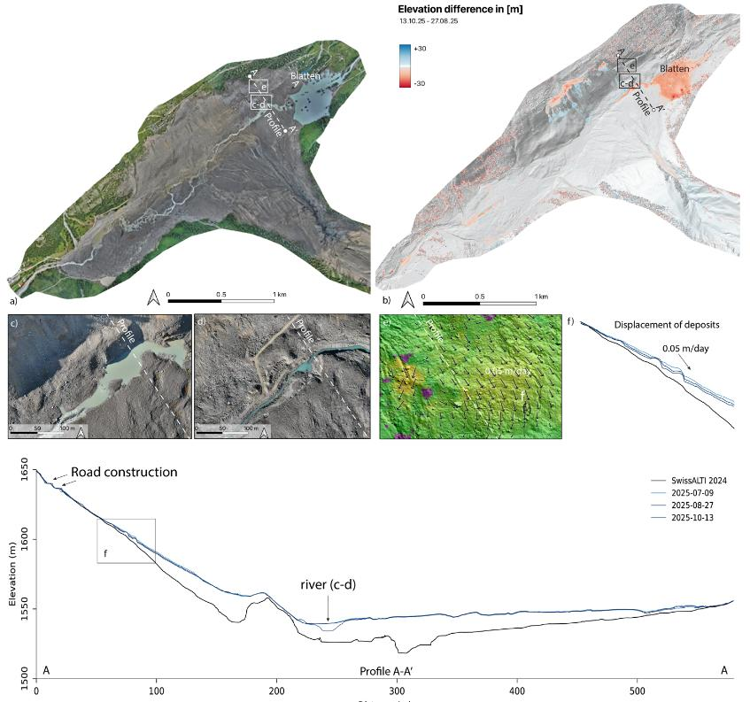
Figure 1: a) Orthophoto of the monitored area after the rock-ice avalanche event at Blatten. b) DoD elevation difference between 27 August and 13 October 2025. c-d) Changes along the river channel between 27 August and 13 October 2025. e) Horizontal displacement (DIS) of the deposits on the adjacent slope. f-g) Profiles through the deposits. The black lines correspond to the terrain before the event (Swiss Alti 2024), while the blue lines are selected UAV surveys after the event between July and October.
Floods and Inundations: UAVs capture high-resolution optical imagery that, combined with Deep learning models, can detect flooded zones with over 90% accuracy [8], enabling cost-efficient damage assessment and prioritization of relief efforts. Further, when combined with precision Digital Terrain Models, UAV imagery allows for the processing of advanced hydrological simulations. Within the Copernicus Emergency Management Service, frameworks like the Extrapolated Flood Surface (EXFLOS) model combine observed flood extents with a hydraulic model [4]. EXFLOS integrates the well-established Interpolated Flood Surface model [3], providing reliable flood depth estimates in urban and vegetated areas (cf. Figure 2). This methodology utilizes initial volume estimates and iteratively distributes water across the DTM based on gravitational parameters and topographic depressions, yielding highly accurate, physically plausible flood extents even in concealed urban areas [3].
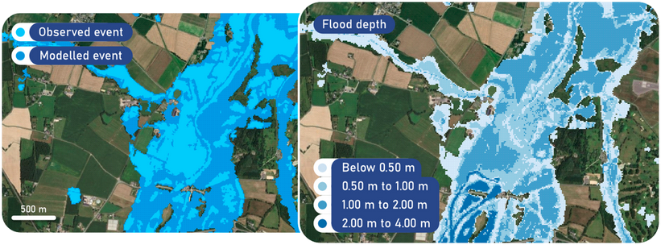
Figure 2: Example of flood depth product, generated with EXFLOS for January 2025 flood in Ille-et-Vilaine, France. Starting from September 2025, users have access to flood depth estimates, simulated based on the observed event, and expanded into concealed areas, to reveal a more realistic flood extent.

Earthquakes and Volcanic Eruptions: For seismic events and volcanic eruptions, the monitoring framework shifts heavily toward structural integrity analysis and extreme thermal mapping. Following earthquakes, drones are rapidly deployed for Ground Deformation Monitoring, capturing high-resolution orthomosaics that, when processed along with other modalities such as Interferometric Synthetic Aperture Radar (InSAR) can precisely map fault ruptures, surface displacements, and the extent of structural collapses [3].
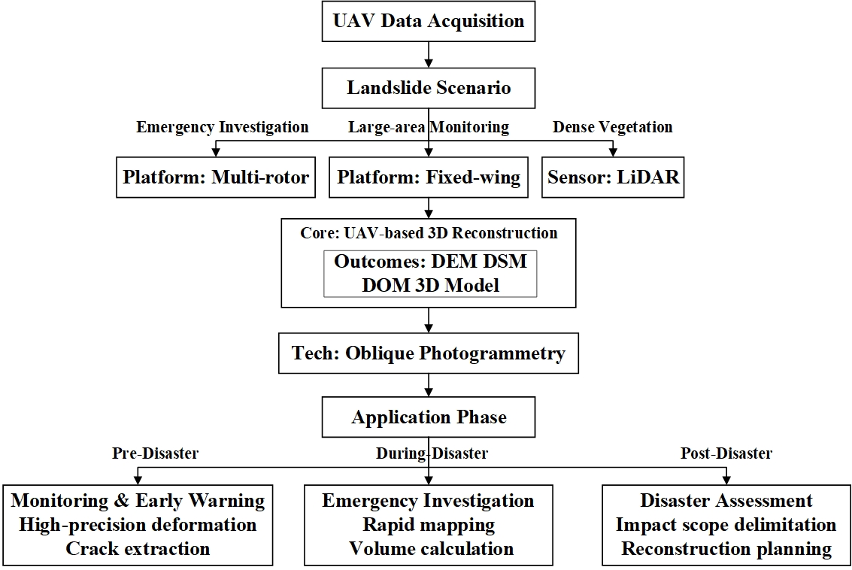
Figure 3: A decision support framework for delineating the application boundaries of UAV-based 3D reconstruction in landslide disasters [1].

2. Open Software Data Processing and Interoperability Standards

A 2007 US National Academy of Sciences study, ‘Successful Response Starts with a Map’ (Board on Earth Sciences and Resources 2007) concluded that geospatial information should be an essential part of all aspects of emergency and disaster management [6]. A disaster monitoring framework is functionally obsolete if the captured data cannot be rapidly disseminated and universally understood by external decision-makers. The integration of UAV data into global and national emergency systems relies heavily on data interoperability protocols established by the Open Geospatial Consortium (OGC) [5].
Through open standards - TCP/IP, HTTP, HTML and others - the Internet and the Web connect computers in an extraordinary communications network. The open standards developed by the OGC build on this platform to connect, among other resources, the geospatial software products used in emergency and disaster management [7]. These open standards ensure that diverse software ecosystems can seamlessly share and analyze spatial data without proprietary bottlenecks. The Open Geospatial Consortium (OGC) is an international voluntary consensus standards organization that was founded in 1994 [5]. In the OGC, more than 475 commercial, governmental, nonprofit and research organizations worldwide collaborate in a consensus process encouraging development and implementation of open standards for geospatial content and services, GIS data processing, location services, sensors, and data modeling [5].
The OGC Web Map Service (WMS) provides a standardized HTTP interface for requesting geo-registered map images, allowing an orthomosaic generated by a drone team in the field to be instantly viewed as a layer on the operational dashboards of a centralized command center. Similarly, the Web Feature Service (WFS) enables the querying, retrieval, and management of vector-based geographic features, such as building footprints or identified hazard zones. For raw measurement data, the Web Coverage Service (WCS) facilitates interoperable access to complex multidimensional coverages, including satellite imagery and digital elevation data [6,7].
Crucially, the integration of physical UAV sensors into broader networks relies on the OGC Sensor Web Enablement (SWE) framework, specifically the Sensor Model Language (SensorML). SensorML provides standardized XML encodings that describe the specific capabilities, inputs, outputs, and calibration parameters of the drone's sensors. This standard enables true "plug-and-play" interoperability, allowing civil protection systems to autonomously discover available drone sensors in a specific disaster region, assess their data lineage and accuracy, and dynamically task them to collect information without requiring manual, human-to-human coordination. Furthermore, the Geography Markup Language (GML) and Keyhole Markup Language (KML) provide the underlying grammar to express and visualize these complex geographic models across platforms [6].
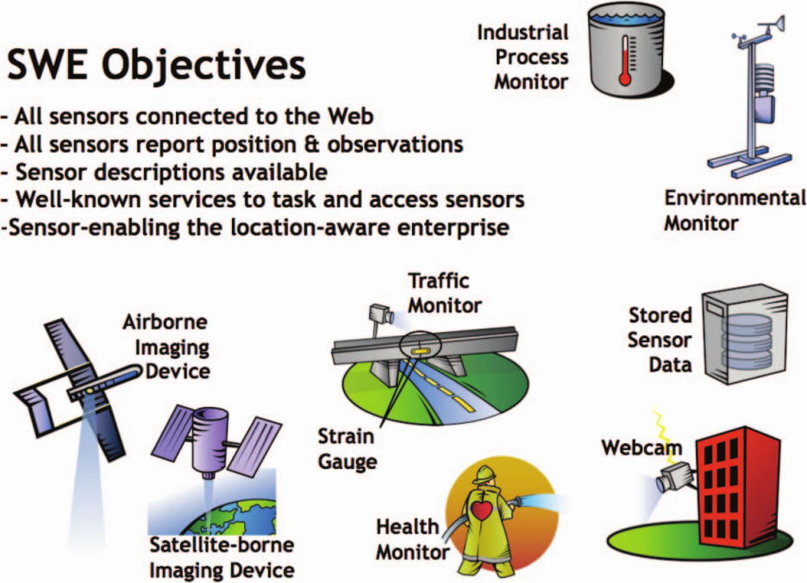
Figure 4: Sensor Web Enablement (SWE) standards provide a platform for describing, publishing, discovering, controlling and collecting data from virtually any kind of sensor [6].
Open source software that implements SWE standards is being used in a number of real-world systems, including a monitoring and control system for the Wupper River watershed in Germany, an Advanced Fire Information System (AFIS), and a wildﬁre monitoring system in South Africa. Another is the German Indonesian Tsunami Early Warning System (GITEWS), a 35 Million Euro project of the German aerospace agency (DLR) and the GeoForschungsZentrum Potsdam (GFZ), Germany’s National Research Centre for Geosciences. GITEWS uses SWE services for sharing tsunami-related information among GITEWS software components. Real time sensors and simulation models provide data for GITEWS [6].
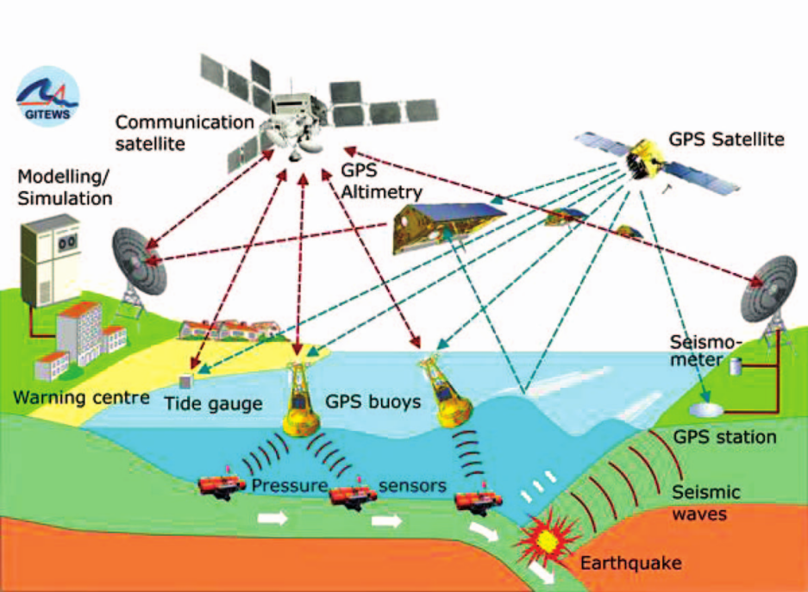
Figure 5: The German Indonesian Tsunami Early Warning System (GITEWS) uses SWE standards to help fuse data from multiple sensors types [6].

3. Integration with Civil Protection Emergency Infrastructures

At the operational command level, the actionable intelligence derived from UAV flights must feed directly into the communication and alerting infrastructure of civil protection agencies. In highly developed frameworks, such as the Integrated Control Centers (ILS) in Bavaria, UAV integration occurs directly within Computer-Aided Dispatch (CAD) systems like ELDIS. ELDIS is a modular, integrated command and control platform designed to support public safety operations. It functions as a central information hub, aggregating data from various sources and enabling interaction with external systems such as alerting
infrastructure, maps, and communication networks. The system supports automated alerting, real-time resource management, and cross-border control center cooperation [8]. The integration with UAVs in ELDIS, utilizes a "Dispatcher-Controller paradigm," allowing highly automated drones to be dispatched simultaneously with traditional ground units. These automated drones arrive at the incident scene prior to human responders, stream real-time situational awareness data through the CAD interface, and execute machine-learning models to classify potential hazards, thereby optimizing the deployment strategy of incoming emergency medical and fire services.
Disseminating this derived intelligence to the public and to allied agencies relies on universal alerting standards, predominantly the Common Alerting Protocol (CAP). CAP is an international, XML-based standard format for exchanging all-hazard emergency alerts. The Common Alerting Protocol (CAP) is an international standard for issuing emergency alerts. It ensures consistent, timely, and effective communication of hazard information across different media platforms, including radio, television, the internet, mobile phones, and public signage [9]. By using CAP, emergency alerts can quickly reach people wherever they are. A consistent warning message—containing standardized elements like event type, severity, certainty, and specific geographic area descriptions—is disseminated simultaneously across diverse media platforms, including television, radio, SMS cell broadcasts, the internet, and digital highway signs. By mapping the precise extent of a hazard via a UAV (such as an expanding flood boundary or a toxic chemical plume) and encoding that spatial boundary into a CAP message, emergency managers can trigger geographically targeted, multi-language evacuation warnings with pinpoint accuracy.
On a global scale, UAV data integration is facilitated by the Global Disaster Alert and Coordination System (GDACS), a cooperation framework between the United Nations and the European Commission [10]. GDACS issues automated disaster notifications and provides risk analysis based on hazard parameters and exposed populations.
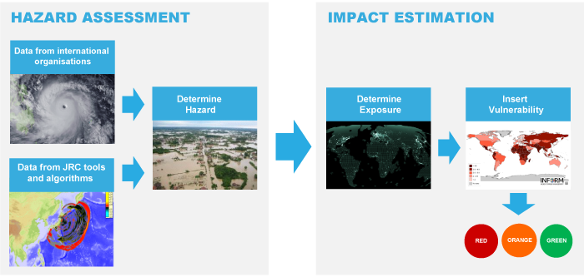
Figure 6: Hazard estimation & Impact Estimation under the GDACS framework.

Why is GDACS important? During the first days after major sudden-onset disasters, the affected country and a vast number of international actors collect and analyse information in order to plan their response. This activity is typically carried out simultaneously with varying speed, relevance and accuracy, using multiple information channels and applying different procedures. During the initial planning phase, there is usually little or no information exchange between international responders. Decisions are often based on patchy information, inaccurate sources or assumptions. The planned or mobilised assistance of other organisations is rarely drawn into consideration. This often results in duplication, gaps, overlap or even inappropriate response, occasionally associated with high costs. GDACS services aim at facilitating information exchange among all actors in support of decision-making and coordination. GDACS services build on the collective knowledge of disaster managers worldwide and the joint capacity of all relevant disaster information systems [10]. This need is streamlined by the «Virtual OSOCC» (On-Site Operations Coordination Centre), a restricted online platform that allows disaster managers worldwide to exchange real-time information, coordinate incoming international relief teams, and share highly localized UAV damage assessments and maps, ensuring a unified and coherent international response to catastrophic events.
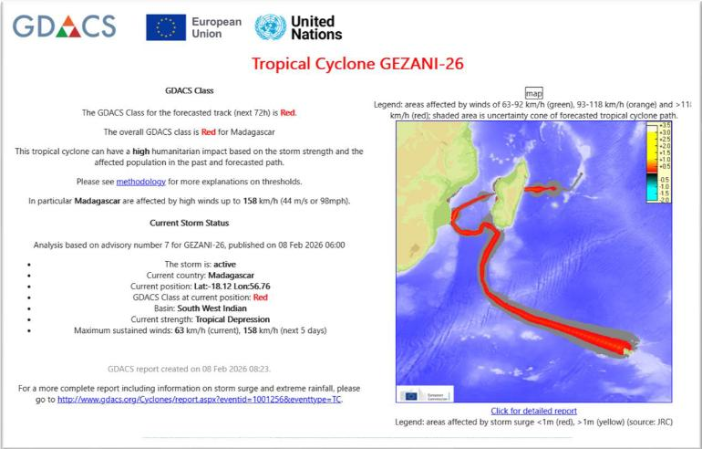
Figure 7: Example of GDACS notification message by email.

4. Discussion Questions

- Name disaster types where you learned that UAV imagery is useful. In what ways does it provide use to experts and rescue teams?
- Why are open standards important?
- To what degree has the integration of UAV-based solutions with civil protection emergency infrastructures advanced?

5. Hands-on Exercise.
In the exercise for this topic, you will be tasked to write code that opens a GeoJSON file.

- Use Regular expressions, Python JSON libaries or other means to write a Python class to create basic functionality that manipulates a GeoJSON file.
- The class should have at least methods to: read a GeoJSON from a file, write the GeoJSON to the file, create a new GeoJSON. Optionally include methods to manipulate the GeoJSON contents.
- Use the sample found at https://gist.githubusercontent.com/wavded/1200773/raw/e122cf709898c09758aecfef349964a8d73a83f3/sample.json for your experiments.
- Use your code to create a new GeoJSON that includes a polygon delineating your home country. Visualize it (e.g. by opening it via the github interface).

💡 Tip
Use the Google Colab badge at the top of the notebook to run it without any local setup. All data files will be available via the course GitHub repository.

Key Terms & Definitions
Sensor Model Language (SensorML) | An Open Geospatial Consortium (OGC) encoding standard that uses XML to describe the specific capabilities, calibration parameters, and outputs of sensors, enabling autonomous discovery and "plug-and-play" interoperability for drone payloads within larger emergency networks.
Web Map Service (WMS) | A standardized HTTP interface that allows for the requesting and sharing of geo-registered map images from distributed databases. In disaster management, it ensures that orthomosaics generated by drones in the field can be instantly visualized as layers on centralized command center dashboards.
Common Alerting Protocol (CAP) | An international, XML-based standard format for exchanging all-hazard emergency alerts. It allows emergency managers to take spatial hazard boundaries mapped by UAVs (like an expanding flood or chemical plume) and use them to trigger geographically targeted, consistent warnings simultaneously across mobile phones, internet feeds, and public broadcast systems.
Global Disaster Alert and Coordination System (GDACS) | A cooperation framework between the United Nations and the European Commission that issues automated real-time disaster notifications, provides risk analysis, and operates a virtual coordination platform where international responders can exchange localized maps and UAV damage assessments.
Extrapolated Flood Surface (EXFLOS) | A specialized hydraulic modeling methodology that combines observed flooded areas with precise Digital Terrain Models (DTMs). By mathematically simulating how water distributes across topographic depressions, it allows analysts to accurately map flood extents even when the water is concealed beneath dense urban infrastructure or tree canopies.

References & Further Reading
[1] | Chen, Yong, et al. "UAV Image-Based 3D Reconstruction Technology in Landslide Disasters: A Review." Remote Sensing 17.17 (2025): 3117.
[2] | Maschler et al., «Automated UAV systems for geohazard monitoring: case studies from the Supphellebreen icefall (Norway), the Skjøld instability (Norway), and the Blatten landslide (Switzerland)», EGUSphere preprint repository, 2026.
[3] | Poterek, Quentin, et al. "Interpolated flood surface (INFLOS), a rapid and operational tool to estimate flood depths from earth observation data for emergency management." Remote Sensing 17.2 (2025): 329.
[4] | Copernicus EU official webiste (https://mapping.emergency.copernicus.eu/about/rapid-mapping-manual/detection-methods-damage-assessment/enhanced-flood-modelling-and-depth-mapping-capabilities-exflos/)
[5] | van Rees, Eric. "Open geospatial consortium (OGC)." Geoinformatics 16.8 (2013): 28.
[6] | Reichardt, Mark. "Open standards-based geoprocessing Web services support the study and management of hazard and risk." Geomatics, Natural Hazards and Risk 1.2 (2010): 171-184.
[7] | Trakas, Athina. «Interoperability - A key requirement for emergency and disaster management», United Nations Office for Outer Space Affairs (UN-SPIDER Knowledge Portal) [https://www.un-spider.org/book/5143/interoperability-key-requirement-emergency-and-disaster-management]
[8] | Chamounta, Iosif, and Simon Schwerd. "Integration Analysis of UAVs into Emergency Response Control Centers." Mensch und Computer 2025-Workshopband. Gesellschaft für Informatik eV, 2025.
[9] | World Meteorogical Organization website, [https://wmo.int/site/wmo-common-alerting-protocol]
[10] | European Commission: Joint Research Centre, Masante, D., Barantiev, D., Destro, E.,  Mastronunzio, M., Paris, S., Proietti, C., Salvitti, V. and Santini, M., Global Disaster Alert and  Coordination System (GDACS) Multi-hazard Early Warning System, Publications Office of the  European Union, Luxembourg, 2025, https://data.europa.eu/doi/10.2760/1461943 ,  JRC141661.
GitHub | Course repository: github.com/<your-username>/drr-course/module_04_high-resolution-imagery-for-disaster-mapping

