Module 04 | Lecture 01
High-Resolution Imagery for Disaster Mapping
Unmanned Systems & Image Processing Basics
Instructor  Dr. Giorgos SFIKAS | Date / Version  30 March 2026 | v1.0 | Duration  90 min lecture + 45 min exercise

Contents

Learning Objectives
01 | Understand UAV Regulatory Frameworks.
02 | Evaluate Platform and Payload Capabilities.
03 | Define Image Processing Fundamentals.
04 | Analyze Digital Image Representation.

In this module, titled «High-Resolution Imagery for Disaster Mapping», we will address the topic in a series of lectures. The key axes that will interest us are «High-Resolution Imagery» on the one hand, related to state-of-the-art sensors that form the standard payload of modern Unmanned Aerial Vehicles (UAVs, or Unmanned Aerial Systems/UAS, or more colloquially, «Drones»). The input provided by these sensors comes in a form ready to be integrated with models, methods & techniques related to the fields of Digital Image Processing, Computer Vision & Photogrammetry, and Machine (Deep) Learning. The second axis of interest in these lectures is Disaster Mapping, covering a multitude of approaches to proactive & reactive actions for disaster response.
The integration of UAVs into emergency management architectures represents a profound paradigm shift in disaster response methodologies. By transitioning operational intelligence from reactive, ground-based observations to proactive, real-time aerial analytics, emergency responders can optimize resource deployment and mitigate hazards with unprecedented precision. The deployment of these sophisticated systems, however requires a rigorous understanding of the evolving regulatory landscape, a comparative analysis of platform typologies, and a strategic approach to payload configuration and mission design. Furthermore, key to understanding strengths & limitations of modern UAVs is a discussion of image processing fundamentals, related to conventional (visible spectrum) and multispectral sensor equipment.

1. Aviation Regulations & Disaster Applications

Operating unmanned systems in disaster environments requires navigating complex and stringent aviation regulations, which have progressively evolved to prioritize risk-based authorization over arbitrary hardware limitations. Within the European Union, the European Union Aviation Safety Agency (EASA) [1] has established a unified regulatory framework that fundamentally dictates how emergency missions are designed, authorized, and executed [2].
As of January 1, 2024, all drones introduced in the European market must bear a corresponding C-class identification label, ranging from C0 to C6, which established standardized technical thresholds and safety features [2,4] (see also Fig.1). Drones placed on the market before this date that lack these labels operate under a restricted legacy category, emphasizing the regulatory shift toward strict hardware compliance for new deployments [3].

Figure 1: The drone C-Class identification labels (CILs) include the symbols for all drones classes (C0 to C6) in a format based on the EU 'Drone Regulation' (Commission Delegated Regulation (EU) 2019/945), as amended by Commission Delegated Regulation (EU) 2020/1058.
Emergency operations typically transcend the operational limitations of the low-risk «Open» category due to the inherent necessity of flying over populated areas, navigating disaster zones, or operating beyond visual line of sight (BVLOS). Consequently, disaster response missions primarily fall under the «Specific» or «Certified» regulatory categories [2]. Operations within the specific category mandate rigorous authorization from national Aviation Authorities (NAAs), often utilizing standardized risk assessment methodologies such as the specific operations risk assessment (SORA) or pre-defined risk assessments (PDRA) [2].
For standardized BVLOS operations, operators previously relied on national standard scenarios, but as of mid-2024, these have been replaced by unified European Standard Scenarios (STS), such as STS-01 for visual line of sight operations over controlled ground areas, and STS-02 for BVLOS operations utilizing airspace observers [7]. See Figures 2 & 3 for an overview of the two scenarios.
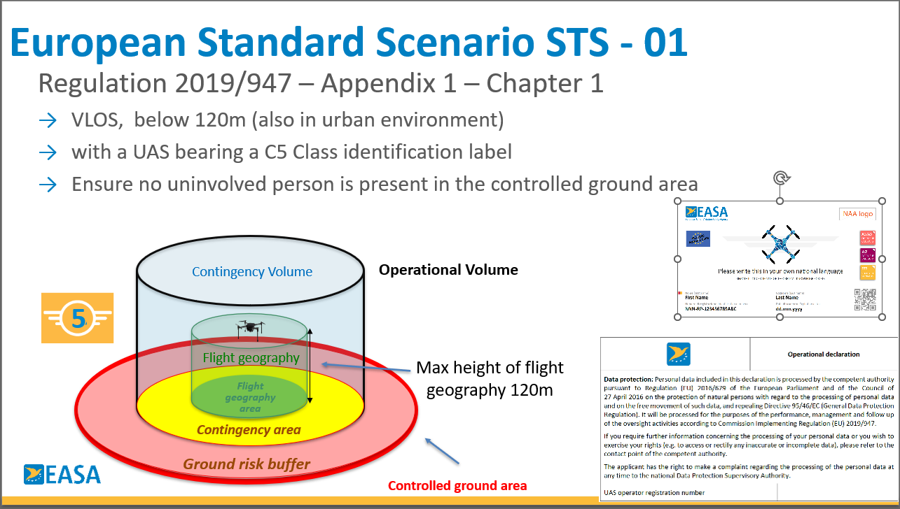
Figure 2: European Standard Scenario STS-01.
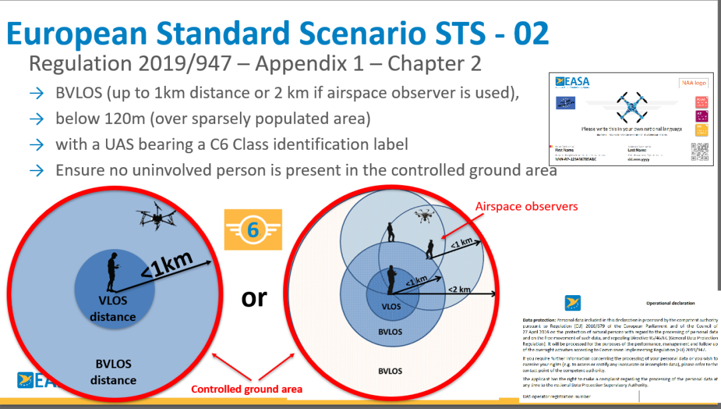
Figure 3: European Standard Scenario STS-02.
A critical component of the evolving regulatory framework is the mandate for Remote identification (Remote ID), which became obligatory in all EASA member states in January 2024. This technology ensures that UAVs operating in chaotic, multi-agency disaster environments can be electronically identified and de-conflicted from crewed aviation, such as helicopter search and rescure (SAR) units [2].
Within the "Certified" regulatory category—which handles the highest-risk drone operations—the safety approach closely mirrors traditional crewed aviation. To operate in this category, unmanned systems require two distinct levels of certification:
- EASA Type Certificates (TCs): Issued directly by the European Union Aviation Safety Agency, a Type Certificate applies to the design of the drone model. It confirms that the manufacturer's blueprint and overall design meet strict European safety and airworthiness standards.
- NAA Certificates of Airworthiness (CoA): Issued by the National Aviation Authority (NAA) of a specific member state, a CoA applies to the individual drone unit. While EASA approves the design, the local NAA verifies that your specific physical aircraft conforms to that approved design standard and is safe to fly.

Regulatory Category | Risk Profile | Key Requirements and Authorizations | Disaster Management Applicability
Open | Low | Visual Line of Sight (VLOS) only; C-class labels mandatory; strict altitude limits; remote ID required. | Initial, localized reconnaissance; minor incident monitoring outside urban centers.
Specific | Medium | BVLOS permitted; NAA authorization via SORA, PDRA, or STS required. | Extensive SAR missions; large-scale hazard mapping; complex urban damage assessment.
Certified | High | EASA Type Certificates (TCs) and NAA Certificates of Airworthiness (CoA) required. | Heavy cargo transport (e.g., heavy medical supplies); potential autonomous passenger evacuation.
Table 1: A summary of regulatory categories and related risk profiles, scenarios and disaster management applicability.

2. Consumer Drones versus Professional Enterprise Systems
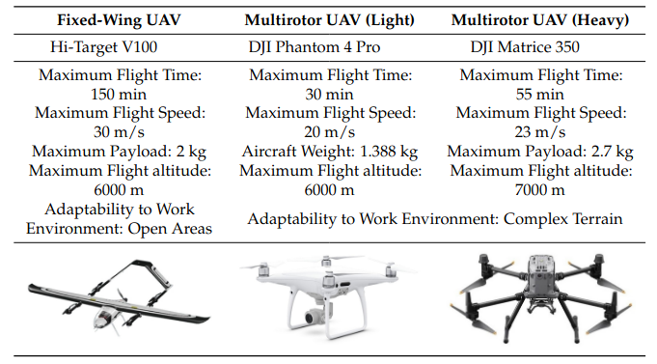
Table 2: Comparison of flight parameters between fixed-wing and multirotor UAVs [8].
The selection of UAV platforms for disaster management applications hinges on a rigorous cost-benefit analysis comparing consumer-grade drones with professional enterprise systems. Consumer drones are characterized by their ease of use, rapid deployment capabilities, and relatively low initial acquisition costs. However, their utility significantly diminishes in large-scale or protracted disaster scenarios due to limited payload flexibility, and the substantial hidden costs associated with manual data processing -- Professional Enterprise drones on the other hand support full workflows, redundant sensors, and overall stronger build quality. Drones with specialized use (professional disaster mapping, agricultural applications, oil-rig monitoring and so on) fall under this category. They are heavily relied upon by police, firefighters, and search and rescue teams. These systems justify their higher costs (ranging between 10k up to even 180k per unit, including infrastructure such as base stations, charging hardware, enterprise software suite) through superior operational endurance, weather resistance and the capacity for «Beyond Visual Line-of-Sight» (BVLOS) operations.
For example, a heavy-lift multirotor platform, such as the DJI Matrice 350 which boasts a maximum payload capacity of 2.7kg, can integrate LiDAR, dual thermal-optical cameras, and precision drop mechanisms within a single deployment. (2026 cost: ~$15k). In specialized applications, such as post-disaster agricultural recovery, models like the Agras T40 can carry up to 40kg of spraying payload (2026 cost: ~40k).

3. Impact of Unmanned Systems and Payload combinations

The impact of unmanned systems in disaster management is profoundly shaped by their ability to expedite search and rescue operations, enhance the safety of first responders, and provide highly cost-effective operational solutions. Traditional ground-based response efforts in flooded areas, earthquake-ravaged cities, or active volcanic zones are fraught with peril and logistical bottlenecks. Drones mitigate these risks by handling forward reconnaissance, identifying potential structural hazards, and executing environmental mapping before human personnel enter the danger zone.
The efficacy of these missions is intrinsically linked to the configuration of their payloads. Designing missions for disaster management requires an intricate understanding of how distinct sensor modalities interact with environmental phenomena.
Standard optical (RGB) cameras provide the high-resolution visual data essential for immediate damage identification and photogrammetric mapping.
Thermal cameras are absolutely indispensable for detecting human thermal signatures during search-and-rescue operations in visually degraded environments, such as smoke-filled areas, dense foliage, or nighttime operations. Other zones of the non-visible EM spectrum are covered by multispectral and hyperspectral payloads.
Light Detection and Ranging (LiDAR) sensors have fundamentally revolutionized topographical mapping in disaster zones. LiDAR emits rapid laser pulses to measure exact distances, generating highly accurate 3D point clouds that can reveal ground deformations, structural anomalies, or concealed disaster victims. This makes LiDAR superior to standard optical photogrammetry in e.g. densely forested landslide zones where the ground surface is obscured from passive optical sensors [8].
Beyond imaging technologies, emergency payloads have expanded to include sophisticated communication relays and acoustic devices (e.g. drones equipped with specialized speakers such as the DJI AS1 speaker).
An outline of standard sensor payloads used in modern drones can be examined in Table 3.

📌 Key Point
The efficacy of unmanned missions is intrinsically linked to the configuration of their payloads.

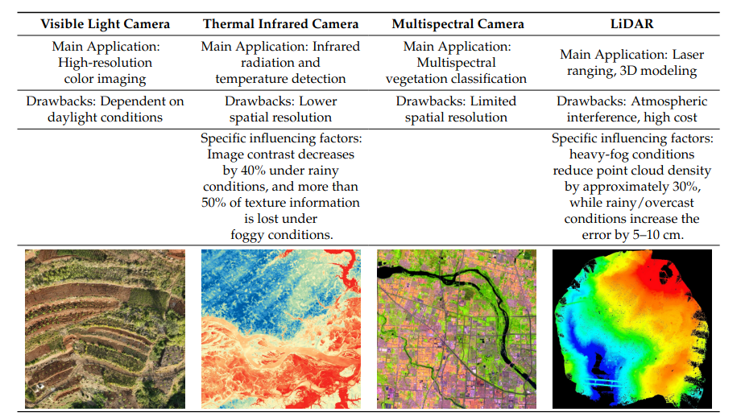
Table 3: Functions and limitations of UAV sensors [8].

3. Basics of Digital Image Processing

Before proceeding with the complex workflows and outputs that are related to UAV imaging and aerophotogrammetry, it is essential to go through the basics of Digital Imaging and Image Processing [9].
The objective process that describes the creation of an image is termed as image formation; a source (or sources) of light, an object of interest, and the camera are the key notions, and in mathematical terms the process hinges on the type of mapping known as central projection. Understanding the mechanism of central projection is fundamental in creating an exegetic model that will allow us to a) model how points in 3D space map to the projected 2D space (the camera film, or the digital sensors, etc.) b) reverse the process to allow for reconstruction of 3D points -- and in general, 3D geometry -- given sets of 2D observations. This latter point boils down to the basic objective of a photogrammetric workflow.
In terms of radiometry, each sensor element is related to a measurement that interests us in terms of the total energy given a particular band or zone of the EM spectrum. This information is typically represented in terms of a matrix of N rows / M columns, when the measurement is a single scalar (gray-scale imaging). Colour images are mapped as high-dimensional orderings (or tensors) made up of N rows / M columns / 3 channels. Multispectral images differ in this respect in terms of requiring extra channels to store their respective content.
Standard image processing is divided in two broad categories: spatial domain processing and frequency domain processing. Spatial domain processing is related with two broad types of processing: point processing (where e.g. thresholding is part of), and linear / non-linear filtering.

4. Discussion Questions

- What are some of the most important types of sensors that UAVs can carry?
- Why is digital imaging important for disaster mapping & reponse?
- Search (web, LLM) for research conferences & journals on the fields of Digital Image Processing, Computer Vision, Photogrammetry. Discuss the overlap between these fields, and between each of them to the field of Machine Learning.

5. Hands-on Exercise

In this exercise you will experiment with a simple digital image processing pipeline.

Steps:
- Open the Jupyter Notebook: module_04/notebooks/01_image_processing_fundamentals.ipynb
- Load the digital image.
- Produce crops of the input image and save them as separate images. Center your crops on objects of interest in the original image.
- Compute histograms for the original image and the cropped images.
- Implement a thresholding point processing pipeline. Experiment with different choices of thresholds.

Example: Opening a digital image and processing it
// Load standard imaging libraries in Python
import numpy as np
import matplotlib.pyplot as plt
from PIL import Image

// Load a test image
import skimage.data as fixtures
A = fixtures.camera()
// Visualize it
plt.imshow(A, cmap="gray")
plt.show()
# We can manipulate the image content by manipulating the numpy array
# For example:
A2 = np.copy(A)
A2[300:400, 300:400] = 0
plt.imshow(A2, cmap="gray")
plt.show()

💡 Tip
Use the Google Colab badge at the top of the notebook to run it without any local setup. All data files will be available via the course GitHub repository.

Key Terms & Definitions
Unmanned Aerial Vehicle | An aircraft operated without a human pilot on board that can be equipped with various sensor payloads to perform missions such as aerial reconnaissance, structural mapping, and disaster response.
EASA | European Union Aviation Safety Agency - the central competent authority responsible for aviation safety and the establishment of unified drone operation and manufacturing regulations across all European Union member states.
C-Class identification label | Mandatory, standardized marking (ranging from C0 to C6) affixed to drones in the EU market to clearly communicate the aircraft's regulatory class, safety compliance, and operational limitations.
BVLOS | «Beyond Visual Line of Sight»
SORA | The SORA is a methodology for the classification of the risk posed by a drone flight in the specific category of operations and for the identification of mitigations and of the safety objectives. It helps the operator to identify operational limitations, training objectives for the personnel essential for the operation (e.g remote pilots, observers, maintainers etc..), technical requirements for the drone and to develop the appropriate operational procedures that will be part of the operator manual [5].
PDRA | The Predefined Risk Assessment (PDRA) is an operational scenario for which EASA has already carried out the risk assessment and has been published as an acceptable means of compliance (AMC) to the Article 11 (risk assessment) of Regulation (EU) 2019/947.  The PDRA still requires an operational authorisation from the National Aviation Authority (NAA) [6].
STS | The European Standard Scenario (STS) is a predefined operation, described in Appendix 1to Regulation (EU) 2019/947 that will become applicable from the 1st January 2024. It is one of the various possibilities for the operators to start their operations.  An operator is not required to obtain an operational authorisation to conduct an operation covered by a STS. So it should be first checked if the operation can be accommodated under an STS. If it is so, then submitting a declaration to the NAA of the state of registration is sufficient [7]

References & Further Reading
[1] | https://www.easa.europa.eu/en/regulations/unmanned-aircraft-systems-uas
[2] | https://www.easa.europa.eu/en/domains/drones-air-mobility/drones-air-mobility-landscape/Understanding-European-Drone-Regulations-and-the-Aviation-Regulatory-System
[3] | https://www.easa.europa.eu/en/the-agency/faqs/drones-uas
[4] | https://www.easa.europa.eu/en/document-library/general-publications/drone-class-identification-labels-and-information-notices
[5] | https://www.easa.europa.eu/en/domains/drones-air-mobility/operating-drone/specific-category-civil-drones/specific-operations-risk-assessment-sora
[6] | https://www.easa.europa.eu/en/domains/drones-air-mobility/operating-drone/specific-category-civil-drones/predefined-risk-assessment-pdra
[7] | https://www.easa.europa.eu/en/domains/drones-air-mobility/operating-drone/specific-category-civil-drones/standard-scenario-sts
[8] | Chen et al., «UAV Image-Based 3D Reconstruction Technology in Landslide Disasters: A Review», MDPI Remote Sensing 2025
[9] | Gonzalez & Woods, «Digital Image Processing», 2006.
GitHub | Course repository: github.com/<your-username>/drr-course/module_04_high-resolution-imagery-for-disaster-mapping

