IIOT Manual

Contents
IIOT Manual 1
1. Introduction 1
2. ESP32 and sensors connection: 2
3. MQTT: 5
4. Installing VS Code on Linux Ubuntu: 7
5. Adding code For New Sensor: 16

1. Introduction

This document specifies information about the IIOT software that is used in the Manufacturing sector to collect data using sensors while keeping the internal systems of the factory intact. The system is expandable, and it is working on the premise.
The data generated by the sensors can help Manufacturing companies gain better insights about the manufacturing process and can further increase productivity and efficiency by using methods such as Big Data, Data Analytics, Energy Management, and Predictive Maintenance.
The Internet of Things (IoT) refers broadly to the extension of network connectivity and computing capability to devices, sensors, software, and other technologies that connect and exchange data with other devices and systems over the internet or network. These devices require minimal human intervention to generate, communicate and consume data. The basic IoT is shown in the following pic.
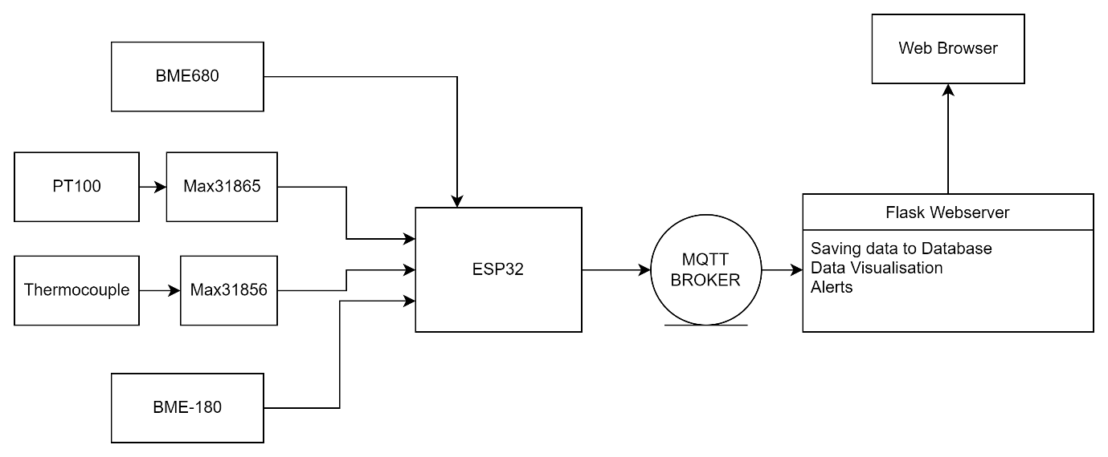

In the above fig, An IoT (Internet of Things) system using an ESP32 microcontroller and MQTT (Message Queue Telemetry Transport) protocol would involve using the ESP32 as the device that collects sensor data and sends it to a broker using the MQTT protocol. The broker then distributes the data to any subscribed clients. This allows for efficient communication and easy scalability as more devices can be added to the system without disrupting existing connections.

2. ESP32 and sensors connection:
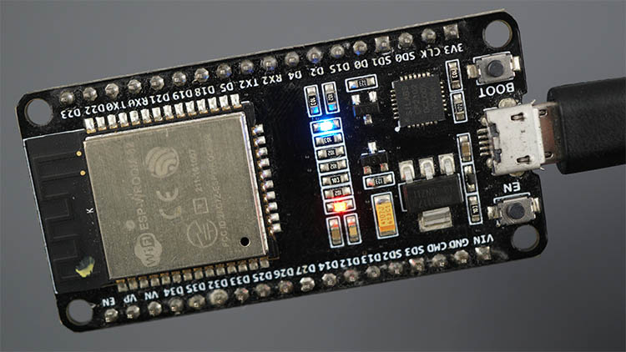
- ESP32 is a microcontroller that is used to process the sensor data in an IoT. This particular ESP32 board comes with 36 pins, 18 on each side. The number of available GPIOs depends on your board model.
- It comes with a microUSB interface that you can use to connect the board to your computer to upload code or apply power. This board also comes with a RESET button (may be labeled EN) to restart the board and a BOOT button to put the board in flashing mode (available to receive code). Note that some boards may not have a BOOT button.
- It also comes with a built-in blue LED that is internally connected to GPIO 2. This LED is useful for debugging to give some sort of visual physical output. There’s also a red LED that lights up when you provide power to the board.
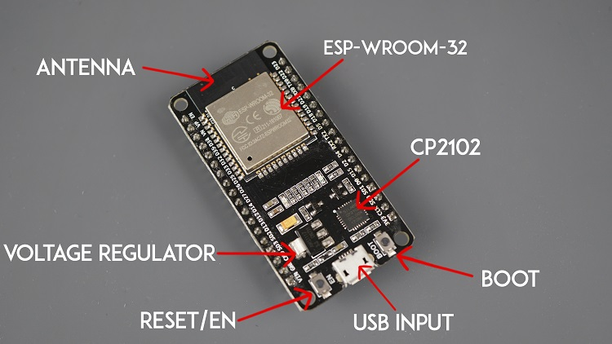

- The ESP32 is a microcontroller that includes support for both SPI (Serial Peripheral Interface) and I2C (Inter-Integrated Circuit) communication protocols. These protocols are commonly used to communicate with peripheral devices such as sensors, displays, and storage devices.
- SPI is a synchronous, full-duplex protocol that can transfer data at high speeds. It uses four wires for communication: clock (SCLK), master out slave in (MOSI), master in slave out (MISO), and chip select (CS).
- I2C is a synchronous, half-duplex protocol that can transfer data at lower speeds than SPI. It uses two wires for communication: clock (SCL) and data (SDA).
- Both protocols can be used with the ESP32, and libraries such as the ESP-IDF (I2C, SPI) and Arduino (I2C, SPI) to easily communicate with devices using these protocols.
- It is possible to use both SPI and I2C communication protocols on the ESP32 microcontroller simultaneously. The ESP32 has two I2C controllers and two SPI controllers, so can connect multiple I2C and SPI devices to the ESP32 at the same time.
- To use both protocols together, one would need to configure the appropriate pins for each communication protocol and use the appropriate libraries to interact with the devices connected to the ESP32

- To use ESP32 SPI Bus as a master with multiple slaves, we require multiple chip select (CS) or slave select (SS) lines from the controller(master). As seen in the following diagram, there is one ESP32 SPI controller and two SPI slave devices are connected to it by using the same MOSI, MISO, and SCLK pins. But different chip select lines are used for each slave device such as CS1 and CS2.here Max31865 and Max31856 are the slave devices which are connected to the ESP32.
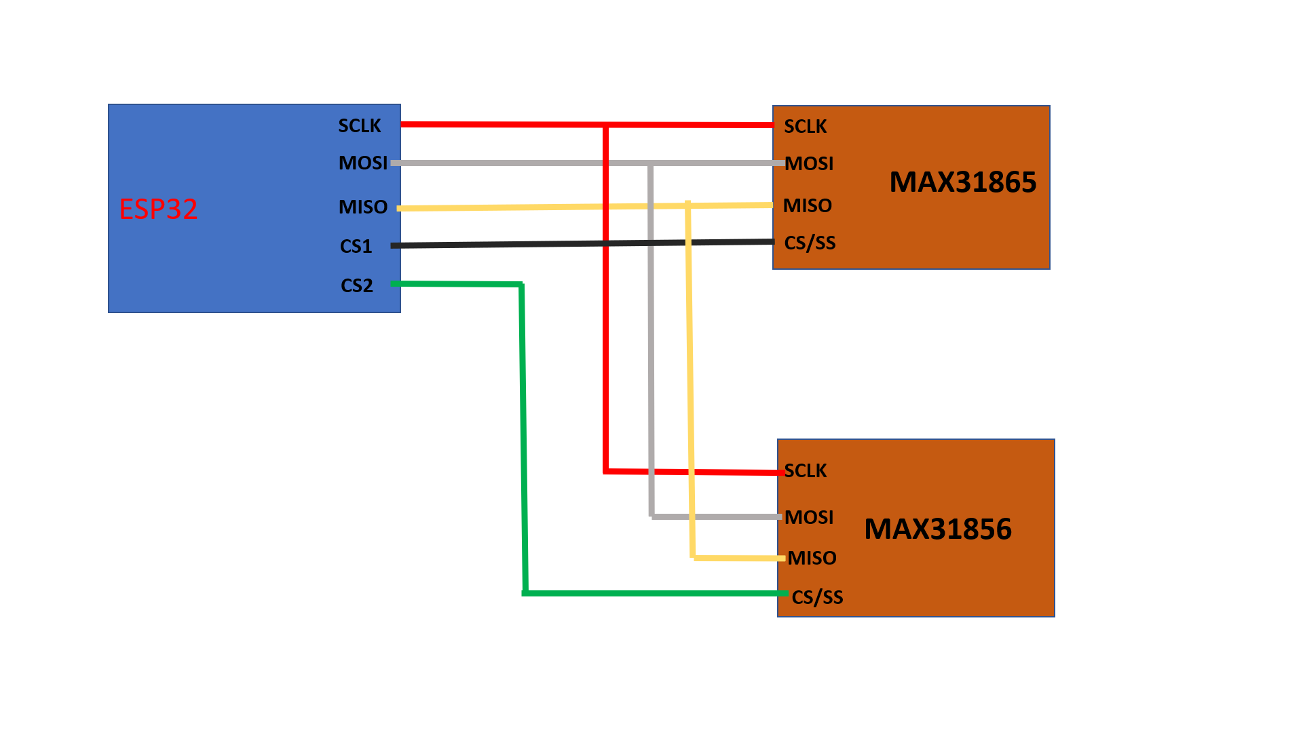

- The BMP180 and BME680 sensor uses an I2C communication protocol. So, you need to use the SDA and SCL pins of the ESP32. with the SDA pin connected to GPIO 21 and the SCL pin connected to GPIO 21.
- As shown below BME180, BME680, MAX31865 and MAX31856 are connected to the ESP32 and the below table shows how to connect different ESP32 pins to the BME180, BME680, MAX31865 and MAX31856.
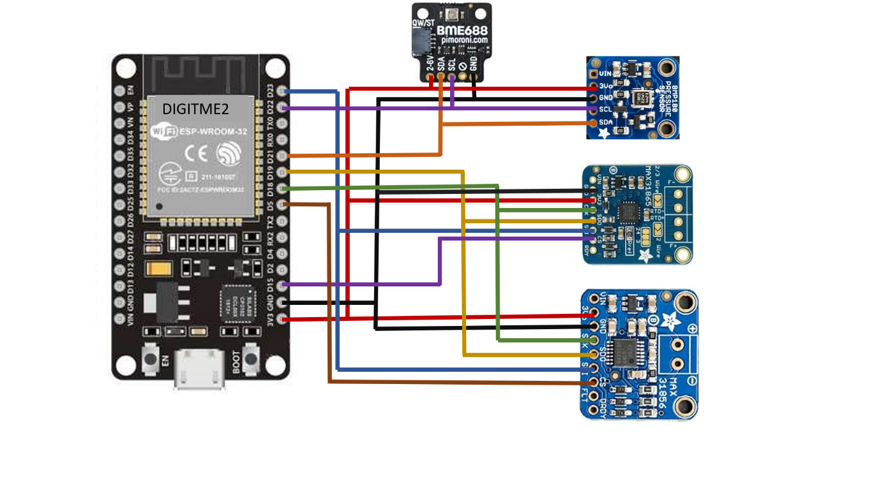

ESP32 | MAX31865 | MAX31856 | BME180 | BME680
VCC | VCC =3.3 V | VCC =3.3 V | VCC =3.3 V | VCC =3.3 V
GND | GND | GND | GND | GND
GPIO 23 | MOSI/SDI | MOSI/SDI
GPIO 19 | MISO/SDO | MISO/SDO
GPIO 18 | CSL/SCK | CSL/SCK
GPIO 5 |  | CS/SS
GPIO 15 | CS/SS
GPIO 21 |  |  | SDA | SDA
GPIO 22 |  |  | SCL | SCL

3. MQTT:
1. MQTT is a lightweight messaging protocol for IoT device communication.
2 . MQTT (Message Queuing Telemetry Transport) is a lightweight messaging protocol for small devices and low-bandwidth networks. It is designed for machine-to-machine (M2M) communication and is often used in Internet of Things (IoT) applications. MQTT is a publish-subscribe protocol, which means that clients can subscribe to topics and receive messages that are published on those topics. The protocol is designed to be lightweight, secure, and efficient, making it well-suited for use in resource-constrained devices and low-bandwidth networks.
3. Unlike, most messaging systems, MQTT clients do not require to assign addresses and it uses simple publish/subscribe communication based on a topic. This protocol runs on top of TCP / IP to provide reliable data delivery. It works as shown below. . MQTT communication works as a publish and subscribe system. Its main applications include sending messages to control outputs, reading and publishing data from sensor nodes and much more.

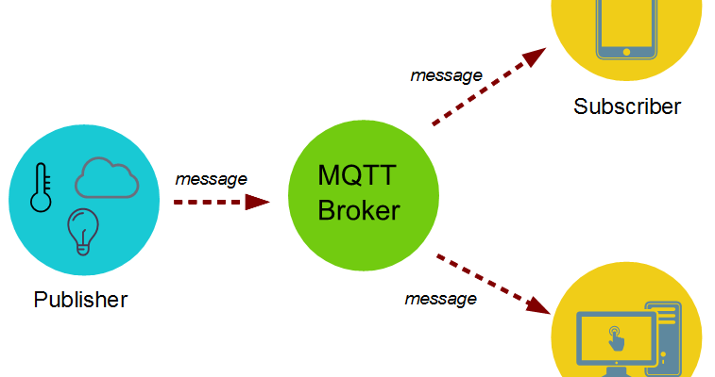

4. First, a client (also called a publisher) connects to an MQTT broker, which is a server that manages the flow of messages. The client then Publishes a message, which includes a topic and a payload to the broker. The topic is a string that identifies the message and the payload data being transmitted.
Another client (also called a subscriber)can then connect to the same broker and subscribe to a specific topic.
5. The subscriber will then receive all messages published on that topic. The subscriber will then receive all messages published on that topic. The Broker then forwards the messages to all clients that subscribe to a specific topic. The subscriber can then receive the message, process it and take necessary actions.
6. The connection between the clients and the broker can be closed when communication is done. For security purposes, Authentication and encryption can also be added as an additional step before the publishing and subscribing process. Note that this is a general overview of the MQTT process and the actual implementation may vary depending on the specific application and the MQTT library being used.

7. Here we install and configure the Mosquitto application which is an MQTT broker, to run an event-driven MQTT server on Ubuntu based on Flask Application.
- Download the IIot Flask application zip folder.
- Extract the IIOT zip folder and place it in the Home directory.
- Now open the terminal using the “Ctrl+Alt+t” command.
- Use the command “sudo apt-get update”
- Now install python3.9 with the command “sudo apt-get install python3.9-venv”
- Now change into the IIot folder using the command “cd IIOT”.
- Now create a Virtual environment using the “python3.9 -m venv venv”
- Now activate the virtual environment using the “source venv/bin/activate”
- Install required libraries by using python pip3 “pip3 install -r requirements.txt”
- Now install the mosquito using the command “sudo apt install -y mosquito”
- Copy the mosuqitto.conf to /etc/mosquitto/mosquitto.conf using “sudo cp mosquitto.conf /etc/mosquitto/conf.d”
- Now use the following command to start the mosquitto “sudo systemctl start mosquitto”
- To check the status of mosquito “sudo systemctl status mosquito”
- To run as a service on Linux Create a file named iiot_server.service “nano iiot_server.service”
Paste the following:
[Unit]
Description=IIOT server
After=network.target

[Service]
User=user
WorkingDirectory=/home/user/iot
ExecStart=/home/user/iot/venv/bin/python3 /home/user/iot/run.py
Restart=always

[Install]
WantedBy=multi-user.target

- Move iiot_server.service file to /etc/systemd/system by the “mv iiot_server.service /etc/sytemd/system”
- Reload deamon: “sudo systemctl daemon-reload”
- Enable service to start on boot “sudo systemctl enable iiot_server”
- Start the service now “sudo systemctl start iiot_server”

4. Installing VS Code on Linux Ubuntu:
- Go to https://code.visualstudio.com/ and download the stable build for your operating system (Linux Ubuntu).
- Open the terminal using “Ctrl +Alt+t” and change in download directory using the “cd Downloads” command
- Use “Sudo apt install ./code_1.49.1-1600299189_amd64.deb ” to install the VS code.
- When the installation is finished, VS Code should be available in the applications menu as shown below.
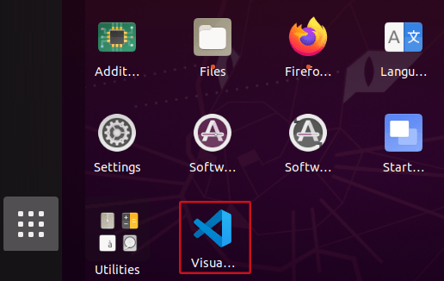

- Open VS Code and you’ll be greeted by a Welcome tab with the released notes of the newest version.
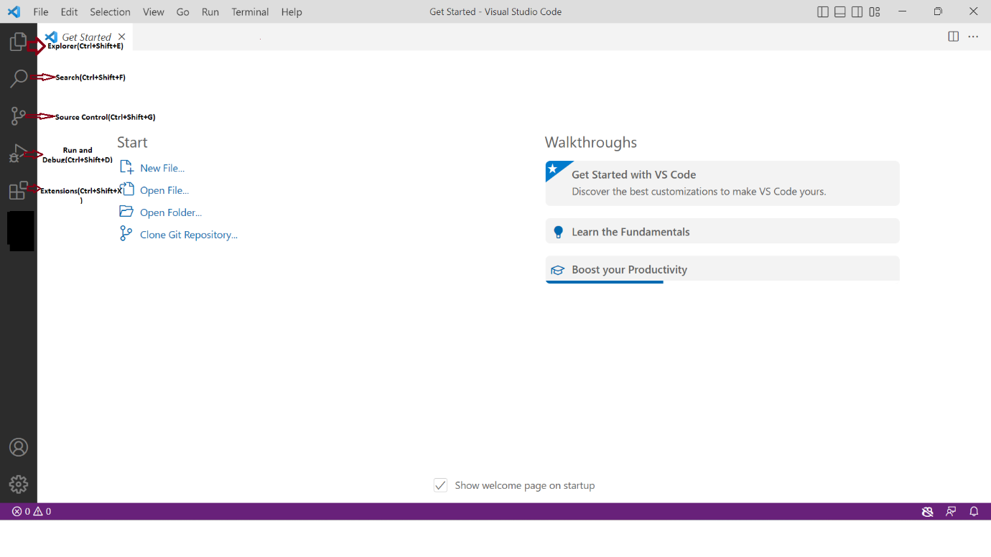

The following print screen shows the meaning of each icon on the left sidebar and its shortcuts:
- File explorer
- Search across files
- Source code management (using gist)
- Launch and debug your code
- Manage extensions
press Ctrl+Shift+P or go to View > Command Palette… to show all the available commands
- Click on the Extensions icon or press Ctrl+Shift+X to open the Extensions tab, Search for “PlatformIO IDE” and click on install.
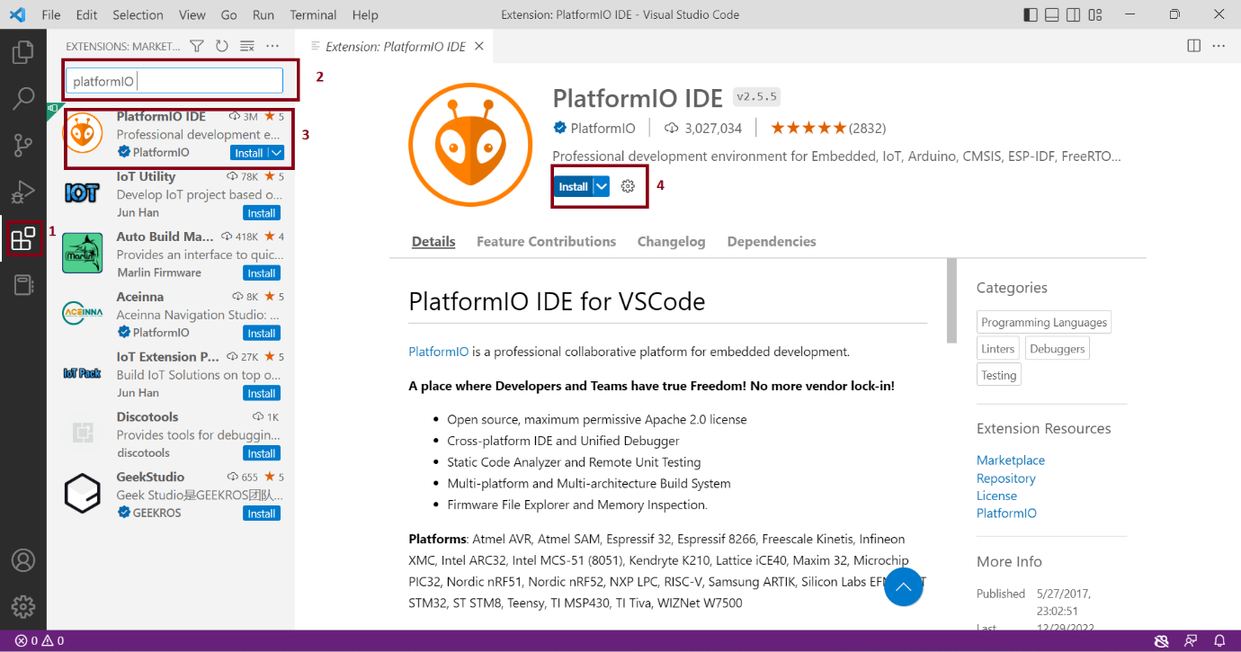

- Make sure that PlatformIO Ide is enabled as shown below.
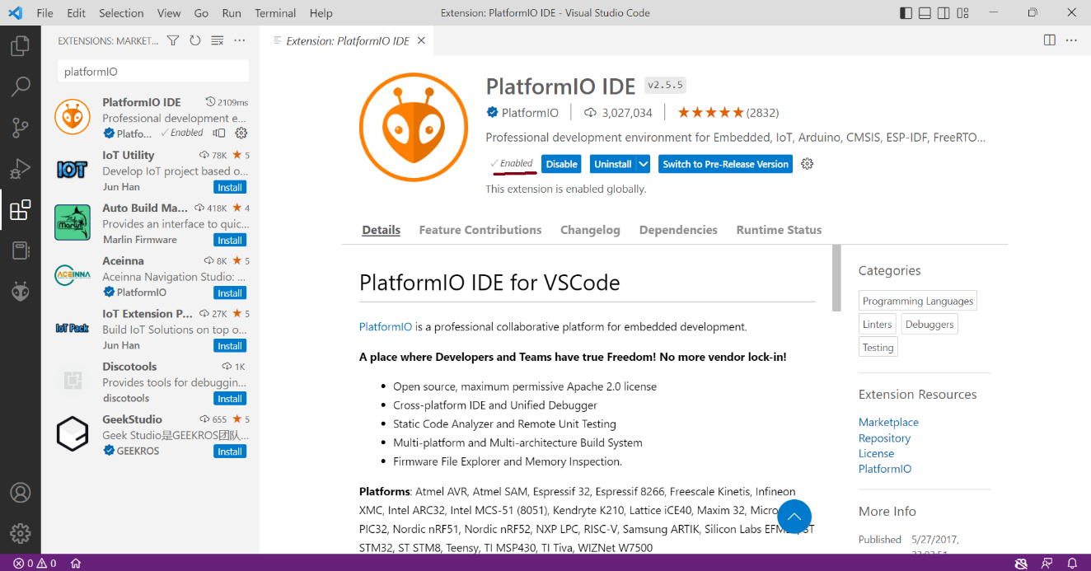

- After that, the PlatformIO icon should show up on the left sidebar as well as a Home icon that redirects you to PlatformIO home which means the PlatformIO IDE extension was successfully added to VS Code.
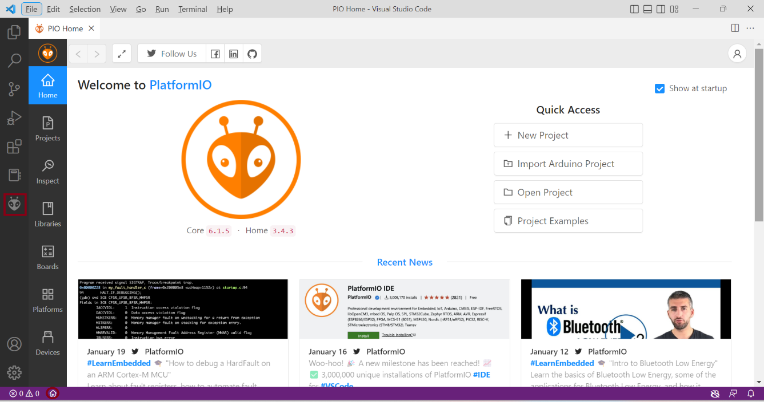

If the PIO icon is not visible then go to the quick tools at the bottom, you may need to restart VS code for the changes to take effect.

- Click on the new project and a new window opens as shown below. enter the project name and select the Board of the microcontroller and click on the finish.
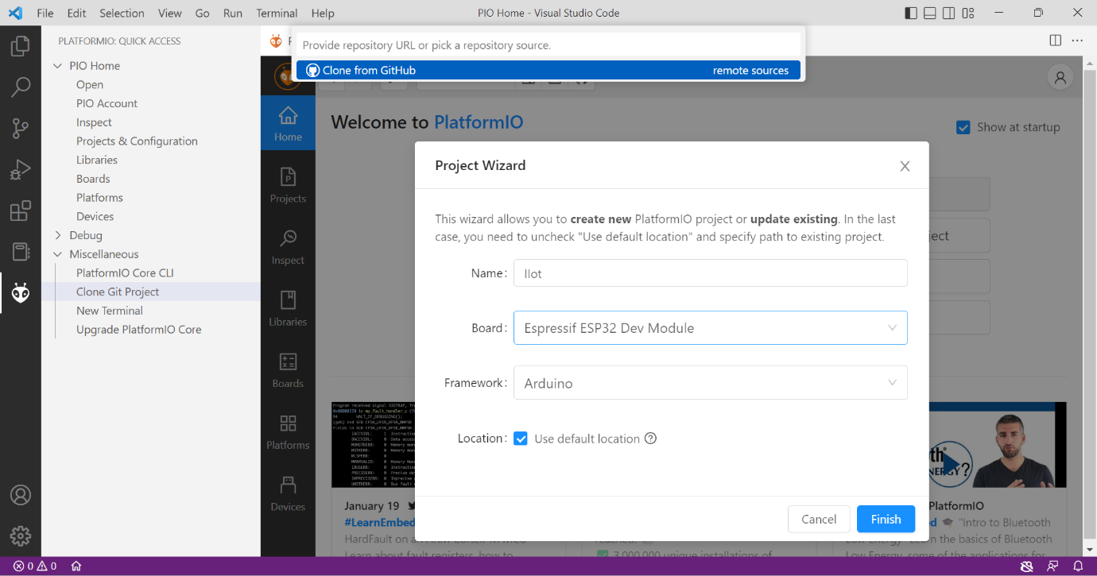

- The new project should be accessible from the Explorer tab as shown below.
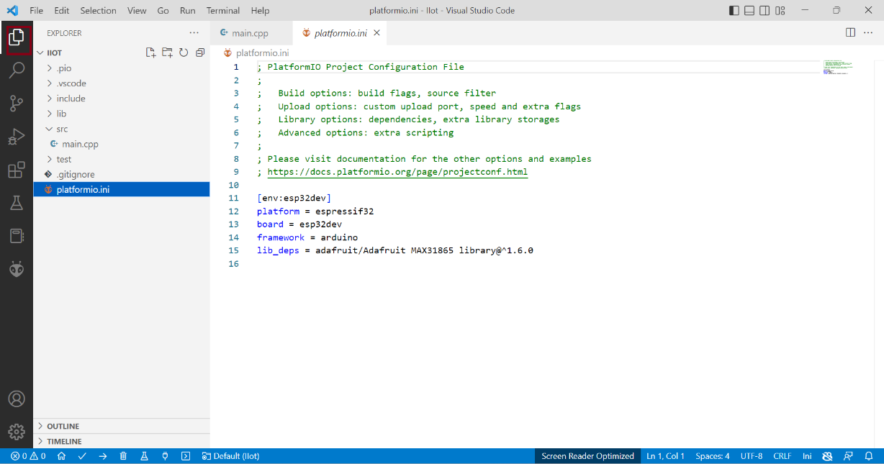
- Click on the PIO icon to see all the PlatformIO tasks as shown below.
Here’s the what icon does from left to right:
- PlatformIO Home
- Build/Compile
- Upload
- Clean
- Serial Monitor
- New Terminal
If you hover your mouse over the icons, it will show what each icon does.
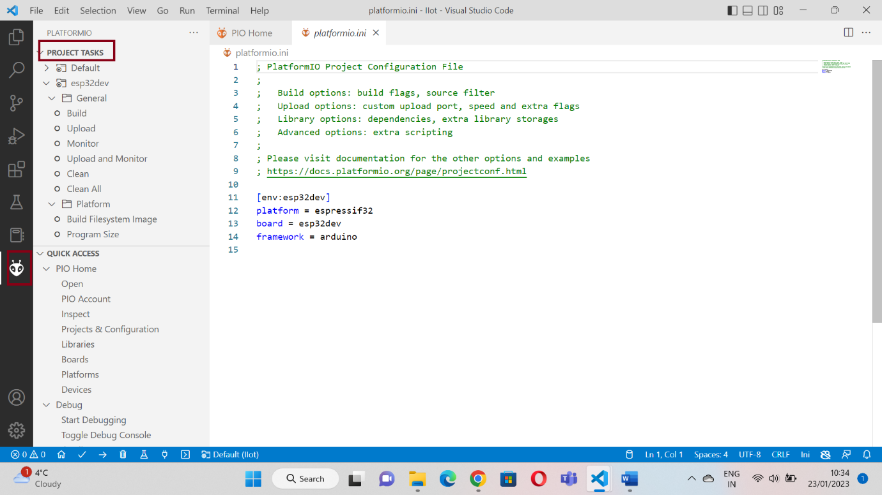

- if the tasks don’t show up on the IDE when clicking the icon, then it is needed to click on the three-dot icon at the top and enable PlatformIO tasks as shown below.
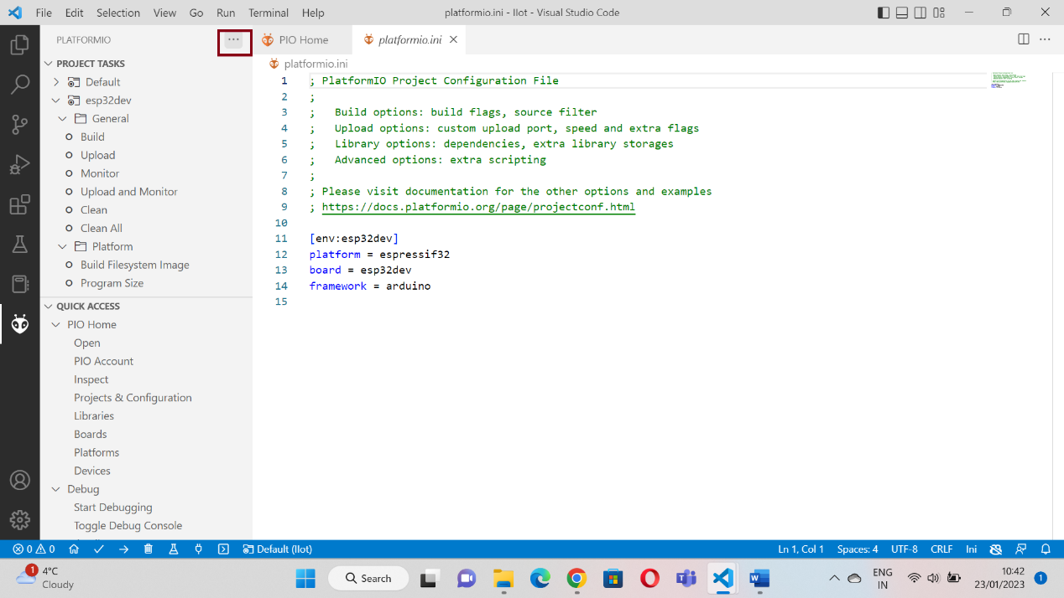

- Now go to PlatformIO >QUICK ACCESS>PIO Home>Libraries and search for the required library. Click on downloads of the required library as shown below.
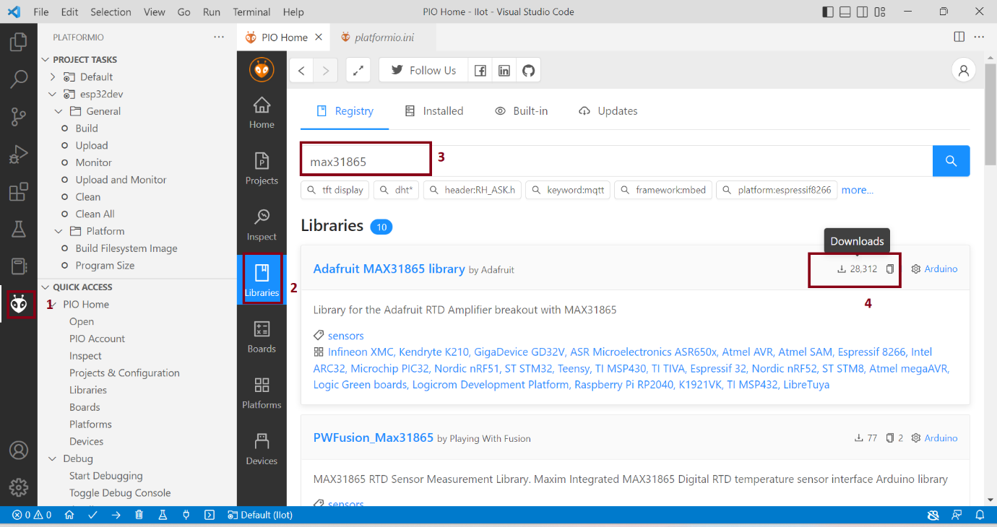

- select the project for the library to be added and click on add. After that, you will get a window saying the successful installation of the library to the project.
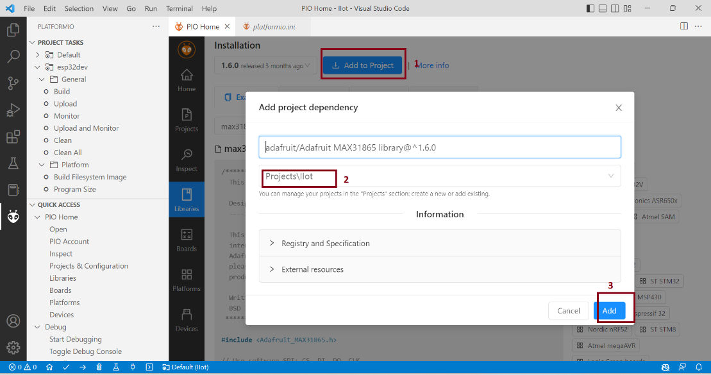
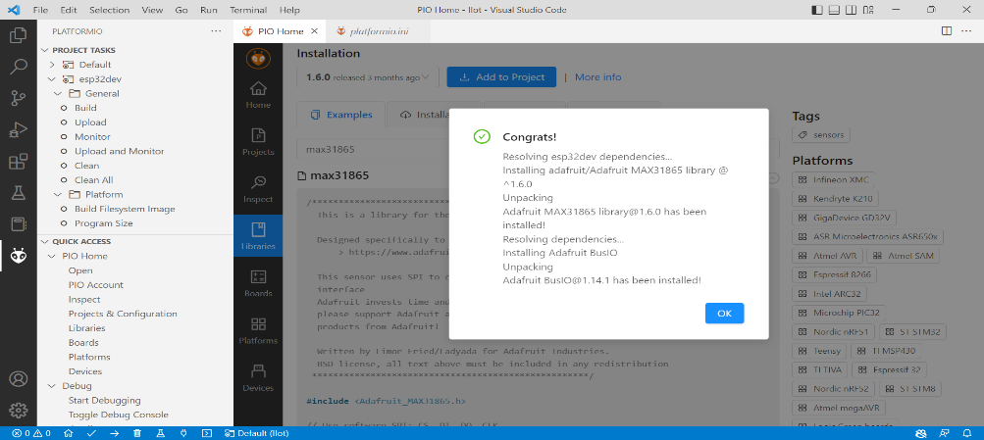
- Now go to The platformio.ini file to check the library is added to the project.Platformio.ini is the PlatformIO Configuration File for your project. It shows the platform, board, and framework for your project. You can also add other configurations like libraries to be included, upload options, changing the Serial Monitor baud rate, and other configurations as shown below.
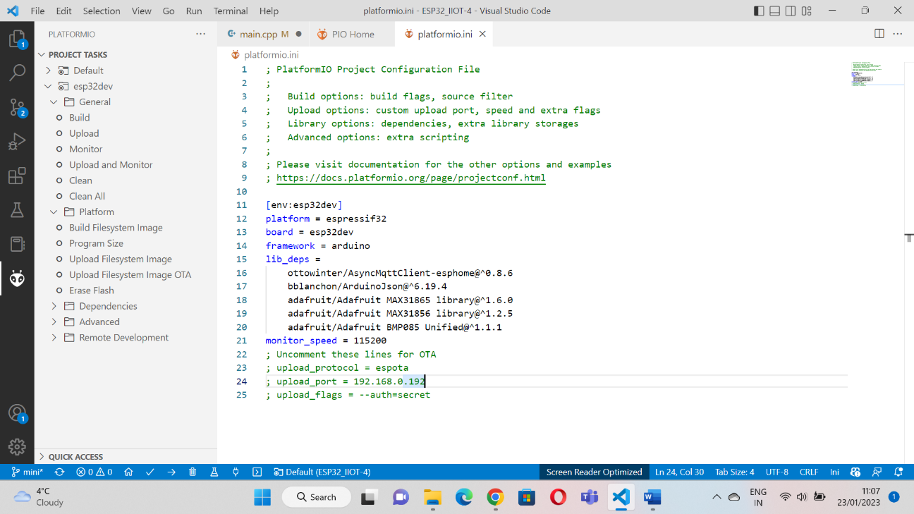

- The src folder is the working folder. Under the src folder, there’s a main.cpp file. That’s where you write your code. Click on that file. The structure of an Arduino program should open with the setup() and loop() functions as shown below.
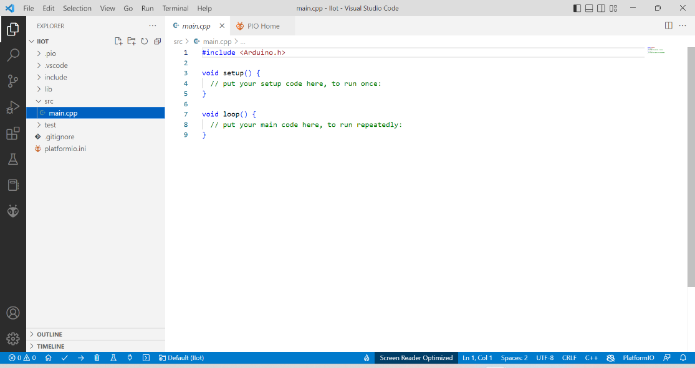

- After writing the code in the main.cpp go to the tasks and click on the Build which will compile the code and then the Success message as shown below.
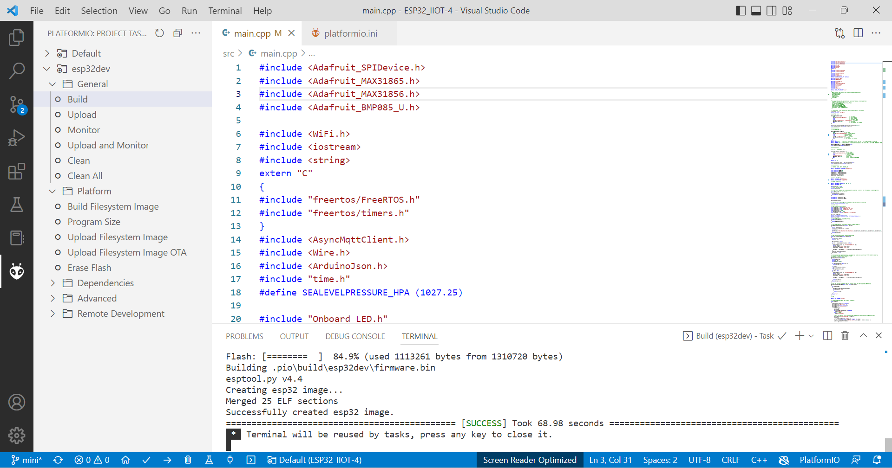

- To upload the code to ESP32 or Microcontroller board click on Upload as shown below. While uploading the code to the board click the boot button of the ESP32 and after uploading the code you will get the message Success as shown Below.
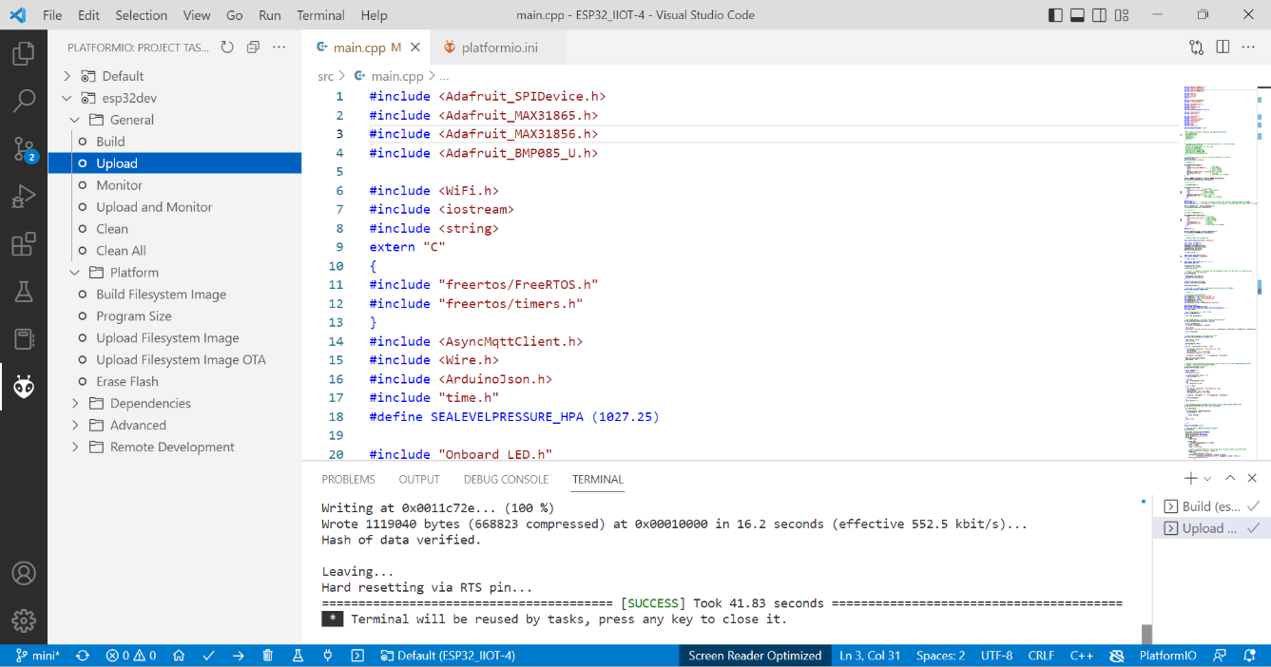

5. Adding code For New Sensor:
This BME680 sensor was used as an example for adding a new sensor to the ESP32.
1. First open the Platform IO ID as shown below.
2. Go to Library and search for the sensor in the library as shown below, in this case for sensor BME688 and click on download.
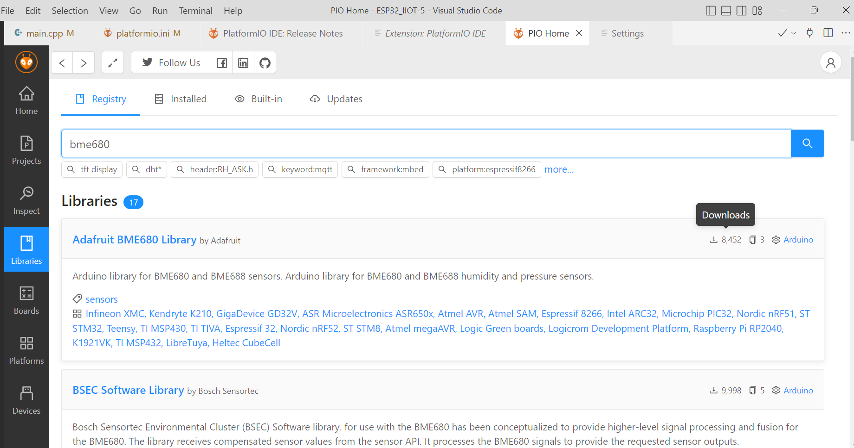

3. After clicking on the download, it will take you to a new window as shown below. And click on add to project.
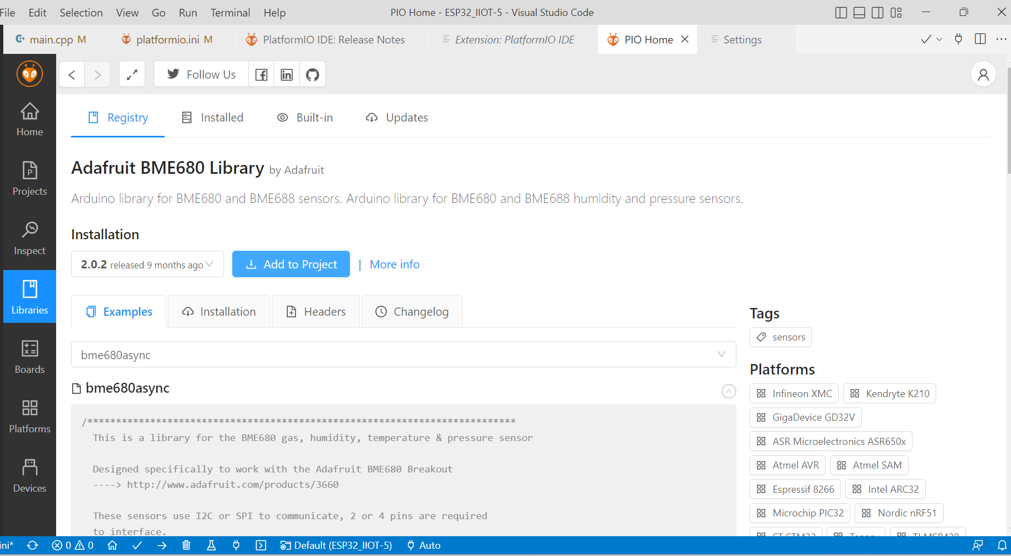
4. After clicking the add to project it would take you to a new window as shown below where you have to select the project to which you want to add the sensor library and click on add which will add the library to the project.
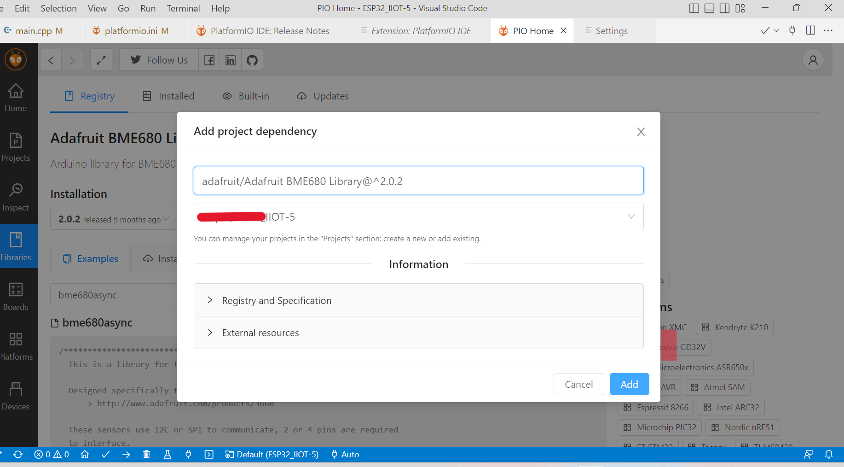

5. Now go to The platformio.ini file to check the library is added to the project in case the BME680 sensor is shown below.
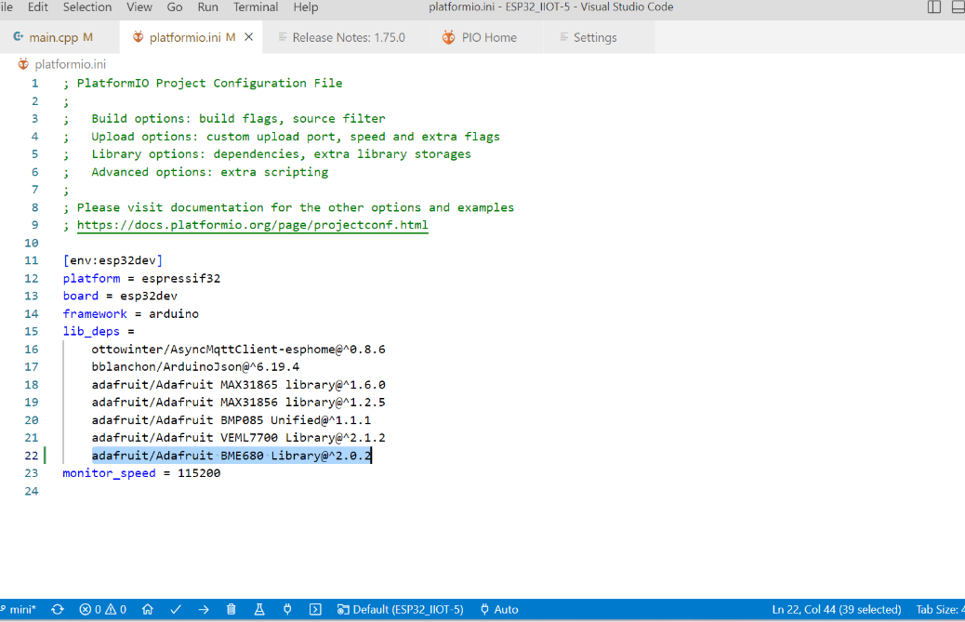

6. Now go to the main.cpp file in the src folder. Import the sensor library, here BME680 by using #include <Adafruit_BME680.h> as shown below. This will import the library into the code.
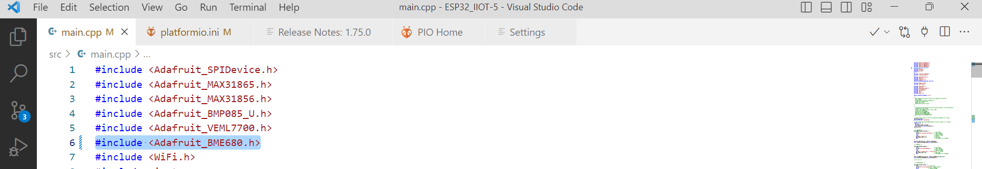
7. now define the Class SensorMQTTaskDef for the BME68, define bme and adding the sensor details in the sensor_array as shown below.
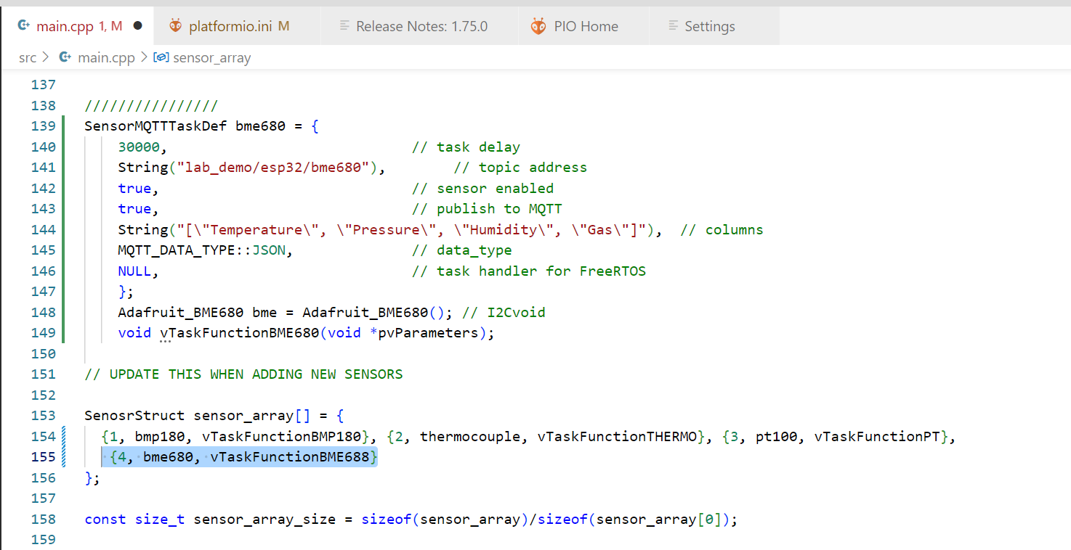
8. In the Class SensorMQTTaskDef, the first line time delay between the readings of the sensor is in milliseconds. The second line defines the topic address of the sensor in this case for bme680 for MQTT. The third line is to enable(true)/disable(false) the sensor and this line doesn't require change. The Fourth line is to enable(true)/disable(false) to publish to the MQTT server, and this line doesn't require change. The fifth line defines the different readings of the sensors as shown above depending on the sensor characteristics and this line edit according to the new sensors. The sixth line defines the data format sent to the MQTT server and this line doesn't require change. The seventh line doesn’t require change.
9. In the line Adafruit_BME680 bme = Adafruit_BME680(), we assign the Adafruit_BME680 class to the variable ‘bme’ for BME680 sensor
10. void vTaskFunctionBME680(void *pvParameters) is TaskFunction for the BME680
11. In the sensor_array we place SensorMQTTaskDef and vTaskFunctionBME680 for BME680 as shown below.
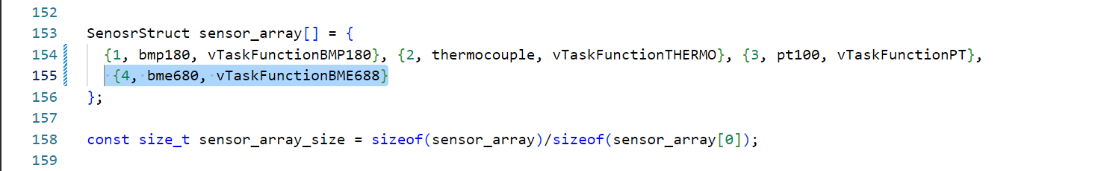
12. In wifi configuration, use your wifi detail to connect the network as shown below.
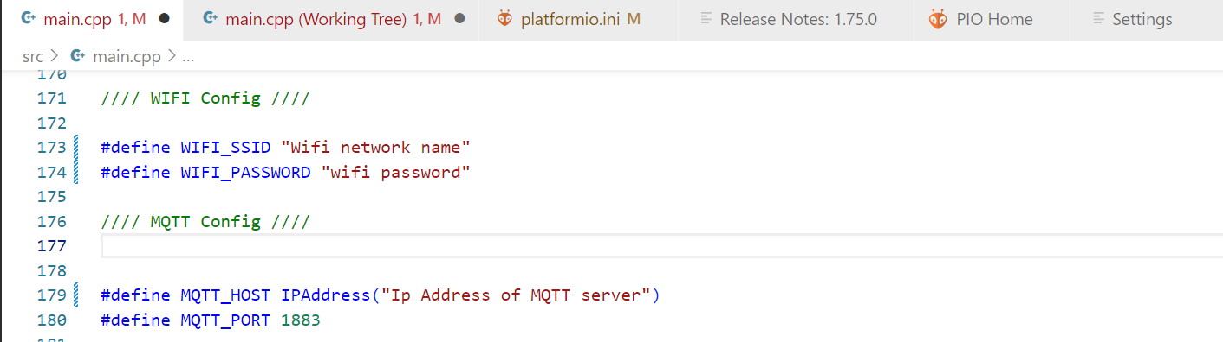
13. Now write setupSENSOR for the BME680 as shown below. Here 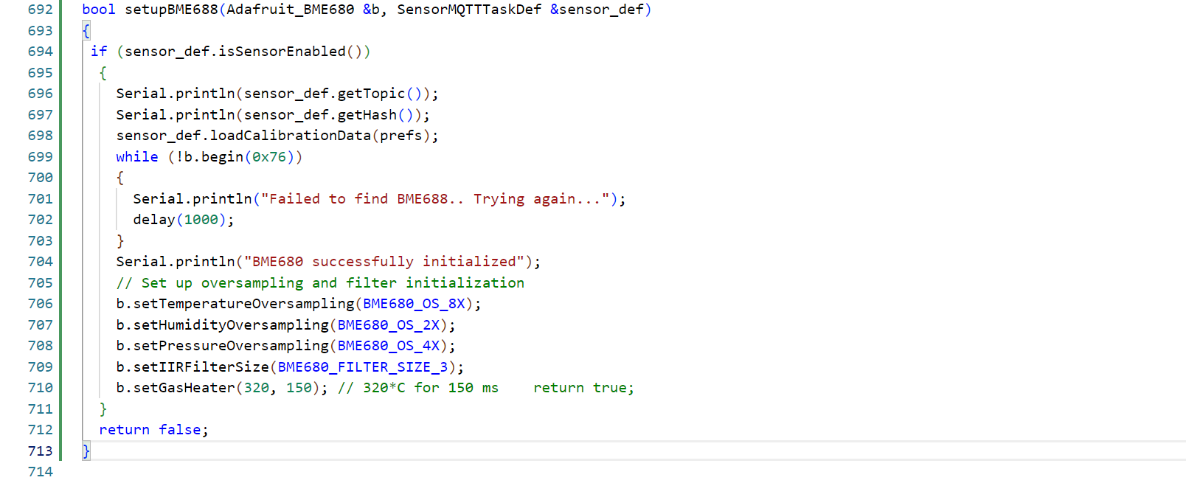
14. now we defined the void vTaskFunctionBME680 for the BME680 as shown below
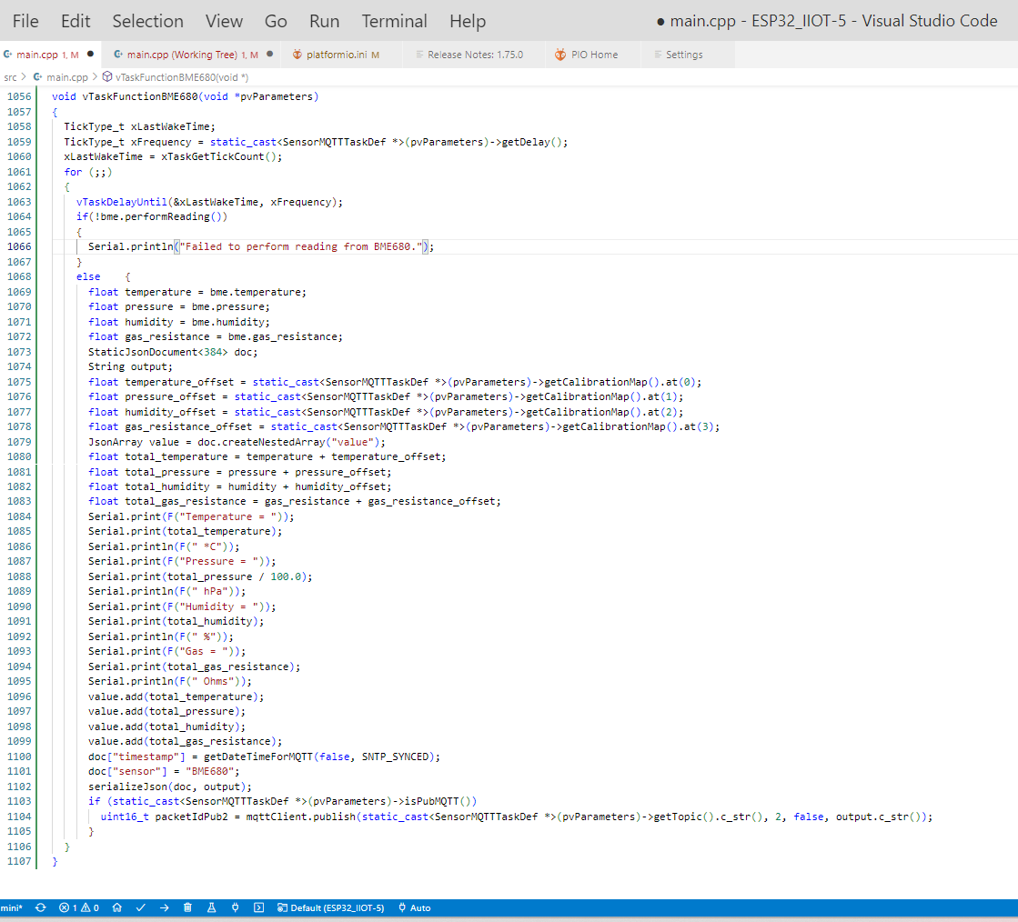

15. now we add the setupBME688(bme, bme688) is added to the Void setup function as shown below.
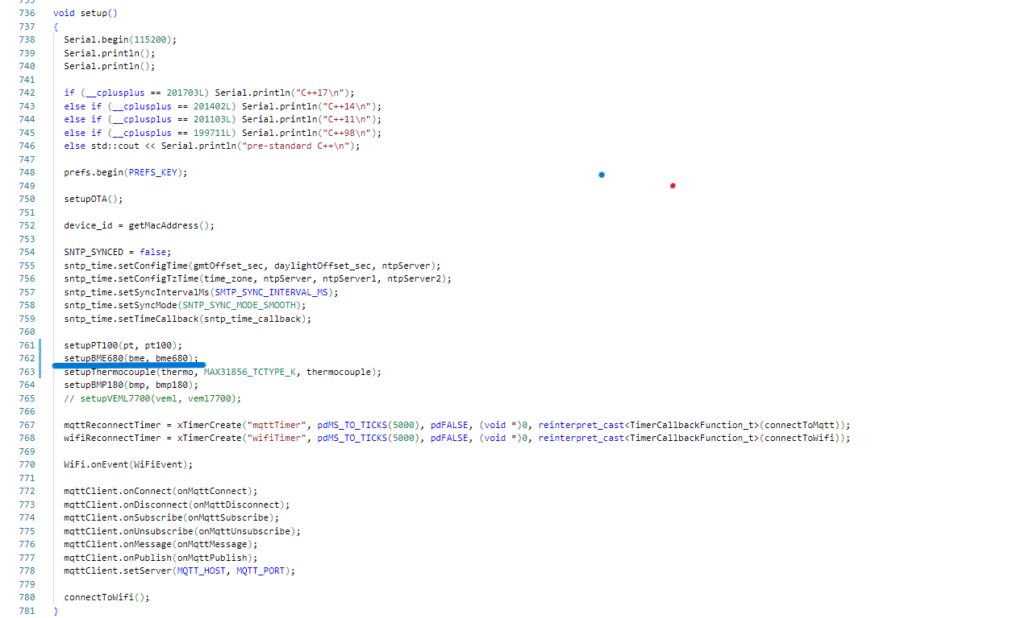

16. After writing the code for the new sensor in the main.cpp, go to the tasks and click on the Build which will compile the code and then the Success message as shown below.
17. To upload the code to ESP32 or Microcontroller board click on Upload as shown below. While uploading the code to the board click the boot button of the ESP32 and after uploading the code you will get the message Success as shown Below.
18.now go to the IIot page in the browser as shown below and click on “Topic Subscription”
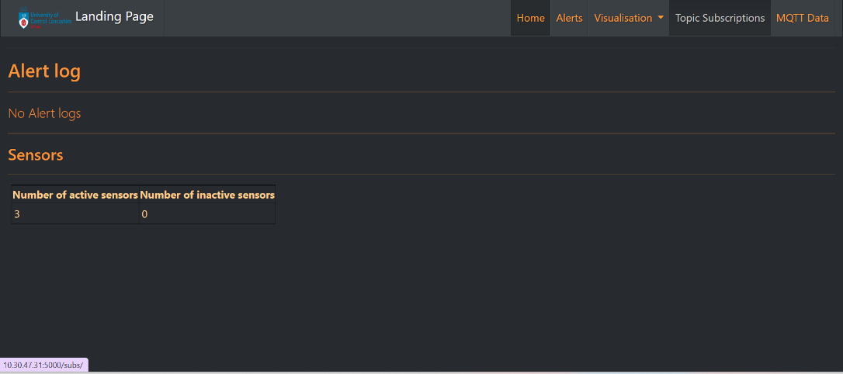
19.After new window will open as shown below and click on “Auto Discover”

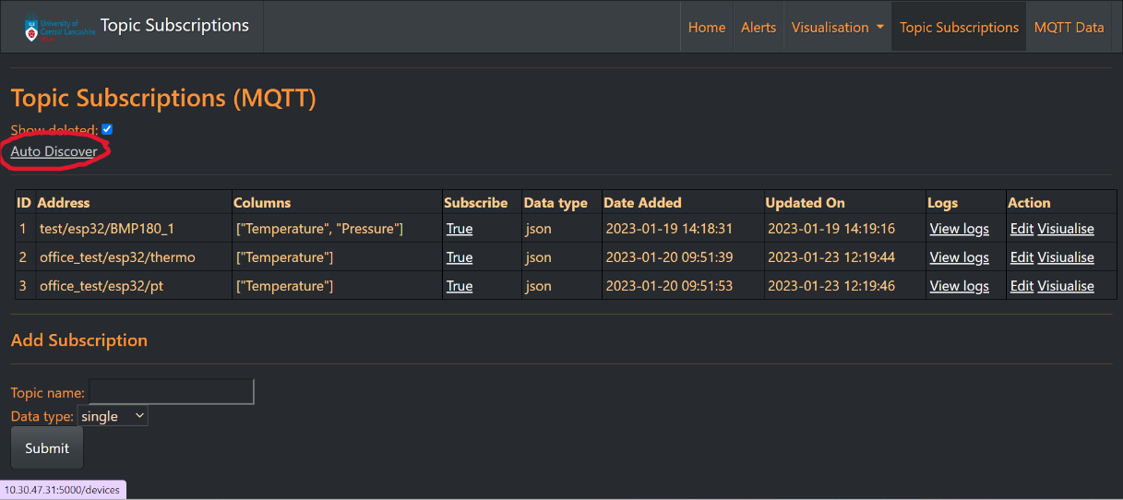
20.this will go to next page as shown below and click on “Refresh”
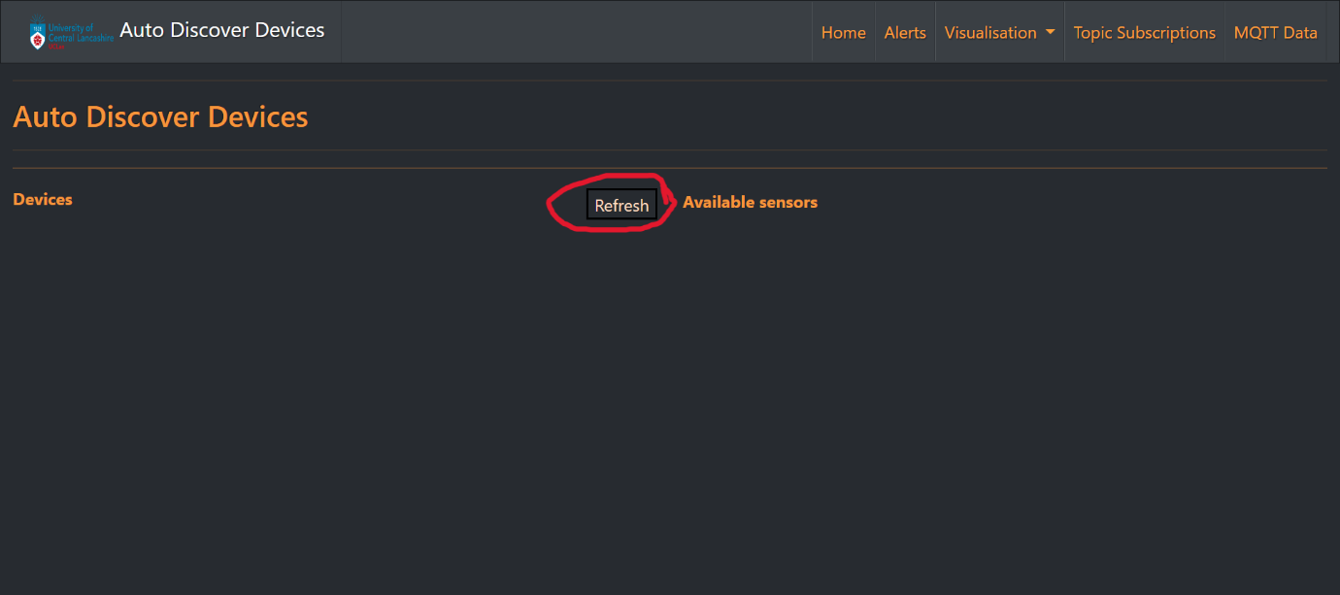
21.this will discover the sensors connected to the MQTT in this case BME680 and click on add
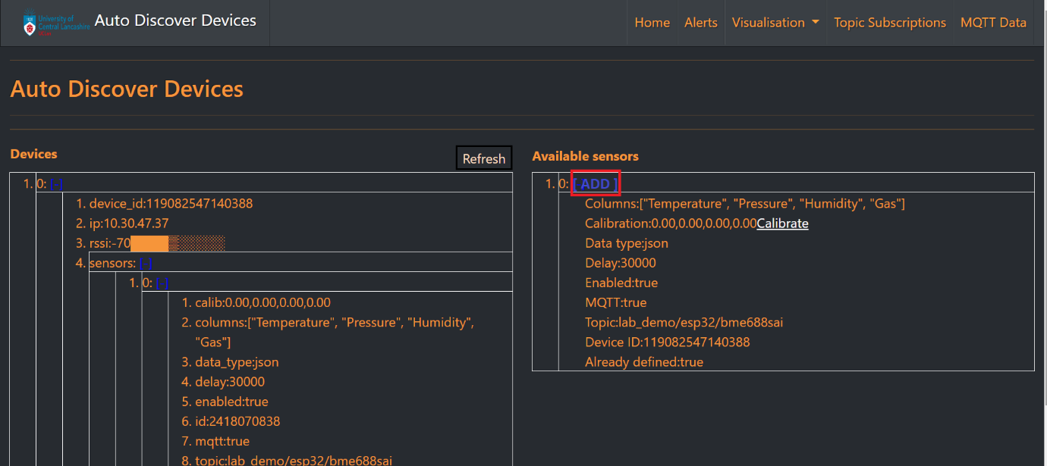
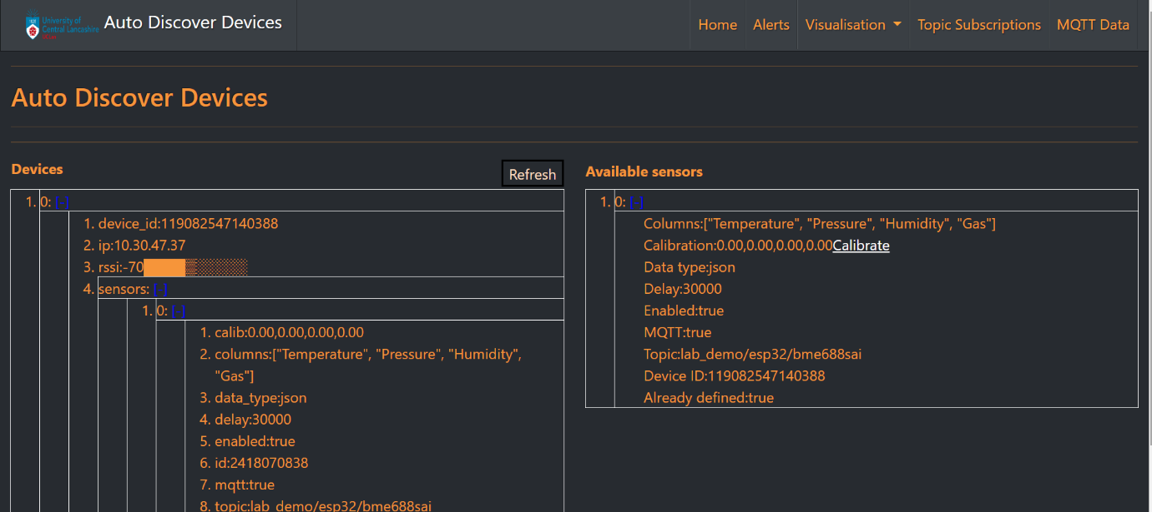

22. the new sensor is added in the Topic Subscriptions Page as shown below and in the” Subscribe” column it should show “True” and to view the readings of sensor click on “View logs”
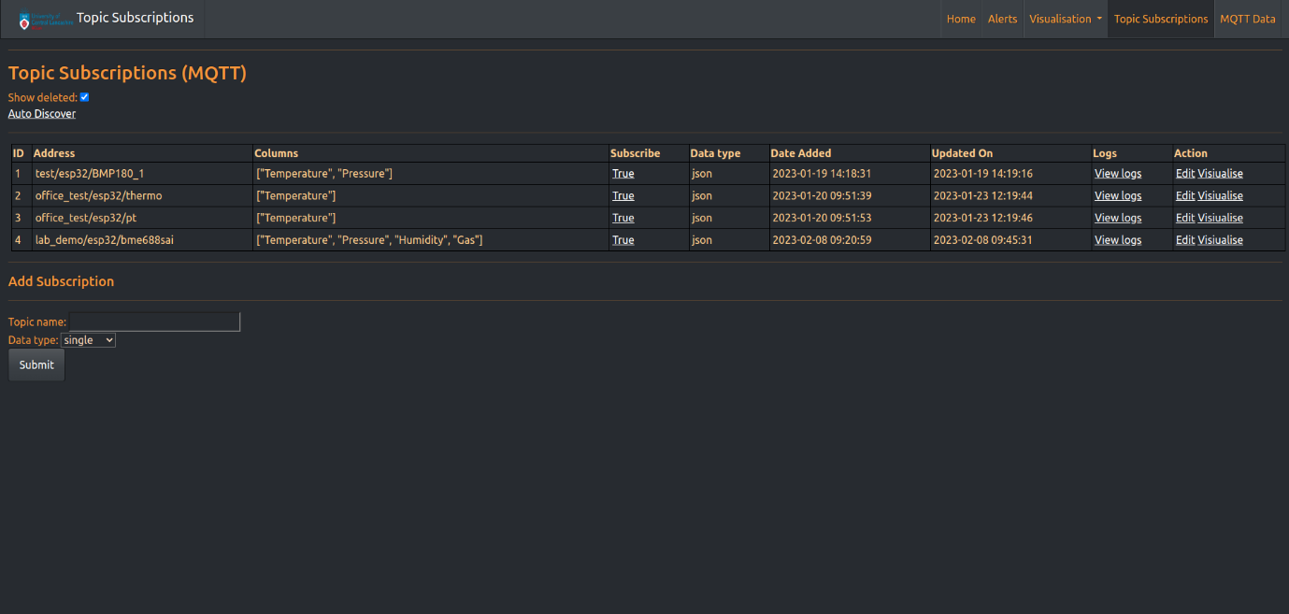
23. After clicking “View logs” it will taken will open window with sensor readings as shown below.


