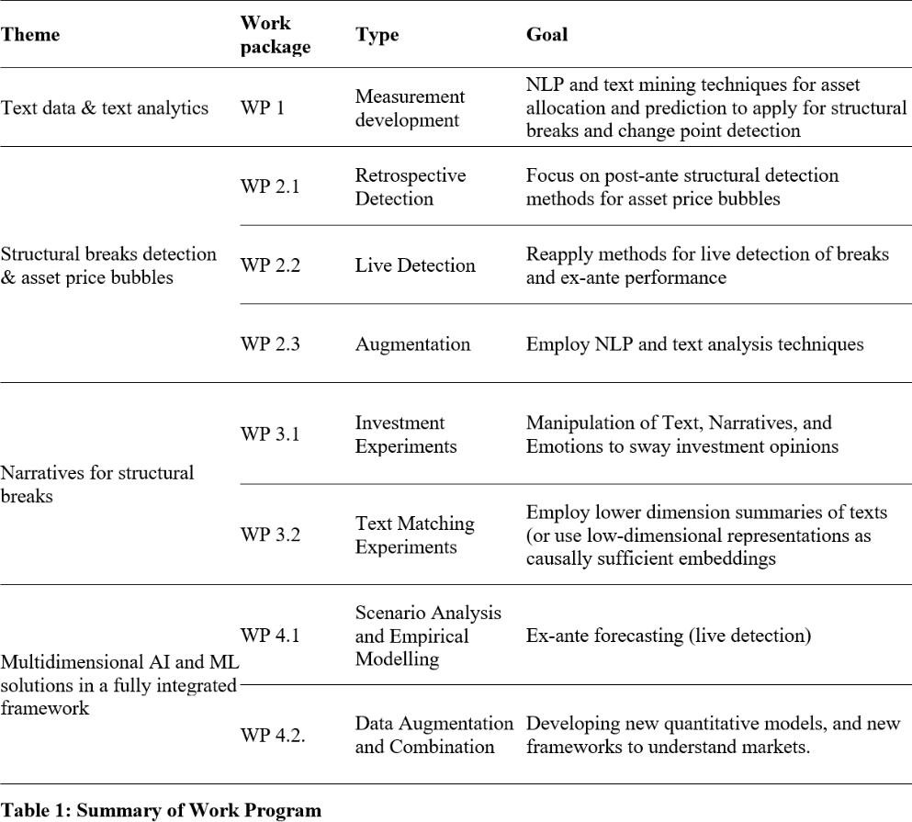
The proposed work program will comprise of four work packages (WP) summarized in Table 1 below. Our suggested approach is conceptually new compared to the existing research in financial market analysis. First, there is a limited number of studies employing narratives and textual information in financial market studies. Second, studies on rational and irrational bubbles have largely ignored the evolution of emotions and narratives underlying these times of change. Third, as it concerns method employed in finance research there is a scarcity of automated text-
analyses and research has by and large not kept up with methodological advances in computer science to make explicit use of large text corpora for empirical analyses. The research topics and methodological contributions are timely and relevant for scientific, technological and but also practical/societal needs. While different prior research has studied these topics in isolation, our empirical set up will allow us to study the interplay of narratives, language, evolutions of language patterns, financial innovation, and financial market performance/outcomes, in a comprehensive broad but also cross-layer and cross-aspect framework where evolutions, causality, and potential interactions can be measured explicitly.
Approach:
In a first step, we will design a tool allowing us to collect all relevant data from various data sources. Indeed, collecting purely financial data, such as stock prices or macroeconomic indicators, can be easily performed using subscription-based platforms such as Bloomberg, Reuters or Investing.com. However, textual data will constitute a substantial challenge in terms of (i) collecting from the web, (ii) formatting, and (iii) pre-processing, including dating and categorising. For this purpose, we will develop an automated tool which will collect textual data, categorise them, date and store them in an easy to analyse format. We will manage our database with SQL solutions. The second step will focus on our research questions and the four building blocks listed below.

We will formulate numerous data-driven general/main and block-specific research questions within our hypothesis-driven project. The main research questions will be:
- In what sense are financial markets (ex-ante) predictable?
- Is the ex-ante forecastability persistent, can it be applied for real use cases and to which extent?
- How can structural break detection and changes in financial time series improve and complement modern portfolio theory?

Block 1: Text data & text analytics

Text mining techniques are frequently used in scientific research for forecasting developments of various financial assets such as FX, equities, bonds, commodities see, for instance, Fung et al. 2003, Hajizadeh et al. 2010, Nassirtoussi et al. 2014, Kumar and Ravi 2016, Loughran and McDonald 2016 (Chan and Franklin 2011, Cambria and White 2014, Xing et al. 2017, Chen et al. 2020). Our solution uses NLP and text mining techniques for asset allocation and prediction to apply for structural breaks and change point detection combined with asset allocation methodology. For instance, those techniques are used for predicting cryptocurrency price bubbles using social media data (Biessey 2021). However, the field of classic financial assets tends to be under-researched. Therefore, we will collect relevant literature, review solution and answer the following research questions:
  - How can textual analysis and the application of natural language processing techniques be efficiently used for portfolio management, including risk management and asset allocation?
  - What are the most promising NLP / text analysis techniques?

Block 2: Structural breaks detection & asset price bubbles

The survey of econometric tests of asset price bubbles shows that, despite recent advances, econometric detection of asset price bubbles cannot be achieved with a satisfactory degree of certainty (Gürkaynak 2008). Furthermore, currently, there exist a relatively low number of scientific papers about the live detection of structural breaks in a systematic way. Most of the existing solutions have not been validated on real-world data. An obvious downside of such experiments is that the dynamics of the simulated data are often particular to the paper, and any model that corresponds to these dynamics has an unfair advantage (van den Burg and Williams 2020).
Hence, we will tackle the issue of structural breaks and asset price bubbles in the three steps. In the first step, we will focus on post-ante structural detection methods for asset price bubbles to identify past breaks in real macroeconomic and financial time series. The breaks will be compared and based on consensus simplified if needed. In the second step, we will reapply well-established, known methods for live detection of breaks and check their ex-ante performance. Based on the current state of literature, we expect a relatively poor forecastability of breakpoints. Therefore, in the third step, we will involve NLP and text analysis techniques as a supporting or main method for detecting breakpoints. Within our research in this block, we will answer the following research questions:
  - How to detect, identify and date structural breaks in online and offline matters?
  - Detection of structural breaks / change points / asset prices bubbles in a live-matter using most recent (alternative) data (Twitter, News etc.)
Block 3: Narratives for structural breaks

The so-called "narratives block" will be highly dependent on results from block 1 and 2. Using newly acquired knowledge and experience with text analysis and NLP and insights into detecting structural changes, we will develop a framework with market narratives for detecting asset price bubbles. Narratives "go viral" and spread worldwide with economic impact (Shiller 2017). There is considerable evidence in the scientific literature showing that people respond strongly to narratives in the fields of marketing (Escalas 2007); journalism (Machill et al. 2007 ); education (McQuiggan et al. 2008); health interventions (Slater et al 2003); and philanthropy (Weber et al. 2006). We will answer the following research questions:
  - Can market narratives help predict financial market bubbles and their bust?

  - Can market narratives help detect financial market bubbles?
  - Can narratives sway investment opinions?

In order to achieve this, one needs to devise experiments for measuring narratives and then incorporate those measurements into predictive models aimed at explaining different aspects of financial market behaviour. Looking at the 3rd research question within this block, we can investigate the effectiveness of specific components of narrative strategies by carrying out an experiment with potential investors who will be given different investment options that: a) incorporate a narrative structure and b) emphasise different positive or negative emotions in the text. Put differently, the participants will have text and information presented to them, where the level of the manipulated component (e.g. emotional content) is low/high and a narrative appears/does not appear in the description of the investment. Once the data is collected, we can employ pre-trained Transformer models (GloVe Embeddings with Long Short-Term Memory Network (GVEL) or Bidirectional Encoder Representations from Transformers (BERT)) and finetune them to model the presence of narratives. This will also enable us to test how text impacts investment option perceptions by using text matching approaches that employ lower dimension summaries of texts (Roberts, Stewart, and Nielsen, 2020) or use low-dimensional representations as causally sufficient embeddings (Veitch, Sridhar, and Blei, 2020). Such experiments will provide evidence of the causal influence that different components of narratives and emotions exert on the appeal of these investments by influencing the judgements of potential investors.
Furthermore, for narratives to be effective they need to resonate with potential investors (van Werven et al., 2019). We thus use a study to test the effectiveness of specific components of narrative strategies in an experimental design. We will introduce participants to different investment options that a) incorporate a narrative structure b) emphasise different positive or negative emotions in the text. Due to practical considerations (sample size), we will employ a 2x2 experimental design for each of the components tested (e.g. narrative element present vs. purely informational text; emotionality of communication low vs. high). The experiments will provide evidence of the causal influence that different components of narratives and emotions exert on the appeal of these investments by influencing the judgements of potential investors. This experiment might also inform us about narratives and biases, where for example, investors forego certain investment options (overlook correlations that may improve their risk-return profile in the portfolio) because of the narratives presented to them.
Block 4: Multidimensional AI and ML solutions in a fully integrated framework

As already mentioned in the literature review, AI and ML techniques possess a substantial potential to revolutionise financial markets (Milana and Ashta 2021). New technologies transform business models and markets for trading, credit and blockchain-based Finance, generate efficiencies, reduce friction, enhance product offerings, and refine the existing financial services industry (Buchanan 2019, Hilpisch 2020, Moloi and Marwala 2020). Since, in previous blocks, we look at detecting structural breaks and asset price bubbles from various perspectives and apply different techniques, it seems to be self-explanatory and expected to check if those methods can be combined into a fully integrated framework.
Research questions:
- Can a combined ML approach outperform each single method?
- Do complex AI and ML approaches outperform simple forecast combinations?

Objectives.

Our study will provide an extensive overview of structural breaks and asset prices, bubbles detection mechanisms and novel methods based on existing solutions, including their applicability documented for real-world case scenarios. Documentation will allow academics, financial authorities and regulators to perform better risk management and understand financial markets. Our solution for detecting structural breakpoints will be unique in numerous matters. First, we will exclusively focus on ex-ante forecasting (live

detection), easily adjustable to a rapidly changing market environment. Second, combining existing data sources, developing new quantitative models, and new frameworks to understand markets.
Existing sources and datasets.

Our research will be based on large-scale financial databases. Notably, those are Bloomberg, Refinitiv, Quandl, OECD data, World Bank Open Data, FRED economic data, covering macro-economic data, and price data for financial instruments.
Data collection strategy and alternatives.

We either already have data licences, or the data is open source. Our existing infrastructure allows us to deal with data processing on a large scale, and we have dedicated computing resources for any deep learning research.

