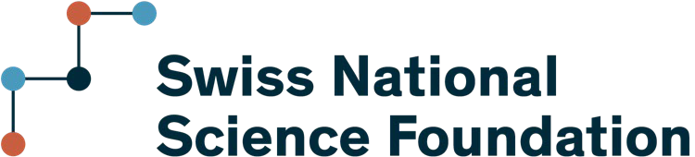

Scientific report

Qualitative scientific report
To submit the scientific report, please fill in sections 1.1-1.4 in this document in the same language as the research plan and upload it in PDF format via mySNF under «Scientific report». The completion of sections 1.1 and 1.4 are mandatory, sections 1.2 and 1.3 are optional. The report has to cover the elapsed period of the grant, i.e. the period from the start of the grant (please see the dates in the task on mySNF). Please adhere to the given structure of the report.

Output data
Enter or update your output data on mySNF under «Output data» including publications, datasets, me-dia appearances, conferences, etc. Please note that the output data must be entered before submitting the scientific report.

Lay summary
At the beginning of your project, you formulated a lay summary and entered keywords (on mySNF un-der «Lay summary») that are accessible on the SNSF Data Portal. Please check your keywords and update your lay summary on mySNF with information on the results and outcomes of your project.

Name
Project number

Bern, 2025 Scientific report

Achievement of research objectives (mandatory)

To which extent have you achieved the research objectives? Describe the major accomplishments and outcomes of the project in detail, directly relating them to the objectives stated in your research plan.
~0.5 – 1.5 pages, up to 6000 characters with spaces

Challenges, negative results and unexpected outcomes

Discuss the following points, if applicable:
    - Challenges encountered during the project and how they were addressed
    - Significant modifications to your original research plan
    - Negative or unexpected results and their causes and implications
up to 0.5 pages, max. 2000 characters with spaces

Contribution to knowledge advancement

Describe how your research findings have contributed to advancing knowledge within your field of re-search and/or your community of stakeholders.
up to 0.5 pages, max. 2000 characters with spaces

Additional reporting requirement (mandatory)

Describe the research collaboration with your co-applicants and project partners. How did the collabo-ration work, and what was its added value to the project as a whole? What did the various collabora-tors contribute to the project? What changes (if any) would you implement in future collaborative pro-jects based on this project?
up to 1 page, max. 4000 characters with spaces

For COST grantees: Please describe the added value through participation in the respective COST Action.
up to 1 page, max. 4000 characters with spaces

