**FOR IMMEDIATE RELEASE**

**NEW WEBSITE OFFERS MAP OF AREAS THAT THE UK GOVERNMENT LICENCESED FOR OIL AND GAS EXTRACTION, INCLUDING SHALE GAS USING FRACKING**

**The data, originally published by the Department of Energy and Climate Change, is finally made available in an accessible and interactive format that anybody can use. The website shows both existing licenses and the areas under consideration for future exploitation.**

The UK Department for Energy and Climate Change (DECC) published in December 2013 the "Environmental report for further onshore oil and gas licensing" report, that specified what areas of the UK are being evaluated for exploitation, with shale gas being the main resource being targeted.

That information, together with data on pre-existing oil and gas licensing, was already available to the public but through government-run websites such as <http://maps.lynxinfo.co.uk/UKOGL_LIVEV2/DeccLicences.html> , that are very difficult to use.

Gianfranco Cecconi, a British data scientist based in Hertfordshire, addressed the problem and used the same data to create a new, user-friendlier map that is now freely available to the public.

Mr Cecconi said: “The website was the result of only a few hours’ work. I believe it is a fantastic example of how the Government’s commitment to open its data to the public is naturally complemented by each of us citizens taking responsibility for making it better and more accessible”.

The new map is available at <http://www.digitalcontraptionsimaginarium.co.uk/oil-and-gas-licensing-map> (or <http://dico.im/uklicensing> for short).   
**______  
ENDS**

More follows…

Continued

**FOR MORE INFORMATION PLEASE CONTACT:**

**Mr Gianfranco Cecconi, the website creator:**E-mail: gianfranco.cecconi@digitalcontraptionsimaginarium.co.uk   
Twitter: @giacecco

**NOTES TO EDITOR:**

* On a journalist’s suggestion, a version of the map that can be embedded in an external website has been developed for anybody to use. See <http://www.digitalcontraptionsimaginarium.co.uk/oil-and-gas-licensing-map/embedTest.html> for an example of how to do it.
* An example of how the Government website referenced in the press release looks is below. Would you be able to find your home address in a map that looks like that?  
    
  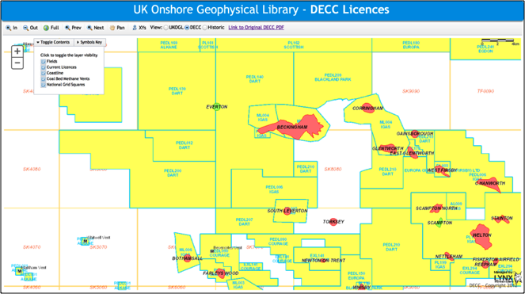

More follows…

Continued

This is how the same geographical area looks in the new map instead:  
  
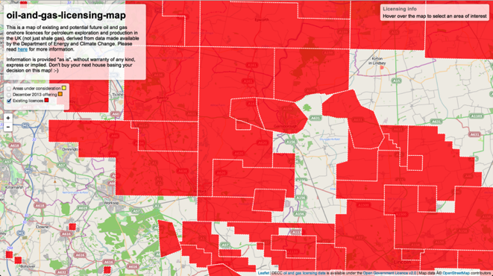  
Higher resolution versions of two example maps above are at <https://raw.github.com/giacecco/oil-and-gas-licensing-map/master/images/map2.png> and <https://raw.github.com/giacecco/oil-and-gas-licensing-map/master/images/map3.png> .

* Mr Cecconi’s work is described in detail at <https://github.com/giacecco/oil-and-gas-licensing-map/blob/master/README.md> .