ROOTSTALK-article-template
--- Progress Bar ---
updated: 5/13/24 9:41 AM
This is the Article’s Primary-Title
by This is the Byline Naming the Author(s)

This is the Article-Type
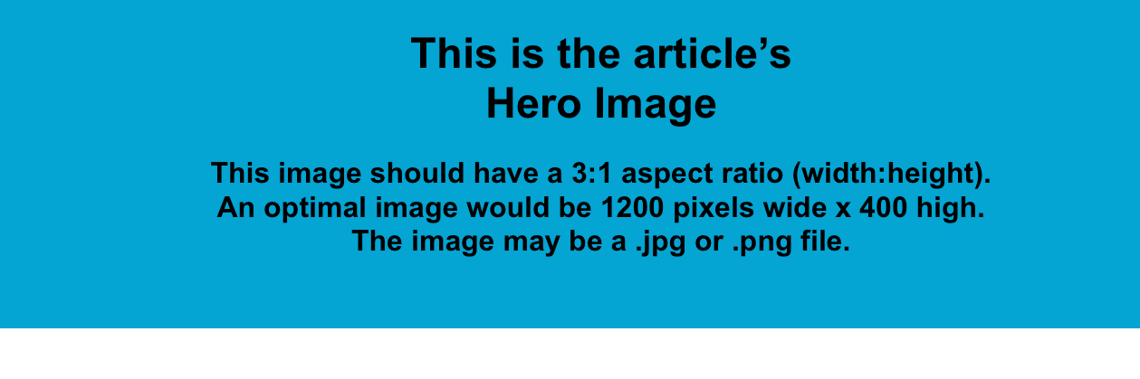
This is an “Emphasized-Paragraph” styled paragraph. It will appear in italics as you see here. Used primarily for introductory or editorial content, or comments about the piece, not “of” the piece. Lorem ipsum dolor sit amet, consectetuer adipiscing elit. Maecenas porttitor congue massa. Fusce posuere, magna sed pulvinar ultricies, purus lectus malesuada libero, sit amet commodo magna eros quis urna. Nunc viverra imperdiet enim. Fusce est. Vivamus a tellus.
- This is an “Attribution” styled statement, commonly used to cite the author/origin of the preceding paragraph

This is a “Normal” paragraph. Use it for most of an article’s text where Emphasis or other specialized text treatment is NOT needed. Lorem ipsum dolor sit amet, consectetuer adipiscing elit. Maecenas porttitor congue massa. Fusce posuere, magna sed pulvinar ultricies, purus lectus malesuada libero, sit amet commodo magna eros quis urna. Nunc viverra imperdiet enim. Fusce est. Vivamus a tellus. Pellentesque habitant morbi tristique senectus et netus et malesuada fames ac turpis egestas. Proin pharetra nonummy pede. Mauris et orci.

This is a “Normal” paragraph with a named, embedded hyperlink in the last sentence. The hyperlink’s displayed text (optional) appears to the reader and clicking on that text opens the hyperlink’s associated address or URL. Click this link to learn more about hyperinks and note that the displayed text may be omitted in which case the address is displayed.

Adding Endnotes
This is a “Normal” paragraph with two footnote (endnote) references expressed using lowercase Roman numerals like `i`, `ii`, `iii` `iv`, etc. All such refenced notes in Rootstalk appear as “endnotes” at the end of the article, not as “footnotes” at the end of the page. Instructions for inserting endnote references into a Word document can be found here: Insert footnotes and endnotes

This is a Title (Secondary) or Section Heading
The next element is an image using the “Article-Image” style. The caption was added by right-clicking on the image in Word and choosing the “Insert Caption…” command. The numeral “1” which appears at the start of the caption was automatically inserted by Word. I could find no way to suppress that behavior, but don’t worry, it will be automatically removed later.

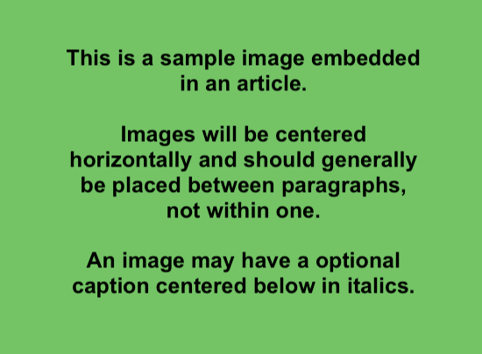
1This image caption was inserted using a right-click on the image.

Just Another Title (Secondary)

The next element is the same image as above using the “Article-Image” style, but its caption was provided on a separate line of text below the image. That caption line uses the “Caption” style.

This is the image caption styled using “Caption”.

A handful of “Normal” paragraphs full of “lorem ipsum” text. Following this first paragraph is a “Pull Quote”, the style name is “Intense Quote”, highlighting text extracted from an upcoming paragraph. Lorem ipsum dolor sit amet, consectetuer adipiscing elit. Maecenas porttitor congue massa. Fusce posuere, magna sed pulvinar ultricies, purus lectus malesuada libero, sit amet commodo magna eros quis urna.

Proin pharetra nonummy pede. Mauris et orci. Aenean nec lorem. In porttitor. Donec laoreet nonummy augue!

Nunc viverra imperdiet enim. Fusce est. Vivamus a tellus. Pellentesque habitant morbi tristique senectus et netus et malesuada fames ac turpis egestas. Proin pharetra nonummy pede. Mauris et orci. Aenean nec lorem. In porttitor. Donec laoreet nonummy augue.

Suspendisse dui purus, scelerisque at, vulputate vitae, pretium mattis, nunc. Mauris eget neque at sem venenatis eleifend. Ut nonummy.

Adding Media
Word templating is available for adding media in the form of embedded audio or video playback. While this is a “Normal” paragraph, the elements you see below are 15-second samples of video (.m4v) and audio (.mp3) captured from my screen while editing this template. The visual “widgets” you see here are optional, I only put them here to remind me of where they fall in the article.

The critical elements here are the “video_azure…” and “audio_azure…” statements wrapped in double-curly-braces! Those are “shortcode” elements that make the media work.

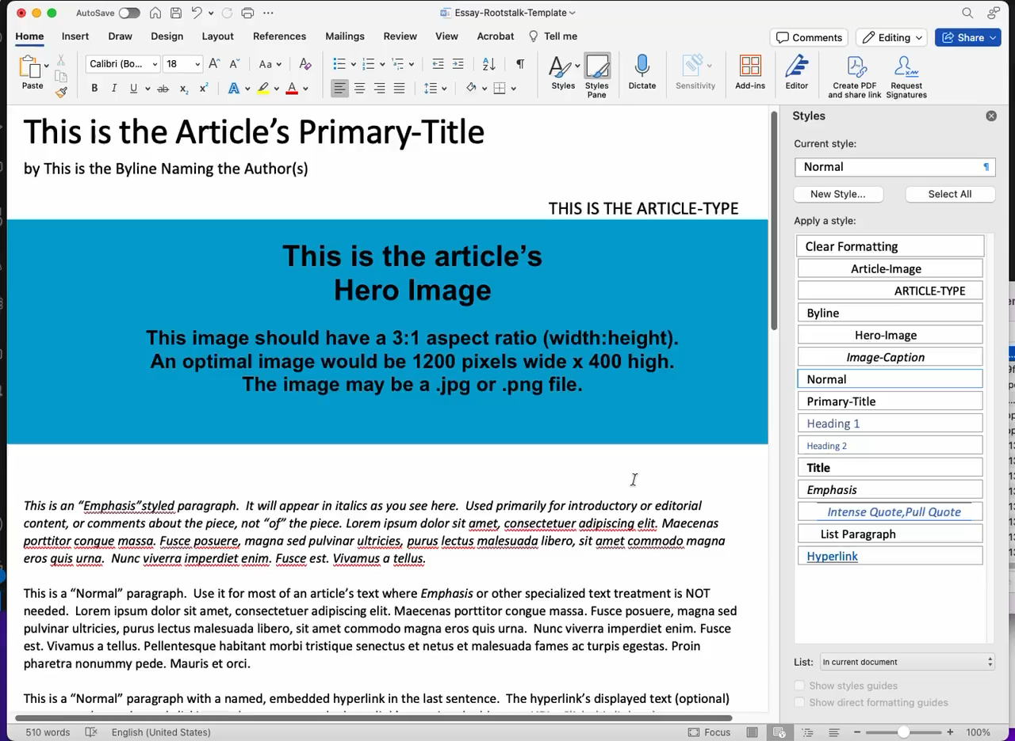
{{% video_azure pid=”15-second-video-sample-with-audio.m4v” %}}
This caption says: “Use this player to see 15 seconds of sample video”

This is a “normal” paragraph situated between a “Video” styled widget and an “Audio” styled widget.


{{% audio_azure pid=”15-second-audio-only.mp3” %}}
Use this player to hear 15 seconds of sample audio

Adding Poetry or Fixed-Format Text
Word templating is available for adding fixed-format text like poetry. The following lorem-ipsum text uses whitespace and the “Fixed-Format” style to selectively position text.

Lorem ipsum dolor sit amet,
This line indented by 4 spaces…consectetuer adipiscing elit.

This line intented by 7 spaces…Maecenas porttitor congue massa.

Fusce posuere, magna sed pulvinar ultricies,
purus lectus malesuada libero, sit amet commodo magna eros quis urna.

This line indented by 6 spaces…Nunc viverra imperdiet enim.

Interview or Transcript Text
Interviewer: This is typical interview or transcript text in “Interview” style. It features a “speaker” identifier followed by a colon then normal text.

Interviewee: Using personal names or even initials in place of “Interviewer:” and “Interviewee:” is recommended. This format can also be used for transcripts, especially where a “speaker” identifier is recommended.

This is a “List Paragraph”
I didn’t create the “List Paragraph” style, it must have come from Microsoft. I’m using it here just to see how it behaves. It’s basically just a “Normal” paragraph but indented by 0.5 inches throughout. Might come in handy for something?

Provide “Author” or Contributor Info in These Styles
“Author” or contributor info may be included as well, generally at the end of your Word document. The fields and styles you should provide include:

- Contributor-Role
- Contributor-Name
- Contributor-Bio
- Contributor-Headshot

Note that each article may have more than one contributor! Placeholders for these fields are included below, each with the appropriate corresponding style. Recommended practice is to copy this block of paragraphs (plus an image) and paste it into your document making substitutions as needed.

Contributor-Role
Contributor-Name
Contributor-Bio
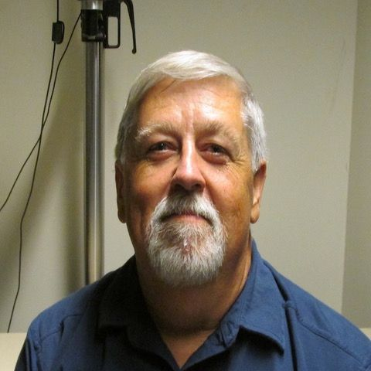

This is endnote #1 referenced with the lowercase Roman numeral ‘i’. Like other text, an endnote may contain a link like this one.
This is endnote #2. Endnotes typically refer to content supporting the article, generally gleaned from research conducted during the article’s creation.

