Cuba’s Prominence: Modeling the Latin American Afro in Topic Maps[1]

**Introduction**

Afro[2] literary-artistic[3] representations in Latin America have emerged from countless exchanges, inventions and introductions of cultural information[4]. Nevertheless, these representations have been mostly associated with an image (García Canclini 1990, 97) of Afro as tribal and primitive, and directly related to joy, cadence, rhythm, and witchcraft, among others. This image has proven powerful enough to become dominant while establishing itself within an identitarian framework that encompasses everyone and everything Afro. Such dynamics around Afro representations can be found in projects relating to Negritude (Sedar Senghor 1966, 57), and to Afrocentricity (Asante 1988, 65), as well as Westernization and Orientalism (Said 1978, 70).

The objectives of this article are many-fold: firstly, we aim at locating the various centers of production associated with the generation of such an image of the Latin-American Afro; secondly, we will evaluate the causes that make certain centers, i.e., Cuba and various Cuban intellectuals, emerge as key nodes in the network of production of Afro-Latin American representation; and thirdly, we propose a methodology that takes advantage of both traditional qualitative techniques in the humanities as well as mathematical and computer science tools such as network analysis and representation, topic maps and network theory.

In order to do so, we organize and treat as a network the information extracted from the close reading of the selected bibliographic sources most relevant to the subject of Afro and Latin America. This set of sources includes many traditional texts widely related to Afro criticism and, therefore, they could be used in many other contexts. Our criterion of selection has to do with the relevance of those authors and texts for both the creation of dominant discourses on the Afro during the 20th century and, more specifically for the reception they enjoyed in texts specifically used to construct images of the Afro as it pertains to Latin America. In this regard, the selection of texts implies a controlled bias that will affect the visual results and our interpretation. We are aware of this bias, but when confronted with the decision about achieving a balance between the possibilities opened by the methodology explored here and the specific cultural domain we are addressing, we think that the benefits of applying this selection are worth the bias. Likely, a significant change in the range of texts selected would translate into a different network. We are not sure that the same would happen if we just increased the amount of texts about the same subjects; actually, we think that one of the important results of this work comes off the central role played by Cuban intellectuals in the formation of a strong and pervasive discourse about the Latin American Afro.

We develop two processes throughout this article. The first relates to the analysis of the topic map of bibliographic influences that represent the network of connections in the Afro artistic world. During this analysis we shall deal with concepts such as eccentricity, closeness centrality, betweenness centrality and modularity among others. We shall also establish the level of influence (considered as the relational value) between the nodes of the network, to see which are the most influential in establishing the Afro image. To do this, we build a topic map model of our subject domain using Wandora[5] that also helps us to store the data. Then we export it to Gephi[6] to perform different types of analysis. Mainly, we shall use the Page Ranking Algorithm[7], the algorithm used by search engines such as Google to classify the most influential and visited pages on the web. In the second part of the article, we shall focus on two of the great figures around what we call “the Cuba cluster” in our network —Nicolás Guillén and Alejo Carpentier— in order to complement the results of the network analysis with a socio-literary study that will focus on the detailed reading of some of their texts (works, paratexts, prologues, interviews, etc.).

The bibliographic analysis is based on the study of fifty-three different sources. The selection is made up of 36 journal articles, 11 books, 4 interviews and 2 book’s introduction or prologues. All of them are texts whose primary focus is the consideration of a historical-literary perspective about Latin American literature in general and Afro-Latin American in particular. The reader will find a complete list of sources as an appendix at the end of the article.

The basis for the analysis of these texts, as well as for the development of the model in general, has been the consideration of four main entities: text, author, institution and country. “Author” refers to the entity that has written a particular text, and in our network there will be a direct relation between them. “Institution” refers to artistic movements as well as any social or cultural organization that constitute a means to classify artistic works. For instance, in Afro-Latin American literature *negrismo* becomes an instance of an institution through which some works are classified, read and interpreted. This category is especially interesting for this type of cultural analysis as it allows for a great flexibility: an institution could be an organization or a movement, and it can have a tightly connected author as his production becomes of paramount importance for such an institution. This is the case of Nicolás Guillén, who is not only part of the *poesía mulata* but who in some cases is identified as *poesía mulata* itself; he himself becomes its main figure and, at the same time, the stick to measure new and past works. The third one, “country,” is quite simple but meaningful: in our model “country” entails both one particular artist’s or writer’s country as well as countries which relate in several manners with his/her figure and his/her works. For instance, one author could have been born in Costa Rica, and this would be her primary country, but her work may be related not only with her homeland but with countries like Cuba, Colombia or Brazil. In such a case, this category becomes flexible and it allows for a representation of the transnational links of many of our entities. We establish relationships —the edges of the graph— among these entities: author writes a text, author is born in a country, etc.

Finally, the fundamental idea of the article is not only to show the prominence of Cuba in establishing a dominant discourse of the Latin American Afro, but to test the possibilities of a methodology which allows for the analysis of complex cultural processes such as the dissemination, transmission, and creation of ideas and representations. In this case, that of an artistic image of Afro which is widespread throughout Latin America and other regions of the world. This methodology, based on the use of topic maps, network theory and traditional socio-literary analysis tools, could be a nice addition to the toolbox of the emerging field of digital humanities.

**Towards a topic maps model of the Latin American Afro**

In *Being and Blackness in Latin America* (2006), Patricia D. Fox highlights the floating, dynamic and ever-changing nature of culture and, specifically, of Afro-descendant culture in Latin America and in the diaspora. In order to make her description more specific, she uses the concept of “Uprootedness” which is related to Deleuze’s concept of the rhizome (1977) and Edouard Glissant’s concept of Créolité (1981), where creativity, rupture, and hybridity are elements that are fundamental in understanding the Afro. In her text, Fox indicates how, when researching such a particular cultural aspect and contemporary culture in general, it is no longer possible to focus in the traditional way from one viewpoint alone. On the contrary, she advocates reviewing and interpreting elements that have demonstrated the diversity and multiplicity that characterizes the cultures undergoing a permanent process of exchange and transposition.

With these arguments in mind, we decided to address the problem of Latin American Afro representation by studying the artistic network that has traditionally represented and has been considered to represent Afro as an aesthetic image. To this end, we decided to use an interdisciplinary methodology that combines traditional literary research procedures with the systemization and visualization typical of computer science. In other words, our starting point was to review texts that were considered by critics to be representative of Afro-descendant production, or belonging to movements such as Negritude, Negrismo or mulatto poetry among others, that is, of discourses about the Afro. Then the next step was to systemize this information using a program designed to create topic maps. Consequently, not only were we able to systemize information, which was scattered and mobile, forming what could be called an “Afro bibliographic network,” but we had a visual representation of it, or of part of it – with its elements and relationships- fully functioning.

The software selected to develop the systemization-visual representation process was Wandora, an open source software application that is easy to use and is based on systemizing information through nodes and edges (topics and relationships). Thus, information that seemed “separated” into compartments, which are different to a greater or lesser degree (books, articles, paintings, musical pieces, authors, disseminators, critics, etc.) becomes related to form a network with various levels, elements, relationships, and more interesting, a process visualization. As explained in the introduction to this article, this method gives us the flexibility to put together a collection of formally diverse materials that deal with the same subject. It also introduces a bias as the very selection of the materials and the dependence on our close reading of the content of these objects may tip the balance. However, we think that the strong results are not the result of this bias and that they would hold in this context of the Latin American Afro had we changed the methodology. In fact, our results confirm the way in which the bibliography of Latin American Afro has been built and read throughout the last few decades.

In order to undertake this systemization, the tool involves the creation of a basic structure upon which the information is arranged. In this case, this structure is of a phrasic nature, i.e. based on natural language or on the rules with which we construct phrases. For example, if we take a sentence such as “Guillén was born in Cuba,” we have a particular topic (Guillén) about which something is said by means of another topic (Cuba), linked by a specific relationship (born in).

Furthermore, this structure, whilst adhering to an organization and a set of relationships of a linguistic nature, does not necessarily involve verbalization as a starting point. On the contrary, the initial construction involves an abstraction which is completed with the selected information and which is related on the basis of certain basic rules. So, in the case of the particular project relating to Afro representation, we built the structure on the premise that this system (that of Afro artistic representation in Latin America) was based on the construction and dissemination of artistic objects on the part of producers (authors), mediated by different types of associations. In this case, the work “x” (topic) would be produced (association) by the author “y” (topic). According to this framework, the works, their producers, and their disseminators would establish a network in which the threads were invisible but strong and significant.

This initial system was useful but at the same time limited. The main reasons for this were: a) it enabled us to clarify the basic concepts of what we were looking for through analysis, but b) it was not very flexible and did not enable us to show the complexity of the communication dynamics by means of the basic rules established. We found this last point the most interesting, especially because it demonstrated that the initial structure did not enable us to show how a text[8] – according to the rules, always created by a subject - was able to influence other elements of the network as in fact happens in the life of information.

In view of this problem, and based on the same elements offered by Wandora, we optimized the initial model, making use of a category called “role.” ([Fig. 1](http://www.wandora.org/wandora/wiki/index.php?title=Topic_Maps)) The main contribution of this category was the flexibility that allowed us to shape more complex and diverse relations between the elements taking part in the model. By using the functionalities offered by Wandora, we established layers of information: the first level was reserved for the basic abstract part, whilst the second level, organized in relation to the first, was reserved for the specific information that would be extracted from the texts.

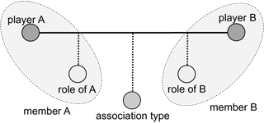

Figure 1- Type of Associations for the Models’ Development

With all of these elements, we then build a topic map to show not only a list of topics related to one another, but, above all, a working network which can be “asked” for answering specific questions with regards to meaning or representation. In this case, our model coincides with the perspectives and judgments formed by experts around topic maps and the Wandora models. For many experts, these tools allow for “managing the meaning of the information, rather than just the information.” (Garshol 2002). This statement is fairly valid if, above all, we consider that the model not only enables us to manage topics of information that we wish to study or systemize, but the representations that have been made of them. For example, in the case of the given phrase – Guillén was born in Cuba - the tool will enable us to see “Guillén” as a topic but at the same time will enable us to “fill” this topic with an image of Guillén (a photograph, for instance) or with another type of document that can build the idea of this author or make it more “concrete” (let us say that, from a legal perspective, what makes up Guillén as such is his identity card which, in turn, describes him as large, born in a specific region and with particular characteristics). Within the program, these kinds of documents that interact and, somehow, give meaning to a more or less abstract topic, are known as “occurrences.” In the case of the model featured in this article, one of the topics could be Nicolas Guillen’s *Songoro Cosongo*, and in turn its occurrence would be either the real text or a copy in PDF or other reader program that allows us to have direct contact with it.

So, what Wandora gives us is the possibility of building a topic model –a bit like an information model in which the fundamental elements are the topics and the associations that interact with one another to breathe life into the world represented. This model interacts with the ideas of the subject being developed as it interacts with the constantly active world of information. Topic maps become a tool that enables us to model the world of information by establishing actual relationships with the world outside of the model; that is, the world of the interpreter, which also is a world based on information, on its processing and handling. ([Fig. 2](http://www.wandora.org/wandora/wiki/index.php?title=Topic_Maps))

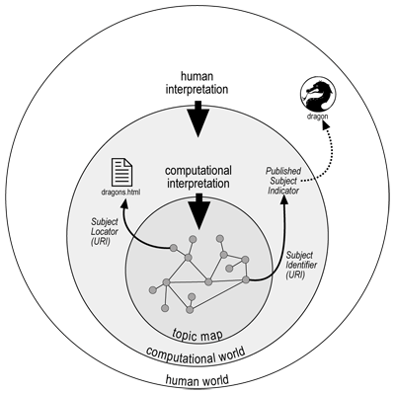

Figure 2. Interdependence of worlds in Wandora. Reproduced from Wandora Web Page.

The network on the Latin American Afro as resulting from our sources shows the diversity of information particular to such subject matter in various regions of the world (See fig. 3). Other regions are not displayed, just because the model adheres to the information found and relating to the initial aim of reviewing the dynamic of representing Afro in an artistic way. This reiterates its condition as a model and, consequently, as an abstract representation of a symbolic dynamic whose scope enables us to understand the world but never to replace it. On this basis we then performed analyses of different types and with different objectives, as we shall illustrate below.

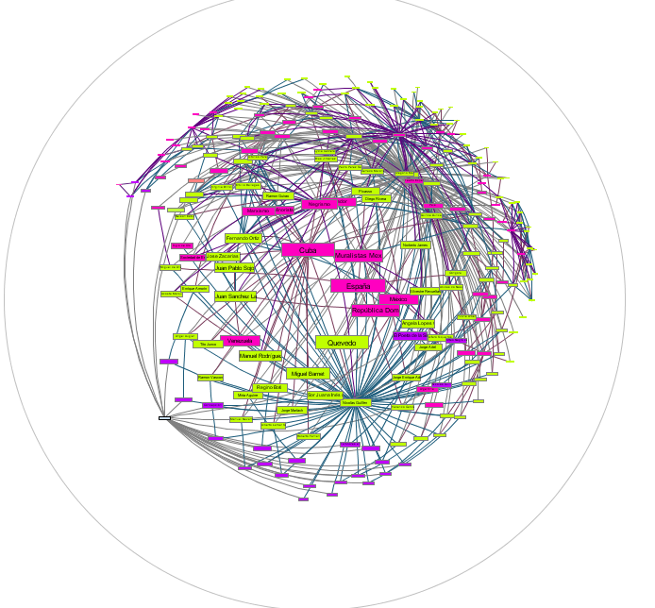

Figure 3. Resulting Topic Map

**Prominence, centrality, and importance of nodes in relation to their connectivity. An analysis of the “Afro representation network” model.**

In order to perform the two types of analysis to which we shall be referring, we use a standard network analysis tool, Gephi[9], which enables us to perform an overall analysis of the network obtained from the Topic Map. The parameters measured here include:

* **Closeness centrality**: expresses how well-connected an individual is to the whole network. A high value in this measurement indicates better connectivity and thus expresses the importance of the individual with respect to other elements in the network.
* **Betweenness centrality**: indicates how important the individual is as a connection and transference point within the network. A high value indicates that it is a topic that is passed through in the communications (relationships) between the other topics on the map.
* **Modularity**: is a coefficient that enables us to group together those nodes which share connections and zones on the network, so that it divides the map into zones with high relationships between them.
* **Influence between nodes**: is an analysis which we shall carry out in the second part of the article. It is based on the Page Ranking algorithm. This is the basic algorithm on which the Google search engine was originally based for calculating the importance of the pages that it comes up with after a search, and which it used to order the results. Its basic idea is that a given node within a network becomes important based on the importance of the nodes that relate with it or that point to it.

These parameters enabled us to obtain three much more specific rearrangements of the information stored on the topic map. Each of these provided different ways of interpreting the dynamic of the Latin American Afro network.

Firstly, we show the information relating to the betweenness centrality measurement, as shown in Figure 4. In this case, the smaller topics shown in green are those which have the lower measurement, whilst at the other extreme, the reddest and largest are those with the highest value of betweenness centrality (i.e., those used as major channellers of relationships between distant topics). As it is shown in that figure, the authors with higher betweenness are (in order, from higher to lower) Nicolás Guillén, Manuel Poveda, Alfonso Pereda Valdés, René Depresté, Aime Césaire, or Alejo Carpentier, as well as institutions such as Negritude or the Haitian magazine *Les Griots*. These points are fundamental (central) to the transmission and continuation of a tradition of representing the Latin American Afro, as well as to the invention of new forms of representation based on the cultural information transmitted. It is important to point out that Guillén, Poveda, Depresté and Carpentier are directly related to Cuba and the production of the Afro-Cuban image as the dominant discourse on the issue.

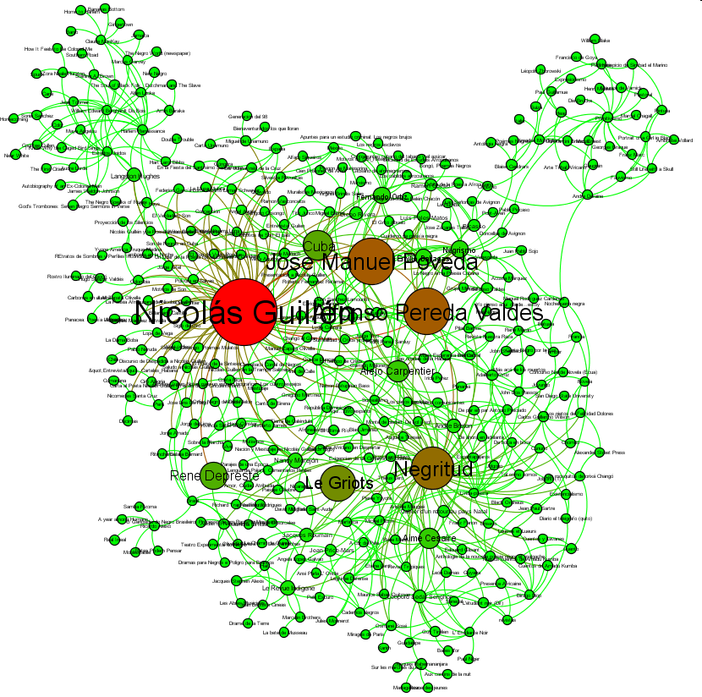

Figure 4. Betweenness centrality measurement

Following the same representation parameters, we show the data relating to the closeness centrality measurement (Fig. 5). Again, the redder nodes are the best connected in the network and the greener ones are those with the worst set of relationships. In this representation, furthermore, the size indicates the value of influence that we shall see in the following section. In this case, we can measure the degree of influence by the closeness between the nodes; we find out which have the greatest power of transmission and have become models to follow. Once again, the centrality of the network is in the hands of Nicolás Guillén, who, together with subjects and institutions such as Manuel Zapata Olivella, Negrismo, Negritude, the Harlem Renaissance, Aime Césaire or Nancy Morejón, not only become transmitters with a high level of connectivity, but nodes with greater closeness in relation to nodes with no direct relationships with one another, or which are very far from one another.

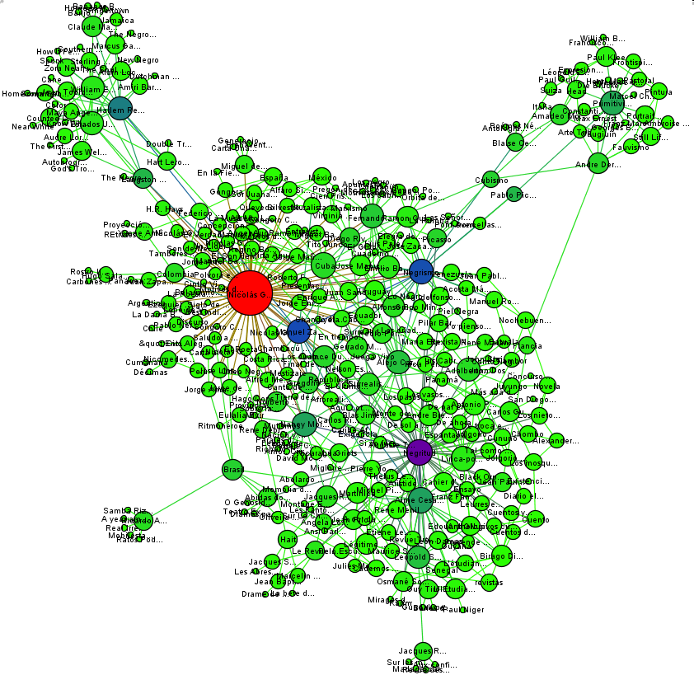

Figure 5- Closeness centrality

Lastly, we show the division that can be formed by using the values of modularity (Fig. 6). Nodes with similar colors represent greater similarity in their features, forming a module that is almost independent from the rest of the network. For instance, some artists can share their focus towards formal problems (verse), around race or they can all be attached to a particular movement such as Negritude. According with this, there are two determining modules in the network in order to make it work: one is led, once again, by Nicolás Guillén, and the other by Negritude. So, this analysis puts at the same level an institution and a subject which, within the network, seem to have the same power of communication and transmission.

In this case, the Guillén node (blue) is larger and has a larger number of relationships, and surprisingly it also has well established links with institutions and authors which are usually related to other cultural and literary movements or problems: García Lorca, Miguel de Unamuno or certain Brazilian authors such as Ricardo Aiello who, on the linguistic front, appear to be further from Guillén’s territory. Likewise, the module relating to Negritude (purple) shows relationships with distant nodes and seemingly not very related from literary readings and traditional critical discourses; such is the case of Pablo Neruda, where the relationships with the module are the byproduct of his political and poetic relationships with movements involved in social struggle and resistance such as Negritude.

The other modules are smaller and more dependent, but no less important. For example, in the case of the module to which Cuba belongs we can see the presence of different influences and relationships. Thus, the importance of Guillén. Although Guillén is independent in terms of modularity with respect to Cuba –his birth place and also where he produced his most significant work-, it provides elements that are significant to the role of the island. It becomes clear through the modularity analysis that in this case the importance of Cuba goes beyond its national boundaries. A good example of this is that of Quince Duncan. This writer, although Costa Rican by nationality appears as part of the Cuba module in the modularity analysis through a relationship that is mediated by the symbolic power of the Guillén node, and which, as revealed in our bibliographic analysis, strongly influences Duncan[10].

With regard to the Carpentier module, on the other hand, although there are patent relationships with the modules of greatest importance –Guillén, Cuba, etc. – it is clear that by the color and by the size shown in the network in figure 5, he seems to be less influential than Guillén, Negritude or Nancy Morejón with regard to the Latin American Afro representation. In spite of his real relationship with the island (he considered himself as Cuban regardless of the fact that he was of Swiss origin), the position of his module shows certain remoteness with respect to Cuba and Afro representations. However, in a different level, Carpentier is not only considered to be one of the first artists concerned with Afro artistic representation in Latin America, but one of the most important and the one who established the most legacies in the region[11]. It is evident that, in our topic map model, Carpentier looks closer to institutions such as surrealism, figures such as André Breton, or with contemporary writers of his like Blas Jiménez. In this case, this part of the model can be seen as the specific effect of the representation that Carpentier will begin to develop around Afro but which, later in his career, will move towards different issues, especially towards the proposal which has given him his renown and status in the Latin American cultural and literary field: marvelous realism[12].

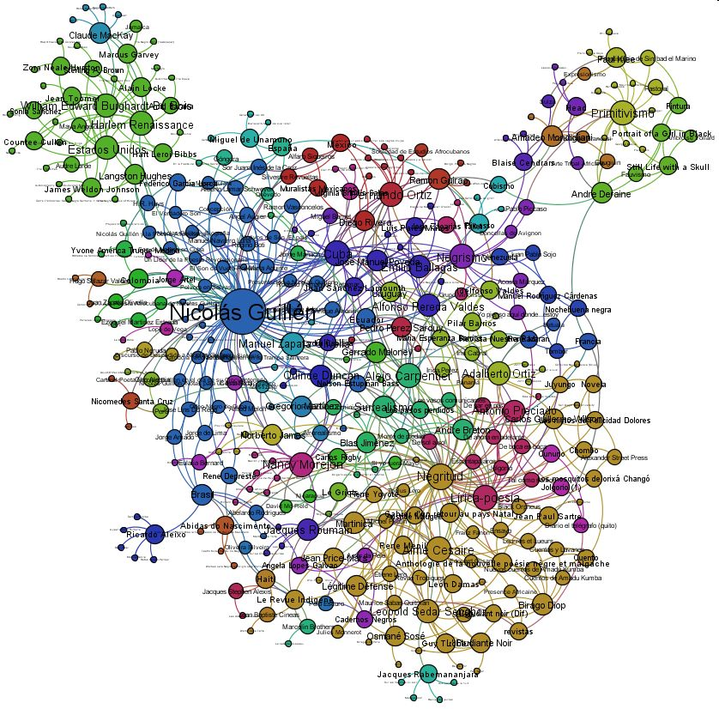

Figure 6. Values of Modularity

In the second part of this study, we have focused on performing different analyses of the influence between the nodes of the network. To obtain a more comprehensive view of these influences, we have carried out different transformations on the original network in order to highlight different aspects of the semantic relationships stored in it.

The algorithm that we have used to study the influence between the different nodes on the network is the one known as “Page Ranking,” on which the Google search engine was originally based to calculate the importance of the pages after a search, and the order in which it showed the results. Put it simply, this algorithm makes use of the following idea: “A web page is more important if many quality pages point to it”. The question then would be: how does one define the quality of a page? Well, one of the possible measurements is precisely the importance, and this therefore becomes a recursive definition: “a page is important if many important pages point to it.” There are mathematical processes for calculating this recursive dynamic in the form of numbers associated with the pages, but it must be taken into account that the results obtained by this method is a comparative result where the importance of a page depends on its value in relation to other pages.

But another even more determinant question arises: how can this concept of importance be applied to the influences between the topics that make up our map? To answer this, we must keep in mind that the importance of a page reflects, somehow, the relationship with other pages. For example, a page “A” that points to a page “B” as a reference becomes important due to the information found on “B”, in relation to the information on “A”. Thanks to the type of semantic connections existing between our topics, we can conclude that if a work, “W,” points to a person, “P,” because “P” has read “W,” the latter, most certainly, can serve as a reference for “P,” and can therefore have had an influence over him. Or, even more precisely, in relation to the central aim of the article: if the work “W” that serves as a reference for “P” in turn has as a reference a more or less abstract context “L” - a country or an institution - “P” will not only have been influenced by “W” but adheres to elements of “L” which are incorporated into the reference work “W.” Thus, given a topic map and its associated network with the semantic relationships between topics interpreted as connections that enable nodes to refer to one another, we can make various rearrangements of the information taking into account what character on the map we wish to study.

An initial rearrangement consists of considering not the whole network (map), but just certain parts of it. So, from a whole map, we can decide not to consider certain types of topics and/or relationships, either because we want to undertake a partial study, or because we think that the elements not considered should not intervene in the study (see the clarification about the bias of this methodology in the “Introduction”). A case arises when, on our map, we do not consider the topics that reflect types of representation (painting, novel, etc.) due to the fact that they reflect concepts that are too general and could distort the results of importance of the other topics involved. In this case, we eliminate from our analysis (by creating a filter) both the nodes representing these types of topics and the connections linking them to the others. Another issue arises when we decide not to consider, for example, the “Country” type topics for the study of influences, because a country establishes relationships between individuals who do not “exert” a direct influence. A final case by way of example arises when we do not consider a whole family of semantic relationships existing on the topic map; for example, on our map we could decide not to consider the relationships of influence that have been established consciously (this does not mean that they are not correct), to find out if the relationships of influence that have been extracted from the existing critics are coherent with the meaning of influence obtained through the other relationships. Of course, there is no major reason to indicate whether or not it is more appropriate to carry out these types of filters, and therefore the conclusions that are extracted from each of the results obtained must be formed according to the rearrangement considered in those cases. In addition to the filters explained in the above paragraphs, there are other options for transforming the network depending on the semantic interpretation of the connections existing between the topics. In the case we are studying, and considering the “born in” relationship existing between people and countries, we can apply a process of grouping the authors above the countries, so that the relationships in which the authors intervene are projected and grouped into the countries to which they belong. Thus, the countries are turned into containers of all the information relating to the authors who were born in them, and the study of influences on the modified network tells us about the importance or influence of the different countries on the modified map.

The following figure (fig. 7) shows a representation of the network obtained initially, reflecting the influence of the overall network (something called “global influence” or with no filtering of any kind) as defined above. In this case, it has been represented by means of the size and color of the node associated with the topic, so that the greater the influence of the node, the greater its size and the intensity of its red colour; on the other hand, the lower the influence, the greener and smaller it is.

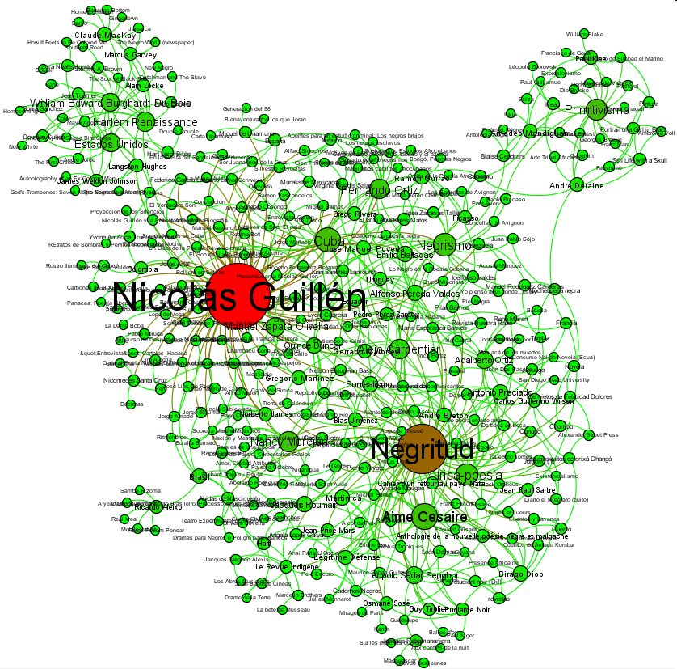

Fig. 7-Complete network, Global influence

This network, after filtered according to any of the methods discussed and depending on the projections of the actual analysis, can be interpreted using certain particular values of importance, influence, centrality, etc. In the case of this article, we analyze the network in three specific ways: a) without filters, b) focusing on countries and c) eliminating countries. The results are obtained once the algorithm for calculating influences, as explained, has been applied, from which we shall show, in each case, the 10 topics with the highest relative influence values. In all cases the explicit influences existing on the topic map have been considered.

In the case of analysis with “no filters”, table 1 shows the calculated values for the main topics. Considering the principle on which the starting algorithm is based, it is possible to state that Guillén is important because he points to and is pointed to by such important institutions as Negritude, Primitivism or the Harlem Renaissance, and people like Nancy Morejón, Fernando Ortiz or W.E.B. Du Bois.

|  |  |  |
| --- | --- | --- |
| **Topic** | **Type** | **Value** |
| **Nicolás Guillén** | Person | 0.014210309 |
| **Negritude** | Institution | 0.008800364 |
| **Primitivism** | Institution | 0.005339698 |
| **Harlem Renaissance** | Institution | 0.004967716 |
| **Nancy Morejón** | Person | 0.004826035 |
| **Fernando Ortiz** | Person | 0.004604043 |
| **Negrismo** | Institution | 0.004430831 |
| **William Edward Burghardt Du Bois** | Person | 0.004260025 |
| **Ricardo Aleixo** | Person | 0.003753282 |

Table 1- Results without filters

On the other hand, in relation to analysis focused on countries, table 2 demonstrates to what extent the importance of Cuba is a determining factor in the actual dynamics of the network. And this test strongly supports our initial claim with respect to the prominence of Cuba within the network of discourses about the Latin American Afro. Nevertheless, the table shows other interesting elements like the second place of Costa Rica, a country whose tradition and national rhetoric try to show it as *mestizo*, or racially mixed, and whose population is mostly of non-Afro descendent. To a certain extent, Costa Rica acquires this prominent level within the network indirectly, thanks to the relative importance acquired by Cuba and to the strong relation that Costa Rican author Quincy Duncan has with the Caribbean country. This is one of the cases in which a different selection of sources could have changed the results as analyzed in this category.

|  |  |  |
| --- | --- | --- |
| **Topic** | **Type** | **Value** |
| **Cuba** | Country | 0.011694091 |
| **Costa Rica** | Country | 0.010051924 |
| **Negritude** | Institution | 0.009783216 |
| **United States** | Country | 0.009513428 |
| **Primitivism** | Institution | 0.007675288 |
| **Brazil** | Country | 0.007239778 |
| **Haiti** | Country | 0.00683879 |
| **Mexico** | Country | 0.006522977 |
| **Colombia** | Country | 0.006461951 |
| **Dominican Republic** | Country | 0.006102954 |

Table 2- Considering grouping into countries

In the third experiment c), we eliminate countries and leave authors and their works (table 3). Here, again, Guillén is the node to which most of the other important nodes point to. The Guillén node becomes a kind of container of other spaces of information like the Cuba node, a label to which many other nodes refer. From these results we can infer that the prominence of Cuba within the network of the Latin American Afro is firmly based on role played by Guillén: Cuba, in terms of the production of the Latin American Afro discourses of the second half of the 20th Century, equals Nicolás Guillén. This statement is based on the materials consulted, on the elements used as a source of information, and is therefore susceptible to being unaware of other levels. The important thing here is to show that in this diverse network there are different levels, different scales, and that the values are not essential and definitive, but are always mediated by co-construction relationships.

|  |  |  |
| --- | --- | --- |
| **Topic** | **Type** | **Value** |
| **Nicolás Guillén** | Person | 0.015309258 |
| **Negritude** | Institution | 0.010336252 |
| **Primitivism** | Institution | 0.00597134 |
| **Harlem Renaissance** | Institution | 0.005408434 |
| **Nancy Morejón** | Person | 0.005242839 |
| **Negrismo** | Institution | 0.004892187 |
| **Fernando Ortiz** | Person | 0.004884662 |
| **William Edward Burghardt Du Bois** | Person | 0.004622801 |
| **Aime Césaire** | Person | 0.004106055 |
| **Ricardo Aleixo** | Person | 0.00407369 |

Table 3- Results eliminating the countries

Finally, we summarized all results in information charts (charts 1 and 2), which help us show the influence exterted by a node over other nodes within the analyzed network. The tables give information about two particular things: 1) the importance of both a country and an institution within the network without considering the additional influences annotated in the database. 2) The importance of both countries and institutions when we consider the influences of writers and texts either born or written in countries and institutions other than those that were subject to the influence of this authors and text. For instance, though Guillén was born in Cuba the level of his influence over the rest of countries is paramount to determine his centrality in the dominant discourse of the Latin American Afro. Likewise, the influence of Cuba on the rest of our authors regardless of their nationality shows the importance of the island vis-a-vis this dominant discourse.

If, on the one hand, the importance of the node Cuba is very clear in our network, on the other, it is also noticeable that the relevance of Cuba relies on the strong connectivity between the country and its most important writers. This brings us to the final section of this paper, in which we shall look at the particular behavior of the two main Cuban authors for this domain. We shall focus on Nicolás Guillén who, for reasons stated above, becomes the centre of the representation dynamics, but also on Alejo Carpentier who, although not shown to be connected in a very significant way in our model, is usually considered by critics as a fundamental figure to the understanding of the Afro aesthetic in Latin America.

Chart 1- Influence of institutions

Chart 2. Influence of the countries

**Guillén and Carpentier: from global predominance to the local domain.**

Within the historiographical tradition that recounts what has been called “negrista poetry” or negrista literature in Latin America, Nicolás Guillén and Alejo Carpentier are two fundamental figures. This tradition places both them from the outset at the highest level of influence in the creation of the Latin American Afro. The questioning arising in relation to this influence has to do with the clear centrality of the first, and the (almost) complete disappearance of the second in our network.

The two authors, as well as being Cuban – by adoption and choice in the case of Carpentier, and by birth and origin in the case of Guillén, and by the creative contribution towards the building of the national image in both cases - form part of the minority group of intellectuals concerned not only with establishing Cuban national poetry, but with articulating the different voices on the island in order to assemble them into one national “unit” projected by the local elite. Afro is one of these different voices and images that both authors “play” with at different moments of their careers. The first, closer to the Hispanic tradition of *entremeses*, or interludes, proposes an aesthetic of speech, of onomatopoeia and of rhythm described as representative of Afro; the second, more concerned with the aesthetic of time and of natural things, is based on *art négre* and the European avant-garde of the 20th Century.

Furthermore, certain literary critics connect Guillén and Carpentier directly with Negrismo which, from the Afro-centric perspective, has very negative connotations. That is to say, Negrismo, unlike Negritude, is a movement that is more associated with European trends than with the representation of an “essence” of what is African in the diaspora. Others classify our Cuban writers as paradoxical due to the process of deafricanisation and museumization that they exert on African cultural manifestations and those typical of the Afro-descendants of the island[13]. However, they always appear as central elements, nodes within the literary network that aims to represent Afro. It is as if the influences, the lines connecting with these nodes (authors), were feeding them, making them “larger” and “larger”, more significant and more influential within the context of the literary world.

On the one hand, Guillén seems to enter the network of influences as a point that changes discourses of the Afro via with his *Motivos de Son* (1930). Thus, several literary critics talk about a Guillén’s discourse as one from within the “language of blacks, of the lyrical palpitations of the most oppressed and least understood sector of the Cuban people” (Pérez, 2003). The fact is that Guillén seems to dominate the field when it comes to ‘Afro’ representation, Negrista poetry or Negritude. But he achieves this position not only due to his figure and to his contribution as such. Without the line of Hispanic Golden Age authors such as Quevedo, Lope de Rueda and the great Góngora, and without his acknowledgement of the influence of García Lorca –in this case Guillén is the one who seems to be contributing towards -[14], the density would seem not to be such. Also, there is the internal relationship (within the “Cuba” node) that Guillén establishes with Carpentier, who in turn establishes other significant and influential information relationships.

These relationships of the poet from Camagüey stretch out to a wide variety of spaces and names; names of critics, authors and readers who centralize him as the inventor of a particular language. Then, Guillén becomes considered the discoverer of the language of a reality which called Afro that had remained hidden for the lettered Latin American elite until this moment. It is clear that Afro was represented as an object – of work and exploitation - but not as an aesthetic element whose artistic representation was interesting. When Guillén began to produce the type of language that would characterize his poetry and his image of Afro, authors such as Jorge Enrique Adoum (1946), Mirta Aguirre (1959), Ciro Alegría (1954), Jorge Amado (1952), Enrique Amorín (1952), Louis Aragón (1949), Langston Hughes (1948), René Depresté (1969) Mario Benedetti (1971), Ezequiel Martínez Estrada (1967), Emilio Ballagas (1931), Jorge de Lima (1964), José Lins do Rego (1947), Jaques Roumain (1942) and Pablo Neruda (1947), among many others, commented on his work and placed him on the peak of the relevant representations of a silenced Afro-descendent voice. In spite of the fact that Guillén, after the *Elegía a Jaques Roumain* (1948), began to develop his writing about Cubaness as a product of a synthesis, his figure continued to be associated with *son* as a language and with Afro (with blacks) as a central image in his work. This is why, in terms of the network, of the connections and of the influences shown, not only does he occupy the first places but it ranking in terms of centrality is very high.

On the other hand, with regard to Alejo Carpentier, at least within the model, there are clear connections not only with the part of Hispanic tradition to which Guillén is also connected, but –as already mentioned- with the surrealist and avant-garde movements in 1920s Europe. He is directly related to Robert Desnos, who helped him leave Cuba and who made it possible for him to establish contacts with Picasso, Breton and many of the intellectuals living in Paris at that time, which he himself classified as “the brain of the world”[15]. But he also seems to serve as a bridge between Latin American and Europe as he actively spreads certain European trends of thought and aesthetics throughout Latin America, in an attempt, however, to establish a kind of thought of his own. The clearest example is indeed his work *Ecue Yamba O!*, which in the 1977 edition includes a prologue in which Carpentier himself highlights the inevitable influence of the European avant-garde of the 20th century on his writing and, in general, on the young writers of his generation. Of course, he begins by considering the avant-garde as something different from the one that Marx had described with respect to the avant-garde as a political/philosophical activity. In this regard, he would say:

However, in the decade 1920-1930, the word “avant-garde” suddenly separated from its political context, adopted, for a while, a new meaning. Faced with a surge of new ideas, in painting, in poetry, in music, the critics and theorists qualified as avant-garde everything that broke away from the established aesthetic norms- from the academic, official and what was generally preferred by bourgeois “good taste”. And every painter, musician or poet who, regardless of any political definition, broke with tradition in terms of technique, invention of forms, experiments in the areas of literature, theatre, sound, color, in search of unprecedented or innovative expressions, encouraged by a young and impetuous desire for originality, is called an “avant-gardist”. (9)

Based on this statement, Carpentier (in the Argentinean edition of 1977) stated that this work was the product of the tensions and tastes particular to the European avant-garde as transferred and adapted to Latin America. There, the issue of Afro representation –coinciding with some of the critics who question the focus of Negrismo in Latin America- serves simply as an element of rupture for a tradition which in Latin America is, somehow, different. In his work the internal problems of those subjects descending from Africans are not represented, but the motive is used to break what “there used to be” there in aesthetic terms.

In the 1977 prologue, his retrospective vision shows the building of an aesthetics which exceeds the particular ethnic limits and which, on the contrary, tries to build a universalized and universalizing artistic image of Latin America. In this regard, Carpentier would say, referring to *El Reino de este Mundo* in particular[16] and to his work in general, that “I have always been very aware that I had a work to produce based on Latin America, that continent that interests me and concerns me the most” (1967). In other words, he is interested in the continent as a whole and not just in an expression and a language particular to one of the cultural lines that make it up. Statements like this combined with the views of his work and of his expressed by critics and cultural agents around the world, launch Carpentier towards a space different from that of Guillén’s. They put him on a greater, more global scale that would explain and represent the new continent as a product of a cultural and biological synthesis. This is why the relationships, the centrality, and the influence of this node in our model are not as significant as those generated by Guillén.

However, works such as those indicated (*Ecue-Yamba-O*, *El Reino de Este Mundo* and *Viaje a la Semilla*) present elements that authors such as Samuel Feijoo, Jorge Rufinelli or Jerome Branche have classified as black and Afro representations in Latin American; in turn, the work of Carpentier will give rise to some very interesting relationships in terms of Afro representations with agents such as Virginia Brindis de Salas in Uruguay, the great Palés Matos in Puerto Rico, Idelfonso Pereda Valdés or Jorge Artel in Colombia, among others. In this respect, the Afro issue – at least as far as its artistic representation is concerned - can be clearly seen as a dynamic process, a moving network where representations, relationships, works and authors go in and out depending on the contexts created by critics and readers of those works and authors.

It is this latest idea that leads us to conclude that, although our methodology shows the authors at radically different levels in terms of Afro representation and its centrality, the predominance of Cuba is due to two complementary movements: a) the local power of Guillén – in terms of the specific discourses about the Afro in Latin America; and b) the power of Carpentier as related to a general image of Latin American —not only Afro— culture. The two, being part of the great Cuba container of information, make it dominant, preeminent and determinant in discourses of the Afro in the 20th Century, both in general and even more when referred particularly to the Afro in Latin American.

**Conclusions**

This article has proved two important points for the history of the Latin American Afro as they revealed some of the turns that this history has taken to become what is considered as a dominant discourse of the Afro in Latin American culture during the 20th century. First, it has shown the prominent role played by “Cuba” in the construction of this discourse. In this respect, the predominance of Cuba in discourses of the Afro has to do not only with the quantity and quality of the productions made with respect to the island. It has to do with the “universalization” of this image through the transmission of information in a network of bibliographic influences which points both to the local – the language that Guillén uses to talk about and represent the Afro and that becomes standard of this vision - and to transatlantic cultural connections –Carpentier’s concern for Latin America as influenced by European avant-gards, as well as Guillén’s less apparent concern for synthesis. Through these two authors. Cuba gets connected to the fundamental nodes of here and there; of Europe and America; of avant-garde and tradition; of local and global, etc. It is this double level that makes Cuba crucial. Thus, it is almost inevitable that all those who try to talk, represent or focus on an Afro aesthetic in the New World are faced with the inevitable process of going through the Cuban node and take into consideration the vision of the Afro express there.

It is also important to note that the methodology has enabled us to visualize in an organized manner different sources of information. And it has been the analysis of this information as represented in a network that has shown the two levels —the local and the global, Guillén and Carpentier— that makes Cuba such an important switch in the particular domain of the Afro in Latin America. If we knew that they were relevant in the bibliography about the issue, we are now able to establish to what extent they are fundamental and what are the reasons for this. In this respect, the multidisciplinary collaboration around a methodology that combines computer tools, network analysis and traditional humanistic reading of texts has proven very productive for our work. We think that it could prove equally useful in other humanistic inquiries that face similar problems.

Appendix

Works used to construct the Model

**Adoum 1946.** Adoum, Jorge Enrique. “Nicolás Guillén en la Pampa Salitrera”. *El Siglo*. Santiago de Chile, 29 de nov. 1946. 12

**Aguirre 1959.** Aguirre, Mirta. “Pólvora en Salvas”. *Hoy Domingo Magazine*. I (2) 20 dic. 1959. 2.

**Alegría 1954.** Alegría, Ciro. “Entrevista con Salvador Bueno”. *Carteles* XXXV (5), 31 Ene. 1954. 100

**Amado 1953.** Amado, Jorge. “Carta al Poeta Nicolás Guillén en el día de su Cincuentenario”. *La Última Hora*. II (28), 14 ago., 1953. 8-50.

**Amorim 1947.** Amorim, Enrique. “Presentación a Nicolás Guillén”. *Tribuna Salteña*. 5 mar., 1947. 20

**Aragón 1949.** Aragón, Louis. “Un Soneto de Nicolás Guillén”. *Hoy Magazine*. 9 de ene., 1949. 5

**Arozarena 1954.** Arozarena, Marcelino. “El antillano Domador de Sones”. *Revista América*. XVII, 1,2. 1954 37-42.

**Auguier 1971.** Augier, Ángel. *Nicolás Guillén*. La Habana: Editorial Unión. 1971.

**Balagas 1931.** Ballagas, Emilio. “Nicolás Guillén y el Mensaje Inédito”. *Diario de la Marina*. 29 de dic. 1931. 10.

**Bandeira 1948.** Bandeira, Manuel. “Homenaje a Guillén y a Cuba en el Brasil”. *Hoy Magazine*. 11 de ene., 1948. 5.

**Barnet 1971.** Barnet, Miguel. “Entrevista”. *Caravelle* 16 (Número especial dedicado a Cuba), 1971. 222.

**Blanco 1945.** Blanco, Andrés Eloy. “Saludo a Nicolás Guillén”. *El Universal*. 22 de nov., de 1945. 15

**Boti 1930.** Boti, Regino E. “El Verdadero Son”. *Diario de la Marina*. 29 de set. 1930. 18

**Branche 2006.** Branche, Jerome. *Colonialism and Race in Luso-Hispanic Literature*. Columbia: Missouri University Press, 2006.

**Carpentier 1932.** Carpentier, Alejo. “La Rue Fontaine, Calle Cubana”. *Revista Carteles*. 9 de oct., 1932. 16

--- **1967. ---**. “Lo real Maravillosos y América Latina”. *Combat*, Paris, 6 de octubre de 1967

--- **1977. ---**. “Prólogo”. *Ecue Yamba –O*. La Habana: Arte y Literatura, 1977. I-XI.

**Coulthard.** Coulthard, Georges Robert. “Nicolás Guillén and West Indian Negritude”. *Caribbean Quarterly* 16. 1. 52-57.

**DeCosta-Willis 2000.** DeCosta-Willis, Miriam. “Can(n)on Fodder: Afro-Hispanic Literature, Heretical Texts, and the Polemics of Canon-Formation.” Afro-Hispanic Review 19.2 (2000): 30- 38.

**Depresté 1984.** Depresté, René. “Hello and Goodbye to Negritude”. *Africa in Latin America*. New York: Holmes & Meier, 1984. 251-272.

--- **---**. “Nicolás Guillén: Orfeo Negro de Cuba”. *La Gaceta de Cuba*. 8, 74. 10

**Droguett 1946.** Droguett, Carlos. “Un Poeta de nuestro Tiempo”. *Periódico Extra*. 19 de ago., de 1946. 27

**Duncan 2005.** Duncan (2005) “El Afrorealismo: una dimensión nueva de la literatura latinoamericana.” *Itsmo*. Jan. 25 de 2005. [http://collaborations.denison.edu/istmo/n10/articulos/Afrorealismo.html](http://collaborations.denison.edu/istmo/n10/articulos/afrorealismo.html)

**Ehremburg.** Ehremburg, Ilya. “La Poesía de Nicolás Guillén”. *La última Hora* 3, 6. 6-7

Feijoo, Samuel. “El Son en la Letra”. *Revista Signos* 1, 3. 198-201.

**Fernández de Castro 1943.** Fernández de Castro, José Antonio. *Tema negro en las Letras de Cuba (1608-1935)*. La Habana: Mirados, 1943.

**Finn 1988.** Finn, Julio. *Voices of the Negritude: with an Anthology of Negritude Poems Translated from Portuguese, French and Spanish*. London: Quarter, 1988.

**García Caturla 1962.** García Caturla, Alejandro. *Prosa de Prisa.* La Habana: Universidad de las Villas. 1962.

**González Tuñón 1947.** González Tuñón, Raúl. “Guillén Entero”. *Hoy Magazine*. 7 de ene. 1947. 5.

**Handelsman 1999.** Handelsman, Michael. *Lo Afro y la Plurinacionalidad: el Caso Ecuatoriano visto desde su Literatura*. University of Missouri: Romance Monographs, 1999.

**Hays 1948.** Hays, H.R. “Nicolás Guillén y la Poesía Afrocubana”. *La Última Hora* 2, 23. 8-29

**Hughes 1948.** Hughes, Langston. “Sobre Guillén”. *The Crisis.* Nov. de 1948. 336.

**Jackson 1982.** Jackson, Richard. «Literary blackness and literary Americanism: toward an Afro model for Latin-American literature», en *Afro-Hispanic Review*, n. º 1 (2), Columbia, mayo 1982, pp. 5- 11.

--- **1984.** **---**. “The Afrocriollo movement revisited”, en *Afro-Hispanic* *Review*, n.º 3 (1), Columbia, January 1984, pp. 5- 9.

--- **1997. ---**. *Black Writers and the Hispanic Canon*. New York: Twayne, 1997.

**Jahn 1969.** Jahn, Janheinz. *Neo African Literature (a History of Black Writing)*. New York: Editorial Grove Press. 1969.

**Kesteloot 1967.** Kesteloot, Lilyan. *Anthologie Negro-Africaine*. Verviers (Belgium). Ed. Marabout Université. 1967.

**Lamar Schewer 1946.** Lamar Schewer, Alberto. “La Musa Mulata”. *El País*. 16 de nov. 1961. 34

**Latcham Alfaro 1946.** Latcham Alfaro, Ricardo. “Nicolás Guillén”. *La Nación*. 19 de ago. 1946. 67

**Lewis 1983.** Lewis, Marvin. *Afro Hispanic Poetry 1940-1980: from slavery to Negritude in South American Verse*. Columbia: University of Missouri Press, 1983.

**Lins Do Rego 1947.** Lins Do Rego, José. “Saludo a Nicolás Guillén”. *O’Globo*. 2 nov. de 1947. 97

**Marinello 1937.** Marinello, Juan. “Hazaña y Triunfo Americanos de Nicolás Guillén”. *Literatura Hispanoamericana*. México: UNAM, 1937.

**Márquez.** Márquez, Robert. “Introducción a Guillén”. *Casa de las Américas*. 11, (65,66). 136-142

**Martínez Estrada 1967.** Martínez Estrada, Ezequiel. “Nosotros, Vosotros y Ellos”. *La Poesía Afrocubana de Nicolás Guillén*. La Habana: Edit., Unión, 1967. 19-28.

**Melon 1947.** Melon, Alfred. “Guillén, el Poeta de la Síntesis”. *Revista Unión* 9, 4. 96-132.

**Neruda 1947.** Neruda, Pablo. “Discurso de Despedida a Nicolás Guillén”. *Periódico Hoy*. 21 de ene., de 1947. 26

**Ortiz.** Ortiz, Fernando. “Motivos de Son, Reseña”. *Archívos del Folklore Cubano* 5, 3. 222.

**Poniatowska 1985.** Poniatowska, Elena. “Entrevista con Alejo Carpentier”. *Entrevistas. Alejo Carpentier*. La Habana: Letras Cubanas, 1985. 108-118.

**Ruffinelli 1985.** Ruffinelli, Jorge. *Poesía y Descolonización*: *Viaje por la Poesía de Nicolás Guillén*. México D.F.: Universidad Veracruzana-Oasis, 1985.

**Roumain 1971.** Roumain, Jaques. “Una Embajada Histórica”. *Hoy*. 23 de set., de 1942. 35

**Sabat Ercasty 1971.** Sabat Ercasty, Carlos. “Presentación”. *Nicolás Guillén*. La Habana: Editorial Unión. 1971. 253-254.

**Salazar 1930.** Salazar, Adolfo. “El Son en las Fritas”. *El Sol*. 29 de jul., de 1930. 65.

**Sosa.** Sosa, Jesualdo. “Nicolás Guillén y España”. *Última Hora.* 2, 23. 22

**Unamuno 1942.** Unamuno, Miguel de. “Carta”. *Songoro Cosongo y otros Poemas*. La Habana. Edit. La Verónica, 1942. 9-10

**Vasconcelos 1930.** Vasconcelos, Ramón. “Motivos de Son”. *El País*. 6 de jun., de 1930. 18

**Vitier 1970.** Vitier, Cinto. *Lo Cubano en la Poesía*. La Habana: Instituto del Libro, 1970.

Notes

1. This research has been possible thanks to the support of SSHRC’s MCRI “The Hispanic Baroque” and is part of the activities of the CFI-funded CulturePlex Lab at The University of Western Ontario.
2. In this article we refer to Afro as a cultural component based on cultural traditions and customs, as well as on the artistic representations of and about the descendants of Africans taken to the New World (North, South and Central America). Furthermore, we believe that this cultural component, for obvious reasons of migration and coexistence, is the result of the interaction and mixing between different groups and complex views.
3. From the article’s perspective, we use artistic in order refer to a field of social and cultural action. This conception is close to the one coined by French sociologist Pierre Bourdieu. In this sense, artistic refers to texts, discourses and codes that set up aesthetic dialogues with social, cultural and political “realities”. In that sense, artistic refers as to the aesthetic texts in itself as to the texts of criticism and theory which try to explain the former. Besides, economic, political and social discourses (e.g. news, laws, economic agreements, policies, etc.) inform not only the creation but the reading of aesthetic texts, which in turn inform the configuration of the so called artistic field.
4. The perspective from which we are considering cultural systems and the transmission of information is deeply rooted in the works of cultural anthropology, and specifically in the proposals of cultural transmission expressed by Cavalli Sforza (2005)
5. [http://www.wandora.org](http://www.wandora.org/)
6. <http://gephi.org/>
7. <http://en.wikipedia.org/wiki/PageRank>
8. In this case, we take the concept of text in the sense that theorists such as Pierre Levy (1999) or Teun Van Dijk(1978) have suggested. From a broad, semiotic viewpoint, which would include such “basic” expressions as orality and such complex expressions as hypermedia texts or hypertexts.
9. “Gephi is an interactive visualization and exploration platform for all kinds of networks and complex systems, dynamic and hierarchical graphs”. It is an open source as well, what means is designed to be used for free and enhanced by a community of specialized and non specialized users. In order to get more information it is possible to consult Gephi’s web site at http://gephi.org/
10. In this regard, see the text of Quince Duncan (2005) “*El Afrorealismo: una dimensión nueva de la literatura latinoamericana*.” *Istmo*. Jan. 25 2005. [http://collaborations.denison.edu/istmo/n10/articulos/Afrorealismo.html](http://collaborations.denison.edu/istmo/n10/articulos/afrorealismo.html)
11. In this regard, among others, see Branche, Jerome (2006), Ruffinelli, Jorge (1985) or Cole, George (2008)
12. See the popular prologue of his novel *El Reino de este Mundo*, published in 1949, as well as “De lo Real Maravilloso Americano”, originally published in *Tientos y Diferencias*. Montevideo: Arca, 1967.
13. In this regard, see the work of professor Jerome Branche (2006) *Colonialism and Race in Luso-Hispanic Literature*,in which he dedicates a chapter to 20th century writers, who show a commitment to the national identity and to unity, including the Afro-descendent as a primitive element. According to Branche, these authors consider blackness more as an aspect of collection and decontextualization typical of museums.
14. Here we refer to “Son de Negros” the text that Lorca wrote following a visit to Havana and his fascination with reading the writings of Guillén.
15. This statement, in addition to the reference to his friendship with Desnos, appears in the interview he gave to Elena Poniatowska in Mexico in 1963 for the magazine *Era*. However, the interview forms part of a compilation, together with other interviews given by Carpentier over a large part of his artistic life, in the book edited by Virgilio López Lemus. *Entrevistas. Alejo Carpentier*. Havana: Letras Cubanas, 1985. 108-118.
16. This is one of the author’s works which, according to the critics, constitutes one of the fundamental points in Afro artistic representation in Latin America. However, as the author himself shows in the famous prologue to the novel, he is not interested in Haiti because of its African ancestry but because it is one of the clear examples of the magic and wonder characteristic of the American continent.