**Revenge of the Nerd:**

**Junot Díaz and the Networks of American Literary Imagination**

Junot Díaz’s writing actively questions the boundaries between genre and “literary” fiction, aesthetics and politics, and English and Spanish, using a framework of multiple linguistic, formal and cultural registers to establish an authorial presence that defies critical categorization. Díaz arrived explosively on the U.S. literary scene with his second book, the novel *The Brief Wondrous Life of Oscar Wao (2007)*. The multi-generational story of a Dominican American family overshadowed by a brutal dictatorship and the challenges of forging a new life in the United States earned many accolades, including the Pulitzer Prize for Fiction and the National Book Critics Circle Award. Three years after its publication in 2008 it remained at the top of Amazon's bestseller list for the “Hispanic American Literature & Fiction” category and is well on its way to central canonical status. The “galvanic” prose of *Oscar Wao*[1] traverses “tropical magic realism, punk-rock feminism, hip-hop machismo, post-postmodern pyrotechnics and enough polymorphous multiculturalism to fill up an Introduction to Cultural Studies syllabus,” to quote two of the novel’s reviews from *The New York Times*, and it illuminates the rules of contemporary canonicity through the incandescent exceptions Díaz has carved out (Scott 2007; Kakutani 2007). I will read Díaz’s transgressive blending of genre and linguistic registers as a “reverse colonization” that calls into question the demarcations of American ethnicity as well as the racial politics of nerds (a term I define below). My argument uses Díaz as both an object of study and a paradigm for the potential of a hybrid digital humanities methodology. The complex cultural translation that Díaz asks his readers to perform creates a middle ground where Caribbean history, language politics and the class and ethnic tensions of immigration collide with the nerdy core of the mainstream American imagination.

My methodology in pursuing these claims is to define a framework for “the literary” in contemporary American fiction by asking how books are contextualized and discussed not just among critics and scholars but also among a general readership online. Digital traces of book culture (by which I mean user reviews, ratings and the algorithmic trails that our browsing and purchasing actions leave online) allow us to make claims about relatively large groups of readers and consumers of books, creating opportunities for the ‘distant reading’ of literary fame, but without losing the specificity of individual texts and authors.[2] As we shall see, this approach attempts to find a middle ground between the trend for large scale, data-driven digital humanities research and the kinds of analysis more comfortable to traditional literary scholars. My research here incorporates book reviews from professional critics and everyday users of the websites Amazon and LibraryThing as well as automated recommendation networks operating on both of those sites. By considering these digital traces of reading through the conceptual frame of the network, this article explores literary culture as a process of contextualization and elevation. My approach draws from John Guillory’s work on cultural capital and his argument that the syllabus and the list are central to the process of canon-making (1995, 28–38). The list, expanded into multiple dimensions, becomes the network. These new dimensions are visible articulations of taste: both book reviews and website recommendations make certain cultural assertions about the relationships between various texts and authors. By recasting these assertions as links and the names and titles as nodes, we can begin to see where books cluster and where they remain solitary. This is a way of studying the social forces influencing books and readers at their intersection with literary production itself, and it draws on related approaches that James English and Mark McGurl have pioneered in their work on contemporary literary culture, and more distantly from Bruno Latour and Pierre Bourdieu (Bourdieu 1993; 1996; 2007; English 2005; Latour 2005; McGurl 2009). In short, I propose a turn in the digital humanities to incorporate not just algorithms but algorithmic culture into our critical framework and to recognize that humans and machines are learning to read in new ways.[3]

Network analysis allows us to explore the middle ground between the individual text and the distant reading of thousands of texts, exploring the emerging space of cultural distinction for a particular author’s work at a particular time.[4] It is this combination of specificity (in terms of time and authors) and generality (in the sense that hundreds or thousands of data-points might influence a particular configuration between books) that offers us a window into a changing system of literary prestige, a glimpse at the middle ground where readers and critics make their judgments within constrained horizons. Professional book reviewing and commercial consumption are two major intersections between the worlds of art and commerce, zones of exchange where popular canonicity and literary prestige are forged. As Pierre Bourdieu noted, “the boundary has never been as blurred between the experimental work and the *bestseller*,” a truth that can hardly be better demonstrated than with the runaway commercial and critical success of Díaz’s *Oscar Wao* (Bourdieu 1996, 347). The novel’s deliberate complication of genre and ethnic literary boundaries has led Díaz to an almost defiant acknowledgement of his mainstream success: “They’re so happy to claim me as literature because it makes them all look better. They don’t want to relegate me to areas of ethnic studies” (Céspedes & Torres-Saillant 2000, 905).

This position has led scholarly reception of Díaz to its own complex multivalent space, with critics from the Latino/a, Caribbean, African Diaspora and Dominican literary traditions all interpreting his success (Díaz acknowledged each of these traditions in the interview quoted above). Daniel Bautista agrees that Díaz is “somewhere both inside and outside of the ‘mainstream,’” writing fiction that defies a simple binary between ethnic studies and the mass market (Bautista 2009, 89). Indeed, Elena Machado Sáez suggests that “the picture emerging from the criticism of *Oscar Wao* is of a superheroic literary text…that breaks through oppression to posit an ideally marginal but resistant diasporic subject” (Sáez 2011, 525). A reaction to this superheroic reading argues instead that the novel is a darker meditation on the violence inherent in narrative. For example, the text’s own charming but dictatorial narrator (Yunior, a version of a recurrent protagonist from Díaz’s earlier stories) serves as a troubling proxy for its primary narrative engine, the dictatorship of Rafael Trujillo in the Dominican Republic from the 1930s–1960s (Hanna 2010). Reading the novel as a “historiographic battle royale” clearly aimed at a United States reader, as Monica Hanna does, neatly encapsulates the challenges Díaz’s work poses to the established categories of genre[5] and comfortable patterns of reading. Its gripping style conceals a refusal to translate along multiple axes: the novel does not gloss its Spanish and Spanglish slang for that mainstream reader, nor does it contextualize its references to Caribbean literary figures like Edouard Glissant any more than it explicates its allusions to comic and fantasy characters like Darkseid or Sauron. This “weird English,” as Evelyn Nien-Ming Ch’ien calls it, demands that its readers bridge the gap, confronting the untranslatable and interpolating around it, grappling with Díaz’s rebellious idiom.

By insisting on blending codes and discourses beyond Dominican and “standard” English, Díaz alienates himself from particular communities in the tradition of commercially successful postcolonial writers around the globe (Brouillette 2007, 60). In applying the same technique to subcultures within the mainstream United States, he makes a subtler point about racial politics. As an immigrant, Díaz did not take solace in his identity as a Dominican American, since that identity was continually pressured by poverty and racial bias. Instead, he claims “what saved my life was being a nerd, watching all those bad science fiction movies and reading cartoons” (Ch’ien 2004, 221). Díaz doubly rejects normative behavior, embracing neither the standards of his own ethnic community nor those of mainstream American culture. This renunciation is standard nerd practice, but the staging is usually quite different. The nerd is a complex and shifting figure in contemporary culture with its roots in what Mary Bucholtz calls “hyperwhite ” performance, including “superstandard English” (like Oscar Wao with his “flash words”) and the rejection of “cool” culture (Bucholtz 2001, 86, 87; Díaz 2007, 50). I extend this frame to assert that the nerd is defined in relation not merely to “superstandard” language but highly specific dialects—the mastery of technoscientific skills, obscure popular genres and, increasingly, a socially impermissible obsession with almost any arcane subject. For example wine nerds, XML nerds and comic book nerds are all likely to be among the readers of this article. In this sense, the nerd as I deploy the term here is an extreme version of the “fan” or “fanboy,” a phrase Díaz also uses and to which I will return below.

With Díaz as just one example, it is also important to note that the racial categorization of the nerd is becoming increasingly nuanced, with Michael Hanson defining the “Afrogeek” categories of “thug-nerds” and “rap-geeks” (Hanson 2007). Oscar’s status as an ambiguously dark-skinned Dominican completes his own hybrid role as a “GhettoNerd” (Díaz 2007, 32, 11). In fact, as Ron Eglash notes, the figure of the nerd is not so much a bastion of white male elitism as it is a “potential paradox that might allow greater amounts of gender and race diversity into the potent locations of technoscience” because it is not racially but performatively white, or “implicitly white” (Eglash 2002, 50, 60). While the future of nerds may be defined more by Barack Obama than *The Simpsons*’ Comic Book Guy, whiteness continues to function as a powerful stigma and defining attribute of the category, leading African American students who excel in science and technology to be accused of “‘acting white’” even as it sustains a form of “hyperwhiteness” performed by nerds of all kinds (Eglash 2002, 59). Díaz’s choice to deploy the dialects of comic book nerds, science fiction nerds and others establishes a correspondence between ethnic boundaries and the deep, nerdy interior of the mainstream white imagination.

Allow me to develop this point through my own nerd self-affirmation as I discuss my methodology. The data I present here is drawn from literary culture “in the wild”—newspaper and magazine book reviews along with traces of digital consumption (consumer reviews and automated recommendations) from the websites Amazon and LibraryThing. Each of these sources links us to only a fraction of Díaz’s public readership, but they are communities of literary practice that illuminate how his stylistic project has played out in the mainstream. I will use two basic sets of data to build these empirical arguments. First, book reviews: I have collected and analyzed a set of professional reviews, author profiles and other literary press from nationally recognized newspapers and magazines, as well as a complementary database of consumer book reviews from Amazon.[6] I identify the proper nouns, particularly authors and texts that are mentioned together in these book reviews and create networks based on the number of times different terms co-occur in the same paragraph.[7] Over the course of this research project I assembled a hand-tooled dictionary of proper nouns and used a Perl script to seek potential matches in individual documents from this corpus (repeating the process numerous times as I extended the dictionary). The script created a series of basic XML files with proper nouns tagged as nodes that I checked for errors before analyzing for co-occurrences using another set of Perl scripts that indexed those nodes by paragraph. I stored the resulting connections in a MySQL database and output co-occurrences in GraphML format for viewing with yEd, a network graph editor (yWorks GmbH 2011).

The result is a basic network of primary literary entities—authors and texts—that are explicitly named[8] in particular paragraphs of Díaz’s professional and consumer book reviews. As a brief example, if we were to apply this system to a one-sentence review that said “Díaz reminds me of Frank Herbert, but also of Julia Alvarez,” we would get the following:

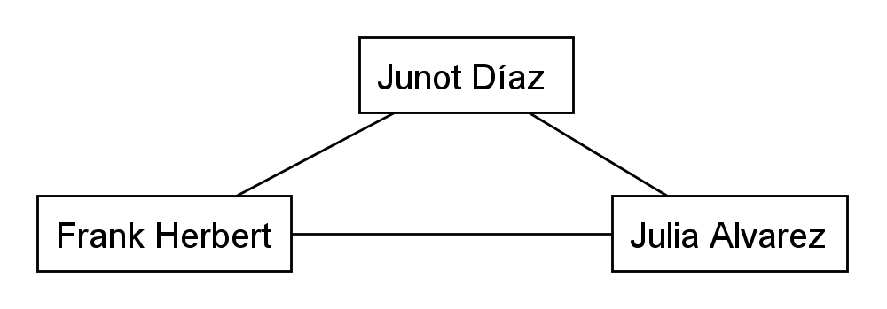

Figure : A Co-Occurrence Example

The co-occurrence links all three nodes in an equal, non-directional way. The method treats each paragraph as a “bag of words” with no attention paid to syntax or nuance. Replacing the review above with the following would generate the same diagram: “Díaz is nothing like Frank Herbert or Julia Alvarez.” This may seem counterintuitive, but I posit that the fact of connection is at least as important as its tenor. As I have argued elsewhere, the canonizing influence of a reference or a list in a piece of criticism serves to put the books in question into the same context, even if the reference itself is negative (Finn 2011, 16). Another way of making this point is to consider the peculiar economy of the book review, a piece of publicly oriented secondary literature challenged with keeping the reader’s attention in a compressed format that is by definition a metanarrative. The set of major reviewing publications yielded 22 articles on Díaz, with an average word length of 1,294. By contrast I collected 613 Amazon reviews, averaging just under 166 words each. Reviewers deploy references with purpose in this context, and a negative comparison carries as much cultural weight for the reader as a positive one, establishing in both cases a contextual framework for the subject of the review.

As the average lengths indicate, this economy is especially true for reviewers on Amazon, where the competition for literary attention is sharpened by multiple reviews of the same book and the status of the arbiter is always in question. My methodology compares these two fields of literary discourse through the framework of proper noun networks. Tracing these webs of allusion, reference and context allows us to explore both sides of that great literary event horizon, the purchasing of a book. While there are of course exceptions, people tend to read professional critics before they buy something, and they tend to write Amazon reviews afterwards. If book critics are “gatekeepers” to the literary marketplace, readers on Amazon report back from beyond the turnstiles, telling us why they went through. Below we will see that as the balance of power between the two groups shifts, everyday readers are coming to define the “literary” in new ways.

The project’s second data set, recommendations, focuses on this literary exchange as a market: I have collected data from Amazon, the world’s largest bookseller, and LibraryThing, a leading “social reading” community site, regarding how consumers on Amazon associate books through their shopping patterns and readers on LibraryThing do the same by listing books together in their virtual libraries. Amazon and LibraryThing present this data in recommendations such as the “Customers Who Bought This Item Also Bought” mechanism on Amazon, providing an algorithmically driven feedback loop between accumulated acts of cultural distinction and specific kinds of literary desire. In this instance, I used Perl scripts to record an expanding web of recommendations on each site from a given start page (arbitrarily selected by me as the author in question’s most prestigious book). For Amazon, the script would start at *Oscar Wao* and record the first ten[9] “Customers Who Bought This Item Also Bought” links, and then move on to record the first ten links on each of those pages, continuing to three levels of depth. The same process was repeated for LibraryThing based on the first ten “LibraryThing recommendations.” As a brief example of how these recommendations are diagrammed, consider this excerpt from :

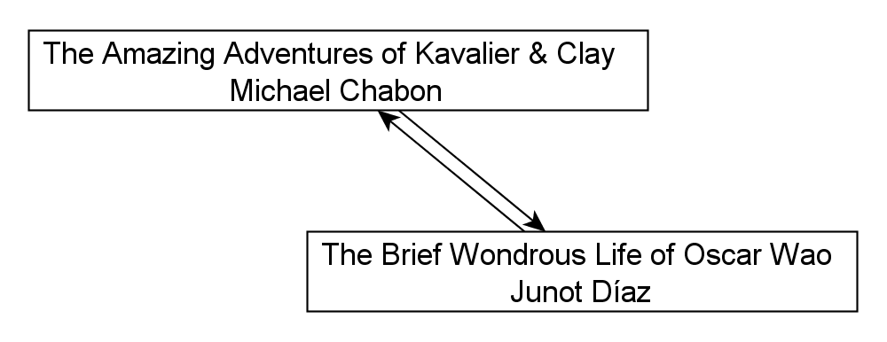

Figure : A Recommendation Example

In this data, the lines between nodes have directionality: browsers on the *Oscar Wao* page will see a link pointing them towards *Kavalier & Clay*. Likewise, those starting out on the Chabon page will see a link back to *Oscar Wao*. In this case, Amazon believes that readers of one book will enjoy the other, and the two texts end up mutually supporting each other in the larger system of recommendations.

The mutual link is based, Amazon claims, primarily on purchase data: enough people who bought one book went on to purchase the other that Amazon codified the connection, hoping to entice further sales from users making a similar cultural calculus. The fact that this feedback loop is maintained, manipulated and studied by Amazon speaks both to our increasingly corporate cultural lives and to the importance of recognizing the contingency of data—all data. Amazon sells books and manipulates its recommendations in order to sell them more efficiently, so it is possible that the mutual connection above is shaped by other factors, such as marketing campaigns, but we can rest assured that the connection is productive, or it would be replaced by another, more productive one.[10] That is to say that given Amazon’s dominance, we can assume it is reasonably deft at this particular cultural game: acting as an algorithmic mirror to its users’ literary desires, inflecting and reflecting taste through countless computations and statistical judgments.

A full analysis of Amazon’s growing dominance in literary production, from author contracts to sales, is beyond the scope of this article, but I want to briefly sketch out its role and my reasons for studying it. At this stage the relevance of Amazon to mainstream literary life is hard to deny, if we give any credence to critics like John O’Brien, publisher of the Dalkey Archive Press, who believes “the greatest threat to book publishing in the United States right now is Amazon” (quoted in White 2011). Whatever role Amazon plays in our readerly futures, its role in the present is to influence a huge number of acts of literary distinction, and to study these acts is to explore a core sample of mainstream American literary culture. And it is mainstream in all the ways Díaz inflected that term above: its users are better-educated, wealthier and less likely to be Hispanic than the U.S. Internet user average (Quantcast 2011). Reading Díaz through Amazon is to read him through a broad American public still rooted in a white mainstream, unveiling a cultural politics of authenticity and success that surfaces constantly in the data below. That contest of literacies is mirrored by my methodology’s contest for what Ted Striphas calls “algorithmic literacy” (Striphas 2011). Just as I am “reading” Amazon here, Amazon is “reading” its users and perfecting algorithms to perform that reading ever more efficiently and more closely.

For his part, Díaz confronts the question of literacies with a culturally charged mixture of the familiar and the exotic (an effect that varies in specifics but not in nature depending on whether the reader identifies most readily as Latino/a or white, an English professor or a science fiction nerd), and my approach does something similar by challenging our notions of reading on several levels. “Reading,” in this framework, is a fundamentally social action, bound up in collectively negotiated conceptions of language and inflected at every stage by the sociocultural influences that lead us to books and shape our thinking before, during and after our direct engagements with them. It is also, as I noted above, a form of collective interpretation that can be performed by Amazon’s servers as well as human beings. As more of our literary cultural actions, from browsing to discussion, migrate to screens and digital media, reading takes place increasingly online. “Readers,” then, are the users visible through their aggregate choices in the methodology just described.[11] It should also be noted that professional critics and Amazon reviewers are not necessarily distinct, though I have yet to encounter a professional critic who also voluntarily (or openly) reviews books on the site. But of course there are overlaps—this is a marketplace, and professional critics influence markets, just as markets influence critics—perhaps the most obvious being that many critics purchase books on Amazon. The middle ground perspective that I adopt here balances out the impact of such individual overlaps by looking at reviews and recommendations in aggregate, exploring the remarkable public literary spaces created by thousands of readers online.

### Negocios: The Literary Marketplace

Where established authors have clearly defined canonical positions, Díaz is an authorial signifier whose meaning is still being negotiated by arbiters from all corners of the literary universe. In the few years since its publication, *Oscar Wao* has already appeared on hundreds of college and high school syllabi.[12] Yet Díaz continues to hold a fluctuating position in networks of literary prestige as groups of readers contextualize him in various ways. The literary marketplace is the most active and hotly contested zone of cultural distinction, capturing both the influence of other, less commercial forms of critical elevation (book reviews, best books of the decade lists, etc.) and the direct impact of school reading assignments. We can glimpse these competing forces by contrasting Díaz’s presence in Amazon’s “Customers Who Bought This Item Also Bought” networks at a particular point in time with a look at persistent nodes in the same network over several months. Figures 1–4 represent those texts recommended from the Amazon page of *Oscar Wao* at four roughly monthly intervals from December 2010 to March 2011, with Figure 5 combining the data into a holistic view of persistent nodes.

In early December Díaz appears in the context of mainstream commercial success, surrounded by novels that straddle the middlebrow zone between critical acclaim and mass popularity like *White Teeth*, *The Road*, *Olive Kitteridge* and *The Known World* (). One axis of distinction at work here is clearly the Pulitzer: *Tinkers* won the prize in 2010, as did every other text just mentioned. Where the networks of more established authors often present multiple valences of influence (Oprah's Book Club selections, genre connections and biographical affiliations, for example), Díaz is being read here primarily in the context of the Pulitzer. I will speculate (briefly) that we see the holiday shopping season at work here and the release of major lists such as the *New York Times* “Best Books of the Year.” *Oscar Wao* spent far more time on the bestseller lists in paperback than it did in hardcover, and its status as a significant book of the decade was clearly being cemented in editorial offices around the country. The gift-giving season also signals prime advertising, and publishers can allegedly “buy” recommendations on Amazon just as they can rent display cases and sales areas at brick and mortar stores (Roychoudhuri 2010). While reliable sales numbers are elusive, the website NovelRank tracks Amazon’s Sales Rank metric and traced a surge for *Oscar Wao*’s ranking from 2,652 on November 29, 2010 to its best position of the year, 209 on January 21, 2011 (NovelRank 2011).[13] Since the rank of 1 is assigned to the top-selling book on Amazon at any given time, December and January were obviously very good months for *Oscar Wao*, which would correlate with a shift in Díaz’s recommendations context. The feedback loop of advertising and consumer desire plays a major role here, in this case highlighting those texts with the prestigious gold stickers that embody prize capital. Díaz is on a rare plane of the publishing world at this moment, placed among books that are expected to sell hundreds of thousands of copies. While we might draw a number of these texts together around the rubric of travelers and homelands, we can only encompass all of them by calling them prize-winners, list-makers, blockbusters.

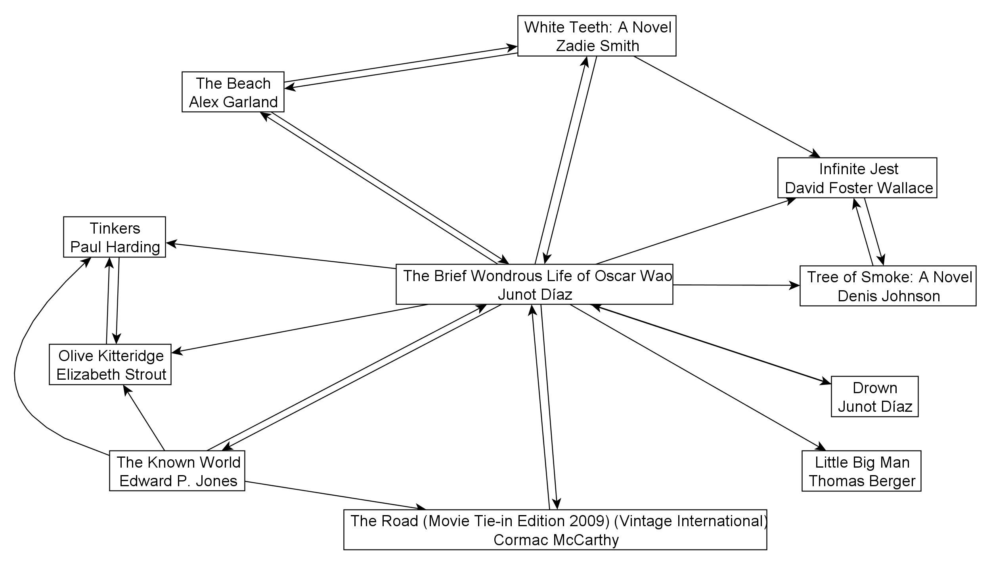

Figure **3**: Amazon Recommendations, Díaz, Early December 2010

By the end of December, this newly commercial position has begun a shift into something else: another Pulitzer-winner, Michael Chabon, appears in the network and the Caribbean classics *Dreaming in Cuban* and *In the Time of the Butterflies* are linked in *Oscar Wao*’s first-order subnet (). These, along with the Spanish-language edition of *Oscar Wao*, clearly align Díaz with a particular genre, once again placing him back in the context of the list Amazon calls “Hispanic & Latin American Fiction.” Nevertheless, he remains a literary gateway from this genre of ethnic literature to a distinct canon of mainstream prize-winners. Díaz’s academic audience also makes itself known here with another critical text on migration issues linked to *Oscar Wao*. These shifting networks mark out the ways in which multiple constituencies, responding to different elements of Díaz’s fiction, vie for cultural dominance in contextualizing his work. In these forces almost seem to be pulling *Oscar Wao* in different directions, creating a more nuanced kind of prestige—an effect that will be evident below as competing cultural forces seek to interpret Díaz through reviews of his work.

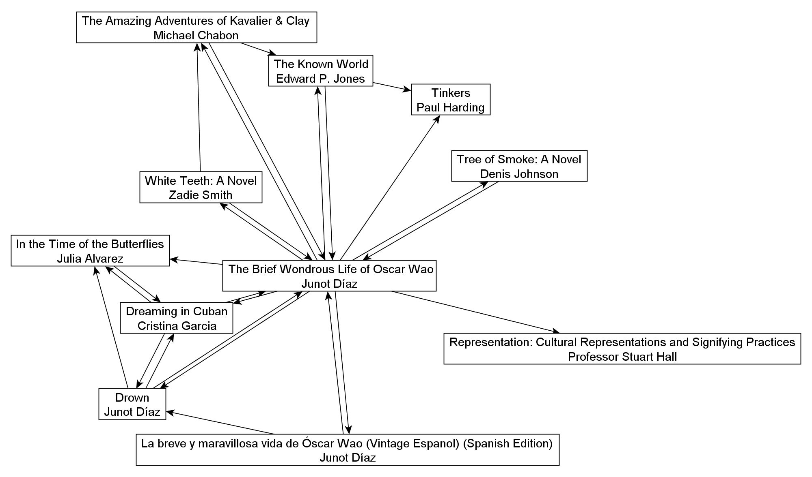

Figure : Amazon Recommendations, Díaz, Late December 2010

In January and February of 2011, Díaz readers begin to link him into a grander plane of the mainstream American canon, first superseding the genre barrier to align him with Allen Ginsberg and Robert Haas, and later linking him to established major novelists Toni Morrison and Don DeLillo (, ). At the same time, he is, like Morrison before him, helping to transform a loosely defined genre into a clearly demarcated space of literary study. The anthology *Latino Boom* does not excerpt Díaz directly, but Amazon claims it is frequently bought together with both *Oscar Wao* and *Dreaming in Cuban*, and it is not difficult to imagine the literature classes currently being taught around those three texts. The simultaneous emergence of professional anthologies and affiliation with established canonical titans like Morrison and DeLillo also mark an inversion point for Díaz where his work is no longer in need of illustration and explanation, but can now be used to reinterpret established canons. The transition marks the moment where race and gender cease to operate as explicit categorical functions (i.e. “Hispanic & Latin American Fiction”) and instead become implicit gravitational forces for a mainstream canon that includes Morrison and Díaz but remains predominantly white and male.

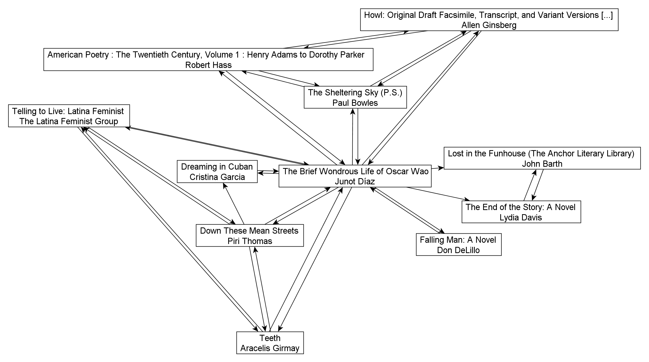

Figure : Amazon Recommendations, Díaz, Late January 2011

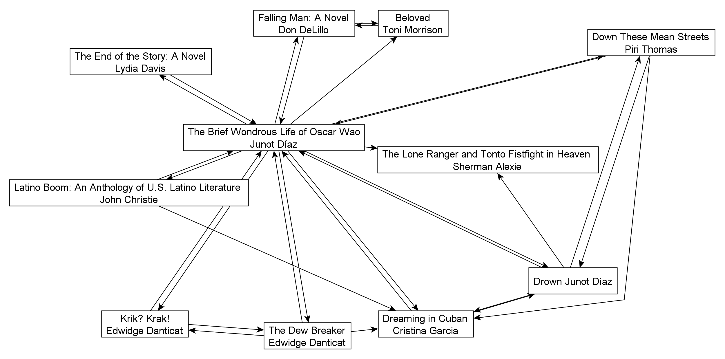

Figure : Amazon Recommendations, Díaz, Early March 2011

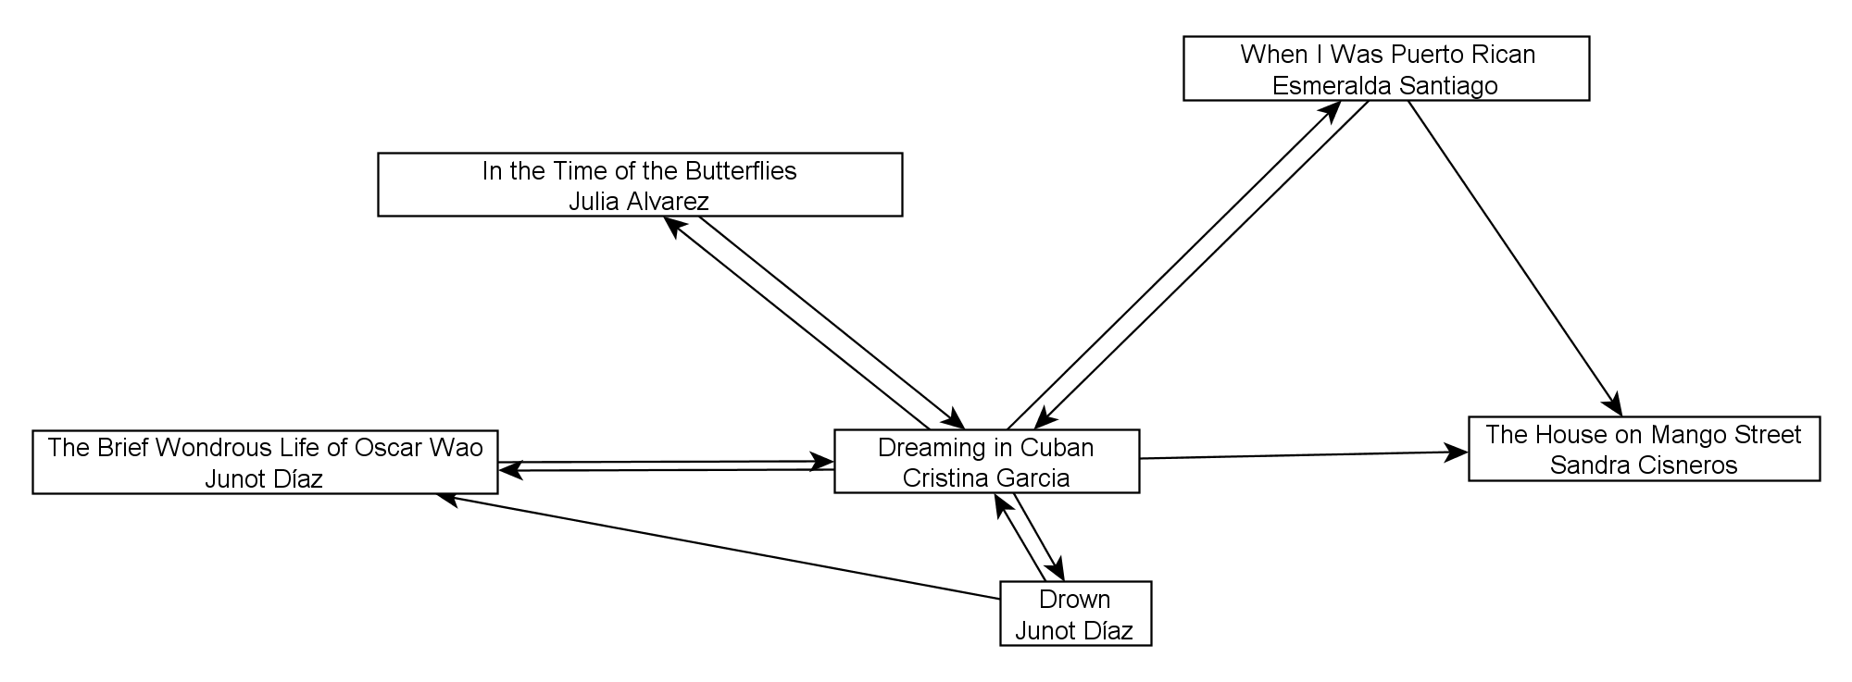

Figure : Persistent Recommendations, Díaz, December 2010 – March 2011

As Díaz teeters between ‘ethnic studies’ and mainstream canonicity, we can get a clearer glimpse of the enduring substructure of his fame when we limit our network only to explore links that have persisted across several monthly snapshots. offers a completely different view of Díaz, identifying him as a peripheral member of a Latin Caribbean literary community dominated by Cristina García, Julia Alvarez, Sandra Cisneros and Esmeralda Santiago. These sustained links mark Díaz squarely within an ethnic tradition of writing inspired by the Dominican Republic, Haiti and Puerto Rico. Just as striking is the extent to which this particular sub-genre is represented on Amazon by female authors. When Díaz is compared to other writers of what booksellers might call “serious literary fiction” the list is almost entirely male, but here the market tells a different story, placing Díaz on the edge of a subnet of immigration narratives penned by, and largely about, women. Celebrated for his innovative style, his nerd credentials and his esoteric references, Díaz is still defined primarily by genre in the market.

### “Across and Back”: Professional Reviewers

If the commercial status of Díaz’s work continues to shift between the registers of big ambitious novels, Latin American fiction, *New Yorker* elect and pop culture fandom, his various readerships present him in a different light when the question of context is no longer framed through book shopping. In the network of authors and texts mentioned at least twice in Díaz’s professional book reviews, the author of *Oscar Wao* is contextualized through multiple registers (, with more frequently linked notes at the top). When professional critics write about Díaz, they unsurprisingly mention him in the same paragraph as *Oscar Wao* and *Drown* more often than any other terms, and that shared presence is our unit of measurement here. But the next most frequent co-occurrence in the network is Rafael Trujillo, marking the significance of *Oscar Wao*’s engagement with Dominican history. Díaz would no doubt be pleased to learn that the “Dictatingest Dictator” whose malevolence overshadows his novel is also haunting his reviews very effectively as critics situate *Oscar Wao* within a Caribbean context (Díaz 2007, 80). The larger network bears out this point, freighted as it is with nodes like Tolkien and *Dune*. Critics often used David Foster Wallace as an exemplar in discussing Díaz’s footnotes, though in his own reviews Wallace tended to have his complex arrangements of cultural references described rather than explained (Finn 2011). Yet here Díaz’s footnotes and allusions are extensively unpacked by reviewers introducing readers to this strange new beast, the nerdy immigration narrative. Díaz himself is an author who needs explaining before readers can be told about his work—the Oscar Wilde node here reflects Díaz’s story, repeated by several reviewers, about the mispronunciation of “Wilde” in Spanish and the easy segue it offers for describing the author’s transnational, bilingual work.

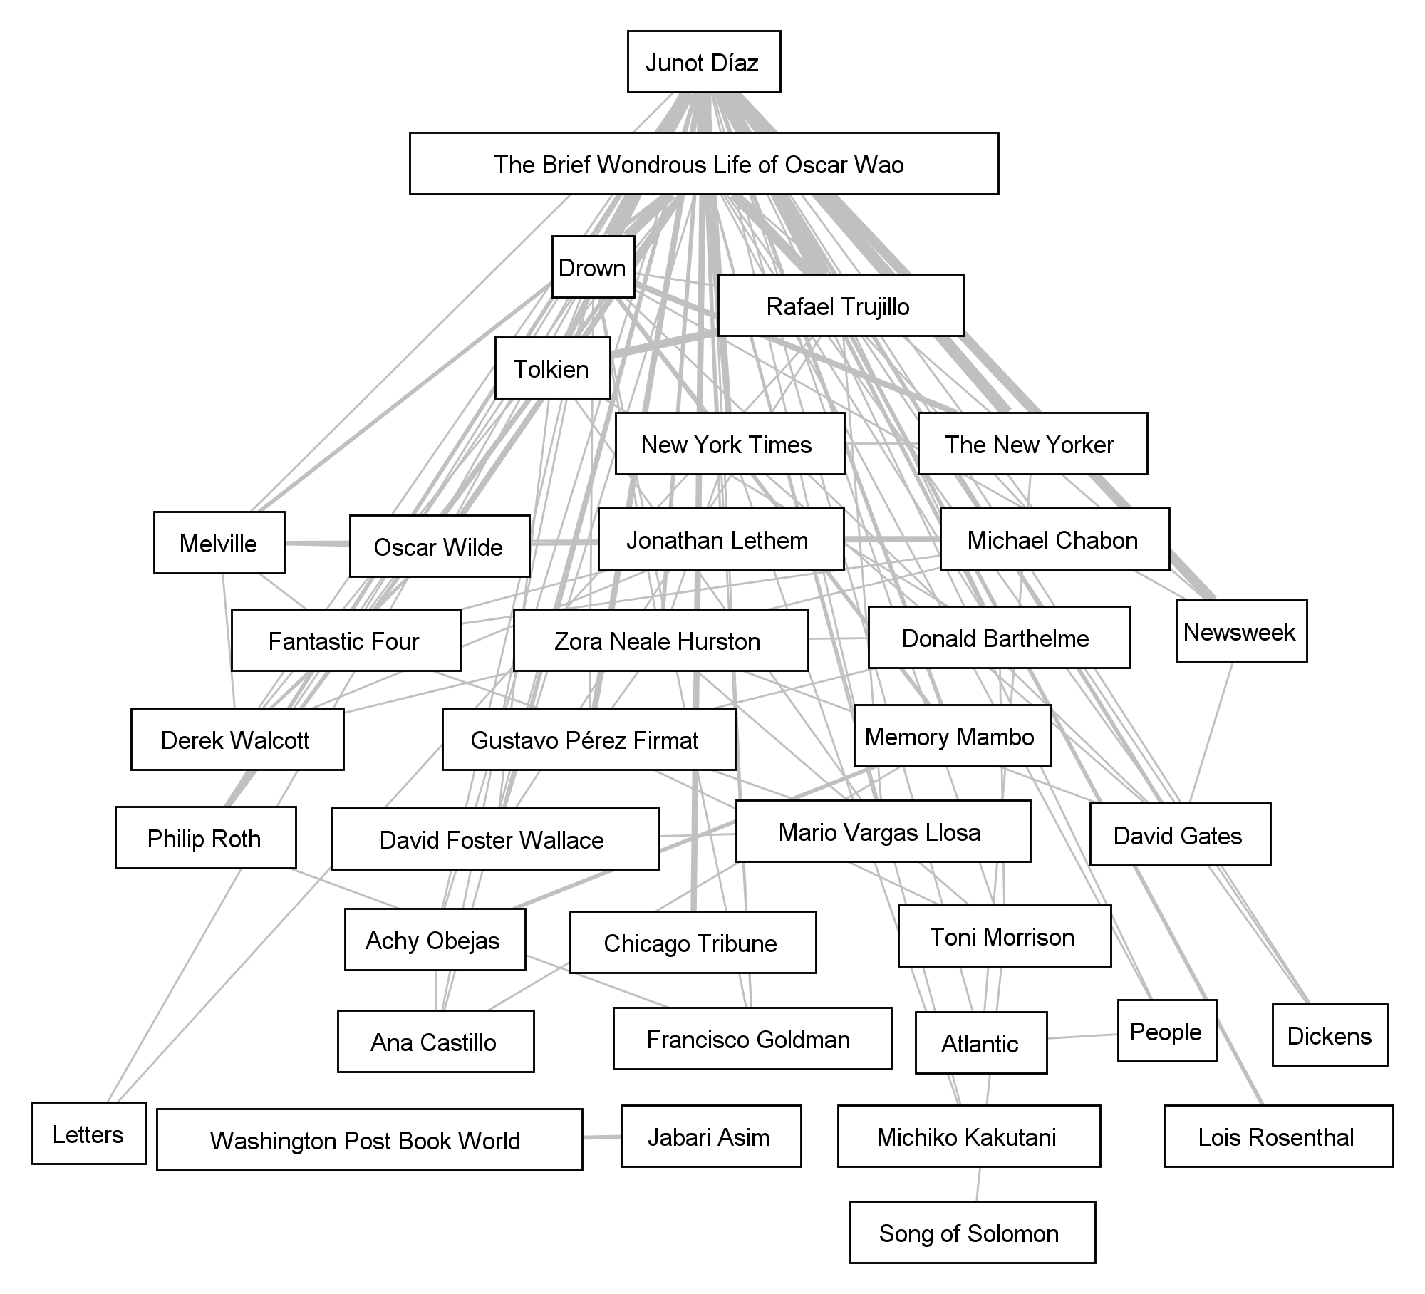

Figure 8: People and Books in Díaz Professional Review Collocations, Ordered Vertically by Centrality

Yet in many ways, Díaz’s fiction is much more polylingual and multicultural than it is merely a combination of English and Spanish. The diversity of references indicates a lack of consensus among professional reviewers. As a Dominican American, Díaz falls easily into the Caribbean and Latin American spaces of Derek Walcott, Gustavo Perez Firmat, Francisco Goldman and Mario Vargas Llosa. As a writer describing oppression and ethnic tension, his work aligns with Zora Neale Hurston, Toni Morrison and Philip Roth. Yet he is also firmly linked to popular culture, from Tolkien to Stephen King, and many of the single-instance references not shown here trace those connections, from Sauron and Mordor to *Star Wars* and *The Matrix*. The presence of Dickens in the diagram brings particular nuances to Díaz’s role as a literary protestor and political activist. A review of *Drown* in the *Los Angeles Times* suggests that it is “artists who offer most of us the only way across and back” between immigrant hardships and the comfortable mainstream (Eder 1996). Díaz’s almost lustful exposure of a cultural underbelly is, it seems, just what we mainstream American readers need—the challenges of immigration and (with *Oscar Wao*) political repression brought to life in fiction. And yet the authentic experience, the “horrors below” that the review describes as Díaz’s core subject, include not only colonial and immigrant nightmares but the deep interior of the American nerd imaginary—*Star Trek*, *The Lord of the Rings* and comic books celebrated primarily by a subset of the white mainstream.

Díaz’s work as a go-between does not stop at providing the mainstream with news from the subaltern underbelly of ‘ethnic studies.’ This review presages that element of critical reaction to *Oscar Wao* which marveled at Díaz’s particularly American cultural fluency—his comic book knowledge, his literary references, his sitcom allusions—which served to persistently yank the narrative out of ethnic literature and into the cultural mainstream, troubling both spheres to remind readers that these dramas were playing out not in some stylized America but the same landscape we inhabited already. In 2007 Díaz described his intention to

contaminate the real with all this nerdy narrative, and then the same way just doing the exact reverse—contaminating the nerdy with the painfully real….[F]anboys and consumers of what we’ll call “nerd culture” resist any infection by the real. Fanboys will go out of their way, they’ll bend over backwards to swear to God that J.R.R. Tolkien has no racist elements, which is hilarious. (Zaurino 2007)

This two-way contamination haunts the Díaz review network in and its tight link between social and genre boundaries is reflected by critics who work to convey the complexity of Díaz’s stance, his position across and against established genres, through the very language of genre itself.

### Middle Earth: Trujillo, Fantasy and American Publics

The process of literary reverse colonization, of deliberately contaminating the language of one discourse with the icons of another, has drawn a diverse readership around *Oscar Wao* and Díaz’s work as a whole. When we use the same methodological lens to explore co-occurrences in Amazon reviews (), it is immediately obvious that the most prominent nodes in both networks are identical.[14] Like professional critics, “real” readers respond to the dark history at the heart of Díaz’s work, making Trujillo an even more central node in the network than Díaz’s first book, *Drown*, and the centrality of Trujillo in both networks speaks to the character’s influence over reader reactions. By personifying history so pointedly in Trujillo and adapting a distinctly American cultural mythos to convey that history, Díaz not only earned accolades but also achieved the rare accomplishment of eliciting the same reaction across the board, from both professional and non-professional readers. The Trujillo we see at the center of this network is the “prototypical Latin American caudillo” Díaz describes in his first footnote for *Oscar Wao*, establishing this postmodern literary device as a vehicle for subaltern history, rage and cultural reference all at once: “He was our Sauron, our Arawn, our Darkseid, our Once and Future Dictator, a personaje so outlandish, so perverse, so dreadful that not even a sci-fi writer could have made his ass up” (Díaz 2007, 2, FN 1). The escalating rhetoric is hilarious and sad at the same time, presenting the anger of the Dominican people in the slightly bemused and jaded tone of a partisan scholar scoring points in, of course, a footnote. Sauron, arch-villain of the *Lord of the Rings*, is a connection that many readers make, but Arawn and Darkseid, of *The Chronicles of Prydain* and the DC Comics universe, raise the stakes, signaling a level of fandom and genre knowledge that leaves most readers behind and imposing a surprising metanarrative on the metacomment of the footnote itself.

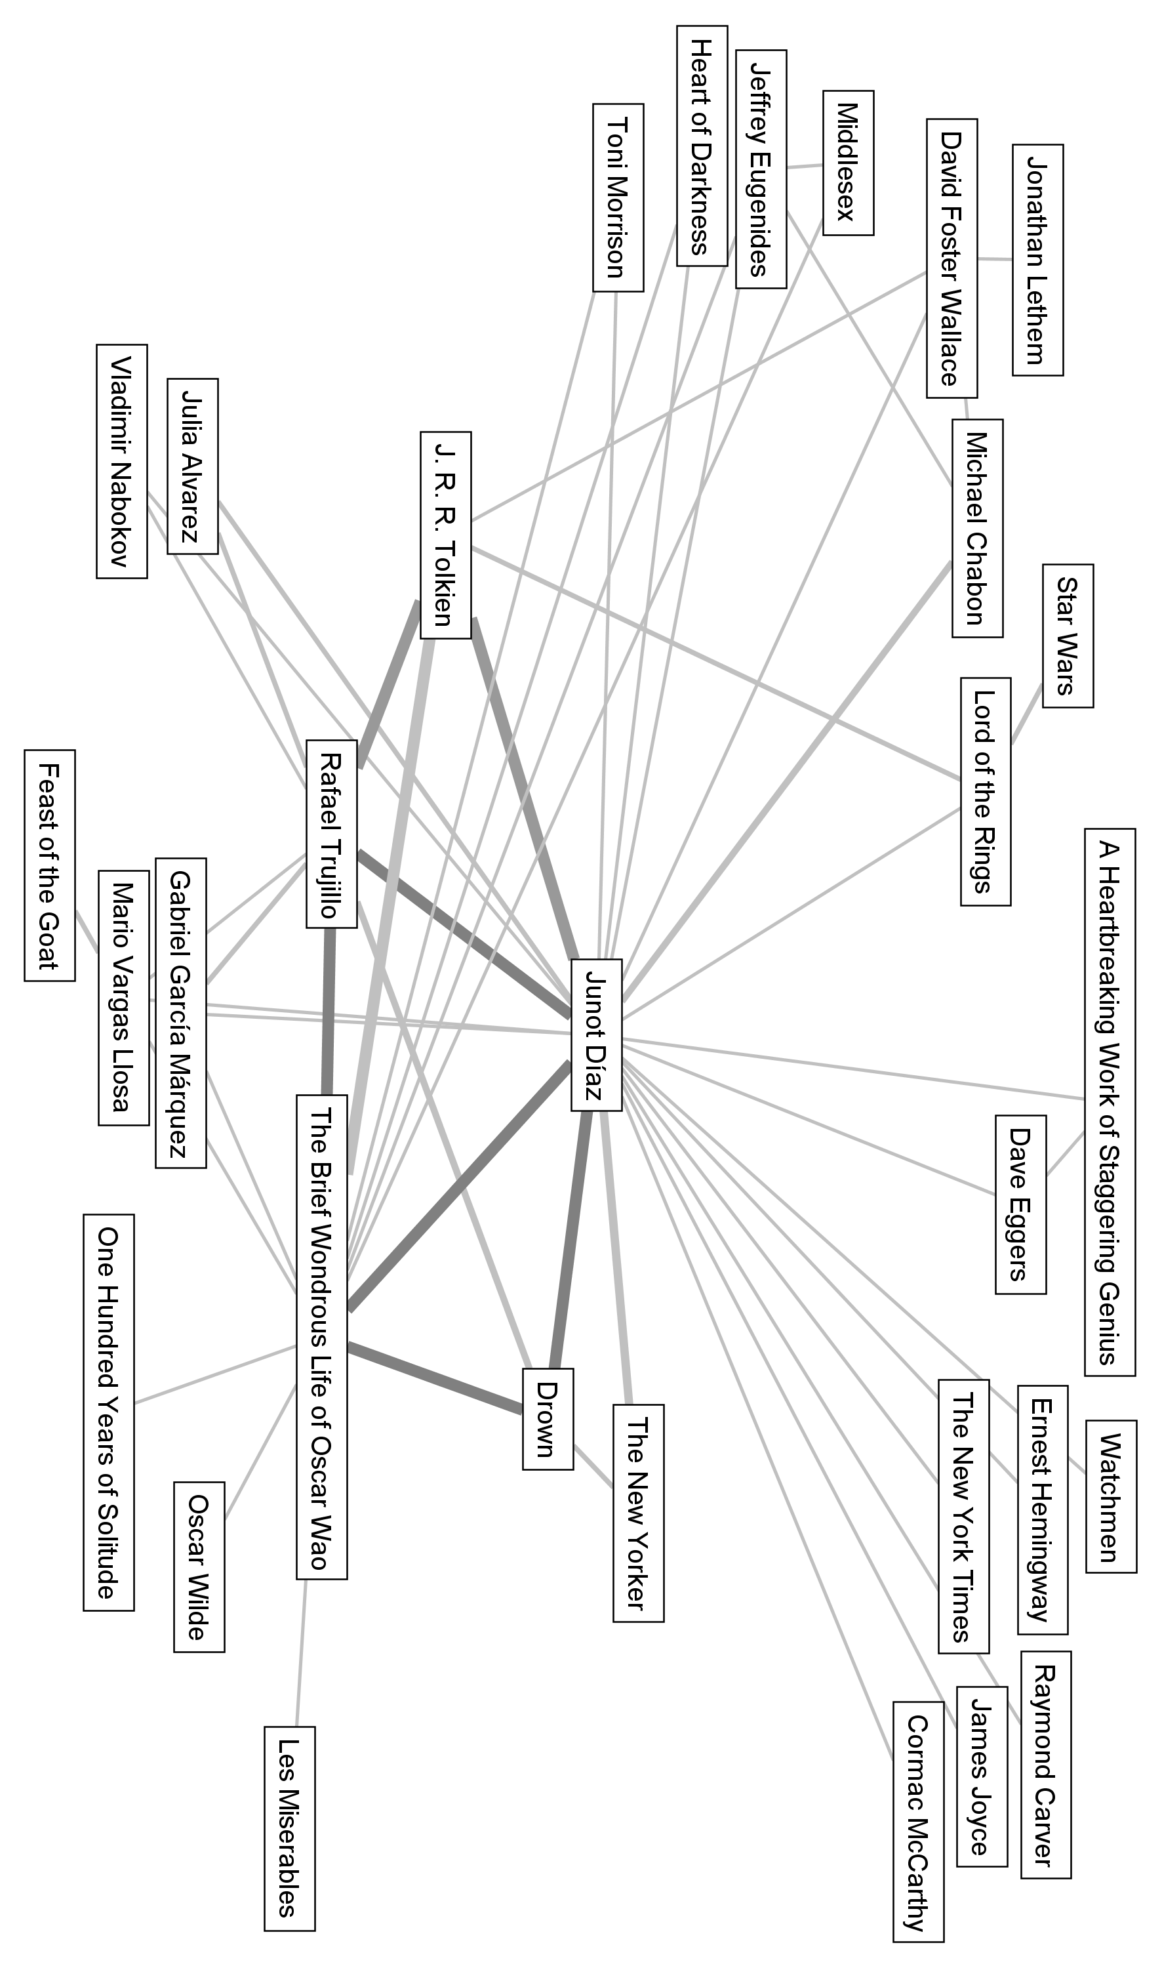

Figure **9**: People and Title Collocations in Amazon Reviews

If we look at the center of as a series of triangles, we can see Díaz’s game of cultural stacking as readers uncover and interpret his layers of reference. The central, expected triangle is between Díaz and his two published books. But this core is mirrored and even overshadowed by the triangle Trujillo forms with Díaz and *Oscar Wao*: the dictator actually overwhelms discussion of Díaz in the literary context of his short stories in favor of the history of the Dominican Republic. Yet this triangle, too, has its reflection in the shape Tolkien makes with Díaz and Trujillo, a cultural echo or inversion that manages to humanize this alien history for American readers and demonize its antagonist in one fell swoop. This narrative doubling and redoubling, which appears so seamlessly in the casual references Díaz works into his novel, becomes its own source of challenging discussion as readers identify its different narrative components.

The racism inherent in Middle Earth is a metaphor Díaz does not employ so much as he reverse colonizes it, suggesting that the cherished fantasy series confronts the same dark impulses that overshadow Dominican history and the lives of immigrants in the United States today. Shadows and darkness—these are the terms that Díaz seeks to trouble for us across the cultural landscape of four-color archvillains. Trujillo, that “portly, sadistic, pig-eyed mulato who bleached his skin” is a figure from the same troubled color zone as these imagined enemies; the forces of evil we have so carefully illustrated as unreal are still manifestations of real fears, hatreds and bigotries (Díaz 2007, 2, FN 1). A whole segment of the nerd demographic is drawn to Díaz through the magic of that Tolkien triangle, recognizing him as one of their own. One tongue-in-cheek writer suggests that Díaz has given him the perfect snapshot of Dominican culture, with injuries explained “in terms of hit points—perfect for those of us who understand how similar life is to the terms laid out in the *Dungeons & Dragons Player's Handbook*” (Fogle 2010). The connection to *Dungeons & Dragons* is particularly significant since it links *Oscar Wao* to a performative, collective form of fan-driven narrative. Just as players gather around a table and transform die rolls and paper notes into an act of collective imagination, Díaz calls on his readers to reinterpret a literally “alien” story through uniquely American touchstones, to use their well-developed faculties of the fantastic to conjure up the discomfiting real.

The series of triangles in the center of this graph marks off two territories, then, serving as “the pivot along which the culture swings” in the world literary system of commodifying authentic ethnicity (Okie 2008).[15] The space above the triangles is the one Díaz was thinking of when he mentioned fanboys protecting their sacred Tolkien. As one reader described this divide:

If you love any of the great Latin American modernists, or American writers like Chabon, Lethem, Eggers, and the recently departed David Foster Wallace, or if you can imagine a great combination of the two, then this book is for you…Diaz [sic] my man, wherever you are, know that you're the best you are at what you do, and a No-Prize is winging its way to you through the phantom mailways of the Universal Nerd Alliance! (Smith 2009)

Here the full cultural territory is laid out. Díaz combines the “great Latin American modernists” and “American writers,” and his transcultural work has earned him a “No-Prize,” an iconic non-award Marvel Comics bestows on readers who successfully identify and rationalize continuity problems in the ever-expanding Marvel Universe. In other words, Díaz brings together the political, historical discourse of Latin America and the innovative energy of the best contemporary (white, male) American writers, uniting them in a literary package that reinterprets both according to the logic of an ironic nerd discourse.

We can get a second bearing on this subcurrent, this *other* metanarrative in the Trujillo footnote quoted above, by exploring another data set, one that stands between the diffuse network of Amazon purchase-driven recommendations and the highly intentional acts of contextualization drawn from literary reviews. The website LibraryThing encourages book collectors and aficionados to join a “social reading” community by sharing their libraries, book reviews, local literary events and other reading activities. The gravitational center of the site is the user library, where individuals can itemize, categorize, rate and review their book collections. Each work has its own page, much like on Amazon, but the commercial undertone is largely replaced by a social one: browsers can see which other users have read a particular book or see what books others have recommended for those who enjoyed a particular title.[16] In effect, this creates a voluntary, non-commercial, user-generated analog to the purchase-driven recommendations on Amazon. True to its social mission, LibraryThing also allows other users to endorse or critique a particular recommendation with a “thumbs up or thumbs down” mechanism, allowing us to measure the strength of positive and negative ties within this network of texts. When we graph this recommendation network, the results are dramatically different from Amazon, in part because of the uneven results of such crowdsourcing.

To begin with, this human hive-mind recommendation network is less consistent than Amazon’s algorithms, which typically churn out 80 or more recommendations for each text. Here, the number varies, with *Oscar Wao* attracting fifteen suggestions but the average node in its three-level network garnering only 2.28. In this sense, the network is already much more representative of social position: instead of an artificial ten out-links per node, an organic mesh emerges where edge counts demonstrate a real form of popularity. In addition, this network is much more stable, determined not by a constantly fluctuating flow of sales transactions but a much more permanent record of votes left by readers and endorsed by others asynchronously over a period of months or years.

Hence measurements of prestige carry even more weight here, based as they are on human intentionality *weighted* by reader votes for or against particular recommendations. My definition of prestige is one of the simplest in network theory: nodes with the highest number of incoming links are the most prestigious. This measure of “importance” in a network graph aligns closely with the idea of a canonical text that is frequently *listed* in that canon. In this case, the links are weighted according to the number of votes each received from other users, so a link with four votes would count twice as much as a link with two.

This is not to say that the LibraryThing recommendations are any more definitive or unbiased than Amazon’s, merely that they represent a different space of literary consumption. Where Amazon’s recommendations are presumably influenced by thousands of users and transactions, on LibraryThing only ten different users offered suggestions for *Oscar Wao* (though these suggestions were then voted on by a handful of other users). And the LibraryThing group as a whole has its demographic skew, just as our other reading groups do, which becomes apparent when we look at “prestige” rankings for books in the three-level *Oscar Wao* network ().

Table : Prestige in Díaz LibraryThing Network

|  |  |  |
| --- | --- | --- |
| **Title** | **Author** | **Centrality as % of Highest Score** |
| *Nineteen Eighty-Four* | George Orwell | 1 |
| *Brave New World* | Aldous Huxley | 0.62 |
| *Fahrenheit 451* | Ray Bradbury | 0.42 |
| *The Giver* | Lois Lowry | 0.34 |
| *A Clockwork Orange* | Anthony Burgess | 0.27 |
| *The Handmaid's Tale* | Margaret Atwood | 0.26 |
| *The Shadow of the Wind* | Carlos Ruiz Zafón | 0.23 |
| *Animal Farm* | George Orwell | 0.22 |
| *Crime and Punishment* | Fyodor Dostoevsky | 0.22 |
| *The Master and Margarita* | Mikhail Bulgakov | 0.2 |
| *…* |  |  |
| *The Brief Wondrous Life of Oscar Wao* | Junot Díaz | 0.11 |

Between Orwell, Burgess, Bradbury, Lowry and Huxley, a clear dystopian, science fiction bent makes itself evident here. In short, we have entered the realm of the “fanboys,” the American nerd culture that Díaz so deftly adapts to Oscar’s “alien” life in New Jersey. Just as some reviewers of the novel on Amazon found Díaz’s nerd credentials comforting as they learned about the “foreign” culture of Dominican Americans, here we can see Díaz interpreted through a community that is itself positioned deep in a particular territory of genre fiction.

The direct connections from *Oscar Wao* () belie the dystopian cast of the broader LibraryThing network but still bear out its nerd credentials. Readers link Díaz to both science fiction (Cory Doctorow) and graphic novels (Chris Ware) as well as elements of the American popular contemporary canon, including John Irving’s *The World According to Garp* and Chabon’s *The Amazing Adventures of Kavalier and Clay*. As in the Amazon network, Díaz is also brought into contact with a Latin American subnet including the familiar García Márquez, Llosa and Alvarez. The LibraryThing interface offers these book nerds a way to gloss their recommendations, a feature two of them have taken advantage of on the *Oscar Wao* page. *In the Time of Butterflies* is recommended because “*Oscar Wao* mentions *In the Time of the Butterflies* in a footnote. Both dealing so gracefully with the Trujillo regime, they seem like complementary books” (LibraryThing n.d.). The textbook is suggested “to learn more about the DR, and for an essay by Junot Díaz.” In both cases, readers are specifically instructing one another in the context of Díaz’s universe, taking his footnotes at educational face value and collaborating to produce a better network.

These signs of “social reading” signal the appeal of LibraryThing’s basic structure as a collective database of libraries and book notes, a space populated by literary nerds with a penchant for cataloging and sharing their collections. This is our clearest view of Díaz’s effective mobilization of the subaltern nature of nerd culture, or what Matt Hills calls the “‘improper’ identity” of a fan defined by genre cultural artifacts (Hills 2002, xii). The fan, or that more intense instantiation, the nerd, functions as a cultural minority *within* the American mainstream. The fan’s engagements with texts move beyond consumption into the realm of the creative, as Henry Jenkins argues. Building on Pierre Levy’s concept of collective intelligence, Jenkins sees communities like this LibraryThing network as “some of the most fully realized versions of Levy's cosmopedia, expansive self-organizing groups focused around the collective production, debate, and circulation of meanings, interpretations, and fantasies in response to various artifacts of contemporary popular culture” (Jenkins 2002). In light of Díaz’s novel, these impulses also echo the Caribbean traditions Edouard Glissant lays out of *métissage*, a mixing and hybridity of peoples, languages and cultures, and relation, a form of engaging the other that does not rely on erasing or ignoring difference but accepting it as a kind of sacred truth (Glissant 1997, 47–62). The sacrament of the nerd is to embrace the weird and the obscure in a celebration of those very distancing qualities. But the LibraryThing nerd is still a figure deeply linked to projections of whiteness who energetically pursues what Glissant calls the Western impulse of filiation—ordering, ranking and categorizing the universe and striving for empirical mastery.

The *Oscar Wao* page, an attractor for reader interest, utilizes a number of the site’s filiation features that can tell us more about Díaz’s interactions with these book nerds. In classic fan form, users have filled out an extensive Wikipedia-like entry on the book, including a list of major characters, the endorsement quotes on the book jacket, important places in the text, et cetera. This level of detail goes beyond even what Amazon’s deep pockets will finance for its book pages, matching the definitions of collaborative fan cultures identified by scholars like Jenkins and Jason Mittell (Jenkins 2008, Mittell 2009). These links echo the productive literary spirit of The Annotated Oscar Wao site, where users can contribute to a reader’s guide that offers translations, glosses and links to further reading, much of it on Wikipedia (Flournoy 2008). The Annotated Oscar Wao is another complex collective reaction to Díaz, combining elements of both relation and filiation in discussing and glossing his work. In such interpretive spaces, Díaz’s readers can respond to his nerd discourse in kind, celebrating his writing as it references fan universes from *The* *Lord of the Rings* to *The Fantastic Four*. These sustained engagements with his work demonstrate how successfully Díaz drives real dialog with multiple audiences, and this is the crucial pivot on which his game of politicizing language turns.

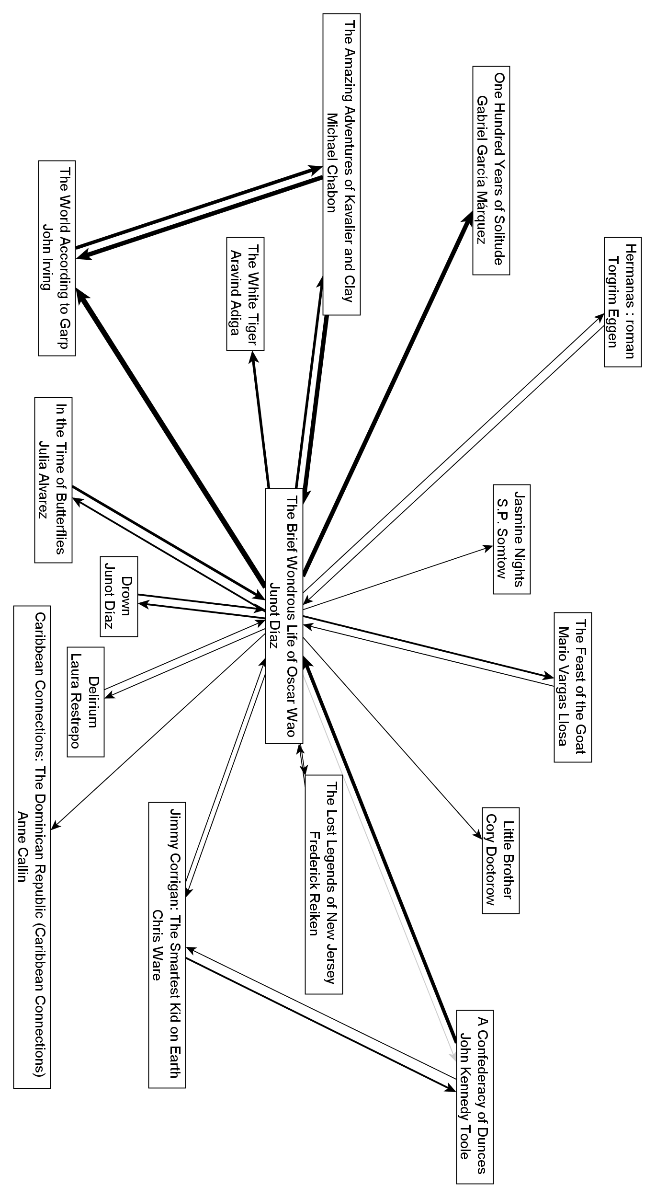

Figure : First-Order Recommendations for *Oscar Wao*, LibraryThing

Revenge of the Nerd: The Middle Territories of Díaz and Digital Humanities

By drawing together Spanish, English, the literary, the nerdy and other discourses into one vibrant creole, Díaz successfully appeals to a broad American readership. But his particular embrace of the nerd accomplishes another goal for the mainstream reader, leading us to confront our own investments in some cultures but not others. The nerd in the guise of filiation, by pushing away non-canonical and transgressive elements of his own cultural universe, defines an extreme, interior superstructure of white popular culture. It is the tribal narrative of the member who takes his myths too seriously, who tries too hard and speaks too carefully.[17] But Díaz inverts this situation, pulling the figure of the nerd to the outside, putting texts like *The Lord of the Rings* in direct conversation with real cultural others. As a nerd, Oscar Wao is both part of the U.S. mainstream and a symbol of the many ways it reflects, traffics in and grapples with African American, Caribbean and other cultural sources for the true power of the alien and the fantastic.

In refusing to translate Spanish or even italicize it in his work, Díaz is only one of several bilingual writers exploring the politically charged zone of code-switching,[18] but he performs a second kind of radicalism by engaging the parallel universe of untranslated Elvish. Díaz sees this blurring of registers as a real political act: “By forcing Spanish back onto English, forcing it to deal with the language it tried to exterminate in me, I've tried to represent a mirror-image of that violence on the page. Call it my revenge on English” (Céspedes & Torres-Saillant 2000). The refusal of italics implicitly asks readers to perform a contextual interpolation, to *learn* the words and sound them out instead of bracketing them or translating them. Díaz even asserted his militancy on this issue with the single most important advocate for his career, the *New Yorker,* successfully lobbying them to stop italicizing foreign language terms (Anon 2011).[19] Cast in the light of this linguistic agenda, the continuous reappearance of Tolkien, *Dune* and other terms in the Amazon data is evidence of a contact zone between nerd and ‘ethnic studies’ dialects. In one striking example, an Amazon reviewer compared Díaz’s use of Spanish to Tolkien, suggesting “it helps to create a mood, a feeling of verisimilitude (overused as that word is), a depth. It really invites you into the inner lives of this Dominican family” (Fisher 2008). Díaz has worked to make his language difficult in a particularly productive way, implicitly demonstrating how we are all implicated in one another’s languages.[20]

By embracing the elevated diction and obscure references of nerd culture, *Oscar Wao* upends our conception of the nerd by linking it to the traumas of immigrant life. We are all faced with unintelligibility as readers of *Drown* and *Oscar Wao*, brought to confront the fissures between notions of America and immigrant communities and within the idea of America itself. The multiplicity of Díaz’s prose, his deliberate polyvocalism, defies conventional ideals of assimilation by demonstrating just how fragile our notion of the mainstream is, how easily Oscar can complicate the “hyperwhite” figure of the nerd by becoming a “ghettonerd.” The psychological fuel that powers this narrative engine for many readers is the story of Díaz himself, an original ghettonerd, who began crafting his writing as a response to the ways in which other immigrant writers catered to mainstream expectations about their lives. Sitting on a writing panel, he realized that his colleagues “were putting on this mask to try to hide the nerd….The great silence on that panel was the silence of this experience these guys lived immediately. Being nerds, loving words, being writers, going to elite graduate schools, going to elite schools—that was the huge silence” (Ch’ien 2004, 226). Through his assault on the mainstream, Díaz both refuses to translate and aggressively contextualizes his work, turning the conflict of authenticity from a silent battleground into a boisterous network of relations.

This narrative of Díaz the nerd, then, is ultimately a story about reconfiguring reading, the tale of a violent assault on English to carve out a new political space for language. By asserting his membership in mutually contradictory groups, Díaz has led us to spell out our own silent boundaries and ask when untranslated Spanish is really not the same as untranslated Elvish. One Amazon reviewer who felt as unfamiliar with his nerd allusions as with his use of Spanish wrote: “As a white, middle-aged woman in mid-america [sic], the world of Oscar is about as far off as another planet. However, thanks to Junot Diaz, I was able to travel there and be sincerely touched by what I ‘saw’” (Reinert 2008). Just as minorities of previous generations carved out mainstream distinction by extracting interior white cultural constructs like Latin verse or classical music and excelling at them, Díaz claims nerdhood as his own. It is an act of recontextualization, a deft game of what Glissant would call relation, that depends on fostering reading that embraces many cultural and national languages. This is, I humbly submit, exactly what scholars in the digital humanities are engaged in as we struggle to speak in the languages of humanities departments, coding schema and cultural relevance all at the same time. We, too, are nerds seeking to change the rules of “reading.”

Like Díaz, I seek to redefine reading by expanding the contested territory: moving from books themselves to that middle ground of reception and recommendation. This essay includes close reading and cultural arguments as well as empirical evidence, shuttling back and forth between academic registers to make its claims. It approaches Díaz through networks, but not vast and impersonal ones—they are familiar, culturally localized core samples that still carry idiosyncratic traces of individual critics and actors. Even the recommendation networks on Amazon reflect the organic engagement of humans and algorithms in feedback loops, producing a far more surprising selection of texts than we might expect from a bookstore or library’s shelving system. In this sense I believe we need to expand “close” reading by looking carefully at the full context of a literary network at a particular point in time, particularly the new dynamic influences of algorithms and digital reading, and to mark that expansion with the term “middle ground” as I have above.

The payoff of this approach, then, is in the cultural and literary work that the networks allow me to perform, the argument about the complicated “otherness” of nerds that builds in the previous two sections. I take my stand in the middle ground between purely data-driven research, close reading and cultural critique: a definition of the literary in the digital humanities that strives for relation as well as filiation. After all, it’s in the middle ground where culture takes place, particularly online—where our e-books might come with highlights from an invisible reading collective, where our authors tweet alongside us, where the game of fame has many more players and many more goals. As the digital humanities continues to define its position in humanistic study, I think one of the best arguments we can make is for our own hybridity as “readers” of many different languages, including software, algorithms and other digital media. If you accepted my opening claim that reading is a social enterprise, you should also accept that technology—the digital—is as well, and that the best digital humanities approaches embrace the social and cultural criticism lurking within our tools and programs. It’s not enough to recognize how algorithms read us—we need to learn how to read them. As Díaz has so elegantly demonstrated, the literary is one more collaborative network, and it’s time to get everyone thinking about who and what we include in the conversation. **Works Cited**

**Anon 2011** Anon. "Create relevant literature for future gen: Junot Diaz." *Times of India*. 22 January 2011. Accessed 10 April 2011. http://articles.timesofindia.indiatimes.com/2011-01-22/jaipur/28354041_1_jaipur-literature-festival-writer-new-yorker.

**Bautista 2009** Bautista, D. "In and out of the mainstream: Dominican-American identity in Junot Díaz’s How to Date a Browngirl, Blackgirl, Whitegirl, or Halfie." *Romance Notes* 49:1 (2009), 81–89.

**Bourdieu 2007** Bourdieu, P. *Distinction: A Social Critique of the Judgement of Taste*. Cambridge: Harvard University Press, 2007.

**Bourdieu 1993** Bourdieu, P. *The Field of Cultural Production* ed. R. Johnson. New York: Columbia University Press, 1993.

**Bourdieu 1996** Bourdieu, P. *The Rules of Art: Genesis and Structure of the Literary Field*. Stanford, CA: Stanford University Press, 1996.

**Brouillette 2007** Brouillette, S. *Postcolonial Writers in the Global Literary Marketplace* 1st ed. Houndsmills, Basingstoke, Hampshire: Palgrave Macmillan, 2007.

**Bucholtz 2001** Bucholtz, M. "The Whiteness of Nerds: Superstandard English and Racial Markedness." *Journal of Linguistic Anthropology* 11:1 (2001), 84–100.

**Céspedes & Torres-Saillant 2000** Céspedes, D. & S. Torres-Saillant. "Fiction is the Poor Man’s Cinema: An Interview with Junot Díaz." *Callaloo* 23:3(2000), 892–907. Accessed 10 April 2011. http://muse.jhu.edu/journals/callaloo/v023/23.3cespedes.html.

**Ch’ien 2004** Ch’ien, E.N.-M. *Weird English*. Cambridge: Harvard University Press, 2004.

**Díaz 2007** Díaz, J. *The Brief Wondrous Life of Oscar Wao* 1st ed. New York: Riverhead Hardcover, 2007.

**Eder 1996** Eder, R. "An Artist in Transit." *Los Angeles Times*, 1 September 1996. Accessed 17 March 2011.

**Eglash 2002** Eglash, R. "Race, Sex, and Nerds: From Black Geeks to Asian American Hipsters." *Social Text* 20:2 (2002), 49–64. Accessed 12 April 2011. http://muse.jhu.edu/journals/social_text/v020/20.2eglash.html.

**English 2005** English, J.F. *The Economy of Prestige: Prizes, Awards, and the Circulation of Cultural Value*. Cambridge: Harvard University Press, 2005.

**Finn 2011** Finn, E. "Becoming Yourself: The Afterlife of Reception." *Pamphlets of the Stanford Literary Lab* 3 (2011). Accessed 3 November 2011. http://litlab.stanford.edu/?page_id=255.

**Finn 2012** Finn, E. "New Literary Cultures: Mapping the Digital Networks of Toni Morrison." *From Codex to Hypertext: Reading at the Turn of the Twenty-First Century* ed A. Lang. Amherst, MA: University of Massachusetts Press, 2012.

**Fisher 2008** Fisher, J. "A Mythology for the Dominican Republic." *Amazon [Review of The Brief Wondrous Life of Oscar Wao]*. 24 October 2008. Accessed 18 March 2011. http://www.amazon.com/review/RK5298A7HD8JG/ref=cm_srch_res_rtr_alt_2.

**Flournoy 2008** Flournoy, K. "The Annotated Oscar Wao: Notes and translations for *The Brief Wondrous Life of Oscar Wao by Junot Diaz*." *The Annotated Oscar Wao*. 2008. Accessed 9 April 2011. http://www.annotated-oscar-wao.com/index.html.

**Fogle 2010** Fogle, G. "Enlightening Look into Domincan Culture!!!" *Amazon [Review of The Brief Wondrous Life of Oscar Wao]*. 4 February 2010. Accessed 18 March 2011. http://www.amazon.com/review/R58JWCMTJOKKO/ref=cm_srch_res_rtr_alt_3.

**Glissant 1989** Glissant, É. *Caribbean Discourse: Selected Essays*. Charlottesville: University Press of Virginia, 1989.

**Glissant 1997** Glissant, É. *Poetics of Relation*. Ann Arbor: University of Michigan Press, 1997.

**Guillory 1995** Guillory, J. *Cultural Capital: The Problem of Literary Canon Formation*. Chicago: University of Chicago Press, 1995.

**Hanna 2010** Hanna, M. “'Reassembling the Fragments': Battling Historiographies, Caribbean Discourse, and Nerd Genres in Junot Díaz’s *The Brief Wondrous Life of Oscar Wao*." *Callaloo* 33:2 (2010), 498–520. Accessed 12 May 2012. http://muse.jhu.edu.ezproxy1.lib.asu.edu/journals/callaloo/v033/33.2.hanna.html.

**Hanson 2007** Hanson, M., 2007. "I’m a Brotha’ but Sometimes I Don’t Feel Black: Thug-Nerds, Rap-Geeks and the Risky Black Masculine." *AfroGEEKS: Beyond the Digital Divide* ed. A. Everett and A. J. Wallace. Center for Black Studies Research, University of California, Santa Barbara, pp. 13–27.

**Hendrickson 2008** Hendrickson, M. "Shelfari and LibraryThing: Awkward Bookends To AbeBooks-Amazon Deal." *TechCrunch*. 1 August 2008. Accessed 3 November 2011. http://techcrunch.com/2008/08/01/shelfari-and-librarything-awkward-bookends-to-abebooks-amazon-deal/.

**Hills 2002** Hills, M. *Fan Cultures* 1st ed. Oxford: Routledge, 2002.

**Jenkins 2002** Jenkins, H. "Interactive Audiences? The 'Collective Intelligence' of Media Fans." *The New Media Book* ed. D. Harries. London: British Film Institute, 2002. Accessed 30 October 2011. http://web.mit.edu/cms/People/henry3/collective%20intelligence.html.

**Jenkins 2008** Jenkins, H. *Convergence Culture: Where Old and New Media Collide,* Revised ed. New York: NYU Press, 2008.

**Kakutani 2007** Kakutani, M. "Travails of an Outcast." *The New York Times*. 4 September 2007. Accessed 3 December 2010. http://www.nytimes.com/2007/09/04/books/04diaz.html.

**Latour 2005** Latour, B. *Reassembling the Social: An Introduction to Actor-Network-Theory*. Oxford: Oxford University Press, 2005.

**LibraryThing** LibraryThing. "The Brief Wondrous Life of Oscar Wao." Accessed 9 April 2011. http://www.librarything.com/work/3165787/.

**McGurl 2009** McGurl, M. *The Program Era: Postwar Fiction and the Rise of Creative Writing* 1st ed. Cambridge: Harvard University Press, 2009.

**Mittell 2009** Mittell, J. "Sites of participation: Wiki fandom and the case of Lostpedia." *Transformative Works and Cultures,* no. 3. <http://dx.doi.org/10.3983/twc.2009.0118>.

**Moretti 2007** Moretti, F. *Graphs, Maps, Trees: Abstract Models for a Literary History*. New York: Verso, 2007.

**NovelRank 2011** NovelRank. The Brief Wondrous Life of Oscar Wao. 2011. Accessed 30 October 2011. http://www.novelrank.com/asin/1594483299.

**Okie 2008** Okie, M. "Mil Máscaras: An Interview with Pulitzer-Winner Junot Díaz." *Identity Theory*. 2 September 2008. Accessed 8 April 2011. http://www.identitytheory.com/interviews/okie_diaz.php.

**Quantcast 2011** Quantcast. "Amazon.com Traffic and Demographic Statistics." 2011. Accessed 14 May 2012. http://www.quantcast.com/amazon.com.

**Reinert 2008** Reinert, M. "Way Beyond My World--But Well Worth the Read." *Amazon [Review of The Brief Wondrous Life of Oscar Wao]*. 22 February 2008. Accessed 18 April 2011. http://www.amazon.com/review/R1XEGGASFFY700/ref=cm_srch_res_rtr_alt_2.

**Roychoudhuri 2010** Roychoudhuri, O. "Books After Amazon." *Boston Review* (November/December 2010). Accessed 3 November 2011. http://bostonreview.net/BR35.6/roychoudhuri.php.

**Sáez 2011** Sáez, E.M. "Dictating Desire, Dictating Diaspora: Junot Díaz’s The Brief Wondrous Life of Oscar Wao as Foundational Romance." *Contemporary Literature* 52:3 (2011), 522–555. Accessed 12 May 2012. http://muse.jhu.edu.ezproxy1.lib.asu.edu/journals/contemporary_literature/v052/52.3.machado-saez.html.

**Sáez & Dalleo 2007** Sáez, E.M. & R. Dalleo. *The Latino/a Canon and the Emergence of Post-Sixties Literature* 1st ed. New York: Palgrave Macmillan, 2007.

**Scott 2007** Scott, A.O. "Dreaming in Spanglish." *The New York Times*. 30 September 2007. Accessed 3 December 2010. http://www.nytimes.com/2007/09/30/books/review/Scott-t.html.

**Smith 2009** Smith, D. "I’m in Love with a Beautiful Girl Reporter from Mexico and Finishing this Book." *Amazon [Review of The Brief Wondrous Life of Oscar Wao]*. 16 June 2009. Accessed 8 April 2011. http://www.amazon.com/review/R3J94CRRSJB85U/ref=cm_srch_res_rtr_alt_1.

**Striphas 2010** Striphas, T. "Algorithmic Culture." 2010. Accessed 3 November 2011. http://www.thelateageofprint.org/category/algorithmic-culture/.

**Striphas 2011** Striphas, T. "Algorithmic Literacies." *The Late Age of Print*. 17 October 2011. Accessed 14 May 2012. http://www.thelateageofprint.org/2011/10/17/algorithmic-literacies/.

**Torres 2007** Torres, L. "In the Contact Zone: Code-Switching Strategies by Latino/a Writers." *MELUS* 32:1 (2007), 75–96. Accessed 10 April 2011. http://www.jstor.org/stable/30029707.

**Wasserman & Faust 1994** Wasserman, S. & K. Faust. *Social Network Analysis: Methods and Applications* 1st ed. New York: Cambridge University Press, 1994.

**White 2011** White, C. "The Late Word." *Lapham’s Quarterly*. 7 October 2011. Accessed 14 May 2012. http://www.laphamsquarterly.org/roundtable/roundtable/the-late-word.php.

**yWorks GmbH 2011** yWorks GmbH. *yEd Graph Editor*. yWorks GmbH. 2011. http://www.yworks.com.

**Zaurino 2007** Zaurino, J. "An Interview with Junot Diaz." *Bookslut*. September 2007. Accessed 3 December 2010. http://www.bookslut.com/features/2007_09_011634.php.

1. Hereafter, an abbreviation for *The Brief Wondrous Life of Oscar Wao*.
2. Franco Moretti has defined “distant reading” in contrast to traditional “close reading” as the study of hundreds or thousands of literary texts (Moretti 2007).
3. Ted Striphas has blazed the trail for the study of “algorithmic culture” (Striphas 2010).
4. I use “network analysis” in the sense of social network analysis, or the quantitative study of relationships between people and/or objects. For an introductory overview see *Social Network Analysis* (Wasserman & Faust 1994).
5. By this I mean ethnic and geographical categories such as Latin American, Caribbean and Dominican fiction as well as formal “mainstream” cultural categories such as historical fiction, fantasy, science fiction, comics and literary fiction.
6. The professional reviews are drawn from nationally recognized reviewing publications: *New York Times*, *Los Angeles Times*, *Chicago Tribune*, *Washington Post*, *Time*, *Newsweek*, *Nation* and *New Yorker*. In Díaz’s case, the *New Yorker* has published more than ten of his stories but never reviewed his work. Amazon reviews include all reviews of the U.S., English-language editions of *Drown* and *The Brief Wondrous Life of Oscar Wao* posted before March 2011.
7. Defining links by paragraph instead of sentence or review provides the best level of granularity for this very simplified approach, avoiding both the complexities of parsing sentences and the tenuous connections that would result by considering all proper nouns in the same review as linked.
8. In the future a more sophisticated algorithm might identify these proper nouns even when they are described using generic pronouns or descriptors like “the author,” but such syntactical sophistication was far beyond my skills as a programmer and remains, to the best of my knowledge, a challenging problem in algorithmic semantic analysis.
9. Amazon offers an irregular number of recommendations depending on the product, typically over 80 per product. I chose to concentrate on the first 10 as these are most visible to consumers on the site and presumably represent the strongest connections in the Amazon network.
10. Amazon’s networks clearly operate in dialog with external forces such as school syllabi, an observation I discuss in more detail in a parallel study of Toni Morrison (Finn 2012).
11. Limiting the field to professional criticism and the reviews and recommendations of Amazon puts us squarely in the first world, affluent consumerism that already defines mainstream American literary culture. When I describe these Amazon consumers as a “general” readership (and given the demographic constraints already mentioned), I use the phrase within the confines of that limited cultural space.
12. This rough measure of prominence can easily be verified by conducting a targeted Google search for Portable Document Format files from academic domains such as syllabus “junot diaz” filetype:pdf site:.edu, which returned 396 files on October 30, 2011. Conducting the same search for .doc files presented another 93 results.
13. NovelRank offers one year of back data, so the year I discuss here stretches from October 30, 2010 to October 30, 2011 based on date of access.
14. For all their similarity to the professional criticism, however, the Amazon reviews are much more diverse in their references. For the sake of legibility this image has been filtered to include only nodes with at least two connections to the central subnet visible here—without this limit, this visible graph would have been ringed with another layer of nodes with just one or no connections at all to the core, many of them unique to Amazon readers.
15. As Sarah Brouillette argues in her excellent study, “several things characterize the postcolonial literature that achieves the greatest success in the current market: it is English-language fiction; it is relatively ‘sophisticated’ or ‘complex’ and often anti-realist; it is politically liberal and suspicious of nationalism; it uses a language of exile, hybridity, and ‘mongrel' subjectivity’” (2007, 61).
16. Ironically, when Amazon purchased AbeBooks in 2008 it also purchased a large (but not controlling) stake in LibraryThing (Hendrickson 2008). So far the site seems to have maintained its cultural independence.
17. This depiction has its reflection in the “elaborate ornamentation imposed on the French language by [Martinican] men of letters” Glissant describes in *Caribbean Overtures* (Glissant 1989, 250).
18. A number of scholars have written on this subject. For a clear overview and discussion of the phenomenon in 1990s U.S. literature, see Lourdes Torres’s “In the Contact Zone” (Torres 2007).
19. Throughout this paper I have written the author’s name with a diacritical “í,” as he has in both of his books. However his name has experienced a typographical evolution over the course of his literary career as publications struggle with his typographical “foreign accent.” The *New York Times* “Times Topic” page for “Junot Diaz” continued to have it both ways as late as April 2011, with the Americanized title belied by book reviews with the name spelled correctly. Database copies of newspaper reviews reveal a number of character encoding issues, often replacing the “í” with an error character similar to “□,” though most databases recognize both “Diaz” and “Díaz” as potential matches for Junot Díaz. This is not to argue that such errors are intentional, but rather that the failure to reproduce non-English diacritical markings, particularly í, is a sign of telling neglect by U.S. media. Díaz’s choice to emphasize this aspect of his identity is part of a larger effort to integrate these markings of cultural difference into the typographical mainstream.

    The story of the “í” is also a technological one: as word processing software has increasingly made us our own typesetters as well as editors, scholars and writers of Latino/a and Chicano/a literature have been able to reclaim the diacritical markings that publishers were once unwilling or unable to reproduce, a process Paula Moya described to me in an email on April 15, 2011..
20. This term also shares productive overlaps with the term in Latino/a and Caribbean studies known as opacity, an integral component of the concept of relation (Sáez & Dalleo 2007, 85, 102).