Joseph Tabbi, University of Illinois at Chicago - UIC, jtabbi@uic.edu

BIO

Joseph Tabbi is the author of two books of literary criticism, *Cognitive Fictions* (Minnesota, 2002) and *Postmodern Sublime: Technology and American Writing from Mailer to Cyberpunk* (Cornell,1995), and co-editor of *Paper Empire: William Gaddis and the World-System* (Alabama, 2007) and *Reading Matters: Narrative in the New Media Ecology* (Cornell, 1997). As a Director of the Electronic Literature Organization, he has set up a peer-to-peer network of emerging scholars who are currently gathering born digital works of literature for inclusion in a developing archive at HTTP: directory.eliterature.org.

ABSTRACT

This critical essay was written for the Prairie Art Gallery catalogue presenting Kate Armstrong's and Michael Tippett's *Grafik Dynamo!* Its argument, implied in the catalogue version, can be stated explicitly in the present scholarly format, namely that *narrative*, associated with the development of the modern novel in print, is distinctly unsuited to literary arts produced in and for the electronic medium. Narrative in the *Dynamo!* is not entirely absent, but its dominance is put into question. The same holds for the place of argumentation in critical writing. The *Dynamo!* develops episodically, haunted by the comics, and by the popular and literary narratives it samples; the essay develops similarly, in blocks of partly autobiographical, partly analytical text. Propositions emerge not sequentially or through feats of interpretation, but at the moment when a block of text encounters a cited image from the *Dynamo!*

Another collocation having implications for criticism, is the reading of Armstrong/Tippett's work in the context of a particular strain of contemporary fiction in print, which itself demonstrates that narrative was only ever a mode, one among many and not necessarily the dominant mode, in print literature itself. References are made to Pynchon's *Gravity's Rainbow*, to Pynchon's (and Armstrong/Tippett's) modernist antecedent, Henry Adams, to non-linear, non-sequential narratives by Robert Coover, Don DeLillo, and William Gaddis that are as open to innovation formally as they are expansive in subject matter. In this context, "Graphic Sublime" also introduces a major, as yet unpublished novel from the early 1970s by Phillip Wohlstetter, *Valparaiso*.

**A Narrative Re-Shuffling  
By Joseph Tabbi**

In Gary Shteyngart's *Super Sad True Love Story*, set in a near-future America that is financially reliant on China and Western Europe, the populace is "starkly divided between the proletariat and the bourgeois, obsessed with pendant-sized devices called 'äppäräti' that display a constantly updating biographical sketch of the holders vis-a-vis those around them." (Ellis) [1] One character, finding himself dispossessed of devices, throws himself off the roof of his apartment building, so painful is the feeling of disconnection. More fortunate residents in the same building are the couple Lenny and Eunice, who put one another through a careful self-screening of characteristics, by no means matching but nonetheless necessary to their connection: "categories of net-worth, 'fuckability,' child-abuse scales, and other measures achingly important to Americans in Shteyngart’s fictional world." (Ellis)

*Narrative*, evidently, is the default setting for new media - as media present themselves to the imagination of current print realism. Novels concerned with happiness and sadness, truth, love, and, not least, *story*, have no trouble absorbing devices as though they were all part of our culture's ongoing sentimental education. The sad truth of this particular novel by Shteyngart might be stated as an allegory of what happens when narrative is personalized and its display is facilitated from one moment to the next, even as the narrated experience is under way. Biographical notations in new media, updated continually, need to be validated by being shared, over long distances and *in the present*. Users need to know, always, where they stand within self-organizing, self-interested systems of professional networking, dating, entertainment, travel, etc. The delay mechanisms in print (separating hand and eye, composition and later presentation on the published page to a relatively amorphous audience) can no longer be tolerated by a sensibility grown accustomed to a life arranged in media. A post is like a phrase spoken in conversation in that a response is needed for its completion. Dynamism, rather than reflection, is more the norm in new media.

The self-conscious migration of literature into new media has been a fevered reconstruction (and continuous presentation) of narrativity, by which I mean the need for constant connection and to make present (as an ongoing story) the events of one's life over time and across long distances. The idea, a given for many scholars and most mainstream fiction writers today, that a life worth living must be lived narratively - that an experience worth sharing had best be told as a story - has been carried into new media but not, as we might have anticipated, through hypertexts and other kinds of born-digital literary writing. Nor can digitized [2] novels, long poems, or continuous dramas have anything approaching the cultural presence of the kinds of narrative now associated with handheld devices and social networks. Even games in new media are said to need a narrative, to justify themselves as educational or fulfilling. (By contrast, nameless designers of the old board games never had to apologize for pleasures that were taken, for the most part, episodically and without narrative reconstruction, with the roll of a dice, the gain of a few millions in play cash, or the construction of a very long word over squares of varying value.)

Could anyone have expected that this one literary element - narrativity - would have come to inhabit new media so thoroughly? That the social and the affective would re-assert itself with such a vengeance, in an environment grounded in what is calculable, useful, and instrumental? Most surprising of all is the way this self-assertion has been reinforced by media whose operations (based in calculations and high speed binary selection) in themselves could not be further from narrative. Even in the realist tradition in print, narrative was never so thoroughly realized, so firmly tied to characters whose desires could be measured from one moment to the next, given a value, and hence made available for *exchange*. What can be held in place, in the mind of a reader who might regard himself as a character in various ongoing fictions, can be reinforced, certainly, by devices held in the hand and suited to the interrogation [3] of others - concerning their traits, their whereabouts (and ours) at any given time, our present availability for social, sexual, or work relations. Life-narratives no longer need to be displaced into the more reflective genres of novelistic fiction. And what's more: our narratives have become newly calculable, measurable from one moment to the next, and hence available for direct participation in an economy of "passionate interests" (Latour [4]).

Does the present re-situation of our personal narratives from novels to apps imply a transformation of literary engagement generally? It might, if one holds that narrative is essential to literature - even as some claim (with very little objective justification) that narrative is essential to a well-lived life. But narrative, in fact, has been only one, arguably a minority, element in the long network of literary fiction in print [5] - whose canonical texts more often demonstrate episodic, fragmentary, and situational aspects of knowledge (even within the realm of 19th century realism, but certainly in epical, allegorical, and a rich variety of modernist forms that tend to explore consciousness more than connection). Musil, Joyce, Proust, Pynchon, and Wallace are no less a part of the literary mainstream than Dickens and Austen. Similarly, our present äppäräti, however great their commercial market share, are only a small portion of what the current technological culture produces, in comparison with databases and supporting softwares. (Consider, for example, how little press coverage is given to the CEO of the German company that holds rights to the enabling software used in every Apple app.) The tendency to focus on that small portion of technology that falls under our individual narrative control is no more accurate or desirable, when it comes to technologies, than is the tendency to equate realism in fiction with a *narrative realism*.

A largely impersonal, non-narrative form also can have a place in new media, though not those media that come down to us in the form of *devices*. When one considers databases, codework, or any of the hundreds of streaming media that refresh the screen that we happen to have open at any given time - the possibilities for other kinds of meaning making become readily apparent. The literary re-opens, when demands for immediacy and for interaction are lowered. When freed from the need always to be responding instrumentally, readers and viewers can cultivate habits of reflection that might echo the experience of print reading but remain wholly within the possibilities and constraints of new media. Such are the literary qualities that I discovered during a period of several months in 2008, when I was asked to write on a digital art installation by Kate Armstrong and Michael Tippett. *Grafik Dynamo!* is a networked cultural artifact that includes arbitrary associations between texts and images drawn from RSS feeds on the Web. The work is a sort of network comic book, which pulls together texts written by Armstrong with more or less random images pulled in from LiveJournal and Flicker. The work was observed, during that particular period, in much the way that I observe most works of born-digital writing - that is to say, in a state of semi-distraction and occasional reflection. I had the *Dynamo!* running on one or two windows, behind or to the side of other windows that required more immediate attention. Those interfaces, apps, and emails at the front of my screen must exist, somewhere. I don't intend to return to these everyday communications, and I hope nobody else will have occasion to want to do so.

For the present collection of essays on new media writing, I return to the written record of my experience with the *Dynamo!* The text that follows originally was included as a catalog essay put together by the Prairie Art Gallery, when the work was exhibited in Grande Prarie, Alberta. I was not able to attend the exhibition and I have not checked to see if the event was documented in new media, but that is not the experience I wish to present here. Rather, the essay offers a sense of how a range of literary qualities can exist, almost accidentally, within or around the instrumental, highly narrativized spaces of new media. Precisely because the work is so minimal - more a matter of framing than narrativizing - there is not so much in the way of stated authorial intention to divert our critical attention; with no need ever actively to *respond* to the images and text organized for us by "the device," a space emerges for unmolested viewing and reflective reading. There will be instances in what follows, where my own conceptual shifts might seem no less arbitrary than the image that happens to be pulled from the LiveJournal at any given moment, on any given screen. The just mentioned "device," which (according to one of the hundreds of text snippets) is "lost in the general flux of ideas," had no connection, in my earlier reading, with the devices in Shteyngart (whom I had not read at the time). Other, more visual connections (to Roy Lichtenstein's prints, for example), occurred to me too late, to be worked into the body of the written text. These connections emerged only on re-reading, and while looking again at the image clips I pulled from LiveJournal (which are not the same as the ones reproduced in the catalog, or the ones presented here, in this slightly revised version for *Digital Humanities Quarterly*).

In this sense, the present essay is also a kind of autobiography, but one that is without the usual, strong narrative that so often attaches itself to new media, and without the strong argumentative thread that characterizes professional literary criticism. Here I am interested in what it means to inhabit the much more extensive environment of streaming images and streaming text, which does not in itself exhibit narrative qualities, which precludes argument, and which only accidentally can be said to have literary qualities. I am increasingly persuaded that electronic literature, if it should ever come to be a widely recognized practice, will emerge not because artists self-consciously interrogate the aesthetic or literary affordances of this or that specific technology.[6] Rather, literature is poised to enter our mediated lives in much the way that literature has always done - at those moments when we cease to involve ourselves too fully or immediately in what can be reported, and we engage not with characters who can be known and stories that can be told but rather with modes of consciousness and cognition.[7] These latter are capable constantly of being refreshed, and revised, generating "patterns of reading that come to be interspersed with regular life" (in Armstrong's words).[8]

The essay that follows is a record of the reflections occasioned by one reader, in the hope that others will bring their own conceptual frames and schema to bear on the work (that remains in place at its *turbulence.org* site and hence is available for further reflection and evaluation).

**Graphic Sublime**

**On the art and designwriting of Kate Armstrong and Michael Tippett**

**By Joseph Tabbi**

We still like to think of it as “out there”: the Web, the World-System. We’ve had it long enough for a generation of children to reach adulthood using computers, and for a generation of new media artists to build bodies of work. No longer are we looking at literary migrations; hybrids are capable now of being born digital, not carried over from print, punch card, or canvas to the screen. We go there, to the terminal, to look things up, to book our vacations, to network, to post resumes, to find the jobs that our parents thought were being “lost” overseas. Or it comes to us – on a mobile, handheld, cell, or pod. “How old world” it seems, to Kate Armstrong and her generation of literary and graphic artists, how labor intensive and exploratory, to go in “search” of information when it can be brought to us through an RSS feed: a Rich Site Summary, RDF Site Summary, or Really Simple Syndication.

*Visit the website? How old world. Why would you, when it – when they – can come to you? An RSS reader, essentially, is a service that can parse any number of sources for updates, so that you don’t have to visit the sites to get their information. The reader pulls it together for you, and rolls everything into one.*

*The automatic delivery of text fragments can generate new patterns of reading that come to be interspersed with regular life.* [Armstrong 2008]

For several months over the Spring/Summer of 2008, the *Dynamo* came to be interspersed with my own writing life, which increasingly takes place online. The habits of attention and (no less important) negligence I’ve developed over the years are not disturbed by what the *Dynamo* sends me, a Running Sense Stream of snapshots and clips from around the world. The images cycling through the panels are not resized – sometimes only part of a picture fits inside the frame, and this, too, gives the mind something to do. There is always “more” to an image than what we see, and there are also always more images, whose happenstance positioning with each other and with Armstrong’s sentences generate meanings potentially no less significant, and much more patterned and expansive, than (what I can find on) my own.

*The relationship to the screen, to the digital page, is changed by having material delivered through feeds. Instead of material coming together into one piece on one screen, where a person can “go” to read it, the material is always being sent out, always in flux. It is never finalized.* [Armstrong 2008]

Over centuries of print literacy, scholars got used to visiting archives in “search” of information. We used to *re*search documents, we were taught to discern arrangements, patterns, and structures that other writers put there before our arrival, or that they failed to see for reasons of ideology, racial or gender bias, or their position in a medial ecology different from that of today. We tried to bring forward something of the past and, when we finished, we left our results in books and in archives, to be built on and corrected (or not) by future scholars. At the same time, people living their regular lives left everyday documents of their own, the tiniest fraction of which could be retrieved by researchers and converted by authors into history, and stories. All this required time – the long time of art and scholarship but also the incredibly short time it takes for the vast majority of documents to be lost.

The documents themselves, those we have kept, precede even the victors who write history.

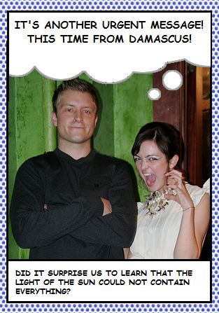

IT’S ANOTHER URGENT MESSAGE! THIS TIME FROM DAMASCUS! [Armstrong 2005a]

***

I’m a literary scholar and an editor, by profession – the kind of person who used to keep 3X5 cards in my shirt pocket, who would then, after a bit of mental processing (and much forgetfulness), transfer some of these notes to my word processor. When I read, even now, I make marks – I think about what the author is saying but I also think ahead to what I’ll be saying about the author, or about topics an author treats and I may want to treat differently. Commissions like this one, to write catalogue copy on a work that could be art, could be electronic literature, or some new amalgam or anomaly, run contrary to habits that I’ve internalized throughout a career that’s concentrated, mostly, on words in print.

The images that cycle through *Grafik Dynamo!* have been scraped from the LiveJournal site [9]. These are photographs, mostly, taken by digital cameras and posted on blogs and websites. I can remember seeing Roman, Greek, Cyrillic, Arabic, and Chinese characters among scraps of text that appear in the photos. (The purchase of the source site by the Russian firm, SUP, may have tilted the frequency toward the Cyrillic.) The images appeared to early reader/viewers, and they are in fact, “somewhat randomly retrieved” [Andrews 2006]. "Somewhat" - because is it ever possible to achieve randomness through programming? Coherence cannot be avoided, even if we try. The *sense* of a narrative, the *impression* of history in the making, persists in what we see.

The similarly “random,” though written, captions, speech, and thought balloons confirm the impression that something, somewhere in the background, is happening:

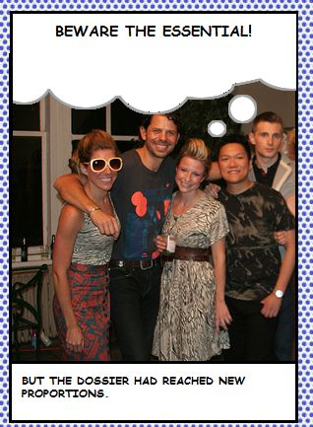

BUT THE DOSSIER HAD REACHED NEW PROPORTIONS.

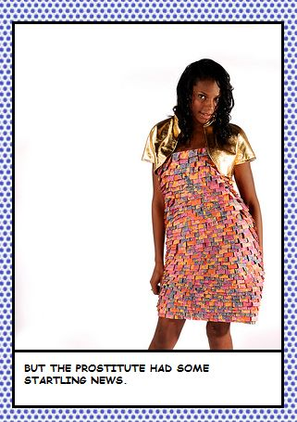

BUT THE PROSTITUTE HAD SOME STARTLING NEWS.

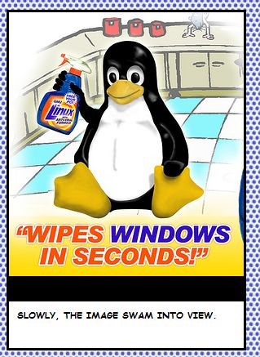

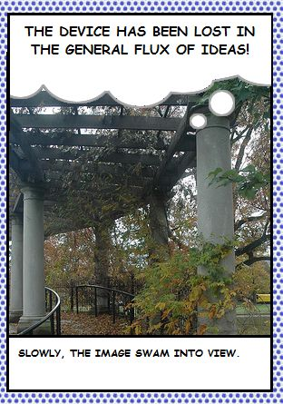

SLOWLY, THE IMAGE SWAM INTO VIEW.

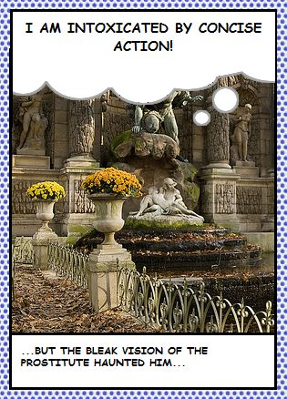

…BUT THE BLEAK VISION OF THE PROSTITUTE HAUNTED HIM… [Armstrong 2005a]

How little it takes, to place us in the stream: a “but,” an “ach!” an

adverb signifying development however “slowly”; the hint of something

“new”, even “startling”. A character, the “prostitute” for example,

needs only to appear more than once – and this is enough to stimulate

recognition, even without her being named or any attempt having been

made at characterization. We don't even know if she's a he or he's a she: that will depend perhaps as much on the image that happens to be attached to the text, as on any gender presumptions a male or female, hetero or gay, reader may bring to the word "prostitute”. What we experience is a sensation of meaning without meaning’s actualization in words. The message is self-contained; it requires no further interpretation on the part of the author, by us, by the LiveJournal, or the *Dynamo.* A narrative always seems to be in process, somewhere.

But not here.

Not in the place where we are reading, viewing, receiving the image/texts. Not in the office working (or playing games) on company time. Not at home where the Internet is paid by subscription. Not at the business center, wifi hotspot, or on the handheld we’re carrying.

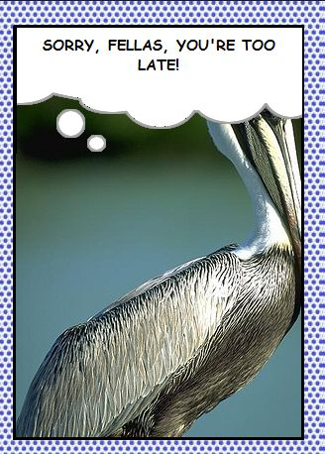

SORRY, FELLAS, YOU'RE TOO LATE! [Armstrong 2005a]

The *Dynamo* gathers images already found on blogs, sent through feeds, and located on various sites as they are updated. But the texts were written. Armstrong says she was drawn initially to science fiction and 1940s spy fiction:

*I was loving the brilliant innocence of both comics and that literature, where everything happens in either London or Damascus, people carry around suitcases of gems, and scientists become deranged by their magnificent powers.* [Armstrong 2005b]

Armstrong’s words arrive on the screen in the form of captions, thought, and speech balloons. They are pulled randomly from the author’s flat file, and sometimes they appear long enough for me to read one and view the accompanying image before I turn my glance to the next panel, and the next. If I’m quick, I can clip a text and paste it to a file of my own, for later reference. But that sort of careful, accurate, and attributed citation really is suited more for print projects. Here, on the screen, the news from London and Damascus reaches me without my having actively to go in search for it or for anyone to consider preserving it.

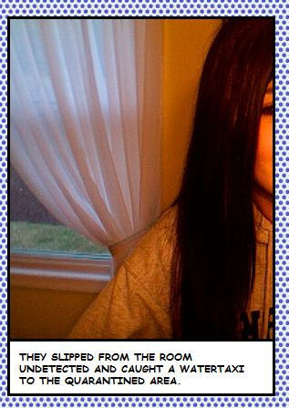

THEY SLIPPED FROM THE ROOM UNDETECTED AND CAUGHT A WATERTAXI TO THE QUARANTINED AREA. [Armstrong 2005a]

In the world of crime novels and comics, decisions emanate from some imperial center (“London”) in response to news from the outposts (“Damascus”). An atmosphere of international intrigue pervades but the center/periphery model does not conform all that well to the *Dynamo’s* present reality. Messages arrive, rather, from all places equally. They are all encrypted, but routinely decoded before they reach us, as plain text or attachments on the computer where we can enjoy a distracted, demanding, but mostly peaceful life in images.

An article of faith for the era of new media: If it is on the screen, if it has been captured already, it cannot harm us.

The news comes at us from everywhere, and if not from everyone in the world exactly, from the cross-section of bloggers who post on LiveJournal. “Incoming mail”: here it’s as if the “news” that reaches Captain Pirate Prentice at the start of Thomas Pynchon’s *Gravity’s Rainbow,* early one morning by way of a V-2 Rocket dropped on London, were now as common as the arrival of the morning email. In 1973 Pynchon, too, was playing off the staples of spy fiction and comics: someone, some somebody, a bureaucrat with a sense of humor, went to the trouble of replacing the bomb the Rocket was meant to carry with a little black box containing coded instructions. It’s also, for Pynchon, something of a stretch to bring an imagination of technology and international intrigue to the forms of conventional narrative. But readers at the time were willing, enough of them, to go with the flow and “suspend disbelief.”

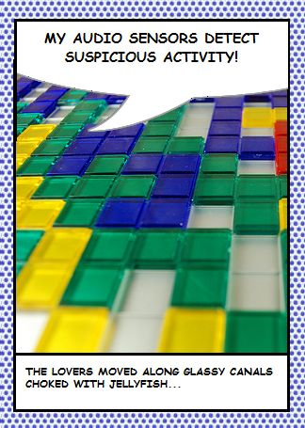

MY AUDIO SENSORS DETECT SUSPICIOUS ACTIVITY [Armstrong 2005a]

A willing suspension of disbelief? Try getting one of the kids from the Internet and computer gaming generation to do that. My own students, I suspect, are not put off so much by 700-plus pages of coruscating, brainy prose, as they are simply unwilling to go beyond their own suspicions, their self-reliant conviction that the materials they’ve gathered on the world are no less valid than what can be compiled by any literary author, living or dead, white, male, or otherwise.

This culture of suspicion, in some ways, is itself a legacy of the paranoid aesthetic advanced by writers of Pynchon’s generation. Technology and information, in the worlds of *Gravity’s Rainbow* and *Grafik Dynamo,* each can inflict its own violence on the texture of everyday life, but each is also capable of evolving. As cultures evolve through contact with an enemy in wartime, so, too, can one medium evolve when a new medium appears – and this medial evolution is enacted in the *Dynamo* when the texts Armstrong had written take on new meanings through contact with the unforeseen images:

*As I was working with these themes I found myself adding references to things that seemed more current, like evangelicals, lobbyists and apocalypse, and started to pull in other concerns, not usually associated with comics or hard-boiled crime novels, such as existential freedom & metaphysical structures like extra-temporal essence. These things started to feed back on each other so that all of a sudden I was discovering implications that philosophical states were being influenced by these mysterious machines, or that powerful non-specific figures were motivated by the desire to have outre religious experiences. So that's how the material evolved in the beginning. When it started to run against the influx of images I was happy to see that these associations became even more complex.* [Armstrong 2005b]

As the example of *Gravity’s Rainbow* shows, past literary practices have worked similarly, not *in* the genres of comics and crime fictions, but *with* these genres to get at the shape of the techno-culture. The “funnies”, purportedly written for children, are like more recent computer games and popular entertainments generally: they are ways that people learn to live with technological violence. (Transferred to the video or computer game screen, people also learn to work, as if work were “play”, within highly structured, desensitized desktop environments.)

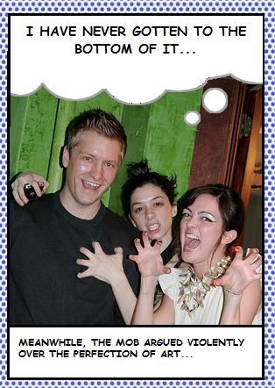

MEANWHILE, THE MOB ARGUED VIOLENTLY OVER THE PERFECTION OF ART... [Armstrong 2005a]

***

The best account I’ve read of the interaction between comics and technology (and the battle within comics between text and narrative, sound and dialogue, image and word) is in print but remains, as yet, (circa 2010) unpublished.

For the past few days, the manuscript on my coffee table has been a memoir in novel form by Phillip Wohlstetter; working title: *Valparaiso.* Going from the screen to the page, *in media res* and literally between media, I have reached Wohlstetter’s narrative of the military takeover of Chile on September 11, 1973. Is it so strange that, under fire, Wohlstetter’s narrator should enter into a digression about, of all things, the art of comics?

*I wonder if the people who drew comic books were vets. Sound bubbles with bold capitals and exclamation points don’t exactly reproduce the noises or explosions to which they allude, but they do capture their importance – their constant and imposing presence – by offering them equal space with dialogue or narrative, and I will follow their lead for a page…*

***TING-TING!***

***WROOKATOMBA!***

***POP! POP! TAKKA-TIK-TAKKA***

***WHOMP! WHOMP!***

***VROOM! VROOM! VROOM!***

***TAKKA-TING-TING-TING!***

***WROOKATOMOBAKKABOOM!!***

***TING! TING!***

***WHAKAWHAKAWHAKTHUMP! WHUP!*** [Wohlstetter, 200]

In his own fashion Wohlstetter, like Armstrong and Tippett, draws on the comic-strip genre even as he reflects on a national tragedy experienced at first hand. With no democratic leaders emerging at this moment to defend the Chilean government, with a personal will to resist the usurpers but no clear political agenda to follow, Wohlstetter (or his narrative persona) follows the lead of comic artists. The list that starts on manuscript page 200 turns into an all-over blast on page 201, filling the left- to the right-hand margin by the same sounds, repeated over and over (with an occasional ***POK!…*** here and there a ***WHUP! WHUP!****…* and at least one good old-fashioned ***RATA-TAT-TAAT!!***).Thereafter, Wohlstetter’s account of the coup continues as conventional reportage, or rather, a report of a halting record-in-progress:

*“I am standing here in Santiago, Chile, a corner across from La Moneda palace,” says a man in tweeds, “the office of President Salvador Allende.” He is talking into a cassette recorder. I didn’t notice his arrival. “I’m looking at the smoke and flames—“ Click. “Damn,” he says. He flips the cassette to the blank side. “I’m standing here in Santiago,” he says, but this time he stops, turning in alarm with the rest of us toward the drone of incoming jet engines.* [Wohlstetter, 188]

We are here, in front of *La Moneda* palace, with a narrator who will soon be running to escape the flames. Or rather, we might imagine ourselves in a photograph, a famous one (reproduced in the Wohlstetter manuscript) that shows a few civilians taking cover (but now running) under a billboard advertising Schick razors:

*“That one hit the roof,” says someone. Meaning it didn’t hit us. The planes draw away. I can feel in the crowd of onlookers a kind of collective exhalation, an unwinding in the gut, or maybe that’s just me. “Close shave,” says Fedora. He nods at the billboard atop our kiosk. It touts the chromium edge of the newest Schick razor blade.* [Wohlstetter, 188]

The contrast between Wohlstetter’s narrative and the dynamic presentation by Armstrong and Tippett is instructive: In *Grafik Dynamo!*, there's no narrator around to say, “it didn’t hit us”; no need, no reason, to establish a sense of place when the reader inhabits all places at once and is always “here,” safe at home, processing images on a screen.

It’s a “close shave”, for sure, between a moment of lasting historical change and its contemporary representation. For a richly diverse, extended period in North American literary history, it seemed that the novel could still register political changes by noting down the expressive changes in contemporary languages, not least the professional languages that were evolving along with a technological society. An account of the whaling industry in *Moby Dick*, the development of the German-American “Rocket State” in *Gravity’s Rainbow*, and the establishment of a neo-liberal autocracy in *Valparaiso*, could each fill in for the emergence of an entire world-system. The quest for domination, by Ahab, by Blicero, by Robert Coover’s comedian character, Richard Nixon, might have been strange accounts of a single, overreaching personality. But these narratives were able, nonetheless, to point a direction through the culture at large, to uncover a living aspiration toward world-domination within current arrangements.

The ever open, ever ambiguous literary representation can hold an audience, it seems, only so long as the world-system itself remains incomplete, and only so long as a sense of wonder exists in readers. Once a world-system takes hold in reality (as in Pinochet’s Chile), literary activity largely ceases. If the short-lived socialist state under Salvator Allende was unique, conforming neither to Marxist nor Maoist precepts, the counter-revolution and authoritarian capitalism that followed would become all too familiar. Although outright military force was usually avoided, the innovations of the U.S. backed Pinochet government were to be picked up and further developed by the Thatcher, Deng, Reagan, Yeltsin administrations and their successors. The revolutionary impulses of the Sixties and early Seventies, it was discovered, could be reigned in not through military force alone, but with a more ambitious, more subtle, and long-term expansion of the military into the social and the economic spheres (even as the military itself would be reconstructed on a corporate model: soldiers to be replaced, largely, by security forces, military engagements overseas decided in days or weeks, from the air, and other innovations described by the Mexican philosopher and sociologist, Manuel DeLanda, in *War in the Age of Intelligent Machines*).

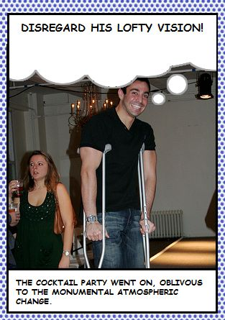

THE COCKTAIL PARTY WENT ON, OBLIVIOUS TO THE MONUMENTAL ATMOSPHERIC CHANGE. [Armstrong 2005a]

In North America, world fictions such as *Gravity’s Rainbow*, *The Public Burning*, *JR*, and *The Names* ceased to appear as the world-system established itself nearly everywhere, peacefully in some times and places, violently in Chile. “The generation of ’73,” Wohlstetter’s generation, the generation of Robert Coover, Don DeLillo, William Gaddis, and Thomas Pynchon, produced narratives that were as open to innovation, formally, as they sought to be expansive in subject matter. The embrace, by these writers, of comic forms can be seen in retrospect to have been more scandalous than the obscenities and broken sexual taboos, a generation or two earlier, in the work of James Joyce, D.H. Lawrence, Henry Miller, and Anais Nin. This latest, arguably the last, generation of world-epical story-tellers in the United States felt an attraction to the more popular, generic appeal of the comic strip, its ability to range from the joke to issues of cosmic importance, and its deflation of the high seriousness of modernist fiction between the World Wars. Knowing that the world was changed forever by technological violence, post-modern, post-World-War II writers in North America still went *out* into the world, they researched their themes, at times exhaustively, seeking power in knowledge. These writers sought not just literary materials, but also political alternatives in the countries where they traveled: Allende’s Chile, Castro’s Cuba, Mao’s China, America itself during the colonial, revolutionary, and antebellum eras. (Pynchon, for decades, was rumored to be walking the length of the Pennsylvania/Maryland border in preparation for *Mason and Dixon*, published in 1997).

In the restless tradition of Herman Melville, Henry Adams, Henry James, and Gertrude Stein, U.S. writers of the generation of ’73 often felt at home only among a community of expatriates.

Despite their cosmopolitanism, these writers worked, for the most part, alone. And their medium remained, for the most part, print: the medium of memory, the medium of language heard in the head, not in the ears.

Comics, the successor to the print novel, were “*what World War II brought back to America. Dulled eardrums.”* [Wohlstetter, 200]

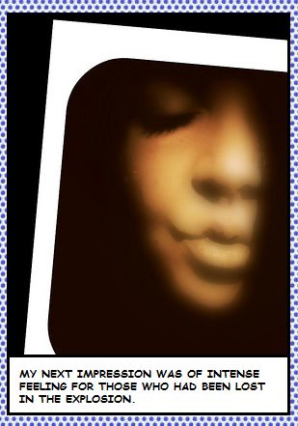

MY NEXT IMPRESSION WAS OF INTENSE FEELING FOR THOSE WHO HAD BEEN LOST IN THE EXPLOSION. [Armstrong 2005a]

***

These days, cassettes don’t break, journalists don’t need to go looking – and authors don’t hold onto manuscripts very long – after events. But can there be said to be an “after”, or a “before”, to be experienced while watching the graphic, dynamic images collected by Armstrong and Tippett? There are many “nexts,” frequent “meanwhiles,” “buts,” “slowlies,” “suddenlies,” and other signifiers of conflict and change. Repetitions and recurrences abound, contexts multiply but there is never a design-governing principle that would allow a narrative or an argument to develop. We still have, frequently, the drone of jet planes and the sounds of life during wartime. The unprecedented and generalized violence of the past century shows no signs of abating, in the new one. History, as such, is nowhere present in the *Dynamo* – not if we mean, by history, a narrative to be told about the rise and fall of nations, the formation and re-formation of imperial powers, the flows, blockages, collective aspirations, and economic segregation of populations. Neither is history present, significantly, in much fiction in the U.S. since the Eighties. Writers in print, during the past twenty or thirty years, have generally reigned in the previous decade’s worldly ambitions. Authors have learned to limit themselves to the domestic sphere, its intellectual range contained by the incorporation of writers into academic Programs, its subjective power channeled into the demands of possessive sexuality and commercial culture.

The comic, it would seem, is the only medium left with a mandate for presenting society whole, in broad canvas.



PATAGONIA HAD FALLEN!

...BUT THE DOSSIER, TOO, WAS MISSING...

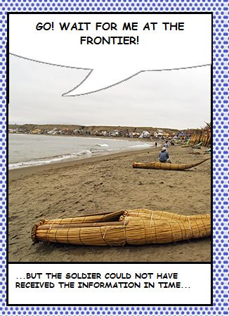

...BUT THE SOLDIER COULD NOT HAVE RECEIVED THE INFORMATION IN TIME... [Armstrong 2005a]

As if answering to the changed media environment, comics, and its upscale cousin the “graphic novel,” use tensions between image and text as a way to present society’s changes and continuing contradictions. This tendency was pushed further, through the Eighties and Nineties in the U.S. and Europe, by electronic media in which text itself could change. Experiments in hypertext and interactive fiction, for example, brought blocks of text together using hyperlinked words or phrases, producing alternative trajectories through a narrative and in principle, avoiding closure. Yet the programming, that made possible such freedom, was still in the hands of the author, so that the claim of readerly freedom proved largely illusory, like much else in a culture based on consumer “choice”. Such work purports not to represent the culture but to enact it.

THE WORK WAS A WONDER OF MONOTONY! [Armstrong 2005a]

The requirement of the new, post-war, post-imperial order is not simply that all work, including works of art, should change, but that change (like the accumulation of capital) needs to be *endless*.

By contrast, the work on our screen at this moment, a kind of designwriting practiced by Armstrong and facilitated by Tippett, is quite stable, formally and in its use of technology. The images change, to be sure, and the scripts themselves might appear one time as a caption, the next as a thought balloon. But the words themselves – what Armstrong actually wrote – are the same each time, and the simple, unchanging three-panel structure makes it possible for multiple meanings to be glimpsed in each sentence and sentence fragment, for associations to occur, complexities to develop.

Or not.

The creators seem to have realized (and their curators recognize) that stability, at the level of the medium, actually creates more opportunities than so-called “reader-interaction” for freedom in reception:

*Together, images and sentence fragments create a strange, dislocated sense and expectation in the reader. Sometimes at complete odds with each other; sometimes in complete synch, they are always moving, always changing. There is no reader-interaction with the work, no way to navigate it by pointing and clicking. Despite this, the work forces the viewer to engage in mental construction…* [Greene and Thorington 2006, 30]

The use of the word “force”, though overstated, is symptomatic and reinforces the military context behind so much of our contemporary rhetoric of “freedom”. So often, in the open networks of new liberal media culture, the user’s freedom becomes a compulsion to continue:

*…to forge a link between text and images…* [Greene and Thorington 2006, 31]

To “forge”: the combination of any two elements (even if only mentally) implies a kind of violence:

*…between thought balloons and sentence fragments, to find a connection between frames, to find a story; or to simply submit to the discontinuity and occasional moments of perfect or seeming sense.* [Greene and Thorington 2006, 31]

Submission to the given, finally, is the condition of narrative in the new media, the infrastructure supporting a new democracy, sort of:

*…of the net, by the net, for the net*. [Greene and Thorington 2006, 31]

Now that technologies facilitate the viewing of atrocities, deaths, events that occur at every instant worldwide, the call of narrative is no longer to locate such events in our own lives. What is required, rather, is a space where events can be at once received and held at a distance. Texts can be written, not as commentary or analysis, but as affective outbursts, capable of combining but only randomly, never through authorial purpose or intention.

NOTHING NEW. [Armstrong 2005a]

A condition of narrative in the new media ecology is that nothing, no alteration to the social or political order, can be allowed to happen, ever. That doesn’t mean that things don’t change, but when change is *endless*, when dynamism and innovation are requirements rather than exceptions, the arts of story-telling suffer. The narratives going on, online in the world at any given moment, can be ours *without touching us*, courtesy of the *Grafik Dynamo!* No other instrument performs so well, as the networked computer, the removal from the world of sequence, consequence, argument, and affect.

Or rather, affects are everywhere, but never in “us,” the reader/viewers.



I WOULD DO ANYTHING FOR SOMEONE WHO WOULD FIGHT ME!

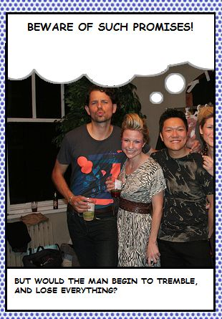

BUT WOULD THE MAN BEGIN TO TREMBLE, AND LOSE EVERYTHING? [Armstrong 2005a]

Still, as nature abhors a vacuum, minds (those accustomed to reading novels, watching films and TV, and listening to radio) cannot live without narrative – and so we respond to narrative’s absence by imagining stories of our own. I indulged the impulse “to engage in mental construction” [Greene and Thorington 2006, 31] on the day when I happened to clip those two *Dynamo* scripts about someone who “would fight me” and someone else, or maybe the same man (why not?) who was trembling. This happened to be the day that Eliot Spitzer resigned as Governor of New York State, hoisted by his own petard when a Federal wiretap recorded his calls to an escort service. A coincidence? Maybe, maybe not – but suddenly the line I’d been noticing for weeks, concerning the man who is about to “lose everything”, puts that other line about the prostitute with “startling news” in a kind of perspective. Meaning begins to accumulate.

Or not.

I know that the texts were written before Spitzer became a headline. In the mind of the author, Kate Armstrong, these sentences can have had nothing to do with Spitzer, but that’s the story I, the reader, happened to be following, offline in the news, those days.

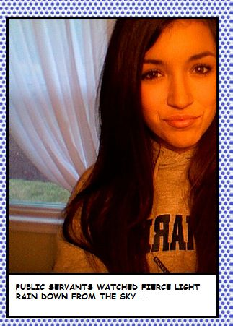

PUBLIC SERVANTS WATCHED FIERCE LIGHT RAIN DOWN FROM THE SKY… [Armstrong 2005a]

The same caption will appear under different images (human, animal, machinic, organic). First the cartoon monkey, then the banana, can be seen speaking the same line. These particular image-captures are part of a poster having to do with Barack Obama, as it happens: the Democratic Party primary campaign was still under way. Around this time, Tuesday 4 June 2008 (the day of caucuses in Vermont, Rhode Island, Texas, and Ohio), I also caught a glimpse of a T-Shirt, “Hot for Hillary”.

As it happens.

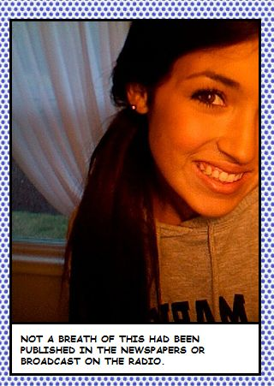

NOT A BREATH OF THIS HAD BEEN PUBLISHED IN THE NEWSPAPERS OR BROADCAST ON THE RADIO. [Armstrong 2005a]

We can be sure that events are happening, unreported and unavailable to the dynamic of Web capture. This knowlege, somehow, is comforting. But not once, not ever, is there more than an accidental connection between one affective moment and another. Narrative is kept, literally, out of the picture.

“There's affect everywhere“ - emotion, pathos, psychological involvement. The scripts, capitalized and presented often as exclamations, might be said to combine the spare diction and thematic expansiveness associated with the classical tradition of the Sublime. The word turns up, I notice, in at least two scripts: There’s the man who’s “clothed in sublime richness.” The crowd, a frequent appearance in the *Dynamo* whose collective agency is more consequential than any individual’s, is said to be “struck, as one, by the sublime mystery.“

But even if the word itself never appeared, Armstrong’s scripts would still be sublime in their frequent concern precisely with what is *not said*. Even as the images depict what cannot have happened (not to us), we are made to sense, through combinations of image and text, those places where language has reached its limit.

The Sublime is what Romantic poets felt in the presence of nature. It’s what Henry Adams felt confronting the first electronic Dynamo, whose powers he felt would usurp those previously associated with sex and religion. It’s why Frank Zappa can’t say where she’s coming from when he’s just met a girl named Dynamo Hum. It’s the sum total of all expression at any moment on the LiveJournal, as captured and presented by the *Grafik Dynamo!*

DISREGARD HIS LOFTY VISION! [Armstrong 2005a]

***

The *Grafik Dynamo!* graphic – where have I seen this before?

I remember seeing something like it the other day on Travelocity, when I was booking a flight (Chicago to Vancouver, Washington, where Kate Armstrong would be presenting her work, then on to Berlin). There has to be a deeper visual history, I know. Without exactly remembering, I have seen something similar on show posters, in prints, on television, and sure enough an Internet search brings me back to those earlier media. The curvilinear title – it descends from Buffalo Bill Cody posters from the 19th Century, that’s where Armstrong and Tippett got the lettering, the drop shadow, gradient red range. It seems to have been a popular choice for monster movies, and the *Grafik Dynamo!* certainly channels plenty of modern monstrosities, mutants, impossible permutations: those animals with diminishing atomic weight, those mysterious things of science, the undisclosed doings, “meanwhile”, at the fumigation center and so forth.

The graphic appears also in shows on Vaudeville and in Nashville, Tennessee.

Oh and there it is, the most famous of all probably: the Ben Hur movie poster, foremost among dozens of adventure film titles that I found on GRAPHICINTENETSIT.COM.

Where will I see it, once I’ve lived with it in my browser window for some several weeks?

In the city of Kiev, en route to somewhere else, I saw it in Cyrillic on a billboard advertising Индиана Джонс (Indiana Jones). *Ben Hur* and its filmic tradition have gone global. In Kiev, one can see almost the same curvature as can be seen in the Armstrong/Tippett title, the same lettering in black and orange.

The curvature, I only just now notice when I glance at my bookshelf, is found also in the second word in Scott McCloud’s book title, *Understanding Comics* – the very book a designer friend lent me, so that I might write knowledgeably about *Grafik Dynamo!* The oversized critical-essay-as-comic-book (offering “a ring-side seat for the battle of words and pictures”) went with me on the plane to Croatia, then to Kiev, back briefly to Chicago and then to Vancouver, Washington, where I returned the book to the friend who lent it to me, so that he could return it, in turn, to his library at the University of Minnesota, Duluth. I was given, in turn, Phillip Wohlstetter’s novel-in-manuscript, to read on the plane home.

The Wohlstetter manuscript was passed to me by Rob Wittig at the 2008 meeting of the Electronic Literature Organization in Vancouver, Washington. Kate Armstrong, whom I met there for the second time in four years, followed up by kindly sending me details on the production of *Grafik Dynamo!* Networks, and occasionally narratives, are capable also of forming *around* a work of electronic literature. There is a practice of everyday life for many who create e-lit involving travel, conferencing, collaboration and attempts at co-production, to keep the work circulating in multiple media. As McCloud’s wording suggests, the medial encounter between words and images can be itself part of a “battle”, but there is also the possibility of opening new cognitive possibilities in the spaces “between” media. In comics, there are mysteries within each panel – the head that comes off the torso with a tip of the hat, is the example McCloud provides. And then the hat that comes off the head.

It’s heady stuff, for sure, what the panel can convey with its lexicon of lines, symbols, icons, and images in combination with words: the way a line, by itself, can convey either “fear, anxiety, and madness,” or “calm, reason, and introspection”; either warmth and gentleness, savagery and deadliness, or a rational, conservative disposition [McCloud 1994, 124-125]; the way that the sketched expression on a face produces the same expression in ours, while reading – even as, in life, we react to others unconsciously with our own expression – and all this happens *prior* to verbal communication.

All that happens within a panel, or inside the panel created when one living body comes into visual range of another – as a friend or enemy, depending on what’s communicated pheremonally and muscularly, in a face-off.

But, for McCloud, “It’s the power of closure between panels” that is most interesting.

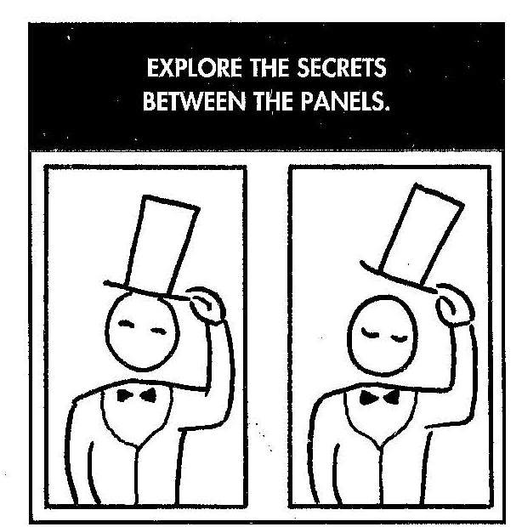

*We already know that comics asks the mind to work as a sort of* ***in-betweener*** *– filling in the gaps between panels as an* ***animator*** *might – but I believe there’s still more to it than that.* [McCloud 1994, 88]

I think so, too. Within a panel, as McCloud notes, “We can only convey information visually” [McCloud 1994, 89]: word balloons and transliterations (CHOP! CHOP! CHOP!) can only *suggest* sounds (but suggestion usually is enough); the squiggly lines above a boiling pot can be all it takes to locate us in a kitchen, where we know something about smells. The same squiggles above a pile of garbage, locate us in an altogether different setting, stimulating several senses at once.

Still, strictly speaking, the visual is the only sense in use, in us, when reading.

*But* ***between*** *panels, none of our senses are required at all.*

*Which is why* ***all*** *of our senses are engaged!* [McCloud 1994, 89]

The total engagement – Arthur Rimbaud would have said the “derangement” or unruliness – of sense experience. *Le dereglement des tous les sense*: this too, is a characteristic of the Sublime, the aesthetic of disruption, the aesthetic of war (in contrast to the Beautiful, which has more to do with sensual life and loves). McCloud has zeroed in on the right aesthetic, for recognizing and realizing the potential of his own “invisible art” of comics. But the engagement, to the point of *disorganizing*, the senses is not, in itself, the full story: the liminal space between frames is all on the side of perception, not communication – and you do not have art without a movement from one to the other, perception, communication, and back, continually. What engages the senses, necessarily, is *operative*: it makes something happen in our minds, but pre-reflectively, and in a way that cannot be communicated to another mind (except by force, even if it’s the genial force of a smile in one person conveying a smile in the other).

Perception works, in aesthetics as in cognition, precisely *because* it is kept offscreen (in comics) and out of consciousness (in face-to-face encounters). When perceptions are fully engaged, this is of course a powerful experience – hence the power of the Sublime in aesthetics, and the highly evolved perceptual power that each person possesses, and has possessed since before the emergence of rational thought. But that power, which necessarily blocks conscious awareness, is only a stage in the development of an artform. The completion comes with reflection, and communication – and for this we need precisely a medium that *reduces* sense experience, which can be conveyed not directly (like light, sound, and touch) but indirectly, as when we grasp a *meaning*.

The medium that remains best suited to such communications, as far as I can tell, is the printed word.

The skilled use of this medium, even in the age of the word’s technological obsolescence, is what distinguishes critical comics by McCloud and the graphic sublime of the *Grafik Dynamo!*

McCloud’s work is not criticism, and Armstrong/Tippett’s work, as I have argued, is not narrative. But these works have the virtue of letting us know, sensually, what it is we’re missing – in an era that systematically denies the development of critical and narrative experience.

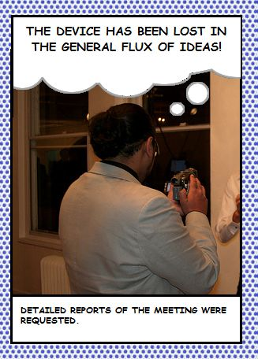

THE DEVICE HAS BEEN LOST IN THE GENERAL FLUX OF IDEAS! [Armstrong 2005a]

**Notes**

[1] Shteyngart's novel was published by Random House (New York, 2001). A description of the book's exaggerated realism appears in the course of James Ellis's critique of James Wood, a reviewer at *The New Yorker* and fierce apologist for narrative and a kind of tempered psychological realism in mainstream publishing. Ellis's essay is under consideration for publication in *ebr* (www.electronicbookreview.com).

[2] The entirely necessary distinction between 'digitized' and 'born-digital' literature, I take from an essay by Serge Bouchardon, "Digital Manipulability and Digital Literature," forthcoming in *ebr* (www.electronicbookreview.com).

[3] Shteyngart, born in Leningrad (not St Petersburg) and hence a child of post-Soviet Russia, must be aware of the convergence of his imagined 'äppäräti' and the social control formerly entrusted to apparatchiks.

[4] In *The Science of Passionate Interests* (Chicago: Prickly Paradigm Press, 2010), Bruno Latour has noticed the renewed relevance to our present new media culture of Gabriel Tarde's 19th century theory of an economy based not in the exchange of commodities, but in the calculation of 'passionate interests.' The difference is that calculations that were, in Tarde's time, tacit and held in consciousness, are now explicit and held in databases, more ranging in their sample, and capable of being carried out quickly.

[5] Gaylen Strawson offers another context for this argument (against the mainstream of cognitive approaches to literature), when he insists that the majority of humanity (for most of history) have experienced their lives without resorting to narrative explanations. Notably, Strawson cites Joyce and Musil as literary figures whose non-narrative fictions are more in line with his own cognition, and his own lack of interest in the narrative shaping of life experiences. (See my essay, "Cognition Against Narrative," an introduction to six essays on contemporary cognitive fictions in *The American Book Review*, available online at HTTP://www.electronicbookreview.com/thread/fictionspresent/antinarrative.)

[6] An early, and still influential call for "media specificity" in writing about born-digital literature was made by N. Katherine Hayles during her keynote lecture at the 2001 meeting in Santa Barbara of the Electronic Literature Organization. My own argument is somewhat different: the closer we get to the operational devices and software, the more we must resist them (the way a musician engages and resists an instrument) in order to achieve the distancing and defamiliarizing effects that are needed to achieve literary qualities in new media.

[7] Shteyngart's soon to be middle aged narrator is not optimistic about the continuation even of this, admittedly reduced, power of the literary novel: he is "learning," like his 24-year-old lover, “to worship my new äppärät's screen, the colorful pulsating moment of it, the fact that it knows every last stinking detail about the world, whereas my books only know the minds of their authors." (*Super Sad True Love Story* 78).

[8] Kate Armstrong, *Tributaries & Text-Fed Streams*, curatorial statement, online at *The Capilano Review* January 18, 2008.

[9] Until 2008 *Grafik Dynamo* pulled images from LiveJournal. From 2008 onward, the work pulled images from Flickr.

## Works Cited

[Andrews 2006] Andrews, Jim. *Poetics*, June 30, 2006

[Armstrong 2008] Armstrong, Kate. “*Tributaries & Text-Fed Streams”*, curatorial statement, in *The Capilano Review* online at <http://www.turbulence.org/curators/armstrong/index.html> , January 18, 2008.

[Armstrong 2005a] Armstrong, Kate. *Grafik Dynamo* online at <http://www.turbulence.org/Works/dynamo/>

[Armstrong 2005b] Armstrong, Kate. Post in Rhizome.org, online at <http://rhizome.org/discuss/view/16320#31190> , February 16, 2005 11:14 am

[Greene and Thorington 2006] Greene, Jo-Anne and Helen Thorington. *Turbulence.Org: A Presentation of Select Commissioned Works for Upgrade Johannesburg*, in *Turbulence Commissions & Support Net Art* on line at <http://new-radio.org/helen/writing/Upgrade_Joburg_06.pdf>, April 7, 2006

[McCloud 1994] McCloud, Scott. *Understanding Comics*. New York: Harper Perennial, 1994

[Wohlstetter -] Wohlstetter*,* Philip. *Valparaiso (manuscript)*