Old Ways for Linking Texts in the Digital Reading Environment:
The Case of the Thompson Chain Reference Bible

Brent Nelson (University of Saskatchewan)
brent.nelson@usask.ca

Jon Bath (University of Saskatchewan)
jon.bath@usask.ca

and the INKE team

INKE (Implementing New Knowledge Environments) is a humanities-led project whose mandate is to inform and influence the development of reading technologies to ensure that the needs of the most exacting of readers (principally, scholars) are met [www.inke.ca]. The textual studies team in INKE adopts a perspective that is at once historical and critical. Our close attention to book history gives us a historical frame in which to assess the present state of digital textuality and to inform future developments in reading technology in the digital environment. It is from this point of view that the present paper addresses what we call the problem of chronologism in this incunable period of digital publication. This problem is evinced, on the one hand, in the dismissal of a mature technology—print—as an outmoded medium that has already been surpassed, and on the other hand, in the popular valorization of the digital medium (still in its infancy) and the revolution in publication that it has launched. As a counter-point to this bias, and a point of context for the work of the Textual Studies team in the larger context of INKE, this paper introduces a powerful system for linking texts, a system that in some ways exceeds the capacity of current Web-based hyperlinking, and one that was born in print. Indeed, this technology is about 100 years old, and its intellectual origins can be traced back almost two millennia. The technology in question is the chain-linking referencing system invented by Frank Charles Thompson and implemented in his Thompson Chain Reference Bible, first published in 1908. The modern iterations of this bible offer powerful reading environments that in many ways offer a critique of the digital reading interface. This paper will briefly survey the historical development of linking systems in the Christian Bible, from their theological foundations to their formation in the architecture of the printed book. It will then examine the apogee of intra-Biblical linking systems in the Thompson Chain Reference Bible, particularly its chain-referencing system for thematic linking between texts. Finally, it will use this mature print technology to consider the state of the hyperlink in current Web-interfaces. It will show that, while in many ways modern attempts at a dynamic hyperlink surpass this elaborate linking system in functionality, in a few key functions, this old print technology out-performs what is commonly and readily available in current Web-browsers. In pursuing this comparative analysis we aim to demonstrate the importance of understanding the organization and navigational structure of the codex in designing digital reading that will meet and surpass the affordances of print.

On the demands of the reader upon reading technology
The development of reading environments goes as far back as the invention of writing supports, but the introduction of print technologies brought new possibilities for rich reading environments that could meet the needs of demanding readers. Among the most exacting of readers were students of the Christian Bible. Scholars and theorists of new media have given scant attention to the achievements of enriched reading environments in the modern study Bible, yet in many ways the modern pioneer of the genre, the Thompson Chain Reference Bible, anticipated both the hyperlink and the graphical interface, foundational and familiar elements of the World Wide Web. Book historians have long recognized the Bible as a central site for the development of reading technology in western history. For centuries, the Bible has been the focus of serious study and scholarship as a sacred text, and the very nature of Christianity as a religion of the book has ensured that this text has been subjected to the most rigorous demands of readership. This is not to suggest that other readers of sacred scriptures weren't demanding, but Christian theology was of a particular nature that demanded a certain kind of access for its followers to their sacred text. From the beginning, Christian exegesis was based on placing passages in dialogue with each other, an intense and intricate hermeneutic of intra-textuality. As the poet George Herbert expressed it in the seventeenth century:
This verse marks that, and both do make a motion
Unto a third, that ten leaves off doth lie:
Then as dispersed herbs do watch a potion,
These three make up some Christians destinie [“The H. Scriptures II,” lines 5–8].
Christian theology of various stripes was built on theme-based linkages between texts. What George Herbert describes here particularly is the hermeneutics of typology. The typological method looks to the Old Testament for characters and incidents (the type) that anticipate or foreshadow by some resemblance an element or aspect of the New Testament, particularly in the life of Christ (the antetype). This typological habit derives from Jesus’ own method of correlating events related to him with historical incidents in the Hebrew Scriptures. For example, “And just as Moses lifted up the serpent in the wilderness, so must the Son of Man be lifted up, that whoever believes in him may have eternal life” [John 3:14–15] alludes to Numbers 21:4–9. In a typological reading, Moses’ act of deliverance on the cusp of the Promised Land is taken to be a type foreshadowing the crucifixion. This method of correlating Christian teaching with Old Testament events is core to St. Paul’s theology and central to the Church Fathers.
This view of the text and what it means to read it made navigation and referencing essential to the needs of a Christian reader of the Bible. It is not surprising, therefore, to find that a great many of the important developments in reading technology were implemented in the course of Bible production, some of which have informed book production more widely, and many more that have never extended beyond Bible-reading environments. In this paper, we focus on one area of functionality, the function of referencing.

Historical background: the development of the reference bible
Referencing helps the user to identify and locate a target text and to share that location with others. In paper-based reading technologies, referencing is enabled by structural divisions and markers in the text. Until these divisions became universalized, readers of the Bible relied on scanning large portions of text or on mnemonic methods for remembering or referencing particular locations. Thus, textual navigation took a big step forward with the introduction of chapter divisions, introduced by Stephen Langton, Archbishop of Canterbury, in the early 13th century to enable referencing and, in turn, cross-referencing, an important function in his system of exegesis [Gibson 1993, 10]. The adoption of these chapter divisions by the commercialized scriptoria of Paris led to their universal implementation. Another divisional marker for navigating the Bible came with the numbering of the folio and then the page, but the limitation of this device, unlike the universally adopted chapter divisions, was that its use was specific to a particular edition and thus could only serve as a device for information exchange if two users were using books from the same printing. Introduced to bibles by Erasmus in his 1516 edition of the New Testament, pagination (according to Paul Saenger) placed a “renew[ed] emphasis on the leaf as a locus point” that “reflected a concern with precision in text location as an indispensible aid in the painstaking task of textual comparison” [Saenger 1999, 35]. This move toward greater structural granularity was driven by both the humanist passion for textual accuracy and the imperative of Christian exegesis. With the Reformation and the printing of the Bible in the vernacular, a greater emphasis was placed on public preaching and exegesis, adding new motivation for a common and universal referencing system.
Neither foliation nor pagination made much of an impact on the architecture and navigation of early bibles. More important was the introduction of mechanisms for locating precise passages within the established chapter divisions. The first major development in dividing chapters was the use of marginal alphabets. This feature of book architecture began as a purely mental system, known as the Dominican index system, developed by Hugh of Saint-Cher in the mid-13th century as a way of thinking about and referring to chapters by dividing them into units, imagined either as four or seven sections nominated A through D or A through G respectively. By this method, a concordance, for example, could reference a particular use of a word by naming an imagined point in a numbered chapter with an added measure of specificity—if the reader was adept at making such mental calculations, and provided the calculations of the creator of the concordance were correspondingly adept. Alphabets were first written upon the margins of manuscript Bibles by the Lollards at the end of the 14th century in their copies of Wycliffe’s vernacular New Testament, which were intended for use by the laity. These were used not as a generalized structuring system for navigation, but rather as dedicated pointers to correlate text and paratext. The letters were placed in the margins adjacent to the point where each new Gospel or Epistle reading for the day began, according to the Use of Salisbury.
By the mid-16th century, the alphabet system was no longer needed for Bibles, which now had standardized verse divisions in place. The first complete numeration of verses through the entire Bible was accomplished by another Dominican friar, Santes Pagini, in a 1528 Lyonese Bible. Robert Estienne (aka Stephanus) introduced the modern verse divisions that are in use today, printing the numbers intra-textually in his 1555 Bible to mark these divisions. The Geneva Bible introduced these same verse divisions into the English Bible. This development of a largely arbitrary common referencing system is unparalleled in print culture. The Christian Bible is the unique instance in the western tradition of a common text that has acquired a universally adopted, canonical referencing system of such granularity. From this canonical referencing system grew a series of navigational aids that have made it the most navigable, and probably most navigated, book in the western tradition. In particular, it made all the more powerful two long-established navigational architectures: the concordance and the marginal cross-reference, both of which are common in modern Bibles. The concordance works much like an index, pointing from outside the Biblical text to passages that contain a particular common word. Marginal cross-references are internal citations that point to a related passage elsewhere in the Bible. These are sometimes, but not always, bi-directional. And sometimes one can jump from one verse to another, and from there to yet another (and so on), following a related theme or idea across the Bible, but usually these linkages are haphazard and not so extensive.

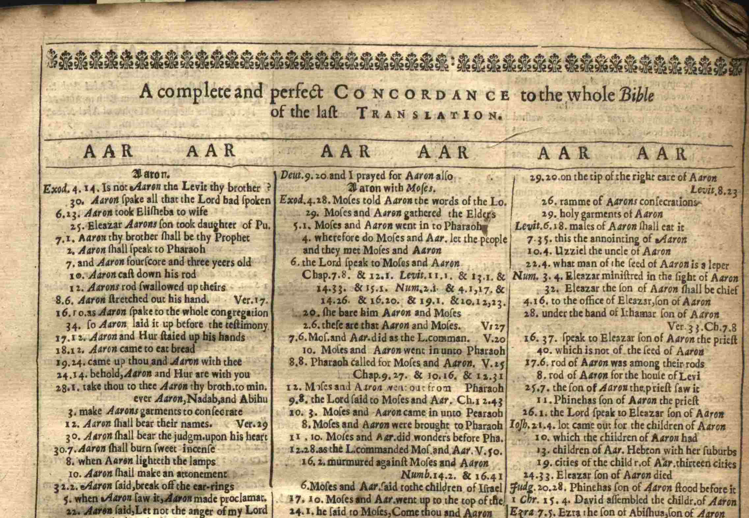

Figure 1. The first modern concordance of the Bible in English. Samuel Newman, A large and compleat concordance to the Bible in English 2nd ed. (1658). Published by permission of the Thomas Fisher Rare Book Library, University of Toronto.

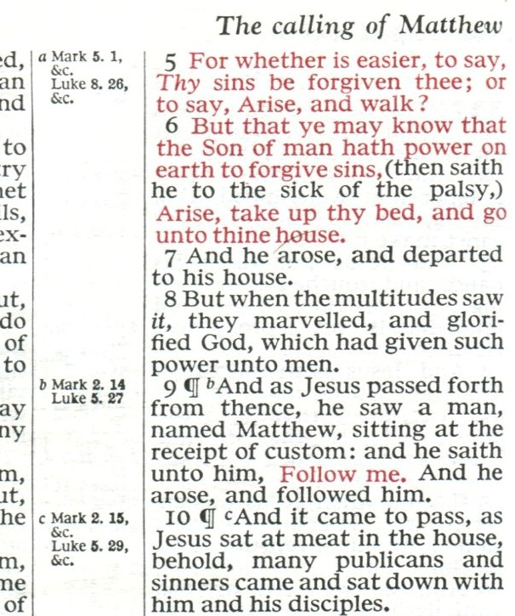

Figure 2. An example of the modern marginal cross-reference.

The point of this brief survey is that a particular kind of reading and an increase in lay readership motivated this important navigational innovation to enable ease of use, and that in this mature medium of print, we have an example of a highly refined, sophisticated, and powerful navigational system that developed over time into such an essential element of Bible reading that it seems perfectly natural to the text.

The Thompson Chain Reference Bible as reading technology
A major development in Bible navigation systems came with the publication of the Thompson Chain Reference Bible in 1908 by Dr. Frank Charles Thompson. Thompson was born in 1858 in Elmira, New York and was ordained in 1879. As a young preacher in the late 1800s, Dr. Thompson became dissatisfied with the reference Bibles that were then available. He recognized a need for a study Bible that was easy to use and yet scholarly, and above all, one that would enable informed navigation of this much-travelled text. He started developing a navigational system for his own use, which would become his chain-link system. Some members of his congregation saw Thompson’s annotated Bible and his linking system and encouraged him to publish it so others could benefit from it. In 1908, the first edition of the Thompson Chain Reference Bible was printed by Methodists Book Concern of Dobbs Ferry, New York. In 1913, Thompson partnered with B. B. Kirkbride in Indianapolis, Indiana, to form the Kirkbride Bible Company, which publishes the Thompson Chain Reference Bible to this day. Published three-quarters of a century before the World Wide Web, Thompson’s chain-reference system in many respects anticipated the modern hyperlink.
Thompson’s system identifies an extensive list of topics and between five and twenty references from throughout the Bible that speak to or exemplify each topic. Thompson’s topics are extensive, though selective, and, as one would expect, theologically determined. The topics are identified in the margins adjacent to the relevant verse, and each verse is linked to the next in a series of references pertaining to the topic, creating a chain of links that run through the Bible on each topic. For example, in the margin at Matthew 9:9, we see:

ch. 4.20, Obedience to Christ,
[ch. 21.6

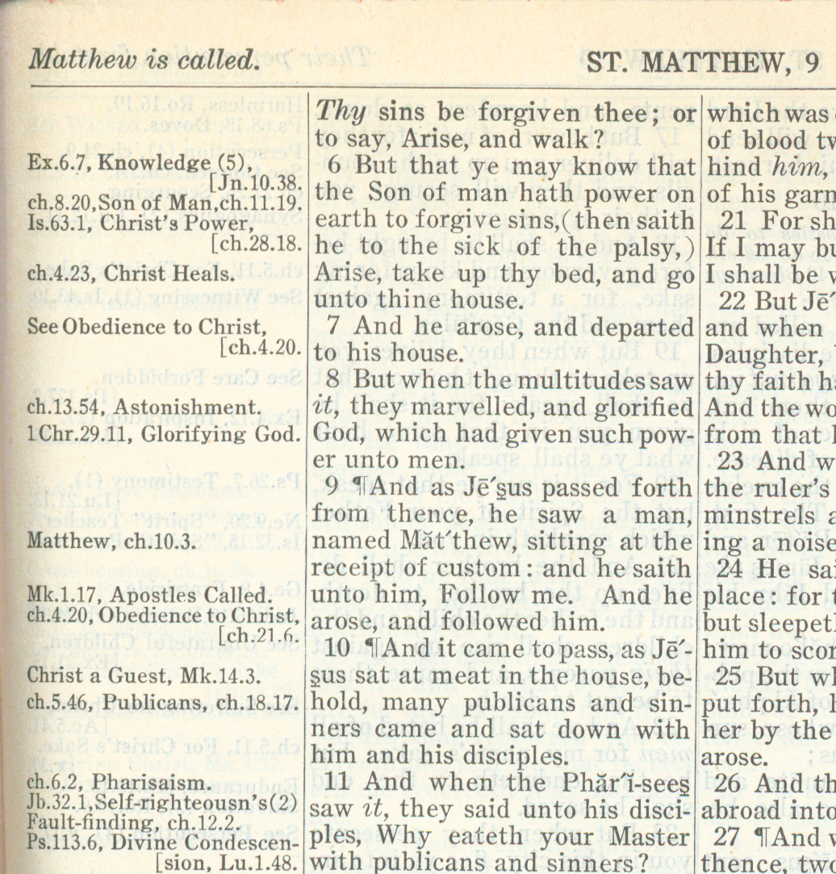

Figure 3. Detail of Matthew 9:6-10 from The Thompson Chain Reference Bible (1908).

This is a link in a chain of topical references, and it points in two directions. It points forward to the next point in the chain—Matthew 21.6 (which in turn points to Matthew 26.19, and so on). And it also points backward to the first link in the chain—Matthew 4.20: that is, one can’t jump to the immediately prior point in the chain, but it is possible to jump back to the first and work through the chain to the present link, and from there onward to the last. The chains are not intended to be exhaustive. For example, at Matthew 9:7 we find a marginal note that says:

See Obedience to Christ,
[ch.4.20.

The verse is not itself part of the chain, but the marginal note again points us in two directions. It points first to the topic, “Obedience in Christ,” which is listed in an alpha-ordered “Subject-Index” at the back of the Bible, under “O.”

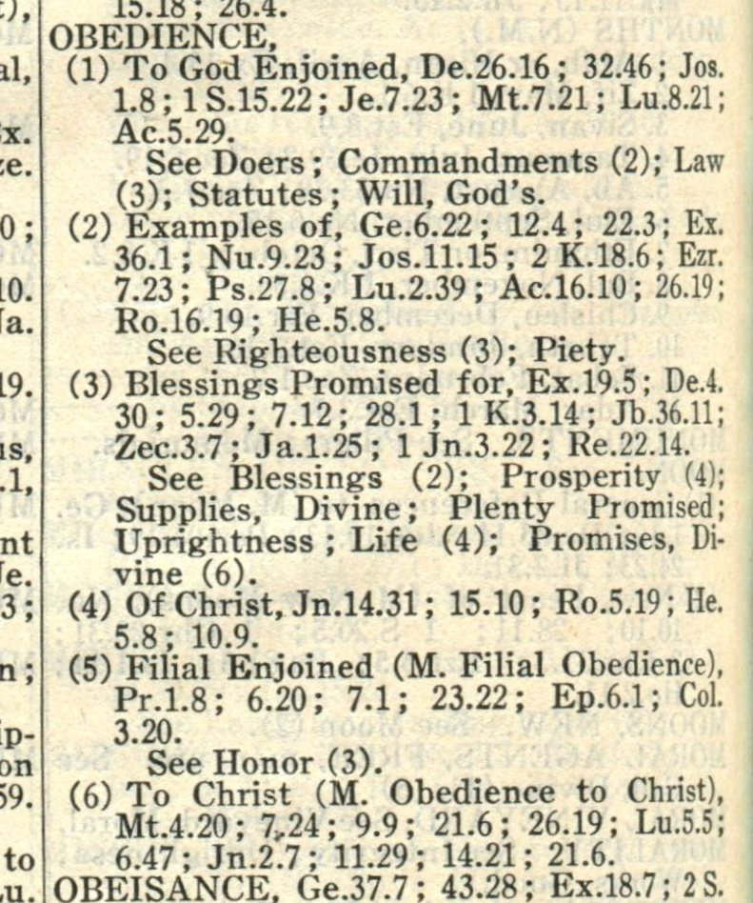

Figure 4. Detail of topic of "Obedience" from The Thompson Chain Reference Bible (1908).

Here one can see at once all the links in the chain. The second direction is, again, back to the first reference in the chain on this topic, Matthew 4.20. In this way, there are really three ways of entering the chain: by a link in the chain, by a topically-relevant verse that is not part of the chain but directs the reader to that chain, and by means of the topical index in the back. Once in the chain, the user can jump forward to the next link, backward to the first link, or to any point in the chain through the topical index at the back, effectively enabling the reader to move back to a point in the text that has not been visited previously.
Thompson’s links are not only multi-directional, but also declarative about the nature of their linkage. Each link indicates the nature of its target. In the instance cited above, the topical title—“Obedience to Christ”—identifies the content of the linkage: all of the verses in the chain have this theme in common. It is also worth noting that in the immediate context of these declarative links, one might see themes of related interest pointing to other chains, such as “Discipleship” or “Christ’s Power” in the context of Matthew 9, or other topics related to “Obedience” in the context of the subject index. In this way the reader has access to a web of thematically related links intersecting along any given thematic chain.

The Thompson Chain Reference Bible in the digital environment
Olive Tree Bible Software has developed an electronic version of the Thompson Chain Referencing system for use with hand-held devices. Based on the description of the product on the company’s Website, which features prominently the history of Thomson’s bible, together with a summary of its study helps, it appears this new version of the Bible is aiming at the same audience that has come to value its print counterpart. Given the similarity between the Thompson Chain Reference Bible’s linking system and the hyperlink, and more generally the need for making textual connection, one might understandably expect an electronic version to exploit the linking functionality so brilliantly anticipated in print. Interestingly, the electronic version provides less hyperlinking capability than the printed Bible does.

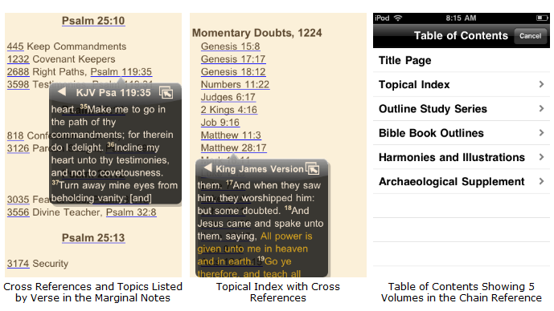
Figure 5. Screen shot of a demonstration of the Thompson Chain Referencing System for iPhone. Olive Tree Bible Software.

The Olive Tree Website declares that this system “works with any Bible translation in your electronic library,” which is not as promising as it sounds. The availability of a canonical referencing system would make it a relatively simple matter to make this navigational superstructure compatible with any of the many versions of the Bible that are available for hand-held devices, but in fact it is tied to the versions published in the Olive Tree electronic library. The possibilities for this sort of stand-off relationship between canonical structure and textual content are illustrated by Paul Dyck’s electronic edition of a seventeenth-century “concordance” or “harmony” (a cut-and-paste patchwork of printed Bibles recomposed to correlate parallel passages in the synoptic Gospels) that was produced by Nicholas Ferrar’s community at Little Gidding in Cambridgeshire. Dyck and collaborator Stuart Williams developed an application called “Gospelgrab” to reconstruct these Bible-based documents. Dyck uses XML to describe the skeletal structure of the concordance based on the canonical referencing system of the Bible. Williams wrote a script in Python that uses these references to “grab” the referenced texts from a public-domain King James Bible to populate the structure. One might imagine a similar function for the electronic Thompson Chain system, but instead, the long history of refinement in biblical navigation stops short at the very point where just such a system seems to lead.
More disappointing is the lack of link-forward functionality within the text itself. In the print version the links are located in the “marginal notes” directly adjacent to the relevant text. In the hand-held version the links are segregated to a separate screen so that they function very much like an index that points into the text, rather than enabling the user to link through the text. In the Android version, the topic number is a hot link that will bring up, in a new window, the full biblical text, cued to the nominated verse. To navigate to another verse in the chain, however, one must leave the Biblical text and return to the skeletal index. The iPhone version is slightly better in that clicking on a link brings up the individual text in a pop-up window, leaving the index visible behind it. Crucially, neither version allows a true hyperlinking, click-forward function. Looking at the page of a printed Thompson Chain Reference Bible, with the topic-number placed in the margin beside the text, one could easily imagine clicking on the topic “link” and moving from text to text through the chain of related passages. The Olive Tree software does not offer this functionality. Further, given that all of the links are already determined, one might also imagine having at each link in the chain the option of linking forward or backward through the chain. Rather than building upon the remarkable functionality of the print architecture of Thompson’s system, the electronic version reverts back to a much more traditional index-based navigational architecture.

Old ways of linking vs. new
So then, what can be learned from this episode in the history of print? Above all, it behooves digital humanists to study and critique such achievements in print as a means of evaluating the current state of Web-based knowledge environments in order to better articulate desiderata in this new medium. For example, the Thompson Chain Reference Bible’s system of chained references immediately calls to mind the Web-browser environment where points in different texts link to other points in other texts, but there is a crucial difference between the two. In current Web browsers one can move forward to another document via a hyperlink or use the “Back” or “History” functions to re-visit documents which have already been viewed. In the Thompson Chain Reference Bible, one can also use the chain system or the index to move backwards through the text to discover previous points in the chain which have never been previously visited. The closest Web-based approximation of this behaviour is to take advantage of a search engine’s index of links to identify pages that link to the page in question; for instance, one can use a standard Google search box to determine which pages link to a certain page using the search syntax: “link:[URL].” For example, “link:www.inke.ca” locates all the pages that link to www.inke.ca and then presents to the user a list of those pages. However, knowledge of this capability is far from widespread, and it is not well integrated into the standard functionality of the Web-browsing environment. The bi-directional capability of the chain system is one capacity of a print-technology that electronic environments are just beginning to implement, and imperfectly at that.
The tremendous amount of intellectual labour involved in the creation of the Thompson Chain Reference Bible speaks to another issue, one of critical importance as ever-increasing amounts of print material are digitized and made available online: link-creation. It is not feasible to hand-code the huge number of links that need to be added to this material, thus systems have been developed to add links automatically. In addition to the obvious time and cost savings over manual creation of all these links, automated link creation is considered to be a more exact and predictable means to link documents because it is assumed that the link-creation algorithms, unlike fallible humans, will be entirely consistent in their linking methodologies [Truran 2007, 1-2]. A further potential advantage of automated-link creation is that the links need not be created ahead of time and can instead be generated during browsing. As opposed to the traditional static hypertext, which presents the same links to all users, regardless of their interest, dynamic or adaptive systems “build a model of the goals, preferences and knowledge of each individual user and use this model throughout the interaction with the user” [Brusilovsky 2001, 87]. A familiar example of this is an online bookstore that suggests other books the user might be interested in based on that user’s past purchases and browsing history and the purchases of other users with similar behaviours. Rather than treating all customers as if they have the same interests, this adaptive system can play the role of the helpful sales clerk and point the user in the (probably) right direction.
While adaptive hypertext systems undoubtedly hold great promise for user-centred Web experiences, one published study of a system of this sort illustrates very well why developing a new interface for information retrieval requires not only technical knowledge of search algorithms, but also a humanities-based understanding of how complex reading processes work. In his PhD thesis and related article, Jim C. Tam discusses a system for creating dynamic links and compares the effectiveness of this system to a system with static hypertext links. Interestingly, this study is based on the Thompson Chain Reference Bible. Tam and his collaborators found that users, especially non-expert users, were more effective at finding information in a hypertext Bible with dynamically created links than they were when using one with static links based on the Thompson chain referencing system. It is worth examining the basis of this comparison. The very prejudice implicit in the terms “static” and “dynamic” aside (calling them “human” and “machine-made” would be equally accurate, and perhaps less loaded), the authors arrive at their result by stripping the “static” system of many of its key features and by asking questions better suited to the dynamic interface. Users of the dynamic system started their queries by being able to do a full-text search of the Bible that generated a list of passages containing those words. These search terms were also used for the initial dynamic link creation: the system parsed the documents for the search terms and made instances of these words and phrases link to each other [Tam 1997b, 350]. As the users followed these links their actions were used to dynamically create further links. Static users, in contrast, were presented with a table of contents that provided little contextual evidence of what was contained in each chapter, so the users had to either know, or guess, where to begin to look. But, of course, most users of the Thompson Chain Bible would not start at the table of contents: they would take advantage of the extensive index to immediately narrow their focus. However, test subjects in this study did not have access to this index, and thus non-expert users were left guessing as to which chapter might contain the information they were looking for. The questions asked of the test subjects were also biased towards fact-finding—“Name a miracle performed by Jesus”; “Name two characters in the Bible who were stoned by the people” [Tam 1997a, 141]—rather than theme-based enquiry. This distinction between fact- and concept-based queries is crucial in understanding the performance of these two systems. Search algorithms are very good at pattern matching, but not nearly as developed for inferring concepts that are not coded in the semantics of a passage. Take for example the topic of “obedience to Christ” in Matthew 9:9. The editor identifies this passage as relevant based on the action of two characters in a scene: Jesus said “Follow me,” and Matthew responds in a way that indicates, dramatically, his obedience: he “followed him.” Nothing in the semantics of this passage indicates obedience.
Given the prejudices inherent in the test, it is not at all surprising that dynamic hypertext was found to be a more effective means for navigating a large text, especially when factual information is what is desired. In our desire to create systems that adapt to user needs (and to avoid the labor required of manual link-creation), we need to continue to look at past systems for information navigation, such as the Thompson Chain Bible, to ensure that developers fully understand the needs and desiderata of the most exacting users and the corresponding affordances of print technologies in these reading domains, so that what is offered in new reading environments represents true and authentic advancement in functionality. The primary advantage of the Thompson Chain linking system over current implementations of dynamic linking is in its facilitation of high-concept searching and navigation; it provides thematic linking that cannot be generated by keywords alone. Semantic linking systems are currently a long way from replicating the associations of a mind trained in the hermeneutics of such a well-developed knowledge domain as theology. The obvious disadvantage of the Thompson Chain linking system is that it requires editorial direction and is thus inherently biased and selective rather than (potentially) exhaustive: it is fixed and non-generative. For this reason, it is also necessarily labour-intensive. This sort of editorial work is practical in this case only because it is applied to a clearly defined and comparatively small domain.
More important to contemporary information interface designers are the points of critique that the Thompson Chain Referencing system brings to bear on the current state of link-driven navigation on the Web. There are several ways in which it outperforms the commonly used Web-based technology, the standard hyperlink:
- It provides "smart linking," that is, it declares the nature of the targeting link by means of the theme word attached to the numerical references. One of the great annoyances of the vast majority of Web-based linking is that hyperlinks are often blind, giving little or no indication to the reader of the nature or content of the target.
- It provides multi-directional linking, giving the reader the ability to move backward in a thematic chain.
- It enables contextual association of links. For example, in the context of Matthew 9:7 and 9:9, “Obedience to Christ” gives the reader access to potentially related thematic chains, “Apostles Called” and “Glorifying God.”
None of these functions is necessarily tied to the canonical referencing system of the Bible, and each could conceivably be achieved in a Web-based reading environment. The further possibilities of a stand-off navigational architecture that locates and links through texts that have a common, canonical referencing system at first seems uniquely suited to the Christian Bible, but it might well be adapted for other, similarly standardized texts such as poetry or drama.

Conclusion: a latter-day attempt at hyperlinking in print
This essay began with a critique of chronologism and the assumption that technological progress always amounts to gains in functionality. A recent peculiarity in print illustrates the sometimes stilted nature of progress in this incunable period of digital publication and the very real possibility that what appears to be an innovation in reading technology might very well be a step backward. In his book, Virtually Anglo Saxon: Old Media, New Media, and Early Medieval Studies in the Late Age of Print, Martin Foys draws attention to the awkward situation of his book at the intersection of old and new media: “Given its subject, there is, of course, a certain irony that this book is a book [i.e. printed book], and also, therefore, ‘nothing like a CD-ROM.’ Though we might be living in the late age of print, the authority of print remains strong” [Foys 2007, 3]. As if to illustrate the complexities and sometime incongruities of remediation à la Bolter and Grusin, and perhaps as a concession to his new-media conscience, Foys adapts to print the defining feature of Web architecture, the hyperlink—at least an approximation of it, and not an altogether successful one. Foys describes this referencing system in his introduction:
As Vannevar Bush noted long ago, our minds remain associative in function, not linear, and despite the neat sequence of media and theory laid out just above [in his introduction], as a New Media inquiry, the argument of Virtually Anglo-Saxon does not, cannot, really, develop in an orderly and linear fashion. While specific New Media theories tend to anchor one discussion or another, other ideas, elsewhere in the book more fully pronounced, continually crop up. Because of this, and because readers may not choose to read this text in a linear order, a number of “links” (similar to World Wide Web hyperlinks) to germane or explanatory discussions will appear, signified by the → symbol. [→40] These links are only suggestions, and certainly not the only possible ones to be made; they also serve as a reminder of the state of hypermediacy that the printed form has reached, and, further, as an easy example of how New Media has already begun to remediate print. [→16] [Foys 2007, 4].
It is a clever compromise in a publishing culture that is still caught between old and new media. This reverse engineering of a hyperlink system, however, falls far short of both the Web browser and what had already been accomplished in print elsewhere, for example, in the Thompson chain system. Following the link to page 16, the reader is left to guess which point on the page was judged relevant in the mind of the author, and then the linkages stop there. One can either continue reading, or return to the point of origin (if the thumb has held the place), but one cannot navigate beyond these two points. It may be that the nature of this material doesn’t require this sort of sequential linking; or perhaps the anticipated benefits didn’t outweigh the considerable editorial effort that would have been required to complete such thematic chains. In other words, the demands of reading and the nature of the material did not supply sufficient motivation for carrying this experiment any further than it was taken, which brings us to the other major conclusion of this essay: that in designing new reading environments, there is much to be learned from past achievements in the domains of highly motivated reading communities. Long before the advent of the Internet and its defining characteristic—the hyperlink—the Thompson Chain Reference system developed only because the particular need to make such linkages in this particular domain of knowledge was so well appreciated and understood by its creator and his community of readers. Scholars in the humanities similarly need to assert their demands upon the development of new knowledge environments in the digital realm.

References:

Brusilovsky 2001 Brusilovsky, Peter. “Adaptive Hypermedia.” User Modeling and User-Adapted Interaction 11 (2001), 87–110.

Dyck 2008 Dyck, Paul and Stuart Williams. “Toward an Electronic Edition of an Early Modern Assembled Book.” Digital Studies / Le champ numérique no 0.12 (2008). http://www.digitalstudies.org/ojs/index.php/digital_studies/article/view/132/181

Foys 2007 Foys, Martin K. Virtually Anglo-Saxon: Old Media, New Media, and Early Medieval Studies in the Late Age of Print. Gainesville, FL: University of Florida Press, 2007.

Gibson 1993 Gibson, Margaret T. The Bible in the Latin West. Notre Dame: University of Notre Dame, 1993.

Herbert 1941. Herbert, George. The Works of George Herbert ed. F. E. Hutchinson. Oxford: The Clarendon Press, 1941.

INKE: Implementing New Knowledge Environments. http:// www.inke.ca

Kirkbride Bible Co. http://www.kirkbride.com/thompson-story.asp

Nave 1896– Nave, Orville James. Nave's Topical Bible. New York: International Bible Agency, 1896–.

Newman 1658 Newman, Samuel. A large and compleat concordance to the Bible in English: according to the last translation. 2nd corrected ed. London, 1658.

The Thompson-Chain Referencing System. Olive Tree Software.
http://www.olivetree.com/store/product.php?productid=17248

Saenger 1999 Saenger, Paul. The Impact of the Early Printed Page on the Reading of the Bible ed. Paul Henry Saenger and Kimberly Van Kampen. London: British Library, 1999.

Tam 1997a Tam, Jim C. Design and Evaluation of Web-Based Dynamic Hypertexts. PhD Thesis. University of Toronto, 1997.

Tam 1997b Tam, Jim C. et al. “Dynamic Hypertext Benefits Novices in Question Answering.” Proceedings of the Human Factors and Ergonomics Society 41st Annual Meeting 1,2, 1997, 350–354.

Thompson 2008 Thompson, Frank Charles (ed.) The Thompson Chain Reference Bible. New York: Eaton & Mains, 1908.

Truran 2007 Truran, Mark, James Golding and Helen Ashman. “Autonomous Authoring Tools for Hypertext.” ACM Computing Surveys 39.3, article 8 August 2007.

There are other instances of seemingly arbitrary reference systems. For instance, the alphabetic organization of reference material or the use of line numbers to identify specific passages both appear arbitrary but are based upon fixed constraints in the text—either the spelling of the words or the presence of line breaks. What makes the division of the Bible into verses unique is that these divisions had little relation to the actual structural divisions in the text, such as paragraph breaks, and that they have remained constant even though the micro-structural form of the Bible has subsequently changed through the processes of translation, linguistic revision and re-punctuation.
This first concordance was completed in the 13th century shortly after Stephen Langton’s division of the Books of the Bible into chapters [Gibson 1993, 10–11]. With the introduction of verse divisions, they soon became common.
The biographical information on Thompson available on the Web derives mostly from Kirkbride’s own Website. http://www.kirkbride.com/thompson-story.asp
These topics owe a great deal to the long history of such topical indexes culminating in Orville James Nave’s topical Bible (essentially a biblical commonplace book) in the 19th century.
Google states that this is one of the most commonly requested features (http://googleblog.blogspot.com/2007/02/who-links-to-your-site.html). The aforementioned page also features a “Links to this post” section, which demonstrates Google Blogger’s implementation of a “backwards” navigation system similar to that of the Thompson Chain Reference Bible.

