Do all politicians sound the same? Comparing model explanations to human responses

Otto Tarkka¹*, Kimmo Elo^{2,3}, Filip Ginter¹, Veronika Laippala¹
¹TurkuNLP, University of Turku
²Centre for Parliamentary Studies, University of Turku
³University of Eastern Finland
*Corresponding author: ohitar@utu.fi

Abstract
It is sometimes said that all politicians sound the same with their speeches mired in political jargon full of clichés and false promises. To investigate how distinct the plenary speeches of political parties truly are and what linguistic features make them distinct, we trained a BERT classifier to predict the party affiliation of Finnish members of parliament from their plenary speeches. We contrasted and compared model performance to human responses to see how humans and the model differ in their ability to distinguish between the parties. We used the model explainability method SHAP to identify the linguistic cues that the model most relies on. We show that a deep learning model can distinguish between parties much more accurately than the respondents to the questionnaire. The SHAP explanations and questionnaire responses reveal that whereas humans tend to rely on mostly topical cues, the model has learned to recognize other cues as well, such as personal style and rhetoric.

keywords: Machine Learning, Linguistics, Data Analytics

Introduction
Language is a fundamental part of doing politics. The way laws are enacted, debates held, and manifestos written are all deeply entrenched in rhetoric and discourses that are both rooted in their time and take inspiration from the past. Scholars such as Edelman claim that “political language is political reality” (1988, p. 104) while Rubinelli says that "the language of politics is essentially rhetorical" (2018, p. 27). Politics are done through language and, thus, through language, we can make inferences about the underlying ideological motivations of political actors. Being able to differentiate between political parties is an important aspect of civil competence, since informed citizens are recognized as the cornerstone of a functioning democratic system, especially with regard to political and civic participation (Converse, 1975). Although many studies have shown that the citizens’ factual knowledge of politics shows remarkable variation (Delli Carpini and Keeter, 1991; Elo and Rapeli, 2010), trusted sources of information - for example friends, schoolmates, colleagues, parties, educational institutions - play an important role as ‘shortcuts’ used to compensate gaps in factual knowledge (Iyengar, 1990; Lupia, 1994).
In this paper, we research how distinct Finnish political parties are in their parliamentary rhetoric by contrasting the performance of a BERT classifier, trained to predict the party affiliation of a member of parliament given one of their speeches, to human performance in the same task. More precisely, we use FinBERT, a Finnish base model built on the Transformer architecture that we fine-tune for our specific task using the FinParl corpus of plenary speeches of the Finnish Parliament (Hyvönen et al., 2021). We use the model explainability method SHAP (SHapley Additive exPlanations) to examine the linguistic features that make the speeches distinct and extract party specific keywords that reflect the words that are most important for the model in its decision-making process. We then compare model performance to human performance by examining responses to a questionnaire in which 438 participants are asked to identify parties based on plenary speeches.
Our research questions are as follows:
Q1: How distinctive are Finnish political parties based on their parliamentary speeches for a machine learning model?
Q2: How well do human respondents perform in distinguishing between the parties compared to the model?
Q3: How do the model and human respondents differ with regards to the linguistic features that they use distinguish between the parties?
The Finnish parliament is an interesting subject to study because, as a multiparty parliament, the differences between party policies are more subtle than in a two-party parliament, which requires more nuanced understanding to distinguish between them. To date, most similar studies have been conducted on parliaments with fewer parties. This also makes the use of a Transformer model more appealing, as they have been shown to be much more accurate than simpler models in a number of tasks. Our results should be of great interest to those working in the fields of political science, computational social science and digital humanities, as it highlights the value of model explainability methods, which are infrequentlyused in these fields. Using deep learning combined with state-of-the-art model explainability methods, we contribute to a deeper understanding of what makes political speech distinguishable. The comparison between model explanations and human responses reveals further details about the distinctiveness of plenary speeches and about the differences of cues identified by humans and machine learning models. We show that the model can make predictions on very different cues than humans.

Background and previous work

Finnish parliament
The Finnish parliament (Suomen eduskunta) is a unicameral parliament with 200 members of parliament (MPs) elected in a general election every four years. The two official languages of Finland, Finnish and Swedish, are also the official languages used in parliament, although, in practice, only around 1-2% of speeches contain some Swedish. The government is typically formed as a coalition of parties with the leader of the party holding most seats assuming the role of prime minister. Although dozens of parties have appeared and disappeared from Finnish politics during the more than a hundred years of democracy, from the 1980s to 2011 there were three major parties: the Social Democratic Party (sosialidemokraattinen puolue, SDP), the National Coalition party (kokoomus, KOK) and the Centre Party (keskusta, KESK). In 2011, the meteoric rise of the Finns party (perussuomalaiset, PS) disrupted the status quo as the Finns overtook the Centre Party as the third largest party in parliament. Smaller parties consistently present in parliament are the Left Alliance (vasemmistoliitto, VAS), the Green Party (vihreät, VIHR), the Swedish People’s Party (ruotsalainen kansanpuolue, RKP), and the Christian Democrats (kristillisdemokraatit, KD). Figure 1 shows the election results in Finnish parliamentary elections since 1983.
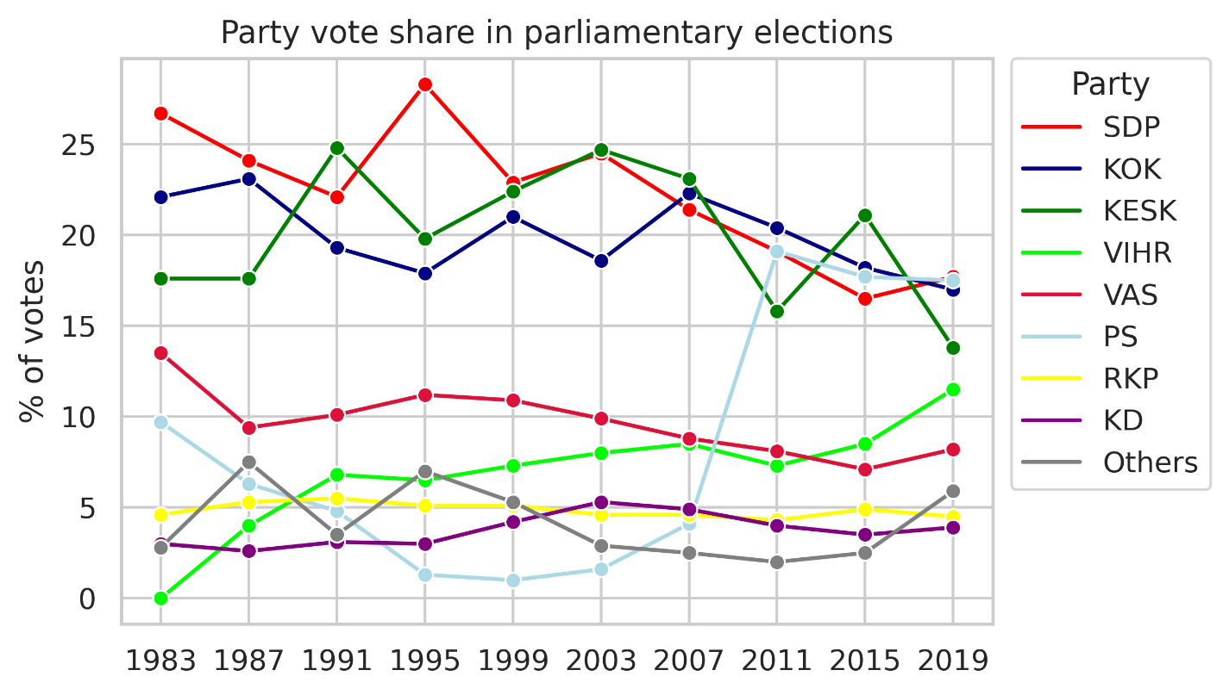
Figure 1 Party vote share in Finnish parliamentary elections from 1983 to 2019.
Plenary sessions (eduskunnan täysistunto) include a variety of sections and agendas. Legislation is debated and enacted regularly and, once a week, ministers have to answer oral questions from MPs during Question Time (Finnish Parliament, n.d.). Plenary sessions are open to the public and are also broadcast online (Finnish Parliament, n.d.). Although, formally, plenary speeches are directed at the chairman, with speeches typically beginning with a direct address, e.g. Arvoisa puhemies [Honoured chairman], they are still audience oriented, given with fellow MPs, media and the electorate in mind (Ilie, 2018). The Finnish parliament is what is known as a working parliament as opposed to a debate parliament. This means that the most heated debates are often held behind closed committee doors whereas plenary sessions tend to be less confrontational. This stands in contrast to debate parliaments, such as the UK House of Commons, in which lively public debates are commonplace (Ilie, 2018). The Finnish parliament is also considered to follow a consensual system (Gallagher et al., 2006) because committee work, and coalition governments require co-operation between members from different parties. This can potentially make distinguishing political speeches in Finland more difficult than in countries with more confrontational parliamentary cultures, since increased partisanship and politically extreme rhetoric has been shown to make party affiliation easier to distinguish for machine learning models (Bayram et al., 2019; Santel and Minai, 2019; Diermeier et al., 2011).
All speeches held in the plenary sessions are transcribed. The transcriptions are close-to-verbatim documentations of the original. In principle, all speeches are presented as spoken. However, the secretaries are allowed to standardize phonological expression or to remove expletives whenever needed to make the transcriptions more readable and understandable. During the entire history of Finnish parliamentarism, the transcriptions have sstriven to document what has been said in plenary sessions. Today, the transcriptions are made according to detailed instructions and guidelines of the eduskunta (Voutilainen, 2016).

Previous work on predicting party affiliation
Renáta Németh (2023) has conducted a review of recent publications that use Natural Language Processing (NLP) methods to study political polarization. She found that the number of new publications is on the rise and that most of these studies use data from the United States and Twitter and present data from a short period of time. Of the studies that she reviewed five use a classification approach, most use bag-of-words models and only three discuss, which linguistic features affect classification. Some studies (see e.g., Bayram et al, 2019; Hirst, Riabinin, and Graham, 2010; Peterson and Spirling, 2018) use classification performance as a measure of party polarization, i.e., good performance means high polarization. We believe that as polarization refers to two opposing entities, it does not fit the Finnish political setting. We are sceptical of using classifier performance as a direct measure of polarization because, as our results and previous research (e.g. Hirst et al., 2010; Potthast et al., 2018) show, the linguistic features that drive classifiers like ours are not necessarily politically or ideologically motivated. For these reasons, we opt to use the more suitable term distinctiveness.
Previous studies on predicting party affiliation from parliamentary speeches include work on the United States’ (Bayram et al., 2019), Lithuanian (Kapočiūtė-Dzikienė and Krupavičius, 2014), Norwegian (Søyland and Lapponi, 2017), and Danish (Navarretta and Hansen, 2020, 2024) parliaments. These studies use a number of different models to predict party affiliation in varying political contexts. Bayram et al. (2019) trained several binary classifiers on data from the U.S. Congress and achieved 78 % accuracy with a Support Vector Machine (SVM). They trained the classifiers on 7 different congresses and used model accuracy as a proxy measure for partisanship across time. They assumed more partisanship means that the two parties are more distinct in their rhetoric and, thus, easier to classify. Peterson and Spirling (2018) show that this method gives results that correspond to conventional knowledge of polarization in the British parliament. Diermeier et al. (2011) examined both politically extreme and politically moderate Republicans and Democrats in the U.S. senate. Their results show that their SVM classifier was worse at distinguishing between moderate senators than more extreme ones, showing that more ideologically distinct politicians are easier to distinguish. A feature analysis shows that senators were distinguishable on economic and moral issues. The paper also shows some evidence of politically extreme senators using signal words or dog whistles, which are used as covert messages to the more extreme elements of the electorate.
Other studies have used classifiers in multi-party settings. Søyland and Lapponi (2017) trained an SVM classifier on speeches held in the Norwegian parliament. After heavy preprocessing and adding metadata, their classifier reached an F1 score of 0.729 on a dataset with 7 parties. Similarly, Navarretta and Hansen (2020) trained several models and reached an F1 score of 0.57 on a 4-class classification task of Danish parliamentary speeches. Kapočiūtė-Dzikienė and Krupavičius (2014) used the Naïve Bayes Multinomial method to classify Lithuanian parliamentary speeches in two datasets, one containing speeches from 12 parties, the other containing speeches from 8 parties with different levels of pre-processing. Their method achieved 49% accuracy.
Hirst et al. (2010) argue that what matters most in party rhetoric is not ideology, but institutional positioning, i.e., the opposition-government divide. They trained an SVM using data from the Canadian House of Commons and found that classification accuracy is better with data from Question Periods than with data from debates. Moreover, they found that when training on one parliament and testing on another in which the government-opposition roles are flipped, "the performance of the classifier completely disintegrates" (Hirst et al, 2010, p. 739). They thus argue that their classifier does not distinguish political parties by ideology but by turns of attack and defence between opposition and government. Navarretta and Hansen (2024) studied the identification of plenary speeches from opposition and government parties in the Danish parliament by training several models based on different architectures. They found that fine-tuning a Danish BERT model gave the best performance.
Most of the research discussed above has been conducted on parliaments with fewer parties than the eight that regularly occupy the Finnish parliament. Thus, our setting requires the classifier to detect and distinguish more minute differences between party rhetoric to make correct predictions. The literature in the field shows that government and opposition roles are reflected in plenary speeches. To mitigate this effect, we trained our model with data that has all parties occupying both government and opposition roles. Therefore, the model cannot reliably base its predictions on linguistic cues caused by this division. Whereas previous studies have mostly used SVMs and other relatively simple models, our deep learning model has the potential to reveal previously unknown distinctive linguistic features of plenary speeches due to it relying on context-aware word embeddings rather than bag-of-words-style features. We also trained an SVM as a baseline comparison and show that the BERT model performs better.

Cues and voter assessment of political parties
A voter’s ability to understand current affairs and to identify major ideological differences is considered central for their political competences, i.e., for "understanding of processes and structural components associated with developing public events" (Genova and Greenberg, 1979, p. 89). This links our current study to the broader field of research on civic competence and political knowledge (e.g., Dahl, 1992; Delli Carpini and Keeter, 1993; Downs, 1957; Popkin and Dimock, 1999). A majority of studies on citizens’ ability to identify and assess political issues focus on the impact of a party’s policy positions on the voting behavior of citizens. Devroe (2020), for example, studied voter assessment of a candidate’s competence based on the candidate’s gender, some biographical information, as well as their policy position on selected issues. The results indicate that voters tend to give positive evaluation to candidates with similar policy positions. Adams, Weschle and Wlezien (2021), in turn, show that voters tend to consider parties that appear cooperative to each other "as sharing more similar ideologies than those that exhibit conflictual relationships" (p. 112). The study of Valentino, Hutchings and White (2002) presents mixed conclusions about the impact of political cues. On the one hand, voters being aware of such cues seem to be able to change their attitudes. On the other, however, without an appropriate knowledge of politics, cues might be left unidentified and negative cues unchallenged. The role of political knowledge and the proper understanding of different party preferences are recognised by Gilens (2001), Tilley and Wlezien (2008), and Just (2022). These studies raise evidence that new policy-specific information and raw facts might have a strong influence in the shaping of political judgements of party placements and positions.
To summarize, a majority of former studies argue that a proper identification of ideological positions is strongly dependent on citizens’ political knowledge and their ability to recognise and use ideational cues. Conversely, analysing citizens’ ability to correctly classify plenary speeches to ideological positions represented by different parties can help us to better understand how well citizens are able to identify the vocabulary of politics and link its use to ideologies underlying the party system.

Data & Methods
In this section, we introduce the FinParl dataset and how we built our corpus of speeches. Next, we explain the basic principles of text classification with deep learning models. Third, we show how the model explainability method SHAP provides explanations to the predictions made by a machine learning model. Finally, we explain our experimental setup, including how we trained our model, how we extracted SHAP explanations and how the questionnaire was structured.

FinParl dataset and pre-processing
The data used for this research was obtained from the FinParl dataset, which consists of parliamentary speeches held in the Finnish eduskunta since its inception in 1907 (Hyvönen et al, 2021). From the years 1907 to 1999, the data is digitised using OCR, whereas later data was collected from HTML and XML files. The contents of the dataset and how it was created is explained in detail in Sinikallio et al. (2021). In the current paper, we focus on speeches from 2000 to 2021.
We converted the data into CSV format containing the full text of the speech, the speaker’s name, the party affiliation and the year. Speeches that were interrupted and were thus separated into two or more segments, were combined, while the interruptions themselves were discarded. While we aimed to keep as much of the original data as possible so as not to introduce bias in the results, some filtering was applied where it was deemed necessary. Speeches with the speaker tag ’chairman’, ’viceChair’, ’secondViceChair’ or ’elderMember’ were discarded, since they mainly consisted of formal boilerplate text rather than ideologically motivated political speech. The data were further cleaned by removing speeches that were deemed too short. To determine a suitable minimum speech length, a manual review of deleted material at different cut-off points was conducted. This led us to remove speeches with 12 tokens (see section on deep learning below) or fewer.
Finally, we removed mentions of party names, because these could make the classification task trivial, especially in speeches with phrases, such as Me perussuomalaiset [We, the Finns]. It also forces the model to make predictions based on other than these obvious linguistic cues, which could reveal more latent features of party rhetoric. Party names were removed using the Named-Entity Recognition (NER) model developed by the National Archives of Finland. Entities tagged with either the ORG or NORP tag that matched a party name or abbreviation were replaced with the string [PUOLUE], meaning [PARTY].
We did not remove Swedish speeches from the dataset, as the Swedish language holds a significant cultural and historical place in Finnish society and politics. Swedish in parliament is today mostly, but not exclusively, used in official communications, and in everyday political debates by members of the Swedish People’s Party. The Swedish People’s Party is a major political force in Finland, being a member of all coalition governments since the 1970s with the exception of one four-year term between 2015 and 2019.
Only speeches from the 8 largest parties from 2000 to 2021 were retained. Short-lived minor parties such as Remonttiryhmä, who only existed for three years and had one MP, were discarded. The distribution of speeches per party from 2000 to 2021 is shown in Figure 2. The figure shows that the Social Democrats (SDP), the National Coalition (KOK) and the Centre (KESK) account for most of the speeches in the dataset, over 50,000 each. The Finns, the Greens and the Left Alliance account for over 20,000 speeches each, the Christian Democrats for 13,000 and the Swedish People’s party for 7,000. The major leap in vote share of the Finns (PS) in the 2011 elections is also reflected in the data by an increased share of speeches. The final dataset has speeches from 605 speakers. The average speaker has 427 speeches in the dataset, the median being 272. Fifty-three speakers have more than a thousand speeches attributed to them. The two most active speakers are Erkki Pulliainen from the Green party and Pentti Tiusanen from the Left Alliance with 4525 and 4043 speeches, respectively. The average speech is 219 words long and the median speech is 130 words long. After pre-processing, the dataset consists of 252,389 speeches.
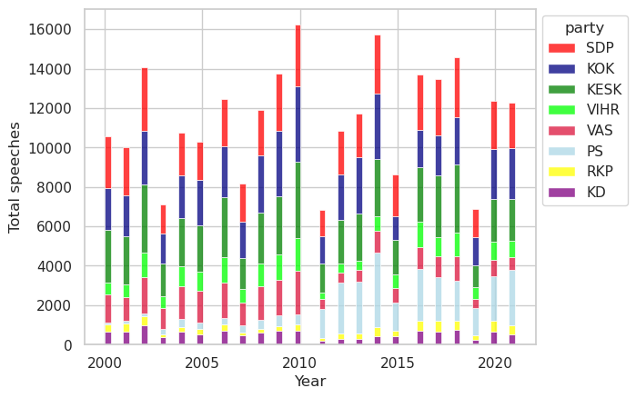
Figure 2 Number of speeches per party from 2000 to 2021.

Text classification using deep learning
Deep learning refers to neural networks that comprise multiple layers of modules that each represent their input in increasingly abstract form. With sufficient layers and training data, exceedingly complex functions can be learned (LeCun, Bengio, and Hinton, 2015). BERT (Bidirectional Encoder Representations from Transformers) is a language representation model released in 2018 that is built on the Transformer architecture. It performs much better on many NLP tasks than previously popular models, such as Support Vector Models (Devlin et al, 2018). More recently, Large Language Models (LLMs), such as ChatGPT, Claude and Mixtral have again transformed the field of NLP. For many classification tasks, however, BERT based models are still preferable because LLMs are both computationally and financially more costly to run.
BERT is trained on a masked language model objective, in which some input tokens are masked (i.e., hidden), and the model is tasked with predicting the masked token given both the left and right context. The original BERT model was trained on English and was soon followed by Multilingual BERT and then other language specific versions. As the base of our deep learning model, we use FinBERT, a Finnish BERT model pre-trained on more than 3 billion tokens of Finnish (Virtanen et al., 2019). Its high performance in many Finnish NLP tasks makes it the best choice for our study. We fine-tuned FinBERT for our text classification task using the FinParl data.
BERT models require their input text to be tokenized using a WordPiece algorithm, first described by Schuster and Nakajima (2012). A BERT model has a fixed vocabulary, with each token being assigned to a unique token ID. Common words are represented by their own token IDs, but fewer common words are represented by a combination of tokens. For instance, the sequence "jatkuvasti kasvava byrokratia" ["ever growing bureaucracy"] is tokenized as jatkuvasti, kasvava, byrokra, ##tia. Additionally, there are a few special tokens, such as [CLS] and [SEP] at the beginning and end of each sequence. In effect, there are typically somewhat more tokens than words in any given sequence. Whereas SVMs process input as bag-of-words, with BERT, word order and context are taken into account. A limitation of the FinBERT model is that its input cannot exceed 512 tokens, which is why long speeches are truncated to fit within this limit.

Model explainability
Model explainability is the field of study that examines how the output of machine learning models can be made understandable to humans. For simple models, the best explanation can be the model itself, but more complex models require a separate explanation model to achieve a human understandable approximation of the model (Lundberg and Lee, 2017). We use SHAP (Lundberg and Lee, 2017) to produce explanations of our deep learning model. SHAP produces explanations by calculating the contribution that each input feature carries towards the outcome. For a simplified explanation of how SHAP calculates the contribution of input features, one can imagine three people digging a hole: A, B, and C. After one hour of digging, they have dug a hole one meter deep. To calculate how much each person contributed to the outcome, we can remove one at a time, dig another hole, and observe the difference. If we remove person A, the resulting hole is only 0.4 meters deep. Removing B results in a hole that is 0.5 meters deep. Finally, removing person C results in a hole that is 1.1 meters deep. Therefore, we can calculate that the effect on hole depth per person is A = 0.6m, B = 0.5m, C = -0.1m.
SHAP is model agnostic and can be used with tabular, visual or textual data. In practice, in a text classification setting, each token is treated as a feature, and the outcome is the prediction that the model produces. SHAP values are calculated by masking sets of tokens in the model input and observing how the prediction of the model changes in response. Previous uses of SHAP for text classification explainability include COVID-19 related fake news detection (Ayoub, Yang, and Zhou, 2021) and humour analysis (Subies, Sánchez, and Vaca, 2021). One major disadvantage of SHAP is that calculating SHAP values for large datasets is computationally demanding. To reduce the computational load, we use SHAP’s partition explainer, which clusters tokens together hierarchically and thereby reduces the number of calculations performed.

Experimental setup
To train our model, we first divided speeches held between the years 2000 and 2021 into train, development and test sets with 80-10-10 splits. The train and development splits are used in model training and the test set is used to evaluate the performance of the model. There are a number of training hyperparameters that need to be set manually to train a deep learning model, such as learning rate and batch size. We used the grid search method to optimize model performance. We used label smoothing, a regularisation technique which prevents models from becoming overly confident, at a factor of 0.1. This also ensures that the prediction probability of a given prediction is more closely aligned with actual accuracy (i.e., at 90% prediction probability the model is close to 90% accurate). To further prevent over-fitting and increase training efficiency, we used early stopping during the training if the model did not improve its performance for 10 evaluation calls. Training was done using the Transformers, Tokenizers and Datasets Python libraries from Huggingface. To verify that our model performed consistently, we used 5-fold random subsampling (see Berrar, 2019). This means that five training, development and test sets are created, and each are used to train a model. The average F1 score of these models is given as the final performance of the model.

Questionnaire
To base our results on human performance we created a questionnaire in which participants were given five speeches to associate with a political party. In addition to answering which party they believed had given which speech, respondents were asked to choose the words or phrases that most influenced their decision and to give a numerical rating on a scale from 1 to 5 (1 = very confident, 5 = not at all confident) on how confident they were in their answer. Each informant was given five speeches that were randomly selected from a stratified sample of 100 speeches that were held between 2010 and 2019 and that were not included in the model training dataset. We also attained the model predictions for this 100-speech sample. This way, we could directly compare human performance against machine performance. The questionnaire was sent to university students as well as circulated online. First, we collected responses from 166 people, the vast majority of whom were students at a Finnish university, who were taking a course in Digital Humanities. Later, the questionnaire was shared by the Finnish national broadcaster Yle, which yielded an additional 272 responses. In total, 438 informants responded to the questionnaire.

Results
In this section, we first analyse the performance of the model quantitatively. We then analyse the SHAP explanations for a sample of speeches and predictions to ascertain what kinds of linguistic features the model uses to make its predictions. After this, we focus on the questionnaire: we examine how well our respondents could identify the parties and then compare their cues to the SHAP explanations. This comparison demonstrates how the model and human respondents differ in distinguishing between the parties.

Model performance
Our fine-tuned FinBERT models achieved an average macro F1-score of 0.66 across 5-fold random subsampling. As a point of comparison, we also trained an SVM baseline on lemmatized data with stopwords removed. The SVM reached a macro F1-score of only 0.58. Fine-tuning FinBERT leads to a substantial eight-point improvement or a relative gain of nearly 14% in macro F1. Beyond the measurable performance boost, FinBERT’s contextualized language representations capture nuanced semantic and syntactic patterns that SVMs with bag-of-words-style features cannot, making FinBERT a clearly justified choice over the simpler baseline.
To address the 512-token limitation of the FinBERT model, we tested the effect of keeping the last 512 tokens of speeches exceeding this length instead of the first. We found the model’s performance to be very similar in both cases. We conclude that there is no clear difference in distinctiveness between the beginning and the end of speeches and we feel confident that truncating longer speeches to the first 512 tokens will not affect the results much. Additionally, only approximately 15% of the speeches exceeded the token limit.
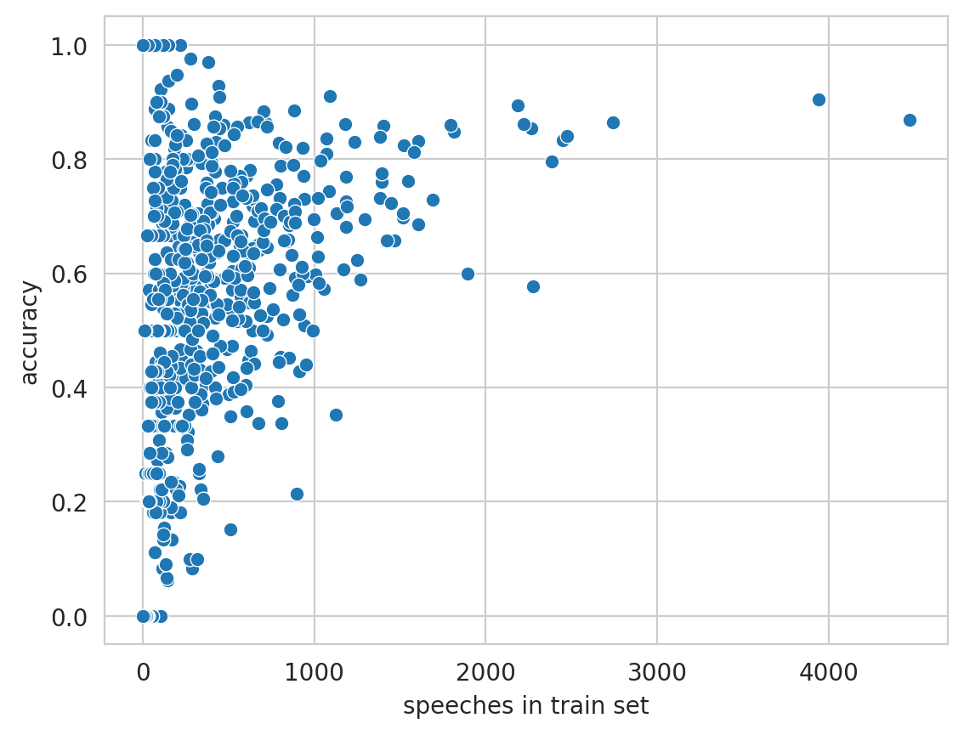
Figure 3 Model accuracy per speaker.
Since some MPs are much more active speakers than others, we consider the fact that the model might learn the speech patterns and typical word choices of individual MPs. Therefore, we tested whether the number of speeches an MP has in the dataset affects how well the model distinguishes that MP’s speeches. We calculated the accuracy of the model on each speaker and found the accuracy to vary between 0% and 100%, the average being 57%. Figure 3 illustrates that there is a weak to moderate (Pearsons’ r = 0.35) correlation between the number of speeches and accuracy. Still, many MPs with few speeches are correctly predicted with high accuracy, while others, such as Liisa Hyssälä (the Centre, 1,128 speeches) and Peter Östman (Christian Democrats, 896 speeches) are predicted with relatively low accuracy, at 35% and 21%, respectively. Thus, even though the model has clearly learned to identify the speech patterns of some speakers, such as MPs Pulliainen and Tiusanen (represented by the two dots in the top right-hand corner in Figure 3), this is not a universal phenomenon that would apply to all highly active speakers. Nonetheless, as we discuss below, the idiosyncrasies of individual MPs, especially in the case of MP Pulliainen from the Green party, can have a profound impact on how the model learns to distinguish between parties.
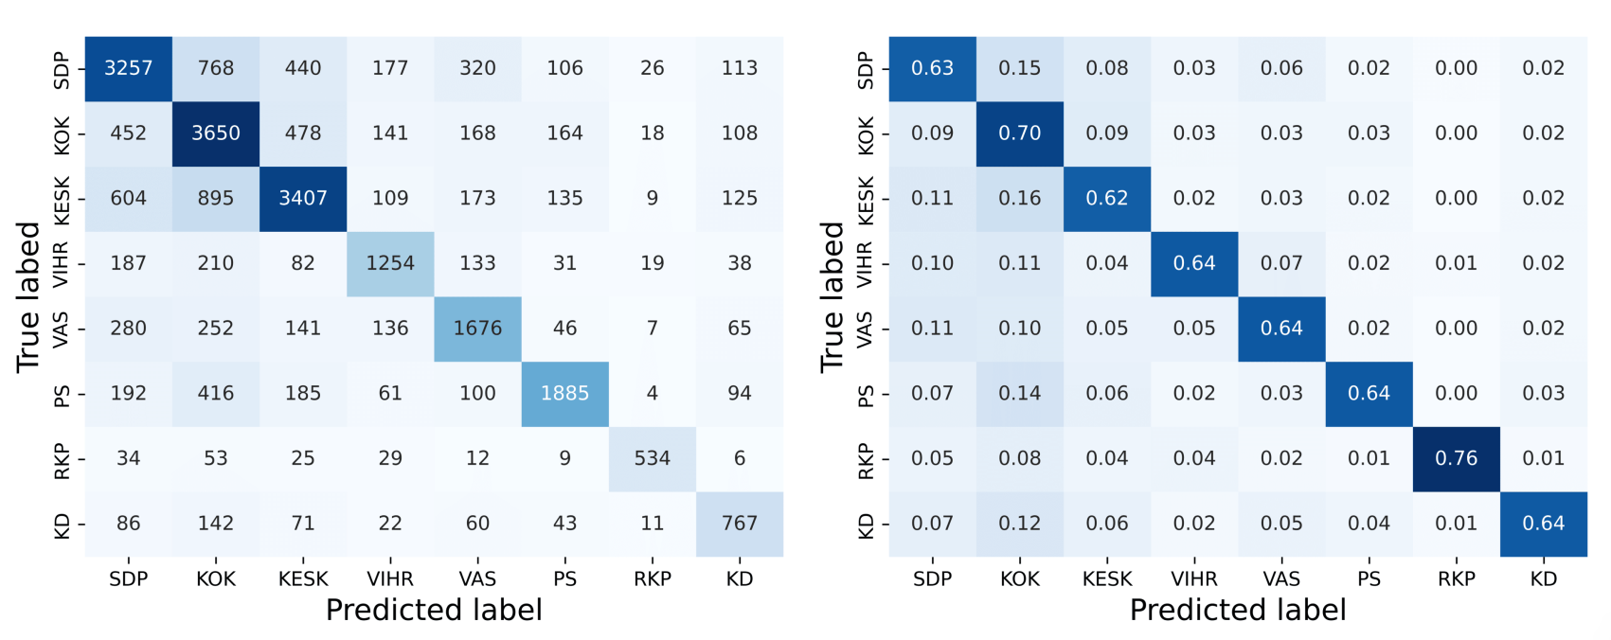
(a) Confusion matrix with absolute values (b) Confusion matrix with relative values
Figure 4 Confusion matrices showing the model performance on the test set. Cells along the diagonal line from the top left to the bottom right represent correctly predicted speeches.
The confusion matrices in Figure 4 depict model performance. In the first confusion matrix, we note that the model tends to confuse speeches from the three largest parties (SDP, KOK, KESK) with each other. This suggests that there is something in common between the speeches of these three parties. As the largest parties in parliament, they often assume a leading role in government and opposition, which could explain these similarities. The second confusion matrix shows that while National Coalition (KOK) speeches are well recognised, it is also over-predicted, i.e., the model often predicts that speeches from other parties are National Coalition speeches. In public discourse, the party is often regarded as Finland’s ’economic party’ and our results show that this reputation is not completely unearned. The strong connection between the National Coalition and economic talk is evidenced by our finding that many speeches that are mistakenly predicted to belong to the National Coalition concern public finances, taxation or entrepreneurship.
Table 1 shows that the Swedish People’s Party (RKP) and the Finns (PS) have the highest class-wise F1 scores, 0.79 and 0.70, respectively. The Swedish People Party’s speeches are often partly or entirely in Swedish, which distinguishes them from other parties. Although they are not the only party to use Swedish in parliament, they are the party that uses the language the most, by far. The Finns, on the other hand, are known for their populist rhetoric and colorful language (Ylä-Anttila and Ylä-Anttila, 2015). This sets them apart from other parties and could explain their higher F1 score. This is also evidenced by the SHAP explanations, discussed below.
Table 1 Party-wise F1 scores, average of 5 training runs
 | SDP | KOK | KESK | VIHR | VAS | PS | RKP | KD
F1 | 0.63 | 0.61 | 0.65 | 0.64 | 0.63 | 0.70 | 0.79 | 0.62
The National Coalition is the label most often given to misclassified speeches, followed by the Social Democrats and the Centre, i.e., the three largest parties. These results are similar to those of Søyland and Lapponi (2017), who observed that larger parties received more misclassification than smaller ones. It would be reasonable to assume that parties that are close to each other ideologically, such as the Social Democrats and the Left Alliance, also speak similarly in parliament, and thus, would be harder to distinguish from each other. However, the misclassifications only give a weak signal that this is the case. Misclassified Left Alliance speeches are labeled as Social Democrat speeches 30% of the time and National Coalition speeches 27% of the time. Social Democrat speeches were most often misclassified as National Coalition speeches (39%) and vice versa (30%). In fact, all the speeches of the parties, except for the Left Alliance, are most often misclassified as National Coalition. Overall, the Centre Party is the one most often misclassified. As they occupy the political centre, they can at times take stances that are more aligned with the political left and at other times align more with the political right, which could explain why their speeches are most often misclassified.

SHAP explanations

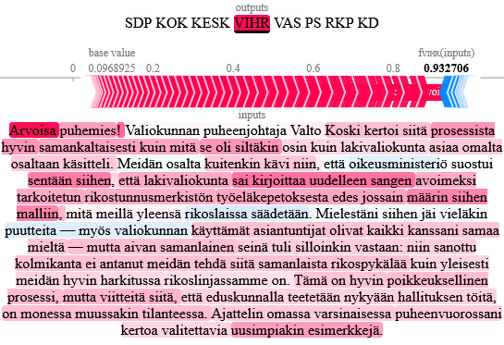
Figure 5 Example of a SHAP explanation.
We analysed the SHAP explanations by taking a random sample of 20 correctly predicted speeches with high prediction probability (>90%) from each party. As an example, Figure 5 shows a speech from the Green party. The words and phrases highlighted in red represent features that were positive evidence (i.e. cue phrases) towards the model prediction and those in blue represent negative evidence, i.e. the presence of these features make the prediction less likely. The darker the color, the stronger the effect that feature has on the prediction. In this example, the phrase Arvoisa puhemies [Honoured chairman] was given a lot of weight by the model. We discuss possible explanations for this at the end of this section.
Our analysis shows that the model paid attention to two types of cue phrases, which we call topical cues and rhetorical cues. Topical cues are phrases that relate to a coherent topic, such as immigration, taxation, the EU. In other words, they convey what the speech is about. Rhetorical cues on the other hand relate to style or tone and are, at least in isolation, not directly linked to the topic of the speech. Rhetorical cues are often identified by the presence of function words, adverbs and adjectives.
Table 2 aggregates some example SHAP cues that the model used to identify the parties. The SHAP cues show that the model has learned to identify both the core political issues of the parties and the style and tone of some individual speakers. The SHAP explanations show that what makes the Social Democratic Party distinct is their focus on the well-being of the unemployed and especially pensioners. They also provide criticism of the free market and often use the term porvarihallitus [bourgeois government] to rebuke the actions of right-wing governments. The names of National Coalition MPs are often strong explanatory features, which shows that the Social Democrats position themselves as a counterforce to their free market policies. The National Coalition is distinct in the way they talk critically about taxes and government welfare programs. They highlight the importance of economic growth and free markets. The fact that they occupied a government position for most of the two decades that the data covers is also shown in the explanations, as phrases that applaud the government can act as cue phrases. The Centre party speaks for the rural population: their topical cue phrases concern different municipalities and areas, agriculture, forestry and peat extraction, while the Christian Democrats stand out by raising issues concerning healthcare and abortion. For the Finns, the model has learned to notice their critical attitude towards the EU and incurring government debt. Another recurring feature is critique against the government, which is likely a product of them occupying the opposition position. Some rhetorical cues also highlight the colloquial style of the party and the populist rhetoric that they are known for. Examples of these are koska koko kansa herää [when do the people wake up] and taitavat olla vanhimmatkin kansanedustajat hallitysryhmistä yhtä narrattavissa kuin joulupukkiin uskovat lapset [even the oldest MPs in government seem to be as easily fooled as children who believe in Santa Claus]. The Left Alliance has topical cue phrases that relate to defending the poor and underprivileged, supporting welfare programs and workers’ rights. Additionally, the party is also distinctive in its push for greener policies. The Swedish People’s Party speeches were most easily identified by the use of the Swedish language. Cue phrases that were not in Swedish concerned topics of equality and welfare as well as the Finnish archipelago, which is where many Swedish speaking Finns live. Finally, for the Green party, although topical cues relating to climate change and environmental protection were present, the strongest cues were a result of the disproportionate activity of MP Erkki Pulliainen, whose personal style has clearly had a strong impact on what the model associates with the party. MP Pulliainen style of speaking in parliament can be described as conversational or even playful and many adjectives and adverbs, such as erikoisesti [peculiarly], täsmälleen [precicely], and äärimmäisen [utmost] often shine bright red in the SHAP explanations. Notably, out of the 20 Green party speeches sampled from the pool of correctly predicted speeches, 16 were from MP Pulliainen.
Table 2 Examples of party cues as indicated by SHAP explanations
Party | Examples of explanatory cues
Social Democratic Party | "bourgeois government", "Zyskowicz", "the government is proposing great cuts into pensioner housing benefits"
National Coalition | "want to keep Finland a land of work and entrepreneurship", "encourage working and diligence"
Centre | "have defended the use of timber and Finnish peat", "to Savukoski"
Green party | "so in other words", "carbon-neutral circular economy", "peculiarly"
Left Alliance | "the poor and the underprivileged", "poverty has increased", "methane is a highly potent greenhouse gas"
Finns | "children who believe in Santa Claus", "more debt leads us on the Greek path"
Swedish People’s Party | "Honoured chairman" (in Swedish), "equality legislation", "I would like to pay attention to our marine conditions"
Christian Democrats | "people’s health and illness", "abortion law", "risk of fetal disorder"

Most of the SHAP cues discussed above are easy to understand to anyone with a thorough understanding of the Finnish political parties and their political leanings. However, there are also some surprising findings that are not easily explainable by party politics. For instance, the customary greeting of the chairman or parts of it that starts virtually all speeches, is shown to be a cue phrase of each party at least once in our sample of speeches. Such is the case in Figure 5, where the word Arvoisa [Honoured] is the strongest individual cue in the whole speech. Why this is the case, when all parties use the same phrase constantly, is unclear. There are variants of this initial greeting where the explanation does make more sense. For instance, the Finns cue phrase Kunnioitettu puhemies [Esteemed chairman!] is, in fact, used more by the Finns than other parties. At times, the gender of the chair is revealed, when the greeting is Arvoisa (herra/rouva) puhemies [Honoured (Mr. /Mrs.) chairman!]. This gendered honorific is sometimes a cue phrase, suggesting that the model has learned some temporal cues, as the chairman is at times a woman and at others a man. Other puzzling explanatory phrases are rhetorical cues that are mostly function words. As discussed above, sometimes they can be attributed to the style and rhetoric of individual speakers that the model has learned to recognise. At other times, the reason is much more obscure. Such is the example of sen tähden minusta tässä [because of that I think here], which is shown to be a strong cue phrase indicating the Centre. This exact phrase appears only once in the training data and when it does, it is spoken by a member of another party, namely the Christian Democrats. Yet, focusing on only the beginning of this phrase, we realised that the Centre MP Timo Kalli uses the phrase sen tähden [because of that] 213 times in 141 speeches in the training data. In total this phrase appears 1190 times in 991 speeches in the training data, which means that MP Kalli was responsible for roughly18% of all uses. Even though MP Kalli is not a particularly active speaker, it seems that the model has noticed this particular idiosyncrasy of one Centre MP and has thus come to associate it with the Centre party. Lastly, the SHAP explanations show that even though mentions of party names were removed and replaced with [PARTY], the model still learned to predict who is being referenced based on the verb in the sentence. The Finns and the Christian Democrats are the only parties whose name is in plural form. Hence, when [PARTY] is the subject of the clause and the verb is in plural form, the model knows that [PARTY] must be one of these two parties.
In sum, our results show that the model has learned to identify the parties with decent accuracy and that the Swedish People’s Party and the Finns are the most distinctive. When the model misclassifies speeches, it most often gives the label of one of the three largest parties. The model has learned to recognise the political leanings of the parties but also uses rhetorical cues to make its predictions.

Questionnaire responses
A total of 438 people responded to the questionnaire. Each respondent labeled five speeches resulting in a total of 2190 responses. Each speech was labeled between 15 and 28 times. Model accuracy on the 100-speech sample dataset was 62%, whereas human accuracy was only 30%. In terms of F1 scores, the respondents correctly identified speeches from the Finns most often, closely followed by the National Coalition and the Swedish People’s Party, as shown in Table 3 and Figure 6. This result is similar to model performance, reinforcing the notion that the Finns and the Swedish People’s Party are distinctive. Conversely, responses were least often correct with Christian Democrats’ speeches, where respondents reached an F1 score of just 0.15. Respondents were asked to report their own estimate of their political knowledge but, surprisingly, we found no correlation between reported political knowledge and accuracy in identifying speeches. In terms of confidence, respondents gave an average score of 3.1 (1 = very confident, 5 = not at all confident). We found that confidence correlates with accuracy. The respondents found some speeches easier to connect to a party as evidenced by high accuracy and high confidence score, while others were much harder.
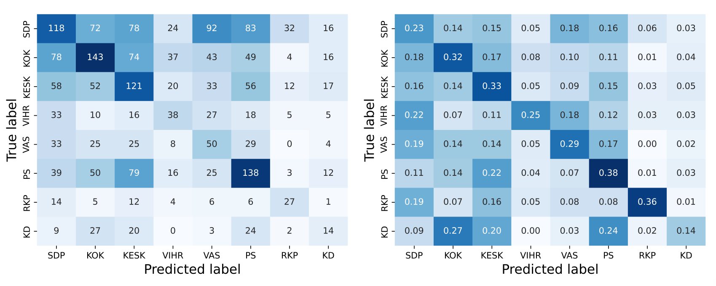
(a)Confusion matrix with absolute values. (b) Confusion matrix with relative values.
Figure 6 Confusion matrices showing how well questionnaire respondents identified the correct parties.

Although the respondents did not perform too well in identifying party-specific political speech, they performed far better when measured against their ability to identify ideological similarities. If we use a simple left-right typology for the Finnish party landscape, the success rate for identifying left-wing speakers was 50.3%, and for right-wing speakers 71.5%. In this respect, our results indicate that respondent right-wing speaking is somewhat easier to identify. However, more research with different political texts and covering different contexts and periods of time is needed to obtain a clearer picture about this.
Table 3 Party-wise F1 scores of human responses.
 | SDP | KOK | KESK | VIHR | VAS | PS | RKP | KD
F1 | 0.26 | 0.35 | 0.30 | 0.25 | 0.22 | 0.36 | 0.34 | 0.15

In addition to choosing a party, the respondents were asked to indicate which phrases in the speech made them think that the speech was from the party that they believed. Based on these responses, we formed a list of keywords. These were calculated by pooling together all phrases that were chosen as cues for a given party. The phrases were tokenized into words and lemmatized. We removed stop words and then calculated the most frequent words for each party, which are shown in Table 4. It should be noted that these keywords come from a set of only 100 speeches and should therefore not be treated as representative of the party speeches as a whole. They do, however, give some indication of what kinds of words people tend to associate with a given party. The keywords indicate that people tend to be more topic focused than the model. The topical keywords closely resemble those that the model has learned to identify: National Coalition talk about economy, the Centre about regional matters and the Left Alliance about unemployment.
Table 4 Response keywords.
SDP | KOK | KESK | VIHR | VAS | PS | RKP | KD
want | must | region | human | human | Finland | Swedish | human
human | Finland | regional | bring down | government | government | then | killing
good | then | country | need | must | mind | word | life
government | National Coalition | then | bear | unemployed | here | own | question
SDP | economy | good | carcass | cut | important | important | child
then | government | MP | set | want | then | right | ending
own | time | municipality | sentence | give | must | different | government
must | here | government | must | time | MP | secure | police
Finland | police | issue | MP | need | very | region | Finland
employment | country | Finland | Finland | well | issue | very | own
issue | also | strong | issue | small | own | go | kill
need | give | well | along | cut | talk | honoured | patient
propose | work | post | juridical | Finland | police | speaker | important
time | good | must | well | issue | current | also | hope
also | growth | whole | sexual | right | want | here | yes
support | get | function | orientation | education | yes | issue | good
well | entrepreneur | important | question | child | year | nordic | must
National Coalition | Europe | different | child | most | country | honoured | mind
say | issue | want | whole | work | Europe | good | suicide clinic
important | company | wood | right | euro | time | court of appeal | doctor

Comparison between model and humans
When comparing the questionnaire response to model predictions, Table 5 shows that the most common case is one in which the model made a correct prediction while humans responded incorrectly. The next common case is one in which both were incorrect. Only 9% of the time are humans correct while the model makes an incorrect prediction. In this section, we analyse and compare the cue phrases chosen by the questionnaire respondents to the cue phrases indicated by SHAP explanations. We do this through a close reading of the speeches in the questionnaire and illustrate the results with a selection of example speeches. The results show that while the model used both topical and rhetorical cues in its decision-making, the respondents relied more heavily on topical cues. In the examples below, the phrases in bold are some of the most important features for the model prediction as indicated by the SHAP explanations.

Table 5 Human and model performance.
 | Model correct | Model incorrect
Human correct | 458 / 21% | 191 / 9%
Human incorrect | 917 / 42% | 624 / 28%

Different cues for model and humans
- "Ja niin kuin edustaja Koskinen tässä jo totesi, niin mielestäni tänään täällä kuullut puheenvuorot esimerkiksi pääministerin toimesta vain ikään kuin haastoivat meitä kaikkia siihen keskusteluun […] [M]eidän on laitettava suitsia näille markkinavoimille, jotta me saamme palautettua näihin järjestelmiin sitä kansanvaltaa, joka tänne kuuluu, näihin nimenomaisiin saleihin eri puolilla Eurooppaa."
"And as MP Koskinen already stated, in my opinion, what we have heard here today, the speeches by for example the prime minister, as it were, challenged us to part-take in the discussion […] [W]e must start controlling these market forces so we can reintroduce democracy to these systems, these exact halls all around Europe."
In Example 1, the speech from the Social Democrats was correctly predicted by the model mostly based on the phrases in bold. The first phrase, a rhetorical cue, is a rather mundane phrase that, intuitively, could be spoken by any MP from any party and, indeed, was not indicated to be a cue phrase by any of the questionnaire respondents. Yet, the model sees this as very informative. This could be due to the broader context, such as the mention of MP Koskinen, which could be three different people, two of whom are members of the SDP. The second phrase is more clearly linked to a coherent topic, namely Europe and the EU, and in context, more specifically to controlling market forces and strengthening democracy. It is curious, why this exact phrase at the end of the speech is so important in the model’s decision making, when the phrases before seem to be more informative, a claim supported by the respondents’ cue phrases. 12 of the 28 respondents who labeled this speech believed it was a Finns speech, 7 guessed SDP correctly, 4 picked the Left Alliance and rest of the answers were scattered to other parties. Almost all respondents chose the phrase “mihin tämä koko unioni, mihin euro on menossa” to be cue, regardless of the party they guessed. This indicates that the respondents identified this phrase to be political but, at least here, devoid of extra-linguistic context, could not connect it to a coherent political ideology and party. In sum, this example illustrates how the model can base its predictions on features that humans mostly ignore, and, in most cases, this makes it perform better. Additionally, it shows an example of many respondents choosing the same cue but being unable to accurately identify what it signifies.
- "Tällä tavallahan tietenkään tilanne ei voi pidemmän päälle toimia, ja mielestäni valiokunta toteaa aivan oikein, että 2013—2015 valtiontalouden kehyksiä tältä osin tarkastellaan uudelleen. [...] Nykyiset raja-asemien tilat sekä henkilöstö ovat käyneet riittämättömiksi rajanylitysten kasvaessa kaksinumeroisilla luvuilla joka vuosi. [...] Takanahan tässä asiassa on kaiken kaikkiaan se, että niin transito- kuin matkailuliikenne kasvaa todella kovaa vauhtia, ja kyllä sen matkailu- ja transitoliikenteen mukana myöskin meille tärkeää lisäarvoa eli rahaa tänne Suomenmaahan tulee."
"The situation cannot go on like this and, in my opinion, the Committee notes correctly that the 2013–2015 state’s financial framework in this regard will be re-examined. [...] The current facilities and staff at border stations are insufficient when border crossings increase by double-digit numbers each year. [...] All in all, what is behind this is the fact that both transit and tourism traffic is growing really fast, and with this tourism and transit traffic, there is also an added value that is important to us, that is, money here in Finland."
In Example 2, another correctly predicted SDP speech, the first SHAP cue is partially rhetorical and partially topical and the latter two are clearly topical. It is hard to tell why the model focused on these phrases, when there are other, more politically salient cues: most respondents believed this was a Finns speech due to the mention of border crossings or a National Coalition speech because of the focus on economy. Only one respondent chose "tourism and transit traffic" as part of their cue phrases, which shows that this was not seen as salient cue even though it did help the model make a correct prediction. Examples 1 and 2 illustrate how a machine learning model can base its predictions on features that stray from human intuition.

Easily identified speeches
- "Maamme on kotimaisten eurofiilien konsensuspoliitikkojen sekä Brysselin byrokraattien toimesta jo melkein täysin alennettu EU:n merkityksettömäksi sivuprovinssiksi. Arvoisa herra puhemies! Suomalaisen kansanvallan edustajan on aina asetettava Suomen ja suomalaisten etu ensimmäiseksi. Tämä vaatii joskus radikaaleja toimenpiteitä, mutta se, mikä on kansan etu, ei voi koskaan olla ylitsepääsemätöntä. […] Kansanäänestysteitse sveitsiläiset ovat voineet painaa jarrua muun muassa vapaamielisten globalisaatiopoliitikkojen sekä heitä hännystelevän valtamedian massamaahanmuutto- ja islamisointiprojekteille ilman, että tästä olisi syntynyt minkäänlaista Sveitsin eristämistä kansainvälisestä yhteisöstä. […] Lopuksi totean nopeasti, että kannatan tätä edustaja Hirvisaaren tekemää erinomaista lakialoitetta."
"Local Europhile consensus politicians and Brussels bureaucrats have almost completely degraded our country into a meaningless EU side province. Honoured chairman! A representative of Finnish democracy must always place Finland and the Finnish people first. Sometimes, this requires radical measures, but what is in the interest of the people can never be insurmountable. […] Through referenda, the Swiss have pulled the brakes on, for example, the mass-immigration and Islamisation projects of liberal globalist politicians and the mainstream media brown-nosing them, without Switzerland being shunned from the international community. […] Finally, I quickly announce that I support this excellent bill proposed by MP Hirvisaari."
Six out of the 100 speeches were correctly identified by at least 80% of respondents. One of these speeches was entirely in Swedish, which is what made it easy to associate with the Swedish People’s Party. Four speeches directly mentioned the name of the party in question. The sixth speech is shown in part in Example 3. This speech comes from the Finns and is easily identified due to its anti-EU and anti-immigrant sentiment as well as the compliments given to MP Hirvisaari, who was a relatively well-known Finns MP. There is considerable overlap between the model’s and the respondents’ cues. Both the model and the respondents identified the EU sceptic populist terminology, such as “Brussels bureaucrats” and “globalist politicians”. This example shows that the model explanations can be closely aligned with human intuition, especially when the cues are as strong as they are here.

Model errors
- ”Tarkastakaa, miten oli euroalueella siihen aikaan, oliko siellä talouskasvua. Oli, ja sen avulla Suomikin pääsi sitten talouskasvun imuun mukaan. Kysyisin pääministeriltä sitä, uskooko hän nyt, että tällainen vastaavantyyppinen elvytys, mikä tehtiin silloin 2009, 2010 ja 2011, aikaansaisi talouskasvua, vai onko se kuitenkin sitä, että meidän pitää täällä kotimarkkinoilla hoitaa kotipesämme kuntoon, ennen kuin päästään kasvuun.”
”Please, check, what was the situation in the Euro zone, did the economy grow? It did and Finland was also able to catch up with that economic growth. I would ask the prime minister, whether (s)he now believes that a similar stimulus, which was carried out in 2009, 2010 and 2011, would lead to economic growth, or is it the case that we need to get our house in order here in the domestic market before we get to growth.”
Rarely, the respondents perform better than the model. The SHAP explanations reveal that, in some cases, the model focusd too much on rhetorical cues, while most respondents could correctly recognise the clear topical cues. In Example 4, most respondents identified the economy related topical cues and, thus, correctly recognised that the speech comes from the National Coalition. The SHAP explanation shows that model also noticed that these cues hint at the National Coalition, but the accusatory question at the end of the speech mislead the model to predict Left Alliance. In Example 5, a Centre speech, the model noticed the repeated mentions of regional viability as Centre cues but predicted Social Democrats because of the topic of education. This speech also split human responses along similar lines and similar reasons: 10 respondents guessed Social Democrats or Left Alliance, but 13 went correctly with the Centre.
- Yhteistyön myötä myös ammattikorkeakoulujen kannalta on hyödyllistä keskittyä tiettyihin vahvoihin paikallisiin aloihin, jolloin korkeakoulu kykenee toimimaan vahvana alueellisena vaikuttajana. [...] [A]mmattikorkeakoulut pystyvät tehokkaasti vastaamaan tulevaisuuden haasteisiin ja [...] toimimaan vahvana alueellisena kehittäjänä. Through cooperation, universities of applied sciences benefit from focusing on specific, local strengths, which enables the university to act as a strong regional player. [...] [U]niversities of applied sciences can effectively meet the challenges of the future and act as a strong regional advocate.

Speeches hard to identify
Some speeches were hard to identify correctly for both the model and the respondents. Many of these speeches contain misleading topical cues, meaning that MPs discuss topics that are strongly associated with a party other than their own. Such is the case in Example 6, a speech from the Christian Democrats, which both the model and most respondents thought was a National Coalition speech. The SHAP explanation and the cue phrases chosen by the respondents both indicate that the talk about economic growth and markets were misleading cues, as these are strongly associated with the National Coalition.
- ”Tarkastakaa, miten oli euroalueella siihen aikaan, oliko siellä talouskasvua. Oli, ja sen avulla Suomikin pääsi sitten talouskasvun imuun mukaan. Kysyisin pääministeriltä sitä, uskooko hän nyt, että tällainen vastaavantyyppinen elvytys, mikä tehtiin silloin 2009, 2010 ja 2011, aikaansaisi talouskasvua, vai onko se kuitenkin sitä, että meidän pitää täällä kotimarkkinoilla hoitaa kotipesämme kuntoon, ennen kuin päästään kasvuun.”
”Please, check, what the situation was in the Euro zone, did the economy grow? It did and Finland was also able to catch up with that economic growth. I would ask the prime minister, whether (s)he now believes that a similar stimulus, which was carried out in 2009, 2010 and 2011, would lead to economic growth, or is it the case that we need to get our house in order here in the domestic market before we get to growth.”

Conclusion
In this paper, we have fine-tuned a BERT model to predict the party affiliation of the speakers of parliamentary speeches in the Finnish parliament to assess the distinctiveness of Finnish political parties and compared the model’s performance to human responses to a similar task. We show that FinBERT outperforms SVM by an 8-point difference in F1 score. This increase in performance comes at the cost of more computation and less directly explainable results. However,with the model explainability method SHAP, we can ascertain which features the model has learned to associate with a given party and how the model’s reasoning compares to human responses. In our analysis, we identified two types of cue phrases: topical and rhetorical. Our results show the model can distinguish between the parties not only by topical cues, but also by rhetorical cues. This confirms previous observations that classification of political language can be strongly affected by non-ideological linguistic features, such as opposition-government positions (Hirst et al., 2010) and stylistic features (Potthast et al., 2018). We also show that some parties, namely the Swedish People’s Party and the Finns are more easily identified than the other parties.
The questionnaire responses indicate that the lack of clear topical cues strongly diminishes a respondent’s ability to identify the parties. Interestingly enough, the respondents seem to be well aware of this: the more uncertain a respondent is about their assessment, the more probable it is that they have made a wrong guess. Human respondents focus primarily on topic and sentiment, whereas the model can also find meaningful information in other linguistic cues. This shows that citizens often cannot make a reasonable assessment about an MPs party affiliation based on text alone and that extra-linguistic context cues or other shortcuts are crucial for a citizen’s understanding of politics and the ideological standings of political parties.
A machine learning model that is given the task to classify texts into distinct categories will use any and all patterns it learns to identify from the training data to do so with no regard to what a human might find intuitive. We have shown that many speeches held in the Finnish parliament do, in fact, require such fine-grained understanding of typical speech patterns and word choices to be labeled correctly, as they often lack overt topical cues. Many speeches also contain misleading cues, i.e., phrases conveying political positions that are strongly associated with a party other than the speaker’s. These speeches were often mislabeled by respondents and by the model, too, although the model was sometimes able to self-correct by looking for other cues in the text. This shows that Finnish political parties discuss a multitude of topics from a variety of viewpoints. The formation of new coalition governments every four years forces the parties to adjust their politics, and thus, the things they say in parliament, to suit their new environment.
Our results not only tell us about the distinctiveness of Finnish political parties and the reasons behind it, but also, on a broader scale, show why model explainability methods are a valuable tool for analysis in computational social sciences and digital humanities. For example, machine learning in combination with model explanation methods could be used to uncover latent political and ideological biases in seemingly neutral text, such as news. As the use of machine learning becomes more prevalent, it is important to consider the reasons a model behaves the way it does. It is easy to assume a model bases its predictions on features that are intuitive to a human analyst but as this study has shown, sometimes the model’s reasoning can be counter intuitive. Depending on the learning task and research questions, this kind of behavior can be unwanted or even harmful if, for instance, it leads to reinforcing racist or sexist stereotypes. Researchers who use machine learning methods in their research should consider employing model explainability methods to support their analysis, instead of just relying on accuracy metrics. Our analysis also shows how the SHAP explanations, even though useful, are still limited: in many cases the model was shown to base its predictions on features that are not intuitively obvious, but the explanation does not tell why these features were important. In other words, we would ideally have an explanation for the explanation. This is an area of research where much work is being done and we will certainly see many advances in the near future.

Data availability
The source code for training our classifier and calculating SHAP keywords are available under the Apache 2.0 license at https://github.com/TurkuNLP/ParliamentSpeechClassifier. The FinParl dataset can be downloaded at https://a3s.fi/parliamentsampo/speeches/xml/index.html.

Declarations
This research was funded by the Research Council of Finland [grant number 353569].
The corresponding author declares membership of the Left Alliance. The party had no role in the funding or design of the study, the collection, analysis, and interpretation of data, the writing of the manuscript or any other aspect of the research.
The authors wish to acknowledge CSC – IT Center for Science, Finland, for computational resources.

References
Adams, J., Weschle, S., and Wlezien, C. (2021) Elite interactions and voters’ perceptions of parties’ policy positions, American journal of political science, 65(1), 101–114. Available at: https://doi.org/10.1111/ajps.12510.
Ayoub, J., Yang, X.J., and Zhou, F. (2021) Combat covid-19 infodemic using explainable natural language processing models, Information Processing and Management, 58. Available at: https://doi.org/https://doi.org/10.1016/j.ipm.2021.102569.
Bayram, U., Pestian, J., Santel, D., and Minai, A.A. (2019) What’s in a word? Detecting partisan affiliation from word use in congressional speeches in 2019 International Joint Conference on Neural Networks (IJCNN)). Budapest: IEEE. Available at: https://ieeexplore.ieee.org/abstract/document/8851739/.
Berrar, D. (2019) Cross-validation. in S. Ranganathan, M. Gribskov, K. Nakai, and C. Schönbach (eds.) Encyclopedia of bioinformatics and computational biology. Academic Press.
Converse, P.E. (1975) Public Opinion and Voting Behavior in Greenstein, F.I. and Polsby, N. W. (eds.) Handbook of Political Science: Nongovernmental Politics. Reading, MA.: Addison-Wesley, pp. 75–171.
Dahl, R.A. (1992) The Problem of Civic Competence, Journal of Democracy, 3(4), pp. 45–59. Available at: https://heinonline.org/HOL/P?h=hein.journals/jnlodmcy3i=485.
Delli Carpini, M.X., and Keeter, S. (1991) Stability and Change in the U.S. Public’s Knowledge of Politics, The Public Opinion Quarterly, 55(4), pp. 583–612. Available at: https://academic.oup.com/poq/article-abstract/55/4/583/1861879.
Delli Carpini, M.X., and Keeter, S. (1993). Measuring Political Knowledge: Putting First Things First, American Journal of Political Science, 37(4), pp. 1179–1206. Available at: https://doi.org/10.1086/269283.
Devlin, J., Chang, M.-W., Lee, K., and Toutanova, K. (2018) BERT: Pre-training of deep bidirectional transformers for language understanding. arXiv. (ArXiv preprint) Available at: https://aclanthology.org/N19-1423/.
Devroe, R. (2020). Voters’ evaluation of (contra-)prototypical political candidates. An experimental test of the interaction of candidate gender and policy positions cues in Flanders (Belgium), Electoral studies, 68. Available at: https://doi.org/10.1016/j.electstud.2020.102240.
Diermeier, D., Godbout, J.-F., Yu, B., and Kaufmann, S. (2011) Language and ideology in congress, British Journal of Political Science, 42(1), pp. 31–55. Available at: https://doi.org/10.1017/S0007123411000160.
Downs, A. (1957) An Economic Theory of Democracy. New York: Harper & Row.
Edelman, M. (1988). Constructing the political spectacle. The University of Chicago Press.
Elo, K. and Rapeli, L. (2010) Determinants of Political Knowledge: The Effects of the Media on Knowledge and Information, Journal of Elections, Public Opinion and Parties, 20(1), pp. 133–146. Available at: https://doi.org/10.1080/17457280903450799.
Finnish Parliament (n.d.). Plenary sessions. Available at: https://www.eduskunta.fi/EN/taysistunto/Pages/default.aspx. (Accessed 11 July 2024).
Gallagher, M., Laver, M., and Mair, P. (2006) Representative government in modern Europe (fourth edition). McGraw-Hill.
Genova, B.K.L. and Greenberg, B.S. (1979) Interest in News and the Knowledge Gap, Public Opinion Quarterly, 43(1), pp. 79–91. Available at: https://doi.org/10.1086/26849325.
Gilens, M. (2001) Political ignorance and collective policy preferences, American Political Science Review, 95(2), pp. 379–396. Available at: https://doi.org/10.1017/S0003055401002222.
Hirst, G., Riabinin, Y., and Graham, J. (2010) Party status as a confound in the automatic classification of political speech by ideology in 10th International Conference on Statistical Analysis of Textual Data (JADT 2010). ROME: LED, pp. 731–742. Available at: https://www.cs.toronto.edu/pub/gh/Hirst-etal-2010-JADT.pdf.
Hyvönen, E. et al. (2021) Parlamenttisampo: eduskunnan aineistojen linkitetyn avoimen datan palvelu ja sen käyttömahdollisuudet. Informaatiotutkimus, 40(3), pp. 216–244. Available at: https://doi.org/10.23978/inf.107899.
Ilie, C. (2018) Parliamentary debates in Ruth, W., and Bernhard, F. (eds.), The Routledge
handbook of language and politics. Routledge.
Iyengar, S. (1990) Shortcuts to political knowledge in Ferejohn, J.A., and Kuklinski, J.H. (eds.), Information and Democratic Processes, University of Illinois Press.
Just, A. (2022) Partisanship, electoral autocracy, and citizen perceptions of party system polarization, Political behavior, 46, pp. 427–450. Available at: https://doi.org/10.1007/s11109-022-09839-6.
Kapočiūtė-Dzikienė, J. and Krupavičius, A. (2014). Predicting party group from the
Lithuanian parliamentary speeches, Information Technology and Control, 43, pp. 321-332. Available at: https://doi.org/10.5755/j01.itc.43.3.5871.
LeCun, Y., Bengio, Y., and Hinton, G. (2015) Deep learning. Nature, 521. Available at: https://doi.org/10.1038/nature14539.
Lundberg, S.M. and Lee, S.-I. (2017) A unified approach to interpreting model predictions in 31st Conference on Neural Information Processing Systems (NIPS 2017). Red Hook, NY: Curran Associates Inc., pp. 4768–4777. Available at: https://github.com/slundberg/shap.
Lupia, A. (1994) Shortcuts Versus Encyclopedias: Information and Voting-Behavior in California Insurance Reform Elections, American Political Science Review, 88(1), pp. 63–76. Available at: https://doi.org/10.2307/294488226.
Navarretta, C. and Hansen, D.H. (2020) Identifying parties in manifestos and parliament speeches in Proceedings of the Second ParlaCLARIN Workshop. Marseille: European Language Resources Association, pp. 51–57. Available at: https://aclanthology.org/2020.parlaclarin-1.10.
Navarretta, C. and Hansen, D.H. (2024) Government and Opposition in Danish Parliamentary Debates in ParlaCLARIN IV Workshop on Creating, Analysing, and Increasing Accessibility of Parliamentary Corpora. Torino: ELRA and ICCL, pp. 154–162. Available at: https://aclanthology.org/2024.parlaclarin-1.23.pdf
Németh, R. (2023). A scoping review on the use of natural language processing in research on political polarization: trends and research prospects, Journal of Computational Social Science, 6. Available at: https://doi.org/10.1007/s42001-022-00196-2.
Peterson, A. and Spirling, A. (2018) Classification accuracy as a substantive quantity of interest: Measuring polarization in Westminster systems, Political Analysis, 26(1), pp. 120–128. Available at: https://doi.org/10.1017/pan.2017.39.
Popkin, S.L. and Dimock, M.A. (1999) Political knowledge and citizen competence in Soltan, K.E. and Elkin, S.L. (eds.), Citizen Competence and Democratic Institutions. University Park, PA.: Pennsylvania State University Press.
Potthast, M. et al. (2018). A stylometric inquiry into hyperpartisan and fake news in Proceedings of the 56th annual meeting of the association for computational linguistics. Melbourne: Association for Computational Linguistics, pp. 231–240. Available at: https://aclanthology.org/P18-1022.
Rubinelli, S. (2018) Rhetoric as a civic art from antiquity to the beginning of modernity in Ruth, W., and Bernhard, F. (eds.), The Routledge handbook of language and politics. Routledge.
Schuster, M. and Nakajima, K. (2012) Japanese and Korean voice search in 2012 IEEE International Conference on Acoustics, Speech and Signal Processing (ICASSP). Kyoto: IEEE, pp. 5149–5152. Available at: https://ieeexplore.ieee.org/abstract/document/6289079/.
Sinikallio, L. et al. (2021) Plenary debates of the parliament of Finland as linked open data
and in Parla-CLARIN markup (Vol. 93) in 3rd Conference on Language, Data and Knowledge (LDK 2021). Zaragoza: Leibniz Center for Informatics, pp. 1–17. Available at: https://research.aalto.fi/en/publications/plenary-debates-of-the-parliament-of-finland-as-linked-open-data-.
Statistics Finland (2022) Parliamentary elections 1983-2019, support for parties.
Available at: https://pxdata.stat.fi/PxWeb/pxweb/fi/ (Accessed 11 November 2022).
Subies, G.G., Sánchez, D.B., and Vaca, A. (2021) BERT and SHAP for humour analysis based on human annotation in Iberian Languages Evaluation Forum (IberLEF 2021). Malaga: CEUR-WS, pp. 821–828. Available at: https://ceur-ws.org/Vol-2943/haha_paper2.pdf.
Søyland, M.G. and Lapponi, E. (2017) Party polarization and parliamentary speech in ECPR 2017 General Conference. Oslo: ECPR, pp. 1–28. Available at: https://www.researchgate.net/profile/Martin-Soyland/publication/319529973_Party_Polarization_and_Parliamentary_Speech/links/59b17168aca2728472d12f82/Party-Polarization-and-Parliamentary-Speech.pdf.
Tilley, J., and Wlezien, C. (2008) Does political information matter? An experimental test relating to party positions on Europe, Political Studies, 56(1), pp. 192–214. Available at: https://doi.org/10.1111/j.1467-9248.2007.00698.x.
Valentino, N.A., Hutchings, V.L., and White, I.K. (2002) Cues that matter: How political
ads prime racial attitudes during campaigns, The American political science review, 96(1), pp. 75–90. Available at: https://doi.org/10.1017/S0003055402004240.
Virtanen, A. et al. (2019) Multilingual is not enough: BERT for Finnish, arXiv. (ArXiv
preprint). Available at: https://arxiv.org/abs/1912.07076.
Voutilainen, E. (2016). Tekstilajitietoista kielenhuoltoa: puheen esittäminen kirjoitettuna eduskunnan täysistuntopöytäkirjoissa in Tiittula, L. and Nuolijärvi, P. (eds.) Puheesta tekstiksi - puheen kirjallisen esittämisen alueita, keinoja ja rajoja. Suomalaisen Kirjallisuuden Seura.
Ylä-Anttila, T. and Ylä-Anttila, T. (2015). Exploiting the discursive opportunity of the Euro crisis: the rise of the Finns party in Kriesi, H. and Pappas, T. S. (eds.) European populism in the shadow of the great recession. ECPR Press.

Appendix A: Example response cues and SHAP explanation
Fig. A1: Comparison of human chosen cue phrases and SHAP explanation. This is a speech from the Finns, which the model has predicted correctly, whereas most respondents believed it was from the Social Democratic Party.

emphasis in original
https://huggingface.co/Kansallisarkisto/finbert-ner
https://huggingface.co/

