

**PES UNIVERSITY**

**(Established under Karnataka Act No. 16 of 2013)**

**100-ft Ring Road, Bengaluru – 560 085, Karnataka, India**

**UE22EC342AC1 – DIGITAL IMAGE PROCESSING**

Aug - Dec 2024

**Report on**

**AGRICULTURE CROP MONITORING USING VEINS ANALYSIS**

*Submitted by*

ANUSHKA KESHRI (PES1UG22EC042)

SPOORTHI N (PES1UG22EC811)

**Course Instructor: Dr. Shikha Tripathi**

Department of Electronics and Communication Engineering

**ABSTRACT:**

Our report presents a dual-method approach for an alyzing leaf health by detecting abnormal vein widths and segmenting diseased areas using HSV-based color segmentation. The vein analysis identifies irregular structures and color segmentation highlights unhealthy regions. This approach aims to detect early pest detection precisily.

**INTRODUCTION:**

As we know, Plants are vital for sustaining life, and their health directly impacts agricultural productivity. So, Detecting early signs of pest damage is necessary manual inspection, time-consuming, and also prone to human error.

This project we use vein analysis and HSV - based segmentation to automate pest damage detection. Vein irregularities often indicate early plant stress, while colour-based segmentation effectively identifies diseased regions. Together, these methods provide a comprehensive solution for assessing leaf health and aiding precision agriculture.

**THEORY AND ALGORITHM:**

**Vein Analysis:**

Abnormal vein structures that is thinning or thickening are indicative of plant stress caused by pests or diseases. Skeletonization and width measurement of veins enable the identification of irregular patterns.

**FLOWCHART:**

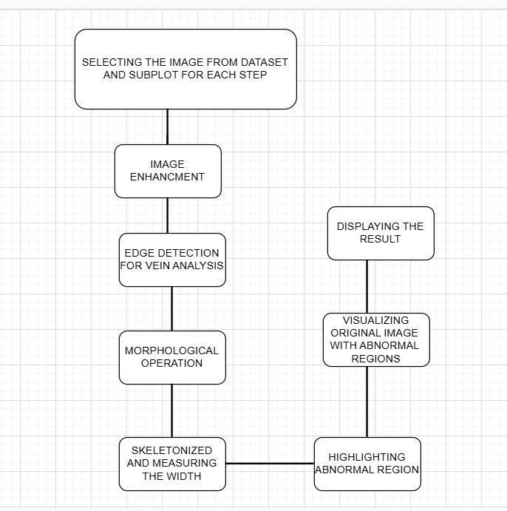

**CODE:**

folderPath = 'C:\Users\91993\Downloads\Cashew anthracnose';

% Get list of all images in the folder

imageFiles = dir(fullfile(folderPath, '.jpg')); % Change '.jpg' if your images have a different format

% Preallocate a cell array to store images

numImages = length(imageFiles);

images = cell(1, numImages);

% Loop through each image and load it

for i = 1:numImages

imgPath = fullfile(folderPath, imageFiles(i).name);

images{i} = imread(imgPath);

end

% Display an example image to verify

imshow(images{1});

title('Example Image from Dataset');

% Begin image processing on the first image

img = images{1};

% Step 1: Convert to Grayscale

gray_img = rgb2gray(img);

figure;

imshow(gray_img);

title('Grayscale Image');

% Step 2: Image Preprocessing (Enhancement)

% Enhance contrast using adaptive histogram equalization

enhanced_img = adapthisteq(gray_img);

figure;

imshow(enhanced_img);

title('Enhanced Grayscale Image');

% Step 3: Edge Detection for Vein Extraction

% Use Sobel or Canny edge detection to extract veins

edges = edge(enhanced_img, 'Canny');

figure;

imshow(edges);

title('Vein Extraction (Edge Detection)');

% Step 4: Morphological Operations to Enhance Veins

% Perform morphological operations to thicken the vein structures

se = strel('line', 2, 90); % Structural element for dilation

dilated_img = imdilate(edges, se);

figure;

imshow(dilated_img);

title('Dilated Veins for Analysis');

% Step 5: Vein Pattern Analysis

% Use regionprops to find connected components in the vein structure

props = regionprops(dilated_img, 'Area', 'Perimeter');

vein_areas = [props.Area];

vein_perimeters = [props.Perimeter];

% Displaying analysis results

fprintf('Number of vein segments: %d\n', length(props));

fprintf('Average vein area: %.2f\n', mean(vein_areas))

fprintf('Average vein perimeter: %.2f\n', mean(vein_perimeters))

**Output screenshot:**

|  |  |
| --- | --- |
|  |  |

**HSV Colour Space Segmentation:**

The HSV (Hue, Saturation, Value) color space is particularly effective for segmenting healthy and unhealthy regions of leaves based on their chromatic and intensity features.

**CODE :**

img = imread("C:\Users\hp\OneDrive\spoorthi\healthy leaf.jpg");

hsvImg = rgb2hsv(img);

hue = hsvImg(:, :, 1);

saturation = hsvImg(:, :, 2);

value = hsvImg(:, :, 3);

healthyMask = (hue > 0.2) & (hue < 0.4) & (saturation > 0.3) & (value > 0.2);

diseasedMask = ~healthyMask & (value < 0.5) & (saturation < 0.4);

% Display original image

figure;

subplot(2, 2, 1);

imshow(img);

title('Original Image');

% Display healthy areas mask

subplot(2, 2, 2);

imshow(healthyMask);

title('Healthy Areas Mask');

% Display diseased areas mask

subplot(2, 2, 3);

imshow(diseasedMask);

title('Disease Areas Mask');

% Highlight diseased areas on the original image

highlightedImg = img;

highlightedImg(repmat(diseasedMask, [1, 1, 3])) = 255; % Highlight diseased areas in white

% Display the highlighted image

subplot(2, 2, 4);

imshow(highlightedImg);

title('Detected Disease Areas');

% Calculate the percentage of diseased area

diseasedPercentage = sum(diseasedMask(:)) / numel(diseasedMask) * 100;

% Display the result in the command window

if diseasedPercentage > 4% Adjust threshold as needed

disp('The leaf is diseased.');

else

disp('The leaf is healthy.');

end

**Output screenshot:**

* **For healthy leaf**

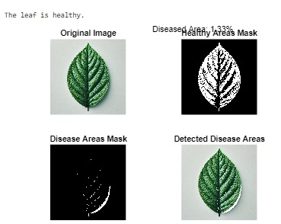

* **For diseased leaf**



**RESULTS**:

* Accurate segmentation of healthy and diseased leaf areas.
* Quantification of the diseased area as a percentage.
* Classification of the leaf health status.

**OBSERVATION:**

1. Diseased regions were segmented using HSV thresholds.
2. Marking of healthy and unhealthy areas was achieved.
3. The code calculated a diseased area percentage and classified leaf health accurately**.**

**CONCLUSION:**

* The method do pest damage detection more effictively, reducing manual effort.
* Fine-tuning thresholds and preprocessing steps enhance robustness across datasets.
* The system is scalable for use in agricultural monitoring applications.

**OBJECTIVE:**

project integrates HSV-based segmentation with vein-level analysis for pest detection. The use of dynamic thresholds ensures adaptability, and the overlay provides a clear representation of affected regions.

**NOVELTY: -**

* This project uniquely combines vein structure irregularities or color-based segmentation to enhance detection accuracy.
* The vein analysis identifies structural abnormalities which helps giving,indicative of pest-induced stress, while HSV segmentation highlights visual discoloration caused by disease or pests.
* The use of skeletonization and distance transforms allows precise vein width measurement.

**INDIVIDUAL CONTRIBUTION:**

* **Anushka Keshri**:
* Implemented the vein analysis algorithm, including skeletonization, vein width measurement, and abnormality detection.
* Enhanced the preprocessing pipeline for feature extraction across image qualities.
* **Spoorthi N**:
* Designed and implemented the HSV segmentation algorithm for healthy and diseased region identification.
* techniques to overlay results on the original image for better result .
* **JOINT CONTRIBUTION:**
* Conducted testing and validation of both methods on dataset of leaf images.
* Integrated the outputs from both codes, ensuring giving higher accuracy.
* Fine-tuned thresholds and preprocessing parameters to improve system robustness

**REFERENCES:**

[**https://ieeexplore.ieee.org/iel7/9622740/9622741/09622812.pdf**](https://ieeexplore.ieee.org/iel7/9622740/9622741/09622812.pdf)

[**https://ieeexplore.ieee.org/stamp/stamp.jsp?tp=&arnumber=6113609**](https://ieeexplore.ieee.org/stamp/stamp.jsp?tp=&arnumber=6113609)

[**https://ieeexplore.ieee.org/stamp/stamp.jsp?tp=&arnumber=5603948**](https://ieeexplore.ieee.org/stamp/stamp.jsp?tp=&arnumber=5603948)