Project Assessment – Assessor Instructions

Details
Qualification code and title | ICT50220 Diploma of Information Technology
Unit code and title | ICTICT517 Match ICT needs with the strategic direction of the organisation  ICTCLD401 Configure cloud services  ICTCLD502 Design and implement highly-available cloud infrastructure
Assessment task title | AT2 — Cloud Foundation Build: YAT LMS Migration
Assessment task number | 2 of 3 | Due Date

Teacher/Assessor name

Teacher/Assessor instructions
Assessment overview | Students are assessed on the implementation of a supplied AWS cloud architecture for the YAT LMS migration, worked through and recorded in a guided build run sheet.  The assessment is a single-task project delivered as one document: the build run sheet in the second half of this instrument, which the student works through and fills in as they build. Implementation occurs in the AWS Academy lab environment authorised for this cluster. There is no presentation or observation event — every piece of evidence is captured in the run sheet itself, in the box beside the task it evidences.  This is an open-book practical assessment. Students may use the YAT intranet, the AWS Pricing Calculator, AWS Academy lab environments, AWS documentation, course reference materials, and external research (which must be cited) throughout.  AT2 is the second of three assessment tasks in the S1-CL1 Cloud Design and Build cluster. It builds on AT1 (Business Case + presentation event) and feeds into AT3 (HA hardening + project closure). The student remains in the same MTS consultant role across all three.  Reasonable adjustment for this assessment may include extending the time allowed, varying the lab access arrangement (e.g. extended lab hours), allowing alternative screenshot-evidence formats where assistive technology requires it, or providing one-on-one verbal explanation of the supplied design where needed.  Teacher/assessor support level: the teacher/assessor may clarify task requirements, scenario context, or the supplied design but must not guide students to specific configuration decisions or correct knowledge-evidence answers. The two Configuration Decisions left to the implementer (per the supplied design §4.16) must be made by the student.  Submission: the completed run sheet (.docx) is submitted via the LMS. There are no separate files — the screenshots and written answers sit in the document itself.  The assessment will not proceed if for any reason it is not safe to do so. You must advise the student of the reason for suspending the assessment, and what safety action should be taken. Advise the student of revised arrangements for the assessment when it is safe to do so.  There is a zero tolerance for plagiarism, cheating and collusion. Students will be expected to make a declaration that all work is their own prior to submission. Refer to the Training and Assessment Policy for further information.
Task(s) to be assessed | Following the YAT board's approval of the action plan in the student's AT1 Business Case engagement, the student took a period of planned annual leave (in-scenario narrative).  During that time MTS Senior Architecture worked with YAT IT to translate the approved direction into a detailed technical design — the YAT LMS Cloud Architecture — Baseline Design — which is now the student's build specification.  The student has returned to MTS to lead the foundation-build phase of the engagement. The task has two parts that combine into a single deliverable:  Implement the supplied AWS architecture for the YAT LMS migration foundation build, in the AWS Academy lab environment authorised for this engagement.  Work through the build run sheet, recording the build as they go. It covers what was built, the two configuration decisions the supplied design leaves open, five tests with their results, written responses to six contextual Knowledge Evidence questions about the student's own build, and where the completed run sheet was filed.  The completed run sheet is the single submitted deliverable. Each screenshot sits in the box beside the task it evidences rather than in an appendix — there is no separate portfolio submission and no presentation event.  The architecture being implemented is intentionally non-HA at this stage. HA hardening is the next phase (AT3) and is explicitly out of scope for AT2.  MTS scope: cloud infrastructure provisioning only. Per the LMS Migration Role Brief on the YAT intranet (§ Scope of the MTS consulting engagement), students must not perform LMS application installation, MySQL data migration, cutover activities, or organisational change management as part of AT2. Those are YAT in-house IT's responsibility in-scenario. The AT2 deliverable stops at infrastructure ready for application deployment. Assessors should not award credit for application-deployment work that falls outside this scope; equally, students who include such work in their report should be redirected to focus their evidence on the in-scope infrastructure deliverables.  Note:  All scenario materials, organisational policies, the supplied design, and previous-project examples for YAT College are available on the YAT intranet — students sign in to the intranet at the start of the engagement and refer to it throughout.

Time allowed

Location
Resources required | Teacher/assessor supplied resources  Access to the YAT intranet — supplying the LMS Application Specification and the Records Management Policy  Both documents are linked in the Instructions to Student below  AWS Academy lab access — Cloud Foundations [104469] + Cloud Architecting [172221]  The worked run sheet later in this document — screenshot descriptions, model answers and per-task UoC mapping  Student supplied resources  Computer with web browser  Word-processing software (e.g. Microsoft Word or equivalent)  A screenshot tool
Assessment criteria | To receive a Satisfactory outcome for this assessment the student must:  Achieve Satisfactory on every criterion in the Marking Guide below  Submit the completed run sheet (.docx) with every task, test, decision and question answered, and every evidence box filled
Second attempt | If the student is deemed not satisfactory, they will be given one (1) more attempt at this assessment (or part thereof) or you can negotiate a further assessment with the student as required. The second attempt must be completed within 10 working days from the date your feedback is given.
Assessment retention | Documentation including supporting papers/forms must be retained in accordance with the BKI Records Disposal and Transfer Procedure.
Assessment Conditions & Setup Requirements | These are conditions the assessor verifies as present before marking begins. They are not student-performance criteria — they are the conditions under which the assessment can validly be conducted.  C1 Lab environment is accessible to the student throughout the assessment — AWS Academy Cloud Foundations [104469] + AWS Academy Cloud Architecting [172221] — providing cloud vendor service provider access, cloud managed database service (RDS), IDE / console / CLI / SSH-RDP tooling, and internet/web browser access  [ICTCLD401 AC 1] · [ICTCLD401 AC 2] · [ICTCLD401 AC 3] · [ICTCLD502 AC 1] · [ICTCLD502 AC 2] · [ICTCLD502 AC 4] · [ICTCLD502 AC 6] · [ICTCLD502 AC 7]  C2 The YAT scenario site / intranet is accessible to the student throughout the assessment — supplying the LMS Application Specification and the organisational policies  [ICTCLD401 AC 4] · [ICTCLD502 AC 3] · [ICTCLD502 AC 5] · [ICTCLD502 AC 8]

Project Assessment – Marking Guide

List the criteria the student will be assessed against for the project assessment.

Assessment criteria
Criteria | Satisfactory?
A1 Network foundation (tasks 2-7) — student builds the VPC; the five subnets, with the three workload subnets in one zone and the two second-zone subnets the load balancer and the database subnet group each require; the internet and NAT gateways; two route tables, the data subnets left on the VPC default which carries no internet route; and the three security groups, with the database reachable only from the application tier  [ICTCLD401 PC 1.7] · [ICTCLD401 PC 2.2] · [ICTCLD401 PE 1] · [ICTCLD502 PC 1.3] | ☐ Yes ☐ No
A2 Identity and access (tasks 1, 8-9) — student accesses the platform; works through the group and user creation to the point of submission and captures the environment’s refusal, with the permissions reasoning in the decision box; and reviews the supplied instance role, naming the services it lets the servers reach. The refusal is the evidence — do not expect created groups, an enabled MFA device, or a student-created role  [ICTCLD401 PC 1.4] · [ICTCLD401 PC 1.5] · [ICTCLD401 PC 1.6] · [ICTCLD401 PC 2.1] | ☐ Yes ☐ No
A3 Compute and load balancing (tasks 10-13) — student creates the launch template with the instance role and both volumes, the target group and internet-facing load balancer, and the Auto Scaling group attached to that target group with a scaling policy  [ICTCLD401 PC 2.3] · [ICTCLD401 PC 2.4] · [ICTCLD401 PC 3.1] · [ICTCLD502 PC 4.1] · [ICTCLD401 PE 2] | ☐ Yes ☐ No
A4 Database (tasks 14-15) — student creates the subnet group spanning two zones and deploys the managed database: single-AZ, encrypted, not publicly accessible, and in the database security group  [ICTCLD401 PC 2.5] · [ICTCLD401 PE 2] | ☐ Yes ☐ No
A5 Monitoring (task 16) — student creates both baseline alarms and evidences their state  [ICTCLD502 PC 4.3] | ☐ Yes ☐ No
A6 Shared responsibility (task 17) — student assigns responsibility for securing each component of the platform they built — facilities, operating system, database engine and host, network access rules, identity, and the data — naming the party and what that party actually does, and identifies which responsibilities the managed database moved and which it did not. A correct list with no statement of what each party does, or the data placed anywhere but with YAT, is not satisfactory  [ICTCLD401 PC 1.2] | ☐ Yes ☐ No
A7 Configuration decisions (tasks 10 and 15) — for each of the two decisions the run sheet leaves open, student names the option not chosen, states the choice made, and justifies it against the YAT LMS workload. Naming the gap between what the environment permits and what the workload needs is a satisfactory answer  [ICTCLD401 PC 1.1] · [ICTCLD401 PC 1.3] | ☐ Yes ☐ No
A8 Testing (T1-T5) — student connects to the application server, reaches the internet, the database and the load balancer from it, and demonstrates the Auto Scaling group scaling out and back in on its own. Each screenshot shows what its box asks for  [ICTCLD401 PC 2.6] · [ICTCLD401 PC 3.2] · [ICTCLD401 PE 3] · [ICTCLD502 PC 4.2] | ☐ Yes ☐ No
A9 Knowledge questions (Q1-Q6) — student answers all six with reference to their own build, not generically, in clear written English  [ICTCLD401 KE 5] · [ICTCLD401 KE 6] · [ICTCLD401 KE 7] · [ICTCLD401 KE 8] · [ICTCLD401 KE 9] · [ICTCLD401 KE 10] · [ICTCLD401 FS Reading] · [ICTCLD401 FS Writing] | ☐ Yes ☐ No
A10 Handover — student states where the completed run sheet was filed and which YAT policy required that location  [ICTCLD401 PC 4.3] | ☐ Yes ☐ No

Scenario
YAT College is migrating their Learning Management System from on-premises to AWS. You are an MTS Consultant on this engagement, reporting to Pat Lin (MTS Senior Consultant). Sam Walker (YAT IT Manager) is your primary YAT-side stakeholder.
At the end of the AT1 engagement the YAT board approved your action plan. MTS Senior Architecture then worked with YAT IT to turn that direction into a cloud architecture design, and an MTS implementation lead turned the design into the build run sheet that forms the second half of this document.
Your job is to work through that run sheet and stand up the infrastructure. You are the implementer: the design decisions have been made, and the run sheet tells you what to build and what to build it to.

Required resources (assessment conditions)
• LMS Application Specification — the workload your two sizing decisions are justified against
• Records Management Policy — where a completed engagement document has to be filed

Instructions to Student
Work the tasks in order. Each one tells you what to build and the settings to build it to; finding your way around the console is left to you.
Take each screenshot as you finish the task, not at the end. Recreating a screen after you have moved on is painful and sometimes impossible. A task you cannot evidence cannot be assessed as satisfactory.
Two tasks ask you to choose between two options. Name the one you did not pick as well as the one you did — a choice with no alternative beside it is not a comparison.
Run the tests yourself and screenshot what actually happened. If a test fails, fix it, run it again, and say what you changed.
Answer the knowledge questions about your own build. Generic answers about cloud computing will not pass.
This engagement's production region is ap-southeast-2 (Sydney). The build environment for this work is us-east-1 — build there, and treat it as standing in for Sydney throughout.
TASK 1

Sign in and confirm your working region
Evidences: [ICTCLD401 PC 1.4]
Sign in to the AWS console for this engagement and set your region.
Region | us-east-1

Evidence
SCREENSHOT — the console with the region selector visible, showing the correct region.
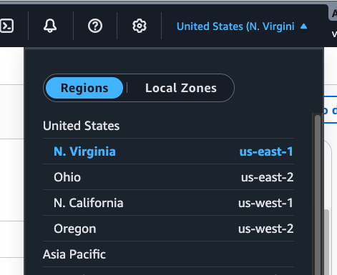

TASK 2

Create the VPC
Create the virtual private cloud all of this engagement's infrastructure sits in.
Name | yat-lms-vpc
IPv4 CIDR | 10.0.0.0/16
DNS hostnames | Enabled
DNS resolution | Enabled

Evidence
No screenshot required. Creating the VPC is not an assessable action on its own — it is the prerequisite for everything that follows, all of which is built inside it.
TASK 3

Create the subnets
Evidences: [ICTCLD401 PC 2.2] · [ICTCLD401 PE 1]
Create five subnets, using the names, address ranges and zones below. Set the zone yourself on every one — the console picks a default, and if two subnets that are meant to be in different zones end up in the same one, the load balancer and the database will both refuse to create later.
public-web-a | 10.0.1.0/24 — zone us-east-1a
public-web-b | 10.0.2.0/24 — zone us-east-1b
private-app-a | 10.0.11.0/24 — zone us-east-1a
private-data-a | 10.0.21.0/24 — zone us-east-1a
private-data-b | 10.0.22.0/24 — zone us-east-1b
Why five | three carry your workload, all in us-east-1a. The two in us-east-1b exist only because the load balancer and the database subnet group each refuse to be created unless you give them subnets in two zones. Nothing is placed in those two

Evidence
SCREENSHOT — the subnet list filtered to your VPC, showing all five with their address ranges and, in particular, the Availability Zone column.
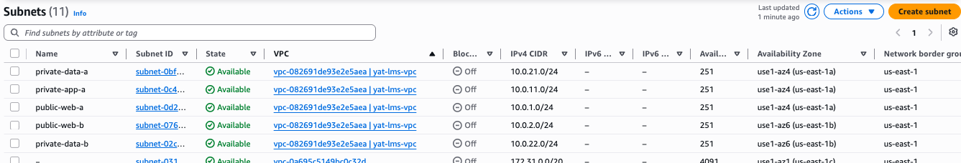

TASK 4

Create the internet gateway
Evidences: [ICTCLD401 PC 2.2] · [ICTCLD401 PE 1]
Create the gateway that gives the public subnet a path to the internet, and attach it to your VPC.
Name | yat-lms-igw
Attach to | yat-lms-vpc

Evidence
SCREENSHOT — the internet gateway showing State: Attached, and the VPC it is attached to.
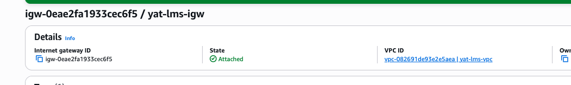

TASK 5

Create the NAT gateway
Evidences: [ICTCLD401 PC 2.2] · [ICTCLD401 PE 1]
Create a NAT gateway, using the settings below. It lets the application servers reach out to the internet for updates and external services without anything on the internet being able to reach them. It sits in the public subnet and takes a few minutes to become available.
Name | yat-lms-nat
Subnet | public-web-a — the NAT gateway goes in the public subnet, not the one it serves
Connectivity type | Public
Elastic IP | allocate a new one here
Before moving on | wait until its state reads Available — you cannot route to it until then

Evidence
SCREENSHOT — the NAT gateway showing State: Available, its subnet and its Elastic IP.
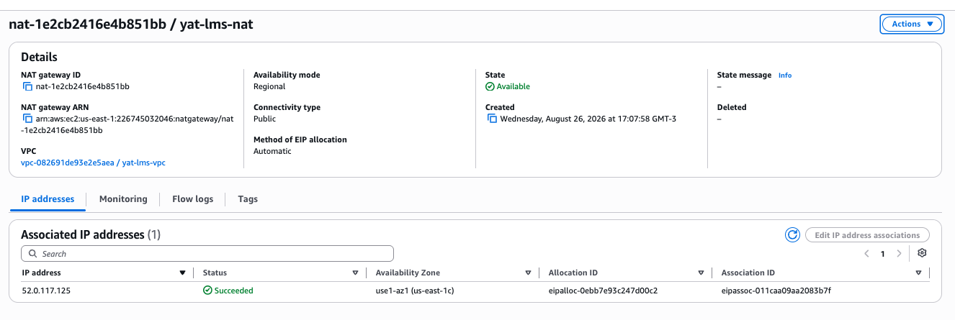

TASK 6

Create the route tables
Evidences: [ICTCLD401 PC 2.2] · [ICTCLD401 PE 1]
Create two route tables, using the settings below. The data subnets are deliberately left on the default route table the VPC already has, which carries no internet route at all — which is exactly what a database tier should have.
public-rt | associated with public-web-a AND public-web-b; 0.0.0.0/0 → the internet gateway
private-app-rt | associated with private-app-a; 0.0.0.0/0 → the NAT gateway
The data subnets | leave them alone — no route table of your own

Evidence
SCREENSHOT — both route tables, showing their routes and their subnet associations.
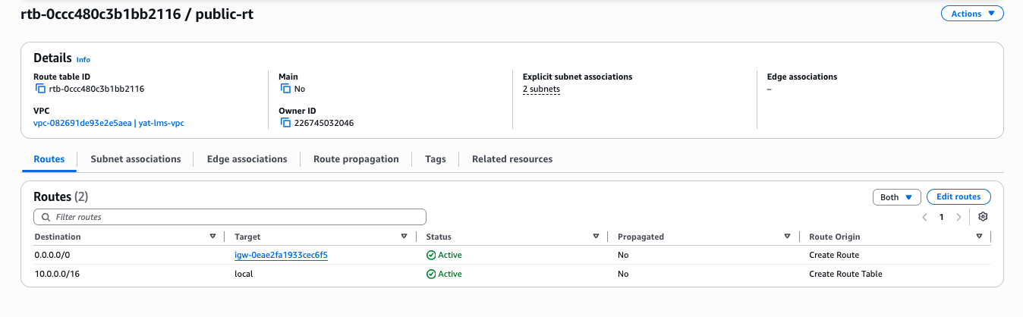

SCREENSHOT — continued
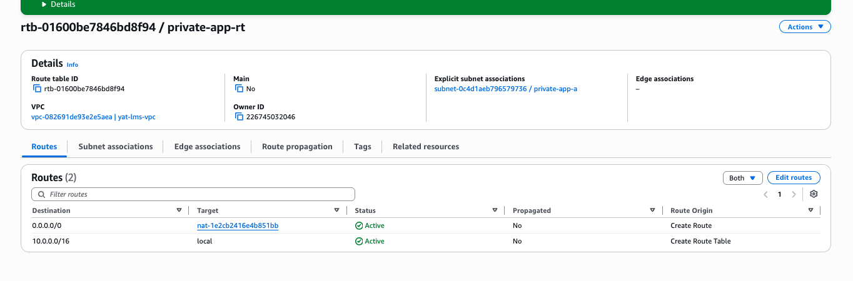

TASK 7

Create the three security groups
Evidences: [ICTCLD401 PC 1.7] · [ICTCLD502 PC 1.3]
Create three security groups, using the names and rules below. Create all three as empty shells first, then go back and add the rules — each one names the others as a source, which you cannot do until they exist. AWS will not accept a name starting with sg- : that prefix is reserved for the IDs it generates.
yat-lms-alb-sg | inbound HTTP 80 from 0.0.0.0/0
yat-lms-app-sg | inbound HTTP 80 from yat-lms-alb-sg
yat-lms-db-sg | inbound MySQL 3306 from yat-lms-app-sg only
Outbound | leave the default allow-all on all three

Evidence
SCREENSHOT — all three security groups with their inbound rules expanded.
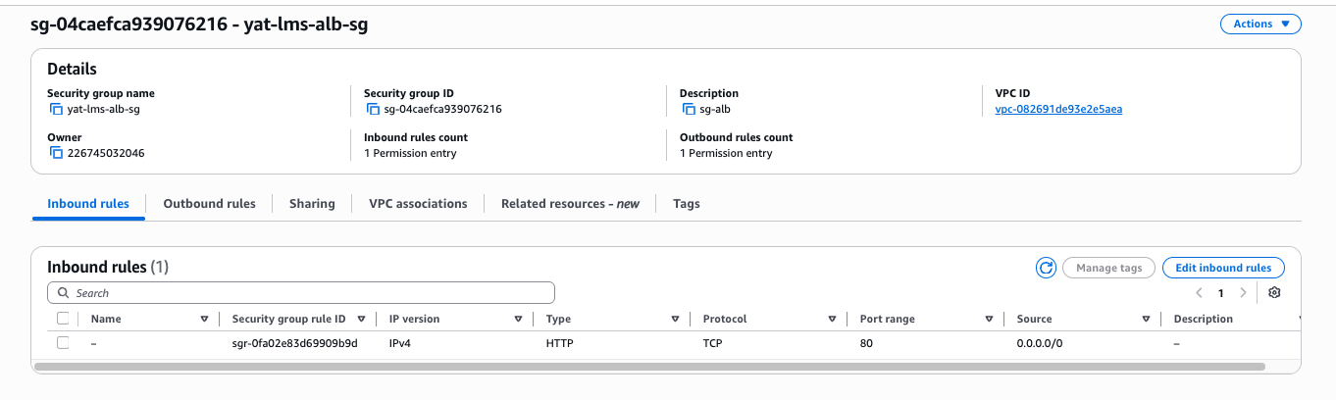

SCREENSHOT — continued
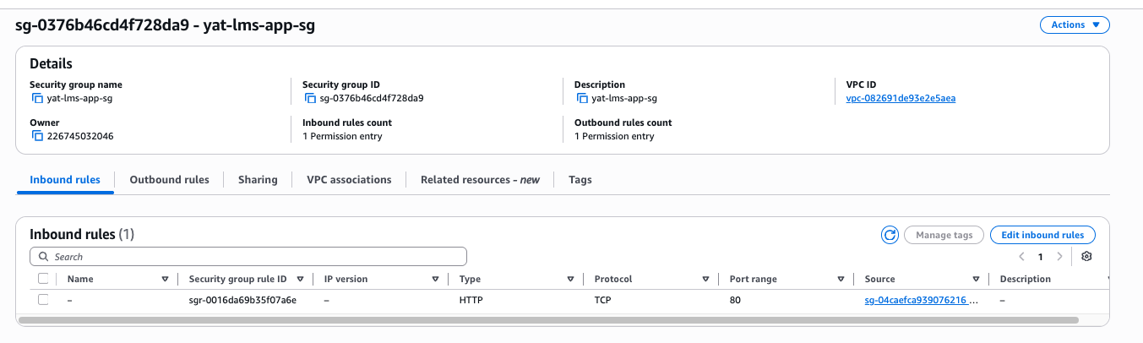

SCREENSHOT — continued
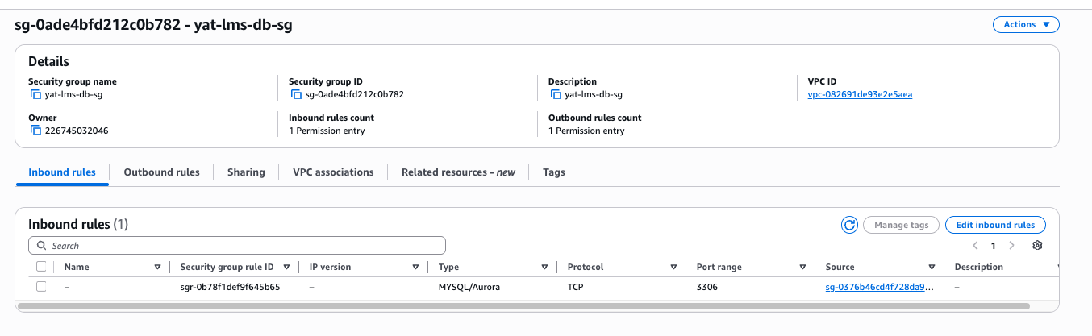

TASK 8

Configure the access model
Evidences: [ICTCLD401 PC 1.5] · [ICTCLD401 PC 2.1]
Create the group that will operate the platform after handover, and a user in it. Complete each form with the values below, submit it, and capture the result.
Environment constraint the lab environment does not permit groups or users to be created. This is a known constraint of the AWS educational environment, not a fault in your work — you will be refused, and the refusal is what you capture.
Group name | YAT-ICT-Admins
Policy on the group | ReadOnlyAccess — filter for it and pick the policy named exactly that, not one of the service-specific ones
User name | swalker (Sam Walker, YAT IT Manager)
Policy on the user | CloudWatchFullAccess
Expected result | both submissions are refused with a permissions error

Your decision
Why does this group get read access to everything but no ability to change identity settings, when it is the group that operates the whole platform?
Identity is what decides who can grant themselves more access. A group that can rewrite its own permissions has no boundary at all — it could give itself anything. So YAT ICT can see and operate everything, and identity stays with whoever governs the account. The user carries CloudWatch access directly rather than through the group, which shows permissions can sit in either place; groups are for not repeating yourself across many users, not a requirement.

Evidence
SCREENSHOT — the completed group form — YAT-ICT-Admins with ReadOnlyAccess attached — and the error returned.
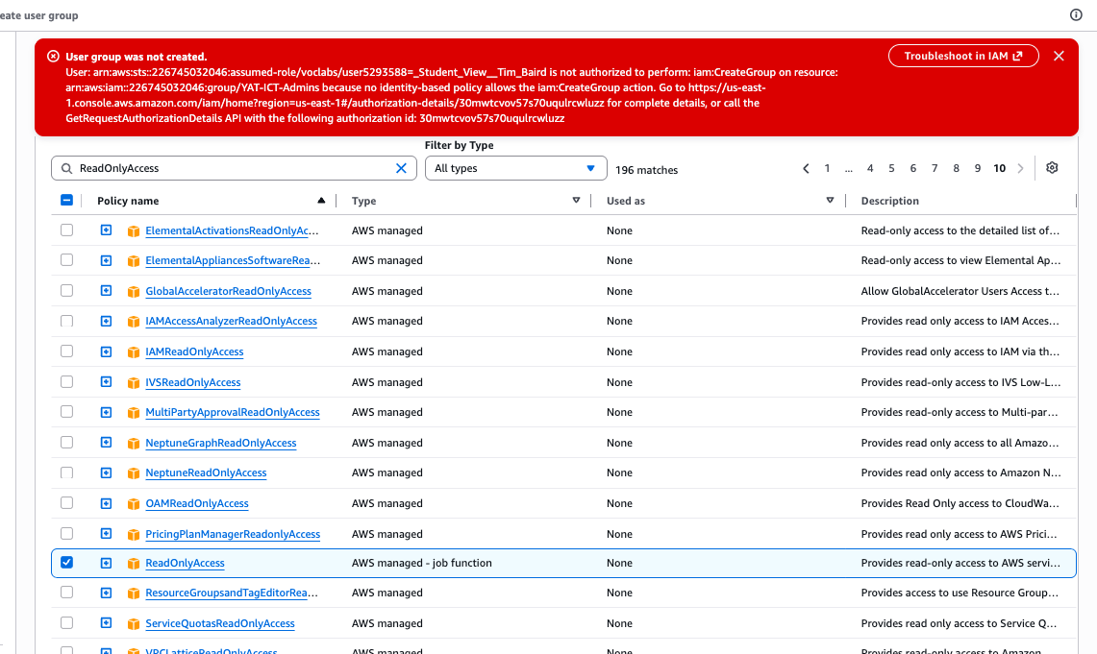

SCREENSHOT — the completed user form — swalker with CloudWatchFullAccess attached — and the error returned.
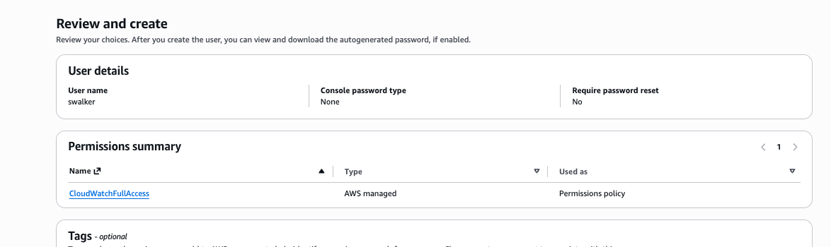

TASK 9

Review the instance role
Evidences: [ICTCLD401 PC 1.6] · [ICTCLD401 PC 1.7]
Open the role named below and look at the policies attached to it, then write its name down. Your servers reach the storage buckets and the logging service through this role, so no credentials are ever stored on a server. You select it in the next task.
Environment constraint the lab environment supplies this role ready-made and does not permit you to create your own, so this task is a review rather than a build.
Go to | IAM → Roles
Open | LabRole (the role the environment provides)
Look at | the Permissions tab — the policies attached to it
Answer for yourself | which services does it let your servers reach?
Write down | the role name, exactly as shown — task 10 asks for it

Evidence
SCREENSHOT — the LabRole summary page with the Permissions tab open, showing the policies attached to it.
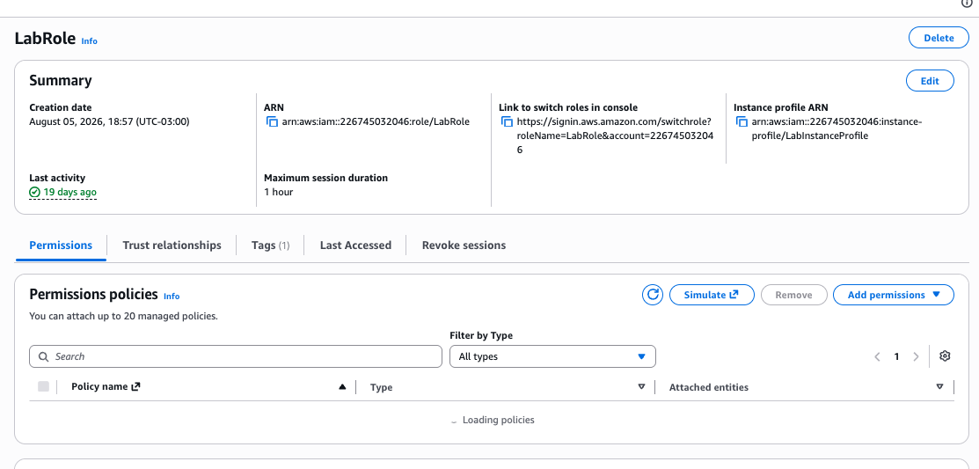

TASK 10

Create the launch template
Evidences: [ICTCLD401 PC 2.3] · [ICTCLD401 PC 2.4] · [ICTCLD401 PC 1.1] · [ICTCLD401 PC 1.3]
Create a launch template, using the settings below. It defines how every application server is built. The Auto Scaling group creates servers from it, so nothing is configured on a server by hand.
Name | yat-lms-lt
AMI | Windows Server (latest available)
Instance type | your choice — see the decision below
Key pair | do not include one
Subnet | do not include one — the Auto Scaling group supplies it
Security group | yat-lms-app-sg
Root volume | gp3, 30 GB
Data volume | add a second volume: gp3, 8 GB, device name xvdb. The console will not accept the volume without a device name, and the /dev/sd... names are greyed out because this is a Windows image
Advanced details → IAM instance profile | LabInstanceProfile
Advanced details → User data | the script below, exactly as written

User data
<powershell>
Install-WindowsFeature -Name Web-Server -IncludeManagementTools
Set-Content -Path "C:\inetpub\wwwroot\index.html" -Value "<html><body>
<h1>YAT LMS</h1><p>Infrastructure ready - awaiting application
deployment.</p></body></html>"
</powershell>

Your decision
Choose the instance type for the application tier: t3.micro or t3.small. Name the one you did not choose, say which you chose, and explain why against the LMS workload described in the LMS Application Specification.
t3.micro has 1 GiB of memory and t3.small has 2 GiB. Windows Server alone uses most of 1 GiB before the application starts, so t3.micro would spend its time paging and the health check would be slow and unreliable. I chose t3.small. Both are well below what the specification's 200–300 typical concurrent users would need — in production I would size to a general-purpose instance several times this — but this environment caps what I can launch, and t3.small is the better of the two available.

Evidence
SCREENSHOT — the launch template summary, showing the AMI, instance type, instance profile, security group and both volumes.
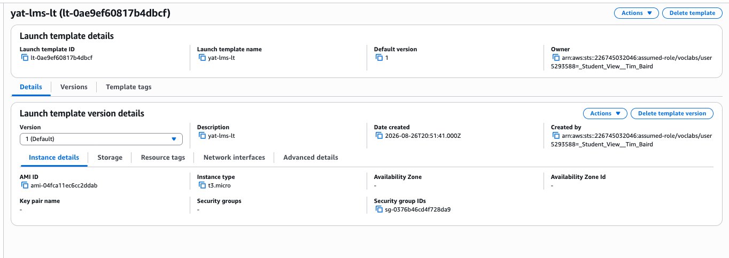

TASK 11

Create the target group
Create a target group, using the settings below. It is the list of servers the load balancer will send traffic to, and the health check that decides which of them are fit to receive it.
Name | yat-lms-tg
Target type | Instances
Protocol and port | HTTP, port 80
VPC | yat-lms-vpc
Health check protocol | HTTP
Health check path | /
Interval | 30 seconds
Unhealthy threshold | 2
Register targets | skip this step and create the group with no targets. The Auto Scaling group registers them for you in task 13

Evidence
No screenshot required. Creating the target group is not an assessable action on its own — it is the prerequisite for the load balancer, which sends traffic to it, and the Auto Scaling group, which fills it with servers.
TASK 12

Create the load balancer
Evidences: [ICTCLD401 PC 2.2] · [ICTCLD502 PC 4.1]
Create an Application Load Balancer, using the settings below. It sits in front of the application tier and sends traffic only to servers the target group reports as healthy.
Type | Application Load Balancer
Name | yat-lms-alb
Scheme | Internet-facing
VPC | yat-lms-vpc
Subnets | public-web-a and public-web-b. It requires two zones and will not create with only one
Security group | yat-lms-alb-sg. Remove the default group if the console adds it
Listener | HTTP on port 80
Listener forwards to | yat-lms-tg

Evidence
SCREENSHOT — the load balancer summary, showing its scheme, DNS name, subnets and security group.
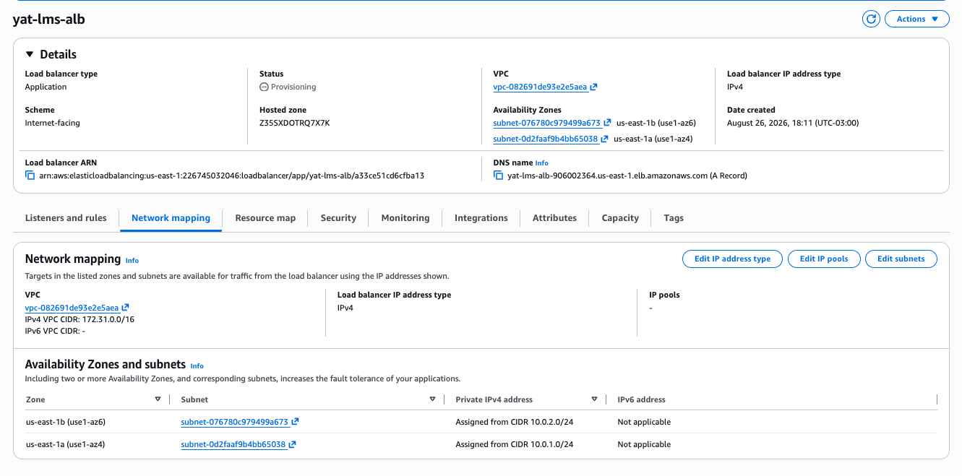

SCREENSHOT — continued
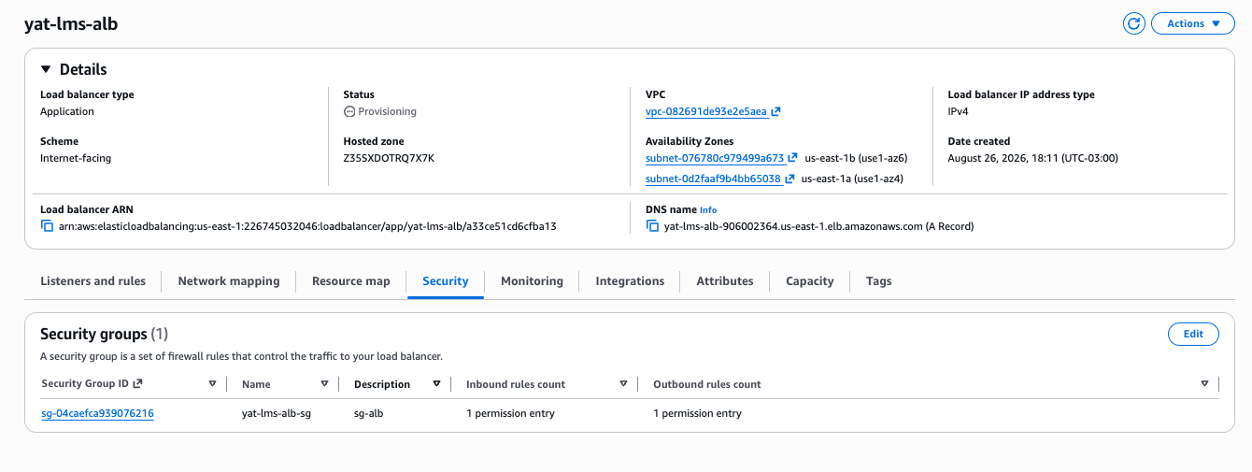

TASK 13

Create the Auto Scaling group
Evidences: [ICTCLD401 PC 3.1] · [ICTCLD401 PE 2]
Create an Auto Scaling group, using the settings below. It adds and removes application servers on its own, without anyone touching the instance count.
Step 1 — Launch template | yat-lms-lt
Step 2 — VPC | yat-lms-vpc
Step 2 — Subnet | private-app-a only
Step 3 — Load balancing | choose Attach to an existing load balancer, then Choose from your load balancer target groups, and select yat-lms-tg. This step defaults to No load balancer, so it is easily skipped
Step 3 — Health check type | tick Turn on Elastic Load Balancing health checks; grace period 300 seconds
Step 4 — Group size | desired 1, minimum 1, maximum 2
Step 4 — Scaling policy | Target tracking, Average CPU utilization, target value 70
Step 4 — Warm-up | 60 seconds

Evidence
SCREENSHOT — the Auto Scaling group details, showing group size, the attached target group and the scaling policy.
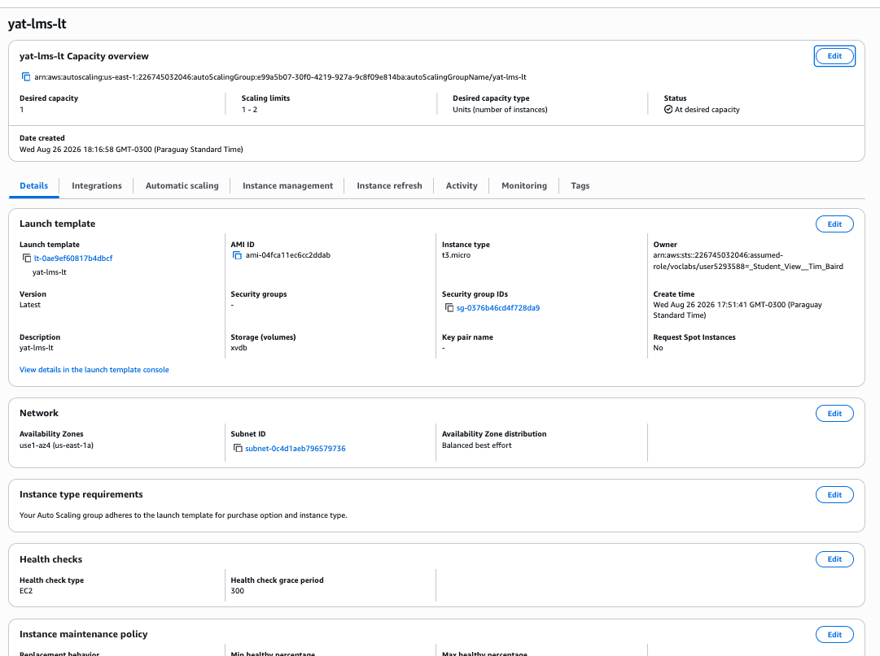

TASK 14

Create the database subnet group
Create a database subnet group, using the settings below. It tells the database service which subnets it is allowed to place the database in.
Environment constraint create this in the RDS console, not the VPC console — RDS → Subnet groups → Create DB subnet group. It is easy to go looking for it where the subnets themselves live.
Name | yat-lms-db-subnet-group
VPC | yat-lms-vpc
Availability Zones | us-east-1a and us-east-1b
Subnets | private-data-a and private-data-b
Why two | the service requires subnets in two zones even though this database is single-AZ. The second one stays empty until the next phase

Evidence
No screenshot required. Creating the subnet group is not an assessable action on its own — it is the prerequisite for the database, which cannot be created without one.
TASK 15

Deploy the database
Evidences: [ICTCLD401 PC 2.5] · [ICTCLD401 PC 1.1] · [ICTCLD401 PC 1.3] · [ICTCLD401 PE 2]
Create the database, using the settings below. Create it empty — loading the schema and the data is YAT ICT job, not yours.
Environment constraint use Standard create, not Easy create. Easy create chooses the network, the subnet group, the security group and the public-access setting for you and does not let you change them, which is four of the settings this task specifies.
Creation method | Standard create
Engine | MySQL
Template | Free tier, if offered
Instance class | your choice — see the decision below
Storage | gp3, 20 GB
Multi-AZ | Do not create a standby. This build is deliberately single-AZ
VPC | yat-lms-vpc
Subnet group | yat-lms-db-subnet-group
Public access | No
Security group | yat-lms-db-sg. Remove the default group if the console adds it
Encryption | enabled
Backup retention | 7 days

Your decision
Choose the database instance class: db.t3.micro or db.t3.small. Name the one you did not choose, say which you chose, and explain why against the workload.
db.t3.micro has 1 GiB of memory, db.t3.small has 2 GiB. An LMS database is read-heavy and benefits from having enough memory to keep frequently-read pages cached, so I chose db.t3.small. As with the application tier, both are well below what the real workload would need; the environment caps the choice and db.t3.small is the better of the two.

Evidence
SCREENSHOT — the database summary showing Available, its class, encryption enabled and public access set to No.
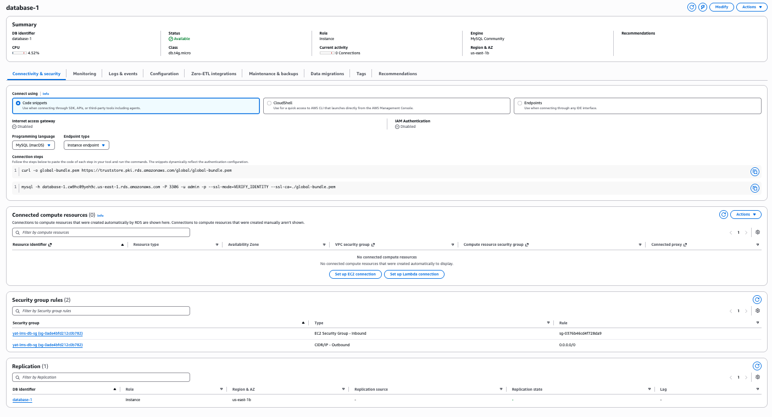

TASK 16

Create the two monitoring alarms
Evidences: [ICTCLD502 PC 4.3]
Create two CloudWatch alarms, using the settings below. They are the baseline monitoring that tells the platform when something is wrong — one watching whether the application tier is serving, one watching whether the database is running out of room.
Notification topic | create an SNS topic named yat-lms-alerts with your own email address, and use it for both alarms. You do not need to confirm the subscription email for the alarm to be created
─ Alarm 1 ─ | the application tier is not serving
Metric | Application ELB → Per AppELB, per TG Metrics → UnHealthyHostCount, filtered to yat-lms-alb and yat-lms-tg
Statistic | Maximum
Period | 1 minute
Threshold type | Static
Condition | Whenever UnHealthyHostCount is Greater/Equal than 1
Datapoints to alarm | 1 out of 1
Missing data treatment | Treat missing data as missing
Notification | In alarm → yat-lms-alerts
Name | yat-lms-unhealthy-hosts
Description | any target behind the load balancer has failed its health check
─ Alarm 2 ─ | the database is running out of room
Metric | RDS → DBInstanceIdentifier, then filter for FreeStorageSpace and tick the row for your database
Statistic | Minimum
Period | 5 minutes
Threshold type | Static
Condition | Whenever FreeStorageSpace is Lower than 3221225472
About that number | it is bytes — 15% of the 20 GiB you allocated. Type the raw digits, no commas and no units. The graph above the field renders in GB, but the field itself is bytes
Datapoints to alarm | 2 out of 2
Missing data treatment | Treat missing data as missing
Notification | In alarm → yat-lms-alerts
Name | yat-lms-db-storage-low
Description | record the allocated size the threshold is based on — 15% of 20 GiB allocated. The number alone does not tell anyone whether it is still correct after the storage is resized

Evidence
SCREENSHOT — the alarm list showing both alarms with their metrics, thresholds and current state.
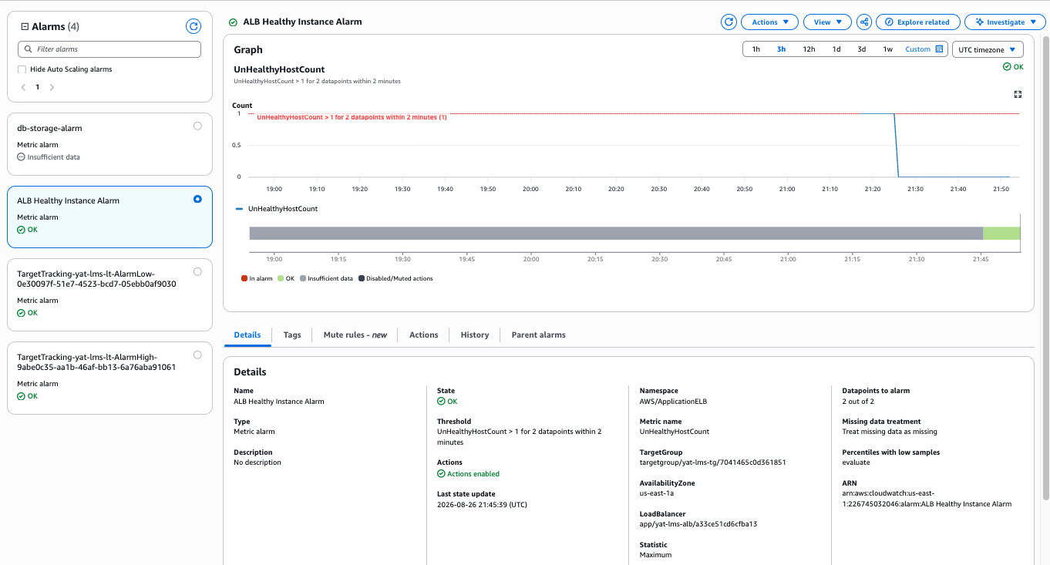

SCREENSHOT — continued
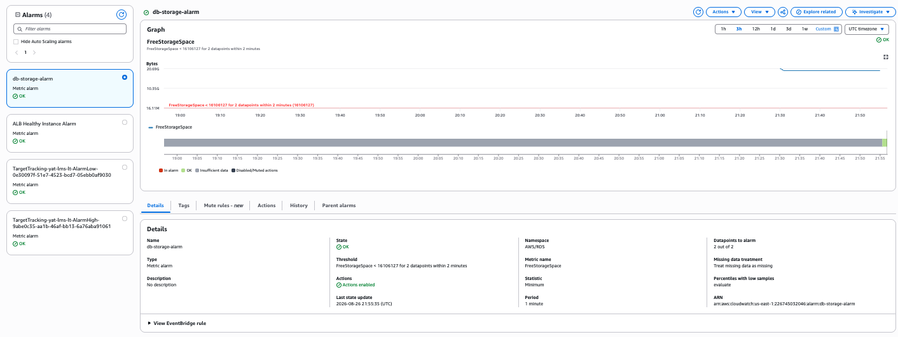

TASK 17

Assign the security responsibilities
Evidences: [ICTCLD401 PC 1.2]
The platform is built. Work through it component by component and record who is responsible for securing each part — AWS or YAT — and what securing it actually involves. Answer for the environment you have just built, naming your own resources; this is not a question about cloud computing in general.
The physical facilities | the data centres, hardware and network the platform runs on
The server operating system | the instances your Auto Scaling group launches from the launch template
The database engine and its host | the managed database you deployed in task 15
Network access rules | the three security groups and the route tables you built in tasks 6 and 7
Identity and permissions | the group and user from task 8, and the instance role from task 9
The data itself | what the LMS stores in the database and on its volumes
For each one | name the responsible party, and say in one sentence what that party actually does to secure it

Your assignment
For each component above, name who secures it and what securing it involves. Then answer one more question: which of these responsibilities moved from YAT to AWS because the design uses a managed database rather than the database engine installed on a server — and which did not move?
Key points the answer should touch on:
• Physical facilities — AWS. Data centre access, hardware, power and cooling. YAT cannot affect it and is not accountable for it.
• Server operating system — YAT. Patching, hardening and configuration of the instances. AWS supplies the image; its state from first boot onwards is YAT's.
• Database engine and host — split, and the split is the point. AWS installs and patches the engine, maintains the host and runs the backup mechanism. YAT owns the schema, the data, and who is permitted to connect.
• Network access rules — YAT. The security groups and route tables are customer configuration. A rule that exposes the database is not something AWS will catch.
• Identity and permissions — YAT. Who exists, what they may do, and the role the servers assume.
• The data — YAT, always, under every service model. Responsibility for content never transfers.
• The impact question: choosing a managed database moved engine patching, host maintenance and backup execution to AWS. It did not move the data, the access rules, or who may connect — those stay with YAT whichever way the database is run. A student who says the managed service made the database 'AWS's responsibility' has missed the distinction this task exists to draw.
• A student who lists the split without saying what each party actually does, or who places the data anywhere but with YAT, has not evidenced this.

Evidence
No screenshot required. Your written assignment above is the evidence for this task.

Testing
Five tests confirm the build works. Each tells you what it demonstrates and the steps to run it. Follow the steps, then paste the screenshot into the box. If a test does not pass, fix the problem, run it again, and note what you changed.
TEST 1

Connect to the application server
Evidences: [ICTCLD401 PE 3]
Connect to your application server using Session Manager, then run the command below. This shows you can reach the server you built.
1. Open EC2 → Instances and select the running instance.
2. Choose Connect, then the Session Manager tab, then Connect.
3. A PowerShell session opens in the browser. Run the command below.

Run this
hostname

Environment constraint Session Manager needs no key pair, no open port and no public IP address. That is why your server can sit in a private subnet with nothing exposed to the internet and still be reachable by you.
Evidence
SCREENSHOT — the session window, showing the connection open and the hostname it returned.
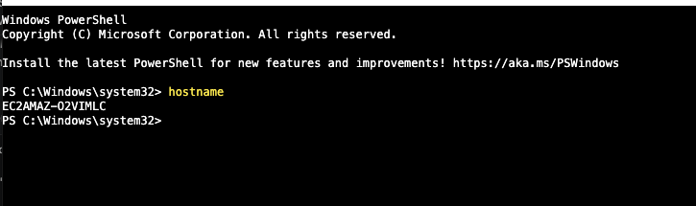

TEST 2

Reach the internet from the application server
Evidences: [ICTCLD401 PC 2.6]
Run the command below in the session you opened in test 1. This shows the server can reach the internet through the NAT gateway.
1. Run the command below.
2. Confirm it returns StatusCode 200.

Run this
Invoke-WebRequest -Uri https://aws.amazon.com -UseBasicParsing |
Select-Object StatusCode

Evidence
SCREENSHOT — the command and the status code it returned.
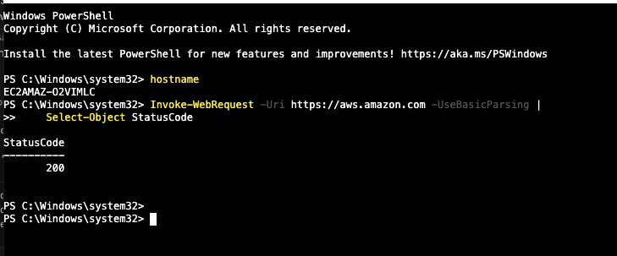

TEST 3

Reach the database from the application server
Evidences: [ICTCLD401 PC 2.6] · [ICTCLD502 PC 4.2]
Run the command below in the same session. This shows the application tier can reach the database tier privately, over the database port.
1. Open RDS → Databases → your database → Connectivity & security, and copy the Endpoint. It looks like yat-lms-db.something.us-east-1.rds.amazonaws.com
2. Run the command below, replacing <YOUR-DB-ENDPOINT> with the address you just copied. Do not paste the command as it is written — it will fail to resolve.
3. Confirm the result reads TcpTestSucceeded : True.

Run this
Test-NetConnection <YOUR-DB-ENDPOINT> -Port 3306

Evidence
SCREENSHOT — the command and its output showing TcpTestSucceeded : True.
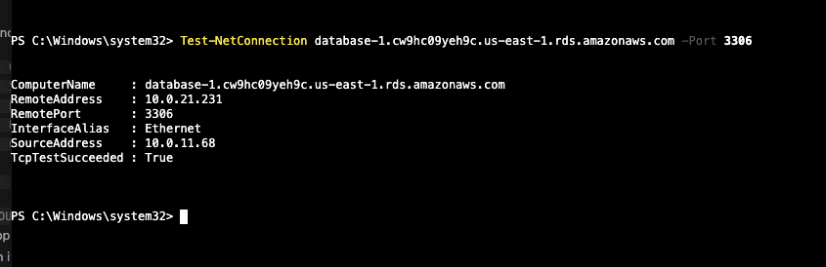

TEST 4

Reach the application through the load balancer
Evidences: [ICTCLD401 PC 2.6] · [ICTCLD502 PC 4.2]
Open your load balancer address in a web browser on your own computer. This shows the whole path works — the internet reaches the load balancer, the load balancer reaches your private server, and the server serves the page.
1. Open EC2 → Load Balancers and copy the DNS name of yat-lms-alb.
2. Paste it into a browser tab on your own machine, with http:// in front of it.
3. Confirm the placeholder page loads.

Environment constraint your server has no public address, so what you are reaching is the load balancer. It is the only thing allowed to talk to the server, which is what the security groups enforce.
Evidence
SCREENSHOT — the browser showing the page, with the load balancer address visible in the address bar.
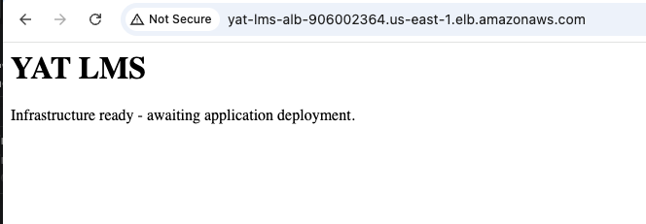

TEST 5

Automatic scaling
Evidences: [ICTCLD401 PC 3.2]
Change the scaling policy as described below and watch what happens. This shows the Auto Scaling group adds and removes servers on its own, without you changing the instance count.
1. Open EC2 → Instances, select your running instance and open the Monitoring tab. Read the CPU utilization figure — on an idle server it will be low, often only one or two percent.
2. Open your Auto Scaling group and go to the Automatic scaling tab.
3. Edit the target tracking policy and set the target value BELOW the figure you just read, then save. The policy keeps average CPU at the target, so a target above current usage tells it to scale in rather than out. If your reading is very low, use 1.
4. Watch the Activity tab until a second instance launches and enters service.
5. Edit the policy again, raise the target value to 90, and save.
6. Watch the Activity tab until the group scales back to one instance.
7. Set the target value back to 70.

Environment constraint scaling in is slower than scaling out — give it several minutes before deciding it has not worked.
Assessor note proven in the lab: an idle Windows t3.small read about 6% CPU, and setting the target value to 1 triggered a scale-out within a few minutes. Expect students to report readings of a few percent and targets of 1. A student who reports a higher reading and a correspondingly higher target has done the same thing correctly. Scale-in takes noticeably longer than scale-out, so a submission showing a long gap between the two Activity entries is normal, not a fault.
Evidence
SCREENSHOT — the Activity tab, showing both the scale-out and the scale-in entries with their times.
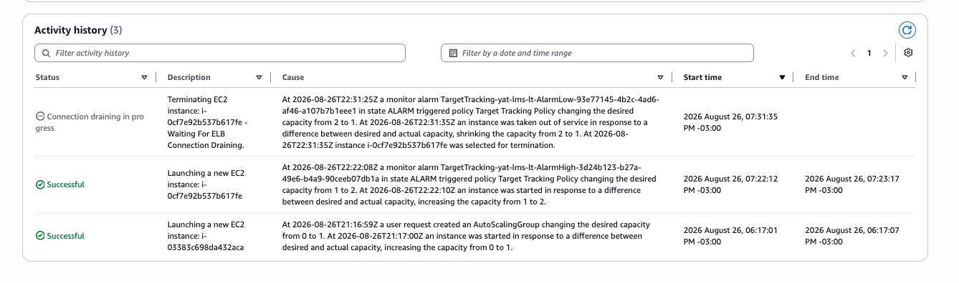

Knowledge questions
Answer each question about your own build, not in general terms. Refer to what you actually created and the choices you actually made.
QUESTION 1

Name the compute, networking and scaling services you depl...
Evidences: [ICTCLD401 KE 5]
Name the compute, networking and scaling services you deployed. For each, explain the feature it provides and how it supports the YAT LMS specifically.
Related resources
• LMS Application Specification — the user population, concurrent load and service-level expectations your services have to support
• LMS Cloud Architecture — Baseline Design — the design your build implements

Key points the answer should touch on:
• Names the three: the instance, the load balancer, the Auto Scaling group.
• Instance: the compute the LMS runs on, sized against the concurrent-user load.
• Load balancer: distributes traffic and removes unhealthy servers from rotation.
• Auto Scaling: adds capacity during assessment-window peaks without anyone acting.
• Each tied to YAT, not explained generically.

QUESTION 2

In your build: (a) why a managed database service rather t...
Evidences: [ICTCLD401 KE 6]
In your build: (a) why a managed database service rather than running the database on the server yourself? (b) your build uses block storage in two places — the volumes on the server and the storage behind the database. Explain how block storage differs from object storage, and when each is the right choice for an LMS. (c) why scale horizontally rather than vertically, and what does that trade off?
Related resources
• LMS Cloud Architecture — Baseline Design — why the design chose a managed database and a scaling group rather than a single larger server
• LMS Application Specification — what the LMS stores, which is what the storage choices have to suit

Key points the answer should touch on:
• (a) Managed: AWS handles patching, backups and monitoring; less for YAT ICT to operate; and multi-AZ is one setting away for the next phase.
• (b) Block storage is a disk attached to one server, addressed in blocks, and it is what an operating system and a database need. Object storage holds whole files retrieved by name over the network, is effectively unlimited, is cheaper at scale, and can age files off to archive. For an LMS: block for the system and the database, object for course attachments and student submissions.
• (c) Horizontal adds servers with no downtime, which suits an LMS that must stay up; vertical needs a restart. Trade-off: the application must tolerate requests landing on different servers.

QUESTION 3

Using your own environment, name two responsibilities that...
Evidences: [ICTCLD401 KE 7]
Using your own environment, name two responsibilities that remain YAT's and one that shifted to AWS under the shared-responsibility model, and say why each falls where it does.
Key points the answer should touch on:
• Two YAT-side: operating-system patching after handover; managing users and MFA.
• One shifted: hardware, data-centre power and cooling; or backup media handling, now the managed database's job.
• Reasons given, not just a list.

QUESTION 4

Pick one IAM group you created. Describe the permissions y...
Evidences: [ICTCLD401 KE 8]
Pick one IAM group you created. Describe the permissions you gave it, the job function it serves, and why its permissions differ from another group in your build.
Related resources
• User Access Policy — YAT's role-based access model, its role groups and permissions matrix, and its rules on privileged access

Key points the answer should touch on:
• Names a real group from their own build.
• Ties the permissions to what that job actually needs to do.
• Contrasts it with another group and explains the boundary — e.g. YAT ICT operate the platform but do not change IAM, because that is a security boundary.

QUESTION 5

The yat-lms-db-sg security group you created in task 7 per...
Evidences: [ICTCLD401 KE 9]
The yat-lms-db-sg security group you created in task 7 permits MySQL traffic on port 3306 from one source only. State the rule exactly as you configured it, explain why the database is restricted this way rather than being reachable from the internet, and describe the risk to YAT if that restriction were removed.
Related resources
• LMS Application Specification § 4, Data stored — what the MySQL database actually holds

Key points the answer should touch on:
• States the rule as built: inbound MySQL on 3306, source yat-lms-app-sg — the application tier's security group, not an address range and not the internet.
• Explains the restriction: only the application tier has any business reaching the database. Naming a security group as the source rather than an address range means the rule follows the instances, however many the Auto Scaling group launches and whatever addresses they get.
• Names a concrete risk grounded in what the database holds — the ~50 GB of student personal information in § 4 of the specification (names, dates of birth, USIs, enrolment and fee status, assessment results) becomes reachable from the internet and the database engine can be attacked directly for credentials. YAT carries Privacy Act and APP obligations over that data.
• A student who says only that it would be "less secure" has not evidenced this.

QUESTION 6

When a YAT staff member types the LMS address into their b...
Evidences: [ICTCLD401 KE 10]
When a YAT staff member types the LMS address into their browser, DNS resolution has to happen before anything else can. Explain what DNS does at that moment in your deployment, and what would fail for YAT if it were misconfigured.
Key points the answer should touch on:
• A browser connects to an address, not a name — DNS is the translation step.
• In this deployment the name resolves to the load balancer.
• The load balancer's addresses change, which is why the name points at it rather than at a server.
• If misconfigured, staff cannot reach the LMS even though every server is running.

Handover

File the completed run sheet
Evidences: [ICTCLD401 PC 4.3]
You have now built the platform, tested it and answered the questions. Hand the build over by filing this completed run sheet where YAT records procedures require, so YAT ICT can find it after the engagement ends. Do this last.
State where you filed it and which YAT policy required that location.
Key points the answer should touch on:
• Names the actual location the report was filed in, not a general intention.
• Names the YAT policy that governs it — the Records Management Policy, or the Backup and Retention Policy.
• A student who says only "I would file it appropriately" has not evidenced this.

Marking Benchmark — UoC traceability (reverse map)
This table closes the loop on bidirectional traceability: every UoC requirement AT2 claims to evidence is named below with the marking criterion that evidences it, and each run-sheet task carries its own Evidences line where the work is done. No UoC requirement claimed by AT2 is left without a criterion.
ICTCLD401 — Configure cloud services (AT2-evidenced items)
UoC item | Evidenced by criterion(ia)
[ICTCLD401 PC 1.1] Discuss and compare different cloud computing solutions, models and services | A7
[ICTCLD401 PC 1.2] Identify impact of shared security responsibility models | A6
[ICTCLD401 PC 1.3] Select best cloud computing solution and service | A7
[ICTCLD401 PC 1.4] Access account on cloud platform | A2
[ICTCLD401 PC 1.5] Identify user access protocols and policies | A2
[ICTCLD401 PC 1.6] Configure access functions within cloud environment | A2
[ICTCLD401 PC 1.7] Identify and assign security responsibilities | A1
[ICTCLD401 PC 2.1] Create users and groups | A2
[ICTCLD401 PC 2.2] Create virtual multi-tier network | A1
[ICTCLD401 PC 2.3] Create virtual machine | A3
[ICTCLD401 PC 2.4] Define, add and expand storage | A3
[ICTCLD401 PC 2.5] Deploy a managed database | A4
[ICTCLD401 PC 2.6] Test external network access | A8
[ICTCLD401 PC 3.1] Configure and apply autoscaling | A3
[ICTCLD401 PC 3.2] Test automatic scaling | A8
[ICTCLD401 PC 4.3] Save and store user documentation per organisational policies | A10
[ICTCLD401 PE 1] Build at least one simple virtual network capable of supporting a workload | A1
[ICTCLD401 PE 2] Configure compute, storage, database and autoscaling resources within virtual network | A3 · A4
[ICTCLD401 PE 3] Conduct simple tests to confirm access to resources | A8
[ICTCLD401 KE 5] VM/networking/scaling features (VM sizing, load balancing, autoscaling, monitoring, storage backups, virtual networks/traffic routing) | A9 (Q1)
[ICTCLD401 KE 6] Vertical vs horizontal scaling; VM vs physical; RDBMS/DW/NoSQL; self-hosted vs managed vs cloud-native DB; storage options (block/object/archive/network filesystems) | A9 (Q2)
[ICTCLD401 KE 7] User, business and vendor responsibilities according to shared security responsibility models | A9 (Q3)
[ICTCLD401 KE 8] User access protocols and policies according to organisation hierarchy and job function | A9 (Q4)
[ICTCLD401 KE 9] Security policies, protocols and mechanisms as they relate to cloud (network traffic limits + security responsibilities per work function/user access) | A9 (Q5)
[ICTCLD401 KE 10] Purpose of DNS for connecting remote servers when web browsing | A9 (Q6)
[ICTCLD401 FS Reading] | A9
[ICTCLD401 FS Writing] | A9
[ICTCLD401 AC 1] Cloud vendor service provider | C1 (pre-condition)
[ICTCLD401 AC 2] Cloud managed database service | C1 (pre-condition)
[ICTCLD401 AC 3] Internet and web browser | C1 (pre-condition)
[ICTCLD401 AC 4] Data to gather information from to determine output and user requirements | C2 (pre-condition)

(Note: 401 PCs not listed above (PC 1.8, PC 4.1, PC 4.2) are evidenced in AT1. 401 KEs not listed (KE 1, 2, 3, 4, 11) are evidenced in AT1 Appendix 2.)
ICTCLD502 — Design and implement highly-available cloud infrastructure (AT2-evidenced items only)
UoC item | Evidenced by criterion(ia)
[ICTCLD502 PC 1.3] Identify level of shared security responsibility models according to business needs | A1
[ICTCLD502 PC 4.1] Implement architecture design in cloud environment | A3
[ICTCLD502 PC 4.2] Demonstrate connectivity between resources at all tiers | A8
[ICTCLD502 PC 4.3] Monitor and measure availability of resources | A5
[ICTCLD502 FS Reading] | A1
[ICTCLD502 AC 1] Cloud vendor service provider | C1 (pre-condition)
[ICTCLD502 AC 2] Cloud managed database service | C1 (pre-condition)
[ICTCLD502 AC 3] Information and data sources required to design and implement cloud infrastructure | C2 (pre-condition)
[ICTCLD502 AC 4] Integrated development environment (IDE) | C1 (pre-condition — AWS Console + CLI counts as IDE)
[ICTCLD502 AC 5] Specific requirements + industry standards + organisational procedures + legislative requirements + business and functionality requirements | C2 (pre-condition — supplied via YAT intranet)
[ICTCLD502 AC 6] Internet and web browser | C1 (pre-condition)
[ICTCLD502 AC 7] Secure shell (SSH) or remote desktop protocol (RDP) client | C1 (pre-condition — RDP for Windows EC2 instances)
[ICTCLD502 AC 8] Data to gather information from to determine output and user requirements | C2 (pre-condition)

(Note: 502 PCs not listed above (PC 1.1, 1.2, 2.1–2.5, 3.1–3.5, 4.4–4.6, 5.1, 5.2, 5.3) are evidenced in AT1 (PC 1.2, 5.2) or AT3 (the rest). 502 KEs not listed (KE 1, 2, 3) are evidenced in AT1 Appendix 2; KEs 4–9 are evidenced in AT3.)

