YAT COLLEGE
YAT College · 175 Cremorne St, Cremorne VIC 3121

Solution Design
YAT Accounting System Cloud Architecture — Baseline Design

Engagement | YAT Accounting System Cloud Migration — Foundation Build
Document type | Technical design (Solution Design)
Version | v1.0 — Approved for implementation
Authored by | MTS Senior Architecture Team, in consultation with YAT ICT
Approved by | Pat Lin (MTS Senior Consultant) · Sam Walker (YAT ICT Manager)
Implemented by | the Accounting System foundation-build Deployment Report
Classification | Internal — YAT ICT, Finance, and MTS personnel on signed MSA

Contents
Right-click and choose “Update Field” to build the table of contents.

1. Purpose and Scope
This document specifies the baseline AWS architecture MTS will implement as the foundation build phase of the YAT Accounting System cloud migration. It translates the approved direction into a concrete, implementable design for the Ledgerline finance and office-administration system. The design stops at “infrastructure ready for application deployment”: the EC2 instance is provisioned with the OS, the RDS instance with an empty PostgreSQL engine, and the load balancer with placeholder health checks — no application binaries or financial data are placed by the MTS build.

In scope of this design
- The production cloud foundation for the Ledgerline accounting application.
- All compute, networking, identity, storage, database, autoscaling and baseline monitoring needed to run Ledgerline as a staff-facing, business-hours workload in AWS.
- Single-region, single-Availability-Zone deployment in ap-southeast-2 (Sydney).
Building this in a lab the design calls for ap-southeast-2 (Sydney). If you are building this in an AWS Academy Learner Lab, deploy to whichever region that environment gives you — us-east-1 — and treat it as standing in for Sydney throughout. That is acceptable.

Out of scope — deferred to the follow-on HA design phase
- High-availability hardening (Multi-AZ database, cross-AZ compute resilience, failure-simulation testing).
- Disaster recovery to a second AWS region; DR runbook and tabletop testing.
- Application re-platforming (Ledgerline remains Amazon Linux + PostgreSQL).

Out of MTS scope entirely — YAT ICT responsibility
- Ledgerline application installation onto the EC2 instance(s) after handover.
- Database migration (extract from the on-premises database, load into RDS for PostgreSQL).
- Cutover — DNS switch, parallel running, decommissioning, user redirection (avoiding month-end and EOFY).
- Organisational change management — CAB approvals, communications, training, post-cutover support.

2. Design Inputs and Requirements

2.1 Inputs
- Accounting System Application Specification — functions, user load, data, integrations, SLAs, data residency.
- Accounting System Migration Requirements — platform preservation, availability, recovery, licensing, retention.
- Accounting System Server Specifications — current server, measured availability, utilisation, growth.
- Engagement Role Brief and Consultation Notes — engagement scope; OS, application and database preservation.

2.2 Requirements the design must meet
Requirement | Target / note
Region / data residency | ap-southeast-2 (Sydney); financial records + staff/debtor PII within Australia (Privacy Act APP 8; financial-records retention)
Application stack | Preserved — Amazon Linux 2023 · PostgreSQL · Ledgerline
Concurrent users | 15–25 typical; 45–55 peak at month-end close and EOFY; idle out of hours
Availability | ≥ 99.5% business-hours (Mon–Fri ~07:30–18:00); no 24/7 requirement
Recovery | RPO ≤ 1 hour (no loss of financial transactions); RTO ≤ 1 business day (≤ 8 business hours)
Data footprint | ~22 GB database, growing ~5 GB/year, plus scanned-document attachments
Retention | Financial records and audit logs retained ≥ 7 years
Licensing | Commercial — Ledgerline per-user licences; the database is open-source (no database licence) is material
Integrations | AD authentication; O365 SMTP; LMS fee-status; payroll-bureau SFTP; banking/payment-gateway file exchange
High availability | Out of baseline scope — Multi-AZ resilience deferred to the follow-on HA design

3. Review of Existing Architecture
Not applicable — this is a greenfield cloud foundation; there is no existing cloud baseline to review. The on-premises current state is documented separately in the Accounting System Server Specifications and the ICT Environment Overview.

4. Architecture Design

4.1 Assumptions and constraints
# | Assumption / constraint | Source
A1 | Region must be ap-southeast-2 (Sydney) for financial-records data residency | Migration Requirements; Privacy Policy
A2 | Application stack preserved: Amazon Linux 2023, PostgreSQL, Ledgerline | Migration Requirements; Role Brief
A3 | Data footprint ~22 GB database, +~5 GB/year, plus scanned attachments | Application Spec; Server Specs
A4 | Concurrent users 15–25 typical, 45–55 at month-end / EOFY; idle out of hours | Application Spec
A5 | Financial records + staff/debtor PII must remain within Australia; retained ≥ 7 years | Privacy Act 1988 APP 8; financial-records obligations
A6 | Preserve AD authentication over a private network to campus AD; staff-only access | Application Spec; Migration Requirements
A7 | Baseline is NOT high-availability; Multi-AZ resilience deferred to the HA design | Scoping decision

4.2 AWS account and region
An AWS account scoped to the migration engagement, provisioned by YAT and shared with MTS for the build. Region ap-southeast-2 (Sydney); no deployment outside Australian regions, to satisfy financial-records residency. Availability Zone ap-southeast-2a for the baseline; the follow-on HA design introduces a second AZ.

4.3 Identity and Access Management (IAM)
Group | Purpose | Indicative permissions
YAT-ICT-Admins | YAT ICT day-to-day ops post-handover | Read-only on infra; full CloudWatch/RDS/EC2 console; no IAM changes
MTS-Consultants | MTS during build + support | Full admin during build; reduced post-handover
Finance-Auditors | Finance / external auditors | Read-only on logs, metrics, configs (financial-audit support)

- No long-lived access keys for humans; programmatic access via IAM roles only.
- The application servers reach the database and the logging service through an EC2 instance role, so no credentials are stored on a server.
- Configuration decision left to the implementer: the MTS-Consultants permission boundary during build vs after handover.

4.4 Network topology
VPC ledgerline-vpc, 10.20.0.0/16, with DNS hostnames and DNS resolution enabled. This is an internal, staff-only service — there is no public internet ingress to the application. Single-AZ subnets in ap-southeast-2a:
Subnet | CIDR | Tier | Internet-facing?
ledgerline-public-a | 10.20.1.0/24 | Load balancer, NAT gateway | Yes
ledgerline-public-b | 10.20.2.0/24 | Load balancer second zone — empty | Yes
ledgerline-app-a | 10.20.11.0/24 | Application / Ledgerline EC2 | No
ledgerline-data-a | 10.20.21.0/24 | Database (RDS for PostgreSQL) | No
ledgerline-data-b | 10.20.22.0/24 | Database subnet group second zone — empty | No

- Internet Gateway used only for NAT egress (Windows Update, vendor patches); no inbound internet path to the app.
- Route tables: public-egress → IGW; private-app → NAT; private-data → no internet route.
- Staff reach the service over the campus Site-to-Site VPN; AD authentication runs over the same private link.
- The follow-on HA design adds the corresponding -b subnets in ap-southeast-2b.
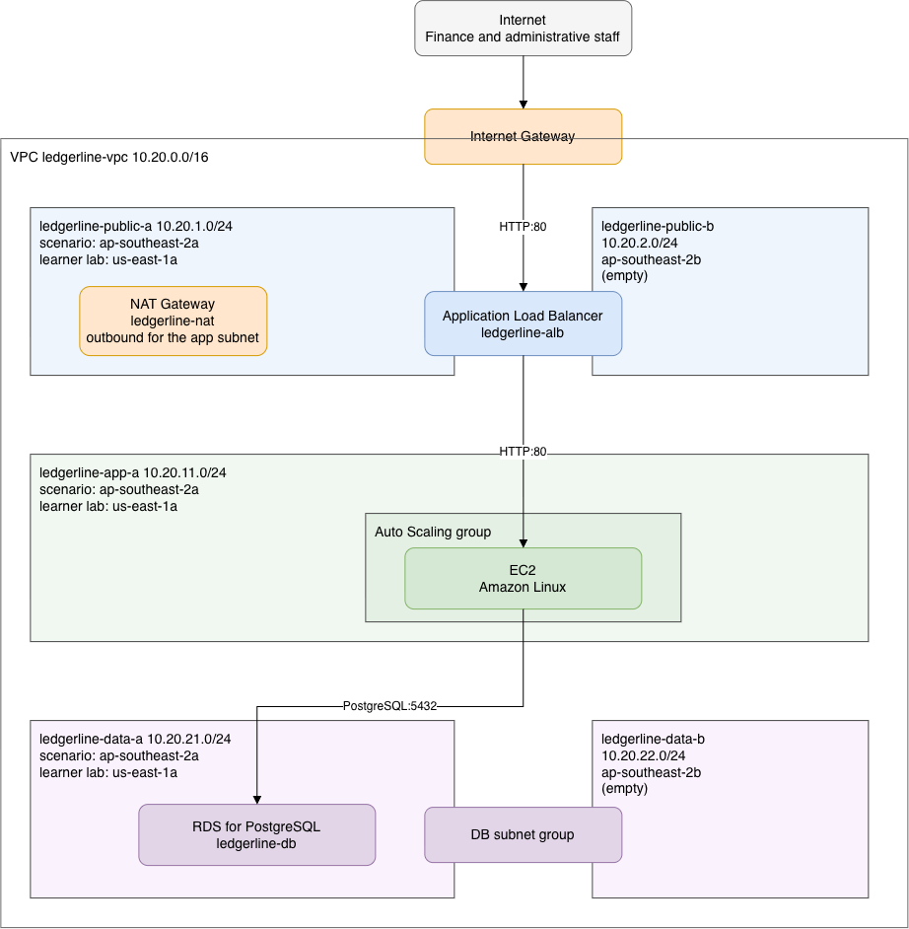
Figure 4.4 — Ledgerline baseline network topology. The workload runs in ap-southeast-2a; the two subnets in ap-southeast-2b carry nothing.

4.5 Compute (EC2 + Auto Scaling)
- EC2: general-purpose burstable — t3.micro or t3.small, a C1 implementer decision; Amazon Linux 2023 AMI; placed in private-app-a (no public IP).
- EBS: gp3 root 80 GB + a gp3 data volume sized by the implementer (footprint + 12-month growth + headroom).
- Auto Scaling Group: min 1 / desired 1 / max 2 (baseline); target-tracking on CPU at 70%; ELB+EC2 health checks; 300 s cooldown.
- The workload is business-hours and idle overnight; the follow-on HA design adds cross-AZ capacity for resilience (not for load).
Building this in a lab Ledgerline's real finance workload — 15–25 typical and 45–55 concurrent users at month-end close — would warrant an instance several sizes larger than either option above. An AWS Academy Learner Lab caps what will launch, so the two offered are ones that actually run there. Size between them on the reasoning you would use at full scale; the reasoning is what matters, not the vCPU count.

4.6 Load balancing (ALB)
- Internet-facing ALB, ledgerline-alb, spanning ledgerline-public-a and ledgerline-public-b — it will not create with only one zone; HTTP:80 listener forwarding to ledgerline-tg.
- Target group = the ASG instances; HTTP health check on the application health endpoint (30 s; 2 unhealthy → out of service).
Building this in a lab the listener is deliberately plain HTTP on port 80 rather than HTTPS. That is a simplification, and a production front door for a finance system would terminate TLS here. It is done this way so that you can paste the load balancer's address into a browser and see the platform you built actually serving a page.

4.7 Database (RDS for PostgreSQL)
- Amazon RDS for PostgreSQL (preserves the existing engine and data); version confirmed against Ledgerline at build time.
- General-purpose burstable instance class — db.t3.micro or db.t3.small, a C2 implementer decision; gp3 storage, 20 GB — sized to ~22 GB + ~5 GB/year growth.
- Multi-AZ DISABLED for the baseline (enabled in the HA design); storage encryption enabled (KMS).
- Placed via ledgerline-db-subnet-group, spanning ledgerline-data-a and ledgerline-data-b — a subnet group requires two zones; not publicly accessible. Automated backups sized to meet RPO ≤ 1 hour, 7-day retention.
- Schema and data migration are YAT ICT's responsibility, not MTS's — MTS provisions an empty instance.
Building this in a lab the same applies here as to the application tier: the ~22 GB financial data footprint and the month-end close profile would in reality call for a database class and storage allocation beyond either option above. Both are sized to what will deploy in a Learner Lab.

4.8 Storage
Resource | Type | Purpose
EC2 root volume | EBS gp3 8 GB | OS and Ledgerline application install
Database storage | RDS gp3 20 GB, encrypted | The PostgreSQL data files

- Object storage for scanned invoices, purchase orders and supporting documents is out of scope for this baseline and is a candidate for the follow-on phase, where the 7-year financial-records hold can be met with versioning and an archive lifecycle.

4.9 Security
Security group | Inbound | Outbound
ledgerline-alb-sg | HTTP:80 from 0.0.0.0/0 | default allow-all
ledgerline-app-sg | HTTP:80 from ledgerline-alb-sg | default allow-all
ledgerline-db-sg | PostgreSQL:5432 from ledgerline-app-sg only | default allow-all

- Each rule names a security group as its source rather than an address range, so it follows the instances however many the Auto Scaling group launches.
- Administrative access to instances is by Session Manager: no key pair, no open management port, no public IP address and no bastion host.
- Encryption at rest: EBS and RDS both enabled (KMS where customer-managed keys are warranted for financial data).
- Operates under the AWS Shared Responsibility Model — AWS secures the cloud; YAT/MTS secure the OS, application, IAM, data and access in the cloud.

4.10 Monitoring (baseline)
Standard CloudWatch metrics for EC2, RDS, ALB and Auto Scaling. Baseline alarms (HA-tuned alarms come in the follow-on HA design):
Alarm | Metric | Threshold
ledgerline-unhealthy-hosts | UnHealthyHostCount, per load balancer per target group | Maximum ≥ 1 over 1 minute — any target has failed its health check
ledgerline-db-storage-low | FreeStorageSpace on the database instance | Minimum below 15% of allocated storage, over two 5-minute periods

- Both alarms notify an SNS topic. The Auto Scaling policy tracks CPU and creates its own alarms, so no separate CPU alarm is required.

4.11 Naming and tagging conventions
Naming pattern ledgerline-<resource-type> — ledgerline-vpc, ledgerline-alb, ledgerline-tg, ledgerline-lt, ledgerline-db. Subnets are named for their tier and zone: ledgerline-public-a/-b, ledgerline-app-a, ledgerline-data-a/-b. Mandatory tags:
Tag | Value
Project | YAT-Accounting-Migration
Environment | Production
Owner | YAT-ICT
ManagedBy | MTS-Migration during build → YAT-ICT post-handover
CostCentre | YAT-Accounting
DataClassification | Financial / Confidential (PII)

4.12 Backup
Resource | Mechanism | Retention
RDS database | Automated daily backups + transaction-log backups (point-in-time recovery) | Sized to RPO ≤ 1 h; long-term financial copies retained ≥ 7 years
EC2 EBS volumes | None — the servers hold no state that is not in the database. They are rebuilt from the launch template, not restored | n/a

- Cross-Region backup copies are out of scope for the baseline — addressed in the follow-on HA design.

4.13 Recovery objectives — baseline state
The baseline meets RPO ≤ 1 hour through RDS automated + transaction-log backups (point-in-time recovery). It does NOT meet the RTO of 2 hours: recovery is by restore from backup, which does not reliably complete inside that window. The single AZ and the single RDS instance remain known single points of failure: tolerable for a business-hours service in the short term, but resilience against an AZ failure is the objective of the follow-on HA design.

4.14 Components requiring vertical scaling
RDS instance-class changes require a modify-and-apply (a brief interruption, taken in the maintenance window, outside business hours); EBS volumes support online resize with no downtime.

4.15 Single points of failure removed
Not applicable — this baseline is single-AZ by design; the single RDS instance and the single AZ are known single points of failure, deliberately deferred to the follow-on HA design.

4.16 Configuration decisions left to the implementer
The design is opinionated where it matters and silent where the implementer must show judgement. Each decision below is to be made and evidenced in the Deployment Report, justified against the Ledgerline workload.
# | Decision | Why left open
C1 | Application-tier instance type (general-purpose burstable) | Size against the Ledgerline workload (15–25 typical / 45–55 month-end peak)
C2 | Database instance class and storage size (general-purpose burstable) | Size against the database workload and its ~22 GB footprint

5. Implementation Sequencing
Not applicable — this is a greenfield build in a new account, not a change to a running system; build order is at the implementer's discretion and there is no live service to sequence around or roll back.

6. Simulation and Verification Plan
Not applicable — failure/resize simulation and availability verification are the subject of the follow-on HA design and its deployment report; the baseline build is verified functionally per the Deployment Report's testing section.

7. Out of Scope
Stated explicitly so the implementer knows what not to build (these are the deliberate inputs to the follow-on HA design):
- Multi-AZ database; the ledgerline-app-b subnet; ASG capacity ≥ 2 across AZs.
- HA-tuned monitoring (cross-AZ latency, replica lag); cross-Region backup copies and DR runbook.
- Failure-simulation testing; automated availability reporting against the recovery objectives.
- And, out of MTS scope entirely: Ledgerline install, database migration, cutover, and change management (YAT ICT).

8. References
- Accounting System Application Specification; Migration Requirements; Server Specifications; Operational Costing.
- Engagement Role Brief; Consultation Notes; ICT Environment Overview.
- Privacy Policy; User Access Policy; Security and Incident Response; Industry Standards Reference (AWS Well-Architected, ACSC Essential Eight).

Document control
Field | Value
Document version | v1.0 — Approved for implementation
Authored by | MTS Senior Architecture Team, in consultation with YAT ICT
Approved by | Pat Lin (MTS Senior Consultant) · Sam Walker (YAT ICT Manager)
Implemented by | the Accounting System foundation-build Deployment Report
Successor document | YAT Accounting System Cloud Architecture — HA Design (follow-on phase)

