YAT COLLEGE
YAT College · 175 Cremorne St, Cremorne VIC 3121

Solution Design
YAT LMS Cloud Architecture — Baseline Design

Engagement | YAT LMS Cloud Migration — Foundation Build
Document type | Technical design (Solution Design)
Version | v1.0 — Approved for implementation
Authored by | MTS Senior Architecture Team, in consultation with YAT ICT
Approved by | Pat Lin (MTS Senior Consultant) · Sam Walker (YAT ICT Manager)
Implemented by | the AT2 build run sheet (foundation build)
Classification | Internal — YAT ICT, and MTS personnel on signed MSA

Contents
Contents 2
1. Purpose and Scope 3
In scope of this design 3
Out of scope — deferred to the follow-on HA design phase 3
Out of MTS scope entirely — YAT ICT responsibility 3
2. Design Inputs and Requirements 3
2.1 Inputs 3
2.2 Requirements the design must meet 3
3. Review of Existing Architecture 4
4. Architecture Design 4
4.1 Assumptions and constraints 4
4.2 AWS account and region 4
4.3 Identity and Access Management (IAM) 4
4.4 Network topology 5
4.5 Compute (EC2 + Auto Scaling) 6
4.6 Load balancing (ALB) 7
4.7 Database (RDS) 7
4.8 Storage 7
4.9 Security 7
4.10 Monitoring (baseline) 8
4.11 Naming and tagging conventions 8
4.12 Backup 8
4.13 Recovery objectives — baseline state 9
4.14 Components requiring vertical scaling 9
4.15 Single points of failure removed 9
4.16 Configuration decisions left to the implementer 9
5. Implementation Sequencing 9
6. Simulation and Verification Plan 9
7. Out of Scope 10
8. References 10
Document control 10

1. Purpose and Scope
This document specifies the baseline AWS architecture MTS will implement as the first build phase of the YAT LMS cloud migration. It translates the action plan approved at the close of the Business Case engagement into a concrete, implementable design. The design stops at “infrastructure ready for application deployment”: the EC2 instance is provisioned with the OS, the RDS instance with an empty MySQL schema, and the ALB with placeholder health checks — no application binaries or production data are placed by the MTS build.

In scope of this design
- The production cloud foundation for the DOODLE LMS application.
- All compute, networking, identity, storage, database, autoscaling and monitoring needed to run the LMS as a multi-tier web workload in AWS.
- Single-region deployment in ap-southeast-2 (Sydney), with the workload in a single Availability Zone.
Building this in a lab the design calls for ap-southeast-2 (Sydney). If you are building this in an AWS Academy Learner Lab, deploy to whichever region that environment gives you — us-east-1 — and treat it as standing in for Sydney throughout. That is acceptable.

Out of scope — deferred to the follow-on HA design phase
- High-availability hardening (Multi-AZ database, cross-AZ compute resilience, failure-simulation testing).
- Disaster recovery to a second AWS region; DR runbook and tabletop testing.
- Application re-platforming (the LMS remains Windows Server 2016 + DOODLE + MySQL).

Out of MTS scope entirely — YAT ICT responsibility
- LMS application installation onto the EC2 instance(s) after handover.
- Database migration (extract from on-prem MySQL, load into RDS).
- Cutover — DNS switch, parallel running, decommissioning, user redirection.
- Organisational change management — CAB approvals, communications, training, post-cutover support.

2. Design Inputs and Requirements

2.1 Inputs
- LMS Application Specification — workload, SLAs, data footprint, integration points.
- LMS Cloud Migration Requirements — SLA, RPO/RTO targets.
- Engagement Role Brief — engagement scope, OS and application preservation.
- ICT Environment Overview and the On-Premises Network Diagram — the current state being migrated from.

2.2 Requirements the design must meet
Requirement | Target / note
Region / data residency | ap-southeast-2 (Sydney); all student PII within Australia (Privacy Act, APP 8)
Application stack | Preserved — Windows Server · MySQL · DOODLE
Concurrent users | 200–300 typical; 500–700 peak during assessment windows
Data footprint | ~178 GB, growing ~25 GB/year
Authentication | Preserve AD-LDAP integration over a private network to campus AD
High availability | Out of baseline scope — the 99.9% target is deferred to the follow-on HA design

3. Review of Existing Architecture
Not applicable — this is a greenfield cloud foundation; there is no existing cloud baseline to review. The on-premises current state is documented separately in the ICT Environment Overview.

4. Architecture Design

4.1 Assumptions and constraints
# | Assumption / constraint | Source
A1 | Region must be ap-southeast-2 (Sydney) for data residency | LMS App Spec; Privacy Policy
A2 | Application stack preserved: Windows Server, MySQL, DOODLE | Engagement Role Brief
A3 | Data footprint ~178 GB, +~25 GB/year (attachments + submissions dominate) | LMS App Spec
A4 | Concurrent users 200–300 typical, 500–700 peak | LMS App Spec
A5 | All student PII must remain within Australia | Privacy Act 1988, APP 8
A6 | Preserve AD-LDAP integration over private network to campus AD | LMS App Spec
A7 | Baseline is NOT high-availability; 99.9% deferred to the HA design | Scoping decision

4.2 AWS account and region
An AWS account scoped to the migration engagement, provisioned by YAT and shared with MTS for the build. Region ap-southeast-2 (Sydney); no deployment outside Australian regions. The workload sits in ap-southeast-2a; the follow-on HA design puts application capacity into the second AZ.

4.3 Identity and Access Management (IAM)
Group | Purpose | Indicative permissions
YAT-ICT-Admins | YAT ICT day-to-day ops post-handover | Read-only across the account; no IAM changes
MTS-Consultants | MTS during build + support | Full admin during build; reduced post-handover
Read-Only-Auditors | Compliance / external auditors | Read-only on logs, metrics, configs

- Individual users are placed in a group, and may also carry a policy of their own where their job needs something the group does not give everyone — Sam Walker (YAT ICT Manager) sits in YAT-ICT-Admins and carries CloudWatch access directly.
- No long-lived access keys for humans; programmatic access via IAM roles only.
- The application servers reach the database and the logging service through an EC2 instance role, so no credentials are stored on a server.
- Identity administration stays with whoever governs the account: the group that operates the platform can see everything and change nothing about who has access.
Building this in a lab an AWS Academy Learner Lab does not permit groups, users or roles to be created, and supplies a ready-made role and instance profile instead. Build this section as far as the environment allows, capture the refusal, and use the supplied role where this design calls for the application's own.

4.4 Network topology
VPC 10.0.0.0/16 (room to expand), with DNS hostnames and DNS resolution enabled. The workload runs in ap-southeast-2a. Two further subnets exist in ap-southeast-2b carrying nothing: the load balancer and the database subnet group each refuse to be created unless they are given subnets in two Availability Zones.
Subnet | CIDR | Zone | Tier | Internet-facing?
public-web-a | 10.0.1.0/24 | ap-southeast-2a | Web / public load balancer | Yes
public-web-b | 10.0.2.0/24 | ap-southeast-2b | Load balancer second zone — empty | Yes
private-app-a | 10.0.11.0/24 | ap-southeast-2a | Application / LMS EC2 | No
private-data-a | 10.0.21.0/24 | ap-southeast-2a | Database (RDS) | No
private-data-b | 10.0.22.0/24 | ap-southeast-2b | Database subnet group second zone — empty | No

- Internet Gateway for public-subnet traffic; NAT Gateway in public-web-a for private-app outbound (Windows Update etc.).
- Route tables: public-rt carries both public subnets → IGW; private-app-rt carries private-app-a → NAT. The data subnets stay on the VPC's default route table, which has no internet route at all.
- Connectivity to campus AD: Site-to-Site VPN (baseline choice); Direct Connect deferred unless latency requires it.
- The follow-on HA design adds private-app-b, the one subnet the second zone is still missing.
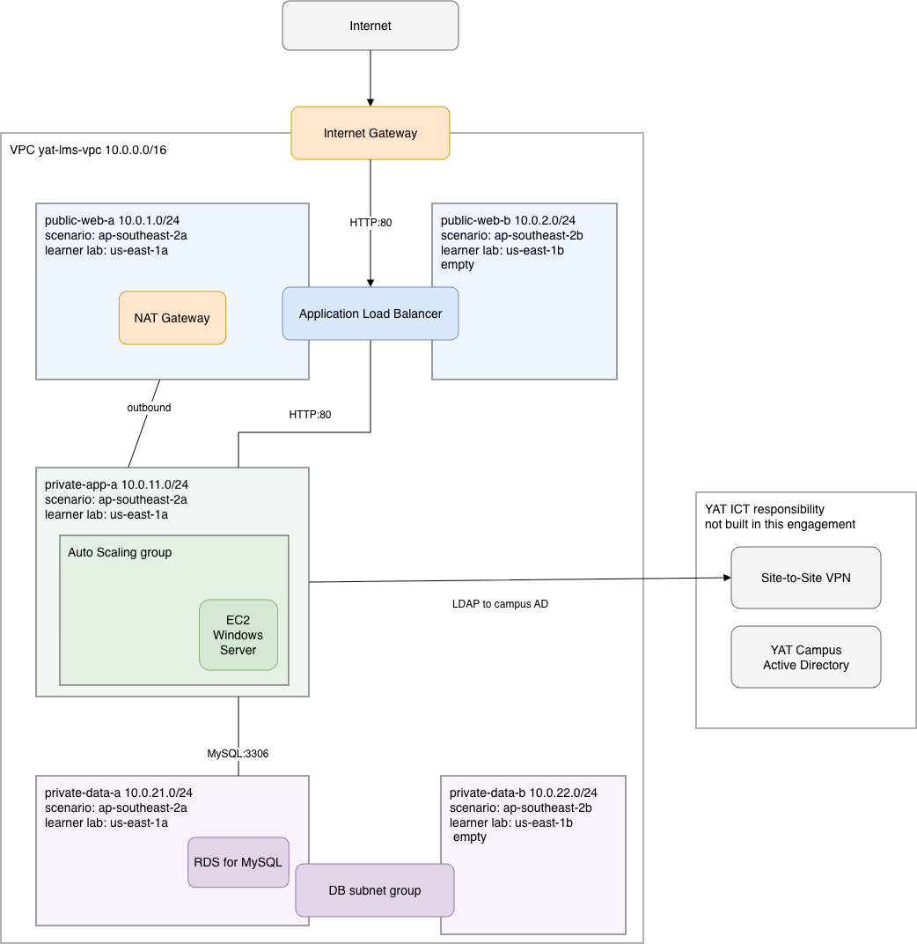
Figure 4.4 — LMS baseline network topology. The workload runs in ap-southeast-2a; the two subnets in ap-southeast-2b carry nothing.

4.5 Compute (EC2 + Auto Scaling)
- Every application server is built from a launch template, yat-lms-lt, so nothing is configured on a server by hand.
- Instance type: general-purpose burstable — t3.micro or t3.small, a C1 implementer decision sized against the concurrent-user load.
- Windows Server AMI; placed in private-app-a by the Auto Scaling group; no key pair and no public IP.
- EBS: gp3 root 30 GB, plus a gp3 8 GB data volume at device name xvdb for application data.
- The instance profile carries the EC2 instance role, which is how the servers reach the database and the logging service.
- Auto Scaling Group: min 1 / desired 1 / max 2, in private-app-a only; target-tracking on CPU at 70%; Elastic Load Balancing health checks with a 300 s grace period; 60 s warm-up.
- The follow-on HA design expands the ASG (min 2, across both AZs) and tunes scaling for assessment-window peaks.
Building this in a lab the LMS workload described in §2.2 — 200–300 typical and 500–700 peak concurrent users — would in reality need an instance several sizes larger than either of these. An AWS Academy Learner Lab caps what will launch, so the two options above are ones that actually run there. Size between them on the same reasoning you would use at full scale; the reasoning is what matters here, not the number of vCPUs.
Building this in a lab the design calls for a Windows Server build preserving the existing DOODLE stack. Use whichever current Windows Server image your environment offers; the version is not what this build turns on.

4.6 Load balancing (ALB)
- Internet-facing ALB, yat-lms-alb, spanning public-web-a and public-web-b — it will not create with only one zone.
- Listener: HTTP on port 80, forwarding to the LMS target group.
- Target group yat-lms-tg = the ASG instances, HTTP on port 80; health check HTTP on / (30 s interval; 2 unhealthy → out of service).
- The LMS hostname and its TLS certificate are issued by YAT ICT and are put in front of this load balancer at cutover, which is outside MTS scope.
Building this in a lab the listener is deliberately plain HTTP on port 80 rather than HTTPS. That is a simplification, and a real production front door would terminate TLS here. It is done this way so that you can paste the load balancer's address into a browser and see the platform you built actually serving a page — which is worth more, while you are learning, than a certificate you cannot issue in a lab.

4.7 Database (RDS)
- Amazon RDS for MySQL (preserves the existing data/schema); engine version confirmed against DOODLE at build time.
- General-purpose burstable instance class — db.t3.micro or db.t3.small, a C2 implementer decision.
- Storage: gp3, 20 GB; storage encryption enabled.
- Multi-AZ DISABLED for the baseline — no standby is created (it is enabled in the HA design).
- Placed via the yat-lms-db-subnet-group, which spans private-data-a and private-data-b; not publicly accessible; 7-day automated backups.
- Schema and data migration are YAT ICT's responsibility, not MTS's — MTS provisions an empty instance.
Building this in a lab the same applies here as to the application tier: the ~178 GB footprint and the read-heavy LMS workload would in reality call for a database class and a storage allocation well beyond either option above. An AWS Academy Learner Lab caps both, so the class and the 20 GB are sized to what will actually deploy there.

4.8 Storage
Resource | Type | Purpose
EC2 root volume | EBS gp3 30 GB | OS and LMS application install
EC2 data volume | EBS gp3 8 GB (xvdb) | LMS application data
Database storage | RDS gp3 20 GB, encrypted | The MySQL data files

4.9 Security
Security group | Inbound | Outbound
yat-lms-alb-sg | HTTP:80 from 0.0.0.0/0 | default allow-all
yat-lms-app-sg | HTTP:80 from yat-lms-alb-sg | default allow-all
yat-lms-db-sg | MySQL:3306 from yat-lms-app-sg only | default allow-all

- Each rule names a security group as its source rather than an address range, so the rule follows the instances however many the Auto Scaling group launches and whatever addresses they get.
- Administrative access to instances is by Session Manager: no key pair, no open management port, no public IP address and no bastion host.
- Encryption at rest: EBS and RDS both enabled.
- Operates under the AWS Shared Responsibility Model — AWS secures the cloud; YAT/MTS secure the OS, application, IAM, data and access in the cloud.

4.10 Monitoring (baseline)
Standard CloudWatch metrics for EC2, RDS, ALB and Auto Scaling. Two baseline alarms — one for the application tier, one for the database tier — establish availability monitoring for the platform. The Auto Scaling policy tracks CPU and creates its own alarms, so no separate CPU alarm is required. HA-tuned alarms come in the follow-on HA design:
Alarm | Metric | Threshold
yat-lms-unhealthy-hosts | UnHealthyHostCount, per load balancer per target group | Maximum ≥ 1 over 1 minute — any target has failed its health check
yat-lms-db-storage-low | FreeStorageSpace on the database instance | Minimum below 15% of allocated storage, over two 5-minute periods

- Both alarms notify an SNS topic, yat-lms-alerts.
- The storage alarm's threshold is entered in bytes and is a percentage of the storage allocated at build time; its description records the allocated size, because the number alone does not tell anyone whether it is still correct after the storage is resized.

4.11 Naming and tagging conventions
Naming pattern yat-lms-<resource-type> — yat-lms-vpc, yat-lms-alb, yat-lms-tg, yat-lms-lt, yat-lms-db. Subnets are named for their tier and zone: public-web-a, public-web-b, private-app-a, private-data-a, private-data-b. Mandatory tags:
Tag | Value
Project | YAT-LMS-Migration
Environment | Production
Owner | YAT-ICT
ManagedBy | MTS-Migration during build → YAT-ICT post-handover
CostCentre | YAT-LMS
DataClassification | Confidential (PII) or Internal

4.12 Backup
Resource | Mechanism | Retention
RDS database | Automated daily backups + transaction logs | 7 days
EC2 EBS volumes | None — the servers hold no state worth recovering. They are rebuilt from the launch template, not restored | n/a

- Cross-Region backup copies are out of scope for the baseline — addressed in the follow-on HA design.

4.13 Recovery objectives — baseline state
The baseline's recovery posture is backup-based: RPO is up to the last automated backup (daily, within a 7-day retention window) and RTO is restore-based, on a single instance with no standby. The HA targets (99.9% availability, RPO ≤ 1 h, RTO ≤ 4 h) are deliberately not met by this baseline and are the objective of the follow-on HA design.

4.14 Components requiring vertical scaling
RDS instance-class changes require a modify-and-apply (a brief interruption, taken in the maintenance window); EBS volumes support online resize with no downtime.

4.15 Single points of failure removed
Not applicable — this baseline is single-AZ by design; the single RDS instance and the single AZ are known single points of failure, deliberately deferred to the follow-on HA design.

4.16 Configuration decisions left to the implementer
The design is opinionated where it matters and silent where the implementer must show judgement. Two sizing decisions are left open. For each, consider at least two candidates, choose one, and record the choice and the reason in the build run sheet.
# | Decision | Why left open
C1 | Application-tier instance type (general-purpose family) | Size against the LMS concurrent-user load
C2 | Database instance class and storage size (general-purpose family) | Size against the database workload and its data footprint

Everything else is specified by this design: the Auto Scaling policy tracks CPU with a 70% scale-out target; the MTS-Consultants permission boundary is limited to the engagement's tagged resources; administrative access to instances is by Session Manager, with no bastion host; the database engine is MySQL; and the LMS hostname and its certificate are issued by YAT ICT at cutover.

5. Implementation Sequencing
Not applicable — this is a greenfield build in a new account, not a change to a running system; build order is at the implementer's discretion and there is no live service to sequence around or roll back.

6. Simulation and Verification Plan
Not applicable — failure/resize simulation and availability verification are the subject of the follow-on HA design; the baseline build is verified functionally by the tests in the build run sheet — reaching the server, reaching the internet through it, reaching the database from it, reaching the application through the load balancer, and watching the group scale.

7. Out of Scope
Stated explicitly so the implementer knows what not to build (these are the deliberate inputs to the follow-on HA design):
- Multi-AZ database; the private-app-b subnet; ASG capacity ≥ 2 across AZs.
- HA-tuned monitoring (cross-AZ latency, RDS replica lag); cross-Region backup copies and DR runbook.
- Failure-simulation testing; automated availability reporting against the 99.9% target.
- Object storage for course attachments and submissions, and the archiving policy over it.
- And, out of MTS scope entirely: LMS application install, data migration, cutover (including the LMS hostname and its TLS certificate), and change management (YAT ICT).

8. References
- LMS Application Specification; LMS Cloud Migration Requirements; Engagement Role Brief.
- ICT Environment Overview; On-Premises Network Diagram.
- Privacy Policy; User Access Policy; Security and Incident Response; Industry Standards Reference (AWS Well-Architected, ACSC Essential Eight).

Document control
Field | Value
Document version | v1.0 — Approved for implementation
Authored by | MTS Senior Architecture Team, in consultation with YAT ICT
Approved by | Pat Lin (MTS Senior Consultant) · Sam Walker (YAT ICT Manager)
Implemented by | the AT2 build run sheet (foundation build)
Successor document | YAT LMS Cloud Architecture — HA Design (follow-on phase)

