YAT COLLEGE
YAT College · 175 Cremorne St, Cremorne VIC 3121

Solution Design
YAT Website Cloud Architecture — Baseline Design

Engagement | YAT Website Cloud Migration (2023) — YAT's first cloud project
Document type | Technical design (Solution Design)
Version | v1.0 — As-built baseline
Authored by | MTS Consulting, in consultation with YAT ICT
Approved by | Pat Lin (MTS Senior Consultant) · Sam Walker (YAT ICT Manager)
Status | Closed engagement — retained as the website baseline of record
Classification | Internal — YAT ICT, and MTS personnel on signed MSA

Contents
Contents 2
1. Purpose and Scope 3
In scope of this design 3
Out of scope — deferred (accepted pilot limitations) 3
Out of MTS scope entirely — YAT responsibility 3
2. Design Inputs and Requirements 3
2.1 Inputs 3
2.2 Requirements the design must meet 3
3. Review of the Existing (On-Premises) Architecture 4
4. Architecture Design 4
4.1 Assumptions and constraints 4
4.2 AWS account and region 4
4.3 Identity and Access Management (IAM) 4
4.4 Network topology 5
4.5 Compute (single EC2 instance) 5
4.6 TLS / HTTPS 6
4.7 Database (RDS) 6
4.8 Storage 6
4.9 Security 6
4.10 Monitoring (baseline) 6
4.11 Naming and tagging conventions 7
4.12 Backup 7
4.13 Recovery objectives — baseline state 7
4.14 Single points of failure (known and accepted) 7
4.15 Configuration decisions left to the implementer 7
5. Implementation Sequencing 8
6. Verification Plan 8
7. Out of Scope 8
8. References 8
Document control 9

1. Purpose and Scope
This document records the baseline AWS architecture MTS implemented for the YAT Website Cloud Migration — YAT's first move to the cloud. The website (marketing site, course catalogue, and online enquiry / application intake) and its CMS were re-hosted from a single on-premises web server onto a simple, cost-minimal cloud deployment in Sydney. The engagement was a deliberately low-risk pilot: the goal was a working, supportable cloud deployment at minimum cost and complexity — not a highly available one.

In scope of this design
- The cloud hosting foundation for the YAT public website and its CMS.
- Compute, networking, identity, storage, database and a basic monitoring baseline sufficient to run the website as a single-instance LAMP workload in AWS.
- Single-region, single-Availability-Zone deployment in ap-southeast-2 (Sydney).
- Migration of the existing website content, CMS database, and uploaded media; production cutover after the enrolment-enquiry peak.

Out of scope — deferred (accepted pilot limitations)
- High availability of any kind: no load balancer, no autoscaling, no Multi-AZ database, no cross-AZ resilience.
- Disaster recovery: no cross-region copies, no DR runbook, no tested recovery objectives.
- Content delivery / edge caching (CDN) and media offload to object storage.
- Web application firewall and advanced security hardening beyond the baseline.

Out of MTS scope entirely — YAT responsibility
- Website content authoring, information architecture, and visual redesign (YAT Marketing — the site was migrated as-is).
- Ongoing operation and support of the website after handover (YAT ICT).
- Domain-registrar account administration beyond the cutover DNS change (YAT ICT).

2. Design Inputs and Requirements

2.1 Inputs
- Website Migration Requirements — the requirements the migration had to meet.
- Engagement Role Brief — engagement scope; re-host (no redesign) and content preservation.
- ICT Manager Consultation Notes — the requirements consultation (drivers, availability stance, integrations, cutover constraints).
- ICT Environment Overview — the on-premises current state being migrated from.

2.2 Requirements the design must meet
Requirement | Target / note
Region / data residency | ap-southeast-2 (Sydney); enquiry/application PII within Australia (Privacy Act, APP 8)
Application stack | Preserved — existing PHP/MySQL CMS on a LAMP stack, migrated as-is
Availability | No formal SLA for the pilot; single-AZ acceptable (a known, accepted limitation)
Recovery | Routine database backups for basic protection; no committed RTO/RPO
Load profile | Light most of the year; predictable Jan–Feb enrolment-enquiry peak
Integrations | Enquiry/application form → email to Admissions + forward to student-admin intake; HTTPS
Cost | Smallest sensible footprint; no year-round redundant capacity

3. Review of the Existing (On-Premises) Architecture
Unlike a greenfield build, this engagement migrated a running system. The source was a single on-premises web server at the Cremorne campus hosting the CMS (PHP/MySQL on a LAMP stack), its MySQL database, and uploaded media on local disk, behind the campus internet connection. It was a single point of failure with no redundancy, strained during the enrolment-enquiry peak, and approaching end of warranty. The cloud baseline below re-hosts this same stack as-is; it improves the hardware and elasticity position but deliberately reproduces the single-instance shape (now in AWS) rather than re-architecting for availability.

4. Architecture Design

4.1 Assumptions and constraints
# | Assumption / constraint | Source
A1 | Region must be ap-southeast-2 (Sydney) for data residency | Migration Requirements; Privacy Policy
A2 | CMS application stack preserved: PHP/MySQL on a LAMP stack, migrated as-is | Engagement Role Brief
A3 | Light load most of the year, with a Jan–Feb enrolment-enquiry peak | Consultation Notes
A4 | Pilot is cost-minimal: smallest sensible single-instance footprint | Consultation Notes
A5 | Enquiry/application PII must remain within Australia | Privacy Act 1988, APP 8
A6 | Baseline is NOT high-availability and has NO disaster recovery | Scoping decision (accepted residual risk)

4.2 AWS account and region
An AWS account scoped to the engagement, in region ap-southeast-2 (Sydney); no deployment outside Australian regions. A single Availability Zone (ap-southeast-2a) hosts the entire baseline — there is no second AZ.

4.3 Identity and Access Management (IAM)
Group / role | Purpose | Indicative permissions
YAT-ICT-Admins | YAT ICT day-to-day ops post-handover | Console access to EC2/RDS/S3/CloudWatch; no IAM changes
MTS-Consultants | MTS during build + cutover | Admin during build; removed at handover
Website-Instance role | EC2 instance profile for the website | S3 read/write (backups); CloudWatch logs/metrics

- MFA required for all human users (User Access Policy; ACSC Essential Eight).
- No long-lived access keys for humans; EC2 access to AWS via the instance profile.
- Configuration decision left to the implementer: the administrative SSH access path to the instance.

4.4 Network topology
VPC 10.0.0.0/16, with DNS hostnames/resolution and VPC flow logs enabled. Single-AZ subnets in ap-southeast-2a:
Subnet | CIDR | Tier | Internet-facing?
public-web-a | 10.0.1.0/24 | Website EC2 (CMS) | Yes
private-data-a | 10.0.21.0/24 | Database (RDS) | No

- Internet Gateway for the public subnet; the EC2 instance has an Elastic IP and serves traffic directly (no load balancer in the baseline).
- Route tables: public-web → IGW; private-data → no internet route.
- There is no second AZ and no -b subnets — the single-AZ shape is the defining property of the baseline.
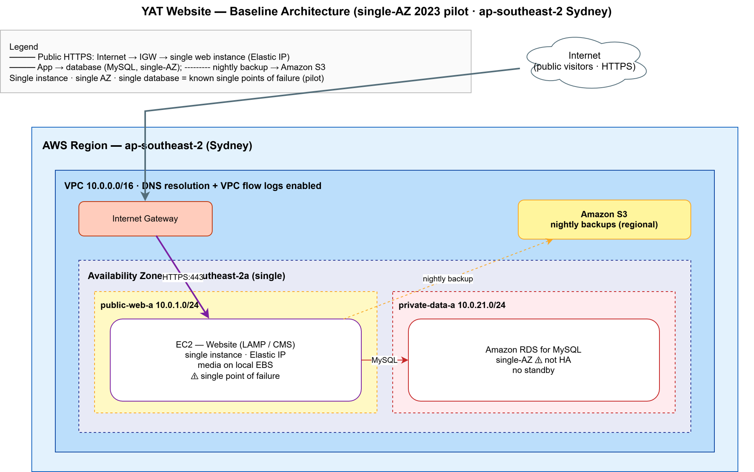
Figure 4.4 — Website baseline network topology (single-AZ, single instance).

4.5 Compute (single EC2 instance)
- A single EC2 instance (e.g. t3.small/medium — final type an implementer decision) running the LAMP stack and the CMS, in public-web-a with an Elastic IP.
- No Auto Scaling Group and no load balancer: the instance is the website. This is the principal single point of failure, accepted for the pilot.
- EBS: gp3 root volume holding the OS, the CMS application, and uploaded media (the CMS stores uploads on local disk by default).

4.6 TLS / HTTPS
- HTTPS terminates on the EC2 instance itself (there is no load balancer or CDN to terminate TLS at the edge).
- The certificate mechanism (e.g. an automatically-renewed certificate on the instance vs an imported certificate) is an implementer decision.

4.7 Database (RDS)
- Amazon RDS for MySQL (preserves the existing CMS schema and data); engine version confirmed against the CMS at build time.
- A small general-purpose instance class (e.g. db.t3.small — an implementer decision); gp3 storage sized to footprint + growth.
- Multi-AZ DISABLED (single-AZ baseline); storage encryption enabled (KMS).
- Placed in private-data-a; not publicly accessible; 7-day automated backups; maintenance in an overnight window.

4.8 Storage
Resource | Type | Purpose
EC2 root volume | EBS gp3 | OS, CMS application, and uploaded media
Backups bucket | S3 | Nightly database dumps and media snapshots

- Backups bucket: block all public access; SSE-S3 encryption; versioning enabled.
- Media is served from the instance, not from object storage or a CDN — an accepted pilot simplification (and a candidate first improvement later).

4.9 Security
Security group | Inbound | Outbound
sg-web | HTTP:80 + HTTPS:443 from 0.0.0.0/0; SSH:22 from an admin source (implementer decision) | MySQL:3306 to sg-db; HTTPS to AWS APIs / updates
sg-db | MySQL:3306 from sg-web only | none

- Encryption in transit: HTTPS to visitors; TLS from EC2 to RDS.
- Encryption at rest: EBS, RDS, and S3 all enabled.
- No web application firewall in the baseline (a deferred improvement).
- Operates under the AWS Shared Responsibility Model — AWS secures the cloud; YAT/MTS secure the OS, application, IAM, data and access in the cloud.

4.10 Monitoring (baseline)
Standard CloudWatch metrics for the EC2 instance and the RDS database, with a small set of baseline alarms:
Alarm | Threshold
EC2 instance status check failed | Any failed check
EC2 CPU high | ≥ 80% over 10 min
RDS CPU high | ≥ 80% over 10 min
RDS free storage low | < 15%

- Logging: web/CMS and RDS logs → CloudWatch Logs; VPC flow logs enabled. No cross-AZ or replica-lag alarms (there is no second AZ or replica).

4.11 Naming and tagging conventions
Naming pattern yat-web-<resource-type>-<env> (e.g. yat-web-ec2-prod). Mandatory tags:
Tag | Value
Project | YAT-Website-Migration
Environment | Production
Owner | YAT-ICT
ManagedBy | MTS during build → YAT-ICT post-handover
CostCentre | YAT-Website
DataClassification | Internal; PII (enquiry/application data)

4.12 Backup
Resource | Mechanism | Retention
RDS database | Automated daily backups + transaction logs | 7 days
EC2 EBS volume | Daily AMI/EBS snapshot (Data Lifecycle Manager) | 7 days
Database / media | Nightly dump + media snapshot to the S3 backups bucket | Versioned

- Cross-Region backup copies are out of scope for the baseline — there is no disaster-recovery tier.

4.13 Recovery objectives — baseline state
The baseline's recovery posture is backup-based and unmeasured: recovery means rebuilding the single instance and restoring from the most recent backup. No RTO or RPO was committed for the pilot. There is no second-AZ or second-region fallback. This is the principal gap a future engagement (and any disaster-recovery plan) would address.

4.14 Single points of failure (known and accepted)
The baseline is single-AZ and single-instance by design. The following are known single points of failure, accepted as residual risk for the pilot and recorded for a future engagement:
- The single EC2 instance — its failure takes the whole website offline.
- The single Availability Zone — an AZ-level event takes everything down.
- The single RDS instance — no standby; failure or maintenance interrupts the site.
- Uploaded media on the instance's EBS volume — not redundant or offloaded.

4.15 Configuration decisions left to the implementer
# | Decision | Why left open
C1 | EC2 instance type | Size against the website's light load + peak
C2 | RDS instance class + storage size | Size from the CMS data footprint + growth
C3 | TLS certificate mechanism on the instance | Implementer's operational preference
C4 | Administrative SSH access path | Adapt to YAT ICT's admin arrangements
C5 | CMS / MySQL engine versions | Confirm against the migrated CMS

5. Implementation Sequencing
Because this migrated a live website, the build was sequenced around a cutover timed to avoid the enrolment-enquiry peak:
- Provision the foundation: account, VPC, single-AZ subnets, security groups, IAM.
- Stand up the EC2 instance and the RDS database; install the LAMP stack and the CMS.
- Migrate content: export the on-premises CMS database and import to RDS; copy uploaded media and assets to the instance.
- Verify on the cloud deployment pre-cutover: content complete, course catalogue correct, enquiry/application form submits and notifies.
- Cut over after the enrolment-enquiry peak: switch DNS to the Elastic IP; ramp down the on-premises server.
- Stabilise, then hand over documentation and the operations runbook to YAT ICT.

6. Verification Plan
The baseline was verified functionally: homepage and key pages load over HTTPS; the course catalogue renders; the enquiry/application form submits, emails Admissions, and forwards to the student-admin intake; migrated content and submitted records reconcile against the source.
Not applicable — failure-simulation and availability verification do not apply to this baseline — there is no redundancy to fail over to. Resilience testing is a matter for a future high-availability and disaster-recovery engagement.

7. Out of Scope
Stated explicitly — these are the deliberate gaps in the baseline, and the natural inputs to any future improvement or disaster-recovery work:
- Load balancer (ALB) and an Auto Scaling Group across multiple AZs.
- Multi-AZ RDS; cross-AZ subnets; replica/standby database.
- Content delivery network (CDN) and media offload to object storage.
- Web application firewall and advanced security hardening.
- Disaster recovery: cross-Region copies, a DR runbook, and tested recovery objectives.
- And, out of MTS scope entirely: website content/redesign and ongoing support (YAT).

8. References
- Website Migration Requirements; Engagement Role Brief; ICT Manager Consultation Notes.
- ICT Environment Overview (on-premises current state).
- Privacy Policy; User Access Policy; Industry Standards Reference (AWS Well-Architected, ACSC Essential Eight).

Document control
Field | Value
Document version | v1.0 — As-built baseline
Authored by | MTS Consulting, in consultation with YAT ICT
Approved by | Pat Lin (MTS Senior Consultant) · Sam Walker (YAT ICT Manager)
Engagement | YAT Website Cloud Migration (2023) — closed 12 May 2023
Status | Retained as the website baseline of record (single-AZ, no HA, no DR)

