YAT COLLEGE
YAT College · 175 Cremorne St, Cremorne VIC 3121

Solution Design
YAT Website Cloud Architecture — HA-Hardened Design

Engagement | YAT Website HA Hardening
Document type | Technical design (Solution Design)
Version | v1.0 — As-built (HA-hardened)
Authored by | MTS Consulting, in consultation with YAT ICT
Approved by | Pat Lin (MTS Senior Consultant) · Sam Walker (YAT ICT Manager)
Predecessor | YAT Website Cloud Architecture — Baseline Design (single-AZ)
Classification | Internal — YAT ICT, and MTS personnel on signed MSA

Contents
Contents 2
1. Purpose and Scope 3
In scope of this design 3
Out of scope — the subsequent Website Global Expansion engagement 3
Out of MTS scope entirely — YAT responsibility 3
2. Design Inputs and Requirements 3
2.1 Inputs 3
2.2 Requirements the design must meet 3
3. Review of the Existing (Single-AZ) Architecture 4
4. Architecture Design 4
4.1 Assumptions and constraints 4
4.2 AWS account and region 4
4.3 Identity and Access Management (IAM) 4
4.4 Network topology 4
4.5 Compute (ALB + cross-AZ Auto Scaling) 5
4.6 Database (RDS — Multi-AZ) 5
4.7 Storage (media offloaded) 5
4.8 Security 6
4.9 Monitoring (HA) 6
4.10 Naming and tagging conventions 6
4.11 Backup 6
4.12 Recovery objectives — HA state 6
4.13 Single points of failure removed 7
4.14 Configuration decisions left to the implementer 7
5. Implementation Sequencing 7
6. Verification Plan 7
7. Out of Scope 7
8. References 8
Document control 8

1. Purpose and Scope
This document records the cloud architecture of the YAT website after high-availability hardening. It takes the single-Availability-Zone 2023 pilot (the Website Cloud Architecture — Baseline Design) and hardens it into a Multi-AZ, fault-tolerant deployment: the single web instance becomes a load-balanced, auto-scaling group spread across two Availability Zones; the single-AZ database becomes a Multi-AZ deployment with an automatic-failover standby; and uploaded media moves off the instance's local disk into shared object storage.

In scope of this design
- Removal of the single-instance, single-Availability-Zone, and single-database points of failure on the website's serving path.
- An Application Load Balancer, a cross-AZ Auto Scaling Group, a Multi-AZ managed database, and media offloaded to object storage.
- Single-region, two-Availability-Zone deployment in ap-southeast-2 (Sydney).

Out of scope — the subsequent Website Global Expansion engagement
- Global serving and edge content delivery (CDN) for an international audience.
- Cross-region disaster recovery (a second region, recovery objectives, DR runbook).
- The audit/access-log microservice and the in-India log store.
- Infrastructure-as-code templating of the footprint.

Out of MTS scope entirely — YAT responsibility
- Website content authoring and CMS configuration (YAT Marketing).
- Ongoing operation and support of the website after handover (YAT ICT).

2. Design Inputs and Requirements

2.1 Inputs
- Website Cloud Architecture — Baseline Design — the single-AZ pilot being hardened.
- Website Specification — workload, traffic, and data profile of the public website.
- Website Infrastructure Specifications — the as-deployed single-AZ resources.

2.2 Requirements the design must meet
Requirement | Target / note
Region / data residency | ap-southeast-2 (Sydney); enquiry / application PII within Australia (Privacy Act, APP 8)
Application stack | Preserved — the existing PHP / MySQL CMS on a LAMP stack
Availability | Survive the loss of a single instance or a single Availability Zone with no manual intervention
Recovery | Automatic database failover; serving continues from the surviving AZ
Scaling | Scale the web tier with demand (the Jan–Feb enrolment-enquiry peak)
Disaster recovery | Out of scope here — cross-region DR is the subsequent expansion engagement

3. Review of the Existing (Single-AZ) Architecture
The starting point is the 2023 single-AZ pilot: a single EC2 instance (LAMP / CMS) with an Elastic IP serving traffic directly, a single-AZ Amazon RDS for MySQL database, and uploaded media stored on the instance's EBS volume, with nightly backups to S3. Its known single points of failure — the single instance, the single Availability Zone, the single database, and media held on one instance's disk — are precisely what this engagement removes.

4. Architecture Design

4.1 Assumptions and constraints
# | Assumption / constraint | Source
A1 | Region must be ap-southeast-2 (Sydney) for data residency | Website Specification; Privacy Policy
A2 | CMS application stack preserved: PHP / MySQL on a LAMP stack | Baseline Design
A3 | Two Availability Zones (ap-southeast-2a, ap-southeast-2b) used for fault tolerance | HA scoping decision
A4 | Light load with a Jan–Feb enrolment-enquiry peak; web tier scales with demand | Website Specification
A5 | Enquiry / application PII must remain within Australia | Privacy Act 1988, APP 8
A6 | Cross-region DR, global serving, and the microservice are out of scope (later engagement) | Scoping decision

4.2 AWS account and region
Region ap-southeast-2 (Sydney); no deployment outside Australian regions. The deployment now spans two Availability Zones (ap-southeast-2a and ap-southeast-2b) so that the loss of one AZ does not take the website offline.

4.3 Identity and Access Management (IAM)
Group / role | Purpose | Indicative permissions
YAT-ICT-Admins | YAT ICT day-to-day ops | Console access to EC2/RDS/S3/ELB/CloudWatch; no IAM changes
MTS-Consultants | MTS during the hardening + support | Admin during build; reduced at handover
Website-Instance role | EC2 instance profile for the web tier | S3 read/write (media + backups); CloudWatch logs/metrics

- MFA required for all human users (User Access Policy; ACSC Essential Eight).
- EC2 access to AWS via the instance profile; no long-lived human access keys.

4.4 Network topology
VPC 10.0.0.0/16, DNS resolution and VPC flow logs enabled. Subnets across two AZs:
Subnet | CIDR | Tier | Internet-facing?
public-web-a / -b | 10.0.1.0/24, 10.0.2.0/24 | Load balancer + NAT (one per AZ) | Yes (ALB)
private-app-a / -b | 10.0.11.0/24, 10.0.12.0/24 | Website EC2 (ASG, one per AZ) | No
private-data-a / -b | 10.0.21.0/24, 10.0.22.0/24 | Database (RDS primary / standby) | No

- Internet Gateway for the public subnets; a NAT Gateway in each AZ for the private subnets' outbound traffic.
- The web instances move OUT of the public subnet (where the single pilot instance sat) into private app subnets behind the load balancer.
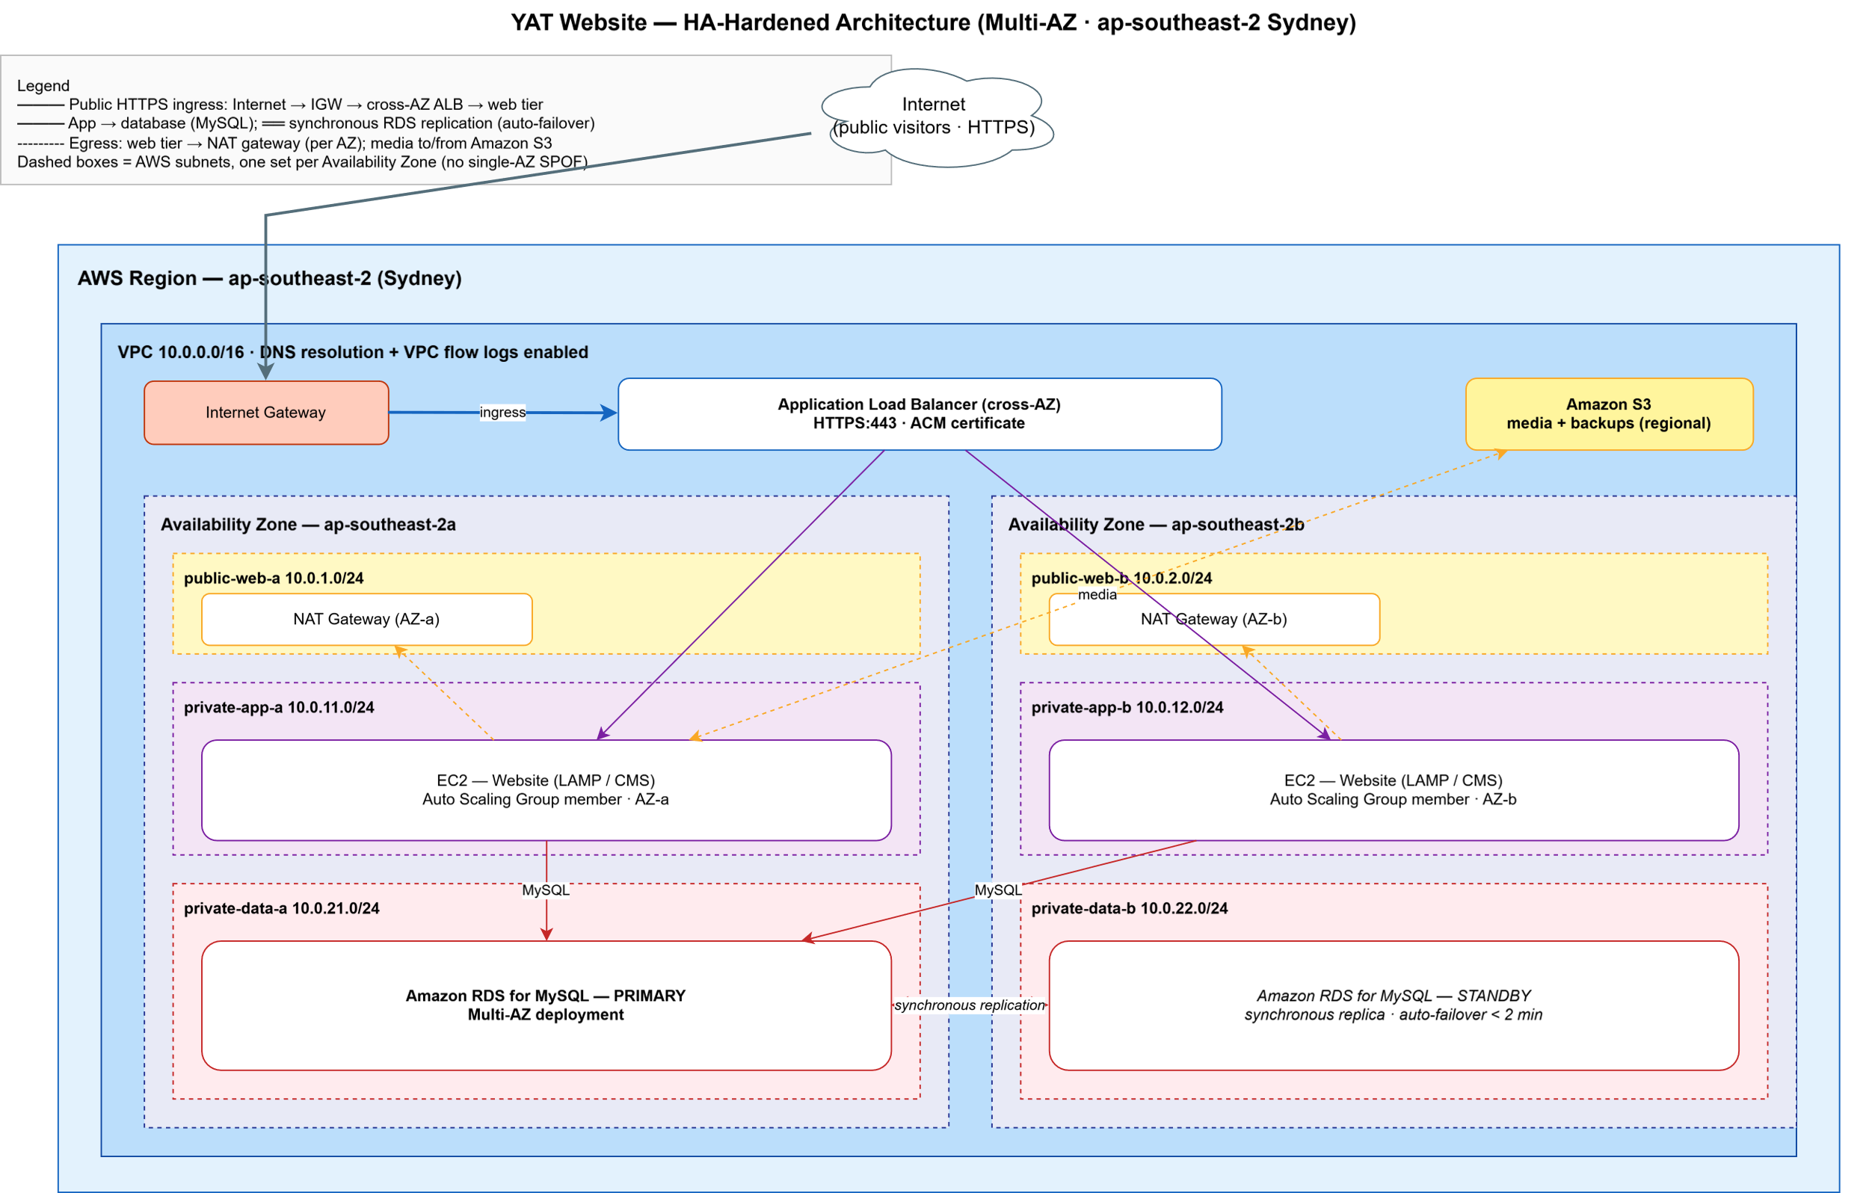
Figure 4.4 — Website HA-hardened network topology (Multi-AZ).

4.5 Compute (ALB + cross-AZ Auto Scaling)
- Application Load Balancer, internet-facing, across public-web-a/b; HTTPS:443 listener; ACM-issued certificate (TLS now terminates at the load balancer, not on the instance).
- Auto Scaling Group of website instances (LAMP / CMS) across private-app-a/b: min 2 (one per AZ), scaling on CPU / request count; target group health-checked by the ALB.
- This removes the single-instance SPOF: an instance or AZ failure leaves healthy capacity serving in the other AZ.

4.6 Database (RDS — Multi-AZ)
- Amazon RDS for MySQL converted to a Multi-AZ deployment: a primary in private-data-a with a synchronously-replicated standby in private-data-b.
- Automatic failover to the standby on primary failure or AZ loss (typically under two minutes), with no application reconfiguration.
- Storage encryption (KMS); not publicly accessible; automated daily backups retained.

4.7 Storage (media offloaded)
Resource | Type | Purpose
Media bucket | S3 | Uploaded media (images, brochures, course PDFs) — moved off instance EBS so every instance serves the same media and no single disk is a SPOF
Backups bucket | S3 | Nightly database and media backups

- Both buckets: block all public access; SSE-S3 encryption; versioning enabled. Edge delivery (CDN) of media is deferred to the global-expansion engagement.

4.8 Security
Security group | Inbound | Outbound
sg-alb | HTTPS:443 from 0.0.0.0/0 | HTTP to sg-app
sg-app | from sg-alb; SSH from an admin source (implementer decision) | MySQL:3306 to sg-db; HTTPS via NAT to AWS APIs / updates
sg-db | MySQL:3306 from sg-app only | none

- Encryption in transit (HTTPS to the ALB; TLS app→RDS) and at rest (EBS, RDS, S3).
- Operates under the AWS Shared Responsibility Model.

4.9 Monitoring (HA)
CloudWatch metrics for the ALB, the Auto Scaling Group, and RDS, with HA-relevant alarms:
Alarm | Threshold
ALB unhealthy host count | ≥ 1 unhealthy target
ASG in-service instances | < 2 (capacity below one-per-AZ)
ALB 5XX | > 10 / min
RDS failover / replica lag | Failover event, or lag above threshold
RDS free storage low | < 15%

4.10 Naming and tagging conventions
Naming pattern yat-web-<resource-type>-<env>-<az> (e.g. yat-web-ec2-prod-a). Mandatory tags: Project=YAT-Website-HA, Environment=Production, Owner=YAT-ICT, DataClassification=Internal; PII.

4.11 Backup
Resource | Mechanism | Retention
RDS database | Automated daily backups + transaction logs (Multi-AZ) | 7 days
Media (S3) | Versioning + nightly snapshot to the backups bucket | Versioned

- Cross-Region backup copies remain out of scope here — they are part of the disaster-recovery work in the subsequent expansion engagement.

4.12 Recovery objectives — HA state
Within the region, the website now tolerates instance and AZ failure automatically: serving continues from the surviving AZ and the database fails over to its standby. Recovery from the loss of the whole region is NOT addressed by this design — that is the cross-region disaster recovery work of the subsequent expansion engagement, and no cross-region recovery objective is committed here.

4.13 Single points of failure removed
The hardening removes the baseline's single points of failure:
Baseline SPOF | Removed by
Single EC2 instance | Cross-AZ Auto Scaling Group (min 2) behind an ALB
Single Availability Zone | Two AZs; serving continues from the survivor
Single RDS database | Multi-AZ deployment with automatic failover
Media on one instance's EBS volume | Media offloaded to shared S3

4.14 Configuration decisions left to the implementer
# | Decision | Why left open
C1 | EC2 instance type and ASG min/max/scaling policy | Size against the website's load + peak
C2 | RDS instance class | Size from the CMS data footprint + growth
C3 | Administrative SSH access path to the private instances | Adapt to YAT ICT's admin arrangements
C4 | Media-migration cutover approach (EBS → S3) | Minimise disruption to the live site

5. Implementation Sequencing
Because this hardens a live website, the work is sequenced to avoid an outage and to steer clear of the enrolment-enquiry peak:
- Add the second Availability Zone's subnets, a NAT Gateway per AZ, and the security groups.
- Convert the RDS instance to a Multi-AZ deployment (a managed change, taken in a maintenance window).
- Offload uploaded media from the instance EBS volume to the S3 media bucket and repoint the CMS.
- Stand up the Auto Scaling Group across both AZs and the internet-facing ALB; move TLS to an ACM certificate on the ALB.
- Cut traffic over to the ALB (DNS), retire the single instance's Elastic IP, and verify.

6. Verification Plan
The HA properties are verified by simulation: terminate an instance and confirm the ASG replaces it with no loss of service; fail an Availability Zone and confirm serving continues from the survivor; trigger an RDS failover and confirm the standby takes over within the expected window; confirm media is served identically from any instance via S3.

7. Out of Scope
Stated explicitly — these are deliberately left for the subsequent Website Global Expansion engagement, which works from this HA-hardened state:
- Global serving and edge content delivery (CDN) for an international / India audience.
- Cross-region disaster recovery: a second region, recovery objectives (RTO/RPO), and a DR runbook.
- The audit/access-log microservice and the in-India log store.
- Infrastructure-as-code templating of the footprint.
- And, out of MTS scope entirely: website content / CMS and ongoing support (YAT).

8. References
- Website Cloud Architecture — Baseline Design (single-AZ) — the predecessor state.
- Website Specification; Website Infrastructure Specifications.
- Privacy Policy; User Access Policy; Industry Standards Reference (AWS Well-Architected, ACSC Essential Eight).

Document control
Field | Value
Document version | v1.0 — As-built (HA-hardened)
Authored by | MTS Consulting, in consultation with YAT ICT
Approved by | Pat Lin (MTS Senior Consultant) · Sam Walker (YAT ICT Manager)
Predecessor | YAT Website Cloud Architecture — Baseline Design (single-AZ)
Status | The website's HA-hardened state of record (Multi-AZ; in-region HA, no cross-region DR)

