YAT COLLEGE
YAT College · 175 Cremorne St, Cremorne VIC 3121

Solution Design
YAT Accounting System Cloud Architecture — Baseline Design

Engagement | YAT Accounting System Cloud Migration — Foundation Build
Document type | Technical design (Solution Design)
Version | v1.0 — Approved for implementation
Authored by | MTS Senior Architecture Team, in consultation with YAT ICT
Approved by | Pat Lin (MTS Senior Consultant) · Sam Walker (YAT ICT Manager)
Implemented by | the Accounting System foundation-build Deployment Report
Classification | Internal — YAT ICT, Finance, and MTS personnel on signed MSA

Contents
Contents 2
1. Purpose and Scope 3
In scope of this design 3
Out of scope — deferred to the follow-on HA design phase 3
Out of MTS scope entirely — YAT ICT responsibility 3
2. Design Inputs and Requirements 3
2.1 Inputs 3
2.2 Requirements the design must meet 3
3. Review of Existing Architecture 4
4. Architecture Design 4
4.1 Assumptions and constraints 4
4.2 AWS account and region 4
4.3 Identity and Access Management (IAM) 5
4.4 Network topology 5
4.5 Compute (EC2 + Auto Scaling) 6
4.6 Load balancing (ALB) 6
4.7 Database (RDS for SQL Server) 6
4.8 Storage 7
4.9 Security 7
4.10 Monitoring (baseline) 7
4.11 Naming and tagging conventions 8
4.12 Backup 8
4.13 Recovery objectives — baseline state 8
4.14 Components requiring vertical scaling 8
4.15 Single points of failure removed 8
4.16 Configuration decisions left to the implementer 8
5. Implementation Sequencing 9
6. Simulation and Verification Plan 9
7. Out of Scope 9
8. References 9
Document control 10

1. Purpose and Scope
This document specifies the baseline AWS architecture MTS will implement as the foundation build phase of the YAT Accounting System cloud migration. It translates the approved direction into a concrete, implementable design for the Ledgerline finance and office-administration system. The design stops at “infrastructure ready for application deployment”: the EC2 instance is provisioned with the OS, the RDS instance with an empty Microsoft SQL Server engine, and the load balancer with placeholder health checks — no application binaries or financial data are placed by the MTS build.

In scope of this design
- The production cloud foundation for the Ledgerline accounting application.
- All compute, networking, identity, storage, database, autoscaling and baseline monitoring needed to run Ledgerline as a staff-facing, business-hours workload in AWS.
- Single-region, single-Availability-Zone deployment in ap-southeast-2 (Sydney).

Out of scope — deferred to the follow-on HA design phase
- High-availability hardening (Multi-AZ SQL Server, cross-AZ compute resilience, failure-simulation testing).
- Disaster recovery to a second AWS region; DR runbook and tabletop testing.
- Application re-platforming (Ledgerline remains Windows Server 2016 + Microsoft SQL Server).

Out of MTS scope entirely — YAT ICT responsibility
- Ledgerline application installation onto the EC2 instance(s) after handover.
- Database migration (extract from on-prem SQL Server, load into RDS for SQL Server).
- Cutover — DNS switch, parallel running, decommissioning, user redirection (avoiding month-end and EOFY).
- Organisational change management — CAB approvals, communications, training, post-cutover support.

2. Design Inputs and Requirements

2.1 Inputs
- Accounting System Application Specification — functions, user load, data, integrations, SLAs, data residency.
- Accounting System Migration Requirements — platform preservation, availability, recovery, licensing, retention.
- Accounting System Server Specifications — current server, measured availability, utilisation, growth.
- Engagement Role Brief and Consultation Notes — engagement scope; OS, application and database preservation.

2.2 Requirements the design must meet
Requirement | Target / note
Region / data residency | ap-southeast-2 (Sydney); financial records + staff/debtor PII within Australia (Privacy Act APP 8; financial-records retention)
Application stack | Preserved — Windows Server 2016 · Microsoft SQL Server (Standard) · Ledgerline
Concurrent users | 15–25 typical; 45–55 peak at month-end close and EOFY; idle out of hours
Availability | ≥ 99.5% business-hours (Mon–Fri ~07:30–18:00); no 24/7 requirement
Recovery | RPO ≤ 1 hour (no loss of financial transactions); RTO ≤ 1 business day (≤ 8 business hours)
Data footprint | ~22 GB SQL Server data, growing ~5 GB/year, plus scanned-document attachments
Retention | Financial records and audit logs retained ≥ 7 years
Licensing | Commercial — Ledgerline per-user + SQL Server; cloud licence treatment (licence-included vs BYOL) is material
Integrations | AD authentication; O365 SMTP; LMS fee-status; payroll-bureau SFTP; banking/payment-gateway file exchange
High availability | Out of baseline scope — Multi-AZ resilience deferred to the follow-on HA design

3. Review of Existing Architecture
Not applicable — this is a greenfield cloud foundation; there is no existing cloud baseline to review. The on-premises current state is documented separately in the Accounting System Server Specifications and the ICT Environment Overview.

4. Architecture Design

4.1 Assumptions and constraints
# | Assumption / constraint | Source
A1 | Region must be ap-southeast-2 (Sydney) for financial-records data residency | Migration Requirements; Privacy Policy
A2 | Application stack preserved: Windows Server 2016, Microsoft SQL Server, Ledgerline | Migration Requirements; Role Brief
A3 | Data footprint ~22 GB SQL Server data, +~5 GB/year, plus scanned attachments | Application Spec; Server Specs
A4 | Concurrent users 15–25 typical, 45–55 at month-end / EOFY; idle out of hours | Application Spec
A5 | Financial records + staff/debtor PII must remain within Australia; retained ≥ 7 years | Privacy Act 1988 APP 8; financial-records obligations
A6 | Preserve AD authentication over a private network to campus AD; staff-only access | Application Spec; Migration Requirements
A7 | Baseline is NOT high-availability; Multi-AZ resilience deferred to the HA design | Scoping decision

4.2 AWS account and region
An AWS account scoped to the migration engagement, provisioned by YAT and shared with MTS for the build. Region ap-southeast-2 (Sydney); no deployment outside Australian regions, to satisfy financial-records residency. Availability Zone ap-southeast-2a for the baseline; the follow-on HA design introduces a second AZ.

4.3 Identity and Access Management (IAM)
Group | Purpose | Indicative permissions
YAT-ICT-Admins | YAT ICT day-to-day ops post-handover | Read-only on infra; full CloudWatch/RDS/EC2 console; no IAM changes
MTS-Consultants | MTS during build + support | Full admin during build; reduced post-handover
Application-Service | EC2 instance role for Ledgerline | RDS read/write; S3 read/write (attachments); CloudWatch logs
Finance-Auditors | Finance / external auditors | Read-only on logs, metrics, configs (financial-audit support)

- MFA required for all YAT-ICT-Admins and MTS-Consultants users (Essential Eight; User Access Policy).
- No long-lived access keys for humans; programmatic access via IAM roles only; EC2 access via instance profile.
- Configuration decision left to the implementer: the MTS-Consultants permission boundary during build vs after handover.

4.4 Network topology
VPC 10.0.0.0/16 (room to expand), with DNS hostnames/resolution and VPC flow logs enabled. This is an internal, staff-only service — there is no public internet ingress to the application. Single-AZ subnets in ap-southeast-2a:
Subnet | CIDR | Tier | Internet-facing?
public-egress-a | 10.0.1.0/24 | NAT gateway only (outbound patching) | Egress only
private-app-a | 10.0.11.0/24 | Application / Ledgerline EC2 + internal ALB | No
private-data-a | 10.0.21.0/24 | Database (RDS for SQL Server) | No

- Internet Gateway used only for NAT egress (Windows Update, vendor patches); no inbound internet path to the app.
- Route tables: public-egress → IGW; private-app → NAT; private-data → no internet route.
- Staff reach the service over the campus Site-to-Site VPN; AD authentication runs over the same private link.
- The follow-on HA design adds the corresponding -b subnets in ap-southeast-2b.
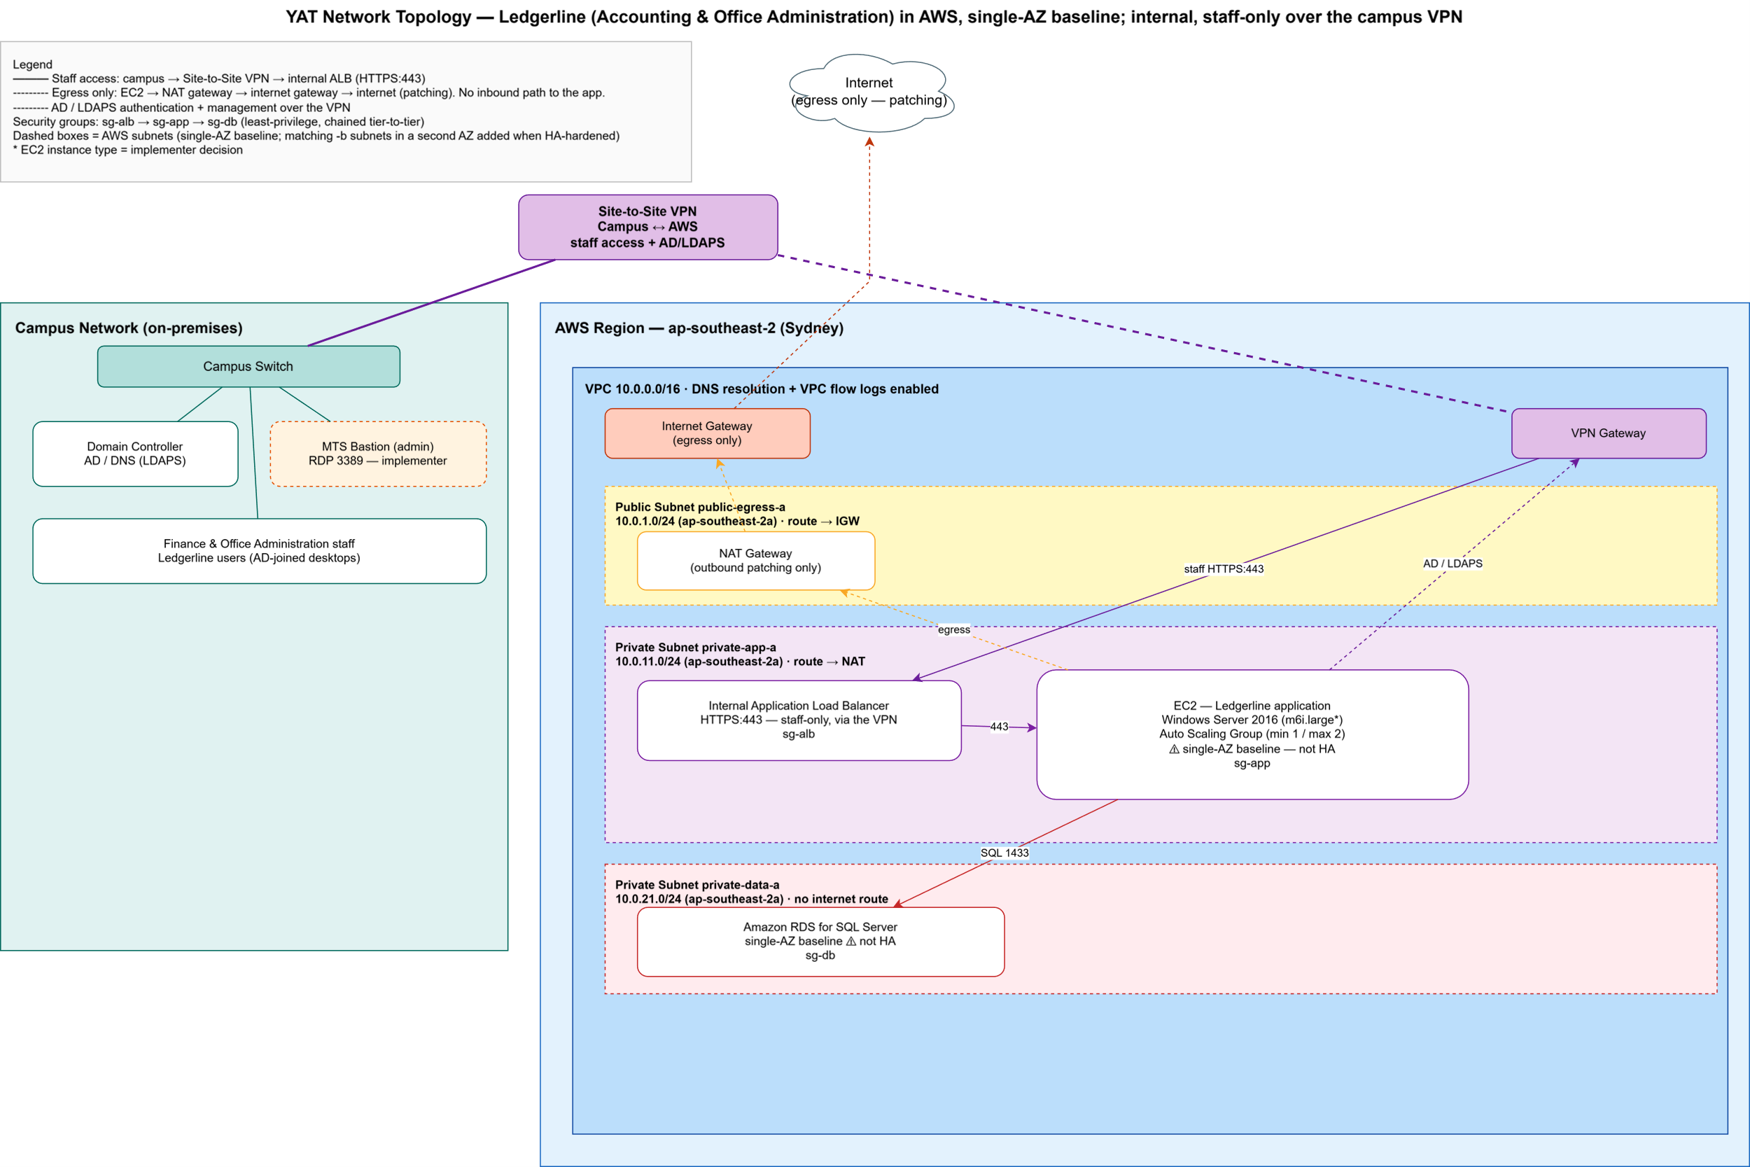
Figure 4.4 — Ledgerline baseline network topology (single-AZ, internal / staff-only over the campus VPN).

4.5 Compute (EC2 + Auto Scaling)
- EC2: general-purpose x86 (e.g. m6i.large — final type a C1 implementer decision); Windows Server 2016 AMI; placed in private-app-a (no public IP).
- EBS: gp3 root 80 GB + a gp3 data volume sized by the implementer (footprint + 12-month growth + headroom).
- Auto Scaling Group: min 1 / desired 1 / max 2 (baseline); target-tracking on CPU at 70%; ELB+EC2 health checks; 300 s cooldown.
- The workload is business-hours and idle overnight; the follow-on HA design adds cross-AZ capacity for resilience (not for load).

4.6 Load balancing (ALB)
- Internal (private) ALB in private-app-a; HTTPS:443 listener forwarding to the Ledgerline target group — reachable by staff over the campus VPN, not from the internet.
- Target group = the ASG instances; HTTP health check on the application health endpoint (30 s; 2 unhealthy → out of service).
- TLS via an ACM-issued certificate for the internal Ledgerline DNS name (DNS strategy a C8 implementer decision).

4.7 Database (RDS for SQL Server)
- Amazon RDS for SQL Server, Standard edition (preserves the existing SQL Server engine and data); version confirmed against Ledgerline at build time.
- General-purpose instance class (e.g. db.m6i.large — a C2 implementer decision); gp3 storage sized to ~22 GB + ~5 GB/year growth.
- SQL Server licensing model — licence-included vs bring-your-own-licence — is a C3 implementer decision with a material cost impact.
- Multi-AZ DISABLED for the baseline (enabled in the HA design); storage encryption enabled (KMS).
- Placed in private-data-a; not publicly accessible. Automated backups + transaction-log backups sized to meet RPO ≤ 1 hour; backup window 22:00–04:00 AEST; maintenance Sun 02:00–06:00 AEST.
- Schema and data migration are YAT ICT's responsibility, not MTS's — MTS provisions an empty instance.

4.8 Storage
Resource | Type | Purpose
EC2 root volume | EBS gp3 80 GB | OS and Ledgerline application install
EC2 data volume | EBS gp3 (sized by implementer) | Ledgerline application data, report staging
Documents bucket | S3 | Scanned invoices / purchase orders / supporting documents; lifecycle to Glacier for 7-year financial retention
Backups bucket | S3 | Off-instance SQL backup exports, file snapshots

- Both buckets: block all public access; SSE-S3 (or SSE-KMS) encryption; versioning enabled; access logging to a log bucket; Object Lock considered for the 7-year financial-records hold.

4.9 Security
Security group | Inbound | Outbound
sg-alb | HTTPS:443 from the campus VPN / staff CIDR only | HTTPS to sg-app
sg-app | from sg-alb; RDP:3389 from MTS bastion (design left to implementer) | SQL:1433 to sg-db; HTTPS via NAT; LDAPS to campus AD; SMTP to O365; SFTP to payroll bureau; banking endpoints
sg-db | SQL Server:1433 from sg-app only | none

- Encryption in transit: HTTPS staff→ALB→EC2; TLS EC2→RDS; AWS calls over TLS via VPC endpoints where available; LDAPS and SFTP for external links.
- Encryption at rest: EBS, RDS, and S3 all enabled (KMS where customer-managed keys are warranted for financial data).
- Operates under the AWS Shared Responsibility Model — AWS secures the cloud; YAT/MTS secure the OS, application, IAM, data and access in the cloud.

4.10 Monitoring (baseline)
Standard CloudWatch metrics for EC2, RDS, ALB and Auto Scaling. Baseline alarms (HA-tuned alarms come in the follow-on HA design):
Alarm | Threshold
EC2 CPU high | ≥ 80% over 10 min
RDS CPU high | ≥ 80% over 10 min
RDS free storage low | < 15%
ALB target 5XX / unhealthy host | > 5 / min or any unhealthy host
RDS connections high | > 80% of max connections

- Logging: VPC flow logs and RDS logs → CloudWatch Logs; ALB access logs → S3; EC2 OS logs via the CloudWatch Agent. Financial-audit-relevant logs retained to meet the 7-year obligation.

4.11 Naming and tagging conventions
Naming pattern yat-acct-<resource-type>-<env>-<az-or-purpose> (e.g. yat-acct-alb-prod). Mandatory tags:
Tag | Value
Project | YAT-Accounting-Migration
Environment | Production
Owner | YAT-ICT
ManagedBy | MTS-Migration during build → YAT-ICT post-handover
CostCentre | YAT-Accounting
DataClassification | Financial / Confidential (PII)

4.12 Backup
Resource | Mechanism | Retention
RDS database | Automated daily backups + transaction-log backups (point-in-time recovery) | Sized to RPO ≤ 1 h; long-term financial copies retained ≥ 7 years
EC2 EBS volumes | Daily AMI snapshot (Data Lifecycle Manager) | 14 days
Documents (S3) | Versioning + lifecycle to Glacier | ≥ 7 years (financial-records obligation)

- Cross-Region backup copies are out of scope for the baseline — addressed in the follow-on HA design.

4.13 Recovery objectives — baseline state
The baseline meets RPO ≤ 1 hour through RDS automated + transaction-log backups (point-in-time recovery), and supports RTO ≤ 1 business day via a single-AZ restore. The single AZ and the single RDS instance remain known single points of failure: tolerable for a business-hours service in the short term, but resilience against an AZ failure is the objective of the follow-on HA design.

4.14 Components requiring vertical scaling
RDS instance-class changes require a modify-and-apply (a brief interruption, taken in the maintenance window, outside business hours); EBS volumes support online resize with no downtime.

4.15 Single points of failure removed
Not applicable — this baseline is single-AZ by design; the single RDS instance and the single AZ are known single points of failure, deliberately deferred to the follow-on HA design.

4.16 Configuration decisions left to the implementer
The design is opinionated where it matters and silent where the implementer must show judgement. Each decision below is to be made and evidenced in the Deployment Report, justified against the Ledgerline workload.
# | Decision | Why left open
C1 | EC2 instance type (general-purpose family) | Size against the Ledgerline workload (15–25 typical / 45–55 month-end peak)
C2 | RDS for SQL Server instance class | Size against the SQL Server workload (read-heavy at month-end)
C3 | SQL Server licensing model — licence-included vs BYOL | Material cost decision under the cloud operating model
C4 | EBS data volume + RDS storage size | Compute from the ~22 GB footprint + ~5 GB/year growth
C5 | Backup retention + RPO mechanism | Meet RPO ≤ 1 h and the 7-year financial-records retention
C6 | Bastion / jump-host design for RDP admin access | Left to the implementer
C7 | Security-group ingress specifics | Confirm AD/LDAPS, SMTP, payroll SFTP and banking endpoints
C8 | DNS strategy + ACM certificate domain | Confirm the internal Ledgerline hostname with YAT ICT

5. Implementation Sequencing
Not applicable — this is a greenfield build in a new account, not a change to a running system; build order is at the implementer's discretion and there is no live service to sequence around or roll back.

6. Simulation and Verification Plan
Not applicable — failure/resize simulation and availability verification are the subject of the follow-on HA design and its deployment report; the baseline build is verified functionally per the Deployment Report's testing section.

7. Out of Scope
Stated explicitly so the implementer knows what not to build (these are the deliberate inputs to the follow-on HA design):
- Multi-AZ SQL Server; cross-AZ subnets (private-app-b, private-data-b); ASG capacity ≥ 2 across AZs.
- HA-tuned monitoring (cross-AZ latency, replica lag); cross-Region backup copies and DR runbook.
- Failure-simulation testing; automated availability reporting against the recovery objectives.
- And, out of MTS scope entirely: Ledgerline install, SQL Server data migration, cutover, and change management (YAT ICT).

8. References
- Accounting System Application Specification; Migration Requirements; Server Specifications; Operational Costing.
- Engagement Role Brief; Consultation Notes; ICT Environment Overview.
- Privacy Policy; User Access Policy; Security and Incident Response; Industry Standards Reference (AWS Well-Architected, ACSC Essential Eight).

Document control
Field | Value
Document version | v1.0 — Approved for implementation
Authored by | MTS Senior Architecture Team, in consultation with YAT ICT
Approved by | Pat Lin (MTS Senior Consultant) · Sam Walker (YAT ICT Manager)
Implemented by | the Accounting System foundation-build Deployment Report
Successor document | YAT Accounting System Cloud Architecture — HA Design (follow-on phase)

