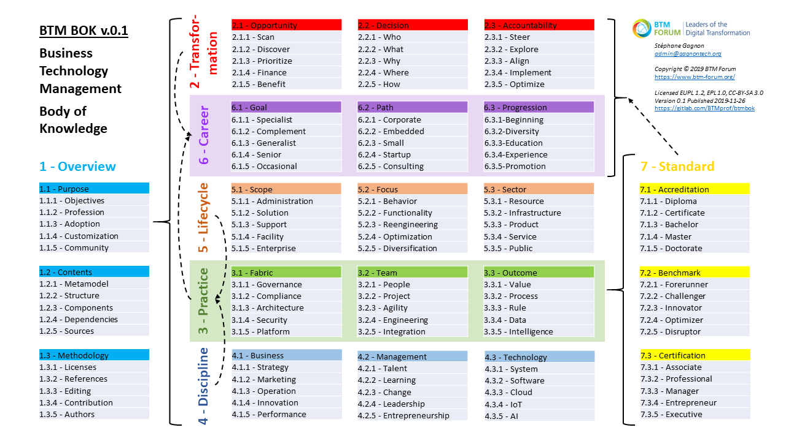

**Contents**

1 Overview 7

1.1 Purpose 8

1.1.1 Objectives 9

1.1.2 Profession 10

1.1.3 Adoption 11

1.1.4 Customization 12

1.1.5 Community 13

1.2 Contents 16

1.2.1 Metamodel 17

1.2.2 Structure 18

1.2.3 Components 23

1.2.4 Dependencies 27

1.2.5 Sources 28

1.3 Methodology 30

1.3.1 Licenses 31

1.3.2 References 33

1.3.3 Editing 39

1.3.4 Contribution 40

1.3.5 Authors 43

2 Transformation 46

2.1 Opportunity 46

2.1.1 Scan 47

2.1.2 Discover 48

2.1.3 Prioritize 49

2.1.4 Finance 50

2.1.5 Benefit 51

2.2 Decision 52

2.2.1 Who 53

2.2.2 What 53

2.2.3 Why 53

2.2.4 Where 53

2.2.5 How 53

2.3 Accountability 54

2.3.1 Steer 54

2.3.2 Explore 54

2.3.3 Align 54

2.3.4 Implement 54

2.3.5 Optimize 54

3 Practice 55

3.1 Fabric 55

3.1.1 Governance 55

3.1.2 Compliance 55

3.1.3 Architecture 55

3.1.4 Security 55

3.1.5 Platform 55

3.2 Team 55

3.2.1 People 55

3.2.2 Project 55

3.2.3 Agility 55

3.2.4 Engineering 55

3.2.5 Integration 55

3.3 Outcome 55

3.3.1 Value 55

3.3.2 Process 55

3.3.3 Rule 55

3.3.4 Data 55

3.3.5 Intelligence 55

4 Discipline 56

4.1 Business 56

4.1.1 Strategy 56

4.1.2 Marketing 56

4.1.3 Operation 56

4.1.4 Innovation 56

4.1.5 Performance 56

4.2 Management 56

4.2.1 Talent 56

4.2.2 Learning 56

4.2.3 Change 56

4.2.4 Leadership 56

4.2.5 Entrepreneurship 56

4.3 Technology 56

4.3.1 System 56

4.3.2 Software 56

4.3.3 Cloud 56

4.3.4 IoT 56

4.3.5 AI 56

5 Lifecycle 57

5.1 Scope 57

5.1.1 Administration 57

5.1.2 Solution 57

5.1.3 Support 57

5.1.4 Facility 57

5.1.5 Enterprise 57

5.2 Focus 57

5.2.1 Behavior 57

5.2.2 Functionality 57

5.2.3 Reengineering 57

5.2.4 Optimization 57

5.2.5 Diversification 57

5.3 Sector 57

5.3.1 Resource 57

5.3.2 Infrastructure 57

5.3.3 Product 57

5.3.4 Service 57

5.3.5 Public 57

6 Career 58

6.1 Goal 58

6.1.1 Specialist 58

6.1.2 Complement 58

6.1.3 Generalist 58

6.1.4 Senior 58

6.1.5 Occasional 58

6.2 Path 58

6.2.1 Corporate 58

6.2.2 Embedded 58

6.2.3 Small 58

6.2.4 Startup 58

6.2.5 Consulting 58

6.3 Progression 58

6.3.1 Beginning 58

6.3.2 Diversity 58

6.3.3 Education 58

6.3.4 Experience 58

6.3.5 Promotion 58

7 Standard 59

7.1 Accreditation 59

7.1.1 Diploma 59

7.1.2 Certificate 59

7.1.3 Bachelor 59

7.1.4 Master 59

7.1.5 Doctorate 59

7.2 Benchmark 59

7.2.1 Forerunner 59

7.2.2 Challenger 59

7.2.3 Innovator 59

7.2.4 Optimizer 59

7.2.5 Disruptor 59

7.3 Certification 59

7.3.1 Associate 59

7.3.2 Professional 59

7.3.3 Manager 59

7.3.4 Entrepreneur 59

7.3.5 Executive 59

**Figures**

Figure 1: BTM Scope and Integration of DTS, IS-IT Management, IS, and IT 8

Figure 2: BTM BOK Objectives 9

Figure 3: BTM Professionals and Community Learning Dynamics 10

Figure 4: BTM BOK Creation and Adoption Cycle 12

Figure 5: BTM BOK Customization Opportunities 13

Figure 6: BTM Community Engagement 15

Figure 7: BTM BOK Wiki Similar to Open Unified Process (OpenUP) 16

Figure 8: BTM BOK Metamodel 17

Figure 9: BTM BOK Structure 18

Figure 10: BTM Positions with Business and Technology Focus 23

Figure 11: BTM BOK Building Upon BTM Learning Outcomes 2.0 24

Figure 12: BTM BOK Practices and Dependencies 27

Figure 13: BTM BOK Sources, Integration, and Reuse 28

Figure 14: BTM BOK Development Process Based on Eclipse Process Framework (EPF) 30

Figure 15: BTM BOK Components and FLOS References 34

Figure 16: BTM BOK Development Interface within EPF Composer 39

Figure 17: BTM BOK Design Using SPEM 2.0 within EPF Composer 40

Figure 18: BTM BOK Development Team Platform 40

Figure 19: BTM BOK Standards Mapping System 42

Figure 20: BTM BOK Development Team Roles 44

Figure 21: BTM Maturity Levels and Digital Lifecycle 46

Figure 22: BTM BOK Cycle and Digital Value Creation 51

Figure 23: BTM Decision-Making Environment 52

Figure 24: BTM Executives and Digital Strategy Accountability 54

**Tables**

Table 1: BTM Benefits 11

Table 2: BTM-Related Professional Groups 14

Table 3: BTM BOK Chapters 18

Table 4: BTM BOK Ch. 1 Overview 19

Table 5: BTM BOK Ch. 2 Transformation 19

Table 6: BTM BOK Ch. 3 Practice 20

Table 7: BTM BOK Ch. 4 Discipline 21

Table 8: BTM BOK Ch. 5 Lifecycle 21

Table 9: BTM BOK Ch. 6 Career 22

Table 10: BTM BOK Ch. 7 Standard 22

Table 11: BTM Leaning Outcomes Aligned with IS 2010 Curriculum 25

Table 12: BTM BOK Dependencies Between Practices 27

Table 13: BTM BOK-Related Proprietary Specifications 29

Table 14: BTM BOK Compatible Licenses 31

Table 15: BTM BOK Detailed FLOS References 34

Table 16: BTM BOK Development Apps and Functionality 41

Table 17: BTM BOK Mapping App Database Tables 43

Table 18: BTM and Innovation Focus 47

Table 19: BTM and Digital Lifecycle 48

Table 20: BTM Context in Private and Public Sectors 49

Table 21: BTM Financing and IT Costs 50

Table 22: BTM Roles and Digital Lifecycle Leadership 53

# Overview

Business Technology Management (BTM) Body of Knowledge (BOK) is a guide for professional development and learning of key roles, core competencies, best practices, and supporting references.

Whether in private, public, or non-profit sectors, organizations everywhere are being transformed by the innovative use of technology and are required to rethink their business models and IT investments. This creates an unprecedented demand for a new generation of leaders with hybrid skillsets, requiring Information Systems (IS) and Information Technology (IT) professions, traditionally separated in business and computing schools, to grow beyond their fragmented and competing specializations.

To overcome these challenges, IT Association of Canada (ITAC) developed the BTM initiative to promote a renewed sense of community and help map the many career paths crossing business and technology functions. It grew into a global community, BTM Forum / Forum GTA (<https://www.btm-forum.org/>), to build new certifications, accreditation, and practice references to support digital transformation leaders.

As the BTM Forum’s core reference, BTM BOK (<https://www.btm-forum.org/standards/bok>) will become a resourceful web site to guide practitioners at all levels of competency: associate, professional, manager, entrepreneur, and executive. It does not replace existing BOKs, but instead provide a generic core model centered on business value and technological innovation, a guide to additional knowledge and sources relevant to enter new BTM positions. It is also fully open, customizable, and reusable, with a version in XMI consumable with APIs to seamlessly integrate its contents in various Talent Management systems, e.g., custom BTM-compliant job descriptions, automated matching of CVs and job competencies, learning path recommendations given prior experience for recognized BTM careers, etc.

BTM BOK reuses primarily 100+ Share-Alike references under CC BY-SA 3.0, EPL 1.0, and EUPL 1.2, with some under freer licenses such as CC-BY, Apache, and MIT. It is developed through an open community effort to help map its contents to several open and proprietary BOKs. It is supported by numerous citations to academic and professional literature, guiding learners to most trusted sources. It is delivered to the community in 3 formats allowing anyone to browse, read, download, edit, reuse, and republish:

1. All can freely download the present guide (links on the BTM BOK web page, no registration required) in PDF as well as DOCX for free open editing. We also provide a ZIP containing all figures in PNG, along with editable versions in VSDX and some in addition with PPTX versions.
2. It can be consulted for free through a detailed menu within an Eclipse Process Framework (EPF) Wiki (<https://www.btm-forum.org/boks/>). The community can also signup to edit, contribute contents, and join our BTM group on Zotero (<https://www.zotero.org/groups/1145457/btm>) to add references to external sources and insert/cite them within various pages of our wiki.
3. More complex editing and customization is possible by importing the contents of the EPF Wiki, including the latest contributed contents regularly vetted by an editorial team, hosted on GitLab (<https://gitlab.com/BTMprof/btmbok>) with all files packaged within an EPF Method Library (<https://www.eclipse.org/epf/>). It is editable within EPF Composer, with an invitation to share back your edits on GitLab within the group, and/or fork your Method Library, and/or publish in your own way your BTM BOK derivatives, e.g., your own EPF Wiki, but without the brand name.

## Purpose

BTM as a “brand” is a new professional designation seeking to unify IS and IT graduates within a stronger community of practice, sharing a distinctive, vibrant, and engaging identity. The BTM name, and its French version Gestion des technologies d’affaire (GTA), are registered trademarks in Canada, and in United States and 104 countries under the Madrid System. A dozen Canadian colleges and universities have rebranded their programs, and more stakeholders worldwide are invited to join the BTM Forum / Forum GTA.

BTM as a “concept” can be understood as a fundamental redefinition of the IS-IT profession, shifting from an “information” to a broader “business” focus, supported by the integration of 4 “streams” of expertise (Figure 1). It builds on Digital Transformation and Strategy (DTS) as the set of key decisions to develop an IT-enabled business at the most strategic level of an organization. It also blurs boundaries and integrates DTS with more traditional expertise in IS-IT Management, IS, and IT. BTM doesn’t replace but instead enriches all “streams” of our profession, providing more fluid, collaborative, and agile approaches to help accomplish digital transformation.

Figure : BTM Scope and Integration of DTS, IS-IT Management, IS, and IT

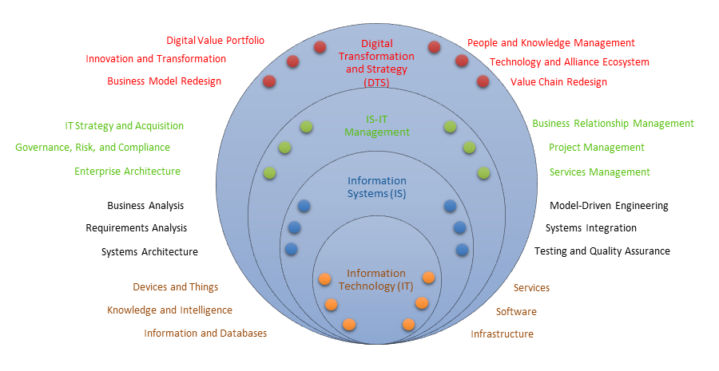

The scope of BTM practices have been studied by various researchers in IS-IT disciplines, primarily in business, computing, or engineering schools. Their integration helps redefine the nature of the profession and its impact, emphasizing distinctive professional abilities for digital leadership, such as:

* Focusing on innovation and digital business value, in addition to leading traditional IS-IT services
* Helping leaders to accelerate digital transformation, in addition to improving IS-IT management
* Ensuring digital leaders share a distinctively hybrid business-technology-management acumen

### Objectives

BTM BOK as a “knowledge tool” aims to support IS-IT professionals to develop a unified BTM expertise, and help all stakeholders at all levels to work together more seamlessly within a coherent profession (Figure 2). It is primarily used to help coach the next generation of ***Leaders of the Digital Transformation***, slogan describing its founding organization, BTM Forum. It also serves to define the distinctive approaches to help strengthen the hybrid business-technology-management acumen, which builds upon existing practices, and provide guidance on their common core knowledge base. It also serves to broaden the vision of digital transformation from an information to a business focus.

Figure : BTM BOK Objectives

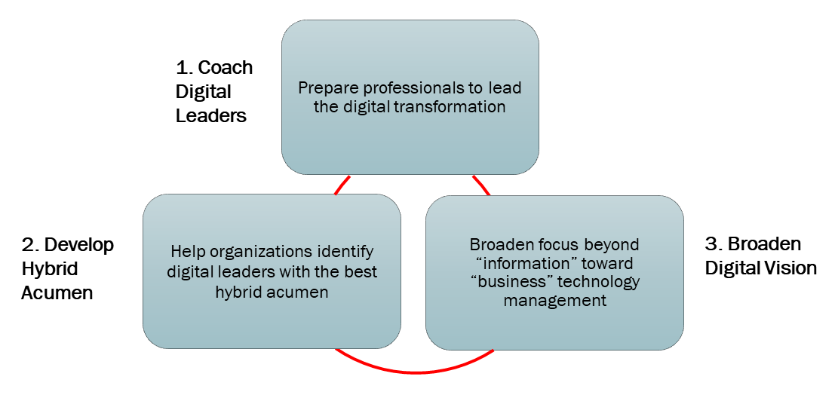

The BTM vision is fueled by an emerging consensus within the profession on converging observations:

1. BTM specializations, such as business analysis, project management, enterprise architecture, data analytics, etc., share the same hybrid acumen in business and technology.
2. BTM specializations are essential to lead the digital transformation, with more diverse (still undefined) career paths crossing beyond traditional roles, reaching increasingly at management, entrepreneurial, and executive levels.
3. BTM is still concerned with supporting operations but is more than ever the centerpiece of digital business strategies in all sectors, with renewed focus on innovation and value creation.

BTM BOK as a “professional guide” aims at addressing these trends, creating seamless bridges between key specializations, identifying expected competencies, and offering learning guidelines to develop new BTM expertise. It can be used as a guide for individual and team-based professional development and learning. It describes the key roles, core competencies, best practices, and supporting references of this emerging profession. It references and builds upon several existing open BOKs and complements them by offering integration pathways between specializations. It seeks to provide a simple logic to integrate complex practices around the core mission of digital transformation.

### Profession

BTM as a “profession” must be viewed beyond its existing job roles loosely based on undergraduate educational credentials. It must be defined by people committed to meeting standards, setting personal goals to learn and master their tradecraft, and passing on this commitment to later generations.

BTM BOK as a “knowledge initiative” seeks to harmonize all facets of how professionals lead their community learning dynamics (Figure 3). It integrates academic research communities with professional practice specializations. It helps transforming IS-IT into an Evidence-Based Profession (EBP), with seamless integration of knowledge development, testing, validation, learning, practice, and feedback.

Figure : BTM Professionals and Community Learning Dynamics

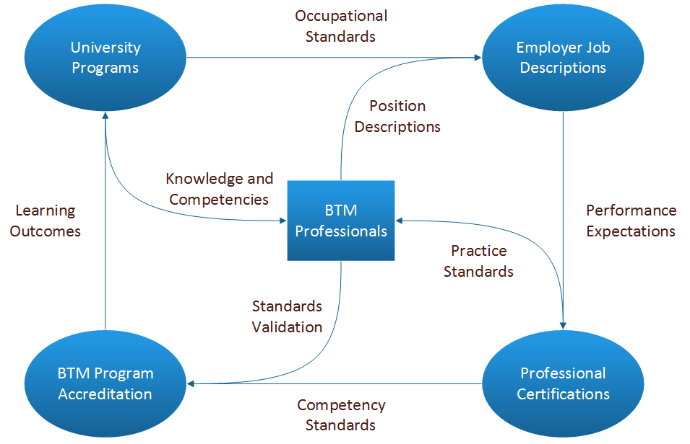

BTM needs a critical mass of people who rank as valuable experts, mastering a broad skillset honed with minimum experience requirements, and recognized by promotion through ranks as these skills become in high demand. They can best identify with the profession if it develops a vibrant and future-minded spirit, with promising and well-paid positions. Reputation is also key, as candidates must first know the profession for its well-defined value-adding services to organizations and society. They are motivated to join when job roles are clear, with realistic and progressive competency requirements, and easy access to a self-sustaining and self-regulating (even if not legally-binding) professional board and job market.

BTM is therefore an “emerging profession”, one that is rapidly meeting these conditions for critical mass, as job roles are undergoing radical shifts, with new requirements for position descriptions, organizational structures, and professional certifications and standards.

BTM practitioners are also changing the way they used to enter the profession. Typically, graduates earned a BBA in IS and/or an MBA, especially following an IT undergraduate degree. They then pursued relatively predictable career paths, often combining several certifications. For example, a frequent profile of IS grads included roles in Business Analysis, Project Management, and IT Services Management as they were promoted through the ranks within a typical corporate IT division.

Major shifts in BTM careers are challenging both employees and employers in developing a more integrated vision of the profession. BTM experts are increasingly from diverse educational credentials, often combining IT expertise gained during work experience within a non-technical profession. BTM profiles also combine a wider mix of positions in corporate, consulting, and start-up environments. They often get broader responsibilities throughout the Digital Adoption lifecycle, leading digital innovation, transformation, or optimization projects. BTM BOK aims to reflect these changes and help professionals gain better positions in leading digital transformation initiatives in all sectors.

### Adoption

BTM and BTM BOK are offered as “free advice” resources and can help guide several groups (Table 1). Adoption is not a uniform process, hence the importance of keeping BTM BOK open and free, ensuring greater diversity of customization. BTM professional groups benefit differently but in a converging way from BTM and BTM BOK adoption. Their respective interests can convergence and help spur the adoption of the BTM BOK, and in turn ensure the growth of BTM as a “change initiative”.

Table : BTM Benefits

|  |  |  |  |
| --- | --- | --- | --- |
| Benefits for … | ... from BTM BOK | ... from BTM Certifications | ... from BTM Community |
| Professionals | **Students:** clear guidance on career paths/growth | **Practitioners:** add new business/management skills | **Careers:** easy recognition of skill level by open network |
| Associations | **Specializations:** formal integration of several BOKs | **Multi-Certified:** complement certifications, no competition | **Membership:** recruit new members, wider visibility |
| Academia | **Faculty:** implement research across all specializations | **Schools:** clear accreditation and curriculum guidance | **Enrollment:** attract talent to get best jobs (cf., CPA, PEng) |
| Employers | **Managers:** formal transdisciplinary job profiles | **Promotion:** standards for promoting through ranks | **Markets:** well-defined talent pools, easier skills discovery |
| Industry | **Innovation:** more open, cross-specialization ideas | **Vendors:** all specializations have same tech. acumen | **Start-ups:** facilitate careers in-and-out of corporate |
| Society | **Government:** specializations share same principles | **Business:** higher org. to address complex ethics cases | **Economy:** fill talent gap, accelerate digital adoption |

BTM BOK creation cycle depends primarily on the organic emergence of expertise from professional practice (Figure 4). One of the best ways to represent this is in the form of a knowledge creation cycle feeding into organizational learning. Expertise development and research, within an Evidence Based Profession (EBP) is the primary source of formal or explicit expertise. It is reused and integrated freely within open practice standards, which in turn inspire the competency profiles of various community end-users. These references are further customized and refined through talent coaching, which in turn completes and resets the cycle as new expertise is externalized and shared within the community. BTM BOK adoption is therefore a continuous development and integration process, one where the opportunities for extracting value opens new possibilities at every step.

Figure : BTM BOK Creation and Adoption Cycle

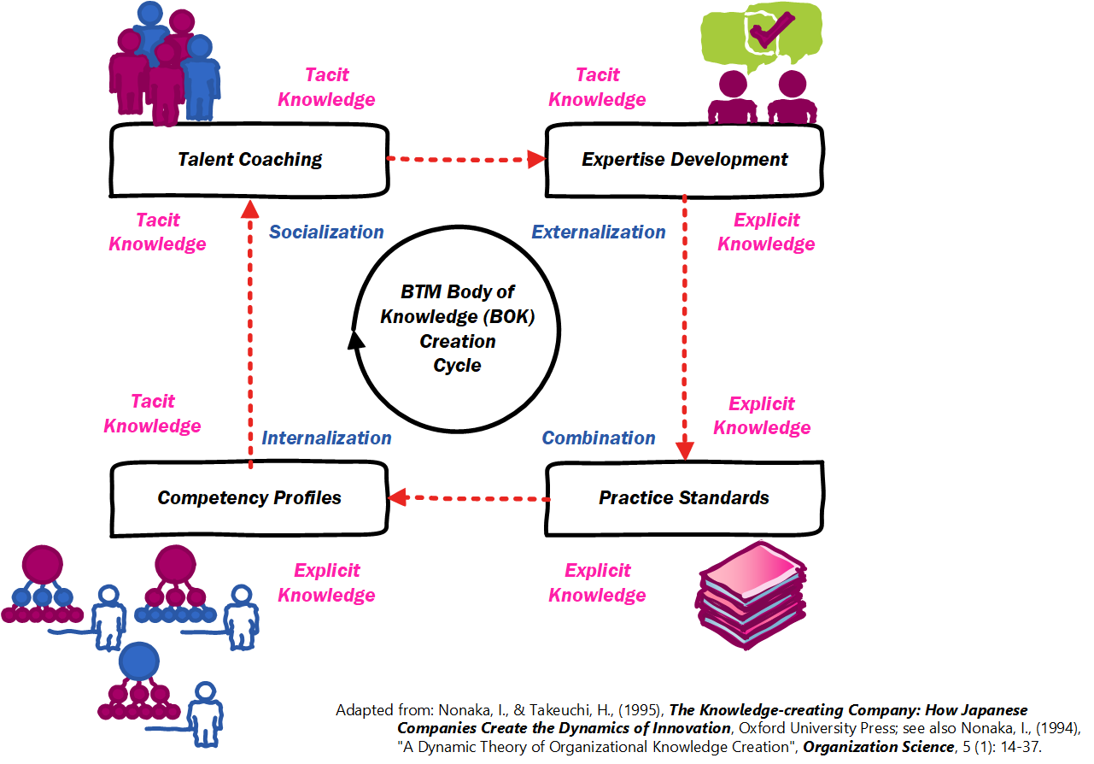

### Customization

BTM BOK customization is essentially an “exploratory/experimental” process like R&D. It is encouraged through the open availability of its contents in various editable and reusable formats. These open assets can have compounded value as they get reused throughout several customization opportunities, leading to a “specification-driven” approach where changes in assets get recovered throughout their continuously updated reuse endpoints (Figure 5).

It can be leveraged among professionals for career development and certification, within organizations of all sectors for HRM and best practice benchmarking, by higher education institutions for program accreditation, and by knowledge base authors who can import and reuse as long as they share-alike their own derivatives. Reintegration of derivatives within BTM BOK is dependent on active participation in community discussions, and exploratory efforts of like-minded professionals.

Figure : BTM BOK Customization Opportunities

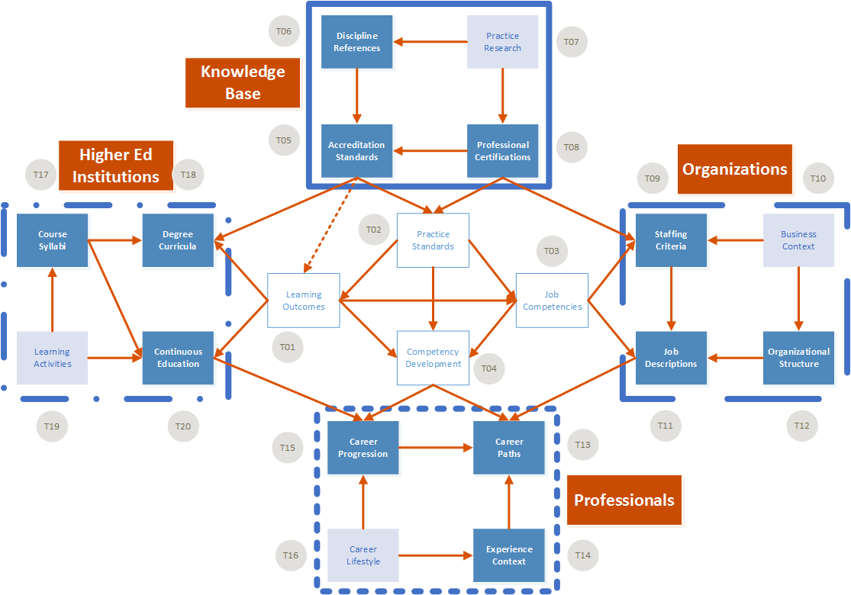

### Community

BTM as a “professional community” is served by many associations competing to attract members, where hybrid skills are not yet fully understood as they are based on complex digital transformations (Table 2). Most BTM specializations are supported by separate professional organizations, offering several certification levels, often guided by a BOK uniting best practices in their field. Professional groups include: AIIM, ARMA, DAMA, IASA, IIBA, ISACA, (ISC)2, itSMF, PMI. Academic groups also include: AIS, ACM, IEEE, IFIP, IRMA. Standards organizations also contribute guidelines: OASIS, OMG, Open Group.

While these more established groups draw most of the BTM professional membership, there is yet to be an organization that would forge an alliance between all associations, of all kinds, to develop a common framework for the whole profession. A good example is the Open Project Management Method (OMP2) community, initially based in Europe, and rapidly attracting attention from around the globe, with the establishment in 2019 of the PM2 Alliance, a partner of BTM Forum with a much larger established base.

There is a need to create a space where both proprietary and open source organizations can leverage their converging interests in growing the IS-IT profession. As such BTM BOK can welcome proprietary groups can actively release their assets in the open and fusion their vision with those of open groups.

Table : BTM-Related Professional Groups

|  |  |  |  |
| --- | --- | --- | --- |
| Scope | Organizations | Standards | Certifications |
| 1. Industry | ITAC, ICTC, CATA, CANWIT, DPI | N/A | N/A |
| 2. Profession | SFIA | SFIA | N/A |
| 3. Discipline | ACM, AIS, IEEE | MIS Curriculum | N/A |
| 4. Technology | CIPS, IP3P, ABET, IEEE, CompTIA | CBOK, Seoul Accord, SWEBOK | ISP, ITCP, CSDP, CompTIA |
| 5. Management | CIOCAN, SIM | Propose a BOK for BTM3 | Future CIO Mentorship, APC |
| 6. Governance | ISACA, PMI | COBIT, Val-IT | CGEIT, CRISC, PMI-RMP |
| 7. Security | ISACA, ISC2, GIAC | COBIT, CISSP | CISA, CISM, CISSP, GIAC ISP |
| 8. Services | itSMF, Verism | ITIL | ITIL Certified |
| 9. Projects | EC, PMI, BCS, Scrum, PM2 | EC OPM2, PMBOK, PRINCE2 | PMP, PMI-ACP, ISPM, Scrum |
| 10. Consulting | CMC Institute | CMC BOK | CMC |
| 11. Analysts | IIBA | BABOK | CBAP |
| 12. Processes | OMG, CMMI, ABPMP, ATMAE | OCEB2 & CMMI Prog., BP BOK | OCEB2, CMMI, ABPMP, ATMAE |
| 13. Innovation | PDMA, IAOIP/ISPIM, GIMI | NPDP, Cert. Inno. Prof., IM BOK | NPDP, CPI |
| 14. Quality | ASQ, QAI, IQPC | CSQE, Lean, Six Sigma, QAI BOKs | CSQE, Lean, Six Sigma, QAI Cert. |
| 15. Data | EDM Council, DAMA | Data Mgmt. Cap. Model, DMBOK | DCAM, CDMP |
| 16. Intelligence | TDWI, INFORMS | Cert. BI Pro., Cert. Analytics Pro. | CBIP, CAP |
| 17. Architects | IASA, Open Group, AEA | ITA BOK, TOGAF | CITA |
| 18. Web | CIW, WOW, EC-Council | CIW & WOW Cert., Ethical Hacker | CIW & WOW E-Commerce, CEH |

BTM Forum can act as a “catalyst organization” as opposed to a traditional professional association, as it can serve as a neutral ground for members of several associations to work toward a joint strategy:

1. **Mission:** help lead the digital transformation in all sectors by federating efforts of associations.
2. **Members:** attract multi-certified people with broad skillset in business and technology.
3. **Mandate:** create a common language and an engaging vision for the profession to unite.
4. **Standards:** provide open source complements that can be reused by existing specializations.
5. **Accreditation:** facilitate convergence among IS and IT programs globally to facilitate mobility.
6. **Benchmark:** identify best practices and their integration for digital transformation.
7. **Certification:** promote professionals through ranks from junior to senior levels.

To ensure the widest engagement of BTM practitioners, BTM Forum is focused community-led services built upon free, libre and open source reference standards (Figure 6). While it was initiated in Canada, by the IT Association of Canada (ITAC), BTM Forum has a global mandate to serve as an emerging community to structure the profession, integrating virtual and local groups, and help catalyze energies of widely distributed professionals. The association aims to engage professionals to acquire a hybrid skillset, get commitment from employers to model their jobs and careers after this standard, and create accreditation and certification processes that are truly people-centric and knowledge-driven, avoiding the rubber-stamping nature of so many such organizations.

Figure : BTM Community Engagement

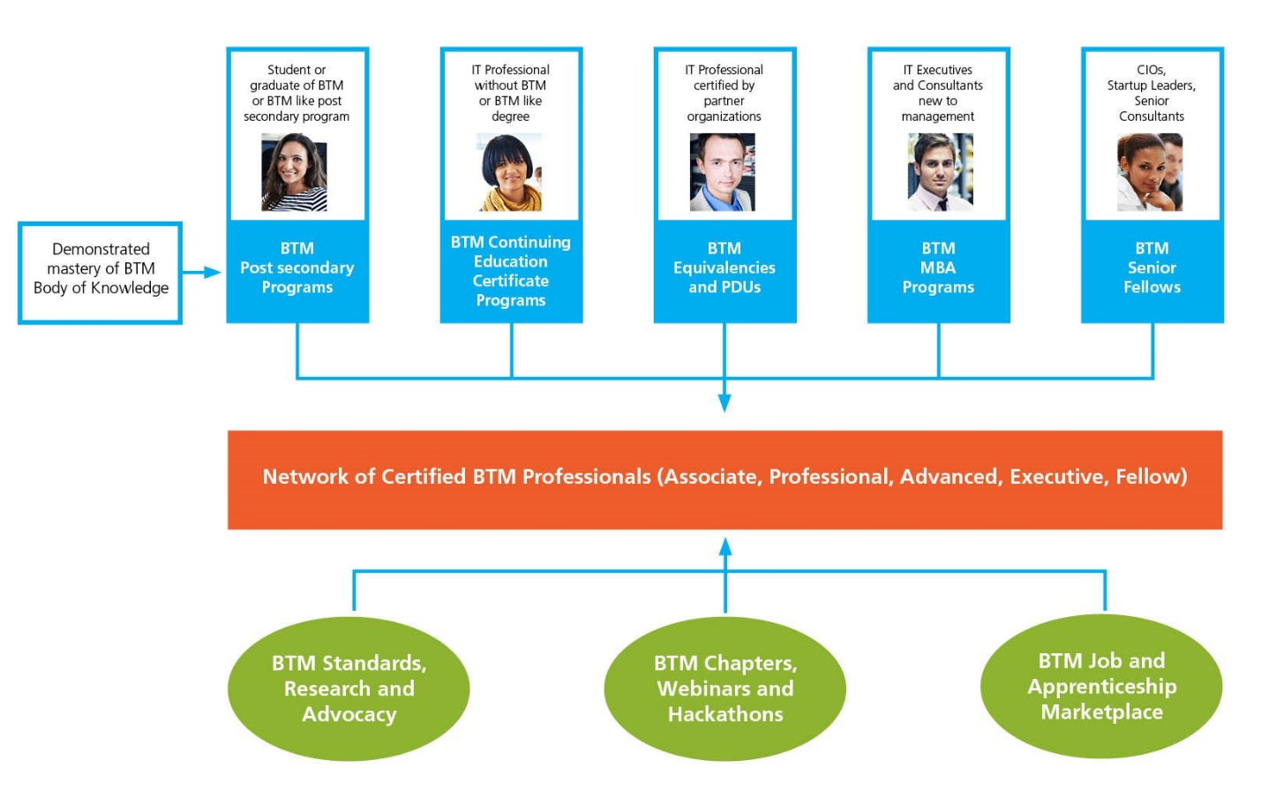

## Contents

BTM BOK contents can be navigated within a single Eclipse Process Framework (EPF) Wiki (Figure 7). The resulting contents are structured along a simple menu-driven navigation, allowing to quickly pinpoint contents of interest, as well as map thoroughly the relationships between all components. It is developed through an open community effort to simplify the relationships between several BOKs. It is supported by multiple citations to academic and professional literature, helping learners find the most trusted sources. It is also highly open and customizable, with API to reuse its contents in various Talent Management functions (e.g., custom BTM-compliant job descriptions, automated matching of CVs and job competencies, learning path recommendations given experience for recognized BTM careers, etc.).

Figure : BTM BOK Wiki Similar to Open Unified Process (OpenUP)

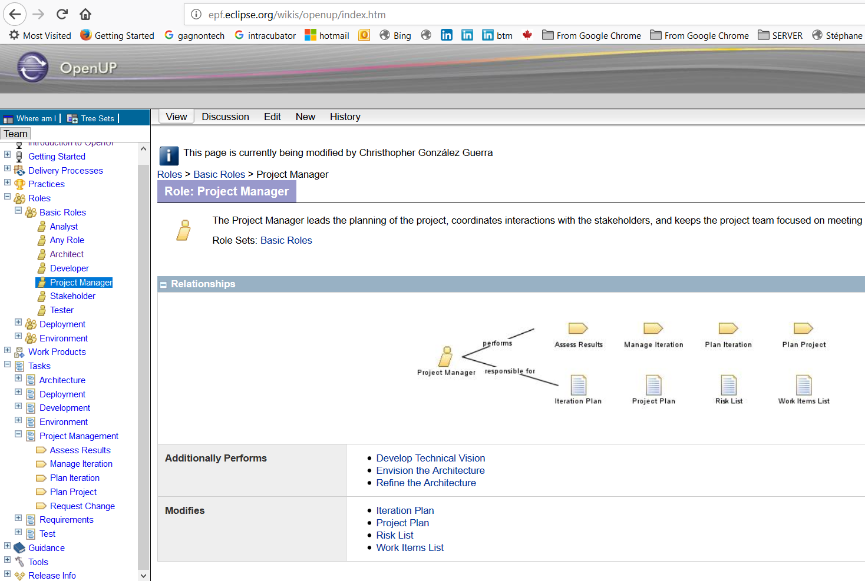

### Metamodel

BTM BOK metamodel helps structure contents around a generic frame for multidisciplinary professional practice. It uses a standard by the Object Management Group (OMG), the Software and Systems Process Engineering Metamodel (SPEM 2.0) (<https://www.omg.org/spec/SPEM/2.0/PDF>). In the future it shall evolve toward a more flexible, state-based standard, namely the OMG Essence Kernel and Language for Software Engineering Process (<https://www.omg.org/spec/Essence/1.2/PDF>). This transition will be initiated as soon as open source tools are available to support this more advanced standard.

The SPEM 2.0 metamodel allows us to draw the key elements of BTM BOK within a coherent framework, and identify all required interdependencies among them to clearly position BTM professionals within their expertise domains and processes (Figure 8).

1. **Role**: outline of job functions and qualifications, related to tasks and deliverables accountability.
2. **Task**: outline of role(s)-centered activities, with step-by-step, and deliverables as inputs-outputs.
3. **Deliverable**: artefacts delivering value for digital transformation, with templates and guidelines.
4. **Guidance**: glossaries, practices, and roadmaps to perform tasks, deliverables, and use tools.
5. **Capability**: combination of tasks as a short “way or work” or set of “states” to reach a milestone.
6. **Workflow**: combination of capabilities across iterations of varying scales to reach stage-gates.
7. **Tool**: documentation of techniques and *-wares used to perform tasks and support teamwork.

Figure : BTM BOK Metamodel

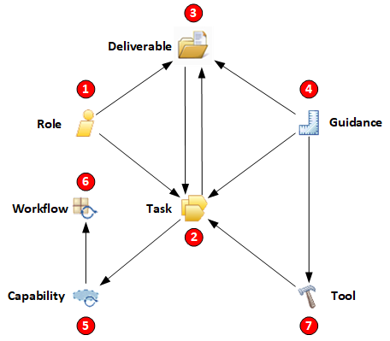

### Structure

BTM BOK structure aims to be systematic, simple and easy to remember for anyone regardless of prior experience. It includes 7 chapters that build upon one another, feeding into professional practice references (Ch. 3) as the source of standards (Ch. 7), converging for career guidance (Ch.6) (Figure 9). It should not be promoted as an exhaustive overview, simply a starting point for team-based discussions in improving practice. BTM BOK chapters are written for modeling and further customization, with ample space for improvement. The 7 chapters vary in scope and are in constant state of progress, as contents will come from both FLOS references and new material contributed by the community (Table 3).

Figure : BTM BOK Structure

Table : BTM BOK Chapters

|  |  |  |  |  |  |  |
| --- | --- | --- | --- | --- | --- | --- |
| Ch. | Title | Color | Meaning | Progress | Contents | Purpose |
| 1 | Overview | Cyan | Sky/Vision | 100% | Original | BTM knowledge base and structure |
| 2 | Transformation | Red | Intense | 100% | Original | BTM leadership role and decisions |
| 3 | Practice | Green | Good/Go | 0% | 100+ FLOS | BTM job roles, tasks, capabilities |
| 4 | Discipline | Blue | Formal | 0% | 100+ FLOS | BTM evidence-based foundations |
| 5 | Lifecycle | Orange | Caution | 0% | Surveys/Cases | BTM use contexts and constraints |
| 6 | Career | Purple | Dream | 0% | Surveys/Cases | BTM job entry and progression |
| 7 | Standards | Gold | Valuable | 0% | Community | BTM best practice and references |

BTM BOK Ch.1 Overview (Table 4) explains the endeavour and how to best use it and contribute too.

Table : BTM BOK Ch. 1 Overview

|  |  |  |
| --- | --- | --- |
| Ch. | Title | Scope |
| 1.1 | Purpose |  |
| 1.1.1 | Objectives | BTM BOK as career guide, integration of IS-IT-TIM disciplines, potential impact |
| 1.1.2 | Profession | BTM BOK as professional growth engine, career dynamics, and converging trends |
| 1.1.3 | Adoption | BTM BOK benefits to various constituencies, knowledge creation cycle |
| 1.1.4 | Customization | BTM BOK reuse opportunities, complementary, Evidence-Based Profession |
| 1.1.5 | Community | BTM BOK as community catalyst, mission, membership, standards and services |
| 1.2 | Contents |  |
| 1.2.1 | Metamodel | BTM BOK elements: roles, tasks, artefacts, guidance, capabilities, workflows, tools |
| 1.2.2 | Structure | BTM BOK chapters, scope, interdependence, potential use, logic, and limitations |
| 1.2.3 | Components | BTM BOK professional roles, learning outcomes, and curriculum standards |
| 1.2.4 | Dependencies | BTM BOK practices and their interdependencies, roles in digital transformation |
| 1.2.5 | Sources | BTM BOK original sources, derivatives, reuse, feedback, and value-added services |
| 1.3 | Methodology |  |
| 1.3.1 | Licenses | BTM BOK Free Libre Open Source (FLOS) strategy, invitation to proprietary groups |
| 1.3.2 | References | BTM BOK FLOS works, relevance, continuous integration, continuous deployment |
| 1.3.3 | Editing | BTM BOK editorial process, components, integration, metamodel elements |
| 1.3.4 | Contribution | BTM BOK editorial systems and tools, engagement, mapping, surveys, and cases |
| 1.3.5 | Authors | BTM BOK roles, tools and processes, teams, and contributor opportunities |

BTM BOK Ch.2 Transformation (Table 5) is a general introduction to the field of digital leadership.

Table : BTM BOK Ch. 2 Transformation

|  |  |  |
| --- | --- | --- |
| Ch. | Title | Scope |
| 2.1 | Opportunity |  |
| 2.1.1 | Scan | BTM leaders identify IT enablement opportunities, team effort, sampling criteria |
| 2.1.2 | Discover | BTM leaders define new IT projects, assess relative impact, customization costs |
| 2.1.3 | Prioritize | BTM leaders target digital transformation program, projects sequence, feasibility |
| 2.1.4 | Finance | BTM leaders demonstrate Digital Economic Impact, transformation ROI |
| 2.1.5 | Benefit | BTM leaders ensure value flows to every part as planned, program feedback |
| 2.2 | Decision |  |
| 2.2.1 | Who | BTM leaders staff all digital projects, make room for initiative, enhance creativity |
| 2.2.2 | What | BTM leaders design digital products and solutions, integrate with digital strategy |
| 2.2.3 | Why | BTM leaders justify digital projects as per strategy, transformation champions |
| 2.2.4 | Where | BTM leaders select candidate units for projects, best feasibility-value, manage risk |
| 2.2.5 | How | BTM leaders apply required practices, train staff, customize into best practices |
| 2.3 | Accountability |  |
| 2.3.1 | Steer | BTM leaders guide digital strategy, ensure compliance, assess digital value |
| 2.3.2 | Explore | BTM leaders experiment new digital products, services, processes, solutions |
| 2.3.3 | Align | BTM leaders align IT and business needs, ensure digital value enterprise-wide |
| 2.3.4 | Implement | BTM leaders create, deploy, and enhance digital solutions and products for value |
| 2.3.5 | Optimize | BTM leaders operate digital platforms and services, ensure continuous innovation |

BTM BOK Ch.3 Practice (Table 6) classifies the 15 areas by the “level” or **layer** of the organization they impact on: **fabric** as where and why of digital transformation, **team** as who and how of digital transformation, and **outcome** as what and how much of digital transformation. Each practice is presented by the same 4th level sub-sections, referring to the 7 key elements of our metamodel: role, task, deliverable, guidance, capability, workflow, and tool.

Practices are in no way exclusive and can in fact serve as placeholders to include many more professional roles that are often spanning several areas (e.g., Business Analysis appears often as a role in Architecture, Engineering, and Process practices). As well, some practices are more an amalgam of various trends and strategic approaches by most companies (e.g., Value and People practices refer to how digital products and services are designed and conceived, as well as how various groups within and outside an organization can effectively use them, how their behavior is impacted, etc.). Finally, while some practices can be viewed as too broad and almost encompassing a whole discipline (e.g., Engineering and Project practices), they are in fact named after a feature that serves to unite their converging approaches, namely the service and value they provide to digital transformation.

Table : BTM BOK Ch. 3 Practice

|  |  |  |
| --- | --- | --- |
| Ch. | Title | Scope |
| 3.1 | Fabric |  |
| 3.1.1 | Governance | BTM roles for digital strategy, risk management, customers and markets |
| 3.1.2 | Compliance | BTM roles for digital regulatory assurance, core requirements, business continuity |
| 3.1.3 | Architecture | BTM roles for digital enterprise architecture, business architecture, model-driven |
| 3.1.4 | Security | BTM roles for digital cybersecurity, networks and devices, end-user safety, privacy |
| 3.1.5 | Platform | BTM roles for digital service management, data center, cloud apps, e-commerce |
| 3.2 | Team |  |
| 3.2.1 | People | BTM roles for digital user experience, behavior, interfaces, learning, talent |
| 3.2.2 | Project | BTM roles for digital project, program, and portfolio management and leadership |
| 3.2.3 | Agility | BTM roles for digital agile methods, scrum, DevOps, test-driven, open source |
| 3.2.4 | Engineering | BTM roles for digital system analysis, design-build-test, deployment, maintenance |
| 3.2.5 | Integration | BTM roles for digital cloud apps, web portals, web services, APIs, enterprise systems |
| 3.3 | Outcome |  |
| 3.3.1 | Value | BTM roles for digital product innovation, design thinking, entrepreneurship |
| 3.3.2 | Process | BTM roles for digital business analysis, process redesign, integration, optimization |
| 3.3.3 | Rule | BTM roles for digital rules, process logic, ontologies, reasoning, automation |
| 3.3.4 | Data | BTM roles for digital information, databases, content and archives, metadata, licenses |
| 3.3.5 | Intelligence | BTM roles for digital business intelligence, artificial intelligence, knowledge extraction |

BTM BOK Ch.4 Discipline (Table 7) offers a list of foundational academic disciplines and research areas, all within the logic of an Evidence-Based Profession (EBP). Once fully developed, each discipline shall be presented by 4th level sub-sections, referring to the 5 key elements of their application by practitioners: definition of core concepts, relevance to digital transformation, theory and foundations most relevant to practice, application specific to BTM, and evidence of effectiveness from empirical research. These contents are taken directly from generic FLOS textbooks and are therefore edited and reshaped for the purpose of best serving digital transformation, yet still conforming to formal academic references.

Table : BTM BOK Ch. 4 Discipline

|  |  |  |
| --- | --- | --- |
| Ch. | Title | Scope |
| 4.1 | Business |  |
| 4.1.1 | Strategy | BTM roots in strategic management, responsible governance, economics |
| 4.1.2 | Marketing | BTM roots in marketing strategy, customer relations, sales, advertising |
| 4.1.3 | Operation | BTM roots in operations management, quality, process reengineering |
| 4.1.4 | Innovation | BTM roots in technology and innovation management, alliances, projects |
| 4.1.5 | Performance | BTM roots in management accounting, value engineering, product design |
| 4.2 | Management |  |
| 4.2.1 | Talent | BTM roots in talent management, strategic HRM, personnel motivation |
| 4.2.2 | Learning | BTM roots in organizational learning, knowledge management, creativity |
| 4.2.3 | Change | BTM roots in change management, communication, complexity theory |
| 4.2.4 | Leadership | BTM roots in organizational behavior, leadership, culture, empowerment |
| 4.2.5 | Entrepreneurship | BTM roots in entrepreneurial process and profile, startup financing, launch |
| 4.3 | Technology |  |
| 4.3.1 | System | BTM roots in information systems, computing platforms, mobility, end-users |
| 4.3.2 | Software | BTM roots in software engineering, programming, design, databases, runtime |
| 4.3.3 | Cloud | BTM roots in cloud services, web apps, open source, e-commerce/e-marketing |
| 4.3.4 | IoT | BTM roots in Internet of Things, embedded apps, devices, logistics, buildings |
| 4.3.5 | AI | BTM roots in Artificial Intelligence, learning, rules, reasoning, multi-agents |

BTM BOK Ch.5 Lifecycle (Table 8) offers various organizational contexts where practices must be customized. They vary according the scope of process deliverables, namely the type of functional role of IT. Lifecycles can also be focused on a specific value or general business or strategic outcome. They also vary widely as per the type of economic sector, especially due to unique technology requirements.

Table : BTM BOK Ch. 5 Lifecycle

|  |  |  |
| --- | --- | --- |
| Ch. | Title | Scope |
| 5.1 | Scope |  |
| 5.1.1 | Administration | BTM applied to digital management, acquisition, licensing, finances, personnel |
| 5.1.2 | Solution | BTM applied to digital architecture, development, DevOps, maintenance, consulting |
| 5.1.3 | Support | BTM applied to digital end-user support, user experience, quality assurance |
| 5.1.4 | Facility | BTM applied to digital infrastructure, things and locations, networks, ubiquitous use |
| 5.1.5 | Enterprise | BTM applied to digital ERP implementation, new product strategy, cloud platforms |
| 5.2 | Focus |  |
| 5.2.1 | Behavior | BTM applied to digital end-user change, adoption, learning, efficiency, intelligence |
| 5.2.2 | Functionality | BTM applied to digital system requirements, functions, information, interfaces, value |
| 5.2.3 | Reengineering | BTM applied to digital processes, people-centric integration, enterprise architecture |
| 5.2.4 | Optimization | BTM applied to digital optimization, intelligence, automation, standardization, reuse |
| 5.2.5 | Diversification | BTM applied to digital market redefinition, value-chain integration, strategic alliances |
| 5.3 | Sector |  |
| 5.3.1 | Resource | BTM applied to digital environment, agriculture, fisheries, forestry, mining, oil & gas |
| 5.3.2 | Infrastructure | BTM applied to digital construction, transportation, telecom, energy, water, waste |
| 5.3.3 | Product | BTM applied to digital manufacturing, logistics, imports, retail, reuse-recycle-disposal |
| 5.3.4 | Service | BTM applied to digital health, education, finance, real estate, tourism, entertainment |
| 5.3.5 | Public | BTM applied to digital democracy, administration, citizens, businesses, international |

BTM BOK Ch.6 Career (Table 9) is used as guide for people to become leaders of digital transformation.

Table : BTM BOK Ch. 6 Career

|  |  |  |
| --- | --- | --- |
| Ch. | Title | Scope |
| 6.1 | Goal |  |
| 6.1.1 | Specialist | BTM practice honed over 10+ years, often double-certified, go-to topic expertise |
| 6.1.2 | Complement | BTM practice as support field, embedded in business units or focused in few tech |
| 6.1.3 | Generalist | BTM practice used in variety of projects, often lead to manager role, good coach |
| 6.1.4 | Senior | BTM practice honed over 20+ years, reaching executive role and digital champion |
| 6.1.5 | Occasional | BTM practice is strong but used in few projects, helps translate digital strategy |
| 6.2 | Path |  |
| 6.2.1 | Corporate | BTM jobs for IT divisions, mostly specialists, follow ladder to IT manager roles |
| 6.2.2 | Embedded | BTM jobs for business units, serve as digital strategy translator, lead end-users |
| 6.2.3 | Small | BTM jobs for small organizations, often handful of experts, favor generalists |
| 6.2.4 | Startup | BTM jobs for new digital product development, translator for business and R&D |
| 6.2.5 | Consulting | BTM jobs for self-employed, often open source, prior manager or executive roles |
| 6.3 | Progression |  |
| 6.3.1 | Beginning | BTM career entry through various routes, mix of new and active, certifications |
| 6.3.2 | Diversity | BTM leadership representativeness, equality of chance from various entry routes |
| 6.3.3 | Education | BTM programs adapted to needs, self-learning, potential for customization |
| 6.3.4 | Experience | BTM job qualifications and relevant prior experience, leadership acumen criteria |
| 6.3.5 | Promotion | BTM leadership roles, promotion criteria, community recognition and certification |

BTM BOK Ch.7 Standard (Table 10) synthesizes practices, disciplines, and lifecycles for implementation.

Table : BTM BOK Ch. 7 Standard

|  |  |  |
| --- | --- | --- |
| Ch. | Title | Scope |
| 7.1 | Accreditation |  |
| 7.1.1 | Diploma | BTM program of 2 years at community colleges, target hands-on experts/doers |
| 7.1.2 | Certificate | BTM program of 1 year at continuing education, equivalent to minor in bachelor |
| 7.1.3 | Bachelor | BTM program of 3 to 4 years at colleges and universities, target new associates |
| 7.1.4 | Master | BTM program of 1 to 2 years at universities, target executives and analysts |
| 7.1.5 | Doctorate | BTM program of 3 to 4 years at universities, target faculty and consultants |
| 7.2 | Benchmark |  |
| 7.2.1 | Forerunner | BTM practices are formalized with digital transformation strategy and projects |
| 7.2.2 | Challenger | BTM practices are mature and create stable digital competitive advantages |
| 7.2.3 | Innovator | BTM practices are evolved to create competitive digital products or services |
| 7.2.4 | Optimizer | BTM practices are customized into distinctive digital practices that are referenced |
| 7.2.5 | Disruptor | BTM practices are fully integrated to create new digital markets and ecosystems |
| 7.3 | Certification |  |
| 7.3.1 | Associate | BTM graduate with full awareness of BTM BOK and with an applied specialization |
| 7.3.2 | Professional | BTM practitioner with at least 5 years of experience, specialized or generalized |
| 7.3.3 | Manager | BTM leader in front-line projects and operations, strong hybrid expertise, acumen |
| 7.3.4 | Entrepreneur | BTM leader with successful launch experience, digital product creation focus |
| 7.3.5 | Executive | BTM leader with major transformation experience, CIO or CDO, or direct report |

### Components

BTM BOK components are the core building blocks of professional practice (Ch.3). They outline the activities, job roles, and positions of BTM professionals at all levels. These profiles can be classified as per their relative mix or ratio of skills requirements in business and technology (Figure 10).

Figure : BTM Positions with Business and Technology Focus

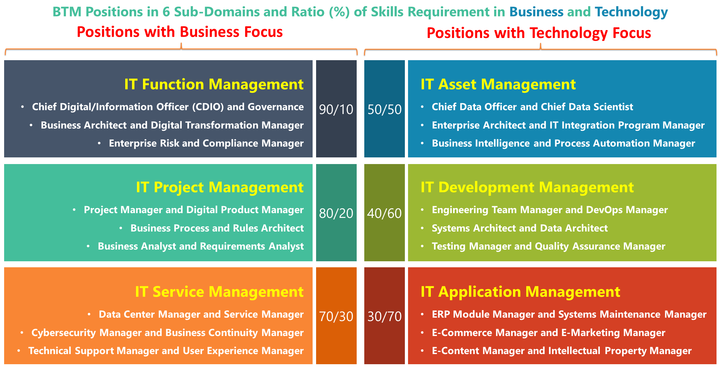

In addition to professional practices, BTM BOK references several foundational disciplines and contextualized lifecycles, each specifying further how practices serve as framework to guide digital transformation. They can be traced back to initial BTM specifications, namely BTM Learning Outcomes (LOs), with edition 1.0 in 2009 comprising 32 items, and edition 2.0 in 2016 with 75 items classified under 6 domains (Figure 11). The model contains 7 knowledge areas of 3 types (referring former 2009 v1 codes): Integrative (I) areas or Roles and Skills, Foundation (F) areas, and Core (C) areas or Outcomes:

1. **Integrative (I1 - I8):** BTM serves to integrate core competencies and produces a “deliverable” of direct relevance. They refer to key roles and opportunities for digital transformation leadership.
2. **Personal and Interpersonal (F1):** Ability to make a meaningful contribution depends upon one’s self-knowledge and ability to have constructive, long term, interactions with others.
3. **Business (F2):** To be effective in the workplace one must have both the broad context of business – its role and place in society – and a working knowledge of how business operates.
4. **Technology (F3):** BTM graduates must understand information and communications technologies, their current capabilities, and future trends.
5. **Technology in Business (C1):** This knowledge area is designed to synthesize the knowledge and competencies gained in the foundational knowledge areas to create an additional competency in understanding: the potential (economic, personal, societal), the risks of, and the governance, acquisition, and management of ICTs in and for business.
6. **Innovation (C2):** BTM graduates are expected to be innovative in the workplace. Innovators should be able to identify new opportunities, validate and resource them.
7. **Processes, Project and Change (C3):** BTM graduates will gain the foundations that enable them to help create well-designed business processes, well-managed projects, and support for the individuals and groups undergoing change.

Figure : BTM BOK Building Upon BTM Learning Outcomes 2.0

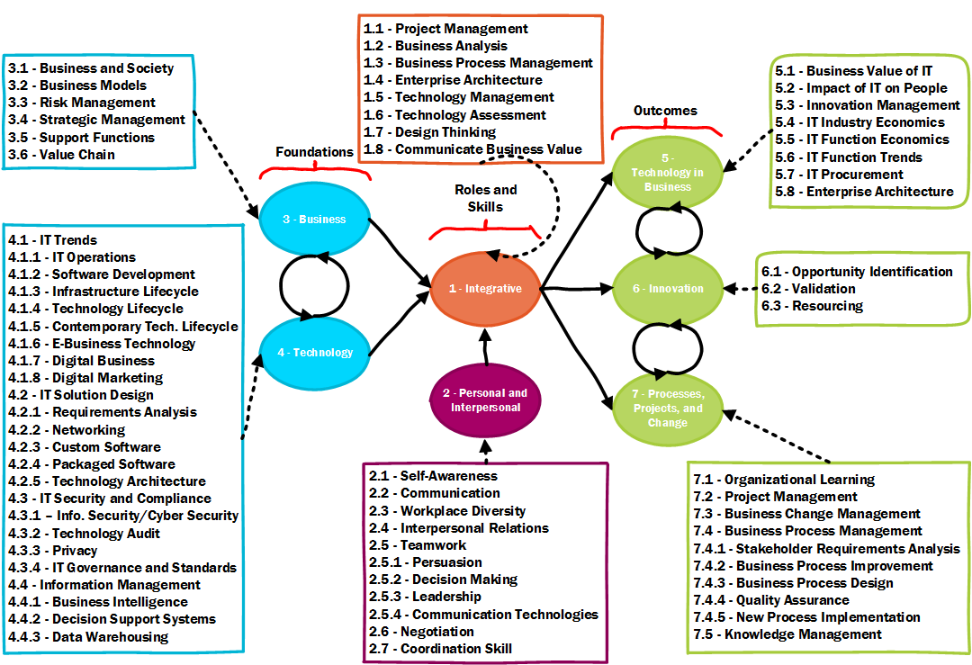

BTM LOs are further aligned (Table 11) with a more widely adopted specification, the ACM/AIS 2010 IS Curriculum, one of a dozen such standards in IS-IT education (<https://computingcurricula.com/>). Its key feature is to outline 7 core knowledge areas for undergraduate IT management education, along with foundational knowledge and computing general knowledge, synthesized in its Appendix 4 as a BOK:

1. **IS-1**: IS Management and Leadership (ITM)
2. **IS-2:** Data and Information Management (DIM)
3. **IS-3:** Systems Analysis & Design (SAD)
4. **IS-4:** IS Project Management (PM)
5. **IS-5:** Enterprise Architecture (EA)
6. **IS-6:** User Experience (UX)
7. **IS-7:** Professional Issues in IS (Pro.)
8. **FK:** Foundational Knowledge, mostly taken from Organizational Behavior (OB)
9. **CG:** Computing General, mostly taken from Computer Science (CS)

These combined specifications synthesize current trends in BTM, from a practice viewpoint (BTM LOs) and an instructional viewpoint (ACM/AIS). They provide broader guides that can help users to interpret and extend BTM BOK contents, especially along the 9 core knowledge areas of the IS Curriculum.

Table : BTM Leaning Outcomes Aligned with IS 2010 Curriculum

|  |  |  |  |  |  |  |  |  |  |  |
| --- | --- | --- | --- | --- | --- | --- | --- | --- | --- | --- |
| **Code** | **BTM Learning Outcomes** | **IS-1** | **IS-2** | **IS-3** | **IS-4** | **IS-5** | **IS-6** | **IS-7** | **FK** | **CG** |
| **1** | **Integrative** | **ITM** | **DIM** | **SAD** | **PM** | **EA** | **UX** | **Pro.** | **OB** | **CS** |
| 1.1 | Project Management |  |  |  | 1 |  |  |  |  |  |
| 1.2 | Business Analysis |  |  | 1 |  |  |  |  |  |  |
| 1.3 | Business Process Management |  |  | 1 |  |  |  |  |  |  |
| 1.4 | Enterprise Architecture |  |  |  |  | 1 |  |  |  |  |
| 1.5 | Technology Management | 1 |  |  |  |  |  |  |  |  |
| 1.6 | Technology Assessment | 1 |  |  |  |  |  |  |  |  |
| 1.7 | Design Thinking |  |  | 1 |  | 1 | 1 |  |  |  |
| 1.8 | Communicate Business Value | 1 |  |  |  |  |  | 1 | 1 |  |
| **2** | **Personal and Interpersonal** | **ITM** | **DIM** | **SAD** | **PM** | **EA** | **UX** | **Pro.** | **OB** | **CS** |
| 2.1 | Self-Awareness |  |  |  |  |  |  |  | 1 |  |
| 2.2 | Communication |  |  |  |  |  |  |  | 1 |  |
| 2.3 | Workplace Diversity |  |  |  |  |  |  | 1 | 1 |  |
| 2.4 | Interpersonal Relations |  |  |  |  |  |  |  | 1 |  |
| 2.5 | Teamwork |  |  |  | 1 |  |  |  | 1 |  |
| 2.5.1 | Persuasion |  |  |  |  |  |  |  | 1 |  |
| 2.5.2 | Decision Making | 1 |  |  |  |  |  |  | 1 |  |
| 2.5.3 | Leadership | 1 |  |  |  |  |  |  | 1 |  |
| 2.5.4 | Communication Technologies |  |  |  |  |  |  |  | 1 |  |
| 2.6 | Negotiation |  |  |  |  |  |  |  | 1 |  |
| 2.7 | Coordination Skill |  |  |  |  |  |  |  | 1 |  |
| **3** | **Business** | **ITM** | **DIM** | **SAD** | **PM** | **EA** | **UX** | **Pro.** | **OB** | **CS** |
| 3.1 | Business and Society | 1 |  |  |  |  |  | 1 |  |  |
| 3.2 | Business Models | 1 |  |  |  |  |  |  |  |  |
| 3.3 | Risk Management | 1 |  |  | 1 | 1 |  |  |  |  |
| 3.4 | Strategic Management | 1 |  |  |  | 1 |  |  |  |  |
| 3.5 | Support Functions | 1 |  |  |  |  |  |  |  |  |
| 3.6 | Value Chain | 1 |  |  |  |  |  |  |  |  |
| **4** | **Technology** | **ITM** | **DIM** | **SAD** | **PM** | **EA** | **UX** | **Pro.** | **OB** | **CS** |
| 4.1 | IT Trends | 1 |  |  |  |  |  |  |  | 1 |
| 4.1.1 | IT Operations | 1 |  |  |  |  |  |  |  | 1 |
| 4.1.2 | Software Development | 1 |  | 1 | 1 |  |  |  |  | 1 |
| 4.1.3 | Infrastructure Lifecycle |  |  |  |  | 1 |  |  |  | 1 |
| 4.1.4 | Technology Lifecycle |  |  |  |  | 1 |  |  |  | 1 |
| 4.1.5 | Contemporary Technology Lifecycle |  |  |  |  | 1 |  |  |  | 1 |
| 4.1.6 | E-Business Technology | 1 |  |  |  | 1 |  |  |  | 1 |
| 4.1.7 | Digital Business | 1 |  |  |  | 1 |  |  |  | 1 |
| 4.1.8 | Digital Marketing | 1 |  |  |  |  |  |  |  | 1 |
| 4.2 | IT Solution Design |  |  | 1 |  | 1 | 1 |  |  | 1 |
| 4.2.1 | Requirements Analysis |  |  | 1 |  |  | 1 |  |  | 1 |
| 4.2.2 | Networking |  |  |  |  | 1 |  |  |  | 1 |
| 4.2.3 | Custom Software |  |  |  |  | 1 |  |  |  | 1 |
| 4.2.4 | Packaged Software |  |  |  |  | 1 |  |  |  | 1 |
| 4.2.5 | Technology Architecture |  |  |  |  | 1 |  |  |  | 1 |
| 4.3 | IT Security and Compliance | 1 |  |  |  |  |  |  |  | 1 |
| 4.3.1 | Information Security or Cybersec. | 1 |  |  |  |  |  |  |  | 1 |
| 4.3.2 | Technology Audit | 1 |  |  |  |  |  |  |  | 1 |
| 4.3.3 | Privacy | 1 |  |  |  |  | 1 |  |  | 1 |
| 4.3.4 | IT Governance and Standards | 1 |  |  |  |  |  |  |  | 1 |
| 4.4 | Information Management |  | 1 |  |  |  |  |  |  | 1 |
| 4.4.1 | Business Intelligence |  | 1 |  |  |  |  |  |  | 1 |
| 4.4.2 | Decision Support Systems |  | 1 |  |  |  |  |  |  | 1 |
| 4.4.3 | Data Warehousing |  | 1 |  |  |  |  |  |  | 1 |
| **5** | **Technology in Business** | **ITM** | **DIM** | **SAD** | **PM** | **EA** | **UX** | **Pro.** | **OB** | **CS** |
| 5.1 | Business Value of IT | 1 |  |  |  |  |  |  |  |  |
| 5.2 | Impact of IT on People | 1 |  |  |  |  | 1 | 1 | 1 |  |
| 5.3 | Innovation Management | 1 |  | 1 | 1 | 1 |  |  |  |  |
| 5.4 | IT Industry Economics | 1 |  |  |  |  |  | 1 |  |  |
| 5.5 | IT Function Economics | 1 |  |  |  |  |  | 1 |  |  |
| 5.6 | IT Function Trends | 1 |  |  |  |  |  | 1 |  |  |
| 5.7 | IT Procurement | 1 |  |  |  |  |  |  |  |  |
| 5.8 | Enterprise Architecture |  |  |  |  | 1 |  |  |  |  |
| **6** | **Innovation** | **ITM** | **DIM** | **SAD** | **PM** | **EA** | **UX** | **Pro.** | **OB** | **CS** |
| 6.1 | Opportunity Identification | 1 |  |  |  | 1 |  |  |  |  |
| 6.2 | Validation | 1 |  |  | 1 |  |  |  |  |  |
| 6.3 | Resourcing | 1 |  |  | 1 |  |  |  |  |  |
| **7** | **Processes, Projects, and Change** | **ITM** | **DIM** | **SAD** | **PM** | **EA** | **UX** | **Pro.** | **OB** | **CS** |
| 7.1 | Organizational Learning |  |  |  |  |  |  |  | 1 |  |
| 7.2 | Project Management |  |  |  | 1 |  |  |  |  |  |
| 7.3 | Business Change Management | 1 |  | 1 |  | 1 | 1 |  | 1 |  |
| 7.4 | Business Process Management |  |  | 1 |  | 1 | 1 |  |  |  |
| 7.4.1 | Stakeholder Requirements Analysis |  |  | 1 |  |  |  |  | 1 |  |
| 7.4.2 | Business Process Improvement |  |  | 1 | 1 |  |  |  |  |  |
| 7.4.3 | Business Process Design |  |  | 1 |  | 1 | 1 |  |  |  |
| 7.4.4 | Quality Assurance |  |  | 1 | 1 |  |  |  |  |  |
| 7.4.5 | New Process Implementation |  | 1 | 1 |  | 1 | 1 |  | 1 |  |
| 7.5 | Knowledge Management | 1 | 1 | 1 |  |  |  |  | 1 |  |

### Dependencies

BTM BOK contents can be reduced to a set of 15 core practice or competency areas. They can be aligned broadly along core issues of digital transformation, with a “dynamic” model representing constant change and fluid state of BTM initiatives (Figure 12). BTM practitioners are accountable for transformation **tasks**, and are bound by a primary **dependency**, among many more forms of collaboration to develop shared foundations and practices (Table 12).

The **layer** they refer to is relative to the level of granularity of digital transformation. The fabric layer refers to organizational context, mostly the structure, hierarchy, regulatory environment, infrastructure, information, and other assets of the organization. The team layer is not just for project teams but also any operational group as well as groups of employees and managers working within cross-functional processes. The outcome layer is focused on tangible value, on actual IS-IT products and systems, along with the relevant information, intelligence, and rules that are embedded within business processes.

Figure : BTM BOK Practices and Dependencies

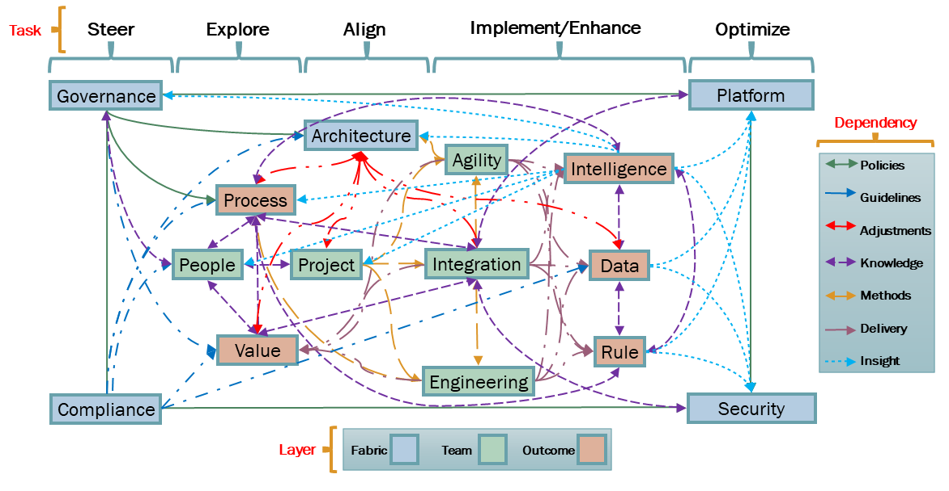

Table : BTM BOK Dependencies Between Practices

|  |  |  |
| --- | --- | --- |
| Line | Dependency | BTM Practices Integrated Through Organizational Fabric, Teams, and Project Outcomes |
|  | Policies | Strategic leadership to steer, explore, and align business and technology decisions |
|  | Guidelines | Business-driven decision deployment across the fabric, compliance and risk assurance |
|  | Adjustments | Coevolution of enterprise architecture and optimizing assets, models, and reuse |
|  | Knowledge | Models, practices, and expertise implemented and embedded in processes and fabric |
|  | Methods | Agile team leadership from requirements to implementation, focus on integration |
|  | Delivery | Value-driven design and integration, DevOps for people-centric product-process-platform |
|  | Insight | Intelligence reuse in business and technology fabric, implementation into rules and AI |

### Sources

BTM BOK sources are primarily from existing FLOS publications and projects (Figure 13). These are directly integrated within Ch.3 Practice and Ch.4 Discipline as constituting materials, which is further edited to ensure continuous integration and harmonization. FLOS sources can also be further adapted and enhanced, especially through mappings between various standards items to help find a common and converging language between specifications, both open and proprietary (e.g., harmonizing the Project Manager role as described in Architecture, Engineering, and Project practices).

As well, BTM BOK development is an open process where co-authors and community end-users both jointly edit chapter contents, as well as customize them and provide feed back. These can occur more sporadically to ensure structure doesn’t evolve too fast, such as Ch.1, 2, and 7. However, in Ch.3-4-5-6, there is a continuous integration and continuous deployment process that enables constant feedback to be adequately harmonized, vetted, and republished for further reuse. As well, BTM BOK assets are reused in a variety of community activities, ranging from BTM Forum functions to value-added services.

Finally, BTM BOK sources can be extensively reused by proprietary standards, that correspond roughly to various Ch.3 Practice sub-sections (Table 13). They serve as external references as BTM BOK doesn’t pretend to compete with any of them. BTM Forum aims to publish assets enabling their convergence.

Figure 13: BTM BOK Sources, Integration, and Reuse

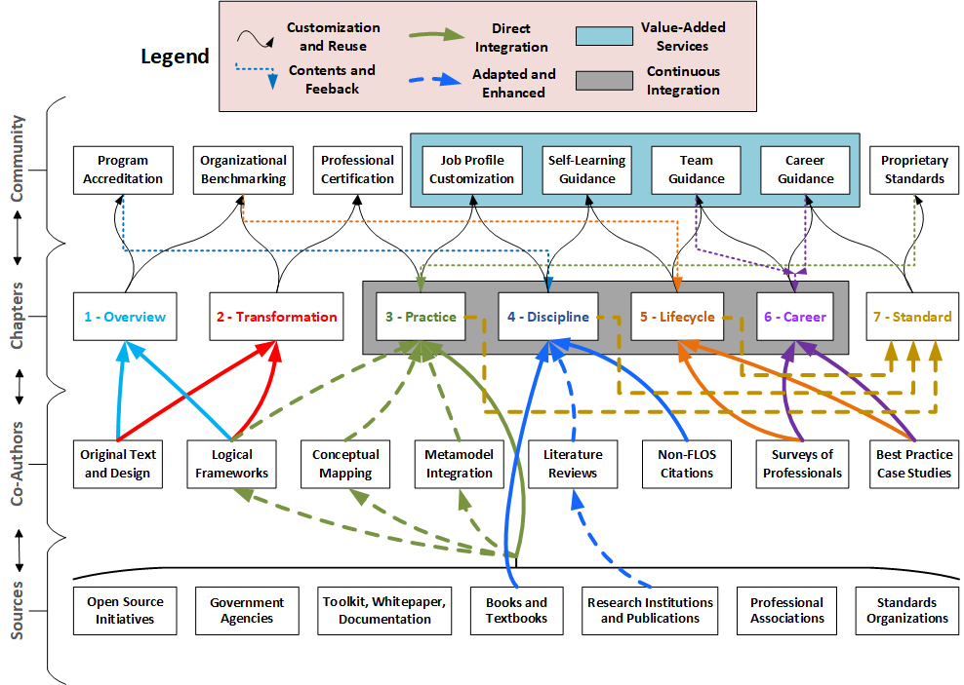

Table : BTM BOK-Related Proprietary Specifications

|  |  |  |  |
| --- | --- | --- | --- |
| Entry Level | Specialization | Standard | Title |
| Associate | 1. Business Analysis | BABOK | Business Analysis Body of Knowledge |
| Associate | 1. Data Analytics | CAP | Certified Analytics Professional |
| Associate | 1. Digital Marketing | OMCP | Online Marketing Certified Professional |
| Associate | 1. Information Management | CIP | Certified Information Professional |
| Associate | 1. Software Testing | CTFL | Certified Tester Foundation Level |
| Associate | 1. User Experience | UXBOK | User Experience Body of Knowledge |
| Professional | 1. Information Security | CISSP | Certified Information Systems Security Professional |
| Professional | 1. Agile Methods | CSM | Certified Scrum Master |
| Professional | 1. Software Quality | CSQE | Certified Software Quality Engineer |
| Professional | 1. Data Management | DMBOK | Data Management Body of Knowledge |
| Professional | 1. Technology Architecture | CITA | Certified IT Architect |
| Professional | 1. Business Process Management | OCEB | OMG Certified Expert in BPM |
| Manager | 1. Electronic Commerce | CECM | Certified E-Commerce Manager |
| Manager | 1. Technology Management | IT4IT | Information Technology for Information Technology |
| Manager | 1. Services Management | ITIL | Information Technology Infrastructure Library |
| Manager | 1. Project Management | PMBOK | Project Management Body of Knowledge |
| Manager | 1. Enterprise Architecture | TOGAF | The Open Group Architecture Framework |
| Executive | 1. Management Consulting | CMC | Certified Management Consultant |
| Executive | 1. Information Governance | COBIT | Control Objectives for Information and Related Tech. |
| Executive | 1. Portfolio Management | Val-IT | Information Technology Value Management |

## Methodology

BTM BOK development methodology relies on the Eclipse Process Framework (EPF), which comes with readily developed practices, such as the Open Unified Process (OpenUP), Scrum, Extreme Programming, Agile Business Rules Development (ABRD), and DSDM. The main feature of EPF is the Composer, a set of extensions installed within the Eclipse Integrated Development Environment (IDE). They are published in a wiki to enable the collaborative editing of open assets, which are then reintegrated as new assets.

* <http://www.eclipse.org/epf/composer_architecture/>
* <https://www.eclipse.org/epf/general/EPFComposerOverviewPart1.pdf>
* <https://www.eclipse.org/epf/general/EPFComposerOverviewPart2.pdf>
* <http://www.etsmtl.ca/Professeurs/rchampagne/documents/epftutorial/index.html>

BTM BOK editorial teams are responsible for separate and parallel tasks (Figure 14):

* Use the EPF Composer to design the BTM BOK framework and integrate various external assets. It is used to develop the “plug-ins” that contain various BTM BOK assets, integrated within various “process configurations” describing BTM certification levels.
* Use the EPF Wiki to maintain and add contents and citations to external BOKs and references. It is used to host the EPF site that helps to navigate the BTM BOK assets and allows registered users to comment and edit the BTM BOK guide (limited to the team and assessors for first year).
* Use EPF Wiki API extensions to help reuse BTM BOK assets into key Talent Management tasks

Figure : BTM BOK Development Process Based on Eclipse Process Framework (EPF)

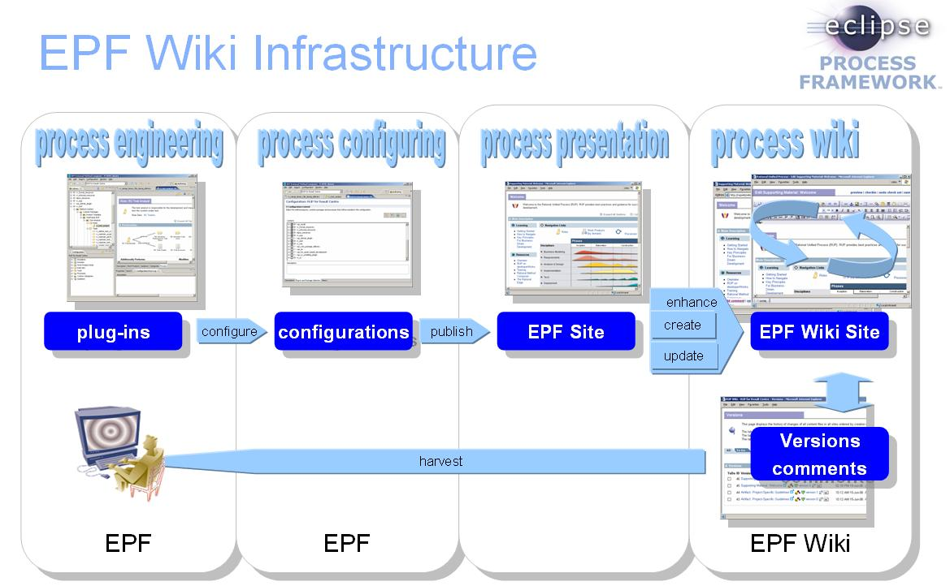

Source: <https://github.com/siguremon/epfwiki/blob/master/doc/infrastructure.jpg>

### Licenses

The BTM BOK will serve as a generic core language to integrate several Free, Libre, Open Source (FLOS) specifications, methodologies, reference models, and standards (Table 14). These have been published under open commercial licenses, such as Creative Commons Attribution-SharelAlike 3.0 Unported (CC BY-SA 3.0), Eclipse Public License 1.0 (EPL 1.0), and European Union Public License 1.2 (EULP 1.2), other more liberal licenses such as CC BY 4.0 International, Apache License, MIT License, etc. When assets contain separate contents with varying licenses, only the commercially reusable contents are used, to avoid limiting the reuse of our BOK by all organizations.

Table : BTM BOK Compatible Licenses

|  |
| --- |
| **Creative Commons Attribution-ShareAlike 3.0 Unported (CC BY-SA 3.0)** |
| * <https://creativecommons.org/licenses/> |
| * <https://wiki.openmod-initiative.org/wiki/Choosing_a_license> |
| **Eclipse Public License (EPL 1.0)** |
| * <https://www.eclipse.org/org/documents/epl-v10.php> |
| **European Union Public Licence (EUPL 1.2)** |
| * <https://joinup.ec.europa.eu/collection/eupl/introduction-eupl-licence> |
| * <https://joinup.ec.europa.eu/collection/eupl/eupl-text-11-12> |
| * <http://oss-watch.ac.uk/resources/eupl> |
| * <https://joinup.ec.europa.eu/collection/eupl/eupl-compatible-open-source-licences> |
| **Comparison with Several Other Licenses** |
| * <https://en.wikipedia.org/wiki/Comparison_of_free_and_open-source_software_licenses> |
| * <https://www.gnu.org/licenses/license-list.html> |

BTM BOK follows a FLOS strategy as we want to encourage reuse everywhere, ensuring the widest uptake and strongest critical mass of users. A rapid growth will generate interest also to attract the most motivated contributors as reuse becomes common practice. We also adopt licenses that require share-alike or copyleft, ensuring other groups that reuse our specs develop innovative ways that will help us promote our framework.

Our FLOS strategy benefits several groups who can find value in joining the BTM BOK initiative actively:

1. Adopters that implement the framework will be free to customize it, and then share it outside in their ecosystem, without any concern whether it is used in commercial or non-commercial settings.
2. Organizations with proprietary specifications will find value in reusing a free generic core language, helping to map their assets to those of others, keeping mappings stable even if others change.
3. Academia will be free to build courseware derived directly from the text/contents of open specs, without having to negotiate with license owners, and relying on free open textbooks to benefit students.
4. Governments will find value in open specs that can effectively be reused and republished as policy documentation, without owing any royalty nor be concerned about costs of maintaining specs.
5. Vendors will want to reuse our assets commercially, refocusing their budgets on R&D instead of costly methods and specs, leaving our assets without commercial alternatives and less competition.

Various organizations (non-profit or commercial) can find value in releasing its specifications as open license. There are more advantages than disadvantages in releasing your assets as CC BY-SA 3.0, EPL 1.0, EUPL 1.2, or any compatible licenses with the same features (i.e., ensure attribution, allow derivatives, allow reuse in commercial context, and require share-alike or copyleft).

If assets are sold and generate revenue, this approach is an immediate loss. This is however a concern for very few organizations, and primarily those that are oriented toward commercial service. Most successful organizations donate specs/methods to end-users to promote learning and help them sample the relevance of other products and services (e.g., certifications, training, software).

Yet most non-profit associations have kept their specs, methods, and standards as proprietary copyright. Many are competing aggressively without much benefit, as the differences between specs are becoming less and less perceptible. The cost of maintaining, expanding, and diversifying these assets is also increasing as specs are becoming more complex and require more quality assurance processes. These initiatives dilute the efforts of their membership, and any delays in releasing new versions also creates concerns about the vitality of the organization and its ability to create a viable strategy for its profession.

Releasing assets as open source ensures that you avoid the costs of proprietary specs, broaden and diversify the reach of your brand, and gain access to new channels to recruit users and contributors.

From a public interest perspective, the enduring competition creates a vacuum in the availability of specs that allow and encourage integration among standards. Hence CIOs and other digital executives are left without a proper mapping as to how to manage the digital transformation. A “do-it-yourself” approach may work for a while, but in-house specs are not cost-effective nor benefiting from outside contributions. This is also affecting organizations concerned with regulatory compliance, where relying on external standards is a requirement, one that cannot be fulfilled given the absence of such assets.

The BTM BOK attempts to fill this vacuum by encouraging non-profit and commercial organizations to take a pioneering step in releasing assets, methods, and specs as CC BY-SA 3.0, EPL 1.0, EUPL 1.2, or similar licenses. By putting an end to costly competition, these organizations will be recognized as those that unlocked the present situation, creating loyalty on part of adopters and contributors. As well, end-users will no longer be forced to “choose who’s the best”, as no organization will make such claims, relying on the BTM BOK instead as a neutral ground to resolve what elements and contents of specs shall be promoted.

Participating organizations can benefit greatly by releasing their assets early on in BTM BOK development. Copyright owners are encouraged to benefit from the first-mover advantage, as “empty placeholders” throughout the BTM BOK will rapidly be filled by various organizations and contributors. Being a follower in this case leaves only the choice of “mapping” proprietary assets to the BTM BOK. A few years later, the odds are the cost of maintaining assets internally will become too large, and the choice of “reusing/integrating” some BTM BOK asset will become inevitable. The outcome will therefore be the same as joining the BTM BOK initiative early on, without first mover, nor any copyright mention.

To ensure a first-mover advantage, the BTM Forum will sign an alliance Memorandum of Understanding (MOU). It will first commit the BTM BOK development team in respecting the terms of the CC BY-SA 3.0, EPL 1.0, EUPL 1.2, or other compatible open licenses, hence ensuring the way in which an organization’s brand is named in BTM BOK assets. It will also ensure that the organization remains in control of its brand and assets, as reuse does not in any way imply transfer of brand use, nor require any commitment on part of the organization.

However, for organization willing to make contribution, and benefit from the BTM BOK development team infrastructure and processes, the MOU can provide clauses for formal collaboration. It can ensure leadership roles of a certain portion of the BTM BOK assets development process, naming representatives to one or many of the 4 teams:

1. **T1 - Contributors:** delegate existing BOK task force members to take leadership of some parts of the BTM BOK.
2. **T2 - Integration:** engage directly with the BTM BOK staff/interns who will edit and map the various assets to one another.
3. **T3 - Review:** delegate senior leaders and co-authors of existing BOKs for quality assurance of BTM BOK assets and conformity to original meaning/intent of reused BOKs.
4. **T4 - Oversight:** elect representatives of your specific profession or specialization to guide the BTM BOK development team in releasing assets that serve your community’s interest.

### References

BTM BOK FLOS assets cover initially 15 core practice or competency areas, with more to come soon, suggestions welcomed of digital transformation leadership, starting with those where references are readily available (Figure 15). Logical models are being explored, first classifying practices broadly along the 3 disciplines of the BTM profession: business, technology, and management.

Figure : BTM BOK Components and FLOS References

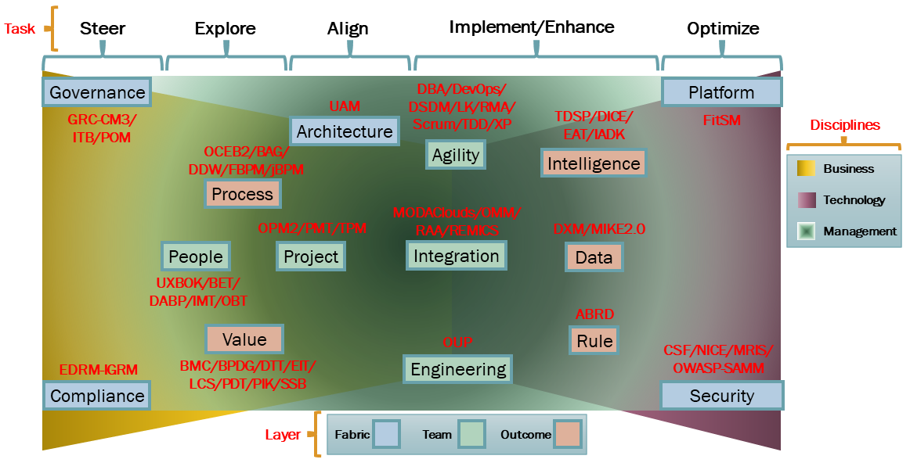

BTM BOK builds upon the widest set of FLOS assets available (Table 15). We integrate 57 FLOS references (aiming to reach 100+), of which 17 are by vendors such as methods, toolkits, whitepapers, or documentation (VM), 15 are by authors of textbooks (TB), 11 are by open source authors or initiatives (OS), 7 are by research institutions (RI), 4 are by government agencies (GA), and 3 are by professional associations or standards organizations (PS).

This table is only a small part of the BTM BOK bibliography, which also reuses parts of 30+ of academic articles under CC BY or CC BY-SA, and references 100+ other academic references.

Reference points to the FLOS specifications, and indicates the name of the first author, the vendor, or the government agency in the case of a method linked to a book, textbook, toolkit, or whitepaper. We do not indicate the author in the case of open source initiatives, professional associations, non-profit organizations, standards organizations, or research institutions. License acronyms refer to standard identifiers (<https://spdx.org/licenses/>).

Table : BTM BOK Detailed FLOS References

|  |  |  |  |  |  |
| --- | --- | --- | --- | --- | --- |
| **Line** | **Domain** | **License** | **Type** | **Acronym** | **Reference** |
|  | **Fabric** |  |  |  |  |
|  | Architecture | EUPL 1.2 | VM | UAM | Unified Architecture Method (UAM) by David W. Enstrom  <http://www.unified-am.com/> |
|  | Compliance | CC BY 3.0 | RI | EDRM -IGRM | EDRM Information Governance Reference Model (IGRM)  <http://www.edrm.net/frameworks-and-standards/information-governance-reference-model/> |
|  | Governance | CC BY-SA 3.0 | PS | GRC- CM3 | Governance, Risk, and Compliance (GRC) Capability Model 3.0 (CM3) by OCEG  <https://go.oceg.org/grc-capability-model-red-book>  <https://go.oceg.org/condensed-grc-capability-model-v3-0> |
|  |  | CC BY 4.0 | TB | ITB | Introduction to Business (ITB) by OpenStax Authors  <https://cnx.org/contents/4e09771f-a8aa-40ce-9063-aa58cc24e77f> |
|  |  | CC BY 4.0 | TB | POM | Principles of Management (POM) by OpenStax Authors  <https://openstax.org/details/books/principles-management> |
|  | Platform | Only parts  CC BY 4.0 | VM | FitSM | Free IT Service Management (FitSM) by ITEMO  <https://fitsm.itemo.org/> |
|  | Security | Public Domain | GA | CSF | CyberSecurity Framework (CSF) by US-NIST  <https://www.nist.gov/cyberframework>  <https://www.nist.gov/itl/applied-cybersecurity> |
|  |  | Public Domain | GA | NICE | National Initiative for Cybersecurity Education (NICE) by US-NIST  <https://www.nist.gov/cyberframework>  <https://www.nist.gov/itl/applied-cybersecurity/nice> |
|  |  | CC BY 4.0 | TB | MRIS | Managing Risk and Information Security (MRIS) by Malcolm W. Harkins  <https://doi.org/10.1007/978-1-4842-1455-8> |
|  |  | CC BY-SA 4.0 | OS | OWASP-SAMM | Open Web Application Security Project (OWASP)  Software Assurance Maturity Model (SAMM)  <https://owaspsamm.org/> |
|  | **Team** |  |  |  |  |
|  | Agility | CC BY-SA 4.0 | VM | DBA | Domains of Business Agility (DBA) by Business Agility Institute (Evan Leybourn, CEO)  <https://businessagility.institute/wp-content/uploads/2019/03/BAI-DomainsOfBusinessAgility-Book.pdf>  <https://theagiledirector.com/article/2017/05/25/domains-of-business-agility-v2/> |
|  |  | CC BY-SA 4.0 | OS | DevOps | DevOps Yoga  [https://devops.yoga](https://devops.yoga/) |
|  |  | CC BY-SA 4.0 | VM | DevOps | DevOps Resources by IBM Red Hat  <https://opensource.com/resources/devops>  <https://opensource.com/downloads/devops-transformation>  <https://opensource.com/downloads/devops-hiring-guide>  <https://opensource.com/downloads/devsecops> |
|  |  | CC BY- SA 4.0 | OS | DevOps | DevOps Toolchain by Kharnagy  <https://commons.wikimedia.org/wiki/File:Devops-toolchain.svg> |
|  |  | CC BY 4.0 | OS | DevOps | DevOps Workflow by Ardemius  <https://github.com/Ardemius/devops-workflow> |
|  |  | EPL 1.0 | OS | DSDM | EPF Practices, Dynamic Systems Development Method (DSDM)  <https://www.eclipse.org/epf/downloads/configurations/pubconfig_downloads.php> |
|  |  | CC BY-SA 3.0 Australia | VM | LK | Lean Kanban (LK) Practitioner: A Lean Approach to Efficient Workflow Management (Student Guide) by Evan Leybourn  <https://theagiledirector.com/training/2013/04/05/lean-kanban-practitioner-a-lean-approach-to-efficient-work-and-workflow-management/>  <https://theagiledirector.com/images/LeanKanban.pdf> |
|  |  | CC BY 4.0 | VM | RMA | Reference Methodology for Agility (RMA) by WSO2  <https://wso2.com/methodology>  <https://github.com/wso2/reference-methodology> |
|  |  | EPL 1.0 | OS | Scrum | EPF Practices, Scrum  <https://www.eclipse.org/epf/downloads/configurations/pubconfig_downloads.php> |
|  |  | CC BY 3.0 | TB | TDD | Test-Driven Development (TDD)  <https://github.com/grzesiek-galezowski/tdd-ebook> |
|  |  | EPL 1.0 | OS | XP | EPF Practices, Extreme Programming (XP)  <https://www.eclipse.org/epf/downloads/configurations/pubconfig_downloads.php> |
|  | Engineering | EPL 1.0 | OS | OUP | EPF Practices, Open Unified Process (OUP)  <https://www.eclipse.org/epf/downloads/configurations/pubconfig_downloads.php> |
|  | Integration | CC BY 4.0 and Apache-2.0 | RI | MODA Clouds | MODAClouds MultiCloud DevOps Toolbox  <http://multiclouddevops.com/>  Model-Driven Development and Operation of Multi-Cloud Applications: The MODAClouds Approach  <https://doi.org/10.1007/978-3-319-46031-4> |
|  |  | EPL 1.0 and  CC BY-SA 3.0 | RI | OMM | QualiPSo Open Maturity Model (OMM)  <http://qualipso.icmc.usp.br/OMM/>  <https://sourceforge.net/projects/qualipso-omm/> |
|  |  | CC BY 4.0 | VM | RAA | Reference Architecture for Agility (RAA) by WSO2  <https://wso2.com/architecture>  <https://github.com/wso2/reference-architecture> |
|  |  | EPL 1.0 | RI | REMICS | REuse and Migration of Legacy Applications to Interoperable Cloud Services (REMICS)  <https://github.com/SINTEF-9012/remics-library> |
|  | People | CC BY-SA 3.0 | PS | UXBOK | Usability BoK (UXBOK)  <https://www.usabilitybok.org> |
|  |  | CC BY 4.0 | TB | BET | Business Ethics Textbook (BET) Stephen M. Byars, Kurt Stanberry, et al.  <https://openstax.org/details/books/business-ethics> |
|  |  | CC BY-SA 4.0 | TB | DABP | Digital Accessibility as a Business Practice (DABP)  <https://pressbooks.library.ryerson.ca/dabp/> |
|  |  | CC BY 4.0 | TB | IMT | Introducing Marketing Textbook (IMT) by John Burnett  <https://open.bccampus.ca/browse-our-collection/find-open-textbooks/?uuid=ddbe3343-9796-4801-a0cb-7af7b02e3191> |
|  |  | CC BY 4.0 | TB | OBT | Organizational Behavior Textbook (OBT) by OpenStax Authors  <https://openstax.org/details/books/organizational-behavior> |
|  | Project | EUPL 1.2 | GA | OPM2 | Open Project Management Methodology (OPM2) by EU-DIGIT  <https://ec.europa.eu/isa2/solutions/open-pm2_en> |
|  |  | CC BY 4.0 | TB | PMT | Project Management Textbook (PMT) by Adrienne Watt  <https://opentextbc.ca/projectmanagement/> |
|  |  | CC BY 4.0 | TB | TPM | Technical Project Management in Living and Geometric Order (TPM) by Jeffrey Russell, Wayne Pferdehirt, and John Nelson  <https://wisc.pb.unizin.org/technicalpm/> |
|  | **Outcome** |  |  |  |  |
|  | Data | CC BY-SA 4.0 | VM | DXM | Data Excellence Model (DXM) by Tobias Pentek and Christine Legner  <https://www.cc-cdq.ch/data-excellence-model> |
|  |  | CC BY 3.0 | OS | MIKE2.0 | Method for an Integrated Knowledge Environment (MIKE)  <http://www.openmethodology.org> |
|  | Intelligence | CC BY 4.0 and MIT | VM | TDSP | Team Data Science Process (TDSP) by Microsoft  <https://aka.ms/tdsp> |
|  |  | Apache-2.0 | RI | DICE | Developing Data-Intensive Cloud Applications with Iterative Quality Enhancements  <http://www.dice-h2020.eu/>  <https://github.com/dice-project/DICE-Knowledge-Repository/wiki/DICE-Knowledge-Repository> |
|  |  | CC BY-SA 3.0 | RI | DICE | Practical DevOps for Big Data  <https://en.wikibooks.org/wiki/Practical_DevOps_for_Big_Data> |
|  |  | CC BY 4.0 and MIT | RI | EAT | Ethics & Algorithms Toolkit (EAT)  <http://ethicstoolkit.ai/> |
|  |  | CC BY-SA 4.0 | VM | IADK | Intelligence Augmentation Design Kit (IADK) by Futurice  [http://iadesignkit.com](http://iadesignkit.com/) |
|  | Process | Granted  EPL 1.0 | PS | OCEB2 | OMG Certified Expert in BPM (OCEB2)  <https://www.omg.org/oceb-2/> |
|  |  | CC BY-SA 3.0 | OS | BAG | Business Analysis Guidebook (BAG)  <https://en.wikibooks.org/wiki/Business_Analysis_Guidebook> |
|  |  | CC BY 4.0 | TB | DDW | Designing Digital Work (DDW) by Stefan Oppl and Christian Stary  <https://doi.org/10.1007/978-3-030-12259-1> |
|  |  | CC BY 4.0 | TB | FBPM | Teaching Material by M. Dumas, M. La Rosa, J. Mendling and H. Reijers, for “Fundamentals of Business Process Management”, 2nd edition, Springer, 2018  <http://fundamentals-of-bpm.org/supplementary-material/> |
|  |  | Apache-2.0 | VM | jBPM | Documentation for Drools, OptaPlanner and jBPM by IBM RedHat  <https://github.com/kiegroup/kie-docs> |
|  | Rule | EPL 1.0 | OS | ABRD | EPF Practices, Agile Business Rule Development (ABRD) by Jérôme Boyer and Hafedh Mili  <https://www.eclipse.org/epf/downloads/configurations/pubconfig_downloads.php> |
|  | Value | CC BY-SA 4.0 | VM | BMC | Business Model Canvas (BMC) by Strategyzer (Alexander Osterwalder, Co-Founder)  <https://www.strategyzer.com/canvas/business-model-canvas>  <https://www.strategyzer.com/books/business-model-generation> |
|  |  | CC BY-SA 4.0 | TB | BPDG | Business Plan Development Guide (BPDG) by Lee A. Swanson  <https://openpress.usask.ca/businessplandevelopmentguide/> |
|  |  | CC BY 3.0 Australia | GA | DTT | Digital Transformation Toolkit (DTT) by South Australian Government  <https://www.dpc.sa.gov.au/responsibilities/ict-digital-cyber-security/toolkits/digital-transformation-toolkit> |
|  |  | CC BY-SA 4.0 | TB | EIT | Entrepreneurship and Innovation Toolkit (EIT) by Lee A. Swanson  <https://openpress.usask.ca/entrepreneurshipandinnovationtoolkit/> |
|  |  | CC BY-SA 4.0 | VM | LCS | Lean Service Creation (LCS) by Futurice  <https://www.leanservicecreation.com/> |
|  |  | CC BY- 4.0 | VM | LCS -IoTT | Internet of Things Toolkit (IoTT) by Futurice  <http://iotservicekit.com/> |
|  |  | CC BY-SA 4.0 | VM | PDT | Platform Design Toolkit (PDT) by Boundaryless  [https://platformdesigntoolkit.com](https://platformdesigntoolkit.com/) |
|  |  | CC BY-SA 4.0 | VM | PDT-POEG | Platform Opportunity Exploration Guide (POEG) by Boundaryless  <https://platformdesigntoolkit.com/opportunity-exploration/> |
|  |  | CC BY-SA 4.0 | VM | PIK | Platform Innovation Kit (PIK)  <http://platforminnovationkit.com/> |
|  |  | CC BY 4.0 | TB | SSB | Scaling a Software Business (SSB) by Brian Fitzgerald et al.  <https://doi.org/10.1007/978-3-319-53116-8> |

### Editing

BTM BOK relies on EPF Composer, an Eclipse development environment, where our selected FLOS assets will be aligned with our digital transformation lifecycle and maturity model (Figure 16). The BTM BOK core language will help integrate assets around the core elements of the EPF framework, as defined by the Object Management Group (OMG) Software Process Engineering Metamodel (SPEM 2.0), initially developed by IBM for the Rational Unified Process (RUP).

Figure : BTM BOK Development Interface within EPF Composer

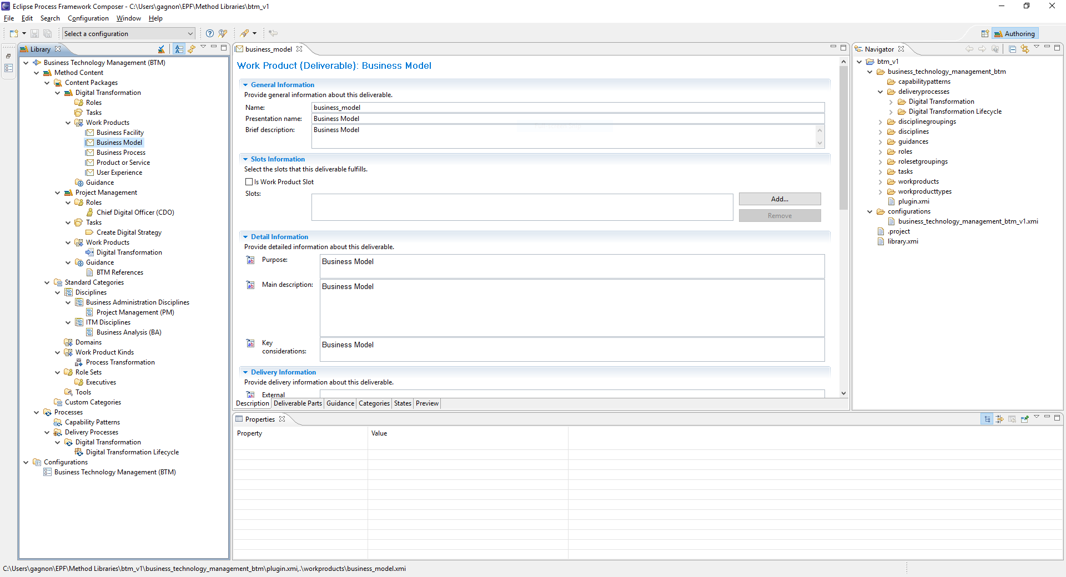

EPF Composer presents several challenges for beginners, but once standard packages have been analyzed, most users are able to understand the logic and relationships between components. These serve to establish editorial priorities and help guide the team in large collaborative development efforts. BTM BOK leverages the generic SPEM 2.0 schema, with EPF Composer integrating them within a set of Method Library assets that simplify method contents reuse and customization (Figure 17):

* **Process:** Overall digital transformation lifecycle and maturity model to align all sub-processes.
* **Disciplines:** 15+ BTM specializations and their main external BOK references.
* **Workflows:** Broad integrated activities guiding BTM leaders to master the digital lifecycle.
* **Workflow details:** Sub-processes connecting the competencies of the 20+ BTM specializations.
* **Role:** BTM certification levels regrouping the 15+ BTM specializations and their roles.
* **Activity or Task:** Competencies required by the 57+ external BOKs and defining the job roles.
* **Artifact or Work Products:** Expected input and output of the typical digital lifecycle tasks.
* **Tools and Tool Mentor:** Tools recommended to BTM professionals to perform the various tasks.
* **Guidance, Checkpoints, Templates, and Reports:** External references to best practices.

Figure : BTM BOK Design Using SPEM 2.0 within EPF Composer

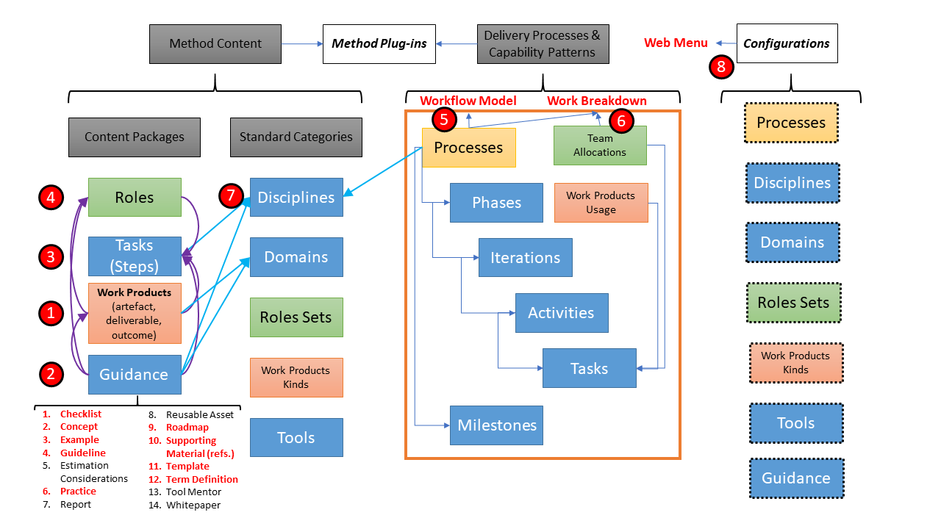

### Contribution

There are 11 main applications that are involved in the BTM BOK development and integration (Figure 18). Documentation is provided on the various tools and software used in developing BTM BOK, along with short video demos for team participants (<https://www.btm-forum.org/standards/bok/tools>). Each app offers complementary functionality integrated within a complete development lifecycle (Table 16).

Figure : BTM BOK Development Team Platform

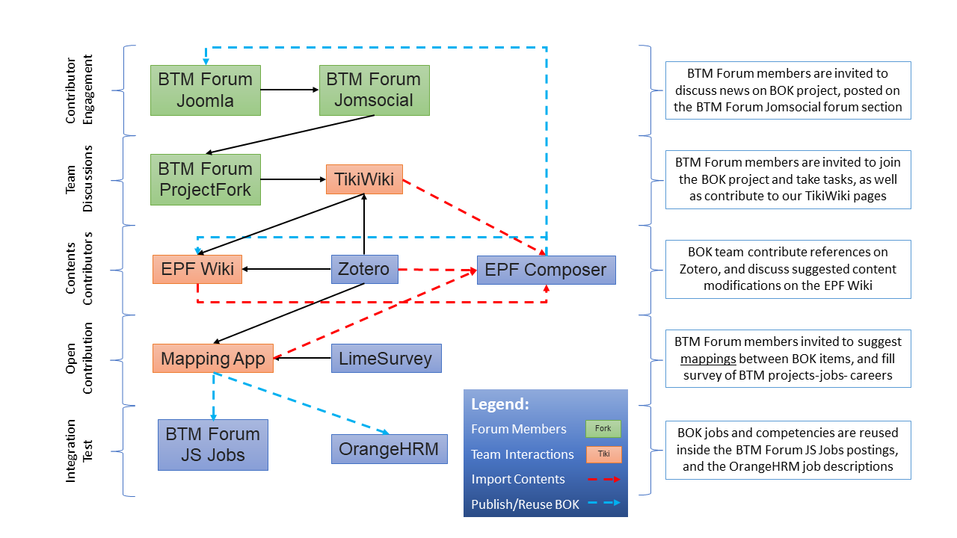

Table : BTM BOK Development Apps and Functionality

|  |  |
| --- | --- |
| BTM BOK Apps | Functionality |
| BTM Forum | ITAC created in 2009 the Business Technology Management (BTM) initiative, promoting a renewed sense of community, mapping many career paths crossing business and technology. In 2016, it launched the BTM Forum (Joomla) website, developing a new Body of Knowledge (BOK) and professional certifications, program accreditation standards, and learning guides to help prepare the next generation of digital transformation leaders. |
| BTM Forum Apps | BTM Forum website integrates several sub-applications or Joomla Extensions: (1) social networking (JomSocial), (2) discussion forums (JomSocial), (3) sophisticated projects plan and development (ProjectFork and JomSocial), and (4) jobs board (JS Jobs). These are accessible by registered users and user groups permissions. They are used for creating development projects, social sharing, discussions as well as for the integration of jobs and CVs reuse. |
| BTM BOK Zotero Group and Citation | Zotero is a free references management software used to manage, collect, organize, cite, and share research. A Zotero referencing app is developed and integrated in BTM BOK apps. To add your references and use them to cite the content inside our apps, you need to:   * Download and install Zotero desktop * Join the BTM BOK Zotero references group on the web * Import references from any journal into your local Zotero desktop app * Add your references into the BTM group using your local Zotero desktop app * Sync from local to web group * Reference and cite the content on the apps as shown on the demos. |
| Core BTM BOK | BTM BOK serves as a reference web site to guide practitioners at all levels of Competency: Associate, Professional, Manager, and Executive. It provides a generic core model "centered" on business value and technology, instructing what knowledge and certifications are required to enter new BTM positions and guiding upcoming digital leaders toward the common core competencies of their profession. The Eclipse Process Framework (EPF) Composer is used to develop and design the BTM BOK library integrating various external plugins and assets in a single BOK. The EPF Wiki (a Ruby app) is used to publish, maintain and add contents to the BOK developed in EPF. A Zotero references app is developed and integrated in EPF Wiki to allow for easy insertion of academic and professional literature citations. |
| Mapping App | BTM BOK mapping application allows members to create mappings or associations between various industry standards and BTM positions to identify and create competencies. Currently 1729 standards and 33 positions information are added and ordered hierarchically. The mapping app also includes adding references and citations through an integrated Zotero references manager app. Each member's created mappings and content can be shared with other members or kept private according to the member intent. |
| Community App | BTM BOK Community (TikiWiki) app aims to creating a knowledge hub for everyone who is interested in the subject to participate and collaborate. It provides members with a wiki-like environment where they can comment, create, add content to discuss various BTM BOK topics and literature. This allows enhancing BTM BOK community knowledge base and encourages sharing and collaboration. |
| Survey App | BTM BOK Survey application (LimeSurvey) enables easily creating surveys to be used to build case studies and career paths. |
| HRM App | BTM BOK Human Resources Management (OrangeHRM) application is used for integrating with other apps to matchmaking between jobs description and candidates. |
| Portal App | BTM Forum uses an e-learning app (Moodle) as its assessment portal. While not depicted on our diagram, this app will soon allow us to reuse BTM BOK positions and competencies. These items will be inserted directly within the certification process. Equipped with BTM BOK assessment criteria, assessors will be able to rapidly process applications while ensuring standards compliance. The app also enables applicants to finish their applications with minimal staff interventions, track status, receive updates, and get their certification and digital badges for inclusion in web profiles. |

One of the key apps for integrating community contributions is the BTM BOK Standards Mapping System (Figure 19). It allows to consult the whole range of recommended practice standards, using a tree-based navigation interface, where contributors can login and recommend specific mappings among items. Each item can also be linked to citations to external references, especially FLOS but also proprietary standards. These standards items are reused and combined to give shape to various competencies, which are in turn reused in jobs or positions, integrated within career progressions (Table 17).

Figure : BTM BOK Standards Mapping System

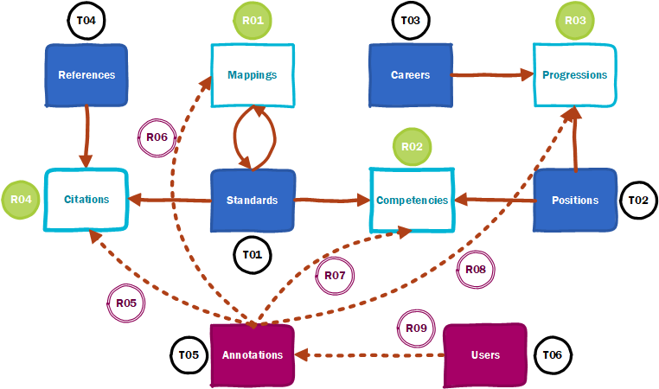

Table : BTM BOK Mapping App Database Tables

|  |  |  |  |  |
| --- | --- | --- | --- | --- |
| Line | Table | Code | Contents | Privileges |
|  | Core Tables |  |  |  |
|  | Standards | T01 | All BOK standards (18 items) | Admin only |
|  | Positions | T02 | All BOKNOS Positions (27 items) | Admin only |
|  | Careers | T03 | All BOK career paths from survey | Users add |
|  | References | T04 | All BOK references on Zotero | Zotero only |
|  | Core Relationships |  |  |  |
|  | Mappings | R01 | Map standards to each other | Users add |
|  | Competencies | R02 | Map standards to positions | Users add |
|  | Progressions | R03 | Map positions to careers | Users add |
|  | Citations | R04 | Map references to standards | Users add |
|  | Support Tables |  |  |  |
|  | Annotations | T05 | All annotations | Users add |
|  | Users | T06 | All users | Admin only |
|  | Support Relationships |  |  |  |
|  | Citations Annotation | R05 | Annotations to citations | Users add |
|  | Mappings Annotation | R06 | Annotations to mappings | Users add |
|  | Competencies Annotation | R07 | Annotations to competencies | Users add |
|  | Progressions Annotation | R08 | Annotations to progressions | Users add |
|  | Annotation User | R09 | User who made annotation | Users add |

### Authors

BTM BOK depends on the integrated activities of 3 development team roles (Figure 20):

* BOK asset **designer** builds the framework, manages contributors, and maps relevant assets;
* BOK asset **integrator** uses EPF composer and wiki to integrate all assets on a fine-grain basis;
* BOK asset **re-user** develops reuse proof-of-concepts for HRM functions through new APIs.

These roles are generically shared by various community contributors. All participants are recruited through BTM Forum portal apps. They all have opportunity to elect their respective choice of role as per ongoing public listings of pending work items. The elected role can be shifted and even combined, none being unique or exclusive.

The choice of roles depends heavily on the ability of a contributor to use the relevant software tools and add their personal experience and their organization’s perspective. As such, it is customary to find people with hands-on experience of software development to act as BOK Assets Integrator, since they will be most familiar with Eclipse Integrated Development Environment (IDE) functionality. Meanwhile, BOK Assets Designer role will often be chosen by those with extensive knowledge of a specific professional practice (e.g., Project Management), and focus on creating the relevant contents to be actively integrated by Integrator roles, both often combined by one person or team-cell if already competent. Finally, the more advanced and complex role is BOK Assets Re-User, where the use of EPF Wiki assets, stored in XMI formats, are carefully integrated into other Talent Management and HRM systems, mostly through XML-based APIs to enable near-real-time update of contents as BTM BOK assets are continuously integrated and deployed in FLOS formats.

Figure : BTM BOK Development Team Roles

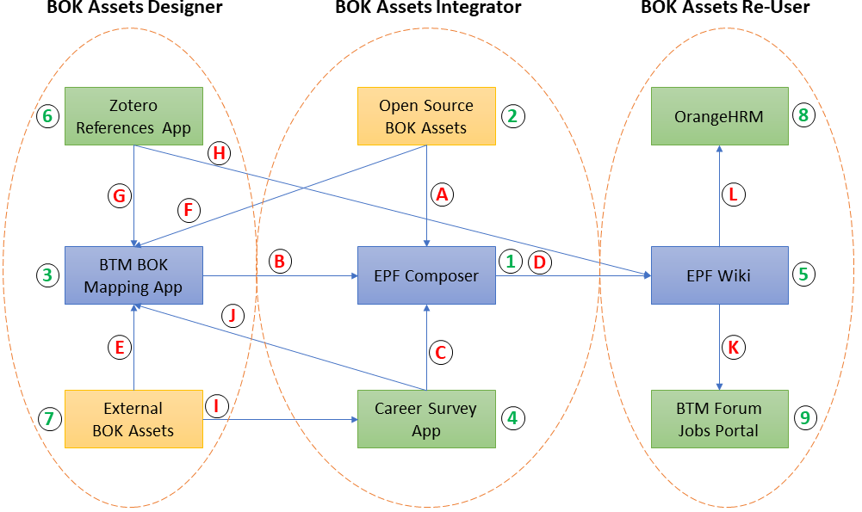

Each role has responsibilities within the development process (capital letters referring Figure 20 arrows):

1. Integrate all open source BOK assets, e.g., Open PM2, Open UP, and others to be released.
2. Import BTM BOK mappings between all elements, especially to connect 20+ BOKs to workflows.
3. Import results of the Career Survey App to find most typical positions and career progressions.
4. Publish BTM BOK assets and maintain EPF Wiki contents to ensure feedback reused in model.
5. Coach community contributions to map 20+ external BOKs using the BTM BOK Mapping App.
6. Coach community contributions to map core open source BOKs in the BTM BOK Mapping App.
7. Coach community to add contents to the Zotero References App and map them to BOK items.
8. Coach community to add contents to the Zotero References App and cite within the EPF Wiki.
9. Configure the Career Survey App using the 20+ external BOKs from BTM BOK Mapping App.
10. Import Career Survey App result as positions and career progressions in BTM BOK Mapping App.
11. Develop EPF Wiki API to integrate BTM BOK assets in key functions of the BTM Forum Job Portal.
12. Develop EPF Wiki API to integrate BTM BOK assets in key functions of the OrangeHRM Web App.

BTM BOK development cycle will initially unfold through 6 milestones that interns meet as a team, with BTM BOK Review Team involved at each point:

1. **M1:** Team recruited; infrastructure installed; plan formalized; IPR agreement starting;
2. **M2:** BTM BOK mock-up with assets; contributor documentation ready; invited 20+ contributors;
3. **M3:** First contributors update; validate BTM BOK mappings; reassign contributor tasks;
4. **M4:** Second contributors update; validate BTM BOK mappings; reassign contributor tasks;
5. **M5:** Public Demo of BTM BOK v3; integration to BTM certifications; integration to HRMS/CVs;
6. **M6:** Transfer BTM BOK assets and infrastructure to ITAC; report to MITACS and UQO.

BTM BOK development teams were created to carry out and supervise the various tasks and responsibilities of these 3 key roles. Here are the 4 teams presently being staffed, with recruitment regularly expanding the capacity to cover more BOK areas requiring integration:

1. **T1 - Contributors Team:** Act as our Free, Libre, Open Specifications (FLOS) team, an international network of open source analysts, researchers, and consultants ready to integrate their best ideas in the BTM BOK. Work regularly on our team servers, and often publish blogs, social network posts, and academic articles, updating the public about progress in some sections of our BOK assets.
2. **T2 - Integration Team:** Act as Continuous Integration (CI) team, responsible for curating all BTM BOK assets, as well as configuring and maintaining all DevOps infrastructures for all teams. Support contributors and ensure coherence in integrating inputs at various stages.
3. **T3 - Review Team:** Act as our Quality Assurance (QA) team, staffed primarily with asset-specific experts, typical either of faculty or integrated BOK authors. Will perform close oversight of BTM BOK contents and development steps, and possibly sit on the doctoral thesis committees of some students who will publish some research re. the BTM BOK.
4. **T4 - Oversight Team:** Act as our Release Candidate (RC) team, a group who makes the call on what assets of the BTM BOK we are to release publicly on GitLab. Staffed with BTM Forum Governing Council members, including a representative from the IT Association of Canada (ITAC) as formal owners of the BTM registered trademarks in Canada and the United States.

# Transformation

The digital transformation journey presents at each phase new leadership challenges to BTM professionals.

## Opportunity

While most traditional organizations are familiar with digital projects and programs of small projects, few have entered the “bulk of change” phase where the organization becomes digital (Figure 21). This is where BTM professionals at all ranks become essential, where the organization becomes truly digital, i.e., BTM leaders help making products, process, people, partners, and business portfolios more agile in using IT. Beyond that point, the digital transformation is self-funding through internal savings and renewed competitive positioning.

Figure : BTM Maturity Levels and Digital Lifecycle

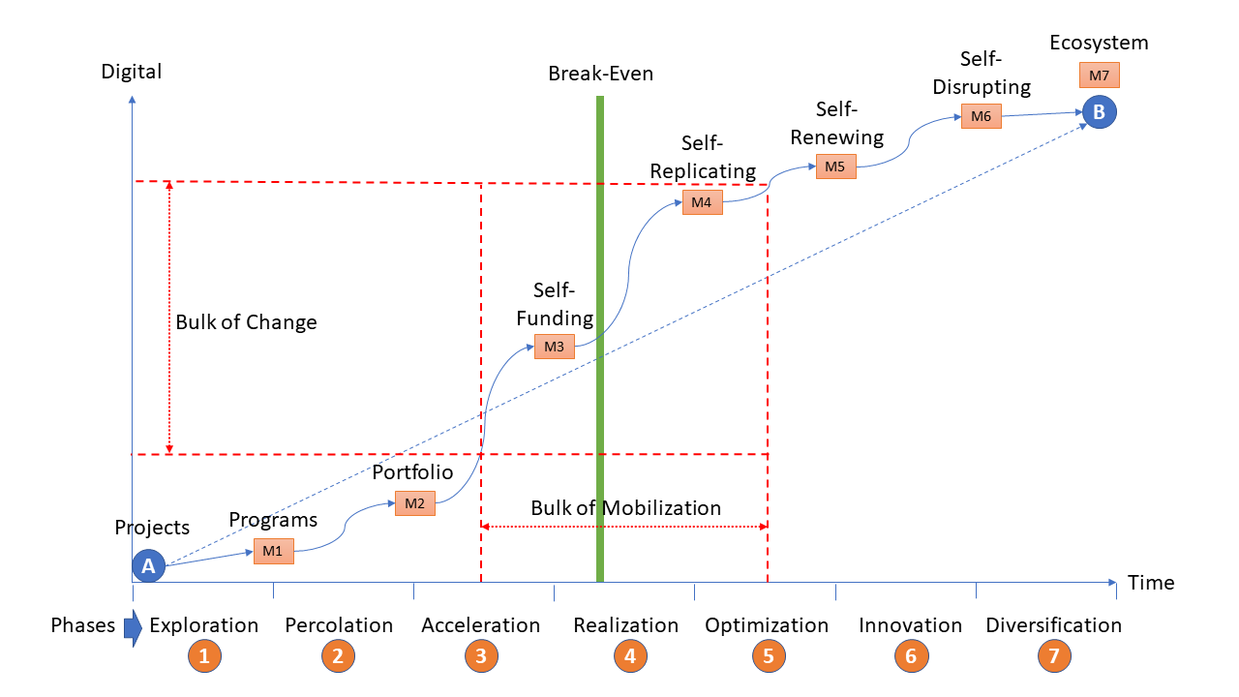

### Scan

Table : BTM and Innovation Focus

|  |  |  |
| --- | --- | --- |
| Dimension | Definition | Criteria |
| New | Innovation is about new concepts and solutions to various needs | New to the world or a region, new to an industry or an organization |
| Contextual | Innovation is contextual to the organization and industry within which it is adopted | The same type of solution can take a distinct nature or shape in others, and still be classified as innovative, at least within that realm |
| Where | Innovation in organizations can occur at strategic and/or operational levels, within a planned and/or emergent activity, with deliberate and/or unintended outcomes | Innovative activities and outcomes will depend on the sector, and occur as per their respective dynamics, e.g., business, government, municipal, para-public, or non-profit |
| What | Innovation can bring new solutions in one or more deliverables | New business models, new products/services, new technology/infrastructure, new production/business processes, new management methods/practices, new ways of thinking/working, etc. |
| When | Innovation happens when forces converge or spontaneously organize as a new “equilibrium solution”, often viewed as a “dominant design” among competing solutions | Dominant designs are typically rooted in a set of evolving needs, and in response to opportunities and/or constraints that form a “complex system” leading to, causing, or driving innovation |
| Why | Innovation typically targets performance or a planned outcome | Profits or Return on Investment (ROI), productivity or quality improvement, meeting end-user/stakeholder needs, serving new markets or constituents/mandates, access to new resources or knowledge, employee initiative and ideas, etc. |
| How | Innovation is best conceived as a project, with a beginning and ending, and unfolding as a process managed by one or more interdisciplinary team(s) throughout a lifecycle | Innovative projects may be composed of one, more, or any of a few stages within which several iterations may occur, with varying degrees of originality and hybridation among innovative needs, options, and solutions, involving: (1) development, (2) implementation, (3) diffusion, (4) adoption and adaptation, (5) abandonment or replacement |

### Discover

Table : BTM and Digital Lifecycle

|  |  |  |  |  |  |
| --- | --- | --- | --- | --- | --- |
| Features \ Activities | Innovation | Adoption | Transformation | Optimization | Diversification |
| IT Mandate | Development | Development | Operation | Management | Governance |
| IT Impact | Products | People | Places | Processes | Partnerships |
| IT Benefits | New model, new arch., new code, new apps, new users, new value | Simplify, open perspectives, collaboration, speed, effective | Mobile, things, intelligent, real time, analytics-driven | Open source, reuse, acquire, integrate, standardize | Assets, supply, competitive, new products, market access |
| BTM Expertise | Entrepreneurship | User Experience | Infrastructure | Architecture | Value Strategy |
| BTM Role | Create concepts and models at core of new solutions | Translate user requirements to ensure best solutions | Integrate new solutions and help users adapt practices | Design new way of working and delivering value with existing IT | Advise on use of IT for new value, link to market vision |
| BTM Partners | Engineers | End-Users | IT Vendors | Line Managers | Executives |

### Prioritize

Table : BTM Context in Private and Public Sectors

|  |  |  |
| --- | --- | --- |
| Project Context | Private Sector (advantages) | Public Sector (constraints) |
| Strategy and Policy Making | * Senior executives make decisions * Competitive intelligence is key * Board will follow CEO guidance | * Long and complex consultations * Election cycles influence decisions * DM must follow Cabinet priorities |
| Value from IT Investments | * Use IT for efficiency and growth * Innovate as often as possible * Justify IT investments based on value | * Use IT to implement and support programs * Innovation mostly at beginning of program * IT investment dictated by policy priorities |
| Flexibility in IT Procurement | * Short-term competitive IT contracts * Vendor accountability and switching * Cloud services and integration are key | * Long-term licensing and outsourcing * Vendor autonomy in IT service delivery * Law remains a challenge for cloud services |
| Project Management | * Strategic projects have mini-CEOs * PM certification and capabilities * PMO with special integrated systems | * Close control of strategic projects * PM profession and capability emerging * PMO uses mostly accounting systems |
| Budgeting Cycles | * Budgets are adjusted quarterly * IT is protected, linked to profitability * Performance control based on ROI | * Annual budgets, difficulty to increase funds * Policy priorities get most funds, IT second * Control based on budget conformity |
| Financial Stability | * Projects that deliver value are priority * Funding follows business growth * Innovate with revenue opportunities | * Programs can get cut without notice * Funding follows Cabinet priorities * Innovate if new IT is absolutely necessary |
| Access to Best Expertise | * Salaries based on knowledge value * Staff changes based on performance * Protect internal strategic IT capabilities | * Union salaries are fixed and uncompetitive * Staffing based on long term temp agencies * Consultants provide strategic IT expertise |

### Finance

Table : BTM Financing and IT Costs

|  |  |  |  |
| --- | --- | --- | --- |
| Units/CIO Branch | Sub-Units (Director) | Direct Costs | % of Budget |
| Application Development | 1. Development Project Office 2. Architecture/Modeling 3. Web Sites/Applications 4. Enterprise Systems 5. Systems Integration 6. Business Req. and Analysis 7. Database Support | Business Analysts/Developers  Consultants/Certification  Multimedia/Production  Integration Appliances  Database Analysts | 35-45 % |
| IT Operations | 1. Shared Services Liaison Role 2. Internal Data Centers 3. Mainframes 4. Networking/Security 5. Business Continuity 6. IT Security Operations | Outsourcing Services  Servers/Facilities  Hosting/Maintenance  Networks/Telecom.  Backups/Recovery | 25-30 % |
| IT Support | 1. End-User Equipment 2. End-User Support 3. End-User Software 4. Telephony/Conferencing 5. Identity/Security | Computers/Peripherals  Printing and Supplies  Software Licenses  Devices/AV/Telecom.  ID Cards/Access Points | 20-25 % |
| Information Management | 1. Content Management 2. Library Services 3. Files and Archives 4. Compliance/Audit | Storage Servers  Consultants/Auditors  Information Management Analysts | 15-20 % |
| Branch Management | 1. Policy and Planning 2. Human Resources 3. Accounting 4. Procurement 5. Legal Counsel 6. Program and Project Management 7. Enterprise Architecture 8. License Management | Strategy Consultants  Temp Agencies  Accountants/Consultants  Vendor Analysis Firms  Lawyers/Consultants  Project and Program Managers  Enterprise Architects  All Licenses for Agency | 5-10 % |

### Benefit

Figure : BTM BOK Cycle and Digital Value Creation

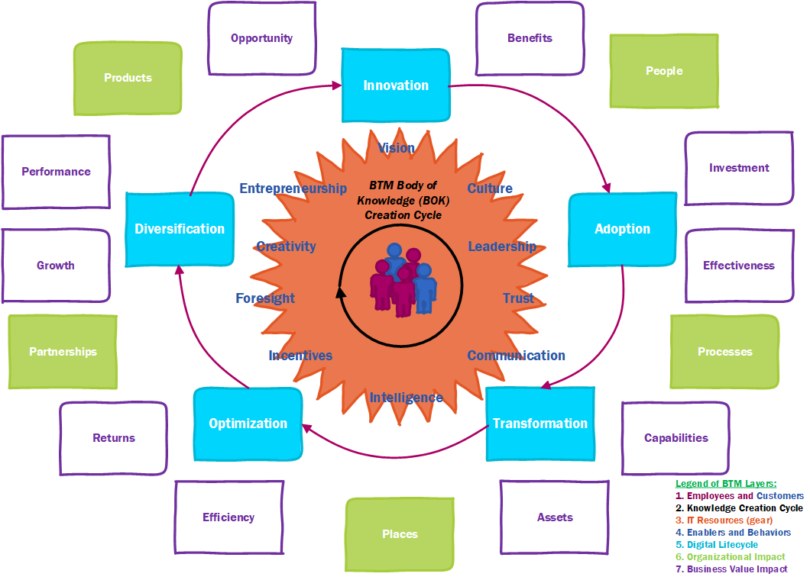

## Decision

Figure : BTM Decision-Making Environment

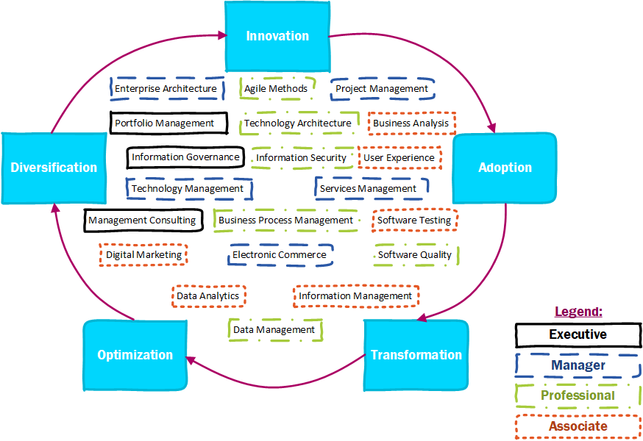

Table : BTM Roles and Digital Lifecycle Leadership

|  |  |  |  |  |  |  |
| --- | --- | --- | --- | --- | --- | --- |
| Entry Level | Specialization | Innova-tion | Adop-tion | Transfor-mation | Optimi-zation | Diversi-fication |
| Associate | 1. Business Analysis | 1 | 1 | 1 | 1 | 1 |
| Associate | 1. Data Analytics | 1 |  |  | 1 | 1 |
| Associate | 1. Digital Marketing | 1 |  |  | 1 | 1 |
| Associate | 1. Information Management |  | 1 | 1 | 1 |  |
| Associate | 1. Software Testing |  | 1 | 1 | 1 |  |
| Associate | 1. User Experience | 1 | 1 | 1 | 1 | 1 |
| Professional | 1. Information Security |  | 1 | 1 | 1 |  |
| Professional | 1. Agile Methods | 1 | 1 | 1 | 1 | 1 |
| Professional | 1. Software Quality | 1 |  | 1 | 1 |  |
| Professional | 1. Data Management |  | 1 | 1 | 1 |  |
| Professional | 1. Technology Architecture | 1 |  |  | 1 |  |
| Professional | 1. Business Process Management | 1 | 1 | 1 | 1 | 1 |
| Manager | 1. Electronic Commerce |  |  | 1 | 1 | 1 |
| Manager | 1. Technology Management |  | 1 |  | 1 |  |
| Manager | 1. Services Management |  | 1 |  | 1 |  |
| Manager | 1. Project Management | 1 | 1 | 1 | 1 | 1 |
| Manager | 1. Enterprise Architecture | 1 | 1 | 1 | 1 | 1 |
| Executive | 1. Management Consulting | 1 | 1 | 1 | 1 | 1 |
| Executive | 1. Information Governance |  | 1 |  | 1 |  |
| Executive | 1. Portfolio Management |  |  | 1 | 1 | 1 |

### Who

### What

### Why

### Where

### How

## Accountability

Figure : BTM Executives and Digital Strategy Accountability

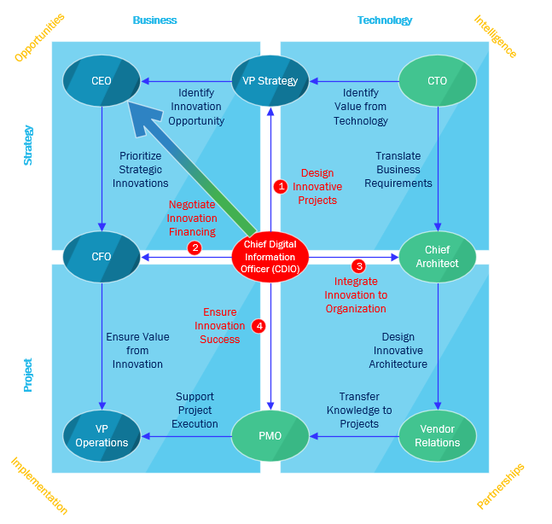

### Steer

### Explore

### Align

### Implement

### Optimize

# Practice

## Fabric

### Governance

### Compliance

### Architecture

### Security

### Platform

## Team

### People

### Project

### Agility

### Engineering

### Integration

## Outcome

### Value

### Process

### Rule

### Data

### Intelligence

# Discipline

## Business

### Strategy

### Marketing

### Operation

### Innovation

### Performance

## Management

### Talent

### Learning

### Change

### Leadership

### Entrepreneurship

## Technology

### System

### Software

### Cloud

### IoT

### AI

# Lifecycle

## Scope

### Administration

### Solution

### Support

### Facility

### Enterprise

## Focus

### Behavior

### Functionality

### Reengineering

### Optimization

### Diversification

## Sector

### Resource

### Infrastructure

### Product

### Service

### Public

# Career

## Goal

### Specialist

### Complement

### Generalist

### Senior

### Occasional

## Path

### Corporate

### Embedded

### Small

### Startup

### Consulting

## Progression

### Beginning

### Diversity

### Education

### Experience

### Promotion

# Standard

## Accreditation

### Diploma

### Certificate

### Bachelor

### Master

### Doctorate

## Benchmark

### Forerunner

### Challenger

### Innovator

### Optimizer

### Disruptor

## Certification

### Associate

### Professional

### Manager

### Entrepreneur

### Executive