**HOMEWORK 3**

Inden jeg gik i gang skrev jeg dette ind og gemte scriptet, herefter ses mit “work environment”

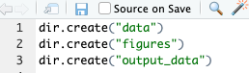

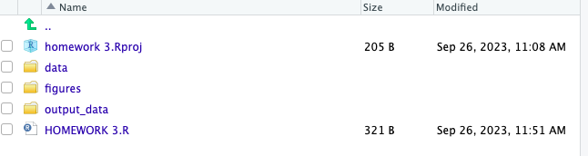

**1) Use R to figure out how many elements in the vector below are greater than 2.**

**rooms <- c(1, 5, 2, 1, 3, 1, NA, 3, 1, 3, 2, 1, NA, 1, 8, 3, 1, 4, NA, 1, 3, 1, 2, 1, 7, 1, NA)**

First i submitted the given list of rooms into R



Then i removed NA from the list, with the following code:



Then i used this code to find the values grater than 2

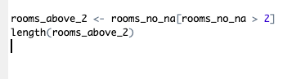

**2) Which function tells you the type of data the 'rooms' vector above contains?**

With the following code: class(rooms), i found that the type of data is numeric.



**3) What is the result of running the median() function on the above 'rooms' vector?**

If i run the median() function on rooms i get this result, since the value NA is still in this list



However when i run the same code with the value NA omitted this is the result:



The median = 2

**4) Submit the following image to Github: Inside your R Project (.Rproj), install the 'tidyverse' package and use the download.file() and read_csv() function to read the SAFI_clean.csv dataset into your R project as 'interviews' digital object (see instructions in** [**https://datacarpentry.org/r-socialsci/setup.html**](https://datacarpentry.org/r-socialsci/setup.html) **and 'Starting with Data' section). Take a screenshot of your RStudio interface showing**

* Først installeres tidyverse
* Herefter downloades filen
* Kommandoen “library(tidyverse)” aktiverer tidyverse
* Kommandoen “read_csv(“... finder filen på computeren og læser det i csv format
* Med den sidste kommando opstilles interview data som variable

**a) the line of code you used to create the object,**

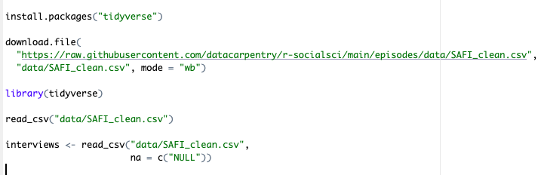

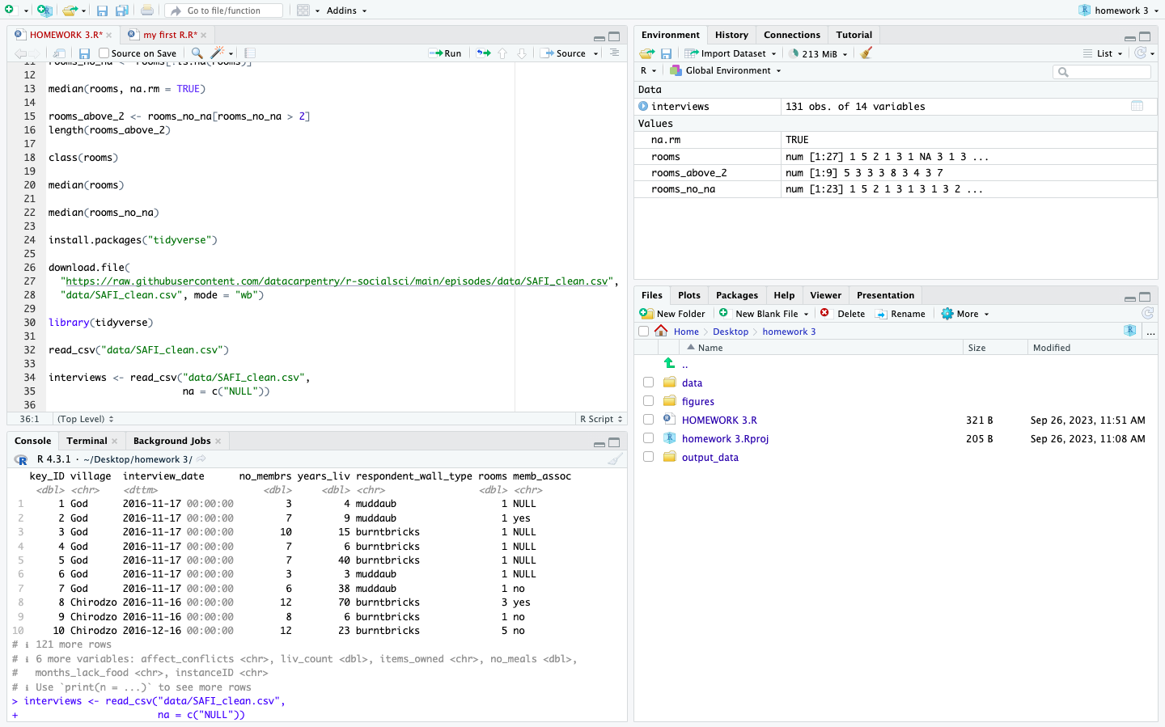

**b) the 'interviews' object in the Environment, and**

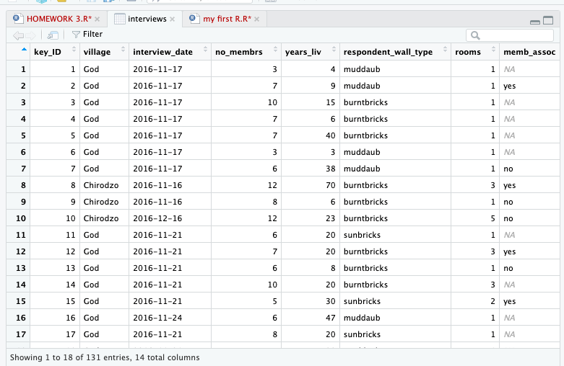

**c) the file structure of your R project in the bottom right "Files" pane.**

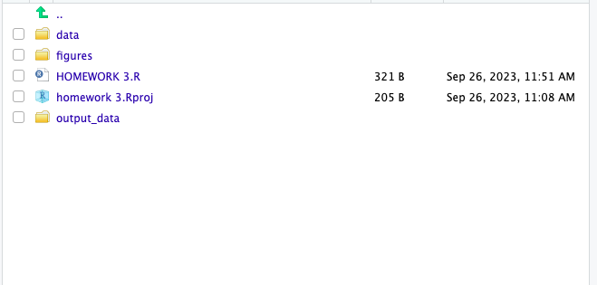

**Save the screenshot as an image and put it in your AUID_lastname_firstname repository inside our Github organisation (github.com/Digital-Methods-HASS) or equivalent. Place here the URL leading to the screenshot in your repository.**

Link til Github: https://github.com/Digital-Methods-HASS/AU611515_Lindegaard_Morten.git