**Homework week 46**

Task 1:

Use R to figure out how many elements in the vector below are greater than 2.

rooms <- c(1, 2, 1, 3, 1, NA, 3, 1, 3, 2, 1, NA, 1, 8, 3, 1, 4, NA, 1, 3, 1, 2, 1, 7, 1, NA)

Answer:

To find out how many elements are greater than 2 I started by by entering the follow code: rooms <- c(1, 2, 1, 3, 1, NA, 3, 1, 3, 2, 1, NA, 1, 8, 3, 1, 4, NA, 1, 3, 1, 2, 1, 7, 1, NA) to get R to make them a value

Then I entered the code: rooms_no_na <- na.omit(rooms) to remove the NA values

After that I used the code: rooms_no_na[rooms_no_na>2] that I did to get the values higher than 2. This wasn't a neccesery step, but I had to make sure that the next code showed the correct number

* The result of this code was: [1] 3 3 3 8 3 4 3 7

To get the number of elements over 2 I used the following code: max(rooms_no_na[rooms_no_na>2])

* The result of this code was that the number of elements higher than 2 was 8

Screenshots of the task in R:

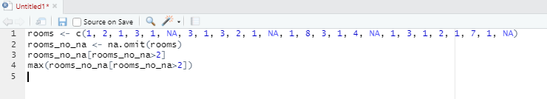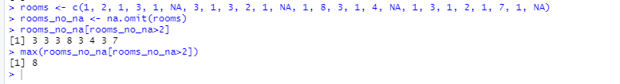

Task 2:

What **type** of data is in the 'rooms' vector?

Answer:

The data type is numeric

To get that answer I entered code: class (rooms)



Task 3:

What is the result of running the median()function on the above 'rooms' vector?

Answer:

When using the code: median (rooms) I got the result NA because I used a value where NA was present therefore it wasn't possible to get a median. Afterwards i used this next code: median(rooms_no_na) because that is the value without NA and i got the result 1.5

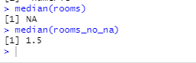

Task 4:

Submit the following image to Github: Inside your R Project (.Rproj), install the 'tidyverse' package and use the download.file() and read_csv() function to read the SAFI_clean.csv dataset into your R project as 'interviews' digital object (see instructions in https://datacarpentry.org/r-socialsci/setup.html and 'Starting with Data' section). Take a screenshot of your RStudio interface showing

a) the line of code you used to create the object,

b) the 'interviews' object in the Environment, and

c) the file structure of your **R project** in the bottom right "Files" pane.

Save the screenshot as an image and put it in your **AUID_lastname_firstname** repository inside our Github organisation (github.com/Digital-Methods-HASS) or equivalent. Place **here** the URL leading to the screenshot in your repository.

Answer:

How I created the object + the code to download the ‘tidyverse’ package:

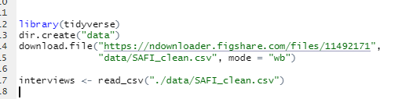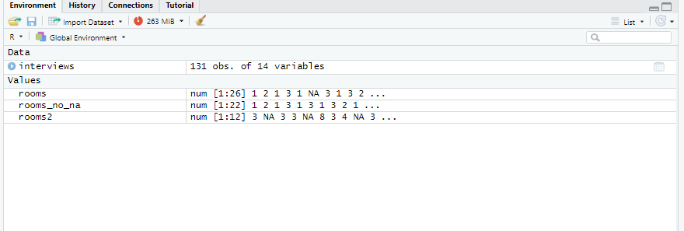

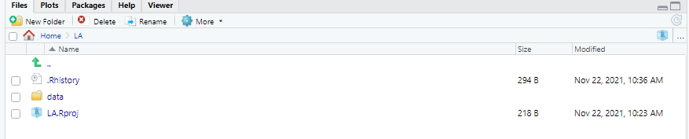

Since I already downloaded the ´tidyverse´ package in the class on Friday, the package is in R, but to get the package to show in this new project I used code: library(tidyverse)

I used the code: dir.create(“data”) to create a folder named data

The code: download.file("https://ndownloader.figshare.com/files/11492171",

"data/SAFI_clean.csv", mode = "wb") was used to download the dataset into the data folder

The code: interviews <- read_csv("./data/SAFI_clean.csv") made the data ‘Interview ‘ shown in the environment (as you can see in the screenshot)

URL to my Github:

<https://github.com/Digital-Methods-HASS/AU664481_Mikkelsen_Andreas.git>