**W46: Start with R**

**DESCRIPTION**

**Instructions: For this assignment, you need to answer a couple questions with code and then take a particular screenshot of your working environment.**

**You can submit the solutions including the URL to the screenshot typed up in a doc/pdf to Brightspace OR upload the document with solutions and the screenshot to your repository on Github and submit here (to Brightspace) only your Github URL (make sure your HW files are immediately findable there).**

**1) Use R to figure out how many elements in the vector below are greater than 2.**

**rooms <- c(1, 2, 1, 3, 1, NA, 3, 1, 3, 2, 1, NA, 1, 8, 3, 1, 4, NA, 1, 3, 1, 2, 1, 7, 1, NA)**

I create the room. Remove the NA and then use length command to find what is above the number 2.

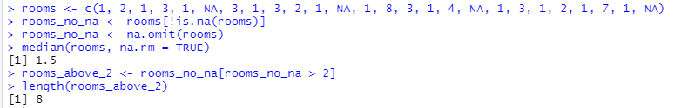

The answer is 8

**2) What type of data is in the 'rooms' vector?**

First, I use the command class(rooms) and the answer is numeric

**3) What is the result of running the median() function on the above 'rooms' vector?**

Use the command median(rooms)

And the answer gives NA, since it can’t do the command while there is NA in the vector.

**4) Submit the following image to Github: Inside your R Project (.Rproj), install the 'tidyverse' package and use the download.file() and read_csv() function to read the SAFI_clean.csv dataset into your R project as 'interviews' digital object (see instructions in https://datacarpentry.org/r-socialsci/setup.html and 'Starting with Data' section). Take a screenshot of your RStudio interface showing**

**a) the line of code you used to create the object,**

**b) the 'interviews' object in the Environment, and**

**c) the file structure of your R project in the bottom right "Files" pane.**

**Save the screenshot as an image and put it in your AUID_lastname_firstname repository inside our Github organisation (github.com/Digital-Methods-HASS) or equivalent. Place here the URL leading to the screenshot in your repository.**

Done

**5) Challenge: Tidy up your Danish monarchs dataset (you created last week) sufficiently so that you can load it into R as a tibble using the read_csv() or some other:) function and calculate the mean() and median() duration of rule over time.**