W46 start with R
1) Use R to figure out how many elements in the vector below are greater than 2.
rooms <- c(1, 5, 2, 1, 3, 1, NA, 3, 1, 3, 2, 1, NA, 1, 8, 3, 1, 4, NA, 1, 3, 1, 2, 1, 7, 1, NA)
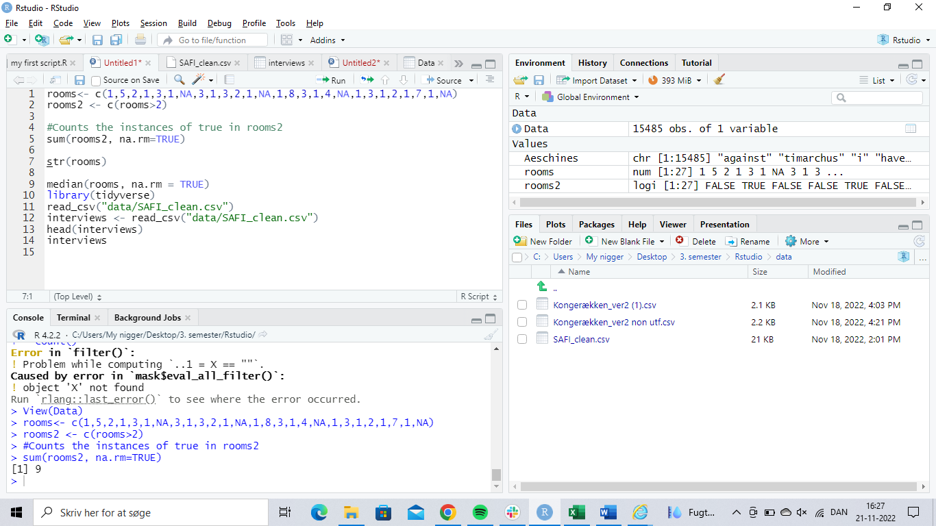
As shown above, I define the number string in question as “rooms” at line 1.
At line two I make a function, “rooms2” that finds all values in the “rooms” string that are above 2 and marks them as TRUE.
Line 5 counts the number of TRUE values found in “rooms2” which is shown in the console as 9, which checks out on manual counting.
2) Which function tells you the type of data the 'rooms' vector above contains?
Line 7 requests the structure of the “rooms” string, it is numerical or as the console calls it: num
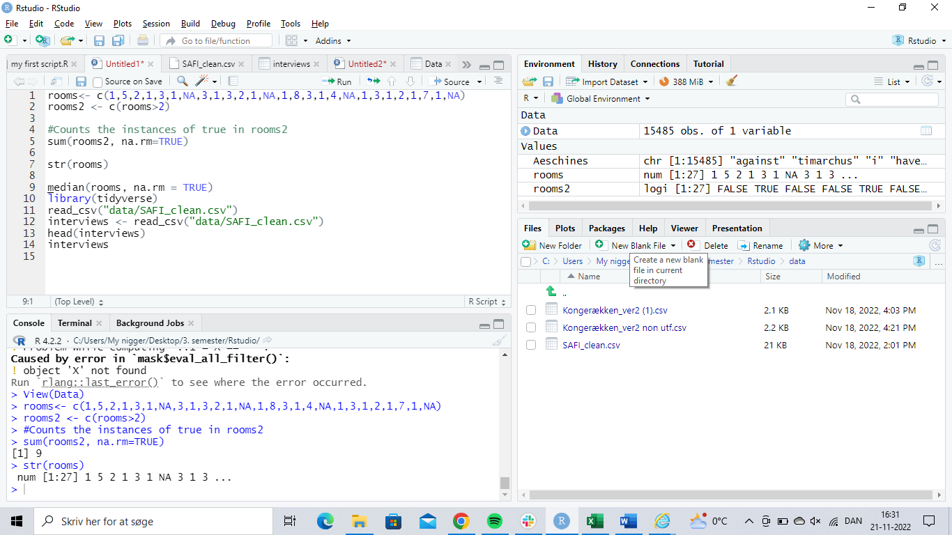

3) What is the result of running the median() function on the above 'rooms' vector?
Line 9 contains the median function, I exclude “na” since it would interrupt the calculation. The result is 2 as seen in the console.

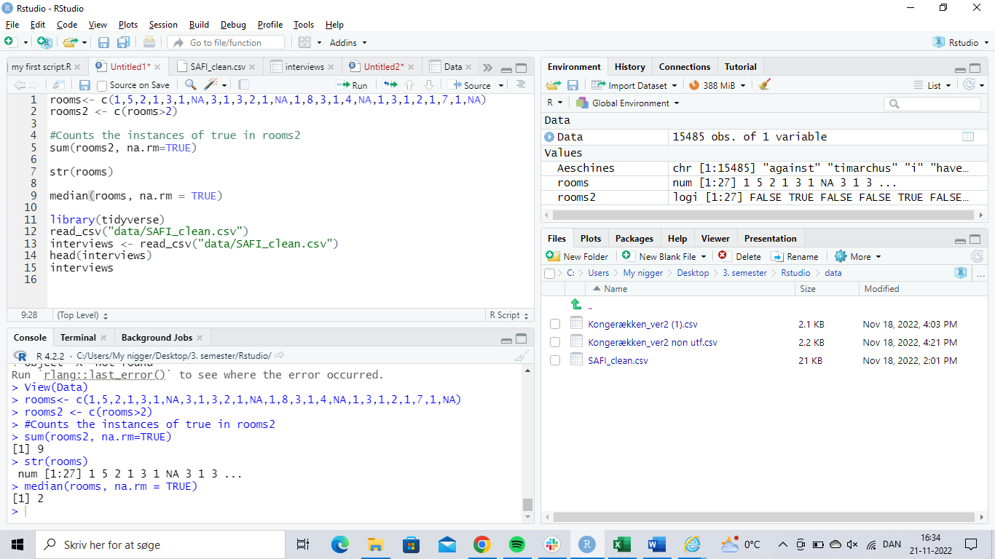

4) Submit the following image to Github: Inside your R Project (.Rproj), install the 'tidyverse' package and use the download.file() and read_csv() function to read the SAFI_clean.csv dataset into your R project as 'interviews' digital object (see instructions in https://datacarpentry.org/r-socialsci/setup.html and 'Starting with Data' section). Take a screenshot of your RStudio interface showing
a) the line of code you used to create the object,
b) the 'interviews' object in the Environment, and
c) the file structure of your R project in the bottom right "Files" pane.
Save the screenshot as an image and put it in your AUID_lastname_firstname repository inside our Github organisation (github.com/Digital-Methods-HASS) or equivalent. Place here the URL leading to the screenshot in your repository.
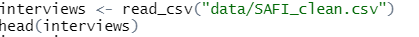
- Line 13 creates the following object
 