W9 starting with R
1) Use R to figure out how many elements in the vector below are greater than 2.
rooms <- c(1, 5, 2, 1, 3, 1, NA, 3, 1, 3, 2, 1, NA, 1, 8, 3, 1, 4, NA, 1, 3, 1, 2, 1, 7, 1, NA)
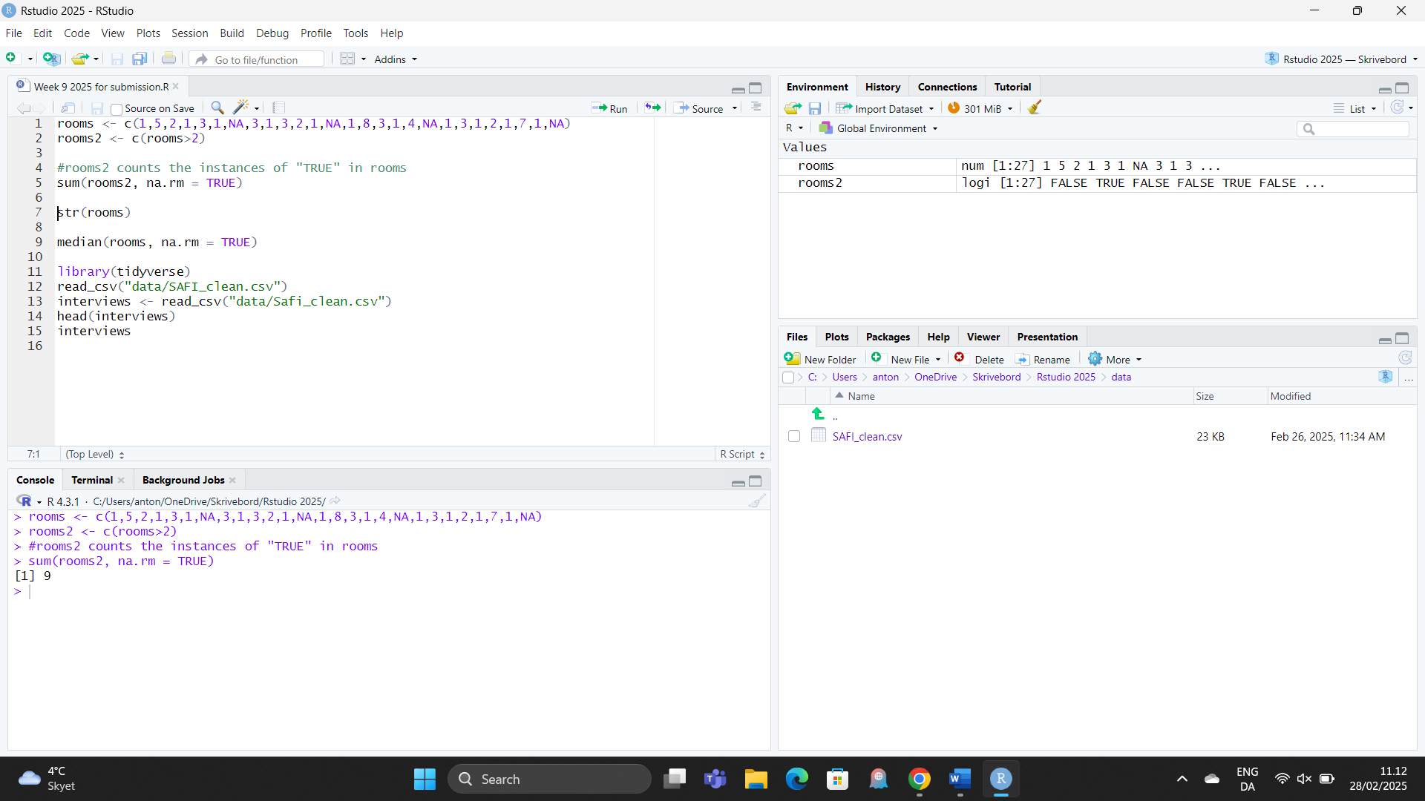
As shown in figure 1, I define the number string in question as “rooms” at line 1.
At line two I make a function, “rooms2” that finds all values in the “rooms” string that are above 2 and marks them as TRUE.
Line 5 counts the number of TRUE values found in “rooms2” which is shown in the console as 9, which checks out on manual counting.
2) Which function tells you the type of data the 'rooms' vector above contains?

Line 7 requests the structure of the “rooms” string, it is numerical or as the console calls it: num

Shown below
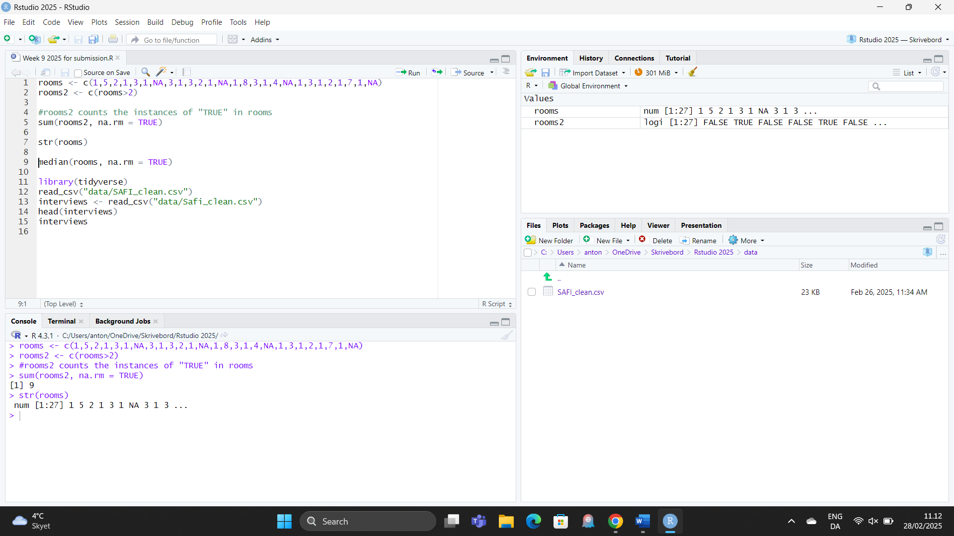

3) What is the result of running the median() function on the above 'rooms' vector?

Line 9 contains the median function, I exclude “na” since it would interrupt the calculation. The result is 2 as seen in the console.

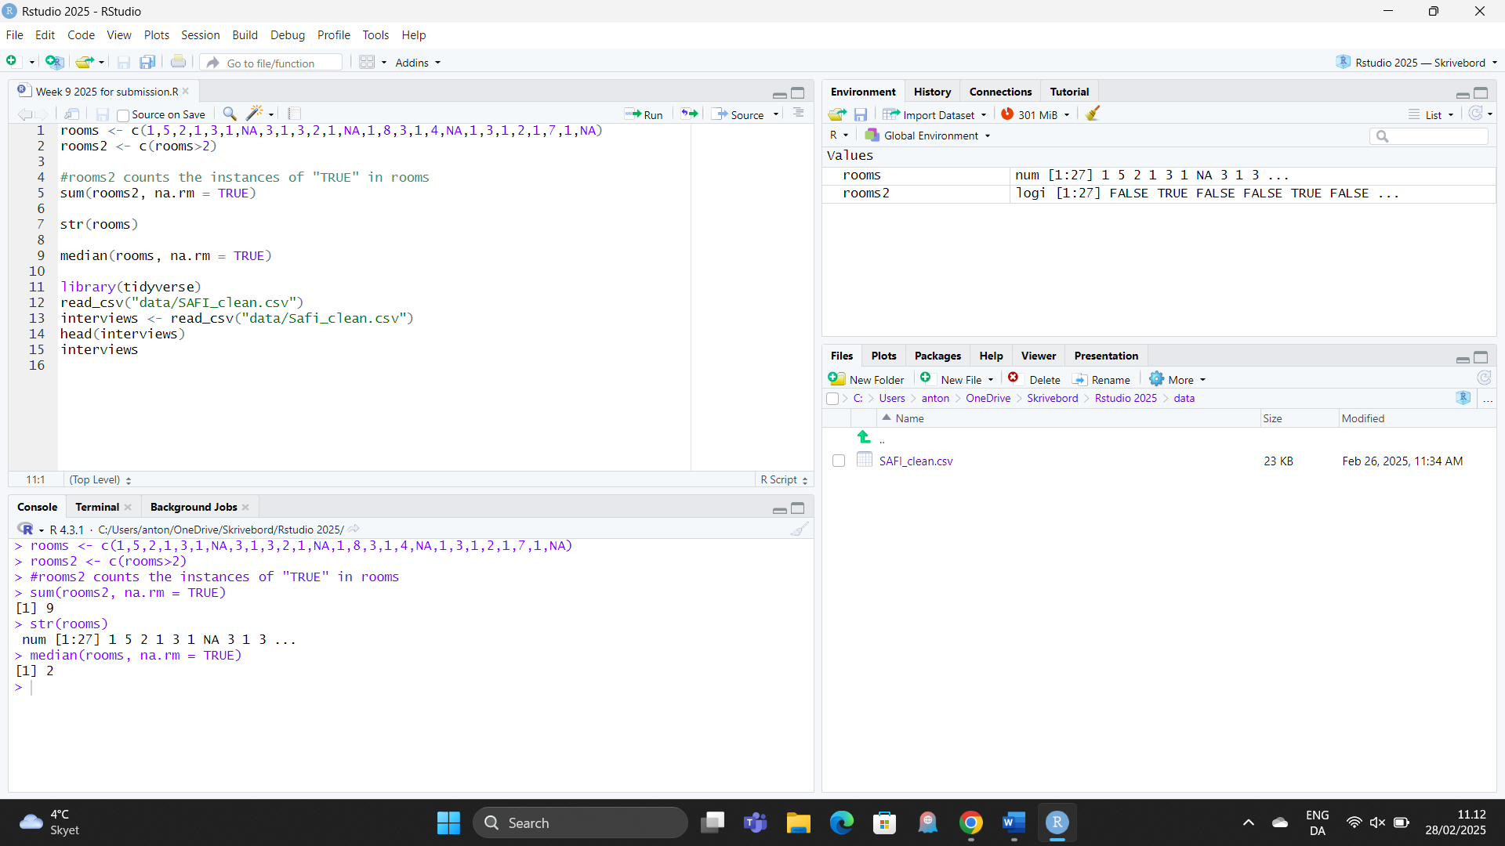

4) In order to submit a screenshot of RStudio, do the following first: Inside your R Project (.Rproj), install the 'tidyverse' package and use the download.file() and read_csv() function to read the SAFI_clean.csv dataset into your R project as 'interviews' digital object (see instructions in https://datacarpentry.org/r-socialsci/setup.html and 'Starting with Data' section). Take a screenshot of your RStudio interface showing
a) the line of code you used to create the object 'interviews', incl. the output in the console,
b) the 'interviews' object in the "Environment" top right pane , and
c) the file structure of your R project in the bottom right "Files" pane.
Save the screenshot as a .png image and put it in your AUID_lastname_firstname repository inside the class Github organisation (www.github.com/Digital-Methods-HASS) or equivalent. Place here the URL leading to the screenshot in your repository.
- Line 13 creates the “interviews” object as seen in the top right corner the console in bottom left 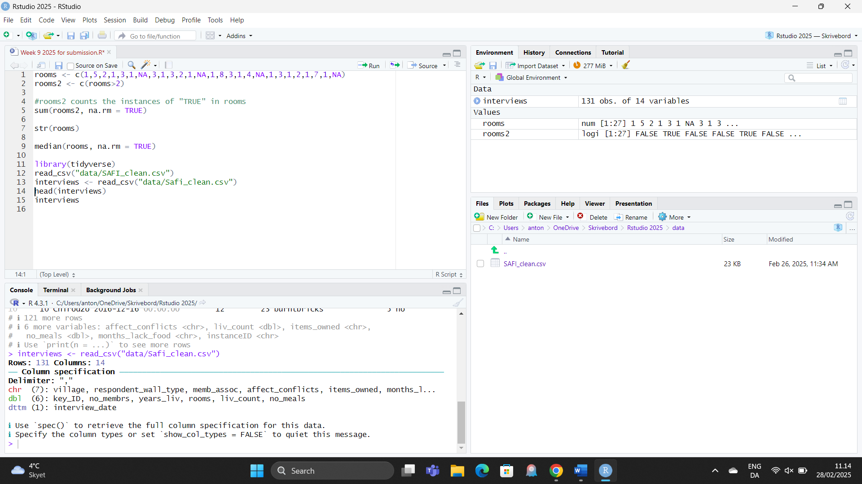
- Interviews still in top right pane left click it to view the data
- A seen above my pathing is: “C:Users/anton/onedrive/Skrivebord/data”
