Working environment: 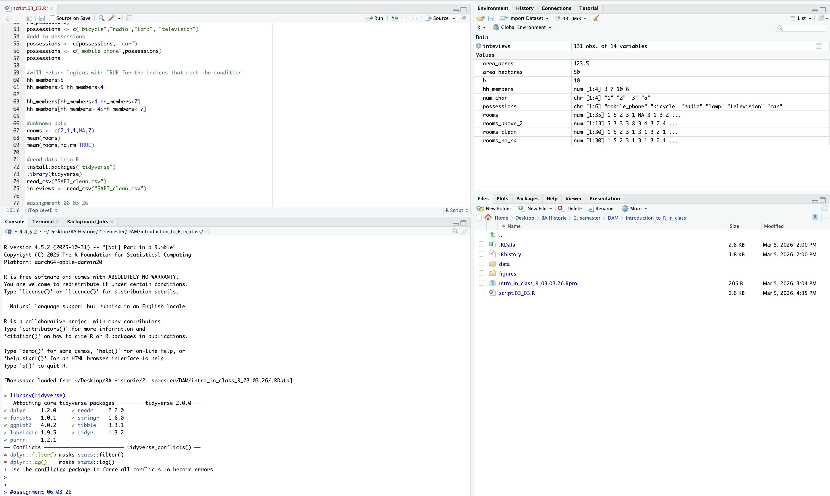
How many elements in the vector below are greater than 2?
rooms <- c(1, 5, 2, 3, 1, NA, 3, 1, 3, 2, NA, 1, 8, 3, 1, 4, NA, 1, 3, 1, 2, 1, 7, 1, NA, 4, 3 ,1 ,7 ,2 ,1 ,NA ,1, 1, 3)
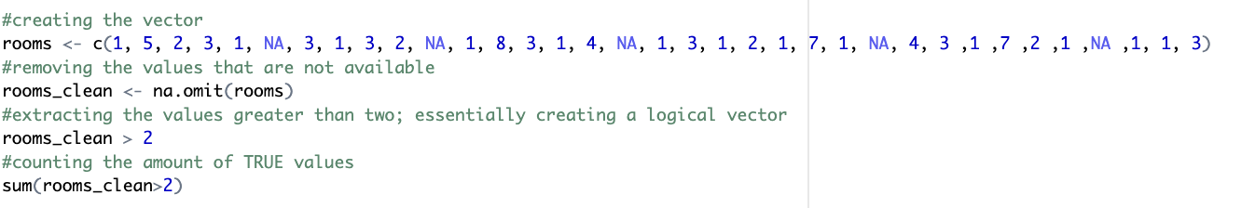
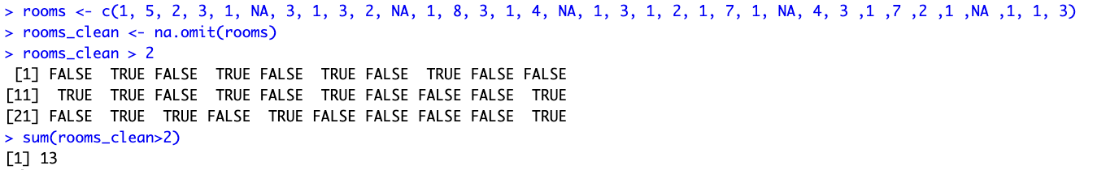
Which function tells you the type of data the 'rooms' vector above contains?
The function typeof(rooms) indicates the internal storage type of an object – the output from this function was: “double”, which essentially means that the vector contains numeric values stored as double precision numbers.
The function str(rooms) provides an overview of the structure of an object and its elements – the output from this function was: num [1:35] 1 5 2 3 1 NA 3 1 3 2 ..., which essentially displays as the scope of the data, and it determines that the type of data is numeric.

3) What is the result of running the median() function on the above 'rooms' vector?
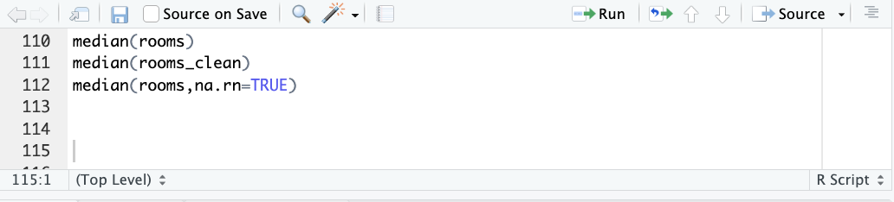
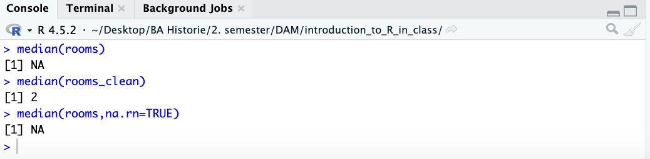
Running the median(rooms) function gives the output [1] NA
since the vector contains missing values, when removing the missing values by typing in and running the function median(rooms_clean) the output resulted in [1] 2.
The line of code creating the object 'interviews', incl. the output in the console
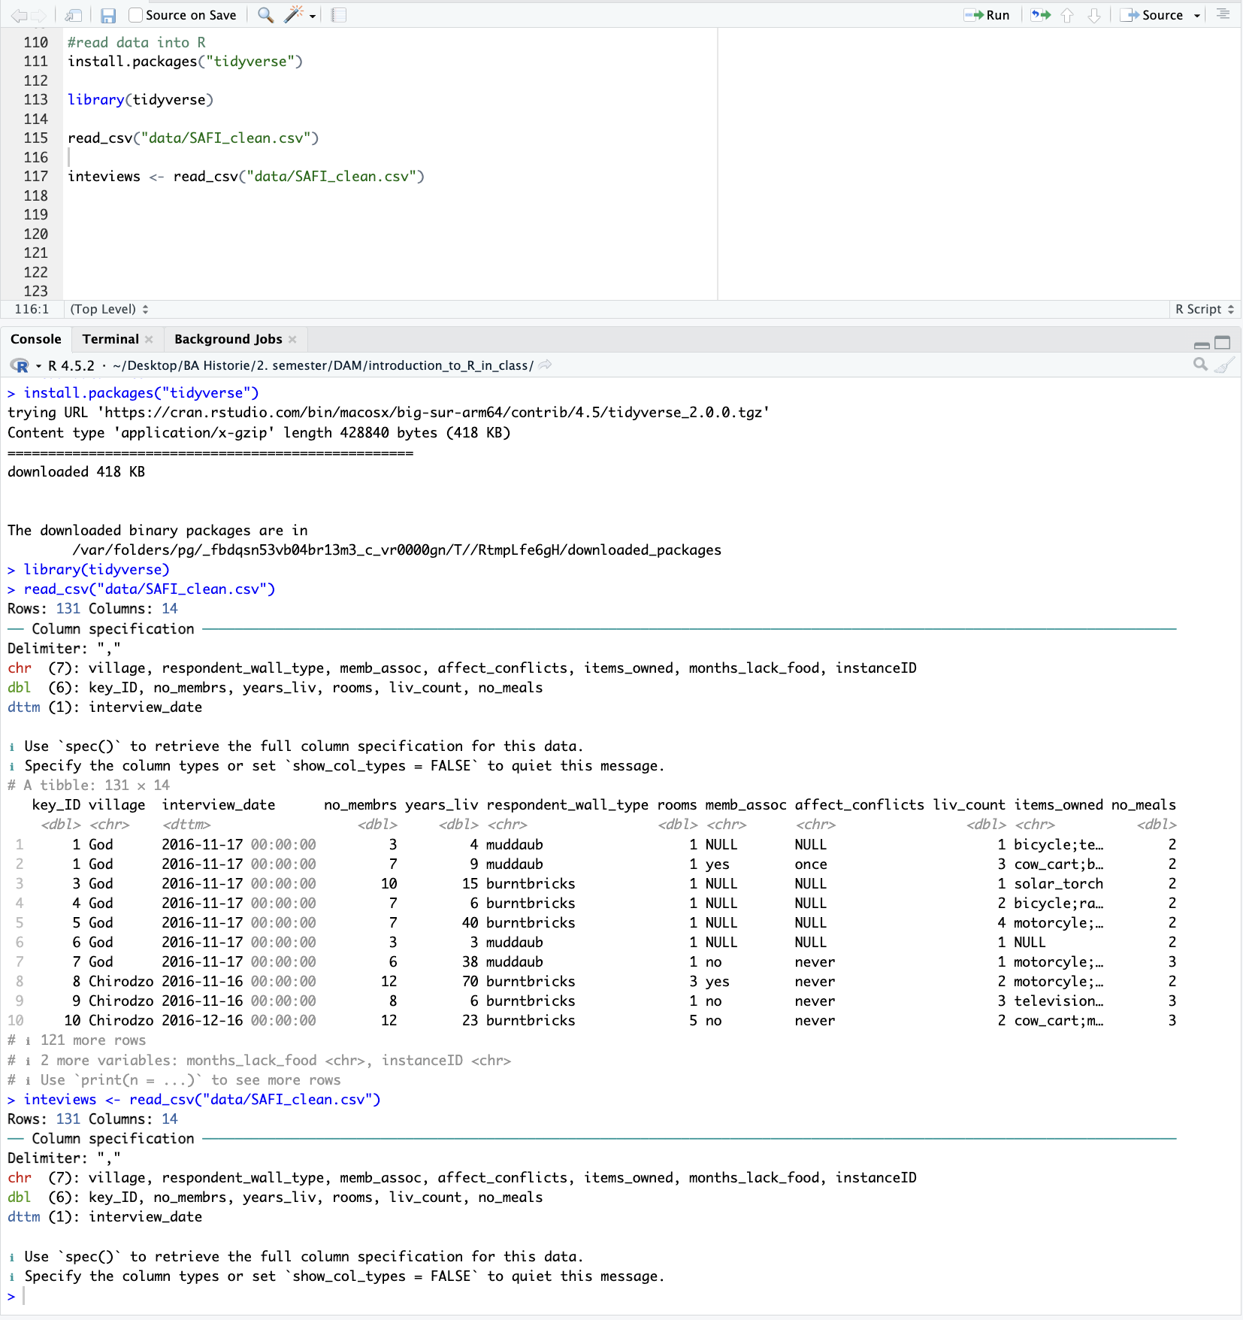
The environment pane:
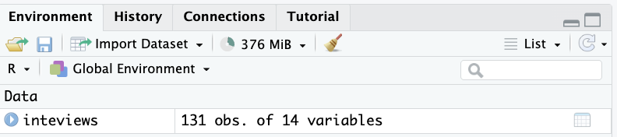
The files pane:
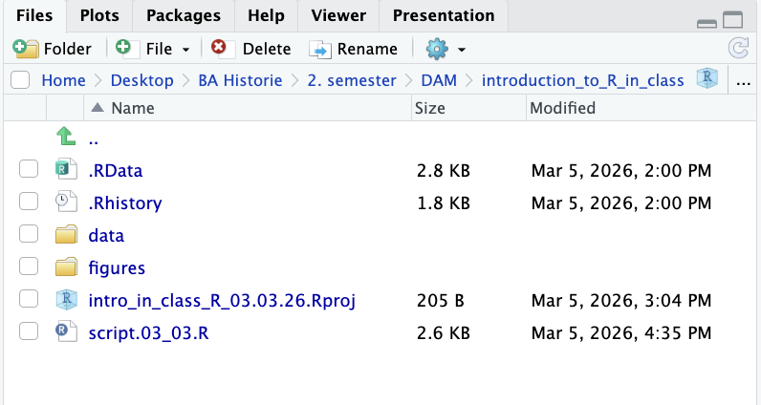
Analyzing the Danish Monarch dataset – calculating the mean() and median() duration of rule
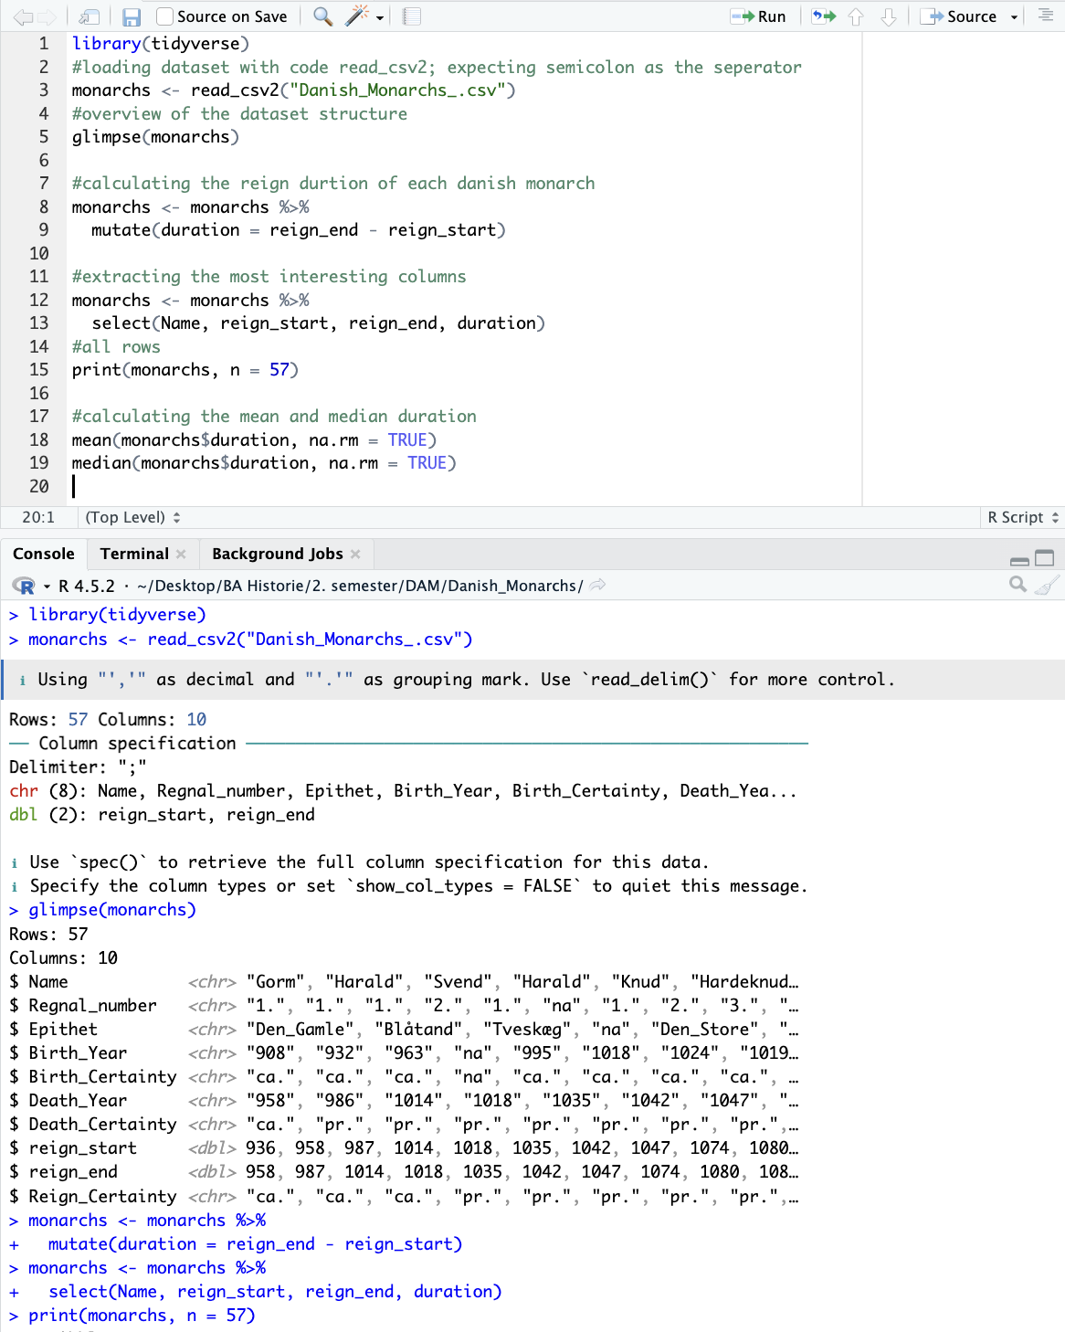
URL to the screenshot of the working environment;
file:///Users/helenahymoellerjensen/Desktop/BA%20Historie/2.%20semester/DAM/Screenshot_working_environment.png

