5:W35: Managing Files on Steroids with Shell

**DESCRIPTION**

Your supervisor has shared a [folder of photos on Sciencedata.dk](https://sciencedata.dk/shared/9ae5ccab83576b9c38d5852e7aab65a3)with you (password is 2020CDS, folder is 500Mb and contains 189 images) and needs your help with a couple diagnostics:

1. Identify the names and format of the 3 biggest files. Can you come up with a command to generate a numerically ordered list of 3 biggest files? (hint: consider using **wc** to gauge image size)

***1.1 ANSWER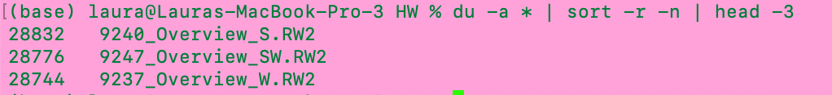***

*By using the line*: du -a \* | sort -r -n | head -3

*I found that the three files above are the biggest files. By manually inspection this appears to be true.*

1. Some of the image files are empty, a sign of corruption. Can you**find** the empty photo files (0 kb size), count them, and generate a list of their filenames to make their later replacement easier?

***2.1 ANSWER***

First, I find all the files that have size 0 by typing:

find . -name '\*.JPG' -size 0

The outcome of the above command will then be appended to a new directory called tinypics, in order to make it easier to replace them later on.

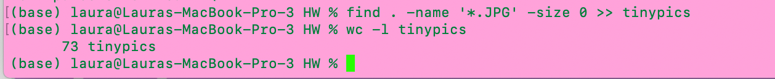

The length of the directory is then printed, and I find that 73 files has the size of 0 and are thus empty.

1. **Optional/Advanced:** Imagine you have a directory [goodphotos/](https://sciencedata.dk/shared/16112a12cc9f57ef697d4502448a3e60?download" \t "_blank) (same password as above) with original non-zero-length files sitting at the same level as the current directory. How would you write a loop to replace the zero length files?