Digital Archives and Methods Portfolio
Portfolio Exercises and Final Project
Markus Kyvsgaard
Group number: 42
5 August 2026
Submitted for Digital Archives and Methods at Aarhus University.

Portfolio overview
This portfolio contains four exercises completed during the course before the final project. The exercises show a progression from data cleaning and regular expressions, through basic R functions and CSV import, to text mining in RStudio. The final project develops these skills further by applying word-frequency and sentiment analysis to protest-song lyrics.
Element | Course exercise | Page
1 | Week 8 - Regular expressions and OpenRefine | 3
2 | Week 10 - Vectors, missing values, and median | 4
3 | Week 11 - CSV import and dataset inspection | 5
4 | Week 13 - Text mining and sentiment analysis | 6-7
5 | Final project report | 8-16
B | Required software and data metadata | 17-18

Submission structure
The portfolio is organised as a continuous submission containing four course exercises, the final project report, and the required metadata. The complete R project, data, figures, and script are available in the accompanying GitHub repository.
The permanent GitHub repository is listed in the software metadata section.

Portfolio Element 1 - Regular Expressions and OpenRefine
This exercise introduced regular expressions and data cleaning in OpenRefine.
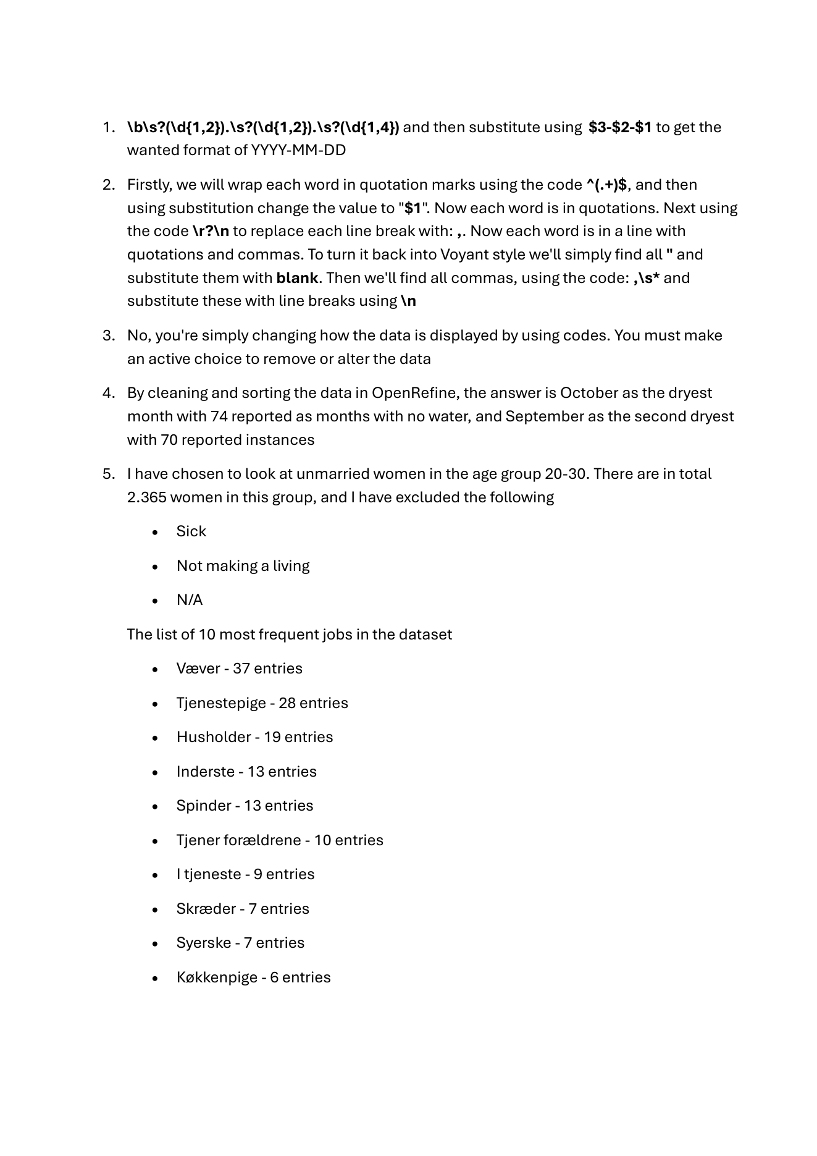

Portfolio Element 2 - Basic R Functions
Week 10 exercise. This task worked with a numeric vector containing missing values and used basic R functions to inspect and summarise it.
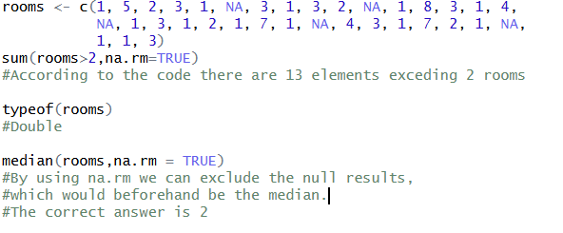
The exercise uses sum() with a logical condition to count values above two, typeof() to inspect the vector type, and median() with na.rm = TRUE to exclude missing values. The result shows thirteen entries above two and a median of two.
The exercise also clarified the difference between NA and NULL in R. The function median() uses na.rm = TRUE so that missing values do not affect the calculation.

Portfolio Element 3 - CSV Import and Dataset Inspection
This exercise focused on importing a CSV file and inspecting its structure in RStudio.
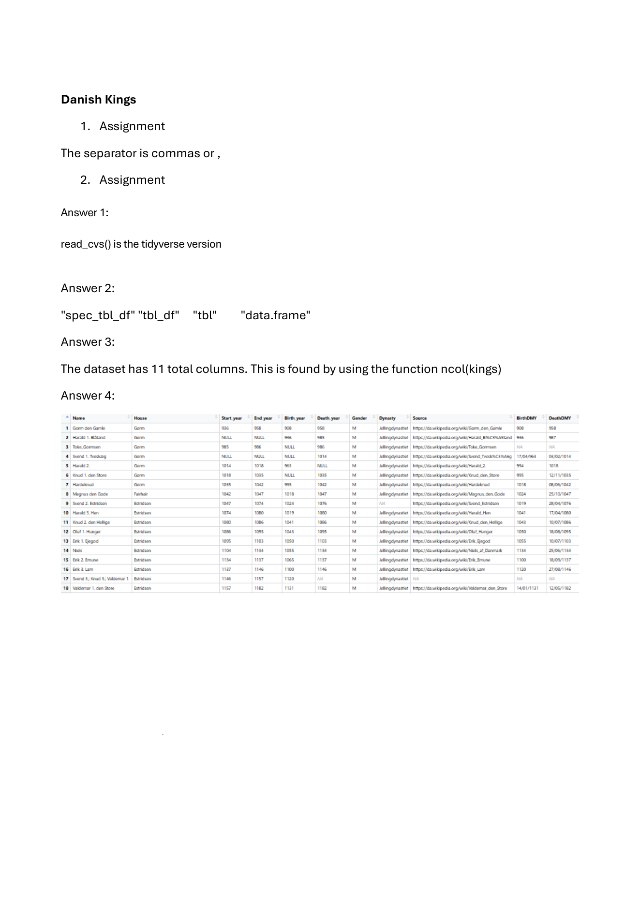

Portfolio Element 4 - Text Mining in RStudio
Week 13 exercise. The task used the text of A Game of Thrones to practise PDF extraction, tokenisation, stop-word removal, word counting, and sentiment analysis. The submitted R Markdown file and RStudio project are included in the accompanying portfolio source folder.
library(tidyverse)
library(here)
library(pdftools)
library(tidytext)
library(textdata)

got_path <- here("got.pdf")
got_text <- pdf_text(got_path)

got_df <- data.frame(got_text) %>%
mutate(text_full = str_split(got_text, pattern = "\n")) %>%
unnest(text_full) %>%
mutate(text_full = str_trim(text_full))

got_tokens <- got_df %>%
unnest_tokens(word, text_full)

got_stop <- got_tokens %>%
anti_join(stop_words)

got_swc <- got_stop %>%
count(word) %>%
arrange(-n)
The important step in this exercise is the change from a PDF into a structured list of words. Once the text is tokenised, common stop words can be removed and the remaining vocabulary can be counted. This is the same basic workflow later used in the final project, although the final project uses a much smaller and more controlled dataset.

Portfolio Element 4 - Output and Reflection
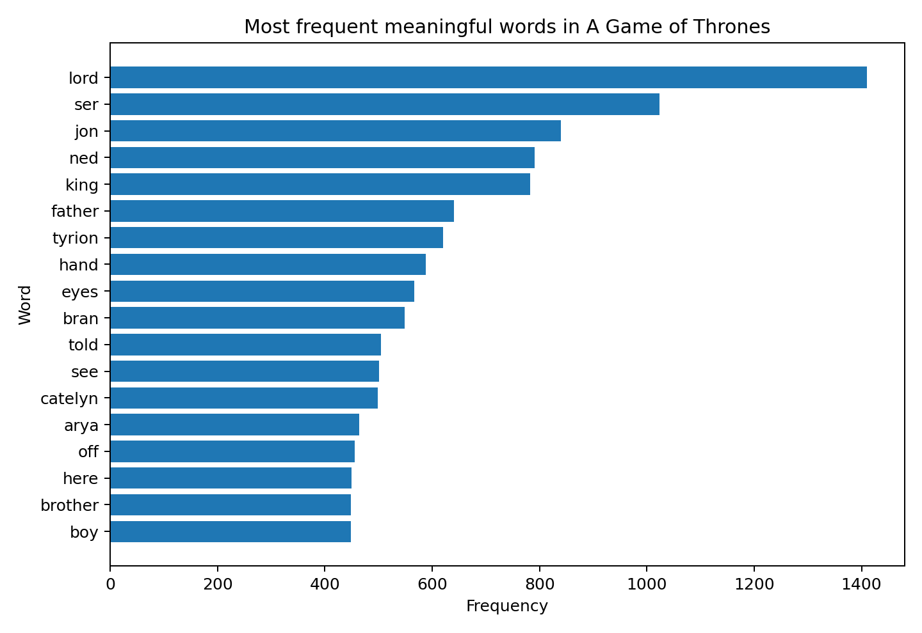
Figure P1. Frequent meaningful words in the submitted A Game of Thrones source after basic stop-word removal.
The output is dominated by character names, titles, and family relationships. This shows why word-frequency results have to be interpreted in relation to the source. A high count does not automatically make a word historically or thematically important; it may instead reflect the structure of a novel or the repeated appearance of major characters.
The exercise also introduced the AFINN sentiment lexicon. This helped prepare the later use of a lexicon-based sentiment method in the final project, while also showing a limitation: assigning a fixed score to individual words cannot fully recognise irony, context, or narrative voice.

