Anti-War Sentiment in Popular Music Lyrics During the Vietnam War

Introduction
Music is not only entertainment. It can also be used as a historical source, because lyrics often show what people were concerned about at a specific time. During the 1960s and early 1970s, the Vietnam War became one of the most controversial events in American society. Many young people were drafted into the army, television showed images from the war, and public trust in politicians weakened. In this period, popular music became an important way to express protest, frustration, and political criticism.
This analysis looks at how popular music lyrics reflected anti-war sentiment and political protest during the Vietnam War era. The central research question is: how did protest songs express opposition to war and political authority, and how can digital methods help analyse this development? The project uses twelve songs released between 1962 and 1970. It expects that many of the earlier songs use broader and more symbolic language, while several of the later songs refer more directly to war, soldiers, political leaders, and the unequal effects of the draft.
The goal is not to explain the development of protest music through numbers alone, but to use RStudio as a tool for finding patterns in the lyrics. Word counts and sentiment analysis make it possible to compare all of the selected songs in the same way. At the same time, the results still have to be interpreted historically. A graph can show that a word appears often, but it cannot explain irony, musical performance, or why the word mattered to listeners at the time. This is where close reading and historical context are still necessary.

Sources and Digital Archives
The main primary sources for this project are lyrics from well-known protest songs from the Vietnam War era. The selection contains twelve songs by artists including Bob Dylan, Creedence Clearwater Revival, Edwin Starr, John Lennon, Crosby, Stills, Nash & Young, The Doors, and Country Joe and the Fish. The songs were chosen because they deal with war, peace, political authority, military service, or the wider protest movements of the 1960s. They also represent different ways of protesting, ranging from broad moral questions to direct attacks on political leaders and military inequality.
The lyrics were collected from digital lyric websites such as Genius and AZLyrics, while Billboard was used to investigate chart performance. These websites are not traditional archives in the same way as a state archive, but they still function as digital collections of cultural material. They make lyrics searchable and easy to compare. However, they can also include transcription mistakes, and they often focus on famous artists. Lesser-known protest singers may therefore be missing. The exact webpage used for every lyric was not recorded when the dataset was first created, and the metadata states this limitation rather than assigning uncertain sources afterwards.
Chart information can still help show whether a song reached a broad audience. For example, Billboard records that both “Fortunate Son” and “Give Peace a Chance” reached number 14 on the Hot 100. Chart position does not prove that listeners agreed with the political message, but it does show that the songs circulated beyond small activist groups.

Dataset and Metadata
The dataset contains twelve songs released between 1962 and 1970. Five songs are placed in an early group covering 1962 to 1965, while seven are placed in a later group covering 1968 to 1970. This division makes the comparison manageable, but it should not be understood as a complete history of protest music. The accompanying metadata file records each song’s title, artist, year, period, word count, and the available information about where the lyric record came from. This makes the selection easier to inspect and shows which decisions shaped the dataset before the analysis began.
Song | Artist | Year | Group
Where Have All the Flowers Gone | Peter, Paul and Mary | 1962 | Early
Blowin' in the Wind | Bob Dylan | 1963 | Early
Masters of War | Bob Dylan | 1963 | Early
The Times They Are a-Changin' | Bob Dylan | 1964 | Early
Eve of Destruction | Barry McGuire | 1965 | Early
The Unknown Soldier | The Doors | 1968 | Later
Fortunate Son | Creedence Clearwater Revival | 1969 | Later
Give Peace a Chance | John Lennon | 1969 | Later
21st Century Schizoid Man | King Crimson | 1969 | Later
War | Edwin Starr | 1970 | Later
Ohio | Crosby, Stills, Nash & Young | 1970 | Later
I-Feel-Like-I'm-Fixin'-to-Die Rag | Country Joe and the Fish | 1970 | Later

Method: Using RStudio for Text Analysis
The method used is a word-frequency analysis followed by a basic sentiment analysis in RStudio. The lyrics are placed in a CSV file with columns for song title, artist, year, and lyrics. RStudio then splits the lyrics into individual words, removes common stop words, and counts which words appear most often. This makes the analysis more systematic, because it looks across all twelve songs instead of only selecting individual lines that support the argument.
The original CSV uses semicolons as separators. It is therefore imported with read_csv2(), which is the tidyverse version suited to this format. The lyrics are then split into single words with tidytext. Common stop words such as “the”, “and”, and “is” are removed, together with a short list of vocal fillers such as “yeah”, “huh”, and “oh”. The cleaned words are counted and used to create Figure 1. The Bing lexicon is then used for the sentiment figures.
The full code is kept in the accompanying R file rather than being printed across several pages of the paper. The project folder also contains the dataset, metadata, figures, and a RStudio project file. The script creates the figure and output folders automatically and saves the result tables. Keeping these files together means that another person can follow the same steps and reproduce the figures instead of having to reconstruct the method from screenshots or isolated pieces of code.

Historical Context
Opposition to the Vietnam War did not develop at one single moment. John Mueller’s study of American public opinion found that support was initially relatively high but declined as American casualties increased. The draft made the war personal for young Americans, while television and newspapers made the conflict more visible at home. Research by Paul Burstein and William Freudenburg also shows that public opinion, demonstrations, and the cost of the war became connected to political decision-making in the United States.
The year 1965 is useful as a historical turning point because American involvement changed in scale. The United States had already supported South Vietnam with money, equipment, and military advisers, but large numbers of American combat troops were deployed from 1965, while the bombing campaign also grew. The war therefore became harder to treat as a distant foreign-policy issue. More families were affected by the draft and by growing casualty numbers, and the conflict became part of everyday political debate. This does not mean that protest began in 1965, but it helps explain why later songs could refer more directly to soldiers, military service, political leaders, and events connected to Vietnam.
The division into an early and a later group is therefore meant as an analytical tool rather than a strict border. The early group runs from 1962 to 1965, while the later group begins in 1968 because the selected dataset does not contain songs from 1966 or 1967. This gap is a limitation and means that the comparison cannot show a smooth year-by-year development. Instead, it compares a group of songs written before or around the major escalation with a group written after the war had become longer, more visible, and more controversial. The groups are useful for identifying broader tendencies, but they should not be understood as complete categories into which every protest song would fit.
Music became part of this political environment because it could carry ideas in a form that was emotional, memorable, and easy to repeat. Ron Eyerman and Andrew Jamison argue that music does not only reflect social movements; it can also help create collective identity and keep traditions of protest alive. Michael Kramer similarly connects rock music and the counterculture to debates about citizenship and political participation during the 1960s. These arguments are useful here because the songs in the dataset were not only comments on the war. Several of them were also performed, repeated, and used in situations where people gathered around a shared political message.
Contemporary historical material is especially useful for understanding “Ohio”. The National Archives explains how the expansion of the war into Cambodia intensified anti-war activity and was followed by the killing of four students at Kent State on 4 May 1970. “Ohio” was written as an immediate response to that event. This gives the song a different relationship to history than a broader song such as “Blowin’ in the Wind”, which could be connected to several political causes.
The growth of mass media also mattered. Radio, television, records, and music magazines helped spread protest songs to a large audience. Political ideas could therefore move through popular culture, not only through speeches, newspapers, or political organisations. This did not mean that every listener agreed with the songs, but it made protest music part of the wider public debate about the war.
This wider circulation also changed the relationship between music and political participation. A song could be heard privately on the radio or a record, but the same chorus could later be repeated at a demonstration or meeting. In that sense, protest music connected individual listening with collective political expression. However, circulation and influence are not the same thing. Chart success can show that a song reached a broad audience, but it cannot tell us whether listeners accepted its argument, ignored the political meaning, or simply liked the music. Contemporary reviews, interviews, and audience surveys would be needed to study that question more closely.

Analysis

Word Frequency
As shown in Figure 1, the word “war” appears much more often than any other word in the dataset. This is not surprising, since war is the main subject connecting the selected songs. Still, the size of the difference needs some explanation. Edwin Starr’s “War” repeats the word throughout its chorus, meaning that one song has a strong effect on the overall count. The figure therefore shows both the importance of war as a theme and a limitation of simple word counting: repeated choruses can make one song influence the full result more than the others.
Other common words include “friend”, “destruction”, “dead”, “soldier”, and “peace”. These words fit the overall subject, but they do not all carry the same meaning. The frequent use of “dead”, “destruction”, and “soldier” shows the connection between the lyrics and themes of violence and military conflict. “Friend” is more difficult to interpret. It may suggest solidarity, but in some songs it is simply part of a repeated line. Looking at the figure is therefore useful for finding patterns, but close reading is needed before deciding what those patterns mean.
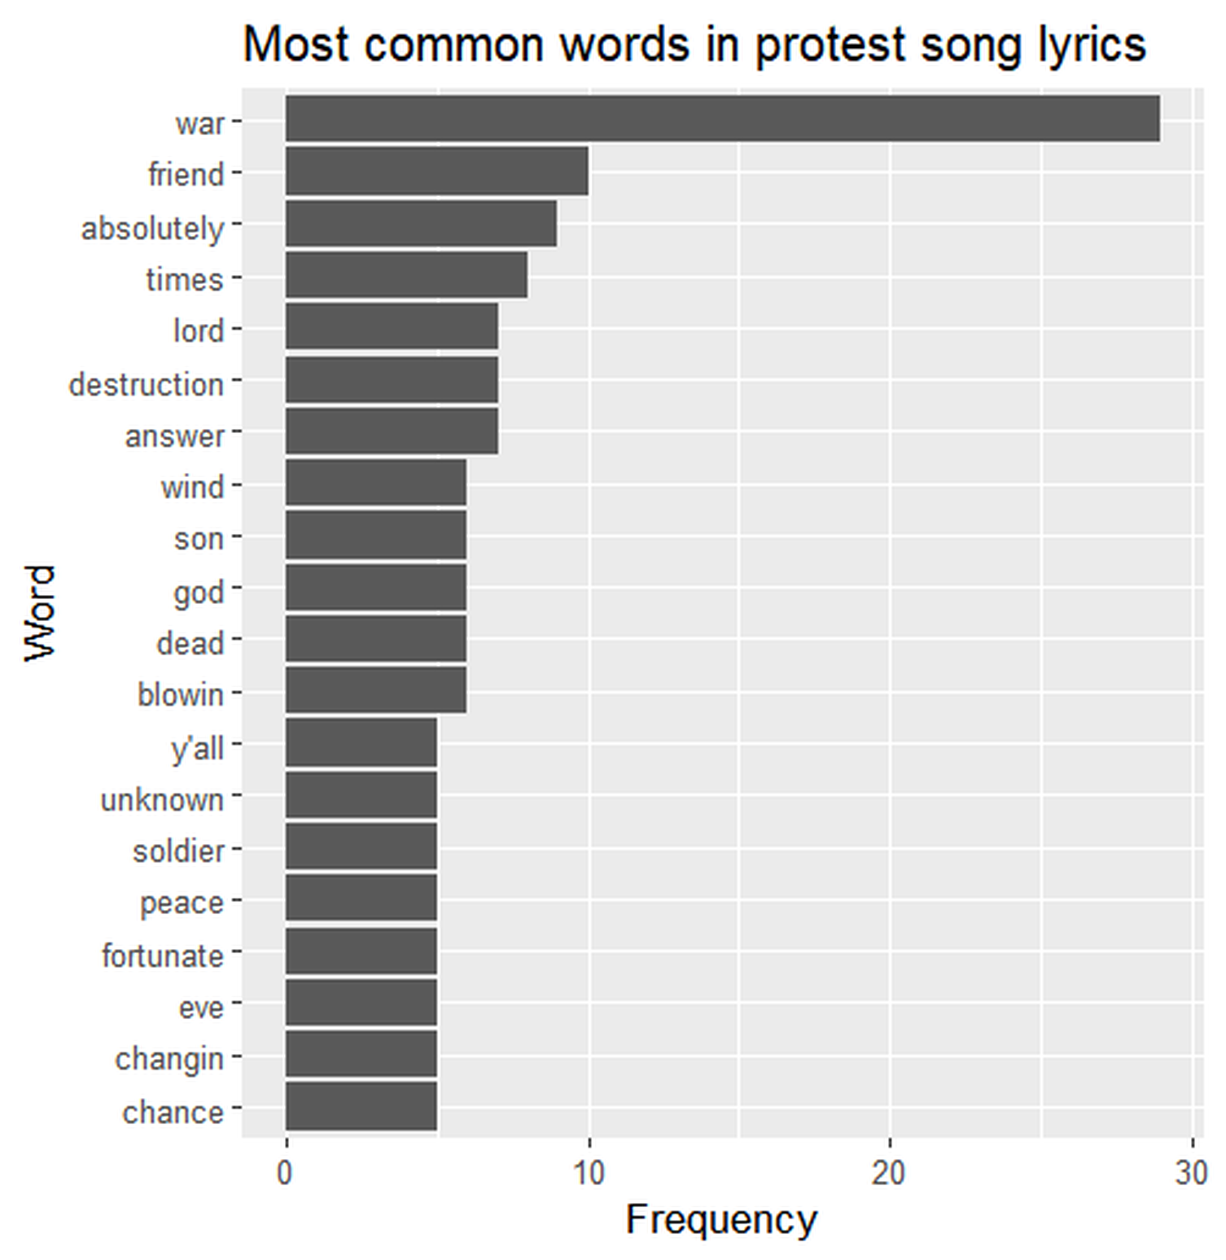
Figure 1. Most common words in the twelve selected songs after stop-word removal.

Early Songs: Moral Questions and Direct Anger
Early protest music often used broad moral questions instead of direct references to Vietnam. “Where Have All the Flowers Gone” presents war as a repeating cycle, while Bob Dylan’s “Blowin’ in the Wind” asks questions about peace, freedom, death, and responsibility. Because the lyrics are open and symbolic, they could be connected to different political movements, including civil rights and anti-war activism. This kind of protest is powerful because it does not depend on one specific event. Instead, it presents war and injustice as wider moral problems.
However, the difference between early and later songs is not completely straightforward. “Masters of War”, released in 1963, is already direct and angry. It attacks those who plan wars while remaining protected from their consequences. This is important because it prevents the paper from making an overly simple claim that early protest was always indirect. Dorian Lynskey’s wider history of protest songs also shows that direct political criticism existed before the major escalation of the Vietnam War.

Later Songs: War, Inequality, and Immediate Events
As the Vietnam War continued, several protest songs became more closely connected to the draft, political leaders, and specific events. Creedence Clearwater Revival’s “Fortunate Son” criticises the unequal burden of military service. The song argues that wealthy and politically connected families could avoid the same risks faced by ordinary people. This makes the song not only anti-war, but also a criticism of class inequality inside the United States. It shows how protest music could connect foreign policy with domestic social problems.
Edwin Starr’s “War” uses a much simpler and more direct strategy. Its central message is repeated until it becomes almost impossible to misunderstand. The song focuses on destroyed lives, grieving families, and the effect of war on a younger generation. “I-Feel-Like-I’m-Fixin’-to-Die Rag” approaches the same subject through dark humour and sarcasm. Together, these songs show that later anti-war music could be direct without always using the same tone.
Crosby, Stills, Nash & Young’s “Ohio” is the most event-specific song in the dataset. It names Nixon and refers to the four students killed at Kent State. The lyrics do not give a detailed account of the shootings. Instead, they turn the event into a short and urgent political statement. In this way, the song works almost like a musical newspaper response: it reacts quickly to a contemporary event and makes it part of popular culture.
The songs were divided into two groups to make it easier to compare how protest music changed during the Vietnam War. The first group contains songs released before the large-scale American troop deployment in 1965, while the second group contains songs released after this point. This division was chosen because the role of the United States changed significantly during these years. Before 1965, many protest songs focused on broader themes such as peace, war in general, and moral responsibility. As the war escalated and more American soldiers were sent to Vietnam, the lyrics increasingly became more direct in their criticism of the war, the draft, and political leadership. Looking at the songs in two periods therefore makes it easier to see whether these historical developments are also reflected in the language used.
Looking across the two groups, the difference is clearest in how closely several songs attach their criticism to particular political circumstances. The early group often discusses war through repeated cycles, moral questions, or criticism of those who profit from conflict. The later group includes more references to soldiers, the draft, Nixon, and events that listeners could connect directly to the ongoing war. This does not create a perfect chronological progression. “Masters of War” is already extremely direct in 1963, while “Give Peace a Chance” continues to use broad and hopeful language in 1969. The comparison therefore suggests a growing connection to Vietnam and immediate politics rather than a complete replacement of one protest style by another.
The uneven number and length of songs in each group also affects the comparison. Five songs are placed in the early group and seven in the later group, and songs with repeated choruses contribute more words than shorter songs. For that reason, the groups are mainly used together with close reading rather than as a statistical measurement of all protest music. A larger study could compare equal numbers of songs, normalise frequencies by the total number of words in each group, and test whether the result changes when highly repetitive songs such as “War” are removed.

Sentiment Analysis
The sentiment analysis, shown in Figures 2 and 3, finds more negative than positive words across the selected songs. This fits the general subject of war and political protest. That said, not every song follows exactly the same pattern. “Give Peace a Chance” contains more hopeful and collective language, while songs such as “Eve of Destruction” and “Masters of War” contain a larger number of words classified as negative. Figure 3 is useful because it shows that the overall result is not created equally by every song.
The results still have to be treated carefully. The Bing lexicon assigns individual words a fixed positive or negative value, but it cannot recognise sarcasm, tone, historical context, or the difference between describing violence and supporting it. Repeated choruses also give some words more weight. Sentiment analysis is therefore used as supporting evidence rather than proof that one song or one period was emotionally more negative than another.
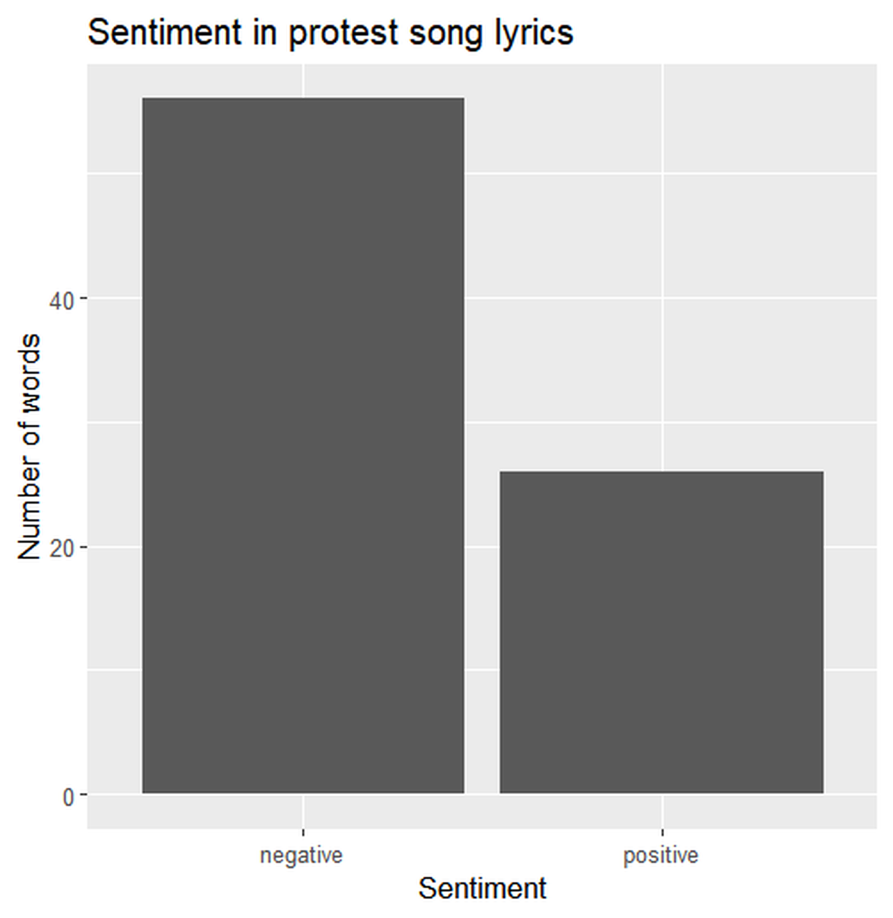 | 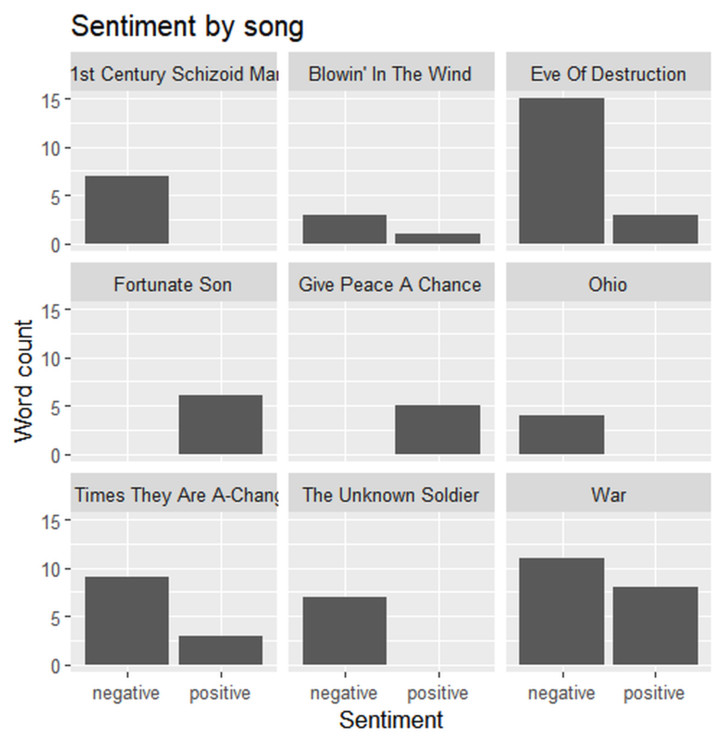
Figures 2 and 3. Overall sentiment and sentiment divided by song.

Music as Mobilisation
Protest music did not only reflect the political attitudes of the time; it could also help people express them together. Songs were performed at demonstrations, shared through mass media, and used as tools for collective expression. Eyerman and Jamison’s argument about music and collective identity fits “Give Peace a Chance”, whose repeated chorus could easily be sung by a crowd. The song does not explain the war in detail, but it gives people a simple and shared language of protest.
Chart success and mass media also mattered because they allowed political messages to move beyond small activist groups. If a protest song appeared on the Billboard chart, this shows that it reached a broader audience. However, popularity should not automatically be treated as evidence that listeners agreed with the message. People could buy or hear a song for many different reasons. Billboard can show circulation, while audience agreement and political effect would require other historical sources, such as contemporary reviews, interviews, letters, or opinion surveys.

Discussion: Strengths and Limits of the Digital Method
The RStudio analysis is useful because it makes the study of lyrics more systematic. It applies the same procedure to every song, identifies repeated vocabulary, and makes it easier to compare several lyrics at once. Saving the steps in a script also means that the analysis can be repeated. This is where digital methods are especially useful: they can reveal patterns that may be difficult to notice when reading twelve songs separately.
This approach also changes how the sources are first approached. A traditional close reading might begin with the most famous lines from one or two songs. The digital method instead begins by treating every lyric in the dataset according to the same rules. That makes the selection of examples less dependent on memory and can draw attention to words or contrasts that deserve further reading. The result is not an automatic explanation, but a way of deciding where historical interpretation should begin.
However, the method also has clear limits. A word-frequency graph cannot explain irony, tone, musical performance, or how an audience reacted. The dataset itself also shapes the result. Twelve well-known songs cannot represent the entire anti-war movement, and the selection is uneven across genre, nationality, race, gender, and political viewpoint. Repeated choruses can make one song dominate a word count. Digital results are therefore shaped by decisions made before the code is run, including which songs were selected, which version of each lyric was used, and which words were removed.
Another limitation is that the method mainly analyses written lyric transcriptions. Protest music also gains meaning through sound, delivery, genre, performance, and the situation in which it is heard. Sarcasm in “I-Feel-Like-I’m-Fixin’-to-Die Rag”, for example, is much clearer in performance than in a simple list of words. The analysis therefore works best when it is used to support, rather than replace, close reading and historical source criticism.
The original expectation is only partly supported. Several later songs are more closely connected to Vietnam, the draft, soldiers, and specific events. However, “Masters of War” shows that direct political anger was already present in 1963. The development is therefore not a simple movement from indirect to direct protest. A more careful conclusion is that protest music became more event-specific and more closely connected to the Vietnam conflict as the war intensified, while broader moral criticism continued alongside it.

Conclusion
Popular music was an important part of anti-war protest during the Vietnam War era, but the selected songs show that protest did not take only one form. Some songs use broad questions about peace, freedom, and responsibility. Others attack political privilege, describe the destruction caused by war, or respond directly to events such as the Kent State shootings. The analysis therefore supports the idea that later protest songs often became more closely connected to Vietnam and specific political issues. At the same time, “Masters of War” shows that direct political criticism was already present before the major escalation of the conflict.
Digital methods help make parts of this development visible. Word-frequency analysis shows which terms appear repeatedly across the dataset, while sentiment analysis gives a basic comparison of positive and negative language. These methods do not replace traditional historical analysis. They cannot explain sarcasm, performance, audience reception, or the meaning of a line in its full context. Their main value is that they provide a systematic starting point and make it possible to compare several songs using the same procedure.
The project also shows why documentation matters in digital history. Keeping the lyrics, metadata, R script, figures, and instructions together allows another person to see how the results were produced and to repeat the analysis. The dataset remains limited and mainly represents well-known protest music, but it provides a manageable example of how cultural sources can be studied both as historical texts and as digital data. A larger project could include more songs, lesser-known performers, contemporary reviews, and information about audience reception. This would make it possible to test whether the patterns found here also appear beyond the twelve songs used in this project.
The comparison between the two periods is one of the main lessons from the project. The later songs are often more event-specific and more directly tied to the American experience of Vietnam, but the material does not support a simple story in which symbolic protest suddenly became direct after 1965. Different forms continued alongside each other, and individual artists used very different strategies. This makes protest music useful as a historical source because it shows both changes over time and disagreement within the same political culture.
More broadly, the project shows that digital and traditional historical methods can strengthen each other. RStudio makes repeated vocabulary and broad differences easier to identify, while historical context explains why those differences may matter. Neither approach is sufficient by itself. A larger investigation could add lesser-known performers, women artists, African American protest music, songs supporting the war, and material from outside the United States. It could also compare lyrics with contemporary newspapers, reviews, concert reports, and interviews. That would make it possible to move from the language of protest songs toward a fuller study of how the music was produced, circulated, and understood.

References
Burstein, Paul, and William Freudenburg. 1978. “Changing Public Policy: The Impact of Public Opinion, Antiwar Demonstrations, and War Costs on Senate Voting on Vietnam War Motions.” American Journal of Sociology 84 (1): 99–122.
Eyerman, Ron, and Andrew Jamison. 1998. Music and Social Movements: Mobilizing Traditions in the Twentieth Century. Cambridge: Cambridge University Press.
Kramer, Michael J. 2013. The Republic of Rock: Music and Citizenship in the Sixties Counterculture. Oxford: Oxford University Press.
Lynskey, Dorian. 2011. 33 Revolutions per Minute: A History of Protest Songs. New York: Ecco.
Mueller, John E. 1971. “Trends in Popular Support for the Wars in Korea and Vietnam.” American Political Science Review 65 (2): 358–375.
National Archives. “Episode 9: Crossing into Cambodia.” Remembering Vietnam online exhibition. https://www.archives.gov/exhibits/remembering-vietnam-online-exhibit/episode-9. Accessed 4 August 2026.
Silge, Julia, and David Robinson. 2017. Text Mining with R: A Tidy Approach. Sebastopol, CA: O’Reilly Media.
Billboard. “Creedence Clearwater Revival Chart History: Hot 100” and “John Lennon Chart History: Hot 100.” https://www.billboard.com/artist/creedence-clearwater-revival/chart-history/hsi/ and https://www.billboard.com/artist/john-lennon/chart-history/hsi/. Accessed 4 August 2026.

Billboard, “John Lennon Chart History: Hot 100,” https://www.billboard.com/artist/john-lennon/chart-history/hsi/ (accessed 4 August 2026).
Billboard, “Creedence Clearwater Revival Chart History: Hot 100,” https://www.billboard.com/artist/creedence-clearwater-revival/chart-history/hsi/ (accessed 4 August 2026).
Julia Silge and David Robinson, Text Mining with R: A Tidy Approach (Sebastopol, CA: O’Reilly Media, 2017).
Paul Burstein and William Freudenburg, “Changing Public Policy: The Impact of Public Opinion, Antiwar Demonstrations, and War Costs on Senate Voting on Vietnam War Motions,” American Journal of Sociology 84, no. 1 (1978): 99–122.
John E. Mueller, “Trends in Popular Support for the Wars in Korea and Vietnam,” American Political Science Review 65, no. 2 (1971): 358–375.
Michael J. Kramer, The Republic of Rock: Music and Citizenship in the Sixties Counterculture (Oxford: Oxford University Press, 2013).
Ron Eyerman and Andrew Jamison, Music and Social Movements: Mobilizing Traditions in the Twentieth Century (Cambridge: Cambridge University Press, 1998).
Dorian Lynskey, 33 Revolutions per Minute: A History of Protest Songs (New York: Ecco, 2011).

