# Week 44

## Exercise 1

\d{1,2}.\d{1,2}.*?\d{4}

Finds all the dates in the text.

## Exercise 2

This expression converts the R expression into a Voyant format. It includes all the Danish special letters and “ and ,

"([\wæøåÆØÅ\.éü’]+)"([,\n]+)

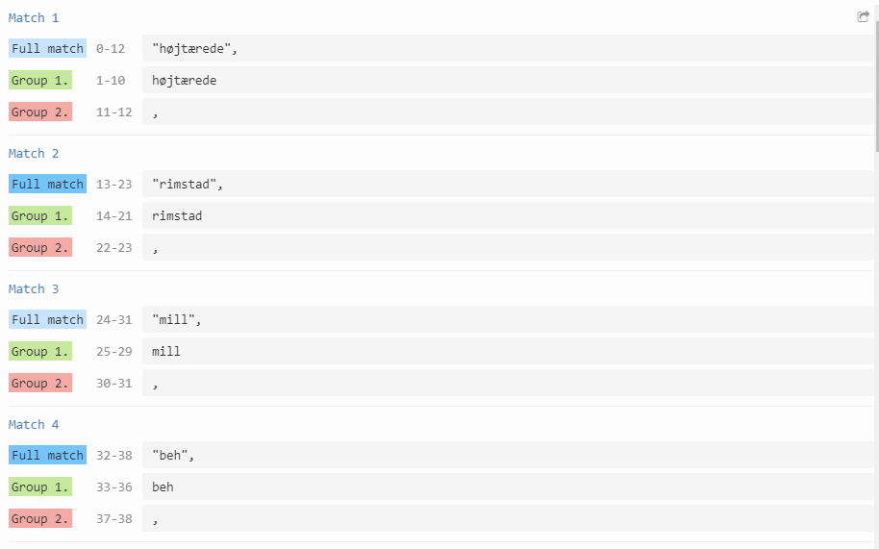

Then I use the substitution: $1\n. This command organizes all the words into a Voyant format. (1 word per line)

In order to convert the format from Voyant to R I use this expression: \n. It matches all line-feeds. Then I use the substitution input to insert “, “ to all the matches, which gives me a list that R can read.

