Week 46: Shell

1. Identify the names and format of the 3 biggest files. Can you come up with a command to generate a numerically ordered list of 3 biggest files? (hint: consider using **wc** to gauge image size)

Firstly, I navigate to the folder by writing: cd/Documents/photos/HW

The command: ls-lS | head -n4 organizes the photos by size. The 3 biggest files are:

* 9240_Overview_S.RW2
* 9247_Overview_S.RW2
* 9237_Overview_S.RW2

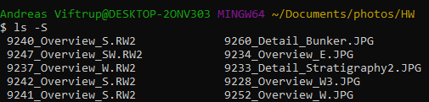

1. Some of the image files are empty, a sign of error in the data processing or corruption. Can you**find** the empty photo files (0 kb size) , count them, and generate a list of their filenames to make their later replacement easier?

(I had a lot of trouble in this exercise. I made it with my colleagues)

I use the following command:



wc -c *.* sorts all files by modification of file status.

| sort -r| reverses order while sorting

grep -H ´ 0 ´ searches the files and finds the corrupted ones.

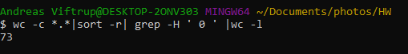

Counts all the corrupted files (0 kb size). There are 73 files.