DESCRIPTION

For this assignment, please submit a page of your journal showing the following solutions:

1) Use R to figure out how many elements in the vector below are greater than 2 . (You need to filter out the NAs first)

rooms <- c(1, 2, 1, 3, 1, NA, 3, 1, 3, 2, 1, NA, 1, 8, 3, 1, 4, NA, 1, 3, 1, 2, 1, 7, 1, NA)

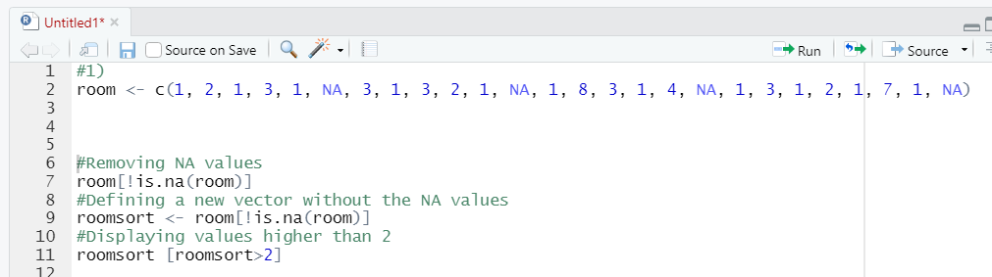

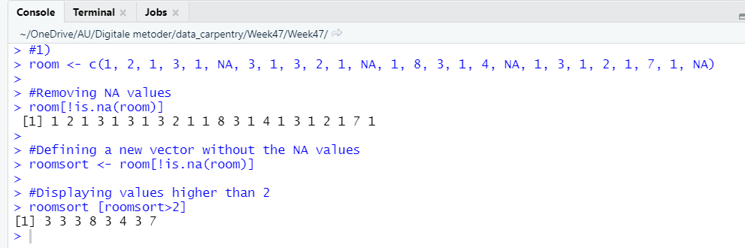

2) What is the average number of rooms (result of running mean() function) in the above 'rooms' vector? Again, best remove the NAs first.

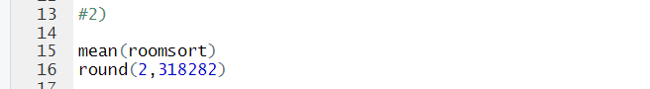

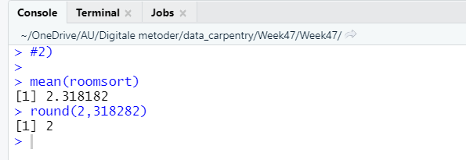

3) What type of data is in the 'rooms' vector? What function helps you determine the answer?

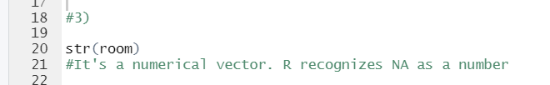

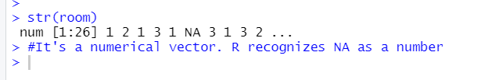

4) Inside your R Project (.Rproj), install the 'tidyverse' package and use the download.file() and read_csv() function to read the SAFI_clean.csv dataset into your R project as 'interviews' digital object (see instructions in https://datacarpentry.org/r-socialsci/setup.html and 'Starting with Data' section). **Take a screenshot**of your RStudio interface showing a) the script you used to create the object, b) the 'interviews' object in the Environment and the c) structure of your R project in the bottom right Files pane. Save the screenshot as an image and put it in your**AUID_lastname_firstname** repository inside our Github organisation ([github.com/Digital-Methods-HASS](https://www.github.com/Digital-Methods-HASS)). In this Blackboard submission, list the URL leading to the screenshot in your github repository.

<https://github.com/Digital-Methods-HASS/au539080_Andreas_Viftrup-/blob/main/Screenshot_3.jpg>