Denne opgave er svaret på skiftevis engelsk og dansk :^) ups.

1. Create a *tidy* spreadsheet/table listing the names of Danish monarchs with their birth- and death-date and start and end of their reign. They should be sortable by year of birth. Suitable source website is for example[here](https://kongehuset.dk/monarkiet-i-danmark/kongerakken), but you can also use another source, provided you reference it. (Collaboration is welcome. Remember to attach this spreadsheet to Brightspace submission)

Ctrl+c fra matrixen på denne hjemmeside: <https://danmarkshistorien.dk/vis/materiale/kongeraekken>  
 ([teksten ser sådan her ud](https://aarhusuniversitet-my.sharepoint.com/:w:/g/personal/au669893_uni_au_dk/EciHedbluuxJpNO-i_UQO2gBQiQetrYuFHLTzaVqGvPmHw?e=bDgXQk))

Indsæt data i Excel, vælg tabulator som separator.

Slet kolonne 2, og alle de rækker der ikke indeholder en konge eller dronning.

Load fil I openrefine;

Uncheck “parse next”, uncheck “store blank rows” og “store blank cells as nulls”

Check “ignore first 4 lines”.

Operationer lavet i openrefine ses på [Dette Link](https://aarhusuniversitet-my.sharepoint.com/:w:/g/personal/au669893_uni_au_dk/EaVQclP9qgZDgoej5g_yuKEBM9Nqzl3QlF3Bk8-KeQ8neg?e=xmFJQP)

Resultat: [Her er mit link](https://aarhusuniversitet-my.sharepoint.com/:x:/g/personal/au669893_uni_au_dk/EYEQKUKNb-1Fq7bJ3pmsR5sBqoiWgB-OkxdvZrIMYaBqfA?email=202004296%40post.au.dk&e=CaXdSc) 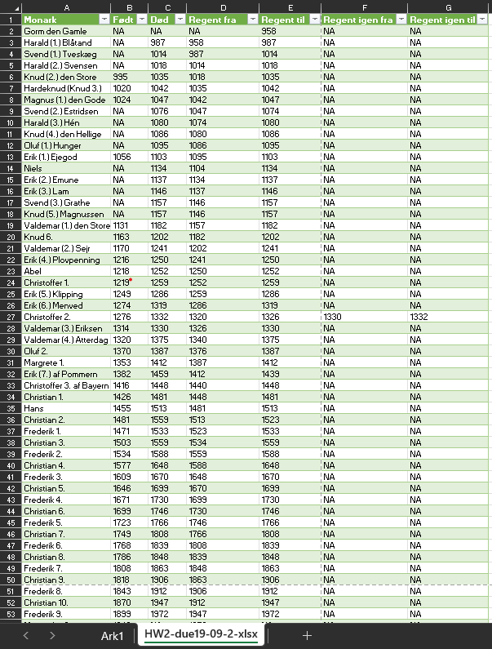

1. Does OpenRefine alter the raw data during sorting and filtering?

No, not during sorting and filtering. However you can edit your data in several ways. But when saving the edited data you create a new file, so the original data is not altered.

1. Fix the[interviews dataset](https://ndownloader.figshare.com/files/11502815) in OpenRefine enough to answer this question: "Which two months are reported as the most water-deprived/driest by the interviewed farmer households?"

Først transformes cellerne I kollonen “months_no_water” med følgende command: value.replace("[", "").replace("]", "").replace("'", "").replace(" ", "")

Dernæst ”create custom text facet” med følgende command: value.split(";")

Ved at sortere facet med “count” kan vi se at de oftest rapporterede tørre måneder er oktober (74) og september (70).