W47: Visualize global development or historical homicides

**DESCRIPTION**

For this Visualisation assignment, you engage in two tasks and submit an rmarkdown document with a knitted result that collects the results of both tasks:

**A:** **same for everyone:** Visualize the duration of reign among Danish kings through time (from ca 900 - today) with ggplot. Use the dataset you/your group has created and submit both the script and the visualisation, ideally as part of an rmarkdown and html document (for details see bottom of this page).

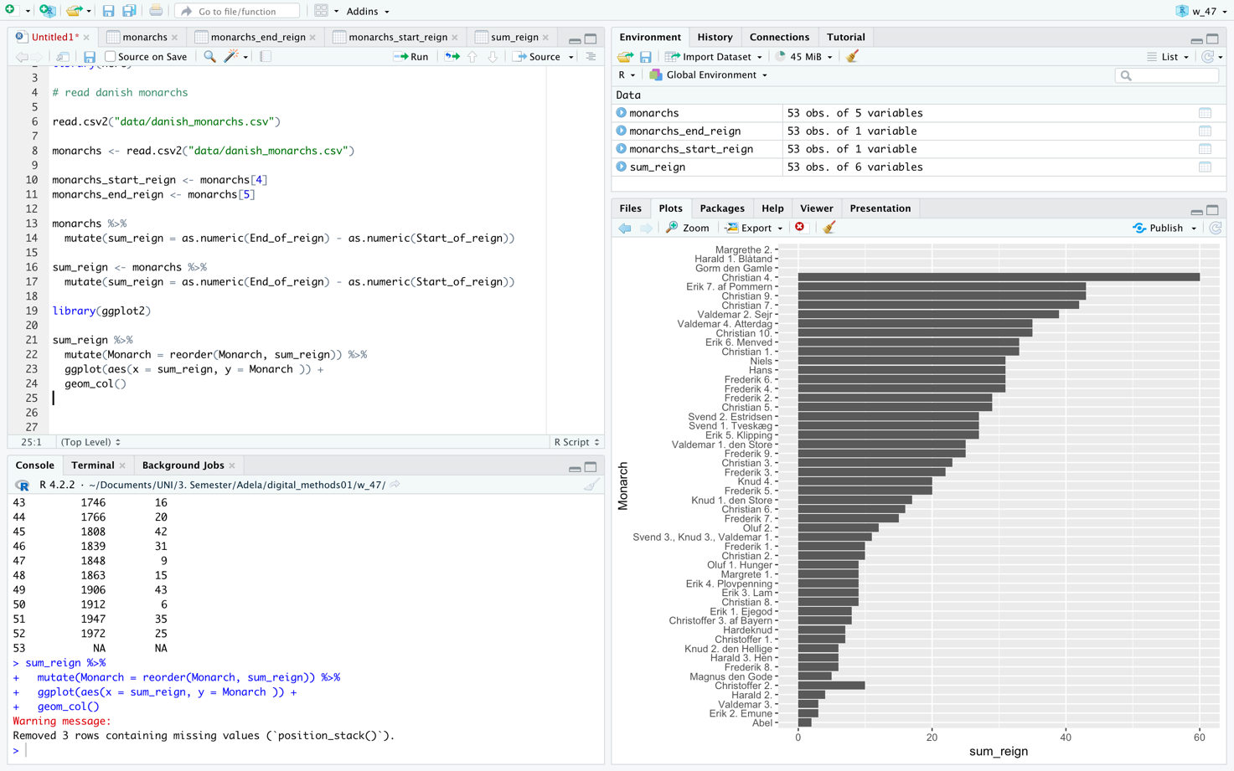

**B:** choose **one** of the two options below and follow the instructions in rmarkdowns. These have slightly different content depending on what you wish to practice, whether facets in ggplot or animation. For the latter, pay attention to the prerequisites R specifies for your system:

1. Historical homicide trends across Western Europe (ggplot practice) <https://github.com/Digital-Methods-HASS/HomicideHistory>

<file:///Users/magnuskrogh/Desktop/HomicideHistory-main/EuropeanHomicide_exercise.html>