Homework W38

1. **Use R to figure out how many elements in the vector below are greater than 2.**

When you run the script

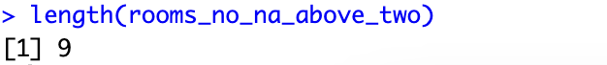

1. **Which function tells you the type of data the 'rooms' vector above contains?**

I use the function: class(rooms_no_na)



1. **What is the result of running the median() function on the above 'rooms' vector?**

I use the function: median(rooms_no_na)

1. **Submit the following image to Github: Inside your R Project (.Rproj), install the 'tidyverse' package and use the download.file() and read_csv() function to read the SAFI_clean.csv dataset into your R project as 'interviews' digital object (see instructions in https://datacarpentry.org/r-socialsci/setup.html and 'Starting with Data' section). Take a screenshot of your RStudio interface showing**

**a) the line of code you used to create the object,**

**b) the 'interviews' object in the Environment, and**

**c) the file structure of your R project in the bottom right "Files" pane.**

<https://github.com/Digital-Methods-HASS/au727836_Vinther_Gustav/blob/main/Sk%C3%A6rmbillede%202023-09-22%20kl.%2012.05.02.png>

**5) Challenge: Tidy up your Danish monarchs dataset (you created last week) sufficiently**

**so that you can load it into R as a tibble using the read_csv() and calculate the mean() and median() duration of rule over time.**

Console:

Mean:

Median

