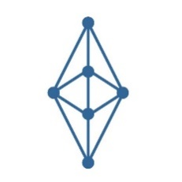 | Digital Monetary Fund  Whitepaper

Digital Monetary Fund (DMF), is a Distributed Autonomous Organisation (DAO) stable-coin provider, with more than 200 different tokens in circulation as of 2021. Due to the importance of stable-coin

Digital Monetary Fund - June 2021

