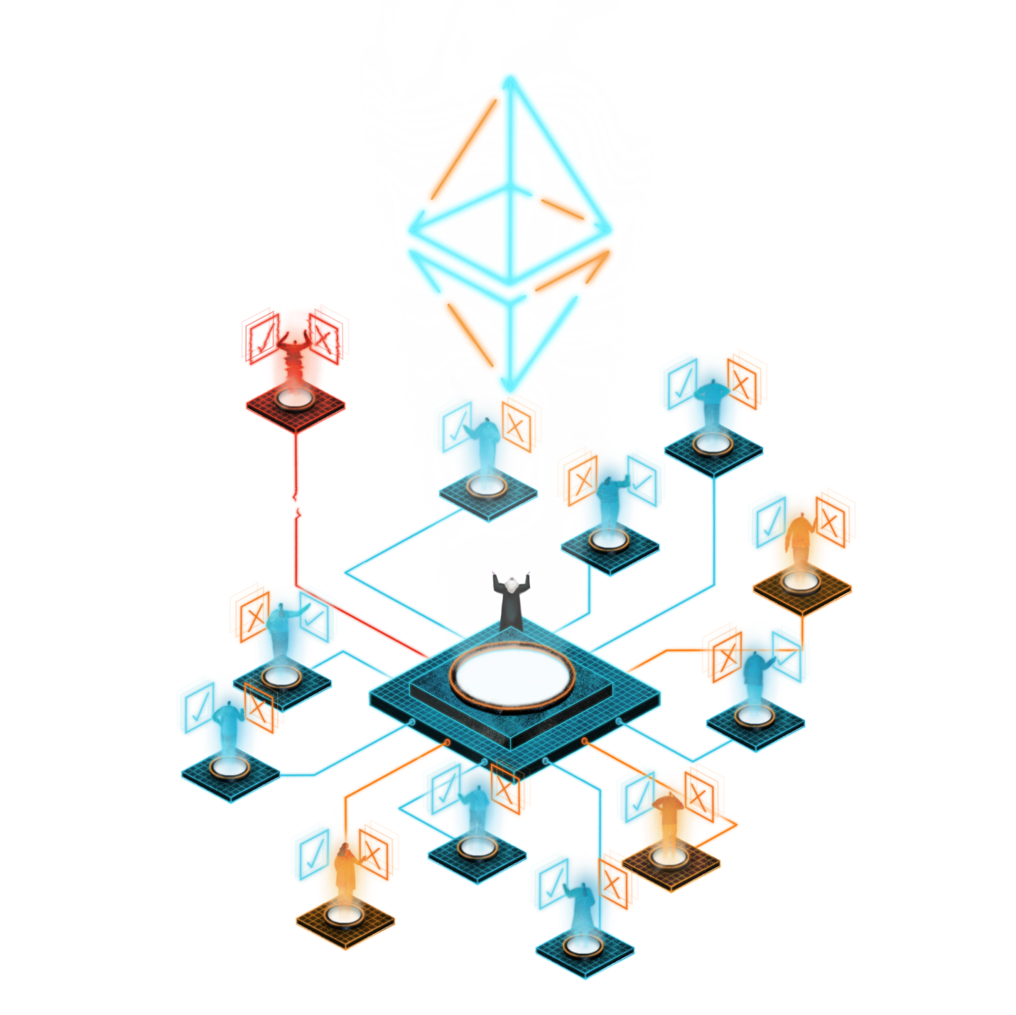

Digital Monetary Fund – Litepaper 2022

Table of Contents

Introduction 3

Problems With Stablecoins 3

Solution – smart Stablecoins 4

Market Size 5

Key Findings #1 5

Key Findings #2 5

Visual Data 6

The Token 7

Digital Monetary Fund ERC20 Token 7

Tokenomics 7

Exchange Listings 7

Team, Vision, Roadmap 8

Contact Details 9

General Email Addresses 9

Leadership Team Email Addresses 9

Internet and Social Media Links 9

Conclusion 10

Key Takeaways 10

# Introduction

The Digital Monetary Fund is a ĐAO (stylized Đ) (digital decentralized autonomous organization) with a mission to implement and manage a network of smart stablecoins.

The ĐAO objective is to provide a community-based decentralized business model for the Digital Monetary Fund. It was instantiated on the Ethereum blockchain and had no conventional management structure, although there is a board of directors that manage the enterprise on a day-to-day basis.

Modern Monetary Theory inspired the Digital Monetary Fund project, and we seek to use blockchain technology to explore how the monetary system can be improved to optimise the modern economy.

# Problems With Stablecoins

## What Is a Stablecoin?

Stablecoins are cryptocurrencies the value of which is pegged, or tied, to that of another currency, commodity or financial instrument. Stablecoins aim to provide an alternative to the high volatility of the most popular cryptocurrencies including Bitcoin (BTC), which has made such investments less suitable for wide use in transactions.

* Stablecoins are cryptocurrencies that attempt to peg their market value to some external reference.
* Stablecoins are more useful than more volatile cryptocurrencies as a medium of exchange.
* Stablecoins may be pegged to a currency like the U.S. dollar or to the price of a commodity such as gold.
* Stablecoins pursue price stability by maintaining reserve assets as collateral or through algorithmic formulas that are supposed to control supply.

## Established Stablecoins

Stablecoins are established and proven for their utility in preserving value and providing instant liquidity in the cryptocurrency markets. The five most popular stablecoins are:

* Tether (USDT) - Market Cap $67,532,179,334 - 24H Volume $42,045,692,764
* USD Coin (USDC) - Market Cap $51,654,083,228 - 24H Volume $5,985,119,029
* Binance USD (BUSD) - Market Cap $19,777,756,308 - 24H Volume $10,035,873,850
* Dai (DAI) - Market Cap $6,418,766,748 - 24H Volume $486,388,709
* Frax (FRAX) - Market Cap $1,478,463,932 - 24H Volume $8,818,462

## Limitations of Current Stablecoins

**Proprietary ownership**

Some stablecoins are owned and controlled by large crypto exchanges. For example, BUSD is from Binance and USDC is from Coinspot. This makes other, competing, exchanges reluctant to support the stablecoin.

Recently Binance announced they would auto-convert USDC, USDP, TUSD to (Binance) BUSD for this reason.

Stablecoins originating from a DAO overcome this proprietary limitation for more universal acceptance.

**Asset Integrity**

Stablecoins need to be backed and substantiated by valuable and liquid assets to ensure trust.

There are various methods to collateralize stablecoins.

Secure and liquid investments such as treasury bills can be purchased to provide a physical asset-backing for stablecoins.

Algorithms can be

Hybrid

Function

Need escrow

Staking/lending

Multi sig

Network of stable coins based on EVM blockchains

Universal, not proprietary to any exchange

Dedicated, single enterprise goal

Make it easier to be adopted by a wide range of exchanges

Transparent and democratic governance

Fragmented, inconsistent stable coins

Centralized control, centred on exchanges

Need smarter stable coins

Escrow

Lending

Stakin

Not limited to any exchanges, both CEX and DEX

Not limited to any blockchain

# Solution – smart Stablecoins

* What Is a Stablecoin?
* Stablecoins are cryptocurrencies the value of which is pegged, or tied, to that of another currency, commodity or financial instrument. Stablecoins aim to provide an alternative to the high volatility of the most popular cryptocurrencies including Bitcoin (BTC), which has made such investments less suitable for wide use in transactions.
* KEY TAKEAWAYS
* Stablecoins are cryptocurrencies that attempt to peg their market value to some external reference.
* Stablecoins are more useful than more volatile cryptocurrencies as a medium of exchange.
* Stablecoins may be pegged to a currency like the U.S. dollar or to the price of a commodity such as gold.
* Stablecoins pursue price stability by maintaining reserve assets as collateral or through algorithmic formulas that are supposed to control supply.

https://www.investopedia.com/terms/s/stablecoin.asp

Network of stable coins

This is where you explain succinctly how you intend to solve the problem you just stated. How does your solution work, and what’s nifty about it; this section should give the reader an idea of how big the market is and how much bigger it can get.

Automated Market Making

Web3

# Market Size

## Key Findings #1



4. Quick market figures

Concrete numbers — because hints are just not enough. The litepaper should have the relevant statistics that back up why you think — and why everyone should think — that your solution is a viable one.

## Key Findings #2



Research and argument



## Visual Data

Insert any data tables/charts/graphs/infographics etc.

# The Token

## Digital Monetary Fund ERC20 Token

We are offering for sale “Digital Monetary Fund” tokens (code “DMF”).

"DMF" is the utility token for governance of Digital Monetary Fund ĐAO and was published on the Ethereum blockchain on 14th May 2021. The ERC20 Contract address is:

<https://etherscan.io/token/0xa42be035918a91406ad0d756e96af0dd442e12df>

The code of the ĐAO ERC20 Smart Contract is open-source and publicly available in our Github site:

<https://github.com/Digital-Monetary-Fund/DAO>

Holders of the DMF token are encouraged to participate in the ĐAO.

## Tokenomics

There is a Maximum Total Supply of 1,000,000,000 DMF tokens, which were minted to the Digital Monetary Fund Treasury address on the Ethereum blockchain.

An initial 12.5% of the total supply of DMF tokens will be issued to the four founding members as compensation for their time and costs incurred launching the Digital Monetary Fund project, as well as their continued participation.

A further 12.5% of the total supply of DMF tokens will be offered in a private presale as “seed funding” at a price of $0.005 USDT or USDC. The proceeds of this presale will be used to fund an Initial Coin Offering of the “DMF” token and to engage Relationship Managers to promote DMF stable coins on crypto exchanges.

It is envisaged that 40% to 60% of the total token supply will be offered in an Initial Coin Offering (ICO) and Initial Liquidity Offering (ILO) at a price between USD $0.02 and $0.05. Proceeds will be used to fund further development of the project and to provide a substantial liquidity pool for the DMF stable coins.

There is no vesting period and the DMF tokens will be immediately transferred to purchasers.

## Exchange Listings

Initially the DMF token will be listed on these exchanges:

|  |  |  |
| --- | --- | --- |
| **Exchange** | **Website** | **Country** |
| Coin Harbour Pty Ltd | <https://www.coinharbour.com.au> | Australia |
| Independent Exchange | <https://www.independent.exchange> | Singapore |
| Yellow Exchange | <https://www.yellow.com> | Seychelles |

# Team, Vision, Roadmap

One of the main things investors look at when checking out start-ups is the team behind the project. Apart from a healthy mix of specializations, each founder should be someone who has an established online presence. A lack of verifiable online history and background is enough to make people think twice about the legitimacy of your project. And you can’t blame them — nowadays, it’s very easy for scammers to put up a website, collect token sale money, and disappear off the face of the web.

Include a roadmap outlining what your future expansion plans are. It’s important to paint a long-term future of your project to gain interest from investors.

Escrow

Staking

No special Wallet required

# Contact Details

## General Email Addresses

|  |  |
| --- | --- |
| General enquiries | [info@digitalmonetary.fund](mailto:info@digitalmonetary.fund) |
| Treasury team (liquidity or market-making) | [markets@digitalmonetary.fund](mailto:markets@digitalmonetary.fund) |
| Media enquiries | [media@digitalmonetary.fund](mailto:media@digitalmonetary.fund) |
| Help Desk for support or technical enquiries | [support@digitalmonetary.fund](mailto:support@digitalmonetary.fund) |

## Leadership Team Email Addresses

|  |  |
| --- | --- |
|  | [andrew@digitialmonetary.fund](mailto:andrew@digitialmonetary.fund) |
|  | [peter@digitialmonetary.fund](mailto:peter@digitialmonetary.fund) |
|  | [conan@digitialmonetary.fund](mailto:conan@digitialmonetary.fund) |

## Internet and Social Media Links

|  |  |
| --- | --- |
| Website | <https://www.digitalmonetary.fund> |
|  |  |
| LinkedIn | <https://www.linkedin.com/company/digital-monetary-fund/> |
|  |  |
| Facebook | <https://www.facebook.com/digitalmonetary.fund> |
|  |  |
| Telegram | <https://t.me/DigitalMonetaryFund> |
|  |  |
| Discord | <https://discord.gg/DigitalMonetaryFund> |
|  |  |
| Twitter | <https://twitter.com/DigitalMoneyFnd> |
|  |  |
| Quora | <https://www.quora.com/profile/Digital-Monetary-Fund> |
|  |  |
| Reddit | <https://www.reddit.com/r/DigitalMonetaryFund/> |
|  |  |
| Medium | <https://digital-monetary-fund.medium.com> |
|  |  |
| ĐAO | <https://client.aragon.org/#/dmf/> |
|  |  |
| Contract Address | <https://etherscan.io/token/0xa42be035918a91406ad0d756e96af0dd442e12df> |

# Conclusion

Time to wrap it up. What is your conclusion? How would you synthesize all the information into something even the busiest CEO wants to read? What are the key takeaways? How does your product/service/methodology uniquely address the issues raised by your study?

## Key Takeaways

* Takeaway #1
* Takeaway #2
* Takeaway #3