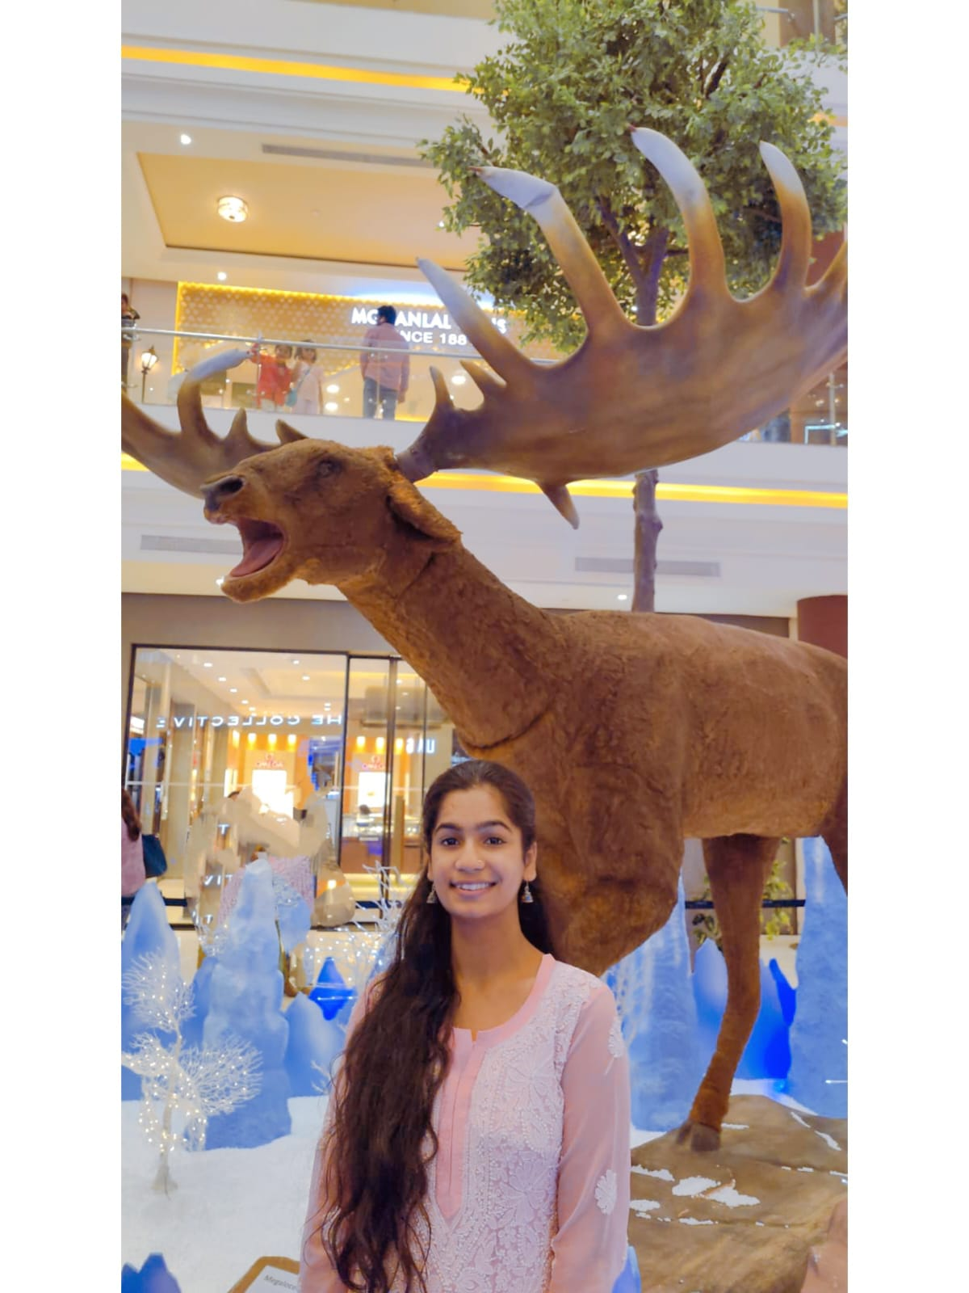
Shraddha Shukla
935419400
shraddhashukla016@gmail.com
ᛙ Lucknow India
CARRER OBJECTIVE
To work with sincerity and dedication, utilizing my abilities to contribute meaningfully to the organization while continuously enhancing my personal and professional growth and I aim to foster a positive and professional work environment for my colleague

EDUCATION
- High school passed from ICSE Board in 2017.
- Intermediate passed from ICSE Board in 2019.
- Graduation (B.Com.) in 2022.
- B.Ed. in 2024
- Perusing M.A. Economics (Online)

COMPUTER QUALIFICATIONS
- CCC.
- D.C.A.

WORK EXPERIENCE
1 Year Teaching Experience

SKILLS
- Good Communication Skill.
- Problem Solving Skill Team Work
- Creative
- Adaptability to new situation

extra curricular / achievements
- Member of college dance society
- Worked as sports coordinator
- Attended workshop on Enhancing Teaching Strategies
LANGUAGE
- Hindi & English

HOBBIES

- Art and Craft
- Dancing

