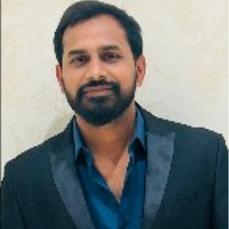  ABHISHEK SINGH  Physical Education Teacher  Contact  Address  Varanasi 221005  Phone  7080450062  E-mail  abhisheksingh.bhu2012@gmail.com  Personal Details  Date of Birth: 18 july 1988  Skills  - Taekwondo  - Cricket (District Level & Inter University Level)  - Kabaddi  - Volleyball  - Karate  - Judo  - Badminton  - Windows 98  - Windows 2000  - Leadership  Languages  English  Hindi | To be associated with the organization where I can use all my learned skills and which gives me maximum opportunity to learn and efficiently deliver my best.  Work History  2015-01 - 2025-02 Physical Education Teacher Buddha Public School - Taught physical education classes covering exercise strategies, sports, and safety. - Established a positive rapport with parents, conducting regular communication to keep them informed about their child''s progress and achievements in physical education classes. - Served as a coach for various school sports teams, leading them to numerous victories and successful seasons.  Physical Education Teacher  Kendriya Vidyalaya 39 GTC, Varanasi  Warden & Physical Education Teacher  Sunbeam Suncity, Varanasi  Official  IIT B.H.U.  - Worked as an official Inter faculty  Official  Navodaya Vidyalaya Sangathan  - Worked as an official in cluster level Handball championship  Physical Education Teacher  Kendriya Vidyalaya No.1, Agra  Worked as a dance teacher from 1st impression.  Education  2008-04 Bachelors of Computer Application(BCA) MBS College - Varanasi  2008-04 - 2009-01 Bachelor Of Physical Education: one Year Professional Course Banaras Hindu University - Varanasi  2010-01 - 2011-01 Master Of Physical Education: 2 Year Professional Course Banaras Hindu University - Varanasi  Extra-Curricular Activities  - Professional Cricket Coaching certified by CAP( Cricket Academy of Pathans)  - Participated in 'Spandan' on BHU, Varanasi  - Participated in various Cultural activities at College and School level Participated in debates, seminars in college  Personal Information  - Father's Name: Lt. Shiv Shankar Singh  - Mother's Name: Mrs. Madhuri Singh  Achievements Awards  - 1st Dan black belt in Taekwondo  - 1st Dan black belt in Karate  - Gold medal in World Championship in World Karate Games  - Fifteen times Gold medalist in State Karate Championship  - Participated in International Karate Championship  - Participated in International Taekwondo Championship 2018
.

