Curriculum Vitae
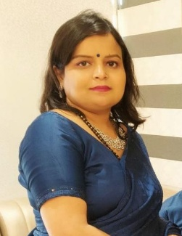
Tanu Singh
 C-1405/6 Indira Nagar, Lucknow, Uttar Pradesh, 226016
- 8299463007
 tanulibra82@gmail.com

Summary
Private tutor with 5 years and 2.5 years in school teaching of experience providing tailored instruction to elementary and middle school students. Proven track record of helping students exceed expectations in math, science, and language, computer. Committed to fostering a positive learning environment and inspiring students to reach their full potential.”

Education
- Bachelor of Education –
- Division –First [73% ]
- Passing Year - July 2015
- Navyug Kanya Mahavidhyalaya, Lucknow, Uttar Pradesh
- Lucknow University

- Bachelor of Computer Application - Computer Application
- Division –First [71% ]
- Passing Year - Jul 2004
- DOEACC Society, Lucknow, Uttar Pradesh
- Makhanlal Chaturvedi Rashtriya Patrakarita Evam Sanchar Vishwavidhalaya , Bhopal

- Intermediate - PCB , English , Hindi
- Division –First [63% ]
- Passing Year -April 2001
- Spring Dale College, Lucknow, Uttar Pradesh
- Council For The Indian School Certificate Examinations (CISCE)

- High School - English, Hindi , Maths , SSC, Science, Computer
- Division –First [78%]
- Passing year - April 1999
- Spring Dale College , Lucknow, Uttar Pradesh
- Council For The Indian School Certificate Examinations (CISCE)

- Certification
Central Teacher Eligibility Test (CTET), 2015

- Experience
- Rani Laxmi Bai Memorial School , Vikas Nagar , Nov 2004 - Jan 2005 as a Computer Teacher
- Pioneer Montessori School , Vikas Nagar , Jul 2005 - Dec 2006 as a Computer Teacher
- Freelancer Home Tutor , Apr 2020 - Nov 2025

- Hobbies
- Dancing, Painting

- Personal Information
- Date of Birth: 09/10/1982
- Marital Status: Married
- Spouse Name: Amit Singh

- References
Neha Tiwari
School Teacher
Delhi Public School , Gurugram
Contact No: 8127811452

- DECLARATION
I hereby declare that the information provided above is true to the best of my knowledge and belief.

Name: Tanu Singh
Location: Lucknow
Date:

