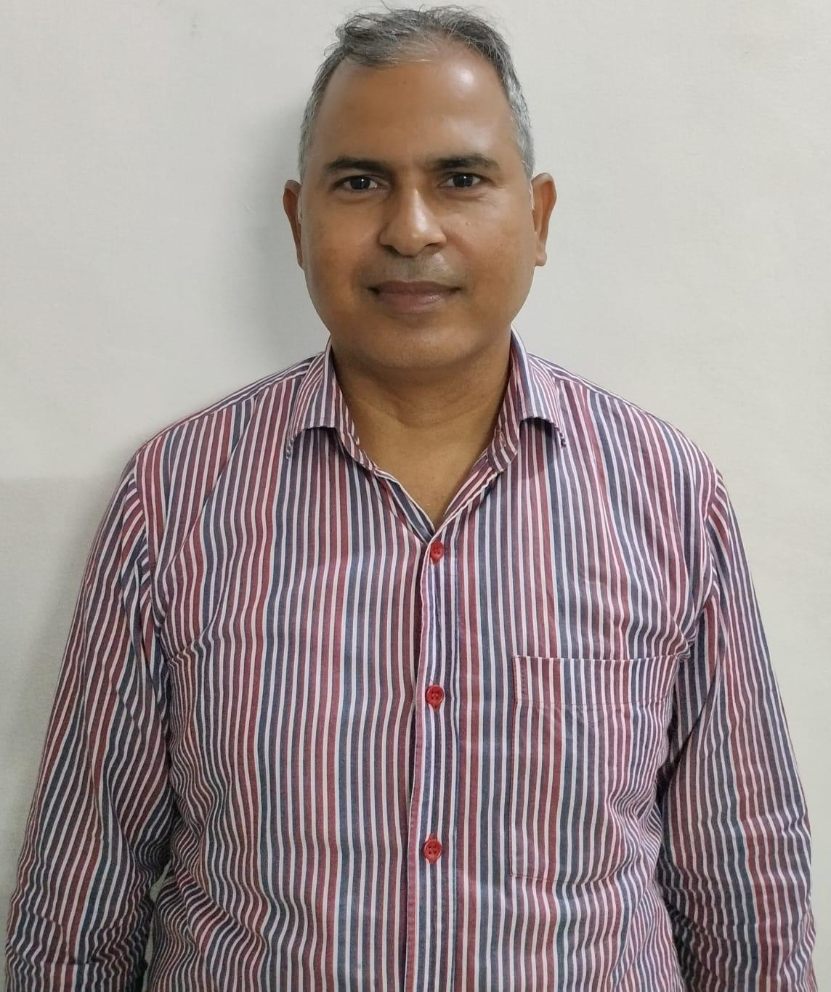

RAJ KUMAR PANDEY

Phone No: 9417631873rkpandey25382@gmail.com

Professional Summary

Dedicated and accomplished Chemistry teacher with over a decade of experience teaching senior secondary classes (Grades 11 and 12). Skilled in delivering complex concepts in Physical, Organic, and Inorganic Chemistry with clarity and enthusiasm, fostering both academic excellence and curiosity among students. Adept at designing engaging lesson plans aligned with curriculum standards, preparing students for board examinations and competitive entrance tests such as JEE (Main) and NEET. Known for creating a supportive classroom environment that encourages analytical thinking, problem-solving, and practical application of scientific principles. Strong track record of mentoring students to achieve outstanding results, while integrating modern teaching methodologies, laboratory experiments, and digital tools to enhance learning outcome.

Core Competencies

Subject Expertise: Deep knowledge of Physical, Organic, and Inorganic Chemistry aligned with senior secondary curriculum.

• Instructional Design: Ability to plan and deliver engaging lessons that simplify complex concepts.

• Exam Preparation: Skilled in preparing students for board exams and competitive entrance tests (JEE, NEET).

• Laboratory Management: Proficient in conducting experiments, ensuring safety protocols, and integrating practical learning.

• Student Engagement: Strong classroom management and ability to foster curiosity, critical thinking, and problem-solving.

• Assessment & Evaluation: Competence in designing tests, assignments, and providing constructive feedback.

• Technology Integration: Use of digital tools, simulations, and e-learning platforms to enhance teaching outcomes.

• Mentorship & Guidance: Supporting students academically and emotionally, motivating them to achieve excellence.

• Curriculum Development: Aligning lesson plans with educational standards and adapting to diverse learning needs.

• Communication Skills: Clear, effective, and empathetic communication with students, parents, and colleague

Professional Experience

Chemistry Teacher
APS FIROZEPUR July|2024– Present

- Developing lesson plans, delivering lectures and conducting lab activities, supervising experiments, assessing student performance, maintaining student records and communicating with parents and colleagues.

Chemistry teacher

DCM Group of Schools (2018-2022)

- Presented comprehensive lessons through class lectures, lab activities and supplemental learning materials.
- Developed and implemented chemistry curriculum to illustrate course concepts and meet diverse learning needs.
- Conducted weekly tutorials outside of regular class to provided additional student instruction and support.

Chemistry Teacher
ARMY PUBLIC SCHOOL, FIROZEPUR (2016-2018)

Developed and implemented chemistry curriculum to illustrate course concepts and meet diverse learning needs.
Promoted interactive learning through technology centered learning tools.

Major Achievements
Got appreciation certificate and cash prize of 55, 000 from Corps Commander for excellent result in chemistry and helping APS firozepur getting 5th Rank all over India among all APS.
Got Gold Certificate from KVS for excellent chemistry result.

Education
B.Sc (Med) PU Chd August: 2006
M.Sc( Chem) VMU November 2010
B. Ed MDU Sept 2011

DECLARATION: I hereby declare that all the facts mentioned above are accurate and I take full responsibility for their accuracy.
Date: 31st December, 2025

