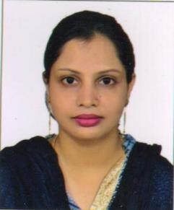
AFREEN KHAN
EMAIL: afreenfkhan272@gmail.com
Contact No: 7408553293
Address: 610/520-A Bari Enclave, Keshav Nagar, Sitapur Road Lucknow- 226020

Career Objective:
An enthusiastic individual with the interest and committed to work in a fast moving environment and challenges, to utilize all my academic and technical skills for the development of the organization and there by my own growth.

Academic Record :

S.No. Degree Board /University Division Marks(%) Year

1. High school CBSC Board ll^{nd} 51% | 2004
2. Intermediate CBSC Board l^{st} 74% | 2006
- B. A. (English & IT College (L.U.) ll^{nd} 50.67% Geography)  - B.L.I.Sc. IT College (L.U.) l^{st} 61% | 2009  2010
5. M.L.I.Sc IGNOU Ist 70% | 2019

Other Professional Certification/Software Skills:
- Diploma in office Automation
- Diploma in Financial Accounting (Tally).
- Certificate Course of Software-Fundamentals, Dos, Windows-XP, MS-Word, MS- Excel, Power Point & CDS/ ISIS.
Strength :
- Self motivated and an ability of shouldering team man responsibility.
- Presence of mind set to learn and improve constantly.
- Good Communication skill and an enthusiastic person.
- Innovative honest and punctual.

Linguistic Proficiency: English, Hindi, Urdu,
Experience :
  - Four years experience working as a librarian in City Montessori School
  - Worked as a examiner supervisor in ICSE board exams.
  - One and half year working experience as an assistant librarian in B.N. DEGREE COLLEGE.
  - One Year working experience In Era Central Library.
  - Experience working in digital library and working on Softwares (Softgranth and greenstone)
  - Experience working on databases like Proquest
INTEREST : To Work And Develop Skills In An Academic Environment. Extra Curricular Activities: Awarded certificate of training & Camps.
- National level BRONZE medalist in JUDO,
- GOLD medalist in JUDO in East Zone and many state level medals.
- Certificate of Appreciation in MAN & ENVIRONMENT EXCUSSION Organized by KARAVAN.
Personal Information :
Date of birth : March, 03, 1986 Marital status : Married
Sex : Female
Nationality : Indian Husband’s Name : Fazal Nabi Khan.

Declaration :
I hereby declare that the above information is true and reliable as per my knowledge and belief.
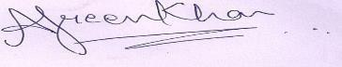
Place : Lucknow (Afreen Khan)
Date : 05 / 02 /2026 SIGNATURE

