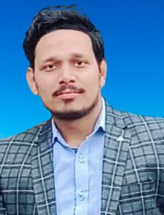
CURRICULUM-VITAE
SHUBHAM DIXIT

Res:- RS-II/169, LDA Colony Tikait Rai Talab Lucknow
Cont:- 9125580056, 6392873761

E-mail : dixitshubham381@gmail.com

OBJECTIVE:-

Seeking to apply my knowledge and learning skills in an institution which provides an encouraging and challenging work environment of original thinking experimentation and innovation.

ACADEMIC QUALIFICATION:-
- Passed High School from UP Board in 2010
- Passed Intermediate from UP Board in 2012
- B.Sc. from University of lucknow in 2015
- M.Sc. from Himalayan University in 2018

PROFISSIONAL QUALIFICATION
- B.Ed. from J.S. University in 2021

WORK EXPERINCE :-
- Worked as a Lecturer in Spring Dale School (ISC board) from 2017 to 2021.
- Worked as a Lecturer in St. Anthony Senior Secondary School (CBSE board) from 2021 to 2022.
- Currently working as a Lecturer in St. Francis School (ISC board) from 2022.

MY PERSONAL DETAILS:-
- Date of Birth : 18/11/1996
- Father's Name : Mr. Arvind Kumar Dixit
- Language Known : Hindi and English
- Gender : Male
- Hobbies : Reading , teaching
- Marital Status : Married

DECLARATION
I do hereby declare that the particulars of information and facts stated herein above are true correct and complete to the best of my knowledge and belief.

Date: …………………

Place: (SHUBHAM DIXIT)

