SANCHITA PANDEY
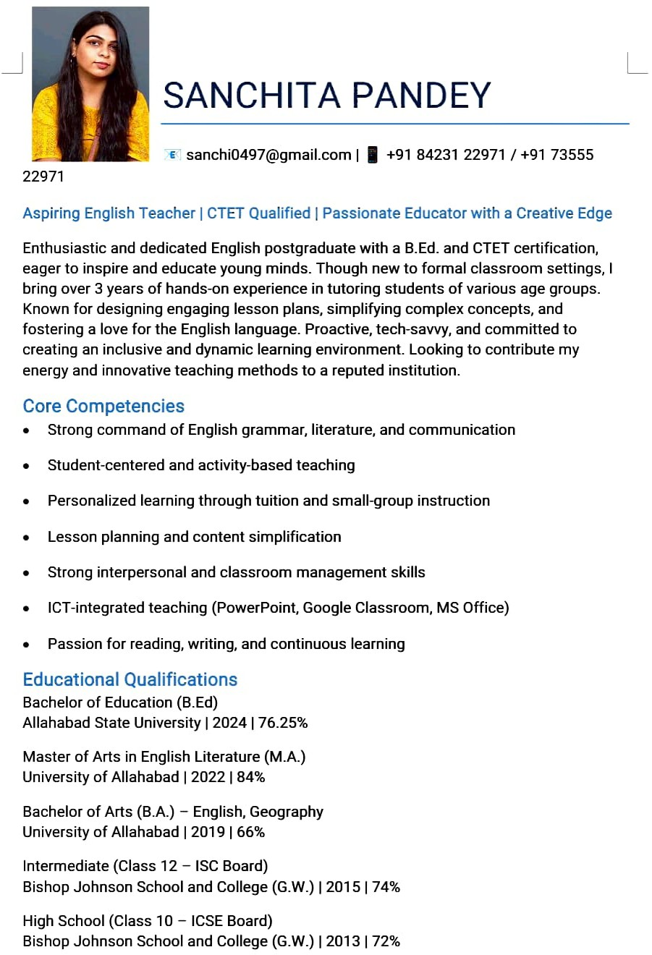
Email: sanchi0497@gmail.com
Phone: +91 7355522971

Professional Summary
Enthusiastic and dedicated English postgraduate with a B.Ed. and CTET certification, currently teaching English Language & Literature and Social Studies for Grades 3rd to 8th at TMPS International School (ICSE Board). With 1 year of formal school-level teaching experience and over 3 years of private tutoring, known for designing engaging lesson plans, simplifying complex concepts, and fostering a love for learning. Skilled in cooperative and collaborative teaching methodologies and committed to creating an inclusive, interactive, and student-centered learning environment.

Core Competencies
• Strong command of English grammar, literature, and communication
• Student-centered and activity-based teaching
• Personalized learning through tuition and small-group instruction
• Lesson planning and content simplification
• Strong interpersonal and classroom management skills
• ICT-integrated teaching (PowerPoint, Google Classroom, MS Office)
• Passion for reading, writing, and continuous learning

Educational Qualifications

• Bachelor of Education (B.Ed.), Allahabad State University – 2024 – 76.25%
• Master of Arts in English Literature (M.A.), University of Allahabad – 2022 – 84%
• Bachelor of Arts (B.A.) – English, Geography, University of Allahabad – 2019 – 66%
• Intermediate (ISC Board), Bishop Johnson School and College – 2015 – 74%
• High School (ICSE Board), Bishop Johnson School and College – 2013 – 72%

Teaching Experience

Primary & Middle School Teacher – English & Social Studies
TMPS International School (ICSE Board) | 2025–Present
• Teaching English Language & Literature and Social Studies for Grades 1–8.
• Designing interactive lesson plans aligned with the ICSE curriculum.
• Using cooperative and collaborative methodologies to promote teamwork and critical thinking.
• Conducting activity-based learning, storytelling, group tasks, and discussions.
• Preparing assessments, worksheets, and tailored materials for mixed-ability learners.
• Supporting holistic development through positive reinforcement and engagement.

Teaching Approach & Strengths
• Cooperative and collaborative teaching methodology.
• Breaking down complex grammar and literature concepts into simple formats.
• Encouraging active participation through discussions and creative exercises.
• Using worksheets, flashcards, and online resources for interactive learning.
• Promoting discipline, empathy, and balanced student growth.

Hobbies & Interests
• Reading fiction and poetry (Sudha Murthy, Robert Frost, Shakespeare)
• Writing short stories and reflective essays
• Public speaking and elocution
• Participating in literary discussions and workshops

Personal Details
• Date of Birth: January 4, 1997
• Languages Known: English, Hindi
• Location Preference: Open to relocation

