DATA+ FDDPS workshop

In this workshop, you will create and submit a dataset to the Fairdata Digital Preservation Service demo environment using Fairdata web services. All of the sites listed here use the same demo account credentials; you should have received a paper slip with the username and password from the workshop organizer.

1. Creating a file to upload
You can create your own preservation-ready document by opening LibreOffice Writer, creating a short text document and saving it as an ODT file (select ODF Text Document (.odt) as the format).

2. Upload file to IDA
2.1. Go to ida.demo.fairdata.fi using your web browser.
2.2. Create a directory with a name of your choice in the staging area.
2.3. Upload a file inside the directory you created.
2.4. Freeze the directory containing the file. For small files this should be nearly instantaneous.
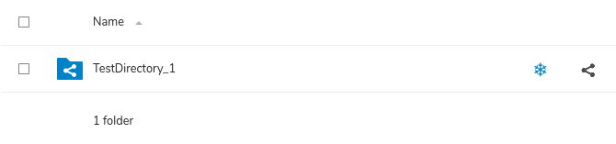

3. Create dataset in Qvain
3.1. Go to qvain.demo.fairdata.fi using your web browser.
3.2. Start creating a new dataset. You only need to fill the fields marked as mandatory.
3.3. Select the directory you uploaded to IDA. Select IDA under File origin, add the directory under Selected files.
3.4. IMPORTANT: Click the edit button next to the directory you added, select Add metadata and select a value for Use category. This field is required or otherwise FDDPS won’t accept the dataset!
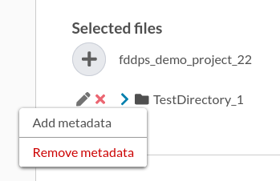
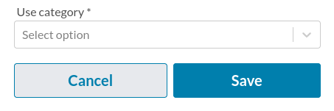

3.5. Save and publish the dataset.

4. Submit dataset to FDDPS
4.1. Go to manage.demo.fairdata.fi using your web browser.
4.2. Go to Datasets and select the dataset you created in Qvain.
4.3. Select Preservation tab to begin the preservation process. Select DATA+ Workshop Demo Contract as the contract.
4.4. Proceed in the preservation wizard. When prompted whether to accept or reject the dataset, select Accept.
4.5. Your dataset should now be submitted to the digital preservation service demo environment. Processing the dataset can take a few minutes, after which you should be able to see the dataset’s preservation status by refreshing the page.

And that’s the process of getting your dataset submitted into the Fairdata Digital Preservation Service. You can fill a short user experience survey at this address: https://link.webropolsurveys.com/S/D1D531451BE85C91

